Report
for
Auto Garage Software

Version 1.0 Approved

Prepared by:
Eman Rafique
Aqsa Nayab
Bisma Shahzad
Noor ul Eman

Quaid-i-Azam University
May 5, 2026

3. Analysis Models

Activity Diagram:
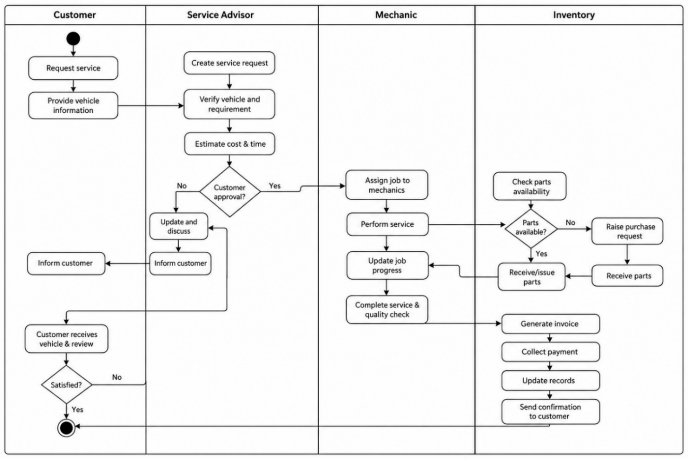
Description:

The activity diagram represents the working flow of the Auto Garage Management System. It explains how different tasks are performed from customer registration to service completion and invoice generation etc.
At first customer books appointment the service manager registers the customer and vehicle information if not registered in the system. A service request is then created and assigned to an available technician. The technician does the job and updates service status. After service completion the accountants generates invoice and records payment in finance module. At last the service history is stored in database for future reference

