Data Flow Diagram:
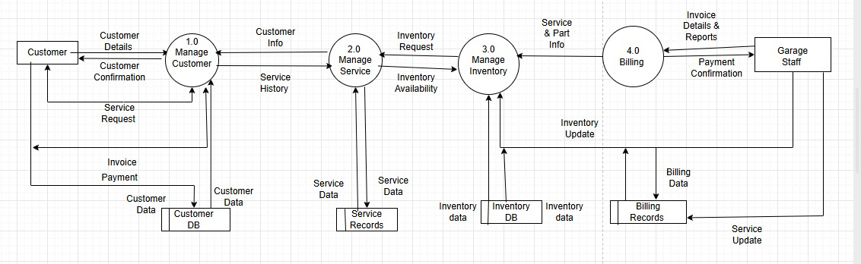
The data flow diagram illustrates how data moves throughout the system.

Level 0 DFD Description (Context Diagram ):

Customer provides vehicle and service request information to system and receive service updates , invoices , and repair details . Mechanics access assigned jobs , salary status , attendance etc. . Service Manager update service records , Finance department manages invoice generation , expenses details etc. . Inventory Management department manages inventory .

Level 1 DFD:

Data flow diagram divides the system into major functional processes , including service management , Inventory Management , Accounts Management etc. . It shows how data flows between these processes , data storage etc. .

Level 2 DFD Description:

This part provides more detailed view of individual processes within system. It breaks down processes into sub-processes such as customer registration, vehicle registration, service scheduling, repair record maintenance, spare parts management, invoice generation and payment processing. This level shows detailed movement of data required to perform operations within system.

