System Sequence Diagram:

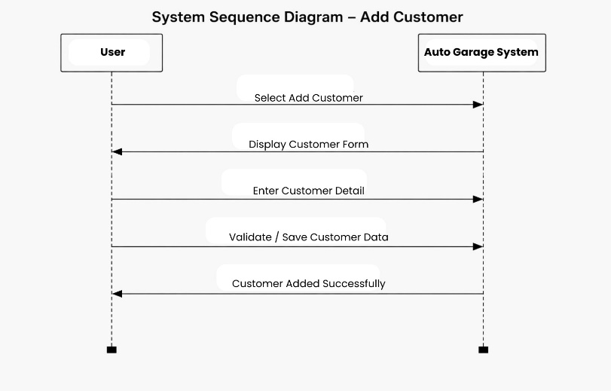
Description:
The system sequence diagram shows interaction between users and system.
Main Sequence:
- Customer requests vehicle service.
- Service Manager creates service record.
- System generates Service ID.
- Technician receives assigned task.
- Technician updates service progress.
- Inventory is updated if spare parts are used.
- System records completed service.
- Billing staff generates invoice.
- Customer makes payment.
- System stores transaction and updates records.

