3.4 Use Case Diagram:

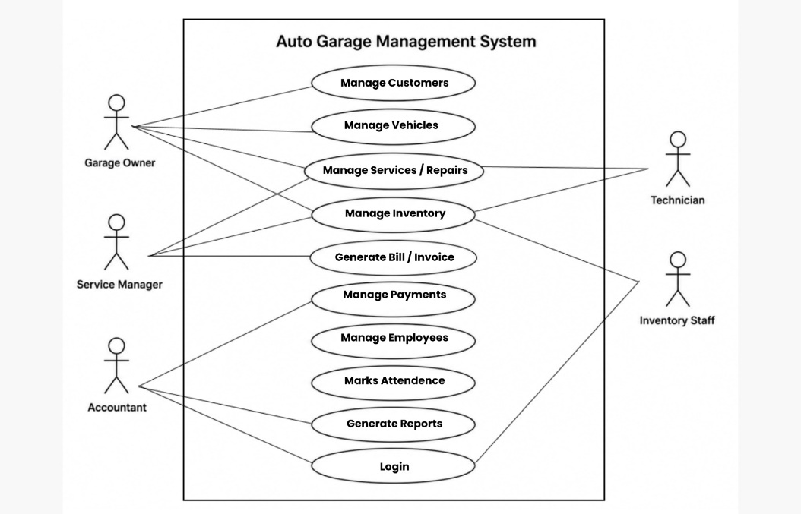

Description
The use case diagram shows major actors and their functionalities.
Actors
- Garage Owner
- Service Manager
- Technician
- Inventory Staff
- Accountant
- Customer

Main Use Cases
- Login
- Manage Customers
- Register Vehicle
- Create Service Request
- Assign Technician
- Update Repair Status
- Manage Inventory
- Generate Invoice
- Record Payment
- Manage Attendance
- Calculate Salary
- Generate Reports
- View Dashboard

