Report
for
Auto Garage Software

Version 1.0 Approved

Prepared by:
Eman Rafique
Aqsa Nayab
Bisma Shahzad
Noor ul Eman

Quaid-i-Azam University
May 5, 2026

4. Design

4.1 System Architecture
The Auto Garage Management System follows a layered architecture that separates user interaction, business processing, and data storage.

4.1.1 Presentation Layer

The Presentation Layer acts as the interface between users and the system. It is responsible for displaying information and receiving user input.

Functionalities

- User Login Interface
- Dashboard Display
- Service Management Screens
- Inventory Management Screens
- Billing and Invoice Screens
- Report Viewing Interfaces

Users Interacting with this Layer

- Garage Owner
- Service Manager
- Technician
- Inventory Staff
- Accountant

This layer makes system interactive and user friendly with help of graphics etc.

4.1.2 Business Logic Layer

The Business Logic Layer contains the main functionalities and business rules of the System.

Functionalities
- Customer Management Processing
- Vehicle Service Management
- Job Assignment Processing
- Inventory Updates
- Invoice Generation
- Attendance Tracking
- Payroll Calculation
- Report Generation
- Access Control Verification

This layer processes user requests, applies business rules, validates data .

4.1.3 Data Access Layer

The Data Access Layer manages communication between the application and the database.

Functionalities
- Store Customer Records
- Retrieve Vehicle Information
- Update Service Records
- Maintain Inventory Data
- Store Attendance Records
- Store salary Information
- Manage Billing Records

This layer provides secure and efficient storage and retrieval of information from the database.

4.1.4 Database Layer

The Database Layer serves as the central repository for all system data.

Stored Information

- Customer Details
- Vehicle Information
- Service Records
- Employee Records
- Inventory Data
- Attendance Records
- Payroll Records
- Billing Information
- Reports History

A database management system such as MySQL can be used to organize and maintain data consistency and avoid data duplication.

4.2 Class Diagram
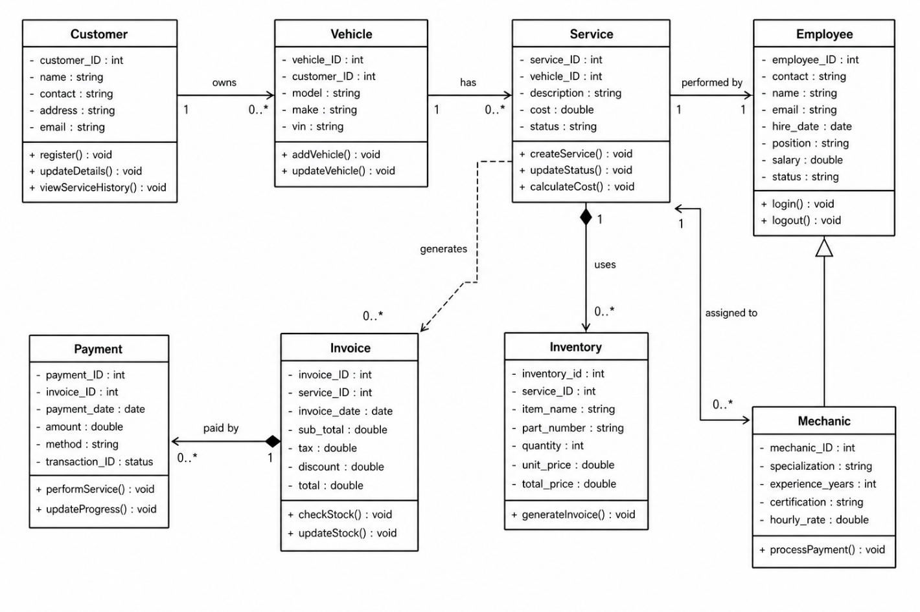

4.3 Sequence Diagrams 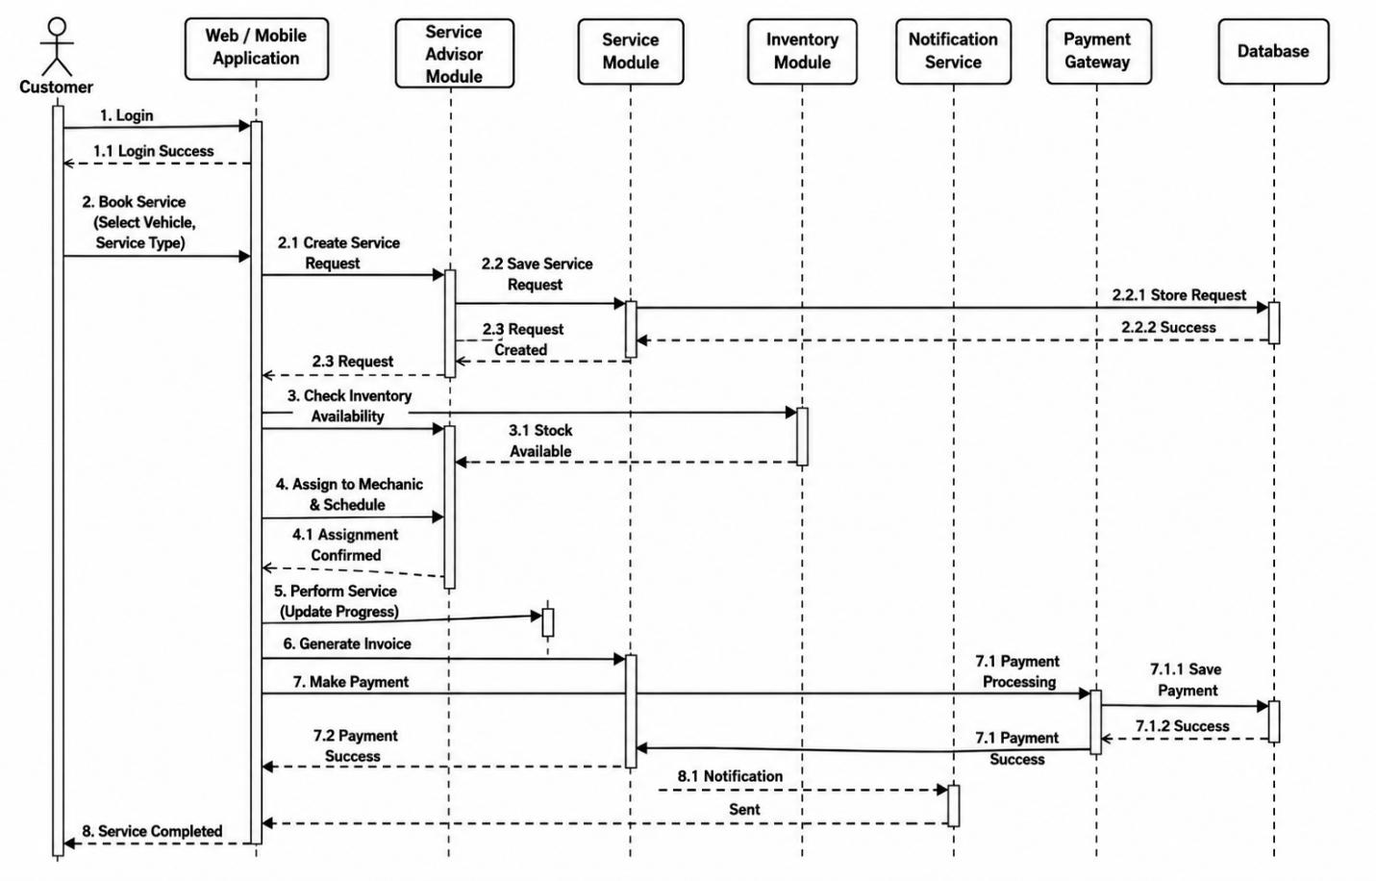

5. Testing

5.1 Test Strategy
The auto garage system will be tested to ensure that it fulfils all user requirements and ensures that all the modules work correctly. Testing will be performed at different levels:
- Unit testing
- Integration testing
- System testing
- Acceptance Testing

Unit Testing
Each module will be tested individually to verify that it performs its intended functions correctly.
Modules to be tested:
- Customer Management
- Vehicle Service Management
- Inventory Management
- Billing and Payment
- User Management
- Attendance and Payroll Management
- Reporting
Integration Testing
Integration testing will verify that different modules communicate and exchange data correctly.
- Service Management with Billing Module
- Inventory Module with Service Management
- Attendance Module with Payroll Module
System Testing
The complete system will be tested as a whole to ensure all functionalities operate properly.
Security testing will verify:
- User authentication
- Role-based access control
- Password protection
- Unauthorized access prevention
Performance Testing
Performance testing will evaluate system response time during normal usage and multiple user access.

5.2 Acceptance Testing
Acceptance testing will be performed to ensure that the system satisfies user requirements and business needs.
Test Case | Expected Result
User Login | User successfully enters the system
Invalid Login | System displays error message
Add Customer | Customer record is saved successfully
Update Customer Information | Customer details are updated
Search Customer | Correct customer record is displayed
Register Vehicle | Vehicle information is stored
Create Service Request | Service request is created successfully
Assign Technician | Technician is assigned to the service task
Update Service Status | Service progress is updated
Add Spare Part | Spare part is added to inventory
Update Inventory | Inventory records are updated
Low Stock Alert | System displays low stock notification
Generate Invoice | Invoice is generated successfully
Record Payment | Payment information is saved
Employee Check-In | Attendance time is recorded
Employee Check-Out | Exit time is recorded
Calculate Salary | Salary is calculated correctly
Generate Service Report | Service report is displayed
Generate Financial Report | Financial report is generated
View Dashboard | Dashboard summary is displayed
Unauthorized Access Attempt | Access is denied
Logout | User session ends successfully
Acceptance Criteria
The system will be accepted if:
- All critical functionalities work correctly.
- Customer records are stored accurately.
- Vehicle service records are maintained properly.
- Inventory updates are reflected correctly.
- Invoices and payments are generated without errors.
- Attendance and payroll calculations are accurate.
- Reports display correct information.
- Unauthorized access is prevented.
- No major defects remain unresolved.
- Users can perform their assigned tasks successfully.

5.3 Test Summary Report
Module | Total Tests | Passed | Failed
Customer Management | 4 | 4 | 0
Vehicle Service Management | 4 | 4 | 0
Inventory Management | 3 | 3 | 0
Billing and Payment | 3 | 3 | 0
User Management | 3 | 3 | 0
Attendance and Payroll | 4 | 4 | 0
Reporting | 2 | 2 | 0
Security Testing | 3 | 3 | 0
Total | 26 | 26 | 0
Result The values in this table are sample results. They should be replaced with actual values after real testing.

Appendix A: Glossary
This appendix defines key terms and abbreviations used in the Software Requirements Specification (SRS) for the Auto Garage Management System.
- Customer: A person who brings a vehicle for repair or maintenance.
- Vehicle: The automobile owned by a customer that requires service.
- Service Request: A record created when a customer requests repair or maintenance.
- Service Record: A detailed history of all services performed on a vehicle.
- Inventory: Stock of spare parts available in the garage.
- Invoice: A document generated for billing the customer after service completion.
- User Role: A category of system user (e.g., owner, mechanic, billing staff) with specific access rights.
- SRS: Software Requirements Specification.
- DBMS: Database Management System used to store system data.

Appendix C: To Be Determined List
This appendix lists features and improvements that may be added to the Auto Garage Management System in future versions.
- Online Booking System: Customers may be able to book service appointments online.
- Mobile Application: A mobile app version of the system may be developed for easier access.
- Online Payment Integration: Integration with digital payment systems for secure online transactions.
- SMS/Email Notifications: Automatic notifications to customers regarding service status and billing.
- Advanced Reporting: More detailed and customizable reports for business analysis.
- Integration with External Systems: Future integration with insurance systems or third-party automotive services.

