**Main Title**

© 2005–2021 UiPath Academy. All rights reserved.

**Subtitle**

**Business Analysis for Robotic Process Automation**



Student

Workbook

# Table of Contents

Table of Contents 2

Module 1: Domain Analysis 4

1.1 Key Questions 4

1.2 Glossary 5

1.3 Activity 1: Journal 6

1.4 Activity 2: Requirement Types 7

1.5 Activity 3: Requirement vs. Design 8

Module 2: Domain Analysis 9

2.1 Key Questions 9

2.2 Glossary 10

2.3 Activity 1: Analysis Models 11

2.4 Activity 2: Planning for Elicitation & Collaboration 12

2.5 Activity 3: Facilitation Guide 13

2.6 Activity 4: Stakeholder Analysis 14

2.7 Activity 5: Business Analysis Approach, Tasks, and Risks 16

Module 3: Domain Analysis 18

3.1 Key Questions 18

3.2 Glossary 19

3.3 Activity 1: Goals and Objectives Brainstorming 20

3.4 Activity 2: Problem/Opportunity Statements 21

3.5 Activity 3: The Importance of Standards: Notation 22

3.6 Activity 4: The Importance of Standards: Taxonomy 24

3.7 Activity 5: Business Context Diagram: Co-Op Application Portal 25

3.8 Activity 6: Evaluating Requirements Statements 26

3.9 Activity 7: Creating Requirements Statements 27

3.10 Activity 8: Adding Non-Functional Considerations/Qualifiers to Requirements Statements 29

Module 4: Domain Analysis 30

4.1 Key Questions 30

4.2 Glossary 31

4.3 Activity 1: Evaluating the Use Case Basic Flow 33

4.4 Activity 2: Evaluating Business Rule Types 35

# Domain Analysis

## Key Questions

* What is business analysis?
* What does a Business Analyst (BA) do?
* Where does business analysis occur in business, product, and/or system development lifecycles?
* How do I apply business analysis practices, and how can they help me, my company, or my clients?
* How does business analysis enable the design and development of intelligent automation solutions?

**Notes**

## Glossary

Throughout this module, define in your own words the terms listed in the table.

| **Term** | **Definition** |
| --- | --- |
| Changes |  |
| Needs |  |
| Solutions |  |
| Contexts |  |
| Stakeholders |  |
| Value |  |
| Business Analyst |  |
| Requirement |  |
| Design Definition |  |

**Notes**

## Activity 1: Journal

Answer the following questions:

My initial reaction to learning about the domain of business analysis is...

Based on the first class, I find the following aspects of business analysis interesting becasue...

I am interested in learning more about...

**Notes**

## Activity 2: Requirement Types

Using the requirements architecture, identify the most appropriate type of requirement for each of the statements listed in the table.

|  |  |
| --- | --- |
| **Requirements** | **Type** |
| 1. Account Manager must view six-months sales data across multiple organizational units in a single view. |  |
| 1. The goal is to reduce the amount of time needed to pick and pack customer orders. |  |
| 1. Display information in English and French. |  |
| 1. Medical Office Administrator must be able to record and access a medical patient’s history. |  |
| 1. New users must receive hands-on instructions when using the system. |  |

**Notes**

## Activity 3: Requirement vs. Design

Using the requirements architecture, identify the most appropriate type of requirement for each of the statements in the table.

|  |  |
| --- | --- |
| Requirements | Design |
| 1. Account Manager must view six-months sales data across multiple organizational units in a single view. |  |
| 1. The goal is to reduce the amount of time needed to pick and pack customer orders. |  |
| 1. Display information in English and French. |  |
| 1. Medical Office Administrator must be able to record and access a medical patient’s history. |  |

**Notes**

# Domain Analysis

## Key Questions

* How do we begin the process for eliciting requirements?
* How do we ensure they are correct?
* When do we use appropriate techniques, or produce models, that ensure our stakeholders can use the outcome of our work?

**Notes**

## Glossary

Throughout this module, define in your own words the terms listed in the table.

| Term | Definition |
| --- | --- |
| Analysis |  |
| Techniques |  |
| Models |  |
| Framework |  |
| Elicitation |  |
| Collaboration |  |
| Workshops |  |
| Approach |  |
| Stakeholder Analysis |  |

**Notes**

## Activity 1: Analysis Models

For your academic institution, develop one of the following models: Domain Model, Process Model, Interface Model. Use your Student Workbook to complete the table.

|  |  |
| --- | --- |
| Model Type | Model Example |
| Domain Model |  |
| Process Model |  |
| Interface Model |  |

**Notes**

## Activity 2: Planning for Elicitation & Collaboration

Based on the models produced for the academic institution in Unit 1, plan for and conduct an elicitation session to verify and validate the model produced.

|  |  |  |
| --- | --- | --- |
| Step | Specific Tasks/Techniques | Notes/Results |
| 1. Prepare |  |  |
| 1. Conduct |  |  |
| 1. Analyze/Synthesize |  |  |
| 1. Verify & Validate |  |  |
| 1. Communicate & Manage |  |  |

**Notes**

## Activity 3: Facilitation Guide

Using Activity 2 as an example, how could you better prepare to conduct a workshop session?

Create a plan to detail key considerations for each phase of your facilitated workshop/session.

|  |  |  |
| --- | --- | --- |
| Workshop Purpose | | |
| Workshop Objectives |  |  |
| Workshop Agenda |  |  |
| Time | Focus/Questions | Results/Findings |
|  |  |  |
|  |  |  |
|  |  |  |
| Next Steps/To-Do | |  |

**Notes**

## Activity 4: Stakeholder Analysis

How could you identify and classify different types of stakeholders?

Determine the techniques you could apply to source stakeholder information when starting a new initiative.

**Types of Stakeholders**

|  |  |
| --- | --- |
| Stakeholder Purpose | Types and Examples |
|  |  |
|  |
|  |
|  |  |
|  |
|  |

**Stakeholder Analysis Sources and Techniques**

|  |  |
| --- | --- |
| Sources and Techniques | Notes |
|  |  |
|  |  |
|  |  |
|  |  |

**Notes**

## Activity 5: Business Analysis Approach, Tasks, and Risks

How can you identify and classify different types of stakeholders? Determine the techniques you could apply to source stakeholder information when starting a new initiative.

|  |  |  |
| --- | --- | --- |
| Approach Section | Approach Details & Tasks | Notes |
| Requirements Approach |  |  |
| Elicitation Approach |  |  |
| Review Approach |  |  |
| Approval Approach |  |  |

Identify and define key business analysis risks that you have to consider prior to starting any business analysis initiative. For each type of risk, identify approaches that could be used to mitigate these risks.

|  |  |  |
| --- | --- | --- |
| Risk Types | Risk Type Definitions | Risk Type Mitigation Approach |
| Requirements Assumptions |  |  |
| Requirements Constraints |  |  |
| Requirements Dependencies |  |  |

**Notes**

# Domain Analysis

## Key Questions

* What is expected of me as a BA while working on a project?
* How do I begin analysis? What should I do when I am first assigned to a new initiative?
* How do I know what this initiative needs to address? How do I know I’m doing the right thing?
* What is the impact of this initiative? How complex is the process?
* What is scope? What is the difference between project scope and requirements scope?

**Notes**

## Glossary

Throughout this module, define in your own words the terms listed in the table.

| Term | Definition |
| --- | --- |
| Discovery Analysis |  |
| Vision |  |
| SIPOC Model |  |
| Business Requirements |  |
| Process |  |
| Process Analysis |  |
| Requirements Scope |  |
| Stakeholder Requirements |  |
| Business Context Diagram (BCD) |  |

**Notes**

## Activity 1: Goals and Objectives Brainstorming

Based on your course/program of study, create goals that the program may seek to achieve. For each goal identified, consider objectives that will enable the quantification and specificity of that goal.

|  |  |
| --- | --- |
| Goals | Objectives |
|  |  |
|  |  |
|  |  |
|  |  |

**Notes**

## Activity 2: Problem/Opportunity Statements

Review the problem/opportunity statements provided. Are either of these statements acceptable starting point for an initiative? What issues do they pose? What may it be missing?

|  |  |  |
| --- | --- | --- |
| Problem/Opportunity  Statement | Issues or missing elements? | Enhanced Statements |
| 1. Student accounts and academic performance information cannot be accessed on smart phones or tablets. |  |  |
| 1. We need to comply with Bill C-28, Canada’s Anti-Spam Legislation (CASL). |  |  |

**Notes**

## Activity 3: The Importance of Standards: Notation

Take time to review the map presented and consider the given questions.

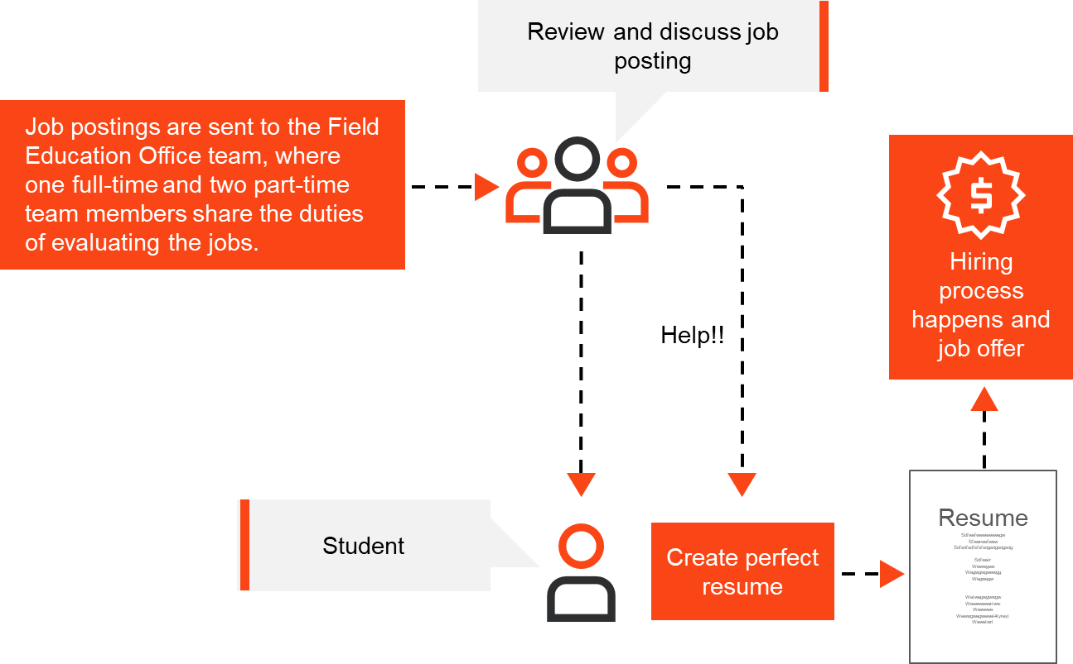

|  |  |
| --- | --- |
| Questions | Notes |
| 1. What is happening in this process? |  |
| 1. What problems to do you identify with the notation? |  |
| 1. As a BA, what would you have to do if using this as an input for your analysis? |  |

**Notes**

## Activity 4: The Importance of Standards: Taxonomy

Take time to review the map presented and consider the given questions.



|  |  |
| --- | --- |
| Questions | Notes |
| 1. What level is this map? |  |
| 1. What problems do you identify with the level? |  |
| 1. As a BA, what would you have to do if using this as an input for your analysis? |  |

**Notes**

## Activity 5: Business Context Diagram: Co-Op Application Portal

Using the description provided, create a BCD (DFD L0). To do this, identify the elements (center/scope, external entities, and data flows) to inlcude in the context diagram from the summary.

|  |  |
| --- | --- |
| Summary | BCD |
| George Brown College would like to create a Co-Op Application Management Portal. This portal will enable employers to submit co-op job postings, allow co-op office staff to review and decision (approve, decline) postings, and provide students with the opportunity to search, view, and apply to approved co-op job postings. Student applications will be submitted via the portal and sent directly to employers. Application metrics will be captured and send to co-op office staff and college management in the form of a report. |  |

**Notes**

## Activity 6: Evaluating Requirements Statements

Review the High-level/Requirements Scope statements. Are they acceptable? What issues do they pose? What may they be missing?

|  |  |  |
| --- | --- | --- |
| Requirements  Statement | Issues or missing elements? | Enhanced Statements |
| 1. The system must generate weekly MIS reports. |  |  |
| 1. Vendors must be able to access records, reports, etc. |  |  |
| 1. Interfaces between systems will provide information to ERP application. |  |  |
| 1. An audit log shall be available showing who did what and when. |  |  |

**Notes**

## Activity 7: Creating Requirements Statements

Review the BCD for the proposed Co-Op Application Management Portal. Based on the human entities identified in the BCD, use the information flows to help in creating High-level/Requirements Scope statements. One sample statement has been created in the diagram.

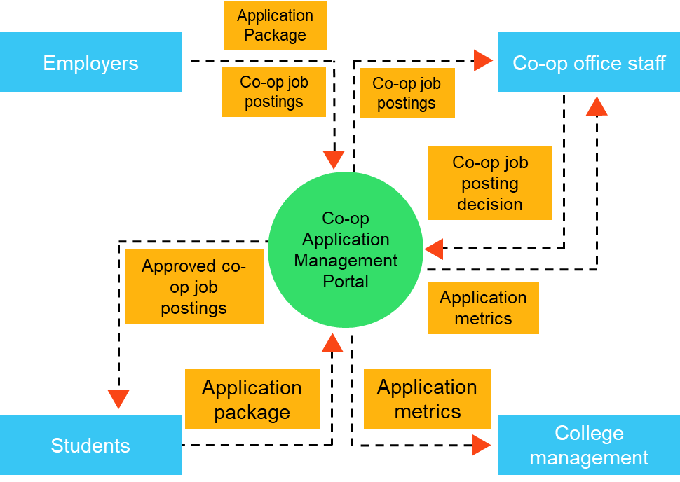

|  |  |
| --- | --- |
| HLR # | Definition |
| HLR001 |  |
| HLR002 |  |
| HLR003 |  |
| HLR004 |  |
| HLR005 |  |
| HLR006 |  |
| HLR007 |  |
| HLR008 |  |
| HLR009 |  |
| HLR010 |  |

**Notes**

## Activity 8: Adding Non-Functional Considerations/Qualifiers to Requirements Statements

Review the above Co-Op Application Portal Requirements Scope statements. For each, identify and/or consider potential non-functional qualifiers to enhance these requirements.

|  |  |
| --- | --- |
| HLR # | Non-Functional Considerations/Qualifiers |
| HLR001 |  |
| HLR002 |  |
| HLR003 |  |
| HLR004 |  |
| HLR005 |  |
| HLR006 |  |
| HLR007 |  |
| HLR008 |  |
| HLR009 |  |
| HLR010 |  |

**Notes**

# Domain Analysis

## Key Questions

* How do we elaborate on the scope that has now been defined?
* How do we ensure that our requirements will be addressed in future state?
* What details are necessary for designers and developers to do their work?
* How detailed do specifications need to be?

**Notes**

## Glossary

Throughout this module, define in your own words the terms listed in the table.

| Term | Definition |
| --- | --- |
| Solution Requirement |  |
| Functional Requirements |  |
| Non-Functional Requirements |  |
| Use Case Diagram |  |
| Use Case Specification |  |
| Business Rule |  |
| Data Requirements |  |
| Interface Analysis |  |
| Report Requirements |  |

**Notes**

## Activity 1: Evaluating the Use Case Basic Flow

Use Case

George Brown College would like to create a Co-Op Application Management Portal. This portal will enable employers to submit co-op job postings, allow co-op office staff to review and approve eligible postings, and provide students with the opportunity to search, view, and apply to approved co-op job postings. Student applications will be submitted via the portal and sent directly to employers. Application metrics will be captured and sent to co-op office staff and college management in the form of a report.

Review this use case describing the how an employer will submit a job posting to the proposed Co-Op Application Management Portal. Identify what information and or steps might be missing. Identify what best practices have not been applied.

**Use Case Flow**

|  |  |  |
| --- | --- | --- |
| Step # | Step Description | Summary of Findings |
| 1 | The system presents employer with job posting landing page. |  |
| 2 | User adds job posting details. |
| 3 | System requests job posting attachment if user details have been successfully added. |
| 4 | User opens attachment search. |
| 5 -7 | User navigates to folder, selects job posting, and attaches it. |
| 8 | System prompts user to save job posting. |
| 9 | Employer can save once satisfied. |

**Notes**

## Activity 2: Evaluating Business Rule Types

Scenario

George Brown College would like to create a Co-Op Application Management Portal. This portal will enable employers to submit co-op job postings, allow co-op office staff to review and approve eligible postings, and provide students with the opportunity to search, view, and apply to approved co-op job postings. Student applications will be submitted via the portal and sent directly to employers. Application metrics will be captured and sent to co-op office staff and college management in the form of a report.

Each of the statements is a business rule. For each, determine which type and sub-type best describes the rule defined.

|  |  |  |
| --- | --- | --- |
| Business Rule Statement | Type | Sub-Type |
| 1. A co-op employer is defined as any business who provide suitable co-op employment to a student. |  |  |
| 1. International students must have a valid co-op work permit to apply for co-op jobs. |  |  |
| 1. Co-op employers must ensure that co-op jobs will provide with a minimum of 360 working hours. |  |  |
| 1. Employer co-op tax credit will be 50% of students total compensation through the duration of co-op. |  |  |
| 1. A student must maintain a GPA of 3.0 to apply for co-op jobs. |  |  |
| 1. A student must submit both a resume and cover letter when applying for a co-op job. |  |  |
| 1. Students will be provided with 72 hours to accept a co-op job offer. |  |  |

**Notes**

