AirControl AI
Smart Hands-Free Computer Control System
Software Design Document
Document | Software Design Document: Architecture, Class Diagram, Sequence Diagram
Project | AirControl AI - Smart Hands-Free Computer Control System
Version | 1.0 (Draft)
Date | October 20, 2026
Prepared by | [Student Name]
Course | Software Engineering
Based on | SRS v1.0 and Use Cases v1.0

1. Introduction
This document describes how AirControl AI will be built. It turns the requirements (SRS) and the Use Cases into a software design: the overall Architecture, the classes of the system (Class Diagram) and the order of interactions for the main scenario (Sequence Diagram). It is the blueprint used in the implementation phases.

1.1 Key Terms
- Architecture: the high-level structure of the system: its main parts and how they are connected.
- Layered Architecture: the parts are grouped in layers; each layer uses only the layer below it.
- Class: a blueprint for objects, with attributes (data) and methods (actions).
- Class Diagram: a picture of the classes and the relationships between them.
- Composition: a relationship where one class owns and creates other objects (filled diamond).
- Sequence Diagram: a picture of the messages objects send to each other over time for one scenario.
- Lifeline: the vertical dashed line under each participant in a Sequence Diagram.

2. System Architecture

2.1 Chosen Style: Layered Architecture
AirControl AI uses a layered architecture that follows the five-stage pipeline of the proposal (camera input, hand detection, gesture recognition, command mapping, action execution). The reasons are:
- Simple to understand and to build step by step, which suits the one-week schedule.
- Each layer has one job, so a layer can be tested or replaced alone (NFR-06 Maintainability).
- New features, such as Presentation Control, need only a new command class and new mapping entries.
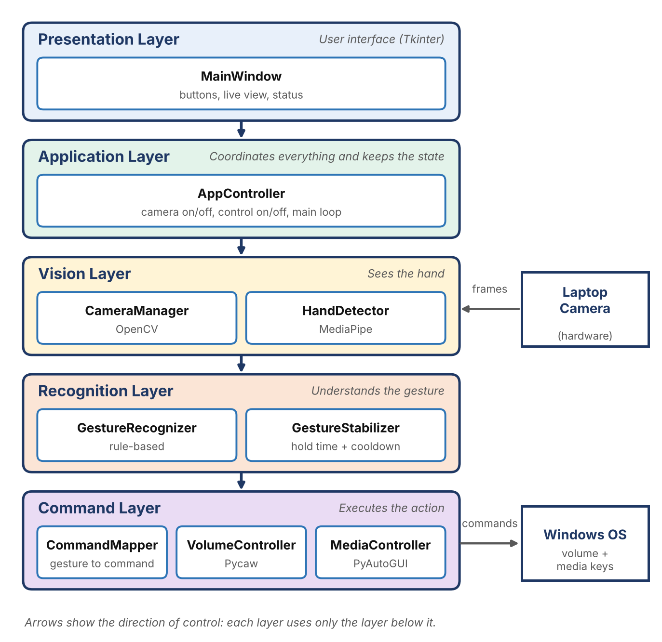
Figure 1: Layered architecture of AirControl AI

2.2 Layer Responsibilities
Layer | Classes | Responsibility | Technology
Presentation | MainWindow | Shows buttons, live camera view, current gesture and volume. Contains no recognition logic. | Tkinter
Application | AppController | Keeps the state (camera on/off, control on/off), creates the other objects and runs the per-frame process. | Python
Vision | CameraManager, HandDetector | Reads frames from the camera and finds the hand and its 21 landmarks. | OpenCV, MediaPipe
Recognition | GestureRecognizer, GestureStabilizer | Decides which gesture is shown, and confirms it only if held steadily and not in cooldown. | Python (rule-based)
Command | CommandMapper, VolumeController, MediaController | Maps a gesture to a command and executes it on Windows. | Pycaw, PyAutoGUI

2.3 Data Flow
For every camera frame, the data moves through the system in this order:
- Frame (image) from CameraManager.
- HandData (21 landmarks) from HandDetector.
- GestureType (for example THUMB_UP) from GestureRecognizer.
- Confirmed gesture from GestureStabilizer (or NONE).
- Command (for example VOLUME_UP) from CommandMapper.
- Action on Windows by VolumeController or MediaController.

3. Class Diagram
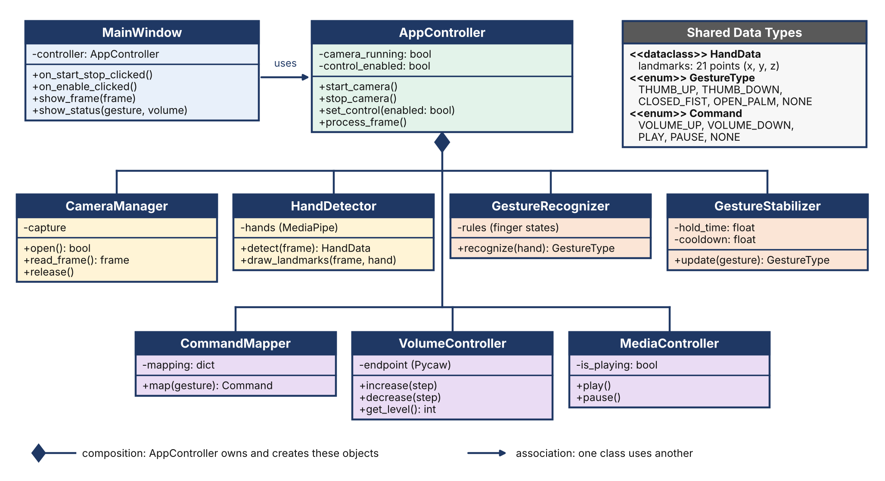
Figure 2: Class Diagram of AirControl AI

4. Sequence Diagram: Control System Volume (UC-04)
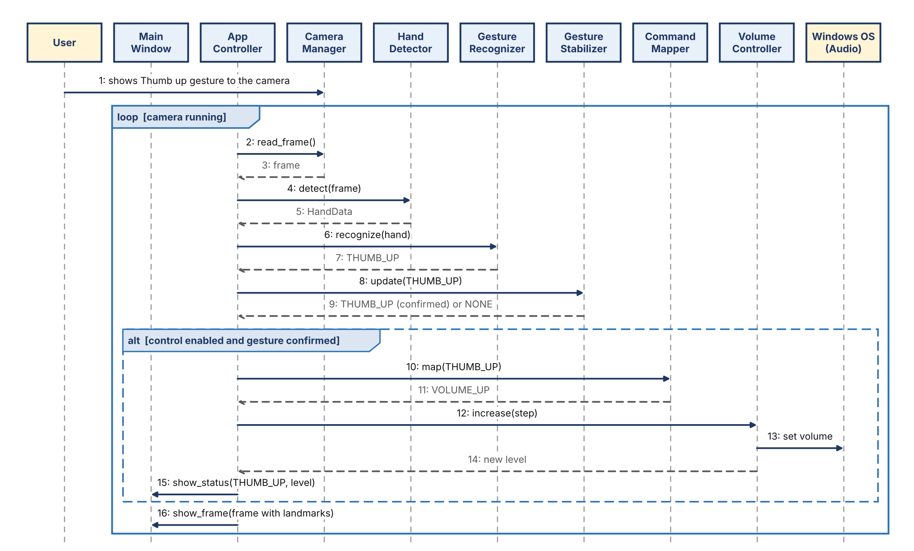
Figure 3: Sequence Diagram for increasing the volume with a Thumb up gesture

5. Reading the Sequence Diagram
The Sequence Diagram shows what happens when the user shows a Thumb up gesture (Use Case UC-04). Time moves from top to bottom.
- Message 1 is the user showing the gesture to the camera. It is a physical action, not a method call.
- The loop frame means messages 2 to 16 repeat for every camera frame while the camera is running.
- Messages 2 to 9 are the pipeline: read the frame, detect the hand, recognize the gesture, and confirm that it is stable.
- The alt frame means messages 10 to 15 happen only if control is enabled and a gesture was confirmed. Otherwise the system skips directly to message 16.
- Messages 10 to 14 map the gesture to VOLUME_UP, raise the Windows volume and return the new level.
- Messages 15 and 16 update the window with the status and the live frame.
- Dashed arrows are return values.
The Play / Pause sequence (UC-05) is the same, except that CommandMapper returns PLAY or PAUSE and the command goes to MediaController instead of VolumeController.

6. Class Responsibilities
Class | Responsibility | Requirements
MainWindow | Shows the Start/Stop Camera and Enable/Disable Control buttons, the live view with landmarks, the current gesture and the volume level. Forwards button clicks to AppController. | FR-01, FR-08, FR-09, FR-10
AppController | Creates and owns the other objects, keeps camera_running and control_enabled, and runs process_frame() for every frame. | FR-01, FR-08
CameraManager | Opens, reads and releases the camera. Reports a failure if the camera is unavailable so the app does not crash. | FR-01, NFR-07
HandDetector | Uses MediaPipe to find the hand and return its 21 landmarks (HandData). Draws the landmarks on the frame. | FR-02
GestureRecognizer | Rule-based logic: checks which fingers are up or down and the thumb direction, then returns a GestureType. | FR-03
GestureStabilizer | Confirms a gesture only after it is held for hold_time, and blocks repeats during cooldown. | FR-11, FR-12
CommandMapper | Converts a confirmed gesture into a Command using a dictionary, so mappings are easy to change later. | FR-04 to FR-07
VolumeController | Reads and changes the Windows system volume with Pycaw. | FR-04, FR-05, FR-10
MediaController | Sends play/pause to Windows with PyAutoGUI and remembers whether the video is playing (is_playing). | FR-06, FR-07
Shared Data Types | HandData (21 landmarks), GestureType (THUMB_UP, THUMB_DOWN, CLOSED_FIST, OPEN_PALM, NONE) and Command (VOLUME_UP, VOLUME_DOWN, PLAY, PAUSE, NONE). | FR-03

7. Design Decisions
ID | Decision | Reason
D-01 | Rule-based gesture recognition | Matches the proposal. No model training is needed; finger states from the landmarks are enough for four gestures.
D-02 | Tkinter window with a timed loop (after) instead of threads | Simplest approach for a first project. The loop processes one frame at a time and keeps the window responsive.
D-03 | Every frame is processed, but a command runs only after a stable gesture | Prevents accidental commands when the hand moves naturally (FR-11).
D-04 | Initial values: hold time about 0.5 s, cooldown about 1 s | Starting values only. They will be tuned during Testing for accuracy and comfort.
D-05 | MediaController remembers is_playing | The Windows media key is a play/pause toggle. Remembering the state avoids pausing a video that Open palm should keep playing. Limitation: the state can be wrong if the user changes it manually.
D-06 | Flip the camera image horizontally (mirror view) | Makes hand movement on screen feel natural, like a mirror.
D-07 | Dictionary-based CommandMapper | Makes future Custom Gestures and new modes easy to add (extensibility from the proposal).

8. Project Folder Structure
Each package matches one layer of the architecture, so the code stays organized and easy to test (NFR-06).
aircontrol/
main.py (starts the application)
requirements.txt
README.md
models/
types.py (HandData, GestureType, Command)
vision/
camera_manager.py
hand_detector.py
recognition/
gesture_recognizer.py
gesture_stabilizer.py
commands/
command_mapper.py
volume_controller.py
media_controller.py
core/
app_controller.py
ui/
main_window.py
tests/ (test cases from the Testing phase)

Appendix A: PlantUML Source of the Class Diagram
Paste this text into PlantUML (plantuml.com/plantuml) to generate the Class Diagram. You can also redraw it manually in draw.io using the UML class shapes.
@startuml
skinparam classAttributeIconSize 0

class MainWindow {
-controller: AppController
+on_start_stop_clicked()
+on_enable_clicked()
+show_frame(frame)
+show_status(gesture, volume)
}
class AppController {
-camera_running: bool
-control_enabled: bool
+start_camera()
+stop_camera()
+set_control(enabled: bool)
+process_frame()
}
class CameraManager {
-capture
+open(): bool
+read_frame(): frame
+release()
}
class HandDetector {
-hands
+detect(frame): HandData
+draw_landmarks(frame, hand)
}
class GestureRecognizer {
-rules
+recognize(hand): GestureType
}
class GestureStabilizer {
-hold_time: float
-cooldown: float
+update(gesture): GestureType
}
class CommandMapper {
-mapping: dict
+map(gesture): Command
}
class VolumeController {
-endpoint
+increase(step)
+decrease(step)
+get_level(): int
}
class MediaController {
-is_playing: bool
+play()
+pause()
}
class HandData <<dataclass>> {
landmarks: 21 points (x, y, z)
}
enum GestureType {
THUMB_UP
THUMB_DOWN
CLOSED_FIST
OPEN_PALM
NONE
}
enum Command {
VOLUME_UP
VOLUME_DOWN
PLAY
PAUSE
NONE
}

MainWindow --> AppController : uses
AppController *-- CameraManager
AppController *-- HandDetector
AppController *-- GestureRecognizer
AppController *-- GestureStabilizer
AppController *-- CommandMapper
AppController *-- VolumeController
AppController *-- MediaController
HandDetector ..> HandData
GestureRecognizer ..> HandData
GestureRecognizer ..> GestureType
GestureStabilizer ..> GestureType
CommandMapper ..> GestureType
CommandMapper ..> Command
@enduml

Appendix B: PlantUML Source of the Sequence Diagram
Paste this text into PlantUML to generate the Sequence Diagram.
@startuml
actor User
participant MainWindow
participant AppController
participant CameraManager
participant HandDetector
participant GestureRecognizer
participant GestureStabilizer
participant CommandMapper
participant VolumeController
participant "Windows OS (Audio)" as OS

User -> CameraManager : shows Thumb up gesture
loop camera running
AppController -> CameraManager : read_frame()
CameraManager --> AppController : frame
AppController -> HandDetector : detect(frame)
HandDetector --> AppController : HandData
AppController -> GestureRecognizer : recognize(hand)
GestureRecognizer --> AppController : THUMB_UP
AppController -> GestureStabilizer : update(THUMB_UP)
GestureStabilizer --> AppController : THUMB_UP (confirmed) or NONE
alt control enabled and gesture confirmed
AppController -> CommandMapper : map(THUMB_UP)
CommandMapper --> AppController : VOLUME_UP
AppController -> VolumeController : increase(step)
VolumeController -> OS : set volume
VolumeController --> AppController : new level
AppController -> MainWindow : show_status(THUMB_UP, level)
end
AppController -> MainWindow : show_frame(frame with landmarks)
end
@enduml

