AirControl AI
Smart Hands-Free Computer Control System
Use Cases and Use Case Diagram
Document | Use Cases and Use Case Diagram
Project | AirControl AI - Smart Hands-Free Computer Control System
Version | 1.0 (Draft)
Date | October 20, 2026
Prepared by | [Student Name]
Course | Software Engineering
Based on | AirControl AI Software Requirements Specification (SRS) v1.0

1. Introduction
This document describes how users and external systems interact with AirControl AI. It turns the requirements in the SRS into Use Cases, which are short descriptions of a goal the user wants to achieve with the system. The Use Cases are the input for the Design phase (Architecture, Class Diagram and Sequence Diagram) and for writing Test Cases later.

1.1 Key Terms
- Actor: someone or something outside the system that interacts with it (e.g., the User, the Camera).
- Use Case: a goal an actor achieves using the system (e.g., "Control System Volume").
- <<include>>: a use case that is always executed as part of another use case (e.g., every gesture command includes "Recognize Gesture").

2. Actors
Actor | Type | Description
User | Primary | The person who controls the computer with hand gestures and uses the application window (buttons and status display).
Camera | Secondary | The laptop camera that supplies the live video frames used to see the hand.
Windows OS | Secondary | The operating system that receives the commands: it changes the system volume and plays or pauses media.

3. Use Case List
UC-07 and UC-08 are internal use cases. They are not started directly by the user; other use cases include them.
ID | Use Case | Actors | Priority | Related FR
UC-01 | Start / Stop Camera | User, Camera | Must | FR-01
UC-02 | Enable / Disable Control | User | Must | FR-08, FR-14 (optional)
UC-03 | View Live Tracking and Status | User | Must | FR-02, FR-09, FR-10
UC-04 | Control System Volume | User, Windows OS | Must | FR-04, FR-05
UC-05 | Play / Pause Video | User, Windows OS | Must | FR-06, FR-07
UC-06 | Seek Forward / Rewind | User, Windows OS | Could | FR-13
UC-07 | Detect Hand (included) | Camera | Must | FR-02
UC-08 | Recognize Gesture (included) | None (internal) | Must | FR-03, FR-11, FR-12

4. Use Case Diagram
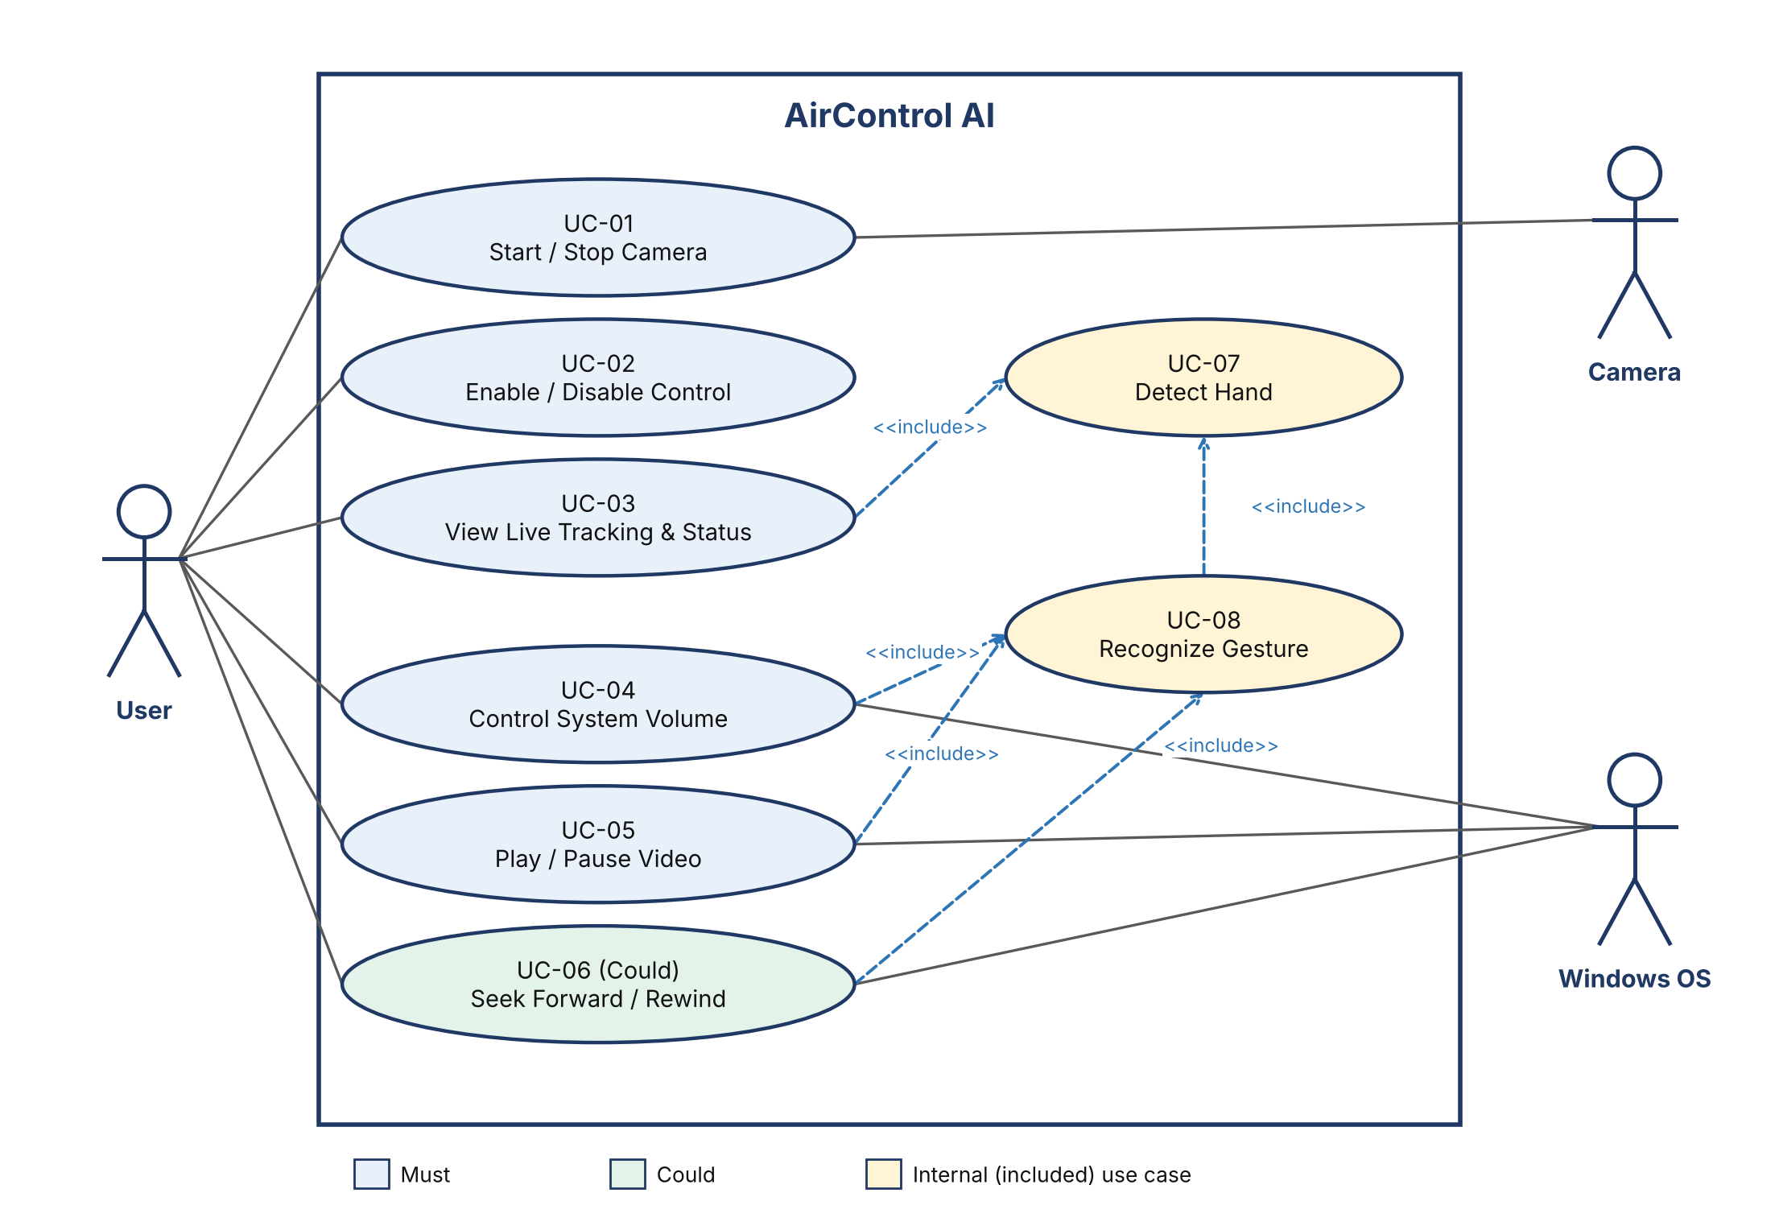
Figure 1: AirControl AI Use Case Diagram

How to read the diagram
- The box is the system boundary. Everything inside it is part of AirControl AI.
- The User (left) is connected to the six use cases they trigger directly.
- Camera and Windows OS (right) are secondary actors: the system uses them to see the hand and to execute commands.
- Dashed arrows labeled <<include>> mean the use case at the arrow tail always runs the one at the arrow head. Every gesture command runs Recognize Gesture, which in turn runs Detect Hand.

5. Use Case Specifications
The most important use cases are described in detail below. UC-03 (View Live Tracking and Status), UC-06 (Seek Forward / Rewind, Could) and UC-07 (Detect Hand) are simple and are fully described by the Use Case List in Section 3.

UC-01: Start / Stop Camera
Primary Actor | User
Secondary Actors | Camera
Description | The user turns the camera on to start hand tracking, or off to stop it.
Preconditions | The application is open.  A camera is connected to the computer.
Trigger | The user clicks the Start Camera (or Stop Camera) button.
Main Flow | - The user clicks Start Camera.  - The system opens the camera.  - The system shows the live camera view in the window.  - The user clicks Stop Camera.  - The system releases the camera and clears the live view.
Alternative / Exception Flows | E1: The camera is unavailable or already used by another application. The system shows a clear error message and stays in the stopped state.  E2: The camera is disconnected while running. The system stops safely and shows an error message instead of crashing.
Postconditions | The camera state (on/off) matches what the button shows.
Related Requirements | FR-01, NFR-07

UC-02: Enable / Disable Control
Primary Actor | User
Secondary Actors | None
Description | The user decides whether recognized gestures are allowed to execute commands. This prevents accidental commands, for example while writing.
Preconditions | The camera is running.
Trigger | The user clicks the Enable Control (or Disable Control) button.
Main Flow | - The user clicks Enable Control.  - The system sets the control state to Enabled and shows it in the window.  - From now on, recognized gestures are executed as commands (see UC-04, UC-05, UC-06).  - The user clicks Disable Control.  - The system sets the control state to Disabled. Gestures may still be displayed, but no command is executed.
Alternative / Exception Flows | A1: The camera is not running. The system asks the user to start the camera first and keeps control disabled.  Optional extension (Could): control can also be turned on with a dedicated activation gesture (FR-14).
Postconditions | Commands are executed only while control is Enabled.
Related Requirements | FR-08, FR-14 (optional)

UC-04: Control System Volume
Primary Actor | User
Secondary Actors | Windows OS
Description | The user raises or lowers the computer's system volume with a hand gesture.
Preconditions | The camera is running.  Control is Enabled.
Trigger | The user shows a Thumb up gesture (increase) or a Thumb down gesture (decrease) to the camera.
Main Flow | - The user shows a Thumb up or Thumb down gesture.  - The system detects the hand (UC-07) and recognizes the gesture (UC-08).  - UC-08 confirms the gesture was held steadily and that no cooldown is active.  - The system sends the volume command to Windows: increase for Thumb up, decrease for Thumb down.  - The system updates the displayed volume level.
Alternative / Exception Flows | A1: The gesture is not held long enough. No command is sent.  A2: A cooldown is still active. The gesture is ignored.  A3: The volume is already at its maximum or minimum. The volume does not change.  E1: Windows volume control is unavailable. The system shows an error message and keeps running.
Postconditions | The system volume has changed by one step (the step size is chosen during implementation).
Related Requirements | FR-04, FR-05, FR-10, FR-11, FR-12

UC-05: Play / Pause Video
Primary Actor | User
Secondary Actors | Windows OS
Description | The user plays or pauses a video with a hand gesture without touching the mouse or keyboard.
Preconditions | The camera is running.  Control is Enabled.  A video is open in a supported player or browser.
Trigger | The user shows an Open palm (play) or a Closed fist (pause) gesture.
Main Flow | - The user shows an Open palm or a Closed fist.  - The system detects the hand (UC-07) and recognizes the gesture (UC-08).  - UC-08 confirms the gesture was held steadily and that no cooldown is active.  - The system sends the play or pause command to Windows.  - The video plays or pauses.
Alternative / Exception Flows | A1: The gesture is not held long enough, or a cooldown is active. No command is sent.  A2: No supported player is active. The command has no visible effect (a known limitation of the project).
Postconditions | The video is in the state matching the gesture (playing or paused).
Related Requirements | FR-06, FR-07, FR-11, FR-12
Design Note | The Windows media key is a play/pause toggle. The system must track the playing state so that Open palm does not pause a video that is already playing. The exact approach will be decided in the Video Control phase.

UC-08: Recognize Gesture (included)
Primary Actor | None (internal use case)
Secondary Actors | None
Description | The system analyzes the detected hand and decides which gesture the user is showing. It is included by UC-04, UC-05 and UC-06.
Preconditions | A hand has been detected and its landmarks are available (UC-07).
Trigger | A calling use case (UC-04, UC-05 or UC-06) needs a recognized gesture.
Main Flow | - The system receives the hand landmarks from UC-07.  - The system analyzes finger positions and hand shape using rule-based logic.  - The system classifies the shape as Thumb up, Thumb down, Closed fist or Open palm.  - The system checks that the gesture has been held steadily for a short time.  - The system checks that the cooldown since the last command has passed.  - The system returns the confirmed gesture to the calling use case.
Alternative / Exception Flows | A1: The hand shape matches no supported gesture. The result is "None" and no command is executed.  A2: The gesture changes before it is stable. The stability timer restarts.
Postconditions | The calling use case receives either a confirmed gesture or "None".
Related Requirements | FR-03, FR-11, FR-12

6. Traceability: Requirements to Use Cases
Every Functional Requirement from the SRS is covered by at least one use case. This table helps prove that no requirement was forgotten.
Requirement | Summary | Covered by
FR-01 | Start and stop the camera | UC-01
FR-02 | Detect the hand and draw landmarks | UC-03, UC-07
FR-03 | Recognize the four gestures | UC-08
FR-04 | Thumb up increases volume | UC-04
FR-05 | Thumb down decreases volume | UC-04
FR-06 | Closed fist pauses video | UC-05
FR-07 | Open palm plays video | UC-05
FR-08 | Enable / Disable Control button | UC-02
FR-09 | Display the current gesture | UC-03
FR-10 | Display the current volume level | UC-03, UC-04
FR-11 | Gesture stability | UC-08
FR-12 | Cooldown between commands | UC-08
FR-13 | Forward / Rewind by hand movement | UC-06
FR-14 | Activation gesture | UC-02 (optional extension)

Appendix A: PlantUML Source of the Diagram
Paste this text into PlantUML (for example at plantuml.com/plantuml or in the PlantUML extension of VS Code) to generate the same diagram. You can also redraw it manually in draw.io using the UML "Use Case" shape library.
@startuml
left to right direction
actor "User" as U
actor "Camera" as C
actor "Windows OS" as OS

rectangle "AirControl AI" {
usecase "UC-01\nStart / Stop Camera" as UC1
usecase "UC-02\nEnable / Disable Control" as UC2
usecase "UC-03\nView Live Tracking & Status" as UC3
usecase "UC-04\nControl System Volume" as UC4
usecase "UC-05\nPlay / Pause Video" as UC5
usecase "UC-06 (Could)\nSeek Forward / Rewind" as UC6
usecase "UC-07\nDetect Hand" as UC7
usecase "UC-08\nRecognize Gesture" as UC8
}

U --> UC1
U --> UC2
U --> UC3
U --> UC4
U --> UC5
U --> UC6

UC1 -- C
UC4 -- OS
UC5 -- OS
UC6 -- OS

UC3 ..> UC7 : <<include>>
UC4 ..> UC8 : <<include>>
UC5 ..> UC8 : <<include>>
UC6 ..> UC8 : <<include>>
UC8 ..> UC7 : <<include>>
@enduml

