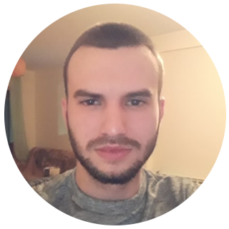
Emanuel Fernandes Azevedo
Lugar do Boucelinho 4540-209 Burgo, Arouca
910028599
emanuelf.azevedo@gmail.com







Profile
Graduate in Technologies of Information at School of Technologies and Management of Águeda in 2018. At the moment studying Master’s degree of Communication and Multimedia, in the area of Interative Multimedia at Aveiro University.
I have experience in backend and frontend, being more interested in the last one and in the use of technologies like ReactJS.

Professional Experience
Best Content Unipessoal, Lda. - Fullstack/Lead Developer Nov 2019 – Nov 2020
Development of a web aplication for digital marketing planning and management
- Fullstack development and maintenance of a web aplication with Vue and Laravel
- Maintenance of a web aplication with Vue and Laravel
- Management of the application and websites servers

Digitalmente Lda. - Fullstack Developer Fev 2018 – Maio 2018
Development of a web aplication for managing portfolios and employees of an energy company – curricular internship
- Fullstack development of a web application with AngularJS and Symfony
- Development of automatic application tests with Katalon/Selenium and Java

Education
Master of Communication and Multimedia - Interactive Set 2019 – Now
Multimedia
Aveiro University

Isolated Curricular Units Set 2018 – Jul 2019
of Master of Communication and Multimedia
Aveiro University

Degree of Technologies of Information Set 2015 – Jul 2018
School of Technologies and Management of Águeda

Formation
Wallstreet English Aveiro Out 2018 – Out 2020
Level reached: C2
First Certificate in English: B2

