***SPRINT 2 REVIEW  
 BURNDOWN CHART***

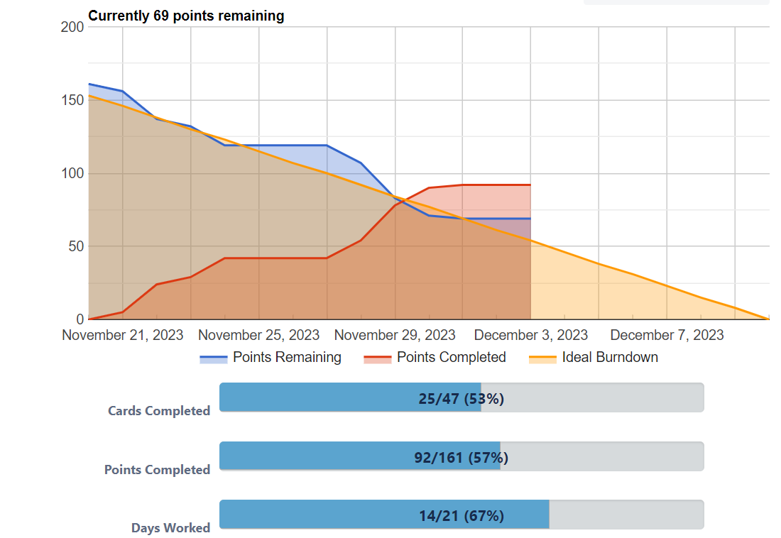

***NEW ESTIMATED VELOCITY***

The estimated velocity of the first sprint was 50, as seen from the burndown chart, where all 50 points were completed. It was observed that these points were accomplished in less time than anticipated, leading to a recalculation of the estimated velocity for the next sprint. Specifically, the sprint velocity will increase from 50 to **56**, based on the following proportion: **50 (Completed Points) : 36 (Work Hours) = x (New Velocity) : 40 (Available Hours).**

***IMPLEMENTED FUNCTIONALITY***The following features have been successfully implemented:

* Save and load rule functionality.
* Functionality for triggeredOnce and Periodic rules.
* Creating the following actions on files: Move, Copy, Delete and writing a string to a file.
* Created the “ExternalProgramAction” with Command-line Arguments.
* Creation of “DayOfWeekTrigger”.
* Creation of “DayOfMonthTrigger”.
* Creation of “DateTrigger”.

100% test coverage for the implemented functionalities. Only a few errors were detected in specific inputs, promptly resolved through the use of Exceptions.

***ISSUES ENCOUNTERED AND RESOLUTIONS* Issue:** Identifying the right type of filefor saving and loading rules**.  
 Resolution:** Using java serilization by creating a.ser file.

**Issue:** Management of periodic rules. Incorrect operation of periodic rule activation. **Resolution:** Using additional attributes, particular methods and additional controls on rule activation.

**Issue:** Execute external programs with command line arguments.  
 **Resolution:** Using a “process builder” and attributes for proper execution.

**Issue:** Serialization error for External program action.  
 **Resolution:** Using the 'transient' modifier on ProcessBuilder.

***PRODUCT BACKLOG CHANGES***  
 Refined some user stories.  
 Added user stories to meet new requirements.  
 Modified story point of user story 16.

***SPRINT 2 RETROSPECTIVE***

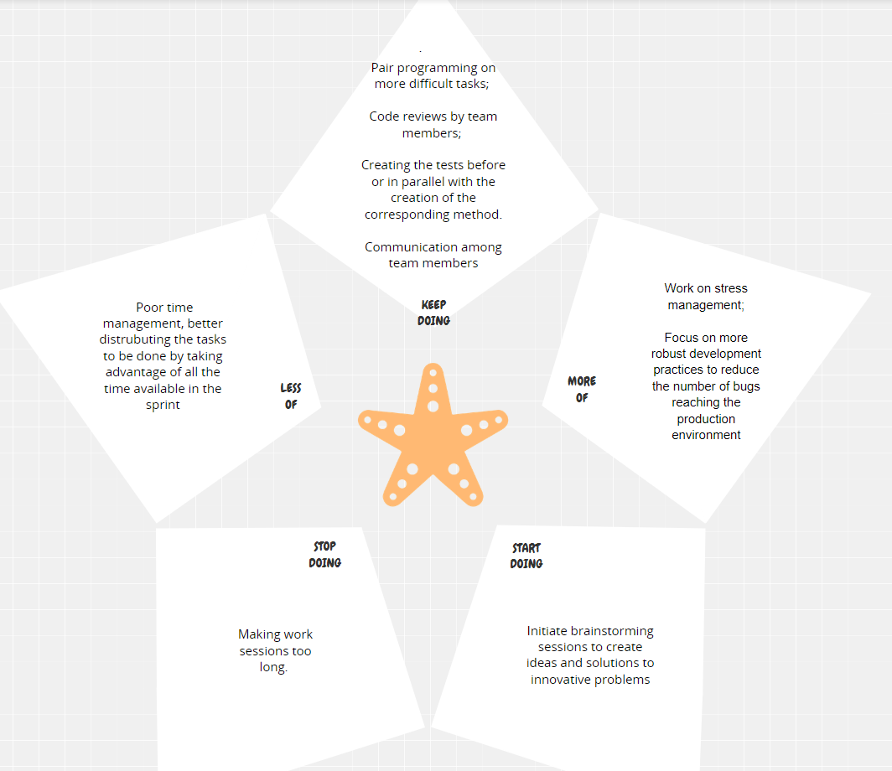***Starfish Diagram***

Focusing too much on one solution without considering others