Supplementary Information
A 45-Year Global Analysis of the Spatial Human-Forest Nexus
Emanuele Massaro¹*, Peter Newton², Juan Carlos Ciscar³, Gregoire Dubois¹, Angela Fanelli^{1,3}, Dolores Ibarreta³, Nicola Riccetti¹, Wojciech Szewczyk³ and Alessandro Cescatti¹*
¹ European Commission, Joint Research Centre (JRC). Via E. Fermi 2749, 21027 Ispra – Italy
² Department of Environmental Studies, Sustainability, Energy and Environment Community, University of Colorado Boulder, 4001 Discovery Drive, Boulder, CO 80303, USA
³ European Commission, Joint Research Centre (JRC). C. Inca Garcilaso 3, 41092 Seville – Spain
* Corresponding authors: emanuele.massaro@ec.europa.eu, alessandro.cescatti@ec.europa.eu

S1. Definition of microregions

In this research, we considered the following microregions for the different continents as shown in Figure S1.

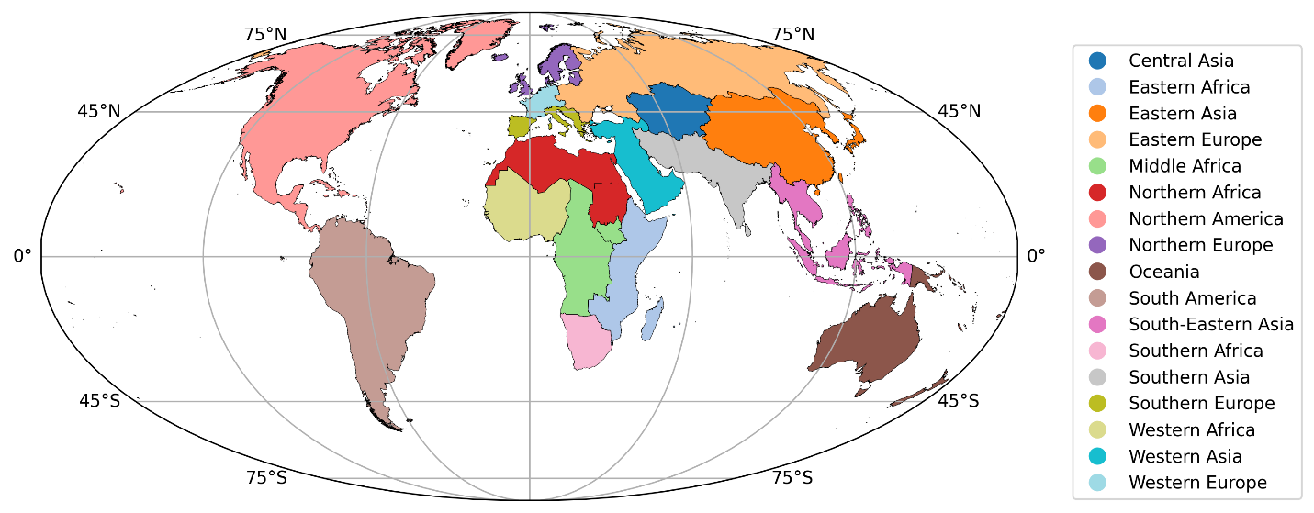Figure S1. Macro-regions defined in this research for aggregating the results

S2. Forest Area per Person (FAP) considerations

In Figure S2 we show the correlations between FAP change and population change on the left and forest area change on the right. Each point corresponds to a macro region defined above. The figure underscores a key insight: changes in forest area per capita (FAP) are predominantly driven by population dynamics.
In the left plot, we observe a strong negative correlation (R=−0.77) between FAP change and population change. This indicates that as populations grow, the amount of forest area available per person tends to decrease significantly. The inverse relationship suggests that population growth exerts considerable pressure on the per capita availability of forest resources, overshadowing other factors in determining FAP change.
In contrast, the right plot shows a moderate positive correlation (R=0.51) between FAP change and changes in total forest area. While increasing or conserving forest area does contribute to improving per capita forest resources, this influence is relatively modest. The weaker correlation here implies that adjustments in forest area alone are not enough to substantially impact FAP when population growth is a major factor.
Overall, the data highlights that population growth is the primary force driving changes in forest area per capita.
Figure S2. The figure illustrates the relationship between changes in forest area per person (FAP) and two other variables: (left) population change, and (right) forest area change across different regions of the world.

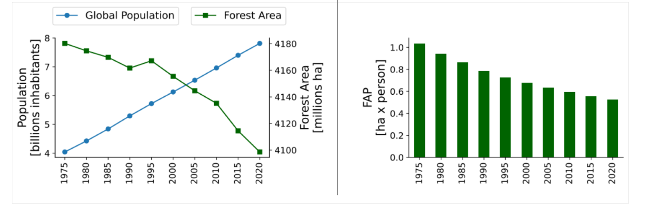
Figure S3. The figure illustrates the temporal evolution of population, forest area and forest area per person. Globally the forest area per person has halved.

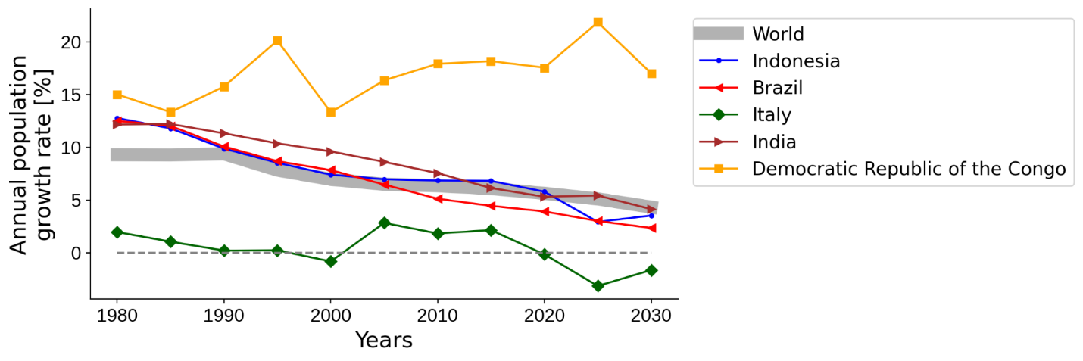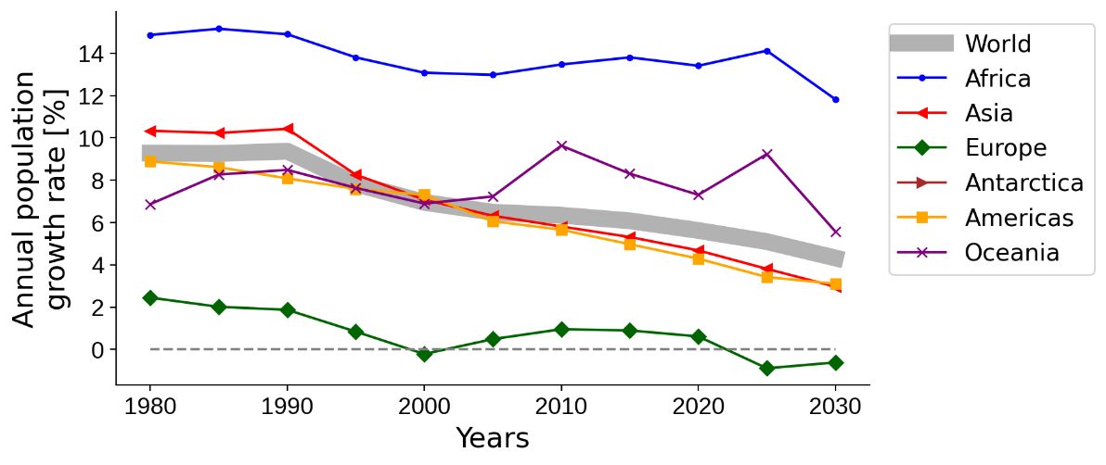
Figure S4. Population growth rate.

Temporal Analysis
In this section, we present a temporal analysis of FAP across different regions. Our methodology involves the identification of critical turning points in the time series data, complemented by a robust assessment of significant trends using Sen's slope analysis. This non-parametric approach allows us to quantify the magnitude of temporal trends while accounting for non-normality in the data distribution. The Sen's slope analysis of Forest Area per Person (FAP) across global macroregions reported in Table S1 reveals pronounced and statistically significant temporal trends in 14 out of 16 regions. The results demonstrate a predominant pattern of decreasing FAP values worldwide, with only limited exceptions.
Table S1. Sen's slope analysis for FAP
Region | Slope | p-value | Significance | Trend | Intercept
0 | Central Asia | -4.112389 | 0.002358 | ** | decreasing | -13.225728
1 | Eastern Africa | -7.327934 | 0.000083 | *** | decreasing | -12.797312
2 | Eastern Asia | -1.188322 | 0.073638 | ns | no trend | -10.617652
3 | Eastern Europe | 0.512293 | 0.474274 | ns | no trend | -13.162488
4 | Middle Africa | -8.000249 | 0.000083 | *** | decreasing | -25.385170
5 | Northern Africa | -8.472980 | 0.001282 | ** | decreasing | -18.270693
6 | Northern America | -3.382202 | 0.001282 | ** | decreasing | -21.664611
7 | Northern Europe | 0.510902 | 0.371093 | ns | no trend | 3.257987
8 | Oceania | -1.252204 | 0.107405 | ns | no trend | -9.104368
9 | South America | -4.155334 | 0.000083 | *** | decreasing | -16.365471
10 | South-Eastern Asia | -7.608905 | 0.000083 | *** | decreasing | -27.489464
11 | Southern Africa | -4.273345 | 0.000083 | *** | decreasing | -38.040861
12 | Southern Asia | -2.394494 | 0.031823 | * | decreasing | -6.439242
13 | Southern Europe | 7.230668 | 0.000172 | *** | increasing | 14.513424
14 | Western Africa | -7.892610 | 0.000172 | *** | decreasing | -12.773363
15 | Western Asia | -4.125136 | 0.001282 | ** | decreasing | -4.111259
16 | Western Europe | 2.890159 | 0.000172 | *** | increasing | 1.034974

Regions with Strong Decreasing Trends:
Eastern Africa, Middle Africa, and Western Africa exhibit the most severe decreasing trends, with slopes ranging from -7.78 to -8.38 (all p < 0.001). Middle Africa shows the steepest decline (-8.38), followed closely by Eastern Africa (-7.97), indicating particularly rapid reductions in forest area per person in these regions.
Regions with Moderate Decreasing Trends:
Northern Africa, South-Eastern Asia, Western Asia, Southern Africa, South America, Southern Asia, Northern America, and Oceania all display moderate but highly significant decreasing trends, with slopes ranging from -4.32 to -6.52 (all p < 0.001). Notably, even regions previously showing no significant trends, such as Oceania and Northern Europe, now demonstrate significant decreases in FAP.
Newly Significant Decreasing Trends:
Eastern Asia now shows a significant decreasing trend (-2.87, p < 0.001), unlike in the previous analysis where it showed no significant trend. Similarly, Northern Europe now displays a significant decrease (-1.27, p < 0.001) rather than a non-significant trend.
Regions with Increasing Trends:
Southern Europe remains the only region with a significant positive trend (2.68, p < 0.01), though the magnitude of increase is lower than in the previous analysis. This unique pattern suggests distinctive regional dynamics affecting FAP in Southern Europe compared to global patterns.
Regions with No Significant Trends:
Only Eastern Europe and Western Europe show no statistically significant trends in FAP values (p > 0.05). Notably, Western Europe has shifted from showing a significant increase in the previous analysis to no significant trend in these updated results.
The intercept values provide context for baseline FAP levels, with Southern Africa showing the most negative intercept (-20.02) and Southern Europe having the highest positive intercept (6.28), indicating substantial differences in initial conditions across regions.
These findings highlight the widespread decline in forest area available per person across most global regions, with implications for ecosystem services, biodiversity conservation, and human well-being. The consistency of negative trends across diverse geographical contexts suggests common underlying drivers, potentially including population growth, deforestation, and land-use changes, warranting further investigation into region-specific causes and potential mitigation strategies.
Figure S5. Correlation between Sen’s slope and relative change
Figure S6. Temporal patterns of FAP for different macroregions and continents. We show stable patterns without significant turning points.

S3. Forest Proximate People considerations
As defined in the literature, the metric of forest proximate people (FPP) measures the number of people living within or close to a forest. In this research we analysed FPP from 1975 to 2020 globally as shown in Fig. S5, Fig. S6, Fig. S7
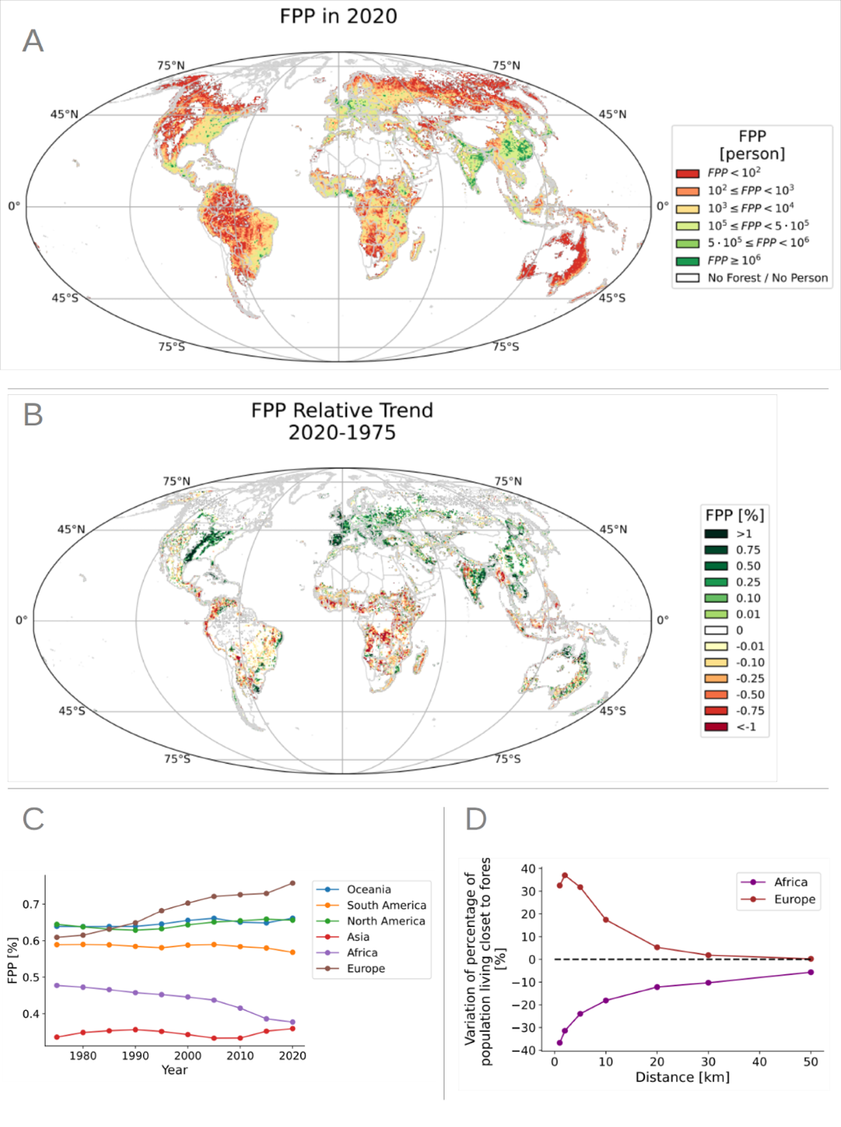
Figure S7. Global and historical distribution of forest proximity people (FPP) from 1975 to 2020. A) FPP observed in 2020. B) Relative trend in FPP between 2020 and 1975. C) Temporal values of the percentage of population living close to forest (5km) over the years and across continents. D) Difference (between 2020 and 1975) of the percentage of population living in given distances to forest in Europe and Africa.

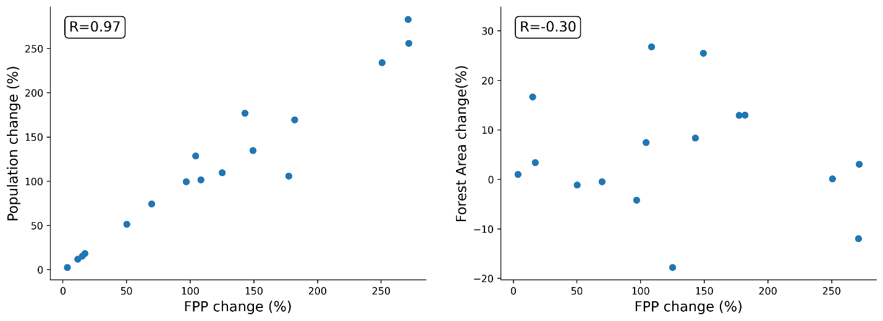Figure S8. The figure illustrates the relationship between changes in average values of forest proximity people (FPP) and two other variables: (left) population change, and (right) forest area change across different regions of the world.

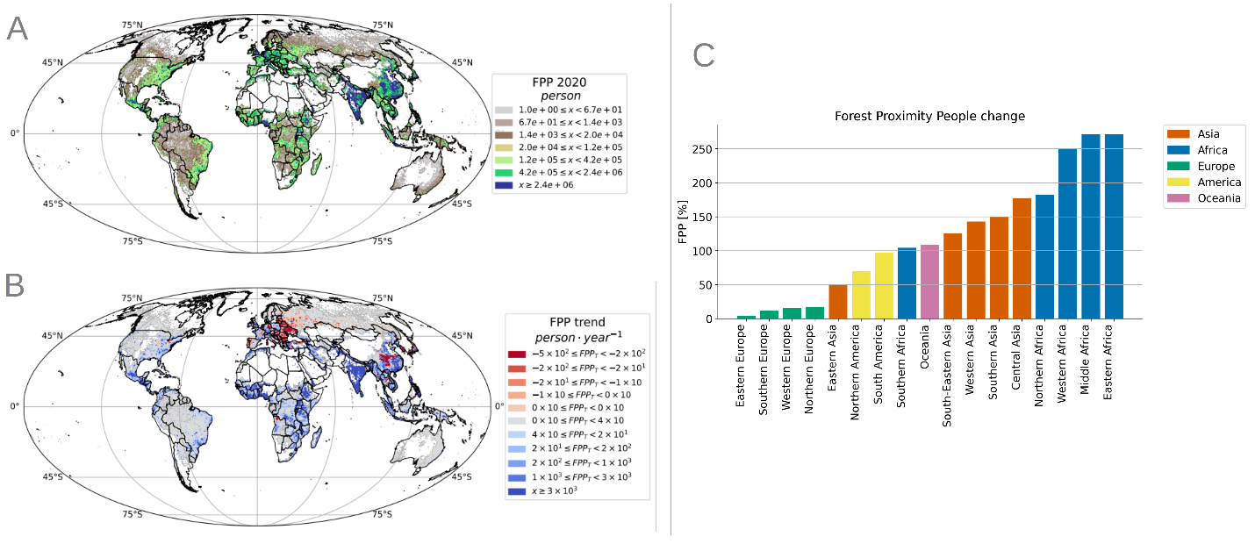Figure S9. Global and historical distribution of forest proximate people (FPP) from 1975 to 2020. A) FPP observed in 2020. B) Trend in FPP between 2020 and 1975. C) Relative change of the mean values of FPP across macroregions.

Temporal Analysis
Our Sen's slope analysis of Forest Proximate People (FPP) as a proportion of total regional population reveals distinct geographical patterns that complement our FAP findings as shown in Table S2 and Figure S10.
S1. Sen's slope analysis for FAP
Slope | p-value | Significance | Trend | Intercept
Middle Africa | -4.002006 | 0.000083 | *** | decreasing | -1.299908
Southern Africa | -3.255300 | 0.000172 | *** | decreasing | 8.392878
Eastern Africa | -2.370563 | 0.000083 | *** | decreasing | 6.425011
Western Africa | -2.224639 | 0.000083 | *** | decreasing | 4.784478
Northern Africa | -1.063717 | 0.000347 | *** | decreasing | 2.882460
Western Asia | -0.946154 | 0.107405 | ns | no trend | 5.071726
South America | -0.757252 | 0.000347 | *** | decreasing | 0.412692
Southern Asia | -0.175789 | 0.858028 | ns | no trend | 12.432647
Oceania | 0.425313 | 0.004208 | ** | increasing | -0.257212
Eastern Asia | 0.614578 | 0.000677 | *** | increasing | -1.872601
Northern America | 0.840848 | 0.007290 | ** | increasing | -2.955139
South-Eastern Asia | 1.241103 | 0.004208 | ** | increasing | -4.266031
Eastern Europe | 1.666695 | 0.000347 | *** | increasing | -1.459188
Western Europe | 2.234722 | 0.000083 | *** | increasing | -0.047398
Southern Europe | 4.218458 | 0.000347 | *** | increasing | 11.507343
Northern Europe | 7.455097 | 0.007290 | ** | increasing | 3.389340
Central Asia | 16.967780 | 0.000677 | *** | increasing | -55.761889

African regions and South America demonstrate significant decreases in the proportion of their populations living near forests (Middle Africa: -4.00, Southern Africa: -3.26, Eastern Africa: -2.37, Western Africa: -2.22, Northern Africa: -1.06, and South America: -0.76, all statistically significant at p < 0.001). This decreasing concentration of people near forests occurs alongside the overall decline in forest area per person (FAP) in these same regions. In contrast, all European regions along with Central Asia show significant increases in the proportion of forest-proximate populations (Central Asia: 16.97, Northern Europe: 7.46, Southern Europe: 4.22, Western Europe: 2.23, Eastern Europe: 1.67, all p < 0.01), indicating a spatial reorganization where populations are becoming more concentrated near forest areas.

Figure S10. Correlation between Sen’s slope analysis and relative change.

This dichotomy suggests fundamentally different human-forest dynamics across global regions. In Africa and South America, the decreasing proportion of people living near forests while overall forest resources per person decline may indicate both diminishing forest accessibility and continued deforestation. Conversely, the European pattern of increasing or stable FAP coupled with increasing proportional FPP suggests a growing integration of forest proximity into settlement patterns, potentially reflecting forest regeneration near population centers, increased valuation of forest amenities, or more effective forest conservation near human settlements. These contrasting trends highlight the complex interplay between demographic changes, development patterns, and forest resources across different socioeconomic contexts. The Sen's slope analysis for relative value of the Forest Proximate People ($\overline{FPP}$) reveals an interesting pattern that contrasts with the FAP results. While FAP predominantly showed decreasing trends globally, $\overline{FPP}$ demonstrates a more balanced distribution of increasing and decreasing trends across
Figure S11. Temporal patterns of FPP for different macroregions and continents. We show stable patterns without significant turning points.

S4. Forest Human Nexus

In this research we introduce a new metric called Forest Human Nexsu (FHN). Here we simple explain how we compute it. We shall consider a window composed by NxN cells as reported in Figure S8.
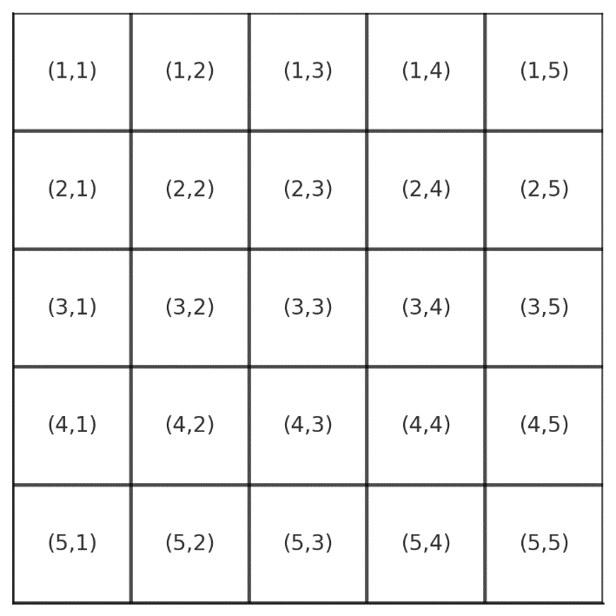
Figure S12. NxN window (N=5).

In each cell we can have forest, people and we can compute the distance to the closest forest as shown in Figure S9.
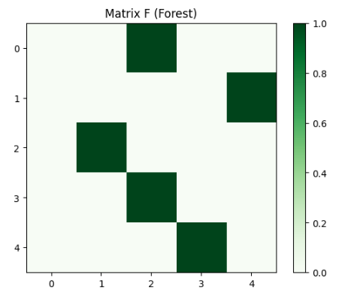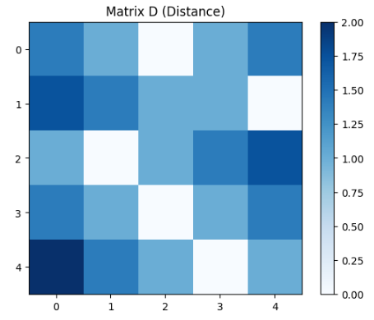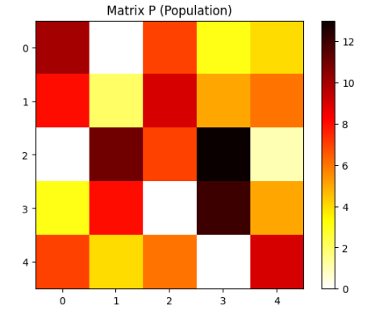
Figure S13. NxN window (N=5) with Forest (0-1), Distance to forest and Population.

We define, Forest Human Nexus of the window w, FHNw as:
$$FHN_{w}=\frac{\sum_{j}{P_{j}}}{\sum_{j}{P_{j}⋅(D_{j}+1)}}$$
where j is the cell j of the window w, P_{j} is the number of people in the cell j and D_{j} is the Euclidean distance from the cell j to the closest forest. That in this case leads to FHNw = 0.96. The FHNw is bounded berween 0 and 1. 0 is when there is not Forest or No people in the window, and 1 when we have all forest and just 1 person.

S4.1 Correlations between FHN and other variables

Figure S11 illustrates the correlations between three variables: Forest Human Nexus (FHN), Forest Proximity to People (FPP), and Forest Area per Capita (FAC). The left panel shows a negative correlation (R = -0.67) between FHN change (%) and FPP change (%), indicating that as the proximity of people to forests increases, the overall FHN tends to decrease. The middle panel displays a strong positive correlation (R = 0.84) between FHN change (%) and FAC change (%), suggesting that changes in the FHN are closely associated with changes in the forest area available per capita. The right panel also shows a strong negative correlation (R = -0.80) between FAC change (%) and FPP change (%), highlighting that as the forest area per capita decreases, the proximity of people to forests increases.
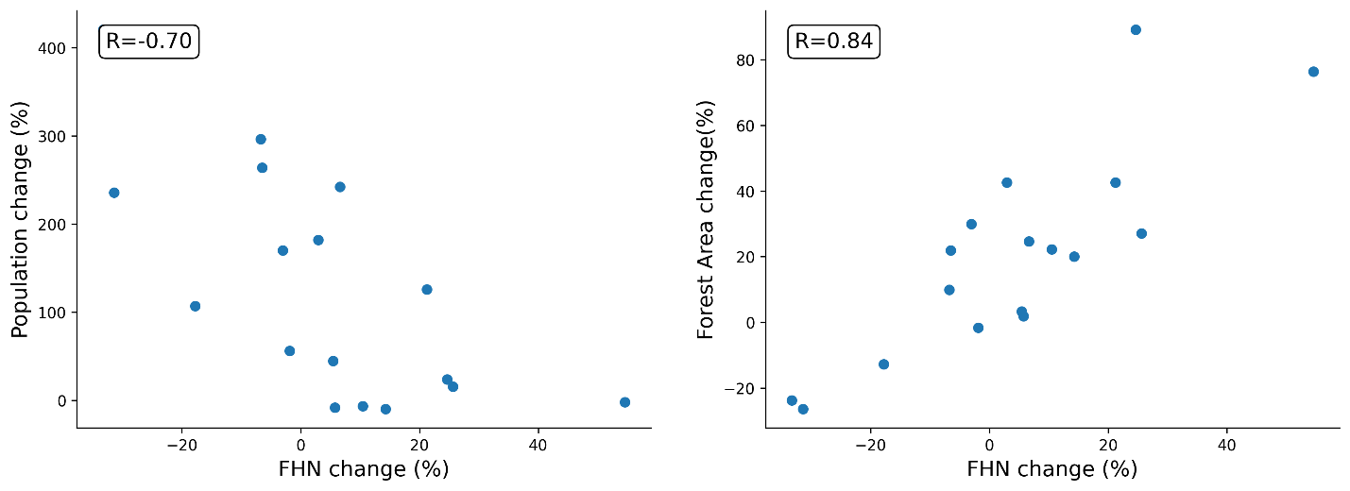Figure S14. The figure illustrates the relationship between changes in median values of forest proximity people (FHN) and two other variables: (left) population change, and (right) forest area change across different regions of the world.
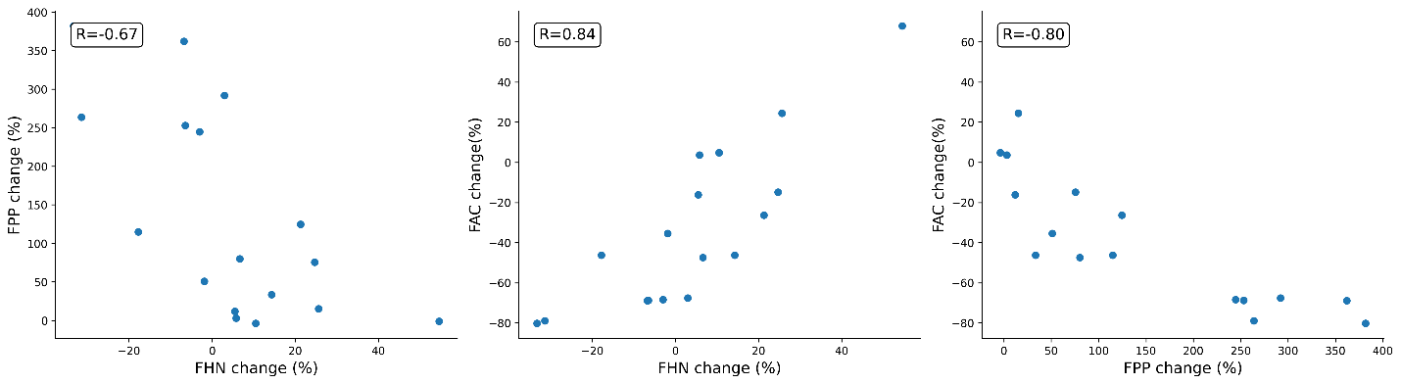Figure S15. From left to right, we show the correlations between FHN vs FPP, FHN vs FAC, and FPP vs FAC.

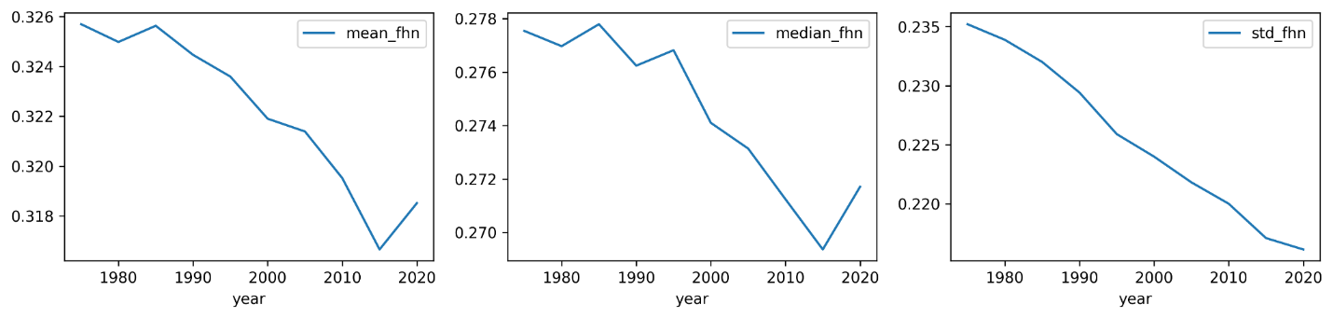Figure S16. From left to right, we show the global values of mean, median and standard deviation values of FHN

Figure S17. FHN values have been relatively stable over the years. However, specific regions reveal contrasting trajectories: South-Eastern Asia, Middle Africa, and South America (in red) show a consistent decline in FHN, indicating increasing distances between human populations and forests. In contrast, Southern Europe and Western Europe (in blue) exhibit stable or rising FHN values, suggesting that these regions have maintained or improved their human-forest proximity over time.

S5. Shift analysis
To quantify the temporal shifts in the Forest Human Nexus (FHN) distribution between 1975 and 2020, we developed a shift function to compute the changes in FHN values across different quantiles of the data (Fig. S18 and Fig. S19). This method provides a detailed understanding of how the distribution of FHN has changed over time, capturing the shifts in human-forest proximity across different percentiles of the population.
We define the swift function as the difference between the quantiles of the FHN distributions in 2020 and 1975, calculated as follows: i) The FHN values for 1975 and 2020 were sorted separately in ascending order to generate two distinct datasets, denoted as data1 (1975) and data2 (2020). For each dataset, the FHN values corresponding to the specified quantiles were calculated. This yielded two sets of quantile values, q1 for 1975 and q2 for 2020. We define the shift for each quantile as the difference between the corresponding quantile values of the two datasets:
Shift = q2 - q1
Positive values indicate that the FHN distribution has shifted to the right, suggesting an increase in human proximity to forests, while negative values indicate a leftward shift, representing a decrease in proximity. This method provides a nuanced view of how FHN distributions have evolved, offering insights into the spatial-temporal dynamics of human-forest interactions across different regions of the world.
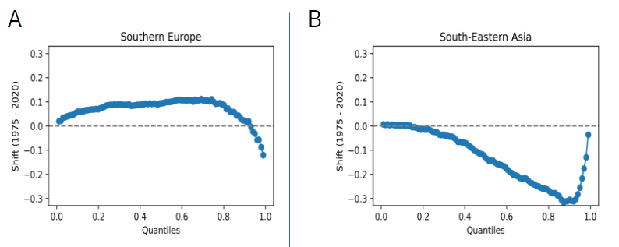Figure S18. Quantiles difference for Southern Europe and South-Eastern Asia.
To further explore the spatiotemporal dynamics of FHN, we analyzed distributional shifts in FHN values between 1975 and 2020 for two contrasting cases: Southern Europe and South-Eastern Asia (Fig. S19).
Figure S19. Change in the distribution of the Forest Human Nexus (FHN) from 1975 to 2020. A) - B) Distributions of FHN for Southern Europe and South-Eastern Asia for 1975 and 2020. C) Global shifts in FHN distribution, representing the difference between the quantiles of 2020 and 1975.
In Southern Europe, the FHN distribution shifted rightward, indicating that a greater proportion of the population lived closer to forests over time, consistent with the positive trend observed. In contrast, South-Eastern Asia exhibited a leftward shift in FHN, signaling increasing distances between human populations and forests. This pattern aligns with regional urbanization trends, deforestation, and population expansion into non-forested areas, which likely contributed to the observed decline in FHN (Fig. S19B).
At a global scale, the difference in FHN distribution quantiles between 1975 and 2020 highlights regions where populations moved closer to forests, as well as areas where they became more spatially distant. Positive shifts indicate increased proximity to forests, while negative shifts suggest growing human-forest separation. The resulting complex spatial mosaic across Europe, Oceania, South America, Africa, and Asia (Fig. S19C) reflects the diverse regional dynamics that have shaped human-forest interactions over time.

Temporal Analysis

