A 45-Year Global Analysis of the Spatial Human-Forest Nexus

Emanuele Massaro¹*, Peter Newton², Juan Carlos Ciscar³, Gregoire Dubois¹, Angela Fanelli^{1,3}, Dolores Ibarreta³, Nicola Riccetti¹, Wojciech Szewczyk³ and Alessandro Cescatti¹*
¹ European Commission, Joint Research Centre (JRC). Via E. Fermi 2749, 21027 Ispra – Italy
² Department of Environmental Studies, Sustainability, Energy and Environment Community, University of Colorado Boulder, 4001 Discovery Drive, Boulder, CO 80303, USA
³ European Commission, Joint Research Centre (JRC). C. Inca Garcilaso 3, 41092 Seville – Spain
* Corresponding authors: emanuele.massaro@ec.europa.eu, alessandro.cescatti@ec.europa.eu

Abstract
Forests play a crucial role in providing important ecosystem services such as biodiversity conservation, carbon sequestration, and biomass production, while supporting the livelihoods of millions of people globally. Understanding the spatial relationship between human populations and forests is vital for assessing how these socio-environmental systems interact and evolve over time. However, a global scale understanding of these spatial relationships remains limited. Here, we address this gap by examining the joint global trends in human population and forest dynamics from 1975 to 2020. We assess two indicators of spatial and temporal trends: Forest Area per Person (FAP) and Forest Proximate People (FPP), illustrating how the spatial interplay between humans and forests has changed over time. We then introduce the Forest Human Nexus (FHN), a spatial indicator that integrates forest area per capita, forest accessibility, and population density to provide a geospatial assessment of human-forest relationships. Our analysis reveals an uneven distribution of FHN trends worldwide, reflecting severe ecological stress in many tropical regions and highlighting the need for targeted interventions. By offering detailed spatiotemporal insights and a new spatial metric for human-forest interactions, this study aims to inform policymakers, conservationists, development practitioners, and researchers in fostering more sustainable human-forest relationships.

Introduction
Forests cover 31% of the Earth’s surface¹ and play a crucial role as complex socio-environmental systems, providing essential ecosystem services such as carbon storage² and sequestration³, and biodiversity conservation⁴, while also supporting the livelihoods of millions of people globally⁵.
The spatial dimension of human-forest interactions has evolved significantly over recent decades due to global land use changes, urbanization, and demographic shifts. Studies have documented substantial changes in the spatial distribution of forest-adjacent communities, with some regions experiencing migration away from forests while others see increasing settlement near forest edges⁶. For example, research in the Brazilian Amazon has shown complex patterns of colonization along forest frontiers, followed by urbanization processes that reshape human-forest spatial relationships⁷. In Southeast Asia, the expansion of plantation agriculture has transformed traditional forest-adjacent communities, altering centuries-old spatial configurations of human-forest coexistence⁸.
Indeed, around one-fourth of the global population (over 1.6 billion people) live within 5km of a forest⁹. In some areas, such as parts of Europe and North America, the number of people living near forests has actually increased as suburban development expands into forested landscapes¹⁰. Conversely, in regions experiencing rapid deforestation, forest-adjacent populations may either migrate away from degraded forest margins or remain in place while the forests recede, fundamentally altering their spatial relationship with forest ecosystems¹¹. Understanding these dynamic spatial patterns is crucial for developing effective conservation and development policies that account for the changing human-forest nexus¹². These landscapes contribute significantly to environmental stability and socio-economic development, offering benefits ranging from health improvements to income generation for those living in or near forested areas¹³. Consequently, the conservation, governance, and restoration of forests, alongside the sustainable development of forest-adjacent communities, are highly important on the global agenda.
Understanding the spatial relationship between human populations and forests is critical for several reasons¹⁴. Access to forest ecosystem services can enhance people’s quality of life¹⁵, support livelihoods⁵, and contribute to sustainable development¹⁶. However, the dynamics of human-forest interactions are complex and multifaceted¹⁷. On one hand, proximity to forests may enhance ecological awareness¹⁸ and foster conservation initiatives¹⁹. On the other hand, increased human encroachment into forested areas can lead to habitat degradation, biodiversity loss²⁰ and forest fragmentation²¹, undermining the services forests provide²². Additionally, exposure to wild areas brings potential health risks, as interactions with wildlife can facilitate the transmission of zoonotic diseases²³, as evidenced by recent outbreaks^{24–26}. Therefore, a comprehensive understanding of how human populations spatially relate to forests is essential, not only to maximise the ecological and socio-economic benefits but also to address the associated health and environmental challenges.
Despite the importance of human-forest relationships, there remain significant gaps in our understanding, particularly on a global scale. Previous studies have often focused on localized²⁷ or short-term period evidence⁹, lacking comprehensive quantitative analyses that encompass large temporal and spatial scales. This paper addresses this gap by examining global trends in human-forest proximity from 1975 to 2020. To do so we used the HILDA+ dataset for land use classification and forest areas²⁸. This dataset reports changes in forest area from 1960 to 2019, including dynamics of deforestation and reforestation. We overlaid this dataset with population density from the Global Human Settlement Layer dataset ²⁹ (see Methods section) at the resolution of 1km, and computed multiple metrics in a moving window of a radius of 50km (see Methods section). First, we computed the Forest Area per Capita (FAP) metric, which measures the forest area available per person, and the number of Forest Proximate People (FPP)⁹, which counts the number of people living within a given distance to the nearest forest. These two metrics and their temporal trends across different regions and periods, quantify how population growth and deforestation have influenced the amount of forest accessible to individuals and communities worldwide. To further evaluate the spatial dimension of human-forest interactions, we introduce the Forest Human Nexus (FHN) index, a composite metric that quantifies the geospatial relationship between human populations and forests. The FHN index is derived as the inverse of the weighted distance from humans to the nearest forest (see Methods section), providing a spatially explicit measure of how human proximity to forests has evolved over time.
In summary, this study provides a spatiotemporal, global-scale analysis of changes in the human-forest nexus over a 45-year period. By quantifying these changes through geospatial metrics, we offer critical insights for policymakers, conservationists, development practitioners, and researchers aiming to understand and address the evolving spatial patterns of human-forest interactions. This work underscores the necessity for targeted spatial planning and interventions to balance human needs with forest conservation, ensuring the sustainability of these landscapes for future generations.

Results
We present a spatio-temporal analysis of three metrics—FAP, FPP, and FHN—for 2020, as well as the relative differences and trends between 1975 and 2020 at pixel level (50km × 50km resolution) and aggregated for macro-regions across continents. More detailed temporal analysis conducted at 5-year intervals between 1975 and 2020 (presented in Supporting Information) reveals no significant inflection points or trend changes for most macro-regions examined. This confirms our focus on the endpoints of this 45-year period, while highlighting that the significant differences in trends and patterns occur predominantly between macro-regions rather than within the temporal evolution of individual regions.

Global analysis of forest area per person
In 2020, In 2020, the average forest area per person globally was approximately 1 hectare (Figure 1), which represents a substantial reduction since 1975. The period from 1975 to 2020 saw a marked decrease in global forest area per person (FAP), as illustrated in Figure 2. This decline reflects the combined impacts of human population growth and deforestation. We found clear trends in the relationship between forest area and human population at both the global and regional levels (Fig. 2).
Our temporal analysis reveals dramatic and stable relative changes in FAP across regions as shown in Figure 2 and in SI. Middle Africa experienced the most severe decline, with a 77.8% reduction in FAP between 1975 and 2020, followed closely by Western Africa (-74.0%) and Eastern Africa (-73.6%). As detailed in the Supplementary Information, these striking relative changes strongly correlate with the Sen's slope analysis, which identified these same regions as having the steepest negative slopes (Middle Africa: -8.38, Eastern Africa: -7.97, Western Africa: -7.78, all p < 0.001), confirming the robustness of the observed trends through multiple analytical approaches.

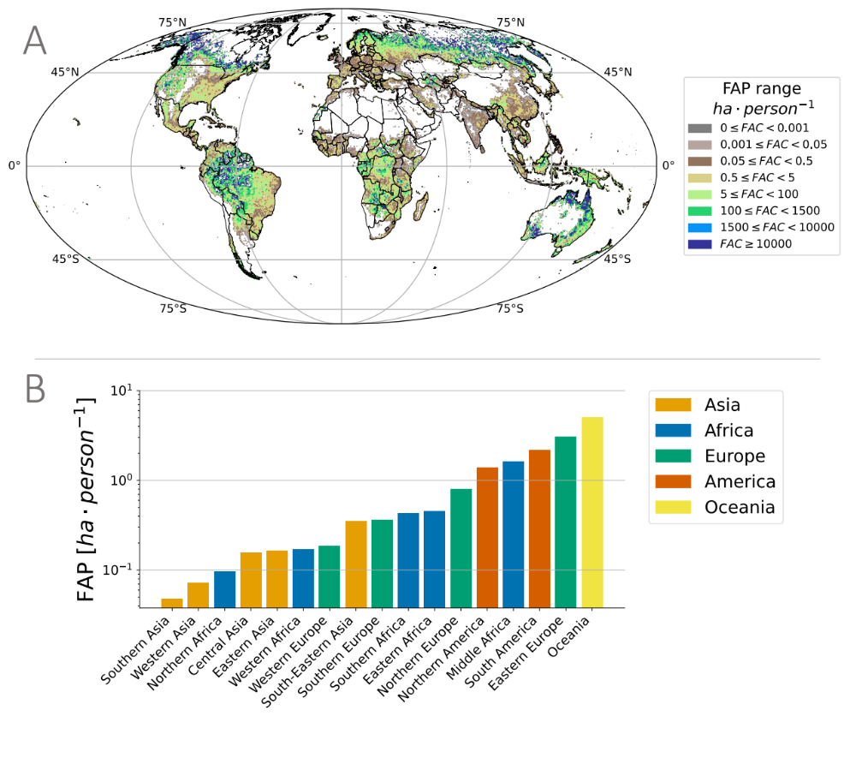
Figure 1. Global distribution of forest area per person (FAP) in 2020. A) Forest Area per Capita observed in 2020 globally and B) for macroregions.
Southern Europe stands out as the only world region that shows a consistent increase of FAP (24.5% relative increase from 1975 to 2020), with Western Europe showing minimal change (+1.0%). This pattern is further confirmed in our Sen's slope analysis (see Table S1 in SI), which identified Southern Europe as the only region with a significant positive trend (slope: 2.68, p < 0.01). These European patterns are due to stable or decreasing populations combined with increasing forest area (Fig. S3 and Fig. S4).
Some of the areas with the highest absolute values of FAP in 2020 (e.g., South America and Middle Africa) were also among those that experienced the greatest declines in FAP, due to deforestation and population growth (Fig. 2A).

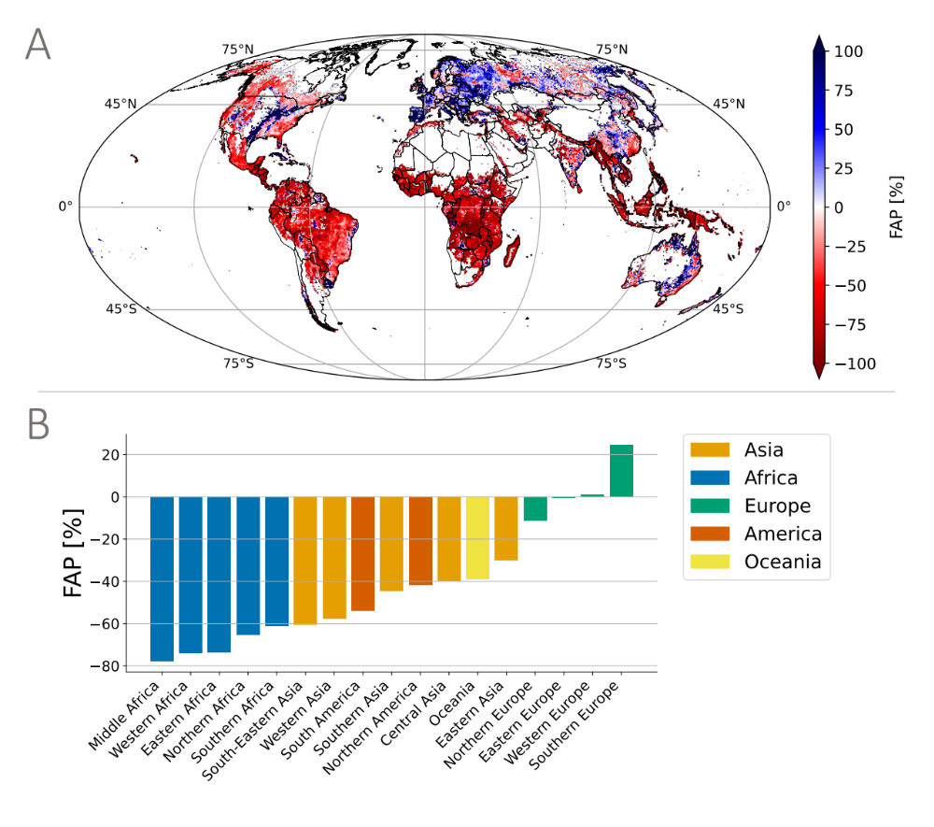
Figure 2. Global change of forest area per person (FAP) between 1975 and 2020. A) Relative change of FAP trend between 2020 and 1975 globally. B) Relative change of median values of FAP across macroregions between 2020 and 1975.
Despite these large declines, these regions still maintain relatively high FAP values because of their large initial forest area and limited population density at the baseline in 1975. The most concerning regions are those showing both a low value and a strong decline of FAP, like Northern Africa (-65.3%) and Western Africa (-74.0%), suggesting the rapid erosion of an already limited forest capital, a pattern confirmed by their significantly negative Sen's slopes documented in the SI. Overall, the data highlights that population growth is the primary force driving changes in forest area per capita (Fig. S2). The spatial-temporal analysis over several decades shows a notable shift in regions with high forest area per person, with some areas experiencing increases (primarily in Europe) and others showing substantial declines, reflecting the complex interplay between demographic trends and forest change. The phenomenon of decreasing FAP in most regions of the world, except parts of Europe, may be connected to historical, ecological, and socio-economic factors. In Europe, the relatively stable or declining population contrasts with the positive population growth rates in other parts of the world (Fig. S4), where ongoing deforestation in regions like Africa, South America, and Southeast Asia is driven also by global demands for agricultural commodity products³⁰.

Temporal patterns of forest proximate people
As defined in the literature, the metric of forest proximate people (FPP) measures the number of people living within or close to a forest⁹. In our study, we assessed the temporal dynamics of FPP (defined as people living within 5 km of a forest) from 1975 to 2020 (Fig. 3).
The selection of 5 km as the threshold distance for defining forest proximity follows recent literature conventions³¹, but we acknowledge this is a subjective parameter that may vary depending on research context and regional characteristics. Different distances might be more appropriate depending on factors such as transportation infrastructure, terrain, land use patterns, and cultural practices that influence human-forest interactions. For instance, walking distances in mountainous regions versus plains, or distances considered accessible in densely versus sparsely populated areas may differ substantially. Our computational framework, available in the public repository accompanying this paper, allows for flexibility in calculating FPP using different distance thresholds. This adaptability enables researchers to conduct sensitivity analyses or tailor the proximity definition to specific regional contexts while maintaining the consistent spatial analytical approach used in this study.
Globally there was an average consistent increase in FPP over the study period, resulting in more people living near forests in 2020 than were in 1975. This pattern is mainly driven by the overall rise in global population rather than by the expansion of forested areas or by people relocating closer to forests (Fig. S8).
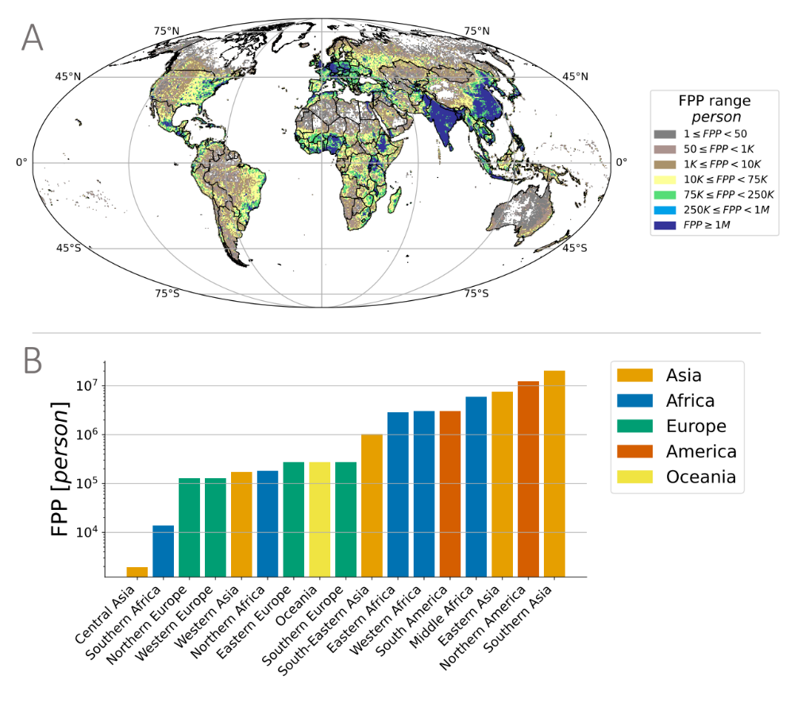
Figure 3. Global distribution of forest proximate people (FPP) in 2020. A) FFP values in 2020 globally and -B) for macroregions.

To factor out the effect of population growth from the trend analysis we define an index of relative change of the normalized value of FPP (named FPP), as
FPP%=100*(FPP2020-FPP1975)/FPP1975
FPPyear=FPP(year)/P(year) defined in the Methods section.
Despite the general growth in population numbers, the relative change in the percentage of the total population living near forests shows different patterns across macroregions (Fig. 4A and Fig. 4B). The trend in normalized FPP value highlights that some regions, including Europe, showed positive relative changes even though the absolute FPP values declined (Fig. 3A, Fig. 4A, and Fig. 4B; Fig. S9B).
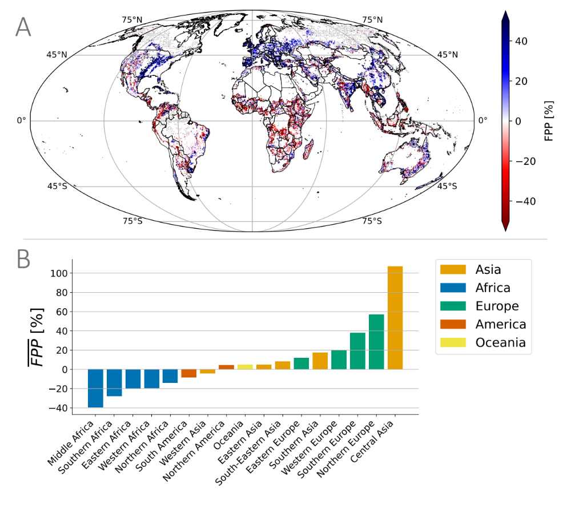
Figure 4. Global change of the relative value of Forest Proximate People (FPP) between 1975 and 2020. A) Relative change of FPP trend between 2020 and 1975 globally. B) Relative change of median values of FPP across macroregions between 2020 and 1975.

In contrast, regions showing decline in $\overline{FPP}$, such as African countries, exhibit significant increases in the absolute value of FPP due to population growth (Fig. S6). This suggests that, despite global trends of urbanization and deforestation, the proportion of people living near forests increased between 1975 and 2020. A comparative analysis between Europe and Africa underscores a stark contrast: Europe’s 40% increase in the fraction of the population living near forests may reflect urban expansion into forested areas and a growing appreciation for accessible green spaces, driven by urban planning that integrates green belts and forest reserves. Conversely, Africa’s 40% decrease highlights extensive deforestation and land-use change for agriculture and urban development, which has outpaced efforts to conserve and expand forested areas (Fig. S7D).
We also examined trends in the proportion of FPP across regions using the Sen's slope analysis (detailed in SI). Our analyses reveal an intriguing geographical dichotomy, with results showing strong correlation with the relative change analysis showed above (see Figure S10 in SI). African regions and South America show decreasing proportions of their populations living near forests (negative Sen's slopes), alongside declining forest area per person. In contrast, European regions exhibit increasing proportions of forest-proximate populations (positive Sen's slopes) while maintaining stable or increasing forest area per person. This pattern suggests different trajectories of human-forest relationships: in developing regions, diminishing proximity to forest resources may indicate both continued deforestation and changing settlement patterns, while in Europe, the growing integration of forests and human settlements reflects different socioeconomic and land use dynamics. The temporal patterns of FPP does not show significant turning points as shown in Figures S11 in SI except for Northern Europe in 1990 and Central Asia in 1995 when a significant increment of FPP have been observed.
FPP

Spatial-temporal analysis of forest human nexus
We introduce the Forest Human Nexus (FHN) index as a novel metric to capture the complex spatial relationship between human populations and forest ecosystems as shown in Figure 5. The Forest Human Nexus (FHN) provides an integrated spatial measure that combines the number of people living near forests, the forest area available, and the proximity (i.e., distance) of human populations to the nearest forested areas (see Methods section and SI). The FHN value ranges from 0 to 1, where 1 represents maximum human-forest proximity (i.e., a single person residing in a window where all surrounding pixels are forested), and 0 indicates the absence of both forests and people. Over the 45-year period (1975–2020), FHN exhibited significant spatial and temporal variations across different macroregions (Fig. 6A).
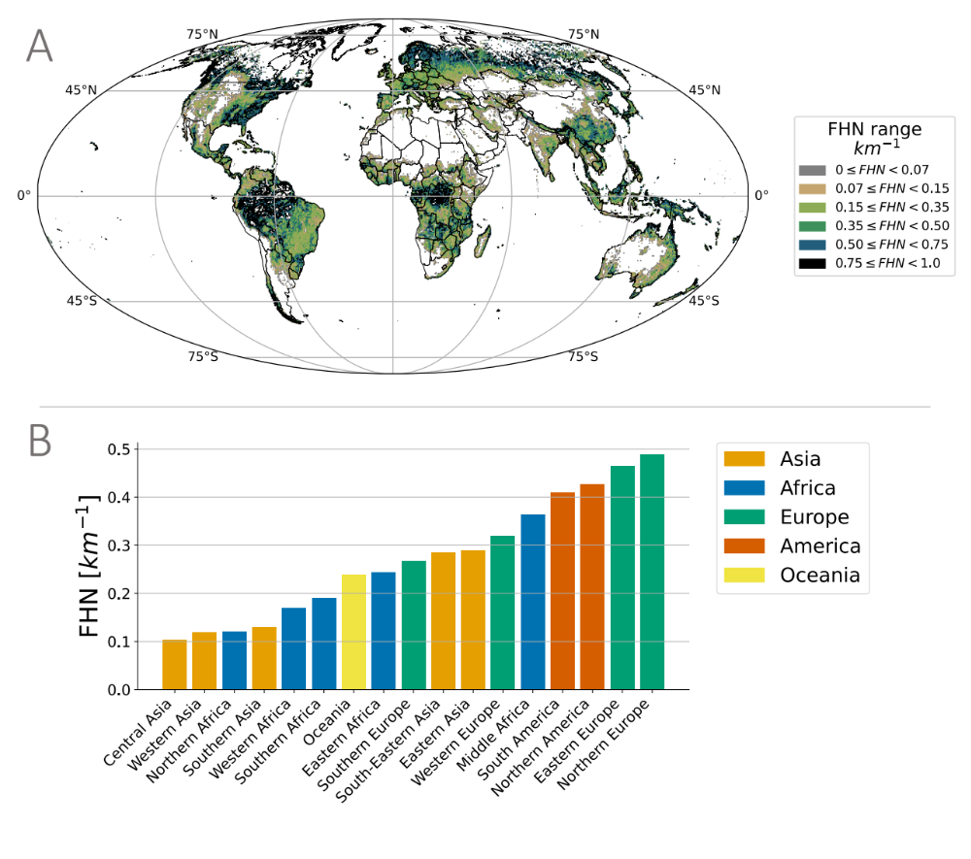
Figure 5. Global distribution of forest human nexus (FHN) in 2020. A) Global and B) macroregions distributions of FHN in 2020, highlighting areas with varying degrees of human proximity to forests. Regions with high FHN values (e.g., Eastern Europe and North America) indicate densely populated areas with substantial forest cover nearby. In contrast, low FHN values reflect regions where human settlements are relatively distant from forested areas, revealing a heterogeneous global pattern of human-forest proximity
Positive trends in FHN suggest increasing human proximity to forests, which may be influenced by forest regrowth, urban planning that integrates green spaces, or demographic shifts toward forested regions. Conversely, negative FHN trends—observed primarily in parts of Africa and South America—suggest an increasing spatial separation between human populations and forests. Multiple factors could underlie these shifts, including forest loss, deforestation-related land-use change, and population dynamics affecting settlement patterns.

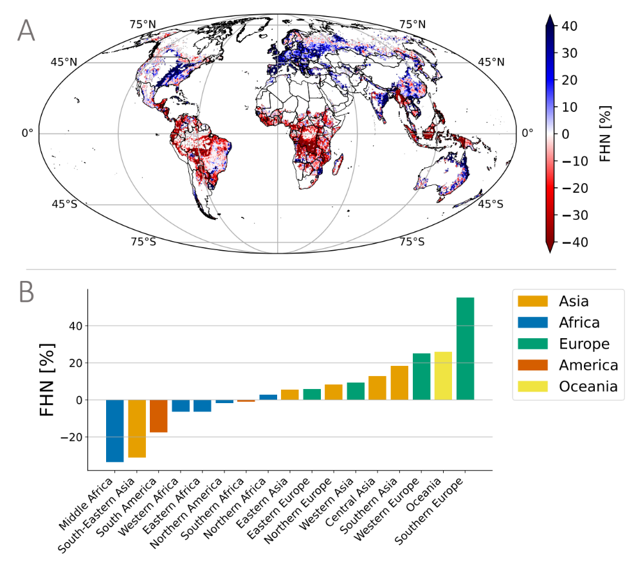

Figure 6. Historical distribution of the forest human nexus (FHN) indicator from 1975 to 2020. A-B) Relative change of the median values of FHN globally and across microregions. Positive FHN trends indicate that human populations have moved closer to forests.

At the regional scale, contrasting trajectories emerge: South-Eastern Asia (-31.2%), Middle Africa (-33.7%), and South America (-17.5%) (in red, Fig. S17) exhibit a consistent decline in FHN, reflecting increasing spatial distances between human populations and forests. In contrast, Southern Europe (+55.2%), Western Europe (+25.1%), and Southern Asia (+18.3%) (in blue, Fig. S17) show substantial increases in FHN values, suggesting that human-forest proximity was significantly improved in these regions. Our Sen's slope analysis (detailed in SI) strongly corroborates these relative change findings, confirming the robustness of these regional patterns. These patterns are observed consistently across major global forest biomes, including the Amazon region, Congo Basin, boreal forests, and Southeast Asian tropical forests, highlighting the value of our consistent 50km × 50km resolution approach for comparative global analysis.
Further analyses of FHN distributional shifts (Fig. S18 and Fig, S19 in SI) demonstrate strong correlation with the FHN trends (Fig. S20 in SI) and relative changes presented in Fig. 6. This supplementary analysis confirms our primary finding that different regions experience divergent trajectories in human-forest relationships. Rather than focusing on specific regional comparisons, these patterns collectively emphasize the need for regionally tailored conservation and sustainable management approaches that account for the distinct socio-ecological contexts of each region. The observed spatial variations in FHN highlight potential implications for ecosystem service flows, biodiversity conservation, and climate change mitigation efforts across diverse landscapes worldwide.
For most of the regions analyzed, the FHN trends follow relatively consistent trajectories without dramatic turning points (see Fig. S21 in SI), suggesting gradual, long-term shifts in human-forest relationships driven by sustained socioeconomic and environmental forces. South America exhibits a steady decline without significant inflection points, indicating a continuous degradation of forest-human relationships over the 45-year period. Similarly, Western Europe, Western Africa, and Eastern Asia display consistent directional trends with minimal deviation.
However, we can observe notable turning points in several key regions. Southern Asia presents one of the most dynamic patterns, with multiple turning points (1985, 1990, 1995, 2005, 2015) creating a distinctive wave-like trajectory that ultimately results in a positive trend. Middle Africa shows a critical inflection point around 1995-2000 where the previously moderate decline accelerates dramatically, suggesting a fundamental shift in forest-human dynamics during this period. Southern Europe displays particularly significant turning points, with a remarkable upward trajectory beginning around 1985-1990 that transforms the region from having modest FHN values to exhibiting the strongest positive trend among all regions.
Central Asia stands out with a clear reversal around 1985, transitioning from a negative to a strongly positive trend. In Northern Africa, the turning point around 2010 signals a shift from decline to recovery, suggesting recent changes in policy or land use patterns. Oceania exhibits turning points around 2005 and 2010 within its consistently improving trajectory.
These regional variations in turning points highlight the complex, non-linear nature of human-forest relationships and suggest that while some regions experience gradual, predictable changes, others undergo more dramatic shifts that may reflect specific policy interventions, socioeconomic transformations, or environmental threshold effects. The identification of these turning points provides valuable insights for understanding historical dynamics and potentially forecasting future trajectories of forest-human relationships across different global contexts.

Discussions
Forests, covering 31% of the Earth's surface, are critical to maintaining environmental stability, biodiversity, and providing essential ecosystem services³². While previous studies have explored various aspects of human-forest interactions^{9,33}, the three indicators presented in this study – Forest Area per Person (FAP), Forest Proximate People (FPP), and Forest Human Nexus (FHN) – offer complementary perspectives on human-forest relationships that together provide a more comprehensive understanding than any single metric alone. While FAP quantifies the theoretical forest resource availability per capita, FPP measures the absolute number of people with potential physical access to forests, and FHN integrates spatial proximity with population distribution. These indicators exhibit different regional applicability and significance. In densely populated regions with limited forest cover (e.g., parts of South Asia), FHN proves particularly valuable for identifying areas where even small forest fragments maintain important connections to human settlements. In contrast, in regions with extensive forest cover but low population density (e.g., boreal regions), FAP may better represent resource availability. The regional differences in indicator performance reflect the diverse socio-ecological contexts of human-forest interactions worldwide³⁴. For instance, in Europe, increasing FHN despite stable FAP reveals improved spatial integration of forests and human settlements through targeted landscape planning, while in parts of Southeast Asia, declining FHN despite high absolute FPP numbers signals the spatial disconnection occurring despite large populations still living near forests³⁵. By analyzing these indicators in conjunction, policymakers can develop more nuanced, region-specific approaches to sustainable landscape management that account for both the quantitative aspects of forest resources and their spatial relationship to human populations³⁶.
In particular, the Forest Human Nexus (FHN) indicator is as a geospatial metric that quantifies human proximity to forests over a 45-year period (1975--2020) at a global scale. The FHN indicator integrates multiple dimensions of spatial human-forest relationships, including the number of people living near forests, forest area per capita, and the average distance from human populations to the nearest forest. This last metric, calculated as the inverse of the weighted average distance from human settlements to forests, provides a spatially explicit measure of how human-forest proximity has evolved over time. Our analysis reveals significant regional variations in FHN, reflecting heterogeneous spatial patterns of human-forest proximity across the globe. The global distribution of FHN in 2020 (Fig. 3A) demonstrates substantial geospatial heterogeneity, with some regions maintaining close human-forest proximity, while others exhibit increasing spatial separation. These patterns align with findings from previous studies on global forest fragmentation³⁷ and urbanization trends³⁸, which have documented increasing separation between human settlements and intact forest ecosystems in many developing regions. Temporal trends in FHN (Fig. 3B) indicate notable shifts in human-forest proximity over the past four decades. Regions such as Southern Europe and Western Europe experienced positive trends, suggesting that human populations in these areas have moved closer to forests. These trends are consistent with documented European forest transition dynamics³⁹, including reforestation efforts, urban planning strategies that incorporate green spaces, and demographic shifts toward rural areas with greater forest cover⁴⁰. Conversely, negative trends were prevalent in Southeast Asia, Middle Africa, and South America, indicating an increasing spatial separation between human populations and forests. This separation aligns with well-documented land-use changes in these regions, including large-scale deforestation for agricultural expansion⁴¹, urbanization in non-forested areas⁴², and population growth concentrated in urban centers distant from remaining forest fragments⁴³. The distributional analysis of FHN changes (Fig. 4) provides additional insight into regional disparities in human-forest proximity. In Southern Europe, FHN distributions shifted rightward, indicating that a greater proportion of the population lived closer to forests over time, consistent with observed forest expansion in abandoned rural areas⁴⁴ and increasing preferences for forest-proximate living. In contrast, Southeast Asia exhibited a leftward shift, signifying an increasing spatial distance between human populations and forests. This pattern is consistent with research documenting rapid urbanization⁴⁵, forest conversion to plantation agriculture⁴⁶, and the concentration of population growth in coastal and peri-urban areas rather than forested regions⁴⁷.
While the FHN metric provides valuable spatial insights into human-forest relationships, it is important to acknowledge several limitations. First, our analysis relies on remote sensing-based forest definitions that may not fully capture forest quality, degradation, or ecological functionality. Second, the FHN does not directly measure actual forest resource use or dependency by adjacent populations, which can vary significantly based on socioeconomic, cultural, and institutional factors. Looking beyond these limitations, the FHN framework has significant potential for broader applications beyond spatial proximity analysis. The metric can be integrated into more comprehensive assessments of bidirectional forest-human interactions by combining it with socioeconomic data, ecosystem service valuations, and governance indicators. Such integration would enable the FHN to contribute meaningfully to monitoring progress toward multiple Sustainable Development Goals (SDGs), particularly those related to poverty elimination (SDG 1), food security (SDG 2), health and wellbeing (SDG 3), clean water (SDG 6), climate action (SDG 13), and terrestrial ecosystems (SDG 15). For example, by overlaying FHN with poverty data, researchers could identify critical areas where forest conservation might impact vulnerable populations, enabling more equitable policy design. Similarly, combining FHN with biodiversity hotspot information could highlight priority zones for conservation that balance human needs with ecological imperatives. Future research should develop these integrative approaches to transform the FHN from a spatial proximity measure into a comprehensive tool for understanding and managing the complex, bidirectional interactions between forests and human societies in pursuit of sustainable development.
These findings emphasize the importance of spatially explicit assessments of human-forest proximity in understanding long-term land-use changes and their potential implications⁴⁸. The observed global heterogeneity in FHN trends highlights the complex interplay between socioeconomic development, environmental policies, and demographic shifts in shaping human-forest relationships⁴⁹. Regions experiencing declining FHN values may face greater challenges in maintaining ecosystem service flows to human populations⁵⁰, while also potentially reducing anthropogenic pressures on remaining forest ecosystems⁵¹. As we look to the future, the FHN can serve as a geospatial tool for researchers, policymakers, and conservationists in monitoring and assessing spatial trends in human-forest proximity. Future research should explore the socioeconomic and environmental drivers underlying the observed FHN patterns, as well as the implications of changing human-forest proximity for biodiversity conservation⁵², ecosystem service provision⁵³, and human well-being⁵⁴. Ensuring a sustainable balance between human presence and forest ecosystems will be crucial for maintaining environmental integrity and long-term landscape resilience in a rapidly changing world.

Methods
This study combines population and land use data. We took the population layer from the EU Global Human Settlement Layer (GHSL)²⁹, while for land use data we made use of the HILDA+ dataset²⁹. We used the GUIDOS toolbox⁵⁵ to compute the distance to forest layer. In this study, we analyzed the relationship between forest land use and population distribution starting from a spatial resolution of 1 km.
To achieve this, we employed a moving window approach with a window size of 50 km by 50 km. This method allowed us to compute spatially explicit metrics that captured the interaction between forest area and population across the landscape. This moving window technique is commonly used in landscape ecology and spatial analysis to capture multi-scale patterns and processes across heterogeneous landscapes⁵⁶. We selected the 50 km × 50 km window size as an optimal compromise between fine-scale detail and computational efficiency, aligning with similar spatial analyses in global land-use studies. Within each window, we computed metrics using a neighborhood function that considers all pixels within the defined window, allowing us to capture spatial relationships beyond administrative boundaries. This approach is particularly suitable for analyzing human-forest interactions as it accounts for the spatial influence of forests that extends beyond their immediate boundaries. The moving window method allows us to quantify spatial patterns at a consistent scale across diverse landscapes, facilitating global comparisons while maintaining sensitivity to regional variations in human-forest distributions.
Specifically, we calculated three key metrics within each window: Forest Area per Person (FAP), Forest Proximate People (FPP), and the new Forest Human Nexus (FHN) indicator. The FAP metric is the sum of the total forest area within the window divided by the total population of the window's constituent pixels. The number of FPP is the number of people living within a given distance to forest inside each window. For the FHN metric, we assess the inverse of the average distance to the nearest forest area, weighted by population density, by computing the sum of the product of population and distance for each pixel and dividing this by the total population within the window. Additionally, we aggregated the data obtained from these computations at continental, regional, and country levels, enabling broader-scale analyses and comparisons that could inform policy and management decisions at multiple geographic scales.

Population dataset
The Global Human Settlement Layer provides the population dataset with a resolution of 1km where residential population estimates between 1975 and 2020 in 5-year intervals and projections to 2025 and 2030. The dataset is available online (https://data.jrc.ec.europa.eu/collection/ghsl).

Land use dataset
For the land use dataset, we used the HILDA+ (HIstoric Land Dynamics Assessment+) global dataset on annual land use/cover change between 1960 and 2019 at 1 km spatial resolution. It is based on a data-driven reconstruction approach and integrates multiple open data streams (from high-resolution remote sensing, long-term land use reconstructions and statistics). It covers six generic land use/cover categories: 1: Urban areas, 2: Cropland, 3: Pasture/rangeland, 4: Forest, 5: Unmanaged grass/shrubland, 6: Sparse/no vegetation. The dataset is available online (https://ceos.org/gst/HILDAplus.html).

Forest definition
HILDA defines forests as land spanning more than 0.5 hectares with trees higher than 5 meters and a canopy cover of more than 10%, or trees able to reach these thresholds in situ. This definition aligns with the Food and Agriculture Organization (FAO) land use guidelines and incorporates both natural forests and plantations. Forests in HILDA+ are mapped using various high-resolution datasets, including the Copernicus LC100 Global Land Cover map, which provides detailed and accurate spatial representation of forest cover as of the base year 2015.
The forest category in HILDA+ includes the following characteristics:
- Tree Density and Height: Areas dominated by trees that meet the height and canopy cover thresholds.
- Land Use: Both primary forests (undisturbed by human activity) and secondary forests (areas regenerating from previous deforestation) are included.
- Spatial Coverage: The dataset captures forests at a 1 km x 1 km grid resolution, ensuring detailed spatial representation and allowing for the analysis of forest dynamics over time.
The forest classification in HILDA+ does not explicitly differentiate between various types of green areas with trees (such as urban parks or agroforestry systems). Instead, it focuses on areas where trees form a significant component of the land cover, contributing to the understanding of broader forest dynamics and their role in global land use changes. By utilizing HILDA+ for our analysis, we ensured a consistent and harmonized approach to defining and mapping forests, enabling a robust examination of forest cover changes and their implications for environmental and climatic processes.
Limitations: While the HILDA+ dataset provided a robust framework for our analysis, several limitations should be considered. First, the integration of multiple datasets with varying spatial and temporal resolutions introduces uncertainties. The harmonization process may sacrifice finer details and create discrepancies in land use/cover classification. Second, HILDA+ relies on a static base year (2015) for initial classification, which may not accurately reflect recent forest dynamics. Changes are modeled based on historical trends that may not capture emerging land use patterns. Additionally, remote sensing data inherently contains errors due to atmospheric conditions, sensor limitations, and misclassification issues that affect forest mapping accuracy. Forest definition variability represents another significant source of uncertainty. The HILDA+ dataset follows FAO forest definitions based on tree height, canopy cover, and minimum area thresholds, but alternative definitions emphasizing different structural characteristics, ecological functions, or land-use practices exist⁵⁷. These definitional differences can significantly impact forest area estimates and consequently affect FPP numbers and spatial patterns. For example, definitions with higher canopy cover thresholds would identify fewer forested areas, potentially underestimating FPP values, while more inclusive definitions might overestimate forest proximity relationships. Furthermore, HILDA+ does not differentiate between natural forests and plantations, which have distinct ecological characteristics and human-forest interaction patterns. These various sources of uncertainty should be carefully considered when interpreting our results and when comparing our FPP estimates with those from other studies and datasets.

Forest area per person
We defined the Forest Area per Person (FAP) raster by summing, in each window, the forest pixels and dividing by the sum of the population living in each pixel of the original datasets.
$$FAP_{w}=\frac{\sum_{j}^{ }{F_{j}}}{\sum_{j}^{ }{P_{j }}}$$
Where P and F are respectively the population layer and the forest data at 1km resolution. For each window at 50km resolution, FAP_{w} is defined by the above equation where P_{j} and F_{j} are respectively the amount of people living the in the pixel j and the forest pixel (0 non-forest, 1 forest) in the pixel j. The unit of measure is $km^{2}⋅person^{-1}$. This also includes the people that are not living in a forest.

Distance to forest
We used GUIDOS toolbox⁵⁵ to generate the distance to forest dataset, which we then used to compute the subsequent metrics. Starting from the land use dataset, we set each pixel 0 as background, 1 if the land use was a non-forest pixel, and 2 if it was a forest pixel. On any location of this map, the pixel value displays the shortest Euclidean distance to the nearest forest boundary. To assess the distance to forest we set as zeros all the values inside the forests including the forest boundary and as positive values all the distances in non-forest areas. The unit of measurement is km.

Forest proximate people
As defined by Newton at al. (2020), the Forest Proximate People (FPP) indicator counts the rural population living within a particular distance from a forest. By considering the population dataset and distance data, we were able to assess the number of FPP at different distances in a moving window of 50km x 50km. As for the other indicators, we aggregated the 1km resolution data to a 50km x 50km resolution data. In each window, we computed FPP as the number of persons living within a given distance to the forest.
In order to factor out the effect of population growth from the trend analysis we define an index of relative change of the normalized value of FPP defined as:.
FPP%=100*(FPP2020-FPP1975)/FPP1975
where FPPyear=FPP(year)/P(year).

Forest human nexus
The Forest Human Nexus (FHN) indicator represents the inverse of the average weighted distance from human. We computed the FHN indicator globally using a moving window approach as described in the Supplementary Information. For each window w (50x50), the FHN_{w}, is defined as
$$FHN_{w}=\frac{\sum_{j}{P_{j}}}{\sum_{j}{P_{j}⋅(D_{j}+1)}}$$
where j is the cell j of the window w, P_{j} is the number of people in the cell j and D_{j} is the Euclidean distance from the cell j to the closest forest. The unit of measure of FHN is km⁻¹ and this value is bounded between 0 and 1, which means that 1 is highest value where only one person lives in an area covered by 100% of forest, while 0 corresponds to a place with no forest and/or where no people live.

Data availability
All the data used in this research is public available: the original datasets and the aggregated data, as well as the Python codes used for the study, are stored in a public available repository (https://github.com/emanuelemassaro/Forest_Human_Nexus).

References
1. Nesha, K. et al. An assessment of data sources, data quality and changes in national forest monitoring capacities in the Global Forest Resources Assessment 2005–2020. Environ. Res. Lett. 16, 054029 (2021).
2. Ameray, A., Bergeron, Y., Valeria, O., Montoro Girona, M. & Cavard, X. Forest Carbon Management: a Review of Silvicultural Practices and Management Strategies Across Boreal, Temperate and Tropical Forests. Curr. For. Rep. 7, 245–266 (2021).
3. Favero, A., Daigneault, A. & Sohngen, B. Forests: Carbon sequestration, biomass energy, or both? Sci. Adv. 6, eaay6792 (2020).
4. Lindenmayer, D. B., Franklin, J. F. & Fischer, J. General management principles and a checklist of strategies to guide forest biodiversity conservation. Biol. Conserv. 131, 433–445 (2006).
5. Oldekop, J. A. et al. Forest-linked livelihoods in a globalized world. Nat. Plants 6, 1400–1407 (2020).
6. Rudel, T. K., Sloan, S., Chazdon, R. & Grau, R. The drivers of tree cover expansion: Global, temperate, and tropical zone analyses. Land Use Policy 58, 502–513 (2016).
7. Richards, P. & VanWey, L. Where Deforestation Leads to Urbanization: How Resource Extraction Is Leading to Urban Growth in the Brazilian Amazon. Ann. Assoc. Am. Geogr. 105, 806–823 (2015).
8. Padoch, C. et al. The Demise of Swidden in Southeast Asia? Local Realities and Regional Ambiguities. Geogr. Tidsskr.-Dan. J. Geogr. 107, 29–41 (2007).
9. Newton, P., Kinzer, A. T., Miller, D. C., Oldekop, J. A. & Agrawal, A. The Number and Spatial Distribution of Forest-Proximate People Globally. One Earth 3, 363–370 (2020).
10. Radeloff, V. C. et al. THE WILDLAND–URBAN INTERFACE IN THE UNITED STATES. Ecol. Appl. 15, 799–805 (2005).
11. Carr, D. Population and deforestation: why rural migration matters. Prog. Hum. Geogr. 33, 355–378 (2009).
12. DeFries, R. S., Rudel, T., Uriarte, M. & Hansen, M. Deforestation driven by urban population growth and agricultural trade in the twenty-first century. Nat. Geosci. 3, 178–181 (2010).
13. Adams, C., Rodrigues, S. T., Calmon, M. & Kumar, C. Impacts of large‐scale forest restoration on socioeconomic status and local livelihoods: what we know and do not know. Biotropica 48, 731–744 (2016).
14. Seeing the Forest and the Trees: Human-Environment Interactions in Forest Ecosystems. (The MIT Press, 2005). doi:10.7551/mitpress/6140.001.0001.
15. Grammatikopoulou, I. & Vačkářová, D. The value of forest ecosystem services: A meta-analysis at the European scale and application to national ecosystem accounting. Ecosyst. Serv. 48, 101262 (2021).
16. Taye, F. A. et al. The economic values of global forest ecosystem services: A meta-analysis. Ecol. Econ. 189, 107145 (2021).
17. Sayer, J. et al. Ten principles for a landscape approach to reconciling agriculture, conservation, and other competing land uses. Proc. Natl. Acad. Sci. 110, 8349–8356 (2013).
18. Gómez-Baggethun, E. & Reyes-García, V. Reinterpreting Change in Traditional Ecological Knowledge. Hum. Ecol. 41, 643–647 (2013).
19. Persha, L., Agrawal, A. & Chhatre, A. Social and Ecological Synergy: Local Rulemaking, Forest Livelihoods, and Biodiversity Conservation. Science 331, 1606–1608 (2011).
20. Fuente, B. D. L. et al. Built-up areas within and around protected areas: Global patterns and 40-year trends. Glob. Ecol. Conserv. 24, e01291 (2020).
21. Scanes, C. G. Human Activity and Habitat Loss: Destruction, Fragmentation, and Degradation. in Animals and Human Society 451–482 (Elsevier, 2018). doi:10.1016/B978-0-12-805247-1.00026-5.
22. Bourgoin, C. et al. Human degradation of tropical moist forests is greater than previously estimated. Nature 631, 570–576 (2024).
23. Decker, D. J. et al. Understanding Risk Perceptions to Enhance Communication about Human-Wildlife Interactions and the Impacts of Zoonotic Disease. ILAR J. 51, 255–261 (2010).
24. Kang, M. et al. Zoonotic infections by avian influenza virus: changing global epidemiology, investigation, and control. Lancet Infect. Dis. S1473309924002342 (2024) doi:10.1016/S1473-3099(24)00234-2.
25. Mitjà, O. et al. Mpox in people with advanced HIV infection: a global case series. The Lancet 401, 939–949 (2023).
26. Soman Pillai, V., Krishna, G. & Valiya Veettil, M. Nipah Virus: Past Outbreaks and Future Containment. Viruses 12, 465 (2020).
27. Herrmann, S. M., Brandt, M., Rasmussen, K. & Fensholt, R. Accelerating land cover change in West Africa over four decades as population pressure increased. Commun. Earth Environ. 1, 53 (2020).
28. Winkler, K., Fuchs, R., Rounsevell, M. & Herold, M. Global land use changes are four times greater than previously estimated. Nat. Commun. 12, 2501 (2021).
29. Ehrlich, D., Freire, S., Melchiorri, M. & Kemper, T. Open and Consistent Geospatial Data on Population Density, Built-Up and Settlements to Analyse Human Presence, Societal Impact and Sustainability: A Review of GHSL Applications. Sustainability 13, 7851 (2021).
30. Veldkamp, E., Schmidt, M., Powers, J. S. & Corre, M. D. Deforestation and reforestation impacts on soils in the tropics. Nat. Rev. Earth Environ. 1, 590–605 (2020).
31. The Number of Forest- and Tree-Proximate People. (FAO, 2022). doi:10.4060/cc2544en.
32. Watson, J. E. M. et al. The exceptional value of intact forest ecosystems. Nat. Ecol. Evol. 2, 599–610 (2018).
33. Herrmann, S. M., Brandt, M., Rasmussen, K. & Fensholt, R. Accelerating land cover change in West Africa over four decades as population pressure increased. Commun. Earth Environ. 1, 53 (2020).
34. Mansourian, S. et al. Putting the pieces together: Integration for forest landscape restoration implementation. Land Degrad. Dev. 31, 419–429 (2020).
35. Riitters, K., Wickham, J., Costanza, J. K. & Vogt, P. A global evaluation of forest interior area dynamics using tree cover data from 2000 to 2012. Landsc. Ecol. 31, 137–148 (2016).
36. Reed, J., Van Vianen, J., Deakin, E. L., Barlow, J. & Sunderland, T. Integrated landscape approaches to managing social and environmental issues in the tropics: learning from the past to guide the future. Glob. Change Biol. 22, 2540–2554 (2016).
37. Haddad, N. M. et al. Habitat fragmentation and its lasting impact on Earth’s ecosystems. Sci. Adv. 1, e1500052 (2015).
38. Seto, K. C., Güneralp, B. & Hutyra, L. R. Global forecasts of urban expansion to 2030 and direct impacts on biodiversity and carbon pools. Proc. Natl. Acad. Sci. 109, 16083–16088 (2012).
39. Kauppi, P. E. et al. Returning forests analyzed with the forest identity. Proc. Natl. Acad. Sci. 103, 17574–17579 (2006).
40. Vuletić, D. et al. How Socio-Economic Conditions Influence Forest Policy Development in Central and South-East Europe. Environ. Manage. 46, 931–940 (2010).
41. Curtis, P. G., Slay, C. M., Harris, N. L., Tyukavina, A. & Hansen, M. C. Classifying drivers of global forest loss. Science 361, 1108–1111 (2018).
42. Bren d’Amour, C. et al. Future urban land expansion and implications for global croplands. Proc. Natl. Acad. Sci. 114, 8939–8944 (2017).
43. Ahrends, A. et al. Current trends of rubber plantation expansion may threaten biodiversity and livelihoods. Glob. Environ. Change 34, 48–58 (2015).
44. García-Ruiz, J. M. & Lana-Renault, N. Hydrological and erosive consequences of farmland abandonment in Europe, with special reference to the Mediterranean region – A review. Agric. Ecosyst. Environ. 140, 317–338 (2011).
45. Schneider, A. et al. A new urban landscape in East–Southeast Asia, 2000–2010. Environ. Res. Lett. 10, 034002 (2015).
46. Vijay, V., Pimm, S. L., Jenkins, C. N. & Smith, S. J. The Impacts of Oil Palm on Recent Deforestation and Biodiversity Loss. PLOS ONE 11, e0159668 (2016).
47. Güneralp, B. & Seto, K. C. Futures of global urban expansion: uncertainties and implications for biodiversity conservation. Environ. Res. Lett. 8, 014025 (2013).
48. Arroyo‐Rodríguez, V. et al. Designing optimal human‐modified landscapes for forest biodiversity conservation. Ecol. Lett. 23, 1404–1420 (2020).
49. Liu, J. et al. Framing Sustainability in a Telecoupled World. Ecol. Soc. 18, art26 (2013).
50. Mitchell, M. G. E. et al. Reframing landscape fragmentation’s effects on ecosystem services. Trends Ecol. Evol. 30, 190–198 (2015).
51. Rudel, T. K. et al. Forest transitions: towards a global understanding of land use change. Glob. Environ. Change 15, 23–31 (2005).
52. Newbold, T. et al. Global effects of land use on local terrestrial biodiversity. Nature 520, 45–50 (2015).
53. Brockerhoff, E. G. et al. Forest biodiversity, ecosystem functioning and the provision of ecosystem services. Biodivers. Conserv. 26, 3005–3035 (2017).
54. Bratman, G. N. et al. Nature and mental health: An ecosystem service perspective. Sci. Adv. 5, eaax0903 (2019).
55. Vogt, P. et al. GuidosToolbox Workbench: spatial analysis of raster maps for ecological applications. Ecography 2022, e05864 (2022).
56. Hagen-Zanker, A. A computational framework for generalized moving windows and its application to landscape pattern analysis. Int. J. Appl. Earth Obs. Geoinformation 44, 205–216 (2016).
57. Chazdon, R. L. et al. When is a forest a forest? Forest concepts and definitions in the era of forest and landscape restoration. Ambio 45, 538–550 (2016).

Acknowledgements
The study was funded by the Exploratory Project APES of the European Commission, Joint Research Centre.

Author contributions
E.M. and A.C. designed the research; E.M. performed the research, collected and analyzed the data; All the authors revised and discussed the results of the research, wrote, and revised the paper.

Corresponding author
Correspondence to Emanuele.Massaro@ec.europa.eu

