Spatial role of land cover on West Nile virus disease in Europe

Nicola Riccettiª* (ORCIDid: 0000-0002-3178-7892), Angela Fanelliª (ORCIDid: 0000-0002-8204-1230), Wojciech Szewczyk^{b}, Alessandro Cescattiª (ORCIDid: 0000-0002-2769-2591), Juan Carlos Ciscar^{b} (ORCIDid: 0000-0001-5558-817X), Grégoire Duboisª (ORCIDid: 0000-0002-0515-7168), Dolores Ibarreta^{b} (ORCIDid: 0009-0002-9669-5347), Jordi Figuerola^{c,d} (ORCIDid: 0000-0002-4664-9011), and Emanuele Massaroª* (ORCIDid: 0000-0002-9287-3743)
Affiliations:
ªEuropean Commission, Joint Research Centre (JRC). Via E. Fermi 2749, 21027 Ispra (VA) – Italy
^{b}European Commission, Joint Research Centre (JRC). C. Inca Garcilaso, 3, 41092 Sevilla – Spain
^{c}Estacion Biologica de Doñana, Consejo Superior de Investigaciones Científicas (CSIC). Avda. Americo Vespucio 26, 41092 Sevilla – Spain
^{d}Centro de Investigación Biomédica en Red Epidemiología y Salud Pública (CIBER ESP). Avda. Monforte de Lemos, 3-5, 28029 Madrid - Spain

Corresponding authors (*):
Emanuele Massaro,
Joint Research Centre (JRC) of the European Commission. Via E. Fermi 2749 Building 26A, 21027 Ispra (VA) – Italy
+39 – 0332 –175528
emanuele.massaro@ec.europa.eu

Summary
Viral mosquito-borne diseases (MBDs) remain a major global health concern due to limited treatment and prevention options, necessitating public health interventions that reduce the contact between humans and vectors. To support more integrated public health strategies, we explored the relationship between land cover the incidence of West Nile virus (WNV) disease in Europe from 2005 to 2019. Using spatial regression models at provincial level, we estimated the influence of land cover types on the prevalence of the disease, alongside socio-demographic and climatic factors. Our analysis found positive associations between WNV disease incidence and presence of shrubland, urban areas, and water bodies, while no significant links were observed for forest or cropland. Climatic and socio-demographic variables also contributed substantially to explaining spatial patterns of WNV disease prevalence. These findings underscore the importance of considering landscape composition, in combination with environmental and socio-demographic factors when designing strategies to reduce the risk of mosquito-borne diseases in temperate regions.
Keywords
Mosquito-Borne Diseases; West Nile virus; Epidemiologic Methods; Geographically Weighted Regression Models; Public Health

Introduction
Though mostly characterized by relatively low mortality [1-4], viral infectious diseases transmitted by mosquitoes (also known as viral mosquito-borne diseases [MBDs, e.g., Chikungunya, Dengue, Yellow fever, West Nile virus disease, and Zika virus disease]), are among the leading causes of the infectious diseases burden worldwide, with millions of individuals estimated to be at risk of developing them [5-7]. In recent years, viral MBDs have increased in both the number of human cases and the geographic areas they affect, spreading to new regions and reappearing in places where they had occurred before [8-10]. For these reasons, viral MBDs are gaining attention in public health due to their current threat and the risk of spreading further in the future, especially as climatic change, land use change, and overpopulation may increase their distribution and incidence in the future [10]. Currently, except for Yellow Fever, there are no approved vaccines for most of these diseases – such as WNV [11] - or they are only recently approved or still in development, like those for Dengue [12] and Chikungunya [13]); similarly, specific treatments are often unavailable [14]. Public health strategies to reduce the burden of viral MBDs relies mostly on limiting contact between humans and mosquitos, and includes personal protection, like repellents and mosquito nets, community-level actions, such as using larvicide or adulticide to control mosquito populations. To make these efforts more effective, public health strategies use models to predict mosquito population dynamics and to plan interventions at the right time and place for the greatest impact.
So far, these models and the research on viral MBDs current and future trends have mostly focused on climate factors like temperature, precipitation, and humidity [15], because mosquitoes abundance and development are largely driven by these conditions [16-18], and higher temperatures can also affect virus’ transmissibility [19]. Whereas the immediate effect of climatic variables on mosquitoes and viruses is largely accepted, several authors have argued that relying only on climate to forecast MBDs prevalence and distribution may be misleading, especially since mosquito responses to temperature are complex and non-linear.
In fact, several mosquito life traits show a unimodal relation to temperature (e.g., larval survival and development, biting rate) whereas adult life traits, such as lifespan, were observed to decrease after 14-16°C [20]. This means that vector population might be impeded by excessive temperatures both directly, with lower survival, and indirectly, with lower fecundity and affecting blood feeding behaviour [9, 17, 21]. Similarly, pathogen-specific traits e.g., infection and transmission efficacy also show a unimodal distribution, peaking around 30-36°, depending on specific pathogen and vector [20]. As a result, several studies have advocated for a more holistic approach to study viral MBDs, additionally including a deeper understanding of the role of anthropogenic changes in the landscape (e.g. urbanization, deforestation, population density), as well as socio-demographic factors (e.g. Gross Domestic Product [GDP], and population density) in the distribution and prevalence of human cases of viral MBDs [9, 22-24]. The anthropogenic changes to the landscape and environment may influence the habitat availability for hosts and vectors [25], as well as creating competitive advantages for certain vector species over others.
In this context, we considered it important for public health to examine how land cover types (especially forest, crop, and urban) relate to differences in MBDs prevalence across European provinces. Using a multi-year cross-sectional approach from 2005 to 2019, our aim is to inform policy makers and the public about how the various factors associated to MBDs incidence might change in importance across different parts of Europe.
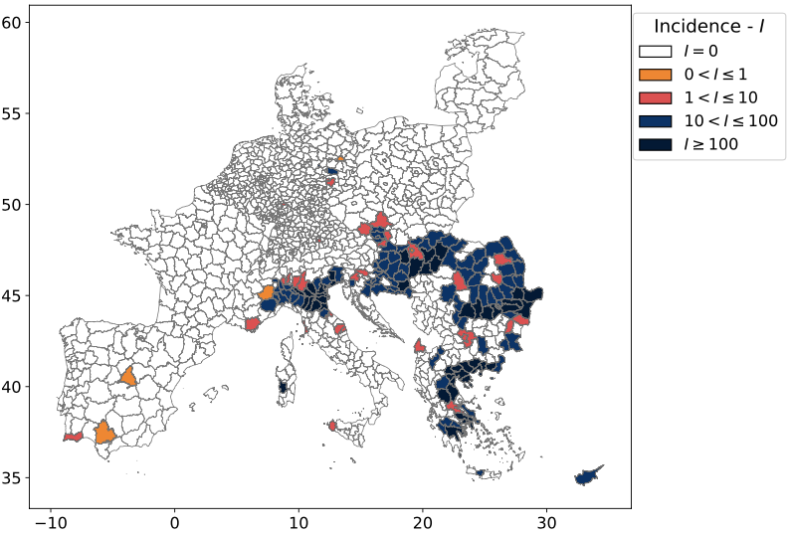
Figure 1. Total prevalence of West Nile Virus in Europe. Total prevalence (P) of West Nile virus disease, expressed as human cases per 100,000 inhabitants, in Continental Europe from 2005 to 2019, at the NUTS 3 level (Nomenclature of territorial units for statistics). The analysis includes only cases where the province of infection was reported. The legend illustrates the five value classes used in the plot.

Results
To explore the relationship between viral MBDs and provincial characteristics, we only considered human cases of viral MBDs where the province of infection was recorded. This resulted in 3,379 cases of West Nile virus disease, and 10 cases of Zika virus diseases. Given the large imbalance between the two diseases only West Nile virus disease cases were used in the final model to ensure more consistent and reliable results.

Descriptive results
In the time frame and area of our analysis, the provinces accounting for the most cases were the Northern Greek province of Thessaloniki (160 cases), the Romanian province of Bucharest (138 cases), and the Italian province of Padua (120 cases). The provinces with the highest incidence/100,000 inhabitants were again all in Northern Greece: Xanthi (1,384 cases/100,000), Imathia (1,239 cases/100,000), Pella (1,219 cases/100,000), and Thasos, Kavala (929 cases/100,000) (Figure 1).
The average forest land cover ranged between 0 and 193,958 km² (median 8,234 and mean 15,072 km²); the provinces with the highest forest land cover were the Latvian provinces of Vidzeme and Kurzeve (193,958, and 163,216 km², respectively) and the Estonian province of Lõuna-Eesti (186,643 km²). The average shrub land cover ranged between 0 and 35,132 km² (median 9 and mean 829 km²); the provinces with the highest shrub land cover were the Greek provinces of Argolis, Arcadia and Laconia, Messenia (35,132 and 28,227 km²), and the Spanish province of Almeria (27,578 km²). The average urban land cover ranged between 0 and 16,263 km² (median 1,268 and mean 1,851 km²); the provinces with the highest urban land cover were the Swiss provinces of Valais and Graubünden (16,263 and 13,845 km², respectively), and the unique province of Cyprus (13,928 km²). The average crop land cover ranged between 1 and 207,653 km² (median 13,720 and mean 23,524 km²); the provinces with the highest crop land cover were the Spanish provinces of Badajoz, Ciudad Real, and Zaragoza (207,653, 172,745, and 160,346 km², respectively). The average water land cover ranged between 0 and 39,255 km² (median 184 and mean 574 km²); the provinces with the highest water land cover were the Estonian province of Lõuna-Eesti (39,255 km²), the Netherlandish province of Flevoland (16,827 km²), and the Romanian province of Tulcea (15,855 km²).
Table 1. Diagnostics of the models. Coefficient estimates, standard errors (SE) and p-values (p) for the linear model (LM) and minimum (Min.), first-quartile (1Q), median, third-quartile (3Q), and maximum coefficient estimates for the spatial lag geographically-weighted model (GWR-SL), with the same outcome variable of interest. In addition, for both models are included measures of model evaluation: Residual standard errors (including the Degrees of Freedom [df]), Multiple R-squared, Adjusted R-squared, F-Statistics [df], and p-values), for the LM, as well as the 5th (P5) and 95th (P95) percentiles, median and mean values of the R-squared (R2) for the GWR.
Covariate | LM |  |  | GWR LM
 | Estimate | SE | p-value | Min | 1Q | Median | 3Q | Max
(Intercept) | -4.09 | 0.24 | <.001 | -35.32 | -15.19 | -5.19 | -1.15 | 70.06
Land Cover
Forest | 0.16 | 0.33 | .622 | -7.4 | -0.65 | 0.07 | 0.93 | 8.92
Shrub | 1.42 | 0.27 | <.001 | -100.97 | -3.87 | 0.0 | 2.26 | 61.23
Urban | 0.77 | 0.26 | .003 | -12.97 | -0.25 | 0.02 | 0.83 | 18.89
Crop | 0.59 | 0.33 | .074 | -27.92 | -1.21 | -0.02 | 0.64 | 12.72
Water | 0.73 | 0.27 | .006 | -16.38 | -0.07 | 0.36 | 2.05 | 18.43
Other | 0.50 | 0.29 | .088 | -16.47 | -0.49 | 0.2 | 0.91 | 12.57
Climate
Mean_P_Winter | 3.85 | 0.39 | <.001 | -12.32 | -1.3 | 0.33 | 2.14 | 28.27
Max_WD_Winter | -2.34 | 0.51 | <.001 | -15.79 | -1.19 | -0.39 | 0.21 | 6.23
Max_DD_Winter | 0.15 | 0.40 | .705 | -6.68 | -0.14 | 0.68 | 1.94 | 6.82
Mean_T_Spring | 2.80 | 0.44 | <.001 | -15.38 | -0.79 | 0.18 | 2.26 | 24.1
Max_DD_Spring | -2.86 | 0.36 | <.001 | -21.78 | -3.21 | -0.85 | 0.24 | 8.83
Max_WD_Autumn | -1.30 | 0.42 | .002 | -5.55 | -0.76 | -0.13 | 0.65 | 14.47
Max_DD_Autumn | 0.80 | 0.43 | .063 | -8.3 | -0.45 | 0.28 | 1.22 | 5.82
Socio-Economic
GDP per capita | -2.43 | 0.31 | <.001 | -40.65 | -0.41 | -0.04 | 0.33 | 49.12
Population Density | 1.02 | 0.27 | <.001 | -84.03 | -0.33 | 0.07 | 0.4 | 6.27
LM Metrics |  |  |  | GWR-LM Metrics
Residual std error (df) | 8.09 (1118) |  |  | P5 R² |  | 0.79
Multiple R-squared | 0.448 |  |  | P95 R² |  | 0.99
Adjusted R-squared | 0.440 |  |  | Mean R² |  | 0.94
F-Statistic (df) | 60.5 (15; 1118) |  |  | Median R² |  | 0.97
p-value | <.001

The average GDP per capita ranged between 2,567 Euro/person and 163,117 Euro/person (median 25,500 and mean 26,441 Euro/person); the provinces with the highest gross-domestic product were the Swiss provinces of Basel and Zug (163,117 and 138,250 Euro/person, respectively), and the German province of Wolfsburg (162,300 Euro/person) (Figure 2, Supplementary material – Table S1).
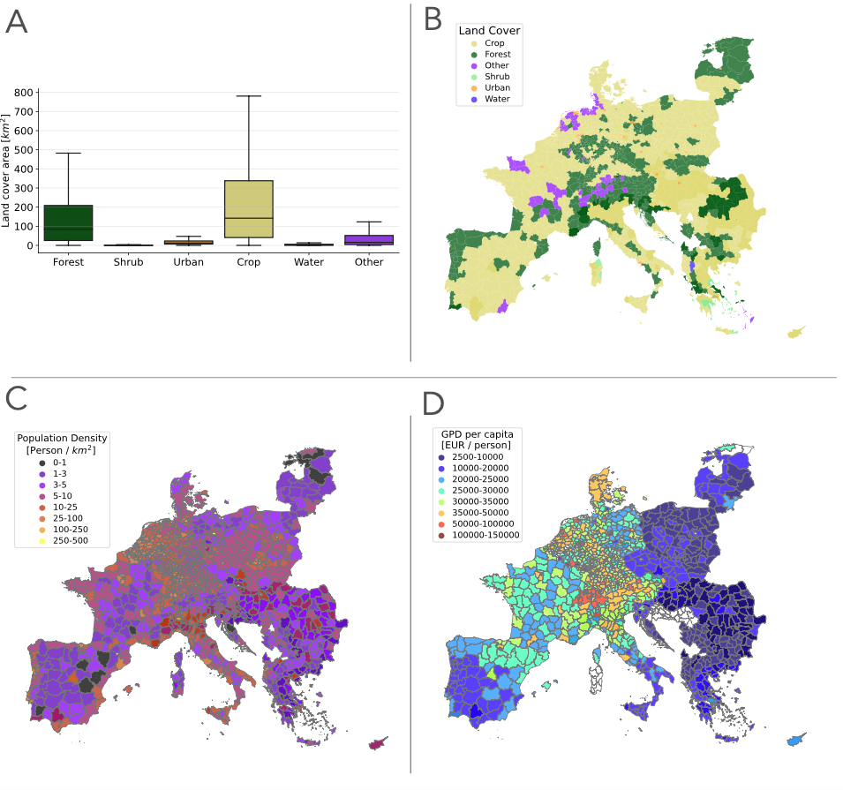
Figure 2. Descriptive statistics of the covariates potentially associated factors. A Distribution of the different land cover variable throughout the entire area of interest (up). B spatial distribution of main land cover variable per each NUTS3 level . C) Spatial distribution of population density and D) gross-domestic product per person (GDP per capita).

Regression analysis
We implemented two linear regression models: an ordinary linear regression (OLS) model and a spatial lagged geographically-weighted model (GWR-SL) as explained in the Methods section. The OLS was statistically significant (p <.001) and explained 56% of the variance in the sample (Table 1 and Figure 3). The factors with the highest statistically significant absolute coefficient estimates were, in order: maximum wet days (defined as the maximum number of consecutive days per season, in which the total precipitation was >0.001m) and mean temperature in spring (-2.856, and 2.794, respectively, both with p <.001), and GDP (-2.435, p <.001). Being the estimated coefficients of standardized variables, these results can be interpreted as each standard deviation change in the independent variable e.g., mean temperature in spring, equals– in this case – a positive change in incidence of WNV disease human cases of 2.79 times its standard deviation (Table 1). The GWR-SL explained between 6 and 99% of the variance in the sample (min and max R², respectively) (Figure 3). Out of the 1,134 considered provinces, the shrub land cover was the most relevant factor in 446 provinces (39%), followed by mean temperature in spring in 186 provinces (16%), and GDP in 166 (15%) (Figure 4). Among statistically significant land cover factors, shrub was most relevant in the German provinces of Munich, Munich (district), and Starnberg (estimates = 61.2, 56.6, and 43.0, respectively), and least relevant in the German provinces of Regen, Cham, and Gütersloh (estimates = -101.0, -90.4, and -84.5, “respectively). Urban land cover was most relevant in the Serbian province of Pčinja and Jablanička, and in the North Macedonian province of Skopski (estimates = 18.9, 17.7, and 17.0, respectively); whereas it was least relevant in the Greek provinces of Kerkyra, Thesprotia, and Ithaki, Kefallinia (estimates = -13.0, -12.2, -11.5, respectively). Water land cover was most relevant in the Greek provinces of Xanthi, Drama, and Thasos Kavala (estimates = 18.4, 18.4, and 17.9, respectively), all of which are in the North-Western region of Eastern Macedonia and Thrace; conversely, water land cover was least relevant in the French province of Moselle, in the German province of Bitburg-Prüm, and in the Belgian province of Arrondissement of Bastogne (estimates = -16.4, -15.7, and -14.8, respectively) (Figure 4). Among the statistically significant socio-demographic factors, GDP per person was most relevant in the Serbian provinces of Pčinjska and Jablanička, and in the Norther Macedonian province of Istočen (estimates = 49.1, 48.6, 44.6, respectively), and least relevant in the Bulgarian provinces of Stara Zagora and Haskovo, and in the Greek province of Evros (estimates = -40.6, -39.1, -34.8, respectively).
Table 2. Absolute number and proportion of provinces where each factor is the most relevant coefficient in the regression analysis of mosquito-borne disease incidence in Continental Europe (2005–2019) at the NUTS 3 level.
Factor | Number of provinces (%)
Land Cover
Shrub | 446 (39.3)
Urban | 6 (0.5)
Water | 41 (3.6)
Climatic variables
Mean_P_Winter | 72 (6.3)
Max_WD_Winter | 12 (0.1)
Mean_T_Spring | 186 (16.4)
Max_DD_Spring | 36 (3.2)
Max_WD_Autumn | 7 (0.6)
Max_DD_Autumn | 23 (2.0)
Socio-economic
GDP per capita | 166 (14.6)
Population density | 56 (4.9)

Population density was most relevant in Bulgarian provinces of Stara Zagora, Gabrovo, and Haskovo (estimates = 6.3, 5.5, and 5.4, respectively), whereas it was least relevant Serbian province of Pčinja and Jablanička, and in the North Macedonian province of Skopski (estimates = -84.0, -82.7, and -76.7, respectively) (Figure 4). When interpreting these figures, it is important to keep in mind that they refer to the incidence of WNV disease over Europe, at provincial level. Therefore, the prodromic or protective direction of their relevance depends on the incidence in the specific province.
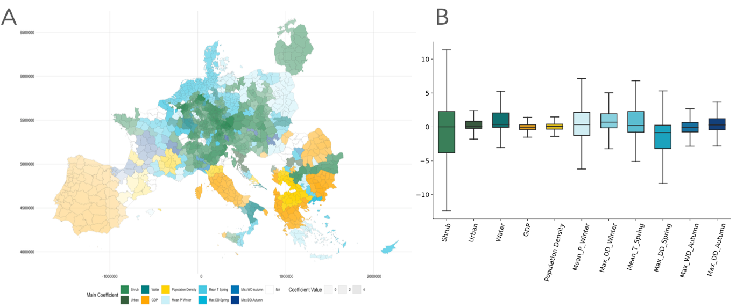
Figure 4. Distribution of the significative coefficients by province/NUTS3 as outcome of interest. A) Spatial distribution of the main coefficients and geographic representation of the results in Table 2. B) Distribution of the single factors considered for the model.

Discussion
Using a spatial regression model (GWR-SL) at provincial level over all continental Europe (2005-2019), we aimed at disentangling the local role of land cover on the incidence of viral mosquito-borne diseases human cases, given socio-demographic, and climatic factors. This is because, emerging and re-emerging viral mosquito-borne diseases are a significant public health threat, with millions of individuals at risk of exposure to infection [5-7]. To date, the effort to control these diseases focus on preventing the contact between humans and vectors, at both personal and general levels. The latter interventions are often guided by epidemiological models, which should inform about the most opportune moment and location to put them in place, to obtain the largest benefit [15]. These models are mostly based on climatic variables (most notably temperature and precipitations) [15], which are known to be extremely influential on the population dynamics and distribution of both vectors and hosts of MBDs [16-19]. Thus, our goal was to disentangle the eventual association of land cover to the incidence of viral MBDs in humans, given climatic factors.
Due to the large number of missing values for the province of infection among official records of viral MBDs, our original aim of observing the role of land cover through all viral MBDs had to be adjusted to consider only West Nile virus (WNV) disease. Our results suggest that all considered land cover factors as well as the socio-demographic factor considered (i.e., gross-domestic product per person) were significantly associated with the incidence of WNV disease in humans, given the effect climatic parameters (i.e., seasonal temperature, precipitation, growth days, and dry days).
In our results, the strongest association between land cover and WNV disease incidence in humans were for shrub (estimate = 1.42, p <.001), urban (estimate = 0.778, p = .003), and water land cover (estimate = 0.738, p =.006). No statistically significant association could be observed for either forest or crop land cover, whereas previous studies reported a positive association between the incidence of WNV disease and the percentage of province covered by irrigated croplands or by populated forests [26]. Speculations might be drawn on the origin of this divergence in results: one potential explanation is the specificity of land cover observed in this study. In fact, we decided to group land cover into six macro-categories (forest, shrub, crop, urban, water, and other), which included several more specific land covers. By observing these macro-categories, we lost the ability to look into more specific categories of land cover, which – though less stable e.g., irrigated croplands – might be more instrumental for the lifecycle of the vectors. This potential limitation of our approach might thus be a potential additional study question arising from this study, and that could be explored in further works. Another potential explanation is the cyclical nature of WNV disease seasons, which spike circa every five or six years. In contrast, the mentioned article was based on data between 2010 and 2012, whereas this analysis is based on data between 2005 and 2019 [26]. Also, we cannot exclude the role of the spatial lag effect: we selected the minimum possible length for the autoregression on the outcome of interest. However, this surely influences the estimates of the different factors, and their statistical significance.
An additional explanation might be the role of the different vectors and hosts in the transmission cycle of WNV to humans in continental Europe, and their distribution in the different habitats. In fact, anthropogenic changes e.g., urbanization could generate favourable conditions for the abundance of specific vector and hosts species [27]. Forest and agricultural land cover have been positively associated with Culex spp abundance in different studies, conversely to urban land cover, which showed a negative association [15]. However, thought true for the majority of Culex spp, these results are not applicable to the abundance of Cx. pipiens, which is one of the main vectors of WNV in Europe, and is considered its most relevant vector in urban areas [15, 25, 28, 29]. Indeed, in our results, urban land cover presents with a positive association to WNV disease incidence in humans, therefore supporting the theory of the major role of Cx. pipiens as vector for the transmission of WNV to humans in Europe. When observing this result – however –it is important to note its speculative nature: in fact, no analysis has been carried out in this study to test a potential association between vector abundance and WNV disease cases in humans. Conversely, previous studies observed how Culex density is indeed not a good predictor of WNV disease cases in humans [30]. In addition, given the small-scale area of impact of the average mosquito population, these results also confirms the role of human density on WNV disease incidence. These aspects become extremely relevant for the risk of developing WNV disease both to date as well as potentially in future years, when considering that it is estimated that 68% of human population worldwide will live in cities, by 2050 [31]. However, these differences between main vectors might also reflect in the different results between studies, which focus on different geographical settings and/or scales.
Conversely to the different speculations that could be drawn from our results regarding the potential role of the different vector species, the same could not be developed for the different lineages of WNV. In fact, Europe has more diversity in co-circulating WNV lineages than other continents, with the presence of the large majorities of lineages that are known to be circulating worldwide [32], thought the essential impact for the distribution of the disease can be considered from lineage I, which was predominant in western Europe, and lineage II, which has spread to the Western European regions, since its first detection in Hungary in 2004 [33]. It is possible, that the dominance of one lineage over the other in the specific country or region, might represent a potential source of bias for our results.
When considering these results, it is important to keep in mind that the two factors, which presented the highest absolute impact on the incidence of WNV disease in humans, were still climatic (i.e., maximum dry days and mean temperature in spring, = -2.856, and 2.794, both with p <.001). These results mean that for every standard deviation change in the maximum dry days and mean temperature between provinces in spring, the incidence of WNV disease human cases decreases by 2.856 and increase by 2.794 times the standard deviations, respectively. The potential explanation of this observation is the effect of temperature on mosquito life-traits (e.g., oviposition), and on the pathogen, both of which were already observed in the specific scientific literature [16-19]. There is a general agreement in the scientific literature, that higher temperatures in spring and early summer, result in earlier and more abundant presence of vectors [34-36], higher pathogen circulation e.g., in non-human hosts [37, 38], and might be among the major responsible for the spatial expansion of WNV in Europe [39]. However, it is important to note that, because we averaged the seasonal climatic variables over the whole observed time period, these results refer rather to the climatic suitability that each single province might have for the pathogen and its vectors, than to the role of climate change or extreme events on virus circulation. Furthermore, when evaluating these results, it is important to keep in mind that, due to high correlation between the mean temperature and precipitation of each season, we decided to exclude from the model the mean temperature in winter, summer, and autumn. Therefore, the results that we observed should be interpreted more in terms of the importance of the temperature on the occurrence of WNV human cases, rather than on an indication of the most important season. Furthermore, regardless of the original scope of the study, which aimed at understanding the impact of land cover factors on the distribution of MBDs in Continental Europe, given the peculiarities of WNV’s transmission cycle, our results should be only referred to this very specific disease, and not generalized for other MBDs.
In designing this analysis, we considered a spatially-lagged geographically-weighted regression (GWR-SL) approach, because of the amount of spatial autocorrelation in the sample (Supplementary material – Table S2). This approach might represent an additional interesting feature of this study, especially in the different ability to explain the variance in the sample between the GWR and a linear model (Figure 3).
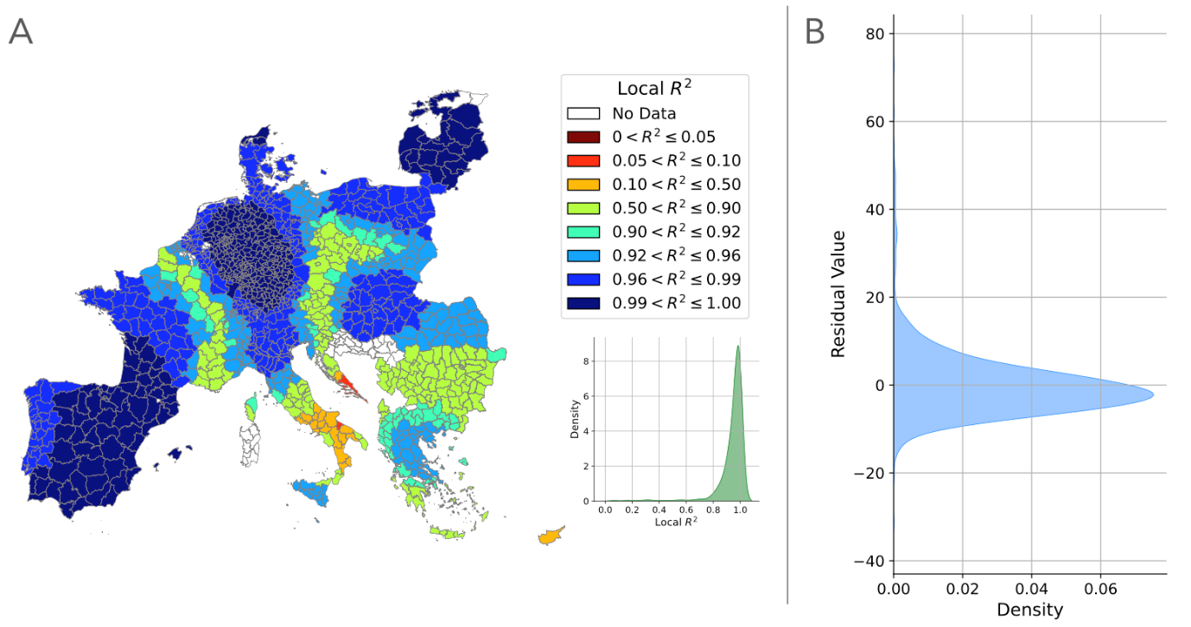
Figure 3. Spatial distribution of the local R² and distribution of the residuals of the spatial model (GWR-SL).

In fact, in the latter approach, an amount between 57 and 56% of the variance in the sample could be explained (Multiple and Adjusted R-squared [R²], respectively), whereas in the first case (GWR-SL) we could improve until a mean and maximum value of R² of 95% and 99%, respectively. In addition, we opted for the spatial distribution of the different land covers, rather than their proportion over the overall size of the province/NUTS3. This choice was done because, the latter approach was severely impeded by spatial autocorrelation, rendering the results practically non-interpretable. However, we still consider of scientific interest and practical relevance to disentangle also the role of different land covers, based on their proportion in each province/NUTS3, rather than of spatial distribution, which could be addressed in further studies on this topic.
We envisioned the public health relevance of this analysis in its ability to inform policy makers on WNV diseases in humans, isolating factors associated with the incidence of the disease at a finer granularity (i.e., provinces), and therefore allowing for more ad hoc small scale interventions, e.g., at provincial level. However, the geographical focus of this study might represent also a limitation. In fact, though a wide-scale understanding of risk and potential interventions, when it comes to viral MBDs it is important to keep in mind that the conditions, which influence vectors population dynamics and distribution (e.g., host selection) [40, 41], and therefore the enzootic cycle of WNV, are often influenced by parameters at geographical scales much smaller that provinces. Analyses over large geographic areas (e.g., Europe) with resolution at smaller scales are extremely complicated to replicate because of the level of granularity, to which human cases are recorded (in the case of this study, province/ Nomenclature of Territorial Units for Statistics lev. 3 [NUTS3]). Similarly, the provincial analysis does not allow to focus on socio-demographic characteristics, which were also associated with the incidence of WNV in humans [42-45]; nor to account for human mobility, which was also associated with the incidence of WNV [46]. Furthermore, a potential bias is present because of WNV disease is potentially underdiagnosed. In fact, it is estimated that 80% of WNV disease cases in human are asymptomatic, 19% present very mild and unspecific symptoms, and the remaining 1% will present with more severe neurological symptoms [47]. In this scenario, it is not unlikely to imagine an asymmetrical distribution of the ability to correctly identify cases (especially with non-neurological symptomatic picture) between countries that have a long story of the disease, and therefore more structured surveillance plans, and countries with more recent story of the disease.
Methods
Data collection
MBDs cases
Data on human cases of Chikungunya, Dengue, West Nile virus disease, Yellow Fever, and Zika virus disease at Nomenclature of Territorial Units for Statistics (NUTS)-3 level collected by each Member State’s Public Health Authority and released by the European Centre for Disease Prevention and Control (ECDC) was obtained from the European Surveillance System – TESSy [48]. Due to the explorative nature of this study, no further refinement (e.g., clinical manifestation, laboratory confirmation) of the included cases was conducted.
Land cover data
Land cover data, in the form of yearly global raster files with a geographical resolution of 300x300 meters, were obtained from Climate Change Initiative (CCI) of the European Space Agency (ESA) for the whole time-frame of the study (2005-2019). We considered this temporal dimension, given the similarity between the values of the single years. The dataset is publicly available [49].
Climatic data
For the hourly air temperature in K, and the precipitation in m we rely on the ERA5 Copernicus data. The dataset is publicly available [50].
Socio-demographic data
Information on population (in number of persons), area (in km²), population density (in persons per km²) and gross domestic product per person (GDP, in Euros), at province/NUTS3 level, were obtained from the European Statistical Office (EUROSTAT) [51]. Dataset were customized to cover the time-frame of the study.

Variables operationalisation
The following variables were included in the study in their original form: area, population, population density, and GDP. Furthermore, two the first three variables (i.e., area, population, and population density) were used in combination to obtain the third, when missing. In addition, it is important to notice that – just as for any other variable included in this study – only one single time-point was considered, which covered the whole observed period (2005-2019), and over which the different values where averaged.
Human cases of viral MBDs were grouped by the province/NUTS3 of infection. From this, a variable for incidence was calculated, dividing the number of cases in each province/NUTS3 for its population
To allow for comparability with the outcome of interest, land cover data – presented as squared-kilometric amount of each land cover variable – were also rescaled to province/NUTS3 level and grouped by province/NUTS3. In addition, the various categories were summarized in six macro-categories as follows:
- Forest: Tree cover, broadleaved, evergreen, closed to open (>15%); Tree cover, broadleaved, deciduous, closed to open (>15%); Tree cover, broadleaved, deciduous, closed (>40%); Tree cover, broadleaved, deciduous, open (15‐40%); Tree cover, needle leaved, evergreen, closed to open (>15%); Tree cover, needle leaved, evergreen, closed (>40%); Tree cover, needle leaved, evergreen, open (15‐40%); Tree cover, needle leaved, deciduous, closed to open (>15%); Tree cover, needle leaved, deciduous, closed (>40%); Tree cover, needle leaved, deciduous, open (15‐40%); Tree cover, mixed leaf type (broadleaved and needle leaved); Mosaic tree and shrub (>50%) / herbaceous cover (<50%),
- Shrub: Mosaic herbaceous cover (>50%) / tree and shrub (<50%); Scrubland; Evergreen shrub land; Deciduous shrub land,
- Urban: Urban areas; Bare areas; Consolidated bare areas; Unconsolidated bare areas,
- Crop: Cropland, rain-fed; Herbaceous cover; Tree or shrub cover; Cropland, irrigated or post‐flooding; Mosaic cropland (>50%) / natural vegetation (tree, shrub, herbaceous cover) (<50%); Mosaic natural vegetation (tree, shrub, herbaceous cover) (>50%) / cropland (<50%),
- Water: Water bodies, and
- Other: Grassland; Lichens and mosses; Sparse vegetation (tree, shrub, herbaceous cover) (<15%); Sparse tree (<15%); Sparse shrub (<15%); Sparse herbaceous cover (<15%); Tree cover, flooded, fresh or brackish water; Tree cover, flooded, saline water; Shrub or herbaceous cover, flooded, fresh/saline/brackish water; and Permanent snow and ice.
The aggregation of the ESA CCI Land Cover classes into six macro-categories—forest, shrub, crop, urban, water, and other—was undertaken to simplify the analysis and focus on broader land cover trends relevant to our study objectives. We considered that this approach would allow us for clearer interpretation and communication of results, especially when dealing with large-scale geographic datasets. Potential drawbacks can be represented by the overlooking of finer distinctions within each category. Future studies could consider additional layers or sub-categories for more detailed investigationsTemperature and total precipitation were averaged after grouping the data by province/NUTS3, and a newly created variable for season (defined as: Winter [January, February, and March], Spring [April, May, and June], Summer [July, August, and September], and Autumn [October, November, and December]). We considered this approach to better represent the seasonal nature of WNV disease cases in humans. In addition, to better understand the impact of climatic variables on mosquitoes’ life traits, six new variables were created:
- Total growth days (counting the days per season in which the average temperature was higher than 14.3 ℃),
- Maximum growth days (counting the maximum number of consecutive days per season in which the average temperature was higher than 14.3℃),
- Total wet days (counting the days per season in which the total precipitation was > 0.001 m, as per definition of the World Meteorological Organization [WMO] of the United Nations [UN]),
- Total dry days (counting the days per season in which the total precipitation was ≤ 0.001 m), and
- Maximum wet and dry days (counting the maximum number of consecutive days per season in which the total precipitation was > and ≤, respectively, of 0.001 m).
Statistical analysis
Descriptive statistics
Incidence of human cases of viral mosquito-borne diseases between 2005 and 2019, as well as average value for land covers of major interest. Similarly, major potential confounders (e.g., socio-demographic factors, and mean seasonal temperatures and precipitations) were reported.
Regression analysis
Before including them in the models, each of the dependent and independent variables was standardized (z-scores); also, the independent variables were observed in a correlation matrix. Variables, which correlated with a value ≥0.8 were considered for exclusion from the model (Supplementary material, Figure S1). When selecting which variable to exclude from the model, we oriented ourselves to favour known relevant factors (e.g., temperature in spring). Following this analysis, and due to the elevated correlation with other variables we decided to exclude from the model the following variables: a) mean temperature in winter and autumn; b) mean precipitation in spring, summer, and autumn; c) total growth days in all winter, spring, summer, and autumn; d) maximum growth days in all winter, spring, and autumn; e) maximum wet days in spring, and summer; and f) maximum dry days in summer. Therefore, the variables included in the final model were: a) land cover forest, shrub, urban, crop, water, other; b) gross-domestic product; c) population density; d) mean temperatures in spring and summer; e) mean precipitation in winter; f) maximum wet days in winter and autumn; and g) maximum dry days in winter, spring, and autumn.
The variable considered for the model were then tested for spatial autocorrelation (Moran’s I), to evaluate their autocorrelation and therefore validate the use of spatial model (Supplementary material – Table S2) [53, 53].
In this research we make use a Geographical Weighted Regression model (GWR) with a spatial lag (SL) on the dependent variable [54].
Spatial Lag Implementation
To account for spatial dependencies in our dependent variable, we implemented a spatial lag model. The spatial lag model incorporates spatial autocorrelation by adjusting the dependent variable based on the values of neighbouring observations. This ensures that the model accounts for the influence of spatially proximate data points. We considered this of specific relevance, given the clustered distribution of WNV cases, throughout Europe.
Let yi represent the value of the dependent variable at location i. The spatial lag model introduces a spatially lagged dependent variable, Wy, where W is the spatial weights matrix. The element Wij ​ of the matrix W quantifies the spatial relationship between locations i and j. To define the spatial weights matrix (WWW), we employed a distance-based approach. We based our selection of neighbours on a metric base. To obtain this, we first transformed our dataset to metric and then developed a distance matrix comprised between 0 and a maximum distance of 150 km. This distance matrix was used to weight our dependant variable. The independent variables were instead weighted using the bandwidth selected for the GWR model. We selected an adaptive bandwidth with a bi-square kernel. Validation of this bandwidth was based on the Akaike information criterion (AIC).
The spatially lagged dependent variable for location i is then defined as:
$${(Wy)}_{i}= \sum_{j=1}^{n}{W_{ij}y_{j}}$$

where n is the total number of observations. The adjusted dependent variable $y_{i}^{*}$ incorporates the lab effect and it is expressed as:
$$y_{i}^{*}= {\left(Wy\right)}_{i}$$

Geographical Weighted Regression model (GWR) with Spatial Lag (SL)
We employed a Geographically Weighted Regression (GWR) model to account for spatial heterogeneity in the relationship between the dependent and independent variables. To enhance the GWR model, we incorporated the spatially lagged dependent variable $y_{i}^{*}$. The implementation of the GWR model with SL (GWR-SL model) involves two main steps: 1) selection of the bandwidth and ii) fitting of the GWR-SL model [54].
Geographical Weighted Regression (GWR) is a local form of linear regression used to model spatially varying relationships. In regression analysis, the strength and direction of association is indicated by the regression coefficients, with one coefficient given for each variable in the dataset. In GWR, instead of one global coefficient for each variable, coefficients are able to vary according to space. This spatial variation in coefficients can reveal interesting patterns which otherwise would be masked. The general formula for a GWR is an extension of an OLS where one regression is calculated for each point using spatial weights. We defined a GWR-SL where we incorporate the spatially lagged dependent variable, allowing it to account for both spatial autocorrelation and spatial heterogeneity. The GWR-SL model can be represented as:
$$y_{i}^{*}= β_{0i}+ \sum_{k=1}^{p-1}{β_{ki}x_{ki}+ ε_{i}}$$

The index i indicates the location of the province of interest. GWR basically fits a set of β coefficients for each location and in a matrix form can be written as:
$$β_{i}={\left(X^{T}W_{i}X \right)}^{-1}X^{T}W_{i}Y$$
where $W_{i}$ is a diagonal matrix (nxn) specific to location i, with the i_{th} element in the diagonal (w_{ij}) given by the value of the kernel function for observation pair i and j. There are various schemes for calculating the weights, nearest neighbors, cubic or exponential kernels.
We used the Akaike Information Criterion (AIC) approach to select the bandwidth for the GWR-SL model. This method determines the optimal bandwidth (b) that balances model fit and complexity. The bisquare kernel function (K) was used, which assigns weights to observations based on their distance, with an adaptive bandwidth allowing the bandwidth to vary based on the density of the data points. Mathematically, the weight w_{ij} for an observation j at location i is given by:
$$w_{ij}= \left\{\begin{aligned}{\left(1- {\left(\frac{d_{ij}}{b}\right)}^{2}\right)}^{2}, if d_{ij}≤b \\ 0, if d_{ij}>b\end{aligned}\right.\begin{matrix} \\ \end{matrix}$$

where b is the distance to the N_{th} nearest neighbour.
To address the risk of spatial multicollinearity within the sample, we calculated the variance inflation factors (VIF) (Supplementary material – Table S3) [55]. Do to the high multicollinearity in the model, we decided to exclude the Mean_T_Summer.
All analyses were conducted in R (version: 4.0.3)

References
- Bartholomeeusen, K., et al. Chikungunya fever. Nature Reviews Disease Primers 9:17 (2023).
- Guzman, M. G., and Harris, E. Dengue. The Lancet 385:453-465 (2015).
- Plourde, A. R., and Bloch, E.M. A Literature Review of Zika Virus. Emerg Infect Dis. Jul;22(7):1185-92 (2016)
- Riccetti, N., Ferraccioli, F., Fasano, A., Stilianakis, N.I. Demographic characteristics associated with West Nile virus neuroinvasive disease – A retrospective study on the wider European area 2006–2021. PLOS ONE 18(9): e0292187 (2023).
- Messina, J.P., et al. The current and future global distribution and population at risk of dengue. Nat Microbiol 4, 1508–1515 (2019)
- Nsoesie, E.O., et al. Global distribution and environmental suitability for chikungunya virus, 1952 to 2015. Euro Surveill. 21(20):pii=30234 (2016)
- Justin Lessler et al. Assessing the global threat from Zika virus. Science 353, aaf 8160 (2016).
- Kraemer, M.U.G., et al. The global distribution of the arbovirus vectors Aedes aegypti and Ae. albopictus. eLife 4: e08347 (2015).
- Franklinos, L.H.V., Jones, K.E., Redding, D.W., and Abubakar, I. The effect of global change on mosquito-borne disease. Lancet infect Dis 19: e302-12 (2019).
- Semenza, J., Rocklöv, J., and Ebi, K.L. Climate change and cascading risks from infectious diseases. Infect Dis Ther 11:1371-1390 (2022).
- Petersen, L., Brault, A., and Nasci, R. West Nile virus: Review of the literature. JAMA 310(3):308-315.
- World Health Organization (WHO). Vaccines and immunization: Dengue. May 10th, 2024. URL: https://www.who.int/news-room/questions-and-answers/item/dengue-vaccines. Last accessed: June 2024
- De Souza, W.M., et al. Chikungunya: a decade of burden in the Americas. The Lancet Regional Health – Americas 30, 100673 (2024).
- Ferguson, N.M. Challenges and opportunities in controlling mosquito-borne infections. Nature 559, 490-497 (2018).
- Giesen, C., et al. A systematic review of environmental factors related to WNV circulation in European and Mediterranean countries. One Health 16, 100478 (2023).
- Paz, S., and Albersheim, I. Influence of warming tendency on Culex pipiens population abundance and on the probability of West Nile Fever outbreaks (Israeli case study: 2001–2005). EcoHealth 5, 40–48 (2008).
- Ruybal, J.E., Kramer, L.D., and Kilpatrick, A.M. Geographic variation in the response of Culex pipiens life history traits to temperature. Parasites Vectors 9, 1–9 (2016).
- Ferraccioli, F., Riccetti, N., Fasano, A., Mourelatos, S., Kioutsioukis, I., and Stilianakis, N.I. Effects of climatic and environmental factors on mosquito population inferred from West Nile virus surveillance in Greece. Sci Rep 13, 18803 (2023).
- Vogels, C.B., Fros, J.J., Göertz, G.P., Pijlman, G.P., and Koenraadt, C.J. Vector competence of northern European Culex pipiens biotypes and hybrids for West Nile virus is differentially affected by temperature. Parasit Vectors 9, 393 (2016).
- Shocket, M.S., et al. Transmission of West Nile and five other temperate mosquito-borne viruses peaks at temperatures between 23°C and 26°C. eLife 9:e58511 (2020).
- Ciota, A.T., Matacchiero, A.C., Kilpatrick, A.M., and Kramer, L.D. The effect of temperature on life history traits of Culex mosquitoes. J. Med. Entomol. 51, 55–62 (2014).
- Alimi, Y., et al. Report of the scientific task force on preventing pandemics. Harvard Chan C-CHANGE and Harvard Global Health Institute, Cambridge (2021).
- Ferraguti, M., Magallanes, S., Suarez-Rubio, M., Bates, P.J.J, Marzal, A., and Renner, S.C. Does land-use and land cover affect vector-borne diseases? A systematic review and meta-analysis. Landsc Ecol 38:2433-2451 (2023).
- Skinner, E.B., Glidden, C.K., MacDonald, A.J., and Mordecai, E.A. Human footprint is associated with shifts in the assemblages of major vector-borne diseases. Nat Sustain 6, 652–661 (2023).
- Ferraguti, M., Martinez-de la Puente, J., and Figuerola, J. Ecological Effects on the Dynamics of West Nile Virus and Avian Plasmodium: The importance of Mosquito Communities and Landscape. Viruses 13, 1208 (2021).
- Marcantonio, M., et al. Identifying the Environmental Conditions Favouring West Nile Virus Outbreaks in Europe. PLOS ONE 10(3): e0121158 (2015).
- Ferraguti, M., Martínez-de la Puente, J., Roiz, D., Ruiz, S., Soriguer, R., and Figuerola, J. Effects of landscape anthropization on mosquito community composition and abundance. Sci Rep 6, 29002 (2016).
- Gangoso, L., et al. Determinants of the current and future distribution of the West Nile virus mosquito vector Culex pipiens in Spain. Environ. Res. 188, 109837 (2014).
- Bravo-Barriga D., et al. The mosquito fauna of the western region of Spain with emphasis on ecological factors and the characterization of Culex pipiens forms. J Vector Ecol. 42(1):136-147 (2017)
- Calzolari, M., et al. Enhanced West Nile Virus Circulation in the Emilia-Romagna and Lombardy Regions (Northern Italy) in 2018 Detected by Entomological Surveillance. Front. Vet. Sci. 7:243 (2020)
- United Nations (UN). 68% of the world population projected to live in urban areas by 2050, says UN. May 18th, 2018. URL: https://www.un.org/development/desa/en/news/population/2018-revision-of-world-urbanization-prospects.html. Last accessed: July 2024.
- Lu, L., et al. West Nile virus spread in Europe: Phylogeographic pattern analysis and key drivers. PLoS Pathog. Jan 25;20(1):e1011880 (2024).
- Koch, R.T., et al. Genomic epidemiology of West Nile virus in Europe. One Health 18:1, 100664 (2024)
- Marini, G., et al. A quantitative comparison of West Nile virus incidence from 2013 to 2018 in Emilia-Romagna, Italy. PLOS Neglected Tropical Diseases 14(1): e0007953 (2020).
- Rosà, R., et al. Early warning of West Nile virus mosquito vector: climate and land use models successfully explain phenology and abundance of Culex pipiens mosquitoes in north-western Italy. Parasites Vectors 7, 269 (2014).
- Riccardo, F., et al. Rapid increase in neuroinvasive West Nile virus infections in humans, Italy, July 2022. Euro Surveill. 27(36):pii= 2200653 (2022).
- Magallanes, S., et al. Warm winters are associated to more intense West Nile virus circulation in southern Spain. Emerging Microbes & Infections, 13:1, 2348510 (2024).
- Magallanes, S., et al. Long-term serological surveillance for West Nile and Usutu virus in horses in south-West Spain. One Health, 17:1, 100578 (2023).
- Erazo, D., et al. Contribution of climate change to the spatial expansion of West Nile virus in Europe. Nat Commun 15, 1196 (2024).
- Riccetti, N., Fasano, A., Ferraccioli, F., Gomez-Ramirez, J., Stilianakis, N.I. Host selection and forage ratio in West Nile virus–transmitting Culex mosquitoes: Challenges and knowledge gaps. PLOS Neglected Tropical Diseases 16(10): e0010819 (2022).
- Wheeler, S.S., Taff, C.C., Reisen, W.K., and Townsend, A.K. Mosquito blood-feeding patterns and nesting behavior of American crows, an amplifying host of West Nile virus. Parasites Vectors 14, 331 (2021).
- Gibb R, Colon-Gonzalez FJ, Lan PT et al. Interactions between climate change, urban infrastructure and mobility are driving dengue emergence in Vietnam. Nat Commun 14, 8179 (2023).
- Ruiz-Lopez, M.J., et al. Genomic Analysis of West Nile virus Lineage 1 Detected in Mosquitoes during the 2020-21 Outbreaks in Andalusia, Spain. Viruses 15, 266 (2023).
- Paz, S., and Semenza, J. Environmental drivers of West Nile fever epidemiology in Europe and Western Asia—a review. Int J Environ Res Public Health, 10(8): p. 3543–62 (2013).
- Ytbarek, S., Chen, K., Celestin, M., and McCary, M. Urban mosquito distributions are modulated bysocioeconomic status and environmental traits in the USA. Ecological Applications 33:e2869 (2023).
- Massaro, E., Kondor, D., and Ratti, C. Assessing the interplay between human mobility and mosquito borne diseases in urban environments. Sci Rep 9, 16911 (2019).
- Sambri, V., et al. West Nile virus in Europe: emergence, epidemiology, diagnosis, treatment, and prevention. Clin Microbiol Infect. Aug;19(8):699-704 (2013).
- European Centre for Diseases Prevention and Control (EDCD).The European Surveillance System (TESSy). URL: https://www.ecdc.europa.eu/en/publications-data/european-surveillance-system-tessy. Last accessed: August, 2024
- European Space Agency (ESA). Climate Change Initiative (CCI). URL: https://www.esa-landcover-cci.org/. Last accessed: August, 2024
- European Centre for Medium-Range Weather Forecasts (ECMWF). ERA5 hourly data on single levels from 1940 to present dataset. URL: https://cds.climate.copernicus.eu/cdsapp#!/dataset/reanalysis-era5-single-levels. Last accessed: August, 2024
- European Statistical Office (EUROSTAT). URL: https://ec.europa.eu/eurostat/data/database. Last accessed: August,2024
- Fotheringham, A.S., Brunsdon, C., and Charlton, M.E. Geographically Weighted Regression: The Analysis of Spatially Varying Relationships. Wiley; p.39 (2002).
- Wheeler, D.C. Geographically weighted regression. In Fischer MM, and Nijkamp P (eds.). Handbook of Regional Science. Springer, Berlin, Heidelberg (2021).
- Shoff, C., Chen, V.Y.J., and Yang, T.C. When homogeneity meets heterogeneity: the geographically weighted regression with spatial lag approach to prenatal care utilization. Geospat Health 8(2): 557-568 (2014).
- Fotheringham, A.S. and Oshan, T.M. Geographically weighted regression and multicollinearity: dispelling the myth. J Geogr Syst 18:303–329 (2016).

Declarations
Acknowledgements
None
Authors’ contribution
Conceptualization: NR, EM
Data Curation and Formal Analysis: NR, EM
Funding Acquisition: NA
Investigation, Methodology, Project Administration, Resources, and Software: NR, EM
Supervision and Validation: NR, EM
Visualization and Writing – Original Draft Preparation: NR
Writing – Review & Editing: NR – NR, AF, WS, AC, JCC, GD, DIR, JF, and EM
Data sharing
The data that support the findings of this study are available from the links included in the methods section, and references section. Restrictions might apply to the availability of these data, which were used for this study under different licenses, and so might not publicly available.
Additional information
Funding
No specific funding was obtained for this study. JF is supported by project ARBOPREVENT from Fundación La Caixa.
Declaration of interests
All the authors declared no competing interests.
Disclaimers
The views expressed in this article are purely those of the authors and may not, under any circumstances, be regarded as an official position of the European Commission. The views and opinions of the authors expressed herein do not necessarily state or reflect those of ECDC. The accuracy of the authors’ statistical analysis and the findings they report are not the responsibility of ECDC. ECDC is not responsible for conclusions or opinions drawn from the data provided. ECDC is not responsible for the correctness of the data and for data management, data merging and data collation after provision of the data. ECDC shall not be held liable for improper or incorrect use of the data.

