Spatial role of land cover on West Nile virus disease in Europe

Nicola Riccettiª, Angela Fanelli^{b}, Wojciech Szewczyk^{b*}, Alessandro Cescattiª, Juan Carlos Ciscar^{b}, Grégoire Duboisª, Dolores Ibarreta^{b}, Jordi Figuerola^{c,d} , and Emanuele Massaroª
Affiliations:
ªEuropean Commission, Joint Research Centre (JRC). Via E. Fermi 2749, 21027 Ispra (VA) – Italy
^{b}European Commission, Joint Research Centre (JRC). C. Inca Garcilaso, 3, 41092 Sevilla – Spain
^{c}Estacion Biologica de Doñana, Consejo Superior de Investigaciones Científicas (CSIC). Avda. Americo Vespucio 26, 41092 Sevilla – Spain
^{d}Centro de Investigación Biomédica en Red Epidemiología y Salud Pública (CIBER ESP). Avda. Monforte de Lemos, 3-5, 28029 Madrid - Spain

Corresponding author (*):
Wojciech Szewczyk, Wojciech.SZEWCZYK@ec.europa.eu

Summary
Mosquito-borne viral diseases remain a growing public-health concern, yet the relative influence of land cover and climate on their spatial distribution in temperate regions remains insufficiently understood. To address this gap, we analysed West Nile virus (WNV) disease incidence in humans across European provinces (NUTS-3) from 2005–2019, the only mosquito-borne virus with sufficiently detailed and long-term geographic reporting. Using spatial regression and a geographically weighted regression with a spatial lag component (GWR-SL), we quantified how land-cover gradients, climatic factors, and socio-demographic variables jointly shape the spatial heterogeneity of WNV disease incidence. Shrubland cover exhibited the strongest and most spatially consistent positive association with WNV disease incidence, while forest cover showed a largely negative relationship across Europe; urban and cropland areas displayed weaker, regionally variable effects. Climatic factors—particularly warm summer temperatures and seasonal moisture balance—were the dominant predictors of WNV incidence, whereas socio-economic variables did not contribute significantly at this scale. The spatially adaptive GWR-SL model captured marked regional variability in these associations, underscoring that drivers of WNV risk are highly context-dependent. These findings highlight the importance of integrating land cover and climatic information into targeted surveillance and vector-control strategies, while also acknowledging limitations arising from land-cover aggregation, climatic averaging, and underreporting of human infections.
Keywords
Mosquito-Borne Diseases; West Nile virus; Epidemiologic Methods; Geographically Weighted Regression Models; Public Health

Introduction
Although West Nile Virus (WNV) disease generally causes relatively low mortality in humans [1–4], it represents one of the most widespread mosquito-borne viral infections in the world. WNV is maintained in a zoonotic cycle involving Culex mosquitoes—particularly Culex pipiens and Cx. modestus in Europe—and avian hosts belonging mainly to Corvus and Passeriformes genera. Humans and other mammals are incidental, dead-end hosts who become infected through mosquito bites but do not contribute to further transmission.
Since its introduction and subsequent establishment in Europe, WNV has expanded geographically and re-emerged periodically in several regions, causing seasonal outbreaks that vary in magnitude and spatial distribution [5–10]. This resurgence has raised growing concern for public-health authorities, particularly under changing climatic and environmental conditions that may increase viral circulation in the future [10]. No licensed vaccine for the disease or specific antiviral treatment for WNV is currently available [11]; consequently, public-health strategies rely primarily on reducing mosquito–human contact through vector control and personal protection measures, and on improving surveillance and early-warning systems.
Predictive models have played a crucial role in guiding these preventive efforts. Historically, most studies of mosquito-borne viruses have emphasized **climatic and environmental factors—such as temperature, precipitation, humidity, vegetation, surface water, and land use/cover—**because these variables directly and indirectly influence mosquito abundance, development, habitat suitability, and viral replication [15–19]. However, temperature effects on mosquito populations and virus transmission are often non-linear.
In fact, several mosquito life traits show a unimodal relationship with temperature (e.g., larval survival, development rate, and biting frequency), whereas adult lifespan tends to decrease beyond approximately 30 °C, indicating that excessively high temperatures can reduce vector survival [20]. Excessive temperatures can therefore suppress vector populations, both directly through reduced survival and indirectly through decreased fecundity and altered blood-feeding behaviour [9, 17, 21]. Similarly, vector competence and viral transmission efficiency peak at intermediate temperatures (typically 30–36 °C, depending on the vector–pathogen combination) [20].
Because of these complex and context-dependent relationships, a growing number of studies have called for more integrative frameworks that incorporate not only climatic drivers but also land-cover characteristics and socio-demographic factors [9, 22–24]. Land use and anthropogenic environmental change can reshape mosquito and host habitats [25], alter the composition and abundance of competent vectors, and modulate exposure risk for human populations.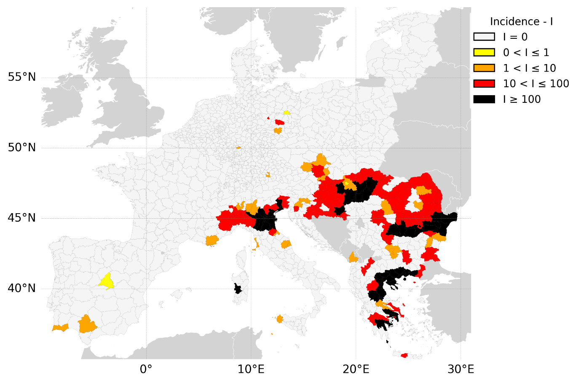
Figure 1. Incidence of West Nile Virus in Europe. Incidence (I) of West Nile virus disease, expressed as human cases per 100000 inhabitants, in Continental Europe from 2005 to 2019, at the NUTS 3 level (Nomenclature of territorial units for statistics). The analysis includes only cases where the province of infection was reported. The legend illustrates the five value classes used in the plot.

In this context, our study focuses specifically on West Nile Virus incidence across European provinces from 2005 to 2019. We examine how land-cover types—particularly forests, croplands, shrublands, and urban areas—interact with climate and socio-demographic variables to explain spatial heterogeneity in WNV disease incidence in humans. By quantifying how the relative importance of these factors varies across Europe, we aim to provide insights that can inform public-health planning and spatially targeted surveillance for this zoonotic disease.

Results
To investigate the spatial determinants of WNV disease incidence in humans, we included only cases with a known province of infection. A total of 3379 WNV disease human cases were recorded during the study period.
Descriptive results
In the time frame and area of our analysis, the provinces accounting for the most cases were the Northern Greek province of Thessaloniki (160 cases), the Romanian province of Bucharest (138 cases), and the Italian province of Padua (120 cases). The provinces with the highest incidence/100,000 inhabitants were again all in Northern Greece: Xanthi (1,384 cases/100,000), Imathia (1,239 cases/100,000), Pella (1,219 cases/100,000), and Thasos, Kavala (929 cases/100,000) (Figure 1).

Table 1. Summary of global (LM) and local (GWR) regression results. For the LM, we report standardized coefficients, standard errors, p-values, and model diagnostics including residual standard error (with degrees of freedom), Multiple R², Adjusted R², F-statistic (with degrees of freedom), and p-value. For the GWR, we report the mean, standard deviation, and range (minimum, median, maximum) of local parameter estimates and the 5th (P5), 95th (P95), mean, and median values of the local R² (R²). All models were estimated using standardized variables (predictors globally z-scored; dependent variable standardized after spatial lagging at 150 km).

Covariate | LM Estimate |  | LM SE | LM  p-value |  | GWR Mean | GWR SD |  | GWR  Min | GWR  Median | GWR  Max
(Intercept) | 0 |  | 0.021 | 1 |  | -0.095 | 0.074 |  | -0.207 | -0.108 | 0.041
Forest | -0.068 |  | 0.03 | 0.021 |  | -0.034 | 0.035 |  | -0.121 | -0.031 | 0.028
Shrub | 0.196 |  | 0.025 | 0 |  | 0.126 | 0.184 |  | -0.206 | 0.076 | 0.47
Urban | -0.072 |  | 0.027 | 0.007 |  | -0.014 | 0.048 |  | -0.159 | -0.002 | 0.082
Crop | -0.116 |  | 0.032 | 0 |  | -0.075 | 0.151 |  | -0.77 | -0.02 | 0.065
Water | 0.04 |  | 0.024 | 0.098 |  | 0.026 | 0.026 |  | -0.002 | 0.018 | 0.147
Other | 0.003 |  | 0.026 | 0.903 |  | -0.01 | 0.021 |  | -0.141 | -0.006 | 0.046
Mean_P_Winter | -0.136 |  | 0.045 | 0.002 |  | 0.009 | 0.141 |  | -0.563 | 0.063 | 0.152
Max_WD_Winter | -0.054 |  | 0.049 | 0.268 |  | -0.09 | 0.096 |  | -0.503 | -0.068 | 0.036
Max_DD_Winter | -0.365 |  | 0.07 | 0 |  | 0.002 | 0.326 |  | -1.078 | 0.142 | 0.379
Mean_T_Spring | -2.718 |  | 0.259 | 0 |  | -1.274 | 1.187 |  | -4.405 | -0.728 | -0.183
Max_DD_Spring | -0.532 |  | 0.042 | 0 |  | -0.316 | 0.257 |  | -1.225 | -0.217 | -0.066
Mean_T_Summer | 4.112 |  | 0.295 | 0 |  | 1.945 | 1.979 |  | 0.253 | 1.107 | 7.836
Max_WD_Autumn | 0.016 |  | 0.041 | 0.689 |  | -0.023 | 0.086 |  | -0.229 | -0.018 | 0.377
Max_DD_Autumn | 0.025 |  | 0.071 | 0.724 |  | 0.014 | 0.068 |  | -0.318 | 0.032 | 0.105
gdp | -0.041 |  | 0.027 | 0.138 |  | -0.021 | 0.018 |  | -0.085 | -0.018 | 0.026
pop_dens | 0.034 |  | 0.025 | 0.174 |  | -0.004 | 0.02 |  | -0.087 | -0.003 | 0.062
Metric |  | LM |  |  | GWR
Residual Std. Error (df) |  | 0.736 (1157) |  |  | 0.558 (1066.3)
Residual SS |  | 627.364 |  |  | 332.156
Multiple R² |  | 0.466 |  |  | 0.717
Adjusted R² |  | 0.458 |  |  | 0.688
F-statistic (df) |  | 63.1 (16; 1157)
F p-value |  | <.001
AICc |  | 2632.579 |  |  | 2089.216
Local R² P2.5 |  |  |  |  | 0.55
Local R² P97.5 |  |  |  |  | 0.78
Local R² Mean |  |  |  |  | 0.69
Local R² Median |  |  |  |  | 0.7

Regression analysis
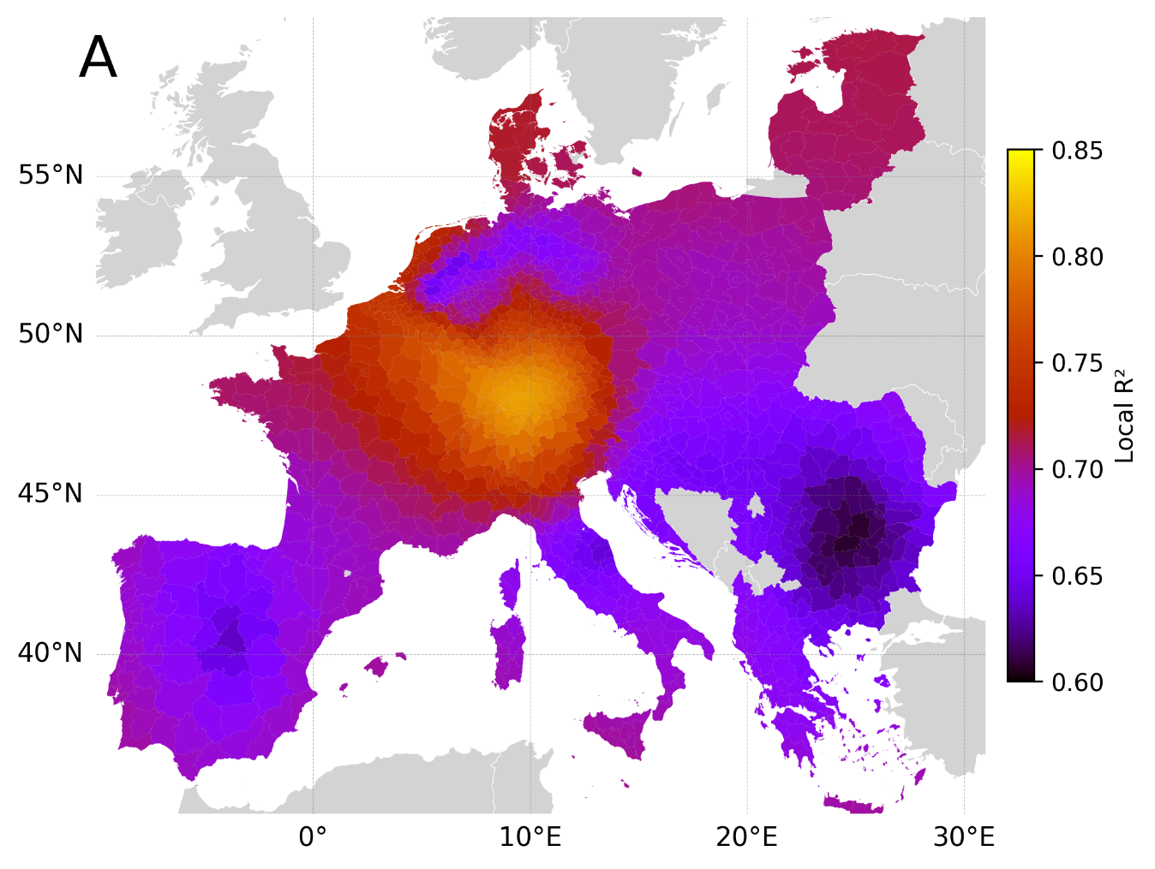
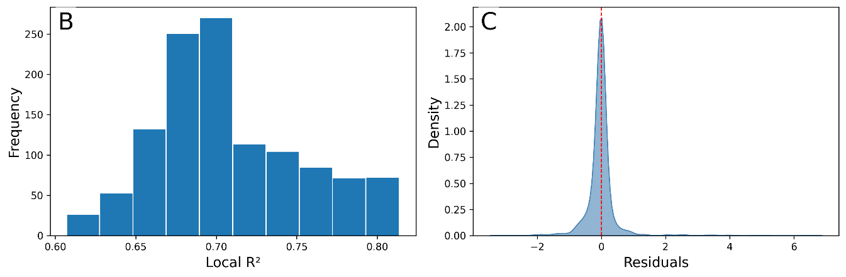
Figure 2. Spatial distribution of the local R² and distribution of the residuals of the spatial model (GWR-SL).

The global OLS model was statistically significant (F(15, 1156) = 58.1, p < .001) and explained 46% of the variance in the spatially lagged WNV disease incidence in humans (R² = 0.466, Adjusted R² = 0.458; Table 1). Among standardized predictors, the strongest effects were observed for mean spring temperature (β = –2.72, p < .001), mean summer temperature (β = 4.11, p < .001), and maximum number of consecutive dry days in spring (β = –0.53, p < .001). Because all variables were standardized, coefficients are expressed in standard-deviation units of spatially lagged WNV disease incidence per one-SD change in the predictor. The GWR-SL model improved fit considerably (AICc = 2089.2; global R² = 0.72; adjusted R² = 0.69). Local R² values ranged from 0.47 to 0.81 (2.5th–97.5th percentile range = 0.55–0.78; mean = 0.69; median = 0.70; Figure 2). This spatial variation in model performance indicates that the strength of environmental and socio-economic effects on WNV disease incidence varies regionally across Europe.
Land use factors
Spatial patterns in the influence of land-cover variables revealed clear geographic contrasts across Europe (Figure 3A–B). Shrubland cover showed the strongest and most spatially consistent positive association with WNV disease incidence, particularly across central and eastern Europe, where local coefficients reached their highest values. Provinces in Germany, Austria, and parts of eastern Europe exhibited positive relationships, suggesting that semi-natural shrub-dominated landscapes may favour mosquito habitats or reservoir host presence. In contrast, forest cover was negatively associated with WNV disease incidence in humans throughout most of Europe, with the strongest negative coefficients in southern and western regions such as Italy, France, and the Iberian Peninsula. Urban and cropland areas displayed weaker and more heterogeneous effects. Urban cover tended to show slightly positive coefficients in parts of central Europe but negative associations in southern regions, indicating that urbanization may not uniformly enhance WNV disease risk in humans. Cropland showed mostly weak negative effects, with stronger decreases in southeastern Europe, where intensive agricultural land use may reduce suitable breeding or reservoir conditions. Overall, land-cover predictors together highlight a gradient from semi-natural landscapes associated with higher WNV disease incidence in humans to more forested or intensively cultivated areas showing a suppressive effect.
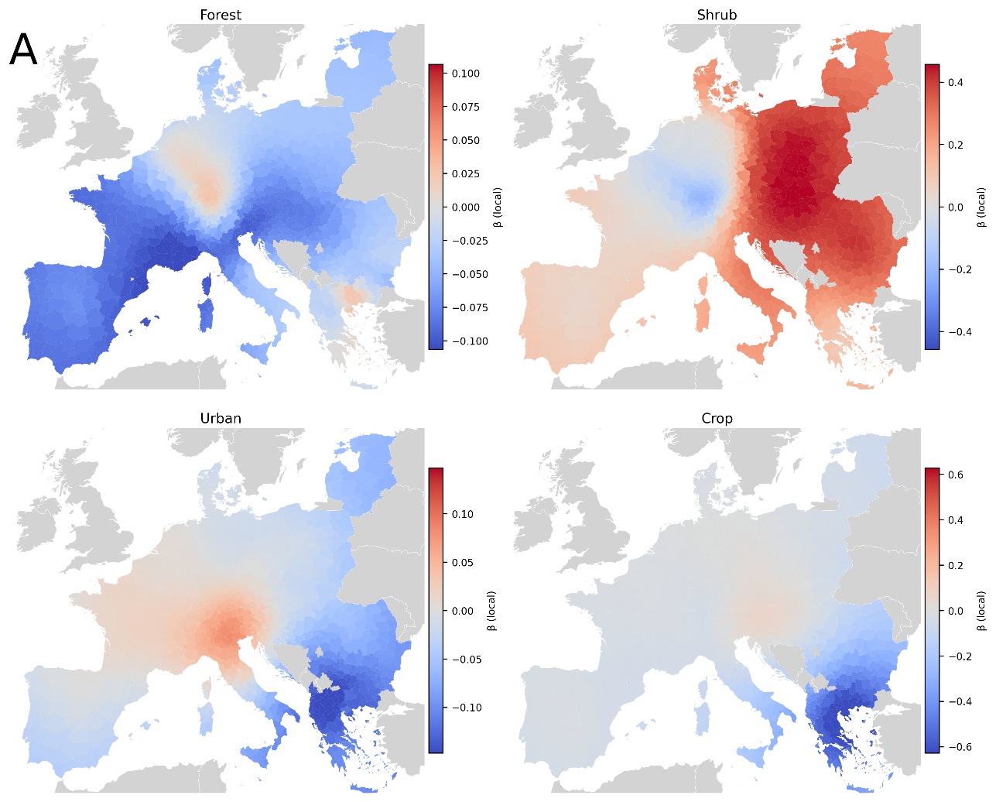
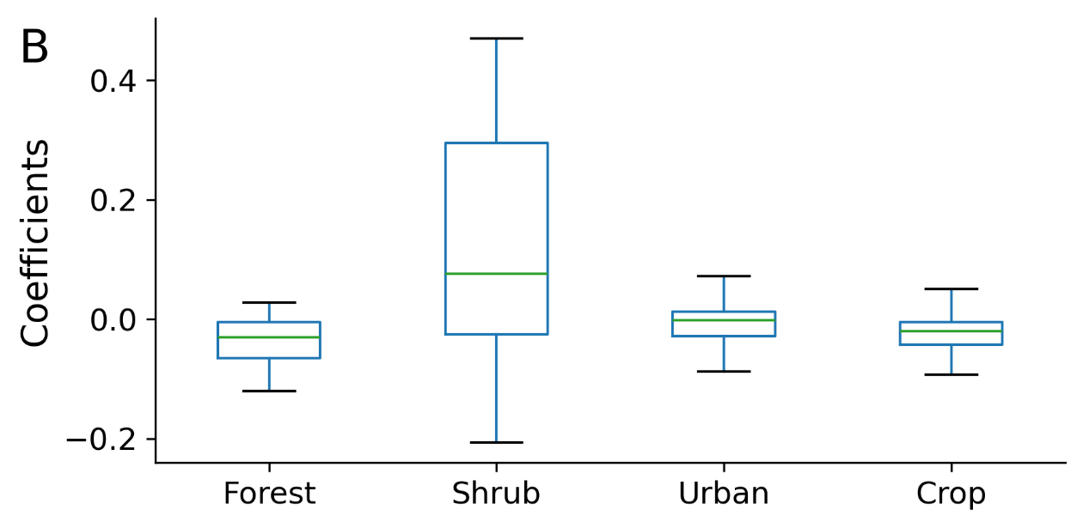
Figure 3. Spatial variation in the effects of land-cover variables on West Nile virus (WNV) disease incidence in humans across Europe. (A) Local coefficients estimated by the geographically weighted regression (GWR) model for the four significant land-cover predictors: forest, shrub, urban, and cropland cover. Warm colors indicate positive associations with WNV disease incidence in humans, and cool colors indicate negative associations. Each map uses a variable-specific symmetric colour scale. (B) Distribution of local coefficients for the same predictors, shown as boxplots summarizing their spatial variability (median, interquartile range, and 5th–95th percentiles). All predictors were standardized prior to modelling, so coefficients represent standardized effects (in SD units) on province-level WNV disease incidence in humans.
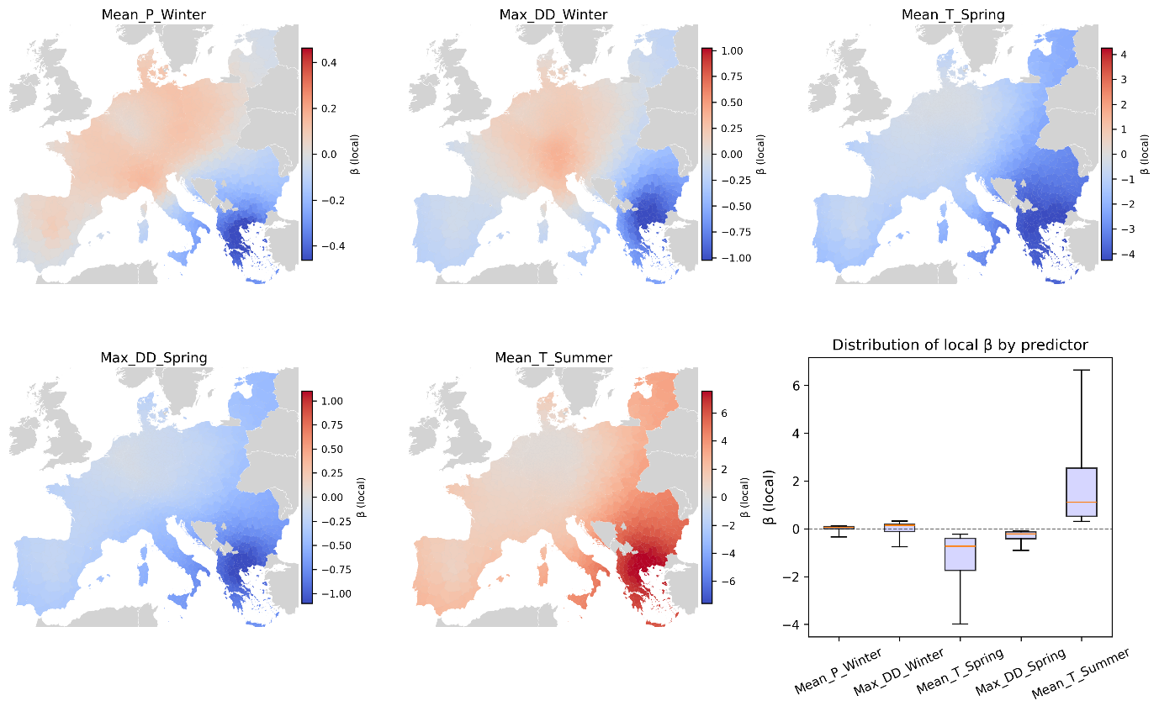
Figure 4. Spatial variation in the effects of climate variables on West Nile virus (WNV) incidence across Europe. Local coefficients estimated by the geographically weighted regression (GWR) model for the five significant climate predictors: mean winter precipitation (Mean_P_Winter), maximum number of consecutive dry days in winter (Max_DD_Winter), mean spring temperature (Mean_T_Spring), maximum number of consecutive dry days in spring (Max_DD_Spring), and mean summer temperature (Mean_T_Summer). Warm colors indicate positive associations with WNV disease incidence in humans, and cool colors indicate negative associations. Each map uses a variable-specific symmetric color scale. The boxplot summarizes the distribution of local coefficients for all predictors (median, interquartile range, and 5th–95th percentiles). All variables were standardized prior to modelling, so coefficients represent standardized effects (in SD units) on province-level WNV disease incidence in humans.

Climatic predictors exhibited strong and spatially structured effects on WNV disease incidence in humans (Figure 4). Mean summer temperature showed the most pronounced positive relationship, particularly across southeastern and eastern Europe, with the highest coefficients observed in Greece, Bulgaria, and Romania, indicating that warmer summer conditions substantially increase transmission risk. Mean spring temperature displayed a consistent negative association over much of Europe, especially in southern regions, suggesting that areas experiencing unusually warm springs may experience earlier but less intense WNV disease human incidence amplification later in the season. The number of consecutive dry days in spring (Max_DD_Spring) also tended to correlate negatively with incidence, with stronger effects in southern and eastern provinces, reflecting the importance of moisture availability for vector breeding. In contrast, both mean winter precipitation and maximum consecutive dry days in winter (Max_DD_Winter) showed weaker and spatially mixed effects, with slight positive associations in western and central Europe and negative ones in the southeast. Overall, these spatial patterns highlight the dominant role of warm summer conditions and seasonal moisture balance in shaping regional WNV disease dynamics in humans across Europe.
Discussion
Using a spatially lagged geographically weighted regression (GWR-SL) model at the provincial level across continental Europe (2005–2019), we aimed to disentangle the local influence of land cover and climatic factors on the incidence of West Nile virus (WNV) disease in humans. Emerging and re-emerging mosquito-borne diseases (MBDs) remain a growing public health challenge, exposing millions of individuals to infection risk each year [5–7]. Control strategies primarily focus on reducing contact between humans and mosquitoes, both through personal protection and targeted vector control. These interventions are often guided by epidemiological models designed to identify the most suitable timing and location for preventive measures [15]. While climatic variables such as temperature and precipitation are well-established determinants of MBD dynamics [16–19], an increasing body of research shows that broader environmental factors—including land use, vegetation, and surface water—also play a major role in shaping WNV risk [15]. Our analysis builds on this understanding by explicitly quantifying the joint influence of land-cover and climatic gradients on human WNV disease incidence at a fine spatial resolution across Europe.
Due to the availability of consistent data, the analysis focused on WNV, the only viral MBD with sufficient long-term coverage at the provincial scale. Our results show that several land-cover and climatic predictors were significantly associated with WNV disease incidence in humans, whereas socio-economic variables (GDP per capita and population density) were not. This finding suggests that, at this spatial scale, environmental heterogeneity—rather than economic or demographic differences—explains most of the spatial variation in disease incidence.
Land-cover effects
Among land-cover variables, shrubland cover showed the strongest and most spatially consistent positive association with WNV disease incidence in humans, particularly across central and eastern Europe. These semi-natural environments may provide favorable conditions for Culex mosquitoes and avian reservoirs by combining vegetation density with suitable microclimatic conditions and standing water availability. In contrast, forest cover exhibited a significant negative association, especially in southern and western Europe, suggesting that closed-canopy forests may reduce vector breeding or host–vector contact. Urban and cropland covers had weaker, spatially variable effects. Urban areas tended to show small negative associations overall, with localized positive values in central Europe, which could be consistent with the already suggest adaptability of Culex pipiens to peri-urban environments [15, 25, 28, 29]. Furthermore, this result could support the development of future research aiming at better understanding this potential relationship, between Culex pipiens and peri-urban environment. Cropland, especially in intensively cultivated regions of southeastern Europe, showed predominantly negative relationships, possibly reflecting the lower persistence of breeding sites in managed agricultural systems. Collectively, these patterns indicate that land-cover configuration—the balance between natural, semi-natural, and managed habitats—strongly mediates local WNV risk and should be considered alongside climate in predictive and management frameworks.

Climatic effects
Climatic variables exhibited strong and spatially structured associations with WNV disease incidence in humans. Mean summer temperature was the most influential predictor, showing a pronounced positive effect across southeastern and eastern Europe, consistent with the known role of high temperatures in accelerating mosquito development, viral replication, and transmission efficiency [16–19, 34–39]. Conversely, mean spring temperature showed negative associations across southern Europe, suggesting that early-season warming may advance mosquito activity but shorten the window for peak viral amplification. The number of consecutive dry days in spring also correlated negatively with WNV disease incidence in humans, especially in southern and eastern regions, underscoring the role of surface moisture in sustaining mosquito habitats. Winter conditions (precipitation and dry days) displayed weaker and spatially mixed effects, with modest positive associations in central and western Europe. Together, these findings confirm that seasonal temperature and moisture balance are central determinants of WNV transmission suitability across the continent.
It is important to note that these climatic coefficients describe long-term suitability patterns rather than short-term fluctuations. Because seasonal means were averaged over 15 years, the model reflects spatial differences in baseline climatic favorability rather than temporal responses to specific extreme events or interannual anomalies.
Model performance and spatial heterogeneity
The GWR-SL model substantially improved model fit compared to the global OLS regression. While the OLS model explained approximately 46% of the variance in WNV disease incidence in humans, the local GWR-SL model achieved a mean local R² of 0.69, ranging from 0.47 to 0.81. This improvement highlights that relationships between WNV disease incidence in humans and environmental factors vary significantly across space, reinforcing the need for geographically explicit models. Spatially adaptive approaches like GWR-SL allow for the identification of regional clusters where specific variables—such as shrubland cover or summer temperature—exert stronger effects, providing a nuanced understanding of ecological risk gradients.
Limitations and implications for public health
Some limitations must be acknowledged. The aggregation of detailed land-cover types into broad categories (e.g., “cropland” or “forest”) may obscure finer ecological variations, such as irrigation or vegetation structure, that influence mosquito habitats. In this scenario, further research on the topic might be looking at different land cover groupings or more granular land cover classes, both in single terms as well as in their interactions. Similarly, the aggregation of the climatic variables in long-term seasonal averages represents rather a broad climatic suitability rather than climatic variability or extreme events; also in this context, further research could aim at disentangling the role of climatic variables in WNV disease incidence in humans, within a geographically weighted regression approach. Differences in Culex vector species and avian host distributions across Europe could further explain regional contrasts in model coefficients. Underreporting also remains a concern, given that up to 80% of human WNV infections are asymptomatic [47], potentially biasing incidence data toward countries with stronger surveillance systems. This issue becomes even more relevant considering that our approach allowed us to include only human WNV cases with a non-missing province of infection. This inevitably further reduced our study population (3,379 human WNV cases) and may have introduced additional bias into the sample.
Despite these limitations, the findings offer clear implications for public health and environmental management. Rather than prescribing direct land-cover modification (e.g., removing shrubs or draining wetlands), the results highlight where specific combinations of land and climate conditions create favorable ecological niches for WNV transmission. These areas—particularly shrub-dominated or peri-urban landscapes under warm summer regimes—should be prioritized for vector surveillance, larval habitat monitoring, and community awareness programs. In practice, such evidence can inform targeted vector control (e.g., larviciding in semi-natural zones), urban planning measures (e.g., maintaining vegetative buffers away from standing water), and risk communication in high-risk regions. Conversely, recognizing areas where forested or intensively cultivated landscapes act as natural buffers may help optimize the allocation of limited surveillance and control resources.
Overall, this study underscores that understanding the spatial interplay between land use and climate is essential to anticipate WNV risk under current and future environmental change. As Europe faces ongoing warming and land-use intensification, integrating ecological indicators into early warning systems will be vital to improve outbreak preparedness, guide localized interventions, and reduce the public health burden of mosquito-borne diseases.

Methods*STAR
Key Resources Table
Dataset/software | Source | Reference
Data collections
Mosquito-borne diseases human case data (Chikungunya, Dengue, West Nile virus, Yellow Fever, Zika) | ECDC/TESSy | [48]
Land cover raster files | ESA Climate Change Initiative (CCI) | [49]
Climatic data (ERA5) | Copernicus | [50]
Socio-demographic data | EUROSTAT | [51]
Data analysis software, packages and functions
Python (v3.14.0) | Python Software Foundation | [52]
libpysal (PySAL core library v4.13. | PySAL Developers (Open-source Python Spatial Analysis Library) | [53]
spreg (Spatial Regression v1.8.4) | PySAL Project (Spatial Econometrics module of PySAL) | [54]
Statsmodels (v0.14.5) | Statsmodels Development Team (Open-source project) | [55]
MGWR (Multiscale GWR v2.2.1) | MGWR Project (PySAL Contributors & Academia) | [56]
scikit-learn (v1.7.2) | scikit-learn Developers (Community-driven, under NumFOCUS) | [57]
GeoPandas | GeoPandas Project (Open-source community) | [58]
Shapely (v2.1.2) | Shapely Project (Open-source, LocationTech) | [59]
Rasterio | Mapbox (Rasterio Open-source Project) | [60]
NumPy (v2.3.5) | NumPy Developers (NumPy Project, NumFOCUS) | [61]
pandas (v2.3.3) | Pandas Development Team (PyData Community) | [62, 63]

Method Details
Data Collection
- MBDs Cases:
Human case data for the specified viral diseases—including Chikungunya, Dengue, West Nile virus disease, Yellow Fever, and Zika virus disease—were analysed at the NUTS-3 level across Europe. Data were collected by each Member State’s Public Health Authority and released by the European Centre for Disease Prevention and Control (ECDC) via the European Surveillance System (TESSy) [48]. No further refinement of cases (e.g., clinical manifestation, laboratory confirmation) was performed due to the explorative nature of the study.
- Land Cover Data:
Yearly global raster files (300x300 m resolution) were sourced from ESA’s Climate Change Initiative (CCI) for 2005–2019 [49]. The temporal dimension was considered, but due to similarity across years, values were averaged.
- Climatic Data:
Hourly air temperature (K) and precipitation (m) data were obtained from ERA5 Copernicus [50].
- Socio-demographic Data:
Population, area, population density, and GDP per person at province/NUTS-3 level were retrieved from EUROSTAT [51] and customised for the study period.

Variables Operationalisation
- Original Variables:
Area, population, population density, and GDP were included as reported. Where missing, area and population were used to calculate population density.
- Temporal Averaging:
All variables were averaged over the study period (2005–2019).
- Incidence Calculation:
Human cases were grouped by province/NUTS-3, and incidence was calculated as cases per population.
- Land Cover Aggregation:
Land cover data were rescaled to province/NUTS-3 level and grouped into six macro-categories: forest, shrub, urban, crop, water, and other. The aggregation of ESA CCI Land Cover classes into these categories was undertaken to simplify the analysis and focus on broader land cover trends relevant to our study objectives [49]. (See Table S5 in Supplementary Information for detailed class definitions and aggregation.)
- Climatic Variables:
Temperature and precipitation were averaged by province/NUTS-3 and season (Winter: Jan–Mar, Spring: Apr–Jun, Summer: Jul–Sep, Autumn: Oct–Dec) [50]. Six derived variables were created:
  - Total growth days (avg. temp > 14.3°C per season)
  - Maximum growth days (max consecutive days > 14.3°C per season)
  - Total wet days (precipitation > 0.001 m per season)
  - Total dry days (precipitation ≤ 0.001 m per season)
  - Maximum wet days (max consecutive days > 0.001 m per season)
  - Maximum dry days (max consecutive days ≤ 0.001 m per season)

Quantification and Statistical Analysis
- Descriptive Statistics:
Incidence of human MBD cases (2005–2019) and average land cover values were reported, alongside socio-demographic factors and mean seasonal climatic variables.
- Regression Analysis:
All dependent and independent variables were standardised (z-scores) as follows:

Predictors (X). All covariates were standardised using classical z-scaling (mean = 0, SD = 1) with the StandardScaler implementation from scikit-learn. This would ensure that all predictors contribute on the same scale and that regression coefficients are comparable across variables. Standardisation was performed globally across all NUTS-3 units, not separately by country or region.
Dependent variable (Y). To avoid mixing the scale of raw incidence with its spatially filtered counterpart, we first computed the spatial lag of incidence:
Wy= Wy
using a row-standardised spatial weights matrix W (DistanceBand, 150 km). Only after constructing the spatial lag did we apply z-standardisation
Wyz = Wy - mean(Wy)std(Wy).
This ensures that the OLS and GWR models operate on the same derived outcome, allowing coefficients to be interpreted as changes in the standardised spatially lagged incidence.
Pearson correlation matrix and the Variance Inflation Factors (VIFs) [64] were calculated for all standardized covariates to identify and exclude variables with correlation ≥0.8, prioritising known relevant factors (e.g., spring temperature) (Table S4). As expected, high collinearity was observed among climate-related variables, particularly between seasonal temperature indicators (Mean_T_Spring–Mean_T_Summer, VIF = 144.9–187.9) and degree-day variables (Max_DD_Winter–Max_DD_Autumn, VIF ≈ 10.7). These patterns reflect the shared climatic gradient across Europe and are ecologically meaningful.
- Final Model Variables:
  - Land cover (forest, shrub, urban, crop, water, other)
  - GDP
  - Population density
  - Mean temperatures (spring, summer)
  - Mean precipitation (winter)
  - Maximum wet days (winter, autumn)
  - Maximum dry days (winter, spring, autumn)
- Spatial Autocorrelation:
Moran’s I was calculated to assess spatial autocorrelation (see Supplementary Table S2) [65].
- Spatial Lag Model:
A spatial lag model was implemented to account for spatial dependencies, using a distance-based spatial weights matrix (max distance: 150 km). Let $y_{i}$represent the value of the dependent variable at location $i$. The spatial lag model introduces a spatially lagged dependent variable, $Wy$, where $W$is the spatial weights matrix. The element $W_{ij}$of the matrix $W$quantifies the spatial relationship between locations $i$and $j$. To define the spatial weights matrix ($W$), we employed a distance-based approach: neighbours were selected on a metric base, with the dataset first transformed to metric units and a distance matrix developed ranging from 0 to a maximum of 150 km. This distance matrix was used to weight the dependent variable. The independent variables were instead weighted using the bandwidth selected for the geographically weighted regression (GWR) model. We selected an adaptive bandwidth with a bi-square kernel, and validation of this bandwidth was based on the Akaike Information Criterion (AIC). The spatially lagged dependent variable for location $i$is then defined as
$(Wy)_{i}=\sum_{j=1}^{n}{}W_{ij}y_{j}$
where $n$is the total number of observations. The adjusted dependent variable $y_{i}^{*}$incorporates the lag effect and is expressed as
$y_{i}^{*}=(Wy)_{i}$.
A sensitivity analysis was performed by varying the distance-band threshold used to construct the spatial weights matrix from 100–200 km in 25 km increments. For each distance, we examined (i) the connectivity of the spatial weights and (ii) the level of spatial autocorrelation in the OLS residuals (see Section SI.1 in SI and Tables S1, S2, and S3). Thresholds below 150 km produced increasingly sparse weight matrices (e.g. 28 units with no neighbours at 100 km; 6 at 125 km), whereas thresholds ≥150 km substantially reduced the number of isolates (4 at 150 km; 3 at 175 km; 2 at 200 km) while avoiding excessively dense neighbour structures. Moran’s I on the OLS residuals decreased monotonically with distance (0.21 at 100 km → 0.09 at 200 km), but remained positive and highly significant for all thresholds tested (p ≤ 0.002), indicating persistent spatial autocorrelation in the residuals regardless of the specific choice of d. Based on this analysis, d = 150 km was selected as it minimises the number of spatial isolates and yields a well-connected weights matrix while keeping spatial interactions local.
- Geographically Weighted Regression (GWR) with Spatial Lag (SL):
We employed a Geographically Weighted Regression (GWR) model to account for spatial heterogeneity in the relationship between dependent and independent variables, incorporating the spatially lagged dependent variable ($y_{i}^{*}$) to address spatial autocorrelation [66, 67]. The GWR-SL model was implemented in two steps: selection of the optimal bandwidth using the Akaike Information Criterion (AIC), and model fitting. GWR is a local linear regression technique that allows regression coefficients to vary spatially, revealing local patterns that may be masked in global models. The GWR-SL model is formulated as
$y_{i}^{*}=β_{0i}+\sum_{k=1}^{p-1}{}β_{ki}x_{ki}+ϵ_{i}$,
where coefficients are estimated for each location using
$β_{i}=(X^{T}W_{i}X)^{-1}X^{T}W_{i}Y$,
with $W_{i}$as a location-specific diagonal matrix of spatial weights. Weights were assigned using a bisquare kernel function with adaptive bandwidth, determined by minimising the corrected AIC (AICc) via golden-section search (mgwr package). The weight for observation $j$at location $i$is
$w_{ij}=(1-(d_{ij}/b)^{2})^{2}$if $d_{ij}≤b$,
and zero otherwise, where $b$is the distance to the Nth nearest neighbour. The optimal bandwidth was stable across all sensitivity scenarios (77 nearest neighbours), indicating robustness in the spatial scale of local relationships.
- Software:
All analyses were conducted in Python (version v3.14.0) [52]. Single libraries and functions are included in the key resource table [53-63].

Data and Code Availability
The aggregated dataset, as well as all the codes, analysis, and output are in the GitHub repository https://github.com/emanuelemassaro/WNV_Europe/.

References
- Bartholomeeusen, K., et al. Chikungunya fever. Nature Reviews Disease Primers 9:17 (2023).
- Guzman, M. G., and Harris, E. Dengue. The Lancet 385:453-465 (2015).
- Plourde, A. R., and Bloch, E.M. A Literature Review of Zika Virus. Emerg Infect Dis. Jul;22(7):1185-92 (2016)
- Riccetti, N., Ferraccioli, F., Fasano, A., Stilianakis, N.I. Demographic characteristics associated with West Nile virus neuroinvasive disease – A retrospective study on the wider European area 2006–2021. PLOS ONE 18(9): e0292187 (2023).
- Messina, J.P., et al. The current and future global distribution and population at risk of dengue. Nat Microbiol 4, 1508–1515 (2019)
- Nsoesie, E.O., et al. Global distribution and environmental suitability for chikungunya virus, 1952 to 2015. Euro Surveill. 21(20):pii=30234 (2016)
- Justin Lessler et al. Assessing the global threat from Zika virus. Science 353, aaf 8160 (2016).
- Kraemer, M.U.G., et al. The global distribution of the arbovirus vectors Aedes aegypti and Ae. albopictus. eLife 4: e08347 (2015).
- Franklinos, L.H.V., Jones, K.E., Redding, D.W., and Abubakar, I. The effect of global change on mosquito-borne disease. Lancet infect Dis 19: e302-12 (2019).
- Semenza, J., Rocklöv, J., and Ebi, K.L. Climate change and cascading risks from infectious diseases. Infect Dis Ther 11:1371-1390 (2022).
- Petersen, L., Brault, A., and Nasci, R. West Nile virus: Review of the literature. JAMA 310(3):308-315.
- World Health Organization (WHO). Vaccines and immunization: Dengue. May 10th, 2024. URL: https://www.who.int/news-room/questions-and-answers/item/dengue-vaccines. Last accessed: June 2024
- De Souza, W.M., et al. Chikungunya: a decade of burden in the Americas. The Lancet Regional Health – Americas 30, 100673 (2024).
- Ferguson, N.M. Challenges and opportunities in controlling mosquito-borne infections. Nature 559, 490-497 (2018).
- Giesen, C., et al. A systematic review of environmental factors related to WNV circulation in European and Mediterranean countries. One Health 16, 100478 (2023).
- Paz, S., and Albersheim, I. Influence of warming tendency on Culex pipiens population abundance and on the probability of West Nile Fever outbreaks (Israeli case study: 2001–2005). EcoHealth 5, 40–48 (2008).
- Ruybal, J.E., Kramer, L.D., and Kilpatrick, A.M. Geographic variation in the response of Culex pipiens life history traits to temperature. Parasites Vectors 9, 1–9 (2016).
- Ferraccioli, F., Riccetti, N., Fasano, A., Mourelatos, S., Kioutsioukis, I., and Stilianakis, N.I. Effects of climatic and environmental factors on mosquito population inferred from West Nile virus surveillance in Greece. Sci Rep 13, 18803 (2023).
- Vogels, C.B., Fros, J.J., Göertz, G.P., Pijlman, G.P., and Koenraadt, C.J. Vector competence of northern European Culex pipiens biotypes and hybrids for West Nile virus is differentially affected by temperature. Parasit Vectors 9, 393 (2016).
- Shocket, M.S., et al. Transmission of West Nile and five other temperate mosquito-borne viruses peaks at temperatures between 23°C and 26°C. eLife 9:e58511 (2020).
- Ciota, A.T., Matacchiero, A.C., Kilpatrick, A.M., and Kramer, L.D. The effect of temperature on life history traits of Culex mosquitoes. J. Med. Entomol. 51, 55–62 (2014).
- Alimi, Y., et al. Report of the scientific task force on preventing pandemics. Harvard Chan C-CHANGE and Harvard Global Health Institute, Cambridge (2021).
- Ferraguti, M., Magallanes, S., Suarez-Rubio, M., Bates, P.J.J, Marzal, A., and Renner, S.C. Does land-use and land cover affect vector-borne diseases? A systematic review and meta-analysis. Landsc Ecol 38:2433-2451 (2023).
- Skinner, E.B., Glidden, C.K., MacDonald, A.J., and Mordecai, E.A. Human footprint is associated with shifts in the assemblages of major vector-borne diseases. Nat Sustain 6, 652–661 (2023).
- Ferraguti, M., Martinez-de la Puente, J., and Figuerola, J. Ecological Effects on the Dynamics of West Nile Virus and Avian Plasmodium: The importance of Mosquito Communities and Landscape. Viruses 13, 1208 (2021).
- Marcantonio, M., et al. Identifying the Environmental Conditions Favouring West Nile Virus Outbreaks in Europe. PLOS ONE 10(3): e0121158 (2015).
- Ferraguti, M., Martínez-de la Puente, J., Roiz, D., Ruiz, S., Soriguer, R., and Figuerola, J. Effects of landscape anthropization on mosquito community composition and abundance. Sci Rep 6, 29002 (2016).
- Gangoso, L., et al. Determinants of the current and future distribution of the West Nile virus mosquito vector Culex pipiens in Spain. Environ. Res. 188, 109837 (2014).
- Bravo-Barriga D., et al. The mosquito fauna of the western region of Spain with emphasis on ecological factors and the characterization of Culex pipiens forms. J Vector Ecol. 42(1):136-147 (2017)
- Calzolari, M., et al. Enhanced West Nile Virus Circulation in the Emilia-Romagna and Lombardy Regions (Northern Italy) in 2018 Detected by Entomological Surveillance. Front. Vet. Sci. 7:243 (2020)
- United Nations (UN). 68% of the world population projected to live in urban areas by 2050, says UN. May 18th, 2018. URL: https://www.un.org/development/desa/en/news/population/2018-revision-of-world-urbanization-prospects.html. Last accessed: July 2024.
- Lu, L., et al. West Nile virus spread in Europe: Phylogeographic pattern analysis and key drivers. PLoS Pathog. Jan 25;20(1):e1011880 (2024).
- Koch, R.T., et al. Genomic epidemiology of West Nile virus in Europe. One Health 18:1, 100664 (2024)
- Marini, G., et al. A quantitative comparison of West Nile virus incidence from 2013 to 2018 in Emilia-Romagna, Italy. PLOS Neglected Tropical Diseases 14(1): e0007953 (2020).
- Rosà, R., et al. Early warning of West Nile virus mosquito vector: climate and land use models successfully explain phenology and abundance of Culex pipiens mosquitoes in north-western Italy. Parasites Vectors 7, 269 (2014).
- Riccardo, F., et al. Rapid increase in neuroinvasive West Nile virus infections in humans, Italy, July 2022. Euro Surveill. 27(36):pii= 2200653 (2022).
- Magallanes, S., et al. Warm winters are associated to more intense West Nile virus circulation in southern Spain. Emerging Microbes & Infections, 13:1, 2348510 (2024).
- Magallanes, S., et al. Long-term serological surveillance for West Nile and Usutu virus in horses in south-West Spain. One Health, 17:1, 100578 (2023).
- Erazo, D., et al. Contribution of climate change to the spatial expansion of West Nile virus in Europe. Nat Commun 15, 1196 (2024).
- Riccetti, N., Fasano, A., Ferraccioli, F., Gomez-Ramirez, J., Stilianakis, N.I. Host selection and forage ratio in West Nile virus–transmitting Culex mosquitoes: Challenges and knowledge gaps. PLOS Neglected Tropical Diseases 16(10): e0010819 (2022).
- Wheeler, S.S., Taff, C.C., Reisen, W.K., and Townsend, A.K. Mosquito blood-feeding patterns and nesting behavior of American crows, an amplifying host of West Nile virus. Parasites Vectors 14, 331 (2021).
- Gibb R, Colon-Gonzalez FJ, Lan PT et al. Interactions between climate change, urban infrastructure and mobility are driving dengue emergence in Vietnam. Nat Commun 14, 8179 (2023).
- Ruiz-Lopez, M.J., et al. Genomic Analysis of West Nile virus Lineage 1 Detected in Mosquitoes during the 2020-21 Outbreaks in Andalusia, Spain. Viruses 15, 266 (2023).
- Paz, S., and Semenza, J. Environmental drivers of West Nile fever epidemiology in Europe and Western Asia—a review. Int J Environ Res Public Health, 10(8): p. 3543–62 (2013).
- Ytbarek, S., Chen, K., Celestin, M., and McCary, M. Urban mosquito distributions are modulated bysocioeconomic status and environmental traits in the USA. Ecological Applications 33:e2869 (2023).
- Massaro, E., Kondor, D., and Ratti, C. Assessing the interplay between human mobility and mosquito borne diseases in urban environments. Sci Rep 9, 16911 (2019).
- Sambri, V., et al. West Nile virus in Europe: emergence, epidemiology, diagnosis, treatment, and prevention. Clin Microbiol Infect. Aug;19(8):699-704 (2013).
- European Centre for Diseases Prevention and Control (EDCD).The European Surveillance System (TESSy). URL: https://www.ecdc.europa.eu/en/publications-data/european-surveillance-system-tessy. Last accessed: August, 2024
- European Space Agency (ESA). Climate Change Initiative (CCI). URL: https://www.esa-landcover-cci.org/. Last accessed: August, 2024
- European Centre for Medium-Range Weather Forecasts (ECMWF). ERA5 hourly data on single levels from 1940 to present dataset. URL: https://cds.climate.copernicus.eu/cdsapp#!/dataset/reanalysis-era5-single-levels. Last accessed: August, 2024
- European Statistical Office (EUROSTAT). URL: https://ec.europa.eu/eurostat/data/database. Last accessed: August,2024
- Python Software Foundation (2025). Python Language Reference, version 3.14.0. Available at Python.org.
- Rey, S. J., et al. (2022). The PySAL Ecosystem: Philosophy and Implementation. Geographical Analysis, 54(3), 467–487. DOI: 10.1111/gean.12276.
- Rey, S. J., & Anselin, L. (2007). PySAL: A Python Library of Spatial Analytical Methods. The Review of Regional Studies, 37(1), 5–27.
- Seabold, S., & Perktold, J. (2010). Statsmodels: Econometric and Statistical Modeling with Python. Proc. 9th Python in Science Conf. (SciPy 2010), 57–61. DOI: 10.25080/Majora-92bf1922-011.
- Oshan, T. M., Li, Z., Kang, W., Wolf, L. J., & Fotheringham, A. S. (2019). mgwr: A Python Implementation of Multiscale GWR. ISPRS Int. J. of Geo-Inf., 8(6), 269. DOI: 10.3390/ijgi8060269.
- Pedregosa, F., Varoquaux, G., Gramfort, A., et al. (2011). Scikit-learn: Machine Learning in Python. J. of Machine Learning Research, 12, 2825–2830.
- Jordahl, K., Van den Bossche, J., Fleischmann, M., et al. (2025). GeoPandas: Python tools for geographic data (Version 1.1.1) [Software]. Zenodo. DOI: 10.5281/zenodo.15750510.
- Gillies, S., et al. (2022). Shapely (Version 2.0.0) [Software]. Zenodo. DOI: 10.5281/zenodo.7428463.
- Gillies, S., & others. (2013). Rasterio: Geospatial raster I/O for Python programmers [Software]. Mapbox. (Available at GitHub: rasterio/rasterio).
- Harris, C. R., Millman, K. J., van der Walt, S. J., et al. (2020). Array programming with NumPy. Nature, 585, 357–362. DOI: 10.1038/s41586-020-2649-2
- Pandas Development Team (2020). pandas (Version 1.0.0) [Software]. Zenodo. DOI: 10.5281/zenodo.3509134.
- McKinney, W. (2010). Data Structures for Statistical Computing in Python. Proc. 9th Python in Science Conf., 56–61.
- Fotheringham, A.S. and Oshan, T.M. Geographically weighted regression and multicollinearity: dispelling the myth. J Geogr Syst 18:303–329 (2016
- Wheeler, D.C. Geographically weighted regression. In Fischer MM, and Nijkamp P (eds.). Handbook of Regional Science. Springer, Berlin, Heidelberg (2021).
- Fotheringham, A.S., Brunsdon, C., and Charlton, M.E. Geographically Weighted Regression: The Analysis of Spatially Varying Relationships. Wiley; p.39 (2002).
- Shoff, C., Chen, V.Y.J., and Yang, T.C. When homogeneity meets heterogeneity: the geographically weighted regression with spatial lag approach to prenatal care utilization. Geospat Health 8(2): 557-568 (2014).
).

Declarations
Acknowledgements
None
Authors’ contribution
Conceptualization: NR, EM
Data Curation and Formal Analysis: NR, EM
Funding Acquisition: NA
Investigation, Methodology, Project Administration, Resources, and Software: NR, EM
Supervision and Validation: NR, EM
Visualization and Writing – Original Draft Preparation: NR
Writing – Review & Editing: NR – NR, AF, WS, AC, JCC, GD, DIR, JF, and EM
Additional information
Funding
No specific funding was obtained for this study. JF is supported by project ARBOPREVENT from Fundación La Caixa.
Declaration of interests
All the authors declared no competing interests.
Disclaimers
The views expressed in this article are purely those of the authors and may not, under any circumstances, be regarded as an official position of the European Commission. The views and opinions of the authors expressed herein do not necessarily state or reflect those of ECDC. The accuracy of the authors’ statistical analysis and the findings they report are not the responsibility of ECDC. ECDC is not responsible for conclusions or opinions drawn from the data provided. ECDC is not responsible for the correctness of the data and for data management, data merging and data collation after provision of the data. ECDC shall not be held liable for improper or incorrect use of the data.

Supporting Information
Descriptive results

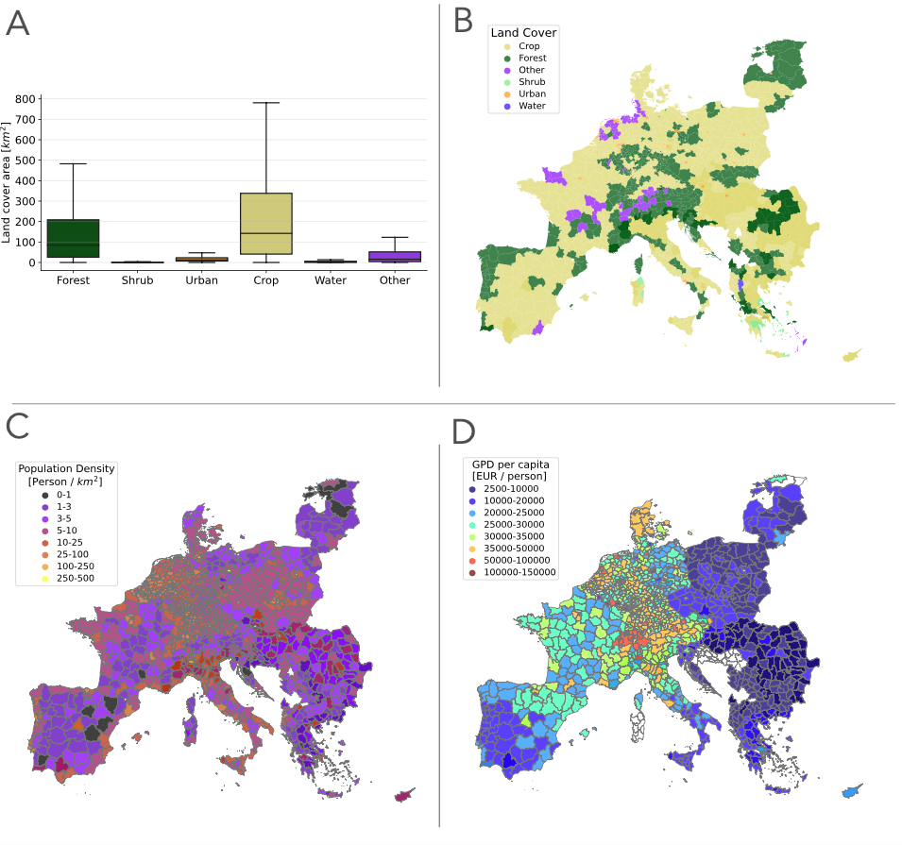
Figure S1. Descriptive statistics of the covariates potentially associated factors. A Distribution of the different land cover variable throughout the entire area of interest (up). B spatial distribution of main land cover variable per each NUTS3 level . C) Spatial distribution of population density and D) gross-domestic product per person (GDP per capita).

The average forest land cover ranged between 0 and 193,958 km² (median 8,234 and mean 15,072 km²); the provinces with the highest forest land cover were the Latvian provinces of Vidzeme and Kurzeve (193,958, and 163,216 km², respectively) and the Estonian province of Lõuna-Eesti (186,643 km²). The average shrub land cover ranged between 0 and 35,132 km² (median 9 and mean 829 km²); the provinces with the highest shrub land cover were the Greek provinces of Argolis, Arcadia and Laconia, Messenia (35,132 and 28,227 km²), and the Spanish province of Almeria (27,578 km²). The average urban land cover ranged between 0 and 16,263 km² (median 1,268 and mean 1,851 km²); the provinces with the highest urban land cover were the Swiss provinces of Valais and Graubünden (16,263 and 13,845 km², respectively), and the unique province of Cyprus (13,928 km²). The average crop land cover ranged between 1 and 207,653 km² (median 13,720 and mean 23,524 km²); the provinces with the highest crop land cover were the Spanish provinces of Badajoz, Ciudad Real, and Zaragoza (207,653, 172,745, and 160,346 km², respectively). The average water land cover ranged between 0 and 39,255 km² (median 184 and mean 574 km²); the provinces with the highest water land cover were the Estonian province of Lõuna-Eesti (39,255 km²), the Netherlandish province of Flevoland (16,827 km²), and the Romanian province of Tulcea (15,855 km²).
The average GDP per capita ranged between 2,567 Euro/person and 163,117 Euro/person (median 25,500 and mean 26,441 Euro/person); the provinces with the highest gross-domestic product were the Swiss provinces of Basel and Zug (163,117 and 138,250 Euro/person, respectively), and the German province of Wolfsburg (162,300 Euro/person) (Supplementary material – Figure S1 and Table S1).

