Web Systems Design and Architecture

0766230 – Emanuele Muzio

Overview

Docs for the WSDA uni project.

Functional Requirements

1. The application will be able to handle pre-paid cards credit-cards.

2. The application will be able to handle multiple stores and multiple merchants for each store.

3. Anyone can check the balance of a card given the number.

4. The application will handle 3 types of user:

* 4.1 Admin: the one and only administrator of the app, can create new credit cards, block or unblock a card by card number, register and disable merchants and generate reports (last two are optionals);
* 4.2 Merchant: multiple across the stores, the merchants can charge or recharge a card and generate reports (optional);
* 4.3 Customer: generate a report (optional).

Technical Requirements

Architecture

The application data must be stored in a relational DB.

For the Backend:

1.Java EE application server

2. Plain Servlet/JSP

Or

1. Java Spring Boot .

For the Frontend: HTML, CSS, JavaScript, jQuery

Project Specifics

Architecture

* Java 17
* Spring Boot 3.1.0
* Apache Tomcat 10
* MySQL 8

Tools, dependencies and external libraries

* Hibernate (implementation of JPA, Jakarta Persistence Api)
* IntelliJ Idea Ultimate (setup of the project via [initializr](https://github.com/spring-io/initializr), running the project, managing dependencies ecc);
* Bootstrap 5.1.3
* jQuery 3.7.0
* Maven 4.0
* Thymeleaf
* Spring Security 3
* Lombok (getters, setters and constructors with annotations)

For further details on version and dependencies, consult the pom.xml file.

Data Model

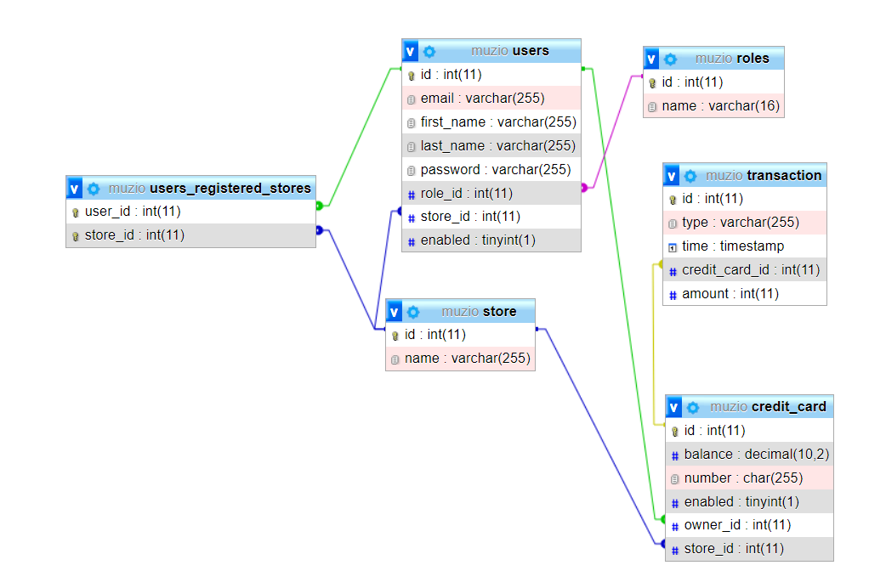

In order to differentiate the various users and the roles they can have, the DB logic has been structured as follows:

1. Three roles have been created: ROLE_ADMIN, ROLE_MERCHANT, ROLE_CUSTOMER, each one can access different sections of the app and do different things

2. The admin user has no store_id and is enabled

3. The merchant role has a store_id to understand which store he works for

4. The customer role uses the users_registered_stores for implementing a ManyToMany relationship with the stores

Additionally, only customers can own a credit card and a credit card has only one owner.

Transactions table has been created for storing infos about customers purchases and recharges.

Admin Manual

Get a card balance

Since being authenticated is not requested for this functionality, it has been integrated in the app home page:

After clicking on the “Check balance” button, a text input will become visible.

The user can now insert the credit card number and receive an error message if the card is not present or the card’s actual balance.

By clicking on the “Private Area” button, we now proceed to authenticate and access the secured part of the application. It is important to notice that during the authentication the user will receive an error if either the credentials are wrong or the user’s account has been disabled.

Dashboard/Report

After the login, the login is the first page the authenticated user gets to see. The content of the page is the same for the 3 roles, but:

1. An admin sees the transactions of every other customer

2. A merchant sees only the transactions of cards registered at the store he works for

3. A customer only sees his transactions

Store Management

In the Admin Panel section of the sidebar, we can create a new store (given the name isn’t already in use) or delete one via the select input.

Merchants Management

In the New Merchant page, we can create a new merchant for one of the existing stores and assign him a password (all the passwords are stored in the database after being encoded server-side by the BCryptPasswordEncoder from Spring Security).

In the Merchant List page, we can instead look at all the app’s merchants, delete them or disable their accounts using the buttons on the right, in the Actions column.

Credit card operations

In the New Credit Card page, we can create a new cc. for one of the existing stores, choosing the balance (simulating a user purchasing the card for the first time). Here the future credit card number is also visible.

The admin user can also chooses, if he possesses the correct credit card number, to enable or disable it: if the card is for example already disabled and the admin chooses to disable that card, an error message will appear. Otherwise, the operation will be completed.

Merchant Manual

Customer management

The dashboard will be almost the same as the admin’s one but with some less data: in fact, merchants can only see transactions that have happened in the store they work (both recharges and purchases).

The customer section present for the merchants lets them create new user for their store (the store is chosen automatically).

From the customers list page, a merchant can now filter the customers by email, disable/enable customers’ profiles, delete them and assign them a free credit card (no owner set yet and has been registered for that store).

Purchases and recharges

From the credit card list page, we can filter the credit cards by card number and owner email.

If a credit card is enabled we can make purchases or recharge it:

* Purchases: the “price” can be a multiple of 5 and no more than the credit card balance
* Recharge: the recharged amount can be a multiple of 5 and no more than 500€

Customer Manual

The customers can only access their past transactions in cronological order.