**ESERCIZI CACHE**

**ESERCIZIO 5.2.1**

|  |  |  |  |  |  |
| --- | --- | --- | --- | --- | --- |
| WORD ADDRESS | BINARY ADDRESS | TAG | INDEX | OFFSET | HIT/MISS |
|  |  |  |  |  |  |
| 0x03 | 0000 0011 | 0000 | 001 | 1 | M |
| 0xb4 | 1011 0100 | 1011 | 010 | 0 | M |
| 0x2b | 0010 1011 | 0010 | 101 | 1 | M |
| 0x02 | 0000 0010 | 0000 | 001 | 0 | H |
| 0xbf | 1011 1111 | 1011 | 111 | 1 | M |
| 0x58 | 0101 1000 | 0101 | 100 | 0 | M |
| 0xbe | 1011 1110 | 1011 | 111 | 0 | H |
| 0x0e | 0000 1110 | 0000 | 111 | 0 | M |
| 0xb5 | 1011 0101 | 1011 | 010 | 1 | H |
| 0x2c | 0010 1010 | 0010 | 101 | 0 | M |
| 0xba | 1011 1010 | 1011 | 101 | 0 | M |

**ESERCIZIO 5.2.2**

**CACHE C1 con blocchi da 1 parole per un totale di 8 parole**

INDEX: 3

TAG: 5

|  |  |  |  |  |  |
| --- | --- | --- | --- | --- | --- |
| WORD ADDRESS | BINARY ADDRESS | TAG | INDEX | OFFSET | HIT/MISS |
|  |  |  |  |  |  |
| 0x03 | 0000 0011 | 0000 0 | 011 |  | M |
| 0xb4 | 1011 0100 | 1011 0 | 100 |  | M |
| 0x2b | 0010 1011 | 0010 1 | 011 |  | M |
| 0x02 | 0000 0010 | 0000 0 | 010 |  | M |
| 0xbf | 1011 1111 | 1011 1 | 111 |  | M |
| 0x58 | 0101 1000 | 0101 1 | 000 |  | M |
| 0xbe | 1011 1110 | 1011 1 | 110 |  | M |
| 0x0e | 0000 1110 | 0000 1 | 110 |  | M |
| 0xb5 | 1011 0101 | 1011 0 | 101 |  | M |
| 0x2c | 0010 1010 | 0010 1 | 010 |  | M |
| 0xba | 1011 1010 | 1011 1 | 010 |  | M |

Miss rate:

**CACHE C2 con blocchi da 2 parole per un totale di 8 parole**

INDEX: 2

OFFSET: 1

TAG: 5

|  |  |  |  |  |  |
| --- | --- | --- | --- | --- | --- |
| WORD ADDRESS | BINARY ADDRESS | TAG | INDEX | OFFSET | HIT/MISS |
|  |  |  |  |  |  |
| 0x03 | 0000 0011 | 0000 0 | 01 | 1 | M |
| 0xb4 | 1011 0100 | 1011 0 | 10 | 0 | M |
| 0x2b | 0010 1011 | 0010 1 | 01 | 1 | M |
| 0x02 | 0000 0010 | 0000 0 | 01 | 0 | M |
| 0xbf | 1011 1111 | 1011 1 | 11 | 1 | M |
| 0x58 | 0101 1000 | 0101 1 | 00 | 0 | M |
| 0xbe | 1011 1110 | 1011 1 | 11 | 0 | H |
| 0x0e | 0000 1110 | 0000 1 | 11 | 0 | M |
| 0xb5 | 1011 0101 | 1011 0 | 10 | 1 | H |
| 0x2c | 0010 1010 | 0010 1 | 01 | 0 | M |
| 0xba | 1011 1010 | 1011 1 | 01 | 0 | M |

Miss rate:

**CACHE C3 con blocchi da 4 parole per un totale di 8 parole**

INDEX: 1

OFFSET: 2

TAG: 5

|  |  |  |  |  |  |
| --- | --- | --- | --- | --- | --- |
| WORD ADDRESS | BINARY ADDRESS | TAG | INDEX | OFFSET | HIT/MISS |
|  |  |  |  |  |  |
| 0x03 | 0000 0011 | 0000 0 | 0 | 11 | M |
| 0xb4 | 1011 0100 | 1011 0 | 1 | 00 | M |
| 0x2b | 0010 1011 | 0010 1 | 0 | 11 | M |
| 0x02 | 0000 0010 | 0000 0 | 0 | 10 | M |
| 0xbf | 1011 1111 | 1011 1 | 1 | 11 | M |
| 0x58 | 0101 1000 | 0101 1 | 0 | 00 | M |
| 0xbe | 1011 1110 | 1011 1 | 1 | 10 | H |
| 0x0e | 0000 1110 | 0000 1 | 1 | 10 | M |
| 0xb5 | 1011 0101 | 1011 0 | 1 | 01 | M |
| 0x2c | 0010 1010 | 0010 1 | 0 | 10 | M |
| 0xba | 1011 1010 | 1011 1 | 0 | 10 | M |

Miss rate:

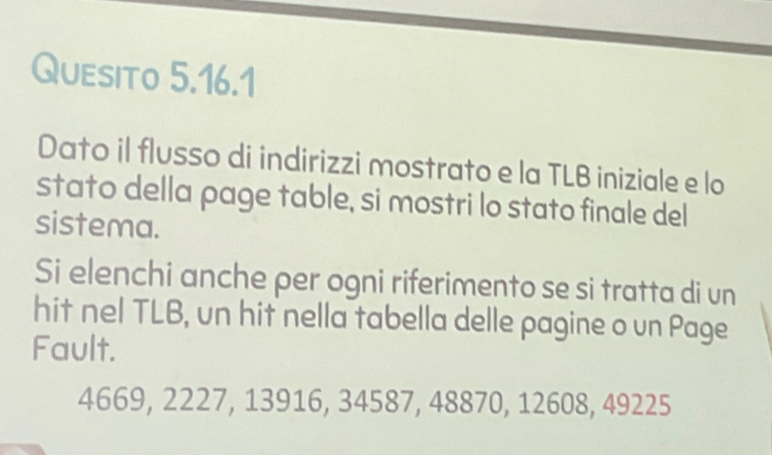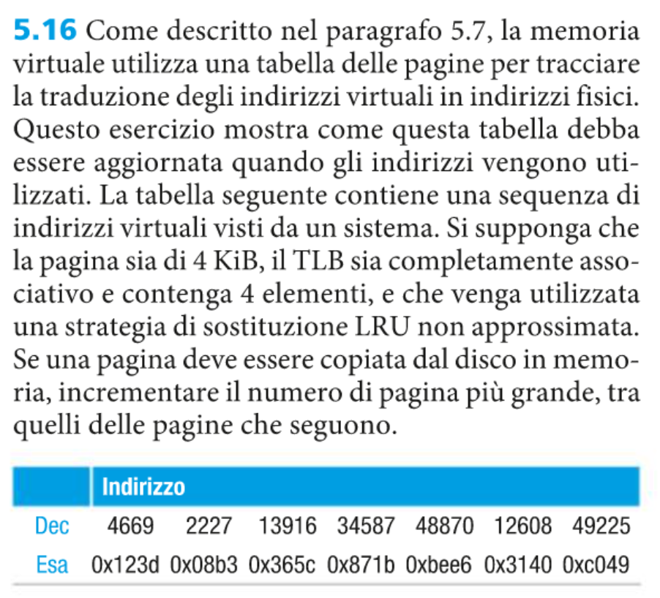

4669 = 1001000111101

48870 = 1011111011100110

12608 = 11000101000000

49225 = 1100000001001001

2227 = 100010110011

13916 = 11011001011100

34587 = 1000011100011011

* OFFSET: 12 bit
* INDEX: 0 bit
* TAG: 20 bit

|  |  |  |
| --- | --- | --- |
| ADDR. | VPN | OFFSET |
| 4669 | 1 | 001000111101 |
| 2227 | 1 | 00010110011 |
| 13916 | 11 | 011001011100 |
| 34587 | 1000 | 011100011011 |
| 48870 | 1011 | 111011100110 |
| 12608 | 11 | 000101000000 |
| 49225 | 1100 | 000001001001 |
|  |  |  |

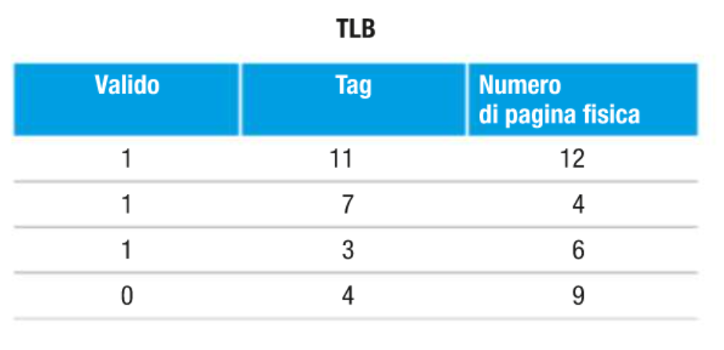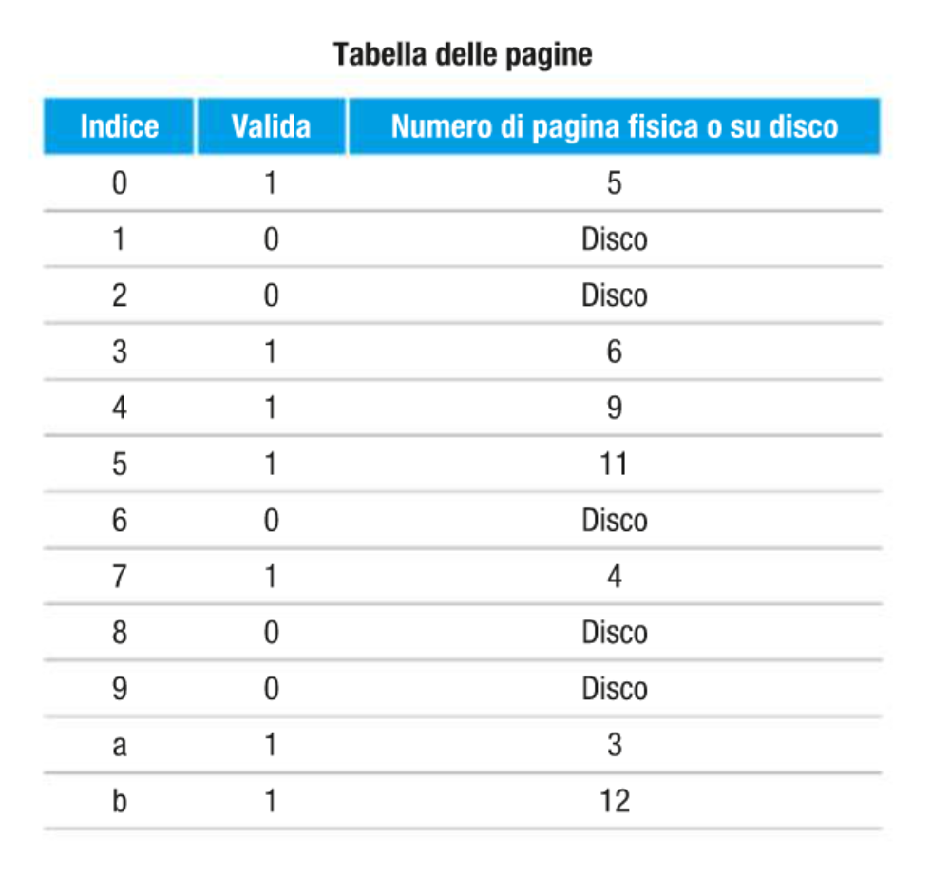

|  |  |  |  |
| --- | --- | --- | --- |
| ADDR. | VPN | TLB H/M | Page Fault |
| 4669 | 1 | M | YES |
| 2227 | 1 | H |  |
| 13916 | 11 | H |  |
| 34587 | 1000 | M |  |
| 48870 | 1011 |  |  |
| 12608 | 11 |  |  |
| 49225 | 1100 |  |  |

1. **4669:** TLB miss, Page fault

**TLB V.1**

|  |  |  |  |
| --- | --- | --- | --- |
| LA | Validità | Tag | PGN |
| 0 | 1 | 11 | 12 |
| 0 | 1 | 7 | 4 |
| 0 | 1 | 3 | 6 |
| 0 | 1 | 1 |  |

1. **2227: TLB hit**

**TLB V.2**

|  |  |  |  |
| --- | --- | --- | --- |
| LA | Validità | Tag | PGN |
| 0 | 1 | 11 | 12 |
| 0 | 1 | 7 | 4 |
| 0 | 1 | 3 | 6 |
| 1 | 1 | 1 |  |

1. **13916: TLB hit**

**TLB V.3**

|  |  |  |  |
| --- | --- | --- | --- |
| LA | Validità | Tag | PGN |
| 1 | 1 | 11 | 12 |
| 0 | 1 | 7 | 4 |
| 0 | 1 | 3 | 6 |
| 1 | 1 | 1 |  |

1. **34587:**

**ESERCIZIO 1:**

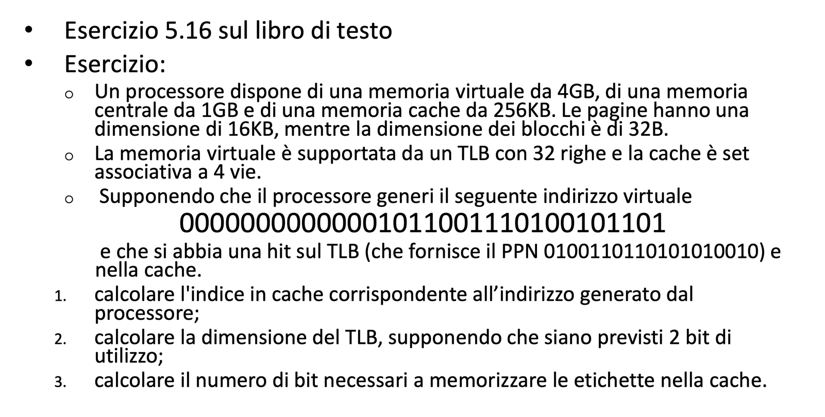

**Dimensione memoria virtuale: 4 GB**

**Dimensione memoria centrale: 1 GB**

**Dimensione Cache: 256 KB = 2^18**

**Dimensione pagine: 16KB = 2^14**

**Dimensione blocchi: 32B 4-way set associative**

**MEMORIA VIRTUALE:**

**Indirizzo virtuale da 32 bit.**

* **VPN: 18 b**
* **OFFSET: 14 b**

**MEMORIA FISICA:**

**Indirizzo da 30 bit.**

* **VPN: 16 bit**
* **OFFSET: 14 bit**

**CACHE:**

* **TAG:**
* **INDEX: 11 b**
* **OFFSET: 5 b**

**TLB:**

8 righe da indicizzare in quanto è 4-way set associative.

* **TAG: 15 b**
* **INDEX: 3 b**
* **VPN: 18**

**Entry = riga TLB**

**Quesito 3:**

* **TAG: 14**
* **INDEX: 11**
* **OFFSET: 5**

**ESERCIZI TLB**

**ESERCIZIO 5.16**

* TLB full associative
* Sostituzione LRU

Converto gli indirizzi virtuali.

|  |  |  |  |
| --- | --- | --- | --- |
| DEC. ADDRESS | HEX ADDRESS | BIN ADDRESS | VPN = TLB TAG |
| 4669 | 0x123d | **000001001000111101** | **0000** |
| 2227 | 0x08b3 | **000000100010110011** | **0000** |
| 13916 | 0x365c | **000011011001011100** | **0000** |
| 34587 | 0x871b | **001000011100011011** | **0010** |
| 48870 | 0xbee6 | **001011111011100110** | **0010** |
| 12608 | 0x3140 | **000011000101000000** | **0000** |
| 49225 | 0xc049 | **001100000001001001** | **0011** |

**Calcolo i campi dell’indirizzo virtuale:**

TLB_HIT se VPN = TLB_TAG

**STATO INIZIALE TLB:**

|  |  |  |  |
| --- | --- | --- | --- |
| INDEX | VALID | LRU | TLB_TAG |
| - | 1 | 0 | 1011 |
| - | 1 | 0 | 0111 |
| - | 1 | 0 | 0011 |
| - | 0 | 0 | 0100 |

1. 4669 **TLB_MISS, PAGE_HIT**

Aggiorno il TLB. Il TLB si aggiorna sempre, anche in caso di hit incrementando LRU.

|  |  |  |
| --- | --- | --- |
| VALID | LRU | TLB_TAG |
| 1 | 0 | 1011 |
| 1 | 0 | 0111 |
| 1 | 0 | 0011 |
| 1 | 1 | 0000 |

1. 2227 **TLB_HIT**

|  |  |  |
| --- | --- | --- |
| VALID | LRU | TLB_TAG |
| 1 | 0 | 1011 |
| 1 | 0 | 0111 |
| 1 | 0 | 0011 |
| 1 | 2 | 0000 |

1. 13916 **TLB HIT**

|  |  |  |
| --- | --- | --- |
| VALID | LRU | TLB_TAG |
| 1 | 0 | 1011 |
| 1 | 0 | 0111 |
| 1 | 0 | 0011 |
| 1 | 3 | 0000 |

1. 34587 **TLB_MISS, PAGE_FAULT**

Aggiorno la tabella delle pagine impostando il valid bit ad 1 (la pagina è stata caricata dal disco). Quando si verifica un page fault si carica il dato dalla memoria.

|  |  |  |
| --- | --- | --- |
| **INDEX** | **VALID** | **PPN** |
| 2 | 1 | Disco |

Aggiorno la TLB.

|  |  |  |
| --- | --- | --- |
| VALID | LRU | TLB_TAG |
| 1 | 1 | 0010 |
| 1 | 0 | 0111 |
| 1 | 0 | 0011 |
| 1 | 3 | 0000 |

1. 48870 **TLB_HIT**

|  |  |  |
| --- | --- | --- |
| VALID | LRU | TLB_TAG |
| 1 | 2 | 0010 |
| 1 | 0 | 0111 |
| 1 | 0 | 0011 |
| 1 | 3 | 0000 |

1. 12608 **TLB_HIT**

|  |  |  |
| --- | --- | --- |
| VALID | LRU | TLB_TAG |
| 1 | 2 | 0010 |
| 1 | 0 | 0111 |
| 1 | 0 | 0011 |
| 1 | 4 | 0000 |

1. 49225 **TLB_HIT**

|  |  |  |
| --- | --- | --- |
| VALID | LRU | TLB_TAG |
| 1 | 2 | 0010 |
| 1 | 0 | 0111 |
| 1 | 1 | 0011 |
| 1 | 4 | 0000 |

**RIPETERE L’ESERCIZIO CON UNA TLB 2-WAY SET ASSOCIATIVE E PAGINE DA 4KB**

* TLB 2 way set associative
* Sostituzione LRU

**Calcolo i campi dell’indirizzo virtuale:**

**TLB HIT:** si cerca l’entry corretta confrontando il TLB INDEX dell’indirizzo fornito con quello che indicizza la TLB. Successivamente si cerca il dato esatto confrontando il TLB TAG. Infine, si controlla il bit di validità.

|  |  |  |  |  |  |
| --- | --- | --- | --- | --- | --- |
| DEC. ADDRESS | HEX ADDRESS | BIN ADDRESS | VPN | TLB TAG (19 bit) | TLB INDEX |
| 4669 | 0x123d | **00010011000111101** | **0001** | **000** | **1** |
| 2227 | 0x08b3 | **0000100010110011** | **0000** | **000** | **0** |
| 13916 | 0x365c | **0011011001011100** | **0011** | **001** | **1** |
| 34587 | 0x871b | **1000011100011011** | **1000** | **100** | **0** |
| 48870 | 0xbee6 | **1011111011100110** | **1011** | **101** | **1** |
| 12608 | 0x3140 | **0011000101000000** | **0011** | **001** | **1** |
| 49225 | 0xc049 | **1100000001001001** | **1100** | **110** | **0** |

**STATO INIZIALE TLB (2 way set associative):**

|  |  |  |  |
| --- | --- | --- | --- |
| INDEX | VALID | LRU | TLB_TAG |
| 0 | 1 | 0 | 1011 |
| 1 | 1 | 0 | 0111 |

|  |  |  |  |
| --- | --- | --- | --- |
| INDEX | VALID | LRU | TLB_TAG |
| 0 | 1 | 0 | 0011 |
| 1 | 0 | 0 | 0100 |

1. 4669: **TLB miss, Page fault**

Aggiorno la page table.

|  |  |  |
| --- | --- | --- |
| **INDEX** | **VALID** | **PPN** |
| 1 | 1 | Disco |

Aggiorno il TLB.

|  |  |  |  |
| --- | --- | --- | --- |
| INDEX | VALID | LRU | TLB_TAG |
| 0 | 1 | 0 | 1011 |
| 1 | 1 | 0 | 0111 |

|  |  |  |  |
| --- | --- | --- | --- |
| INDEX | VALID | LRU | TLB_TAG |
| 0 | 1 | 0 | 0011 |
| 1 | **1** | **1** | **0000** |

1. 2227: **TLB miss, Page hit**

|  |  |  |  |
| --- | --- | --- | --- |
| INDEX | VALID | LRU | TLB_TAG |
| 0 | **1** | **1** | **0000** |
| 1 | 1 | 0 | 0111 |

|  |  |  |  |
| --- | --- | --- | --- |
| INDEX | VALID | LRU | TLB_TAG |
| 0 | 1 | 0 | 0011 |
| 1 | 1 | 1 | 0000 |

1. 13916: **TLB miss, Page hit**

|  |  |  |  |
| --- | --- | --- | --- |
| 1. INDEX | VALID | LRU | TLB_TAG |
| 0 | 1 | 1 | 0000 |
| 1 | **1** | **1** | **0001** |

|  |  |  |  |
| --- | --- | --- | --- |
| INDEX | VALID | LRU | TLB_TAG |
| 0 | 1 | 0 | 0011 |
| 1 | 1 | 1 | 0000 |

* 34587: **TLB miss, Page fault**

|  |  |  |
| --- | --- | --- |
| **INDEX** | **VALID** | **PPN** |
| 8 | 1 | Disco |

|  |  |  |  |
| --- | --- | --- | --- |
| 1. INDEX | VALID | LRU | TLB_TAG |
| 0 | 1 | 1 | 0000 |
| 1 | 1 | 1 | 0001 |

|  |  |  |  |
| --- | --- | --- | --- |
| INDEX | VALID | LRU | TLB_TAG |
| 0 | **1** | **1** | **0100** |
| 1 | 1 | 1 | 0000 |

* 48870: **TLB miss, Page hit**

|  |  |  |  |
| --- | --- | --- | --- |
| 1. INDEX | VALID | LRU | TLB_TAG |
| 0 | 1 | 1 | 0000 |
| 1 | **1** | **2** | **0101** |

|  |  |  |  |
| --- | --- | --- | --- |
| INDEX | VALID | LRU | TLB_TAG |
| 0 | 1 | 1 | 0100 |
| 1 | 1 | 1 | 0000 |

* 12608: **TLB miss, Page hit**

|  |  |  |  |
| --- | --- | --- | --- |
| 1. INDEX | VALID | LRU | TLB_TAG |
| 0 | 1 | 1 | 0000 |
| 1 | 1 | 2 | 0101 |

|  |  |  |  |
| --- | --- | --- | --- |
| INDEX | VALID | LRU | TLB_TAG |
| 0 | 1 | 1 | 0100 |
| 1 | **1** | **2** | **0001** |

**ESERCIZIO 3 SIMULAZIONE**

byte addressable

**VPN: 18 bit**

PPN: 16 bit

Indirizzo virtuale: **00 0000 0011 0100 1010 1100 1000 1101**

**PPN:**

Indirizzo fisico:

**QUESITO 5.2**

**Cache a mappatura diretta contenente 16 blocchi da 1 word. Indirizzo fisico da 32 bit.**

|  |  |  |  |  |
| --- | --- | --- | --- | --- |
| HEX | BIN | INDEX | TAG | H/M |
| 0x03 | 0000 0011 | 0011 | 0000 | Compulsory M |
| 0xb4 | 1011 0100 | 0100 | 1011 | Compulsory M |
| 0x2b | 0010 1011 | **1011** | **0010** | Compulsory M |
| 0x02 | 0000 0010 | 0010 | 0000 | Compulsory M |
| 0xbf | 1011 1111 | 1111 | 1011 | Compulsory M |
| 0x58 | 0101 1000 | 1000 | 0101 | Compulsory M |
| 0xbe | 1011 1110 | **1110** | **1011** | Compulsory M |
| 0x0e | 0000 1110 | **1110** | **0000** | Compulsory M |
| 0xb5 | 1011 0101 | 0101 | 1011 | Compulsory M |
| 0x2c | 0010 1100 | 1100 | 0010 | Compulsory M |
| 0xba | 1011 1010 | 1010 | 1011 | Compulsory M |
| 0xfd | 1111 1101 | **1101** | **1111** | Compulsory M |

* INDEX: 4
* OFFSET: 2
* TAG: 26