Exercises

## CELSIUS TO FAHRENHEIT



1 – Convert Celsius to Fahrenheit and print its value

2 – Ask for user a Celsius value and print the Fahrenheit value

## BODY MASS INDEX

**Body mass index (BMI)** is a value derived from the mass (weight) and height of a person. The **BMI** is defined as the body mass divided by the square of the body height, and is universally expressed in units of kg/m2, resulting from mass in kilograms and height in metres.

<https://en.wikipedia.org/wiki/Body_mass_index>

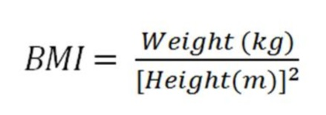

### STEP ONE



Print the BMI value using weight and height;

### STEP TWO

Create a console application that ask user for weight and height. So, print the BMI value;