

JOMO KENYATTA UNIVERSITY OF AGRICULTURE AND
TECHNOLOGY
PROJECT TITLE: FLORAL CULTURE POS SYSTEM.
BY
NAME: SHAMRAN KYESWA.
REGISTRATION NUMBER: SCT121-C004-0447/2024
SUPERVISOR: Mr. PETER WANYAMA.

A project documentation submitted in parted fulfilment of the requirement for the award of Diploma in Information Technology.

© MAY 2025

DECLARATION

I hereby declare that this project report is my original work and has not been submitted to any other institution for the award of a diploma or any other academic qualification.
Signature: ______________________
Name: SHAMRAN KYESWA
Registration Number: SCT121-C004-0447/2024
Date: ______________________

Supervisor’s Approval
This project report has been submitted for examination with my approval as the project supervisor.
Signature: ______________________
Name: Mr. Peter Wanyama
Date: ______________________

ACKNOWLEDGEMENT
First and foremost, I thank Almighty Allah for granting me the strength, knowledge, good health, and perseverance throughout the development of this project.
I would like to express my sincere gratitude to my project supervisor, Mr. Peter Wanyama, for his guidance, encouragement, constructive criticism, and valuable advice during the development of the Floral Culture POS System. His support played a significant role in the successful completion of this project.
I also wish to thank the lecturers of the Department of Information Technology at Jomo Kenyatta University of Agriculture and Technology (JKUAT) for providing the knowledge and skills that enabled me to undertake this project successfully.
Special appreciation goes to my family and friends for their continuous support, encouragement, and understanding throughout my studies and during the preparation of this project documentation.
Finally, I extend my gratitude to everyone who contributed directly or indirectly towards the successful completion of this project.
May Allah bless them all.
ABSTRACT
The Floral Culture POS System is a web-based system developed to improve the management of flower shop operations. The system helps in managing products, customers, suppliers, purchases, sales, payments, and receipts. The project was developed using PHP, HTML, CSS, MySQL, and XAMPP. The system reduces manual record keeping, improves sales tracking, and makes it easier for administrators to manage business activities. Testing showed that the system performed the required functions successfully.

LIST OF TABLES
Table 1.1: Project Risks and Mitigation .............................................. 5
Table 1.2: Project Schedule ............................................................. 6
Table 4.2: Data Flow Analysis .......................................................... 16
Table 4.3: User Interaction Analysis ................................................ 16
Table 4.4: Functional Requirements ................................................. 17
Table 4.5: Non-Functional Requirements ........................................... 18
Table 5.1: Major System Components ............................................... 20
Table 5.2: Home Page Components ................................................... 21
Table 5.3: Login Page Components .................................................. 21
Table 5.4: Registration Page Components .......................................... 22
Table 5.5: Menu Page Components ................................................... 23
Table 5.6: Cart Page Components .................................................... 23
Table 5.7: Order Confirmation Components ....................................... 24
Table 5.12: Input Requirements ..................................................... 26
Table 5.13: System Outputs .......................................................... 27
Table 5.14: Security Features ....................................................... 28
Table 5.15: Navigation Structure ................................................... 28

LIST OF FIGURES
Figure 4.1: Current System Workflow .............................................. 15
Figure 5.1: Entity Relationship Diagram (ERD) ................................. 24
Figure 5.2: Database Relationship Diagram ...................................... 24
Figure 5.8: Floral Culture Database Structure .................................. 25
Figure 5.9: Products Table .......................................................... 25
Figure 5.10: Customers Table ....................................................... 25
Figure 5.11: Sales Table ............................................................ 26
Figure 5.12: Purchases Table ........................................................ 26
Figure 6.1: Login Page ............................................................. 30
Figure 6.2: Dashboard .............................................................. 30
Figure 6.3: Add Category ........................................................... 30
Figure 6.4: Add Product ............................................................ 31
Figure 6.5: Customer Management ................................................. 31
Figure 6.6: Supplier Management ................................................. 31
Figure 6.7: Purchase Management ................................................. 31
Figure 6.8: Point of Sale (POS) ................................................... 32
Figure 6.9: View Cart .............................................................. 32
Figure 6.10: Payment Confirmation ............................................... 32
Figure 6.11: Payment Successful ................................................. 33
Figure 6.12: Order Receipt ....................................................... 33
Figure 6.13: Sales Report ........................................................ 33

Contents
CHAPTER ONE: INTRODUCTION 3
1.1 Introduction 3
1.2 Background of the Study 3
1.3 Problem Statement 3
1.4 Objectives 3
1.5 Scope and Limitations 3
1.6 Justification 3
1.7 Project Risks and Mitigation 3
1.8 Budget and Resources 3
1.9 Project Schedule 3
CHAPTER TWO: LITERATURE REVIEW 4
2.1 Introduction 4
2.2 Overview of Floral Management Systems 4
2.3 Web-Based Information Systems 5
2.4 Database Management Systems 5
2.5 Technologies Used in Web Development 5
2.6 Related Systems 6
CHAPTER THREE: METHODOLOGY 6
3.1 Introduction 6
3.2 System Development Model 7
3.3 Data Collection Techniques 7
3.4 System Design 7
3.5 Database Design 8
3.6 Tools Used 8
3.7 System Testing 9
5.4.1 Conceptual Database Design 21
5.4.2 Logical Database Design 22
5.5.1 Database Overview 23
5.5.2 Products Table 23
5.5.3 Customers Table 23
5.5.4 Sales Table 24
5.5.5 Purchases Table 24
CHAPTER SIX: SYSTEM IMPLEMENTATION SCREENSHOTS 27
6.1 Development Tools 27
6.2 Test Plan 27
6.3 Testing Results 27
6.4 Changeover Strategy 27
Figure 6.1: Login Page 28
Figure 6.2: Dashboard 28
Figure 6.3: Add Category 28
Figure 6.4: Add Product 29
Figure 6.5: Customer Management 29
Figure 6.6: Supplier Management 29
Figure 6.7: Purchase Management 29
Figure 6.8: Point of Sale (POS) 30
Figure 6.9: View Cart 30
Figure 6.10: Payment Confirmation 30
Figure 6.11: Payment Successful 31
Figure 6.12: Order receipt 31
Figure 6.13: Sales Report 31
CHAPTER SEVEN: TESTING RESULTS AND CONCLUSION 32
7.1Testing Results 32
7.2Conclusion 32
7.3 Recommendations 32
7.5 APPENDICE 33
7.5.1APPENDIXA: SYSTEM FLOWCHART 33
7.5.2 APPENDIXB: ENTITY RELATIONSHIP DIAGRAM (ERD) 35
7.5.3 APPENDIXC: DATABASE RELATIONSHIP DIAGRAM 36
7.5.4 APPENDIXD: SAMPLE SOURCE CODE 37
7.5APPENDIXE: USER MANUAL 39
7.6 APPENDIXF: ADDITIONAL SYSTEM SCREENSHOTS 40

CHAPTER ONE: INTRODUCTION

1.1 Introduction
Information technology has significantly improved the way organizations operate. Many institutions are replacing manual processes with computerized systems to improve efficiency, reduce errors, and enhance service delivery. Florals within schools and organizations often experience challenges when managing flowers orders manually.
In many flower shops, customers must physically queue to place their orders. During peak hours this creates long waiting lines and delays. Manual systems also make it difficult to track orders, manage menu items, and maintain proper records of sales.
The Floral Culture Management System is a web‑based application designed to improve the ordering process in flower shops. The system allows users to register, log in, browse menu items, add flowers items to a cart, and confirm their orders electronically.

1.2 Background of the Study
Florals provide flowers services to students, staff, and visitors in many institutions. Traditionally, many flower shops operate using manual methods where customers place orders verbally and payments are processed at the counter. This approach often leads to inefficiencies such as long queues, incorrect orders, and poor record management.
With the advancement of web technologies, digital floral management systems have become increasingly popular. These systems allow customers to browse menus, select flowers items, and place orders electronically. Such systems improve convenience, accuracy, and overall efficiency.
The Floral Culture Management System was developed to demonstrate how modern web technologies such as PHP, HTML, CSS, and MySQL can be used to improve flower shop operations.

1.3 Problem Statement
Many flower shops still rely on manual ordering processes. This creates several operational challenges including:
• Long waiting times due to customers queuing to place orders.
• Human errors when recording flowers orders manually.
• Difficulty in managing records of customer orders and sales.
• Lack of convenience for customers who wish to view menu items before ordering.
These challenges highlight the need for an automated system that simplifies the ordering process and improves record management.

1.4 Objectives
General Objective:
To develop a web‑based Floral Culture Management System.
Specific Objectives:
1. To develop a user registration and login system.
2. To create a digital menu that displays available flowers items.
3. To implement a cart system for managing selected flowers items.
4. To develop an order confirmation system that stores customer orders.
5. To design an attractive and user‑friendly interface.

1.5 Scope and Limitations
Scope:
The system allows users to register, log in, view menu items, add items to a cart, and confirm their flowers orders through a web browser.
Limitations:
• The system does not include online payment gateway integration.
• It is designed for a single flower shop environment.
• Inventory tracking of ingredients is not included.

1.6 Justification
The Floral Culture Management System improves efficiency in flower shop operations. It reduces waiting time for customers and ensures accurate recording of orders. The system also demonstrates the practical application of web development technologies.

1.7 Project Risks and Mitigation
Risk | Mitigation
System bugs or errors | Perform thorough system testing
Database failure | Regular database backups
User input errors | Form validation and error handling
Security threats | Use authentication and secure sessions

1.8 Budget and Resources
Hardware:
• Laptop or Desktop Computer
• Reliable Internet Connection
Software:
• Visual Studio Code – used as the code editor to write and manage PHP, HTML, and CSS files.
• XAMPP – provides Apache server and MySQL database needed to run the system locally.
• MySQL – used to store system data including users, menu items, cart items, and orders.
• Web Browser – used to access and test the system interface.
Human Resources:
• System Developer (Student)
• Project Supervisor

1.9 Project Schedule
Activity | Description | Duration
Research | Understanding the problem and reviewing related systems | 2 Weeks
System Design | Designing system structure and database | 2 Weeks
System Development | Coding the system using PHP, HTML, CSS, and MySQL | 4 Weeks
Testing | Testing system functionality and fixing errors | 1 Week
Documentation | Preparing final project documentation | 1 Week

CHAPTER TWO: LITERATURE REVIEW

2.1 Introduction
This chapter reviews previous studies, technologies, and systems related to online floral management and flower shop management systems.
The purpose of this chapter is to examine existing knowledge and technological solutions that relate to the development of the Floral Culture Management System.
Literature review helps in understanding how similar systems operate, the technologies used in their development, and the advantages they provide compared to manual systems.
It also helps the developer identify best practices that can be applied in the development of the new system.
Modern organizations rely heavily on computerized systems to improve efficiency, reduce errors, and provide better services to users.
Flowers service businesses such as restaurants and flower shops have increasingly adopted web‑based ordering systems to streamline operations and improve customer satisfaction.

2.2 Overview of Floral Management Systems
Flowers ordering systems are digital platforms that allow customers to browse flowers menus, select flowers items, and place orders electronically.
These systems are commonly used in restaurants, cafes, fast flowers outlets, and institutional flower shops.
Traditional floral management methods involve customers physically visiting the flower shop, waiting in queues, and communicating their orders verbally to a cashier.
This process can lead to several problems including long waiting times, incorrect orders, and poor record keeping.
Online floral management systems solve these challenges by allowing customers to view menus digitally and place orders through a computer or mobile device.
Orders are automatically recorded in a database which makes it easier for the flower shop to manage customer requests.
Many modern floral management systems also include features such as order tracking, digital payments, and customer feedback.
Although the project developed in this study is simplified for academic purposes, it follows the same concept used in real‑world floral management systems.

2.3 Web-Based Information Systems
A web‑based system is an application that operates on a web server and is accessed using a web browser such as Google Chrome, Microsoft Edge, or Firefox.
Web systems are widely used because they can be accessed from multiple devices without installing special software.
Web‑based systems follow a client‑server architecture. In this model, the client (user) interacts with the system through a web browser while the server processes requests and stores data in a database.
One major advantage of web‑based systems is accessibility. Users can access the system from different computers connected to the same network or the internet.
Another advantage is ease of maintenance because updates are made on the server rather than on individual user devices.
The Floral Culture Management System developed in this project is a web‑based system designed to run on a local server using XAMPP.

2.4 Database Management Systems
A Database Management System (DBMS) is software used to store, organize, and manage data efficiently.
Databases play a critical role in modern information systems because they ensure that data is stored securely and can be retrieved quickly when needed.
In this project, MySQL is used as the database management system. MySQL is an open‑source relational database that is widely used in web development.
The database used in the Floral Culture Management System contains several tables including:
Users – stores information about registered users.
Menu – stores available flowers items and their prices.
Cart – stores items selected by users before confirming an order.
Orders – stores confirmed customer orders.
Using a database ensures that the system can manage multiple users and maintain accurate records of transactions.

2.5 Technologies Used in Web Development
Modern web applications are built using a combination of different programming languages and technologies.
Each technology plays a specific role in the system.
HTML (HyperText Markup Language) is used to structure the content of web pages. It defines elements such as headings, forms, tables, and images.
CSS (Cascading Style Sheets) is used to control the appearance and design of web pages. It allows developers to add colors, fonts, layouts, and responsive design features.
PHP (Hypertext Preprocessor) is a server‑side programming language used to implement system functionality.
PHP processes user requests, communicates with the database, and generates dynamic web pages.
SQL (Structured Query Language) is used to interact with databases. SQL commands allow developers to store, retrieve, update, and delete data from database tables.
These technologies work together to create dynamic and interactive web applications such as the Floral Culture Management System.

2.6 Related Systems
Several floral management systems exist in the market today. Examples include restaurant websites and mobile floral management applications.
These systems allow customers to browse menus, place orders, and sometimes pay online.
Large platforms such as restaurant ordering websites provide advanced features including delivery tracking and integrated payment systems.
However, many small flower shops and institutions still rely on manual processes.
The Floral Culture Management System developed in this project provides a simplified solution specifically designed for flower shop environments.
The system focuses on basic features such as viewing menu items, adding items to a cart, and confirming orders.
Although it is a simplified system, it demonstrates the key principles used in the development of modern floral management platforms.

CHAPTER THREE: METHODOLOGY

3.1 Introduction
This chapter explains the methods and procedures used in the development of the Floral Culture Management System.
It describes the development model used, the data collection techniques, system design approach, and the tools used during system implementation.
The methodology chapter is important because it explains how the system was developed and how the project objectives were achieved.

3.2 System Development Model
The Waterfall Model was used for the development of this system.
The Waterfall model is a structured software development methodology where development progresses through a series of clearly defined stages.
The main stages of the Waterfall model include:
Requirement Analysis – understanding the problems faced in the current flower shop ordering process and identifying system requirements.
System Design – designing the structure of the system including database tables, user interface layouts, and system architecture.
Implementation – writing the program code using PHP, HTML, CSS, and SQL.
Testing – examining the system to identify and fix errors or bugs.
Deployment – making the final system ready for use.
The Waterfall model was chosen because it provides a simple and organized approach suitable for academic projects.

3.3 Data Collection Techniques
Data collection is the process of gathering information necessary for system development.
In this project, the following methods were used:
Observation – observing how flowers orders are normally processed in flower shops helped identify the challenges of manual ordering systems.
Online Research – reviewing websites, articles, and journals related to floral management systems helped understand how similar systems operate.
Literature Review – academic resources were studied to understand technologies used in web‑based systems and database management.
These methods helped gather sufficient information needed to design and develop the system.

3.4 System Design
System design involves planning the structure and components of the system before development begins.
The Floral Culture Management System follows a client‑server architecture where users interact with the system through a web browser.
The server processes user requests and communicates with the database.
The system includes several main components:
User Interface – allows users to interact with the system through forms and menus.
Application Logic – implemented using PHP to process user requests and manage system operations.
Database – used to store user accounts, menu items, cart data, and customer orders.
Proper system design ensures that the system functions efficiently and meets user requirements.

3.5 Database Design
Database design is an important stage in system development because it determines how data will be stored and organized.
The Floral Culture Management System uses a relational database consisting of several tables including:
Users Table – stores usernames and login credentials.
Menu Table – stores information about flowers items including name, category, price, and image.
Cart Table – temporarily stores items selected by users before confirming orders.
Orders Table – stores confirmed orders made by users.
Relationships between these tables ensure that the system can manage multiple users and track orders accurately.

3.6 Tools Used
Several software tools were used to develop and test the Floral Culture Management System.
Visual Studio Code – used as the main code editor for writing and managing project files. It provides useful features such as syntax highlighting and code suggestions.
XAMPP – used to create a local server environment. It includes Apache web server and MySQL database which allow the system to run locally during development.
MySQL – used as the database management system for storing system data including users, menu items, cart items, and orders.
Web Browser – used to access and test the system interface while developing the application.
These tools made it possible to develop, test, and run the system efficiently.

3.7 System Testing
System testing was performed to ensure that all features of the Floral Culture Management System function correctly.
The following components were tested:
User Registration – verifying that users can create accounts successfully.
Login System – ensuring that only registered users can access the system.
Menu Display – checking that flowers items appear correctly with their details.
Cart Function – confirming that users can add and remove items from the cart.
Order Confirmation – ensuring that confirmed orders are stored correctly in the database.

CHAPTER FOUR: SYSTEM ANALYSIS AND REQUIREMENT MODELING
4.1 Introduction
System analysis is the process of studying an existing system in order to understand how it operates, identify its weaknesses, and determine the requirements of a new system. This chapter presents the analysis of the current flower shop ordering system, the methods used to gather facts and data, requirement definitions, and requirement modeling of both the current and proposed systems.
The diagrams included in this chapter were designed using Python (Matplotlib) for academic documentation purposes, while the system modeling concepts were based on standard UML and System Analysis techniques.
The main objective of this chapter is to clearly show how the manual flower shop ordering system works, identify its challenges, and define the requirements of the computerized Floral Culture Management System.

4.2 Fact Finding Methods
Fact finding is the process of collecting information about the current system before developing a new system. In this project, several methods were used to gather facts and data.
i. Observation
Observation involved watching how customers place flowers orders in flower shops. During observation, it was noted that customers had to physically queue, place orders verbally, and wait for the cashier to manually record the order.
The observation method helped identify several challenges including:
- Long queues
- Delays during peak hours
- Human errors in recording orders
- Difficulty in tracking records

ii. Interviews
Interviews were conducted with students and flower shop attendants to understand the challenges faced in the current system.
The interviews revealed:
- Customers dislike waiting in queues
- Cashiers find it difficult managing many orders simultaneously
- Order records can easily get lost

iii. Record Review
Existing records such as sales books and manual order records were examined.
This helped identify:
- Missing records
- Duplicate entries
- Difficulties in tracking previous transactions

iv. Online Research
Research was conducted on existing floral management systems available online.
This helped understand:
- Features of modern floral management systems
- Design approaches
- Database structures
- Payment integration methods

4.3 Analysis of the Current System
The current flower shop system operates manually.
The process works as follows:
- Customer visits the flower shop.
- Customer checks available flowers items.
- Customer verbally communicates the order.
- Cashier manually records the order.
- Customer pays.
- Flowers is prepared.
- Customer receives flowers.
Although this process works, it presents several challenges.

Problems in the Current System
1. Long Queues
Customers spend a lot of time waiting.
2. Human Errors
Orders may be recorded incorrectly.
3. Poor Record Management
Manual records can be lost.
4. Limited Accessibility
Customers must physically visit the flower shop.
5. Poor Customer Experience
Delays reduce satisfaction.

4.4 Current System Workflow Analysis
The current flower shop ordering system follows a manual workflow where customers physically visit the flower shop to place flowers orders. The workflow begins when a customer arrives at the flower shop and checks the available flowers items displayed at the counter. After selecting the desired meal, the customer verbally communicates the order to the cashier.
The cashier manually records the order details and calculates the total amount to be paid. After payment is completed, the order is forwarded for preparation. Once the flowers is ready, the customer receives the order.
Although this workflow allows flower shop operations to continue, it presents several operational challenges such as delays, inaccurate order recording, and difficulties in managing records during busy periods.
Image 4.1: Current System Workflow
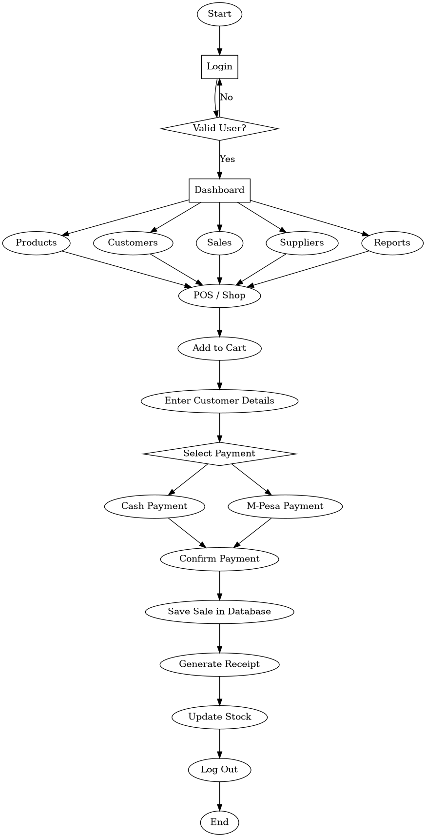
4.5 Data and Information Flow Analysis
In the current system, data flows manually between customers and flower shop staff. Customers communicate their flowers choices verbally, and the cashier manually records the order details. Payment information is also processed manually before the order is forwarded for preparation.
This manual flow of information increases the chances of communication errors, delays, and missing records. The proposed system will automate this process by allowing users to enter their orders directly into the system, which will automatically store the information in the database.
Table 4.2: Data Flow Analysis
Source of Data | Data Collected | Destination
Customer | Flowers selection | Ordering system
Customer | Login details | User database
Customer | Payment method | Order processing
System | Order details | Database
Database | Order records | Administrator

4.6 User Interaction Analysis.
The proposed Floral Culture Management System will allow users to interact with the system through a web-based interface. Users will first create an account and log into the system. After successful login, they will access the menu page where they can browse available flowers items categorized as flowerss, drinks, and desserts.
Users will then add selected items to the cart, review their cart contents, select a preferred payment method, and confirm their orders. The system will automatically store the order details in the database and display confirmation messages.
Administrators will interact with the system by managing menu items, monitoring customer orders, and reviewing transaction records.
Table 4.3: User Interaction Analysis
User Type | Activity | System Response
Customer | Register account | Account created
Customer | Login | Access granted
Customer | View menu | Flowers items displayed
Customer | Add to cart | Item added
Customer | Confirm order | Order saved
Admin | View orders | Orders displayed
Admin | Manage menu | Menu updated

4.7 Functional Requirements
Functional requirements describe what the system is expected to do. These requirements define the main services and operations that the Floral Culture Management System must provide to users.
The system shall perform the following functions:
Table 4.4: Functional Requirements
Requirement | Description
User Registration | Allows new users to create accounts
User Login | Allows registered users to access the system
Menu Viewing | Displays available flowers items
Cart Management | Allows users to add, update, and remove items
Order Confirmation | Allows users to place orders
Payment Selection | Allows users to choose payment method
Order History | Allows users to view previous orders
Admin Management | Allows admin to manage menu and orders

4.8 Non-Functional Requirements
Non-functional requirements describe the quality attributes of the system.

Table 4.5: Non-Functional Requirements
Requirement | Description
Security | User information must be protected
Reliability | System should operate consistently
Performance | System should respond quickly
Usability | Interface should be easy to use
Availability | System should be accessible when needed
Maintainability | System should be easy to update

4.9 Requirement Specifications
Requirement specifications define the inputs, processes, and outputs of the proposed system.
Input Requirements
The system accepts:
Username
Password
Item selection
Quantity
Payment method
Processing Requirements

The system processes:
User authentication
Menu retrieval
Cart calculations
Database updates
Order confirmation
Output Requirements
The system produces:
User dashboard
Menu display
Cart summary
Order confirmation message
Order history

CHAPTER FIVE: SYSTEM DESIGN
5.1 Introduction
System design is the process of transforming the requirements identified during system analysis into a blueprint for system implementation. It provides a detailed description of how the proposed system will operate and how different components of the system will interact with each other.
The main purpose of system design is to ensure that the developed system meets user requirements and operates efficiently. This chapter presents the design of the proposed Floral Culture Management System, including system architecture design, database design, input design, output design, and user interface design.
The design of this system was guided by the requirements identified in Chapter Four, with the goal of developing a reliable, secure, user-friendly, and efficient floral management platform.
5.2 System Design Overview
The Floral Culture Management System was designed as a web-based application that allows customers to access floral management services through a web browser.
The system consists of three main components:
User Interface
Application Logic
Database Management System
These components work together to ensure smooth communication between users and the system.

Table 5.1: Major System Components
Component | Description
User Interface | Allows users to interact with the system
Application Logic | Processes user requests and system operations
Database | Where the data of the system is kept

The system was developed using:
PHP for backend programming
HTML for page structure
CSS for page design
MySQL for database management
5.3 User Interface Design
User interface design focuses on how users interact with the system. The interface was designed to be simple, attractive, and easy to use.
The system contains several user interfaces.
5.3.1 Home Page Design
The home page acts as the entry point of the system. It provides basic information about the flower shop and allows users to access login and registration pages.
Features of the home page include:
Welcome message
Navigation buttons
System branding
Quick access links

Table 5.2: Home Page Components
Component | Purpose
Welcome message | Introduces users to the system
Login button | Directs users to login page
Register button | Directs users to registration page
Navigation menu | Helps users move through the system

5.3.2 Login Page Design
The login page allows registered users to access the system securely.
Features include:
Username field
Password field
Login button
Error validation messages
Table 5.3: Login Page Components
Component | Purpose
Username field | Captures username
Password field | Captures password
Login button | Authenticates user
Validation messages | Displays errors

5.3.3 Registration Page Design
The registration page allows new users to create accounts.
The page collects:
Username
Email address
Password
Password confirmation
Table 5.4: Registration Page Components
Component | Purpose
Username field | Captures username
Email field | Captures email
Password field | Creates password
Submit button | Saves account

5.3.4 Menu Page Design
The menu page displays available flowers items.
Flowers items are categorized into:
Flowers
Each item displays:
Flowers image
Flowers name
Price
Add to cart button
Table 5.5: Menu Page Components
Component | Purpose
Flowers image | Displays flowers visually
Flowers name | Identifies item
Price | Shows item cost
Add to cart button | Adds item to cart

5.3.5 Cart Page Design
The cart page displays selected flowers items.
Users can:
View selected items
Update quantities
Remove items
Proceed to checkout

Table 5.6: Cart Page Components
Component | Purpose
Item list | Displays selected items
Quantity field | Updates quantity
Remove button | Removes item
Checkout button | Proceeds to order confirmation

5.3.6 Order Confirmation Page Design
This page allows users to review their order and select a payment method.
Payment options include:
Cash
M-Pesa
Credit Card
Table 5.7: Order Confirmation Components
Component | Purpose
Order summary | Displays selected items
Payment options | Allows payment selection

5.4.1 Conceptual Database Design
The conceptual database design shows the main entities used in the Floral Culture POS System and how they relate to each other. The main entities include customers, products, categories, sales, suppliers, purchases, and users.
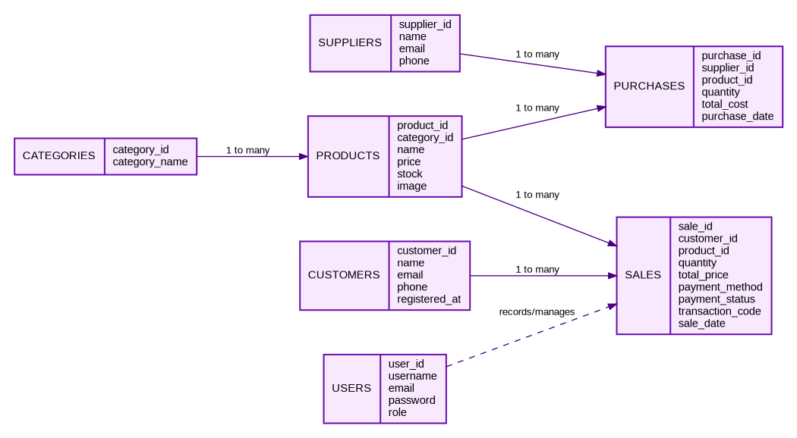
Figure 5.1: Entity Relationship Diagram

5.4.2 Logical Database Design
The logical database design shows how the database tables are connected using primary keys and foreign keys. This helps maintain data accuracy and prevents duplication of records.
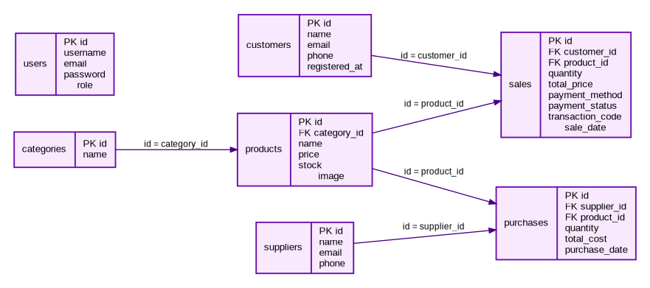
Figure 5.2: Database Relationship Diagram
5.5 Database Design
The Floral Culture Management System uses MySQL to store and manage data. The database contains tables for products, customers, sales, purchases, suppliers, and categories.

5.5.1 Database Overview
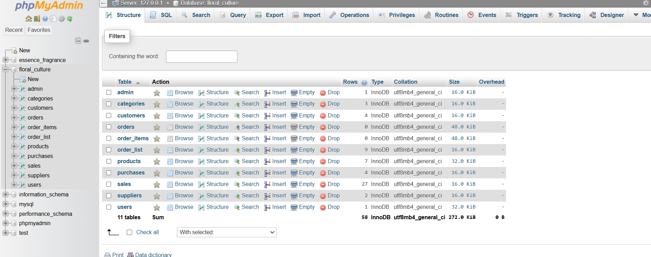Figure 5.8: Floral Culture Database Structure
The figure above shows the complete Floral Culture database as implemented in phpMyAdmin.

5.5.2 Products Table
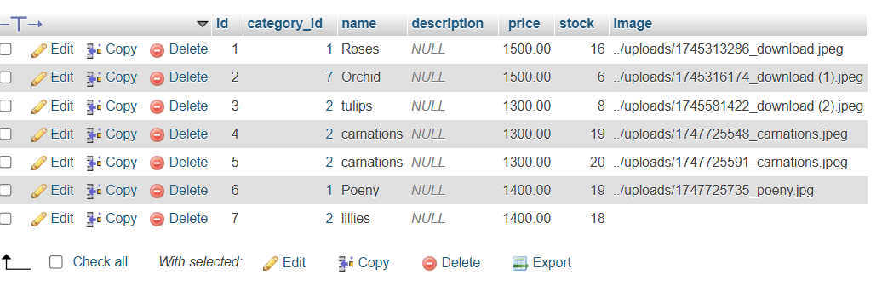Figure 5.9: Products Table
Stores flower information including product name, category, price, stock quantity, and image.

5.5.3 Customers Table
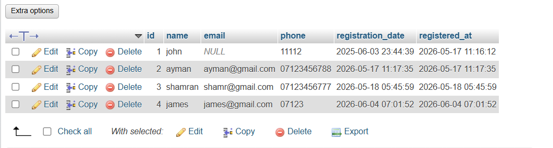Figure 5.10: Customers Table
Stores customer details such as names, phone numbers, and email addresses.

5.5.4 Sales Table
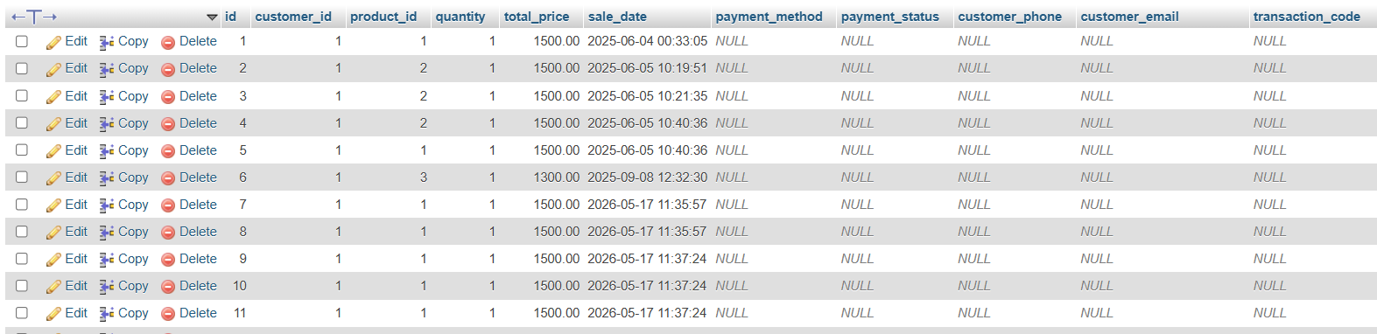Figure 5.11: Sales Table
Stores transaction records including products sold, payment methods, quantities, and transaction codes.

5.5.5 Purchases Table
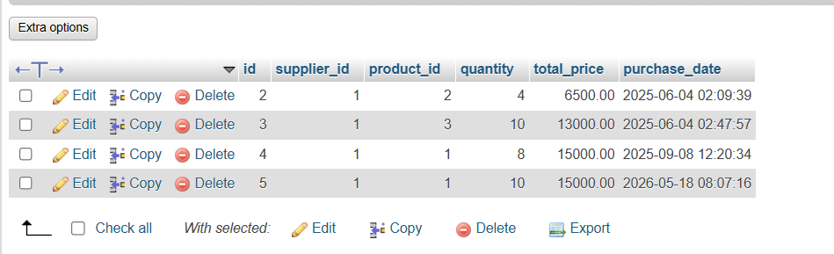Figure 5.12: Purchases Table
Stores stock purchase records from suppliers.

5.6 Input Design
Input design focuses on how data enters the system.
The system accepts the following inputs:
Registration details
Login credentials
Flowers selections
Quantity selection
Payment selection
Table 5.12: Input Requirements
Input | Source
Username | User
Password | User
Flowers item | User
Quantity | User
Payment method | User

To improve data accuracy, validation rules were implemented.
5.7 Output Design
Output design focuses on how information is presented.
The system produces the following outputs:
Login confirmation Menu display
Cart summary Order confirmation Order history
Table 5.13: System Outputs
Output | Description
Menu display | Shows flowers items
Cart summary | Shows selected items
Confirmation message | Confirms order
Order history | Shows previous orders

5.8 Security Design
Security measures were included to protect user information.
Security features include:
Password authentication
Session management
Input validation
Database protection
Table 5.14: Security Features
Feature | Purpose
Authentication | Prevent unauthorized access
Sessions | Maintain user login
Validation | Prevent invalid input

5.9 System Navigation Design
System navigation allows users to move easily between pages.
The navigation structure includes:
Home Page → Login/Register → Menu → Cart → Order Confirmation → Order History
Table 5.15: Navigation Structure
Page | Next Page
Home | Login/Register
Login | Menu
Menu | Cart
Cart  Confirm Order | Confirm Order  Order History

CHAPTER SIX: SYSTEM IMPLEMENTATION SCREENSHOTS

6.1 Development Tools
- VS Code
- XAMPP
- PHP
- MySQL
- HTML
- CSS

6.2 Test Plan
Module | Test
Login | Authentication
Products | Add/Edit/Delete
Customers | Registration
Sales | Recording
Payment | Processing

6.3 Testing Results
Test Case | Expected Result | Actual Result | Status
Login | User accesses dashboard | Dashboard displayed | Pass
Add Product | Product saved | Product saved | Pass
Add Customer | Customer saved | Customer saved | Pass
Add Supplier | Supplier saved | Supplier saved | Pass
Process Payment | Payment confirmed | Payment confirmed | Pass
Generate Receipt | Receipt emailed | Receipt emailed | Pass

6.4 Changeover Strategy
Direct Changeover
This part presents screenshots of the implemented Floral Culture Management System. The screenshots demonstrate the major modules developed including authentication, product management, customer management, supplier management, purchases, sales, cart processing, payment confirmation, and reporting.

Figure 6.1: Login Page
The login page allows administrators and authorized users to securely access the Floral Culture Management System using their credentials.


Figure 6.2: Dashboard
The dashboard provides an overview of the system and allows administrators to access product management, customer management, supplier management, sales, and reporting modules.
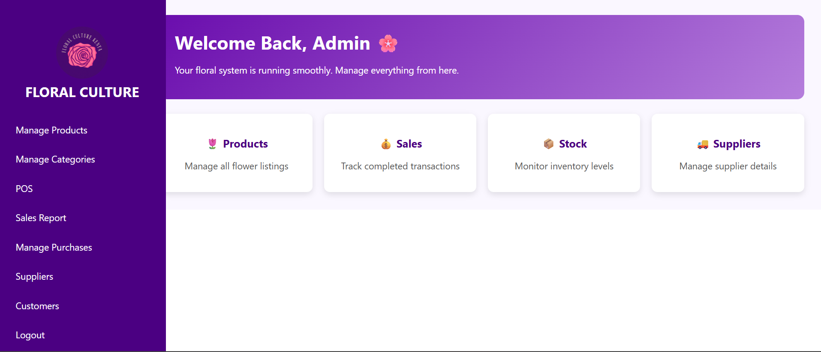

Figure 6.3: Add Category
The category management page enables administrators to create, edit, and delete flower categories used within the system.
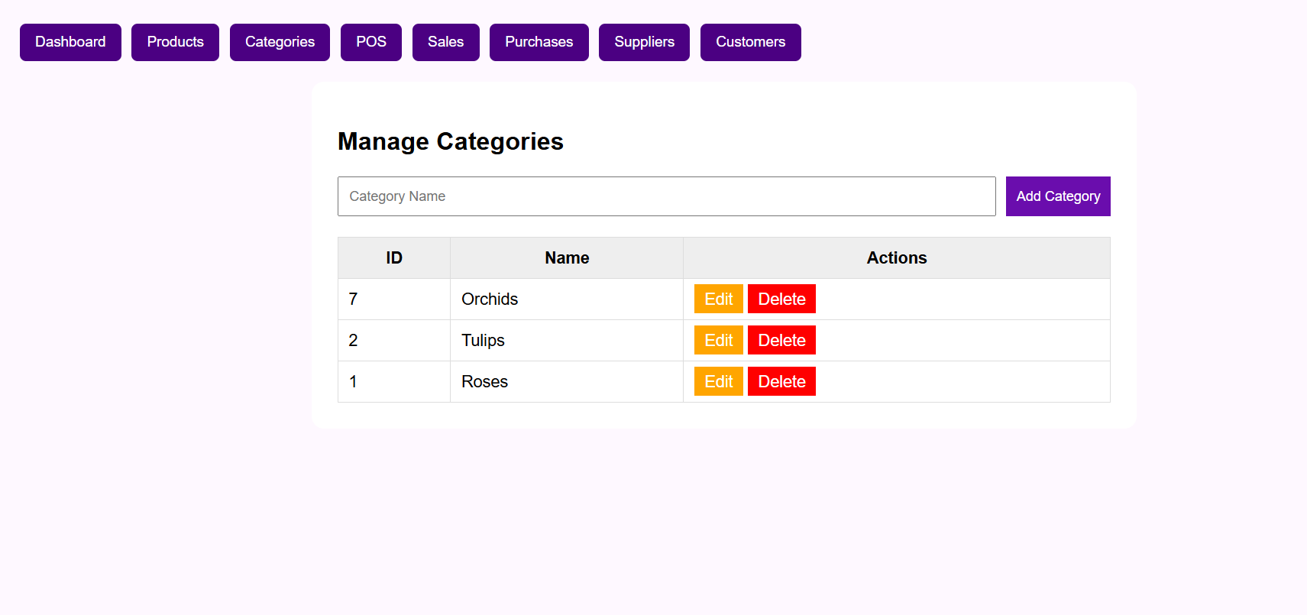

Figure 6.4: Add Product
The product management page allows administrators to add new flowers, update product information, manage stock levels, and upload product images.
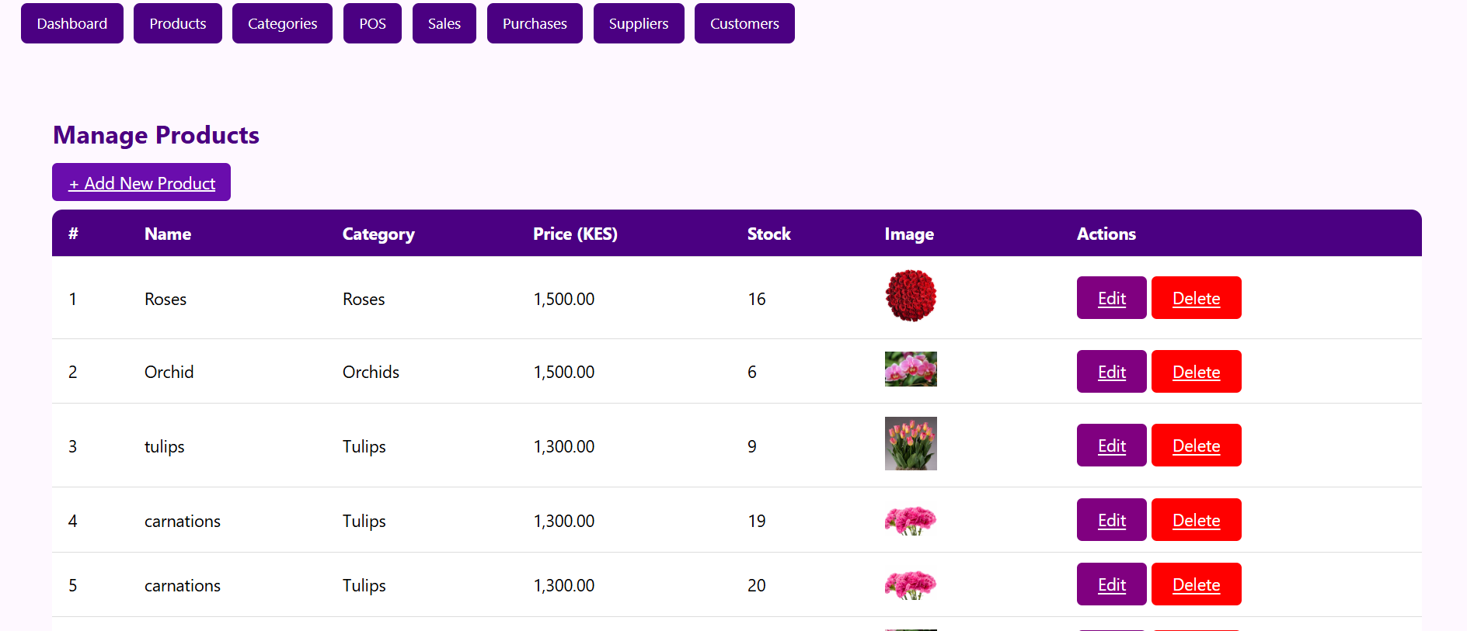

Figure 6.5: Customer Management
The customer management module stores and displays customer information used during sales transactions and reporting.
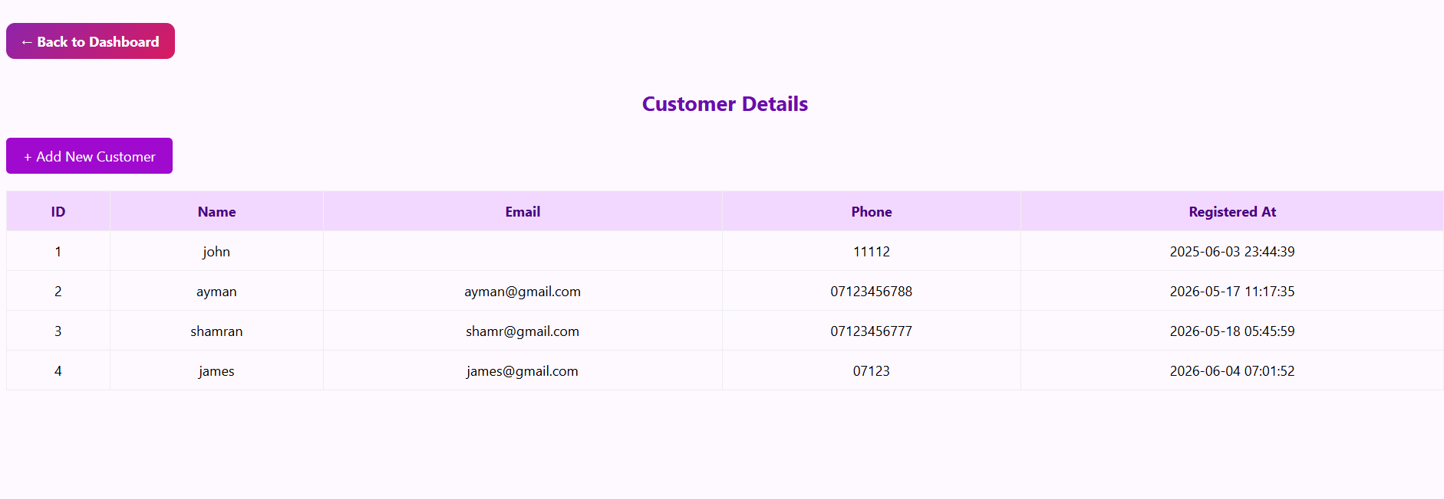

Figure 6.6: Supplier Management
The supplier management page allows administrators to record and manage supplier details for inventory replenishment purposes.
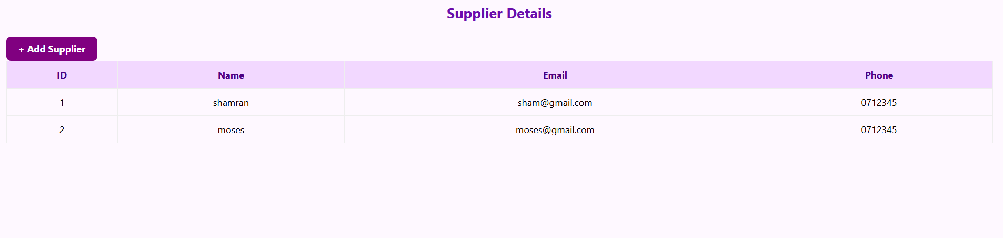

Figure 6.7: Purchase Management
The purchase management module records stock purchases from suppliers and helps track inventory restocking activities.
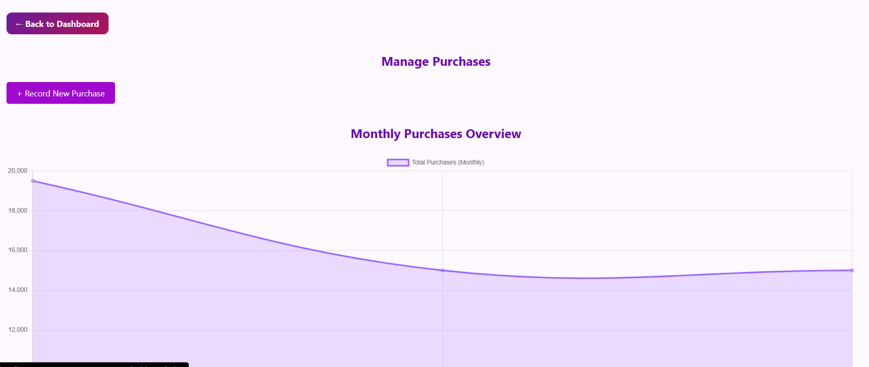

Figure 6.8: Point of Sale (POS)
The Point of Sale interface enables staff to browse available flowers, select products, and initiate customer purchases.
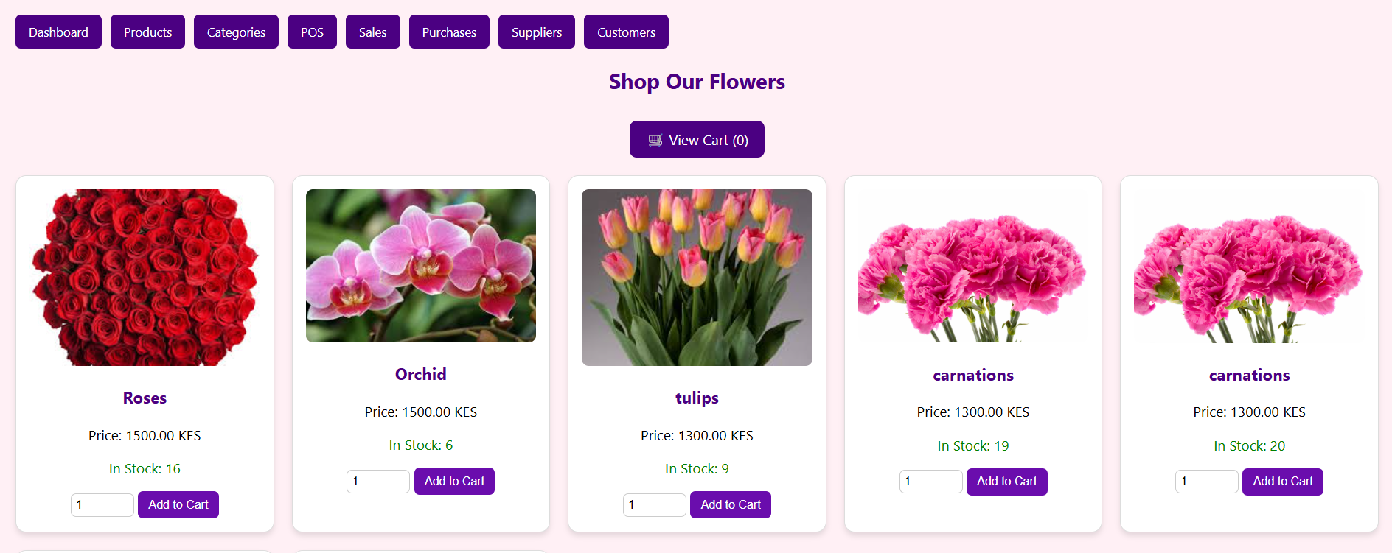

Figure 6.9: View Cart
The cart page displays selected products, quantities, total cost, and customer information before order confirmation.
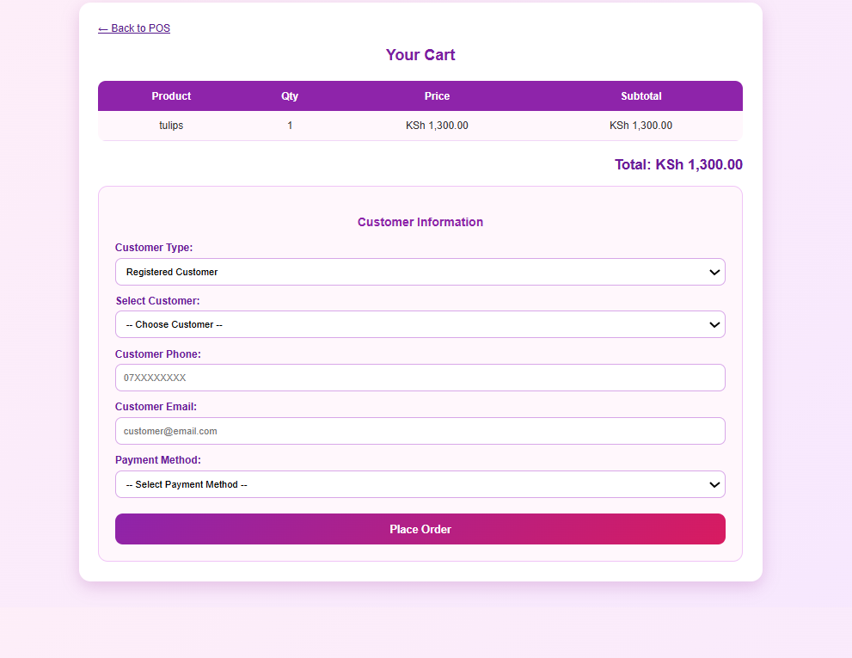

Figure 6.10: Payment Confirmation
The payment confirmation page allows users to verify transaction details and confirm the selected payment method before completing the purchase.
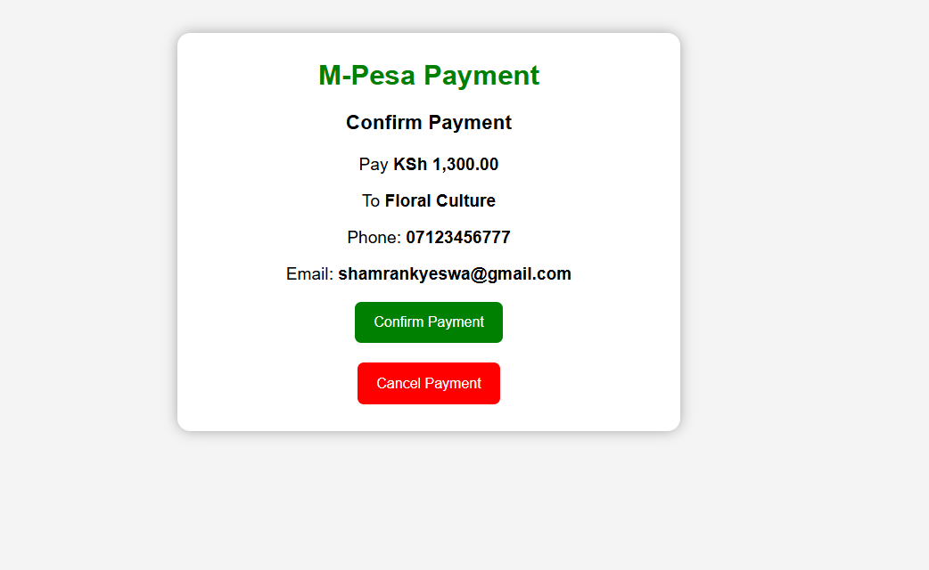

Figure 6.11: Payment Successful
This page confirms that the transaction has been processed successfully and provides a summary of the completed payment.
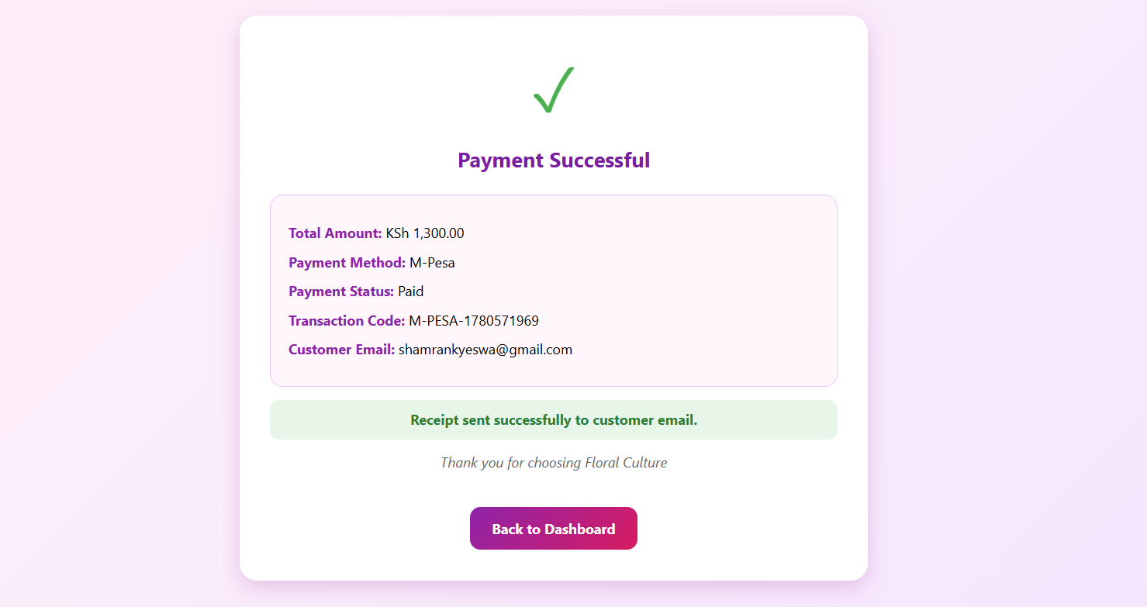

Figure 6.12: Order receipt
The receipt generation module automatically creates and emails a transaction receipt to the customer after a successful purchase.
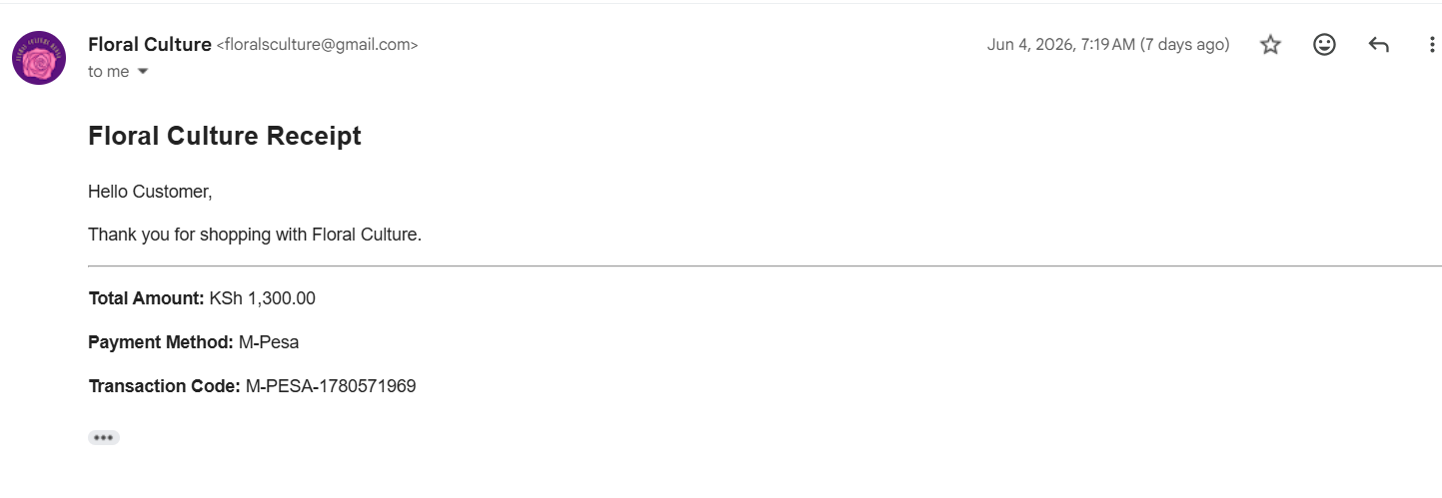

Figure 6.13: Sales Report
The sales report page displays completed transactions and provides information for monitoring business performance and decision-making.
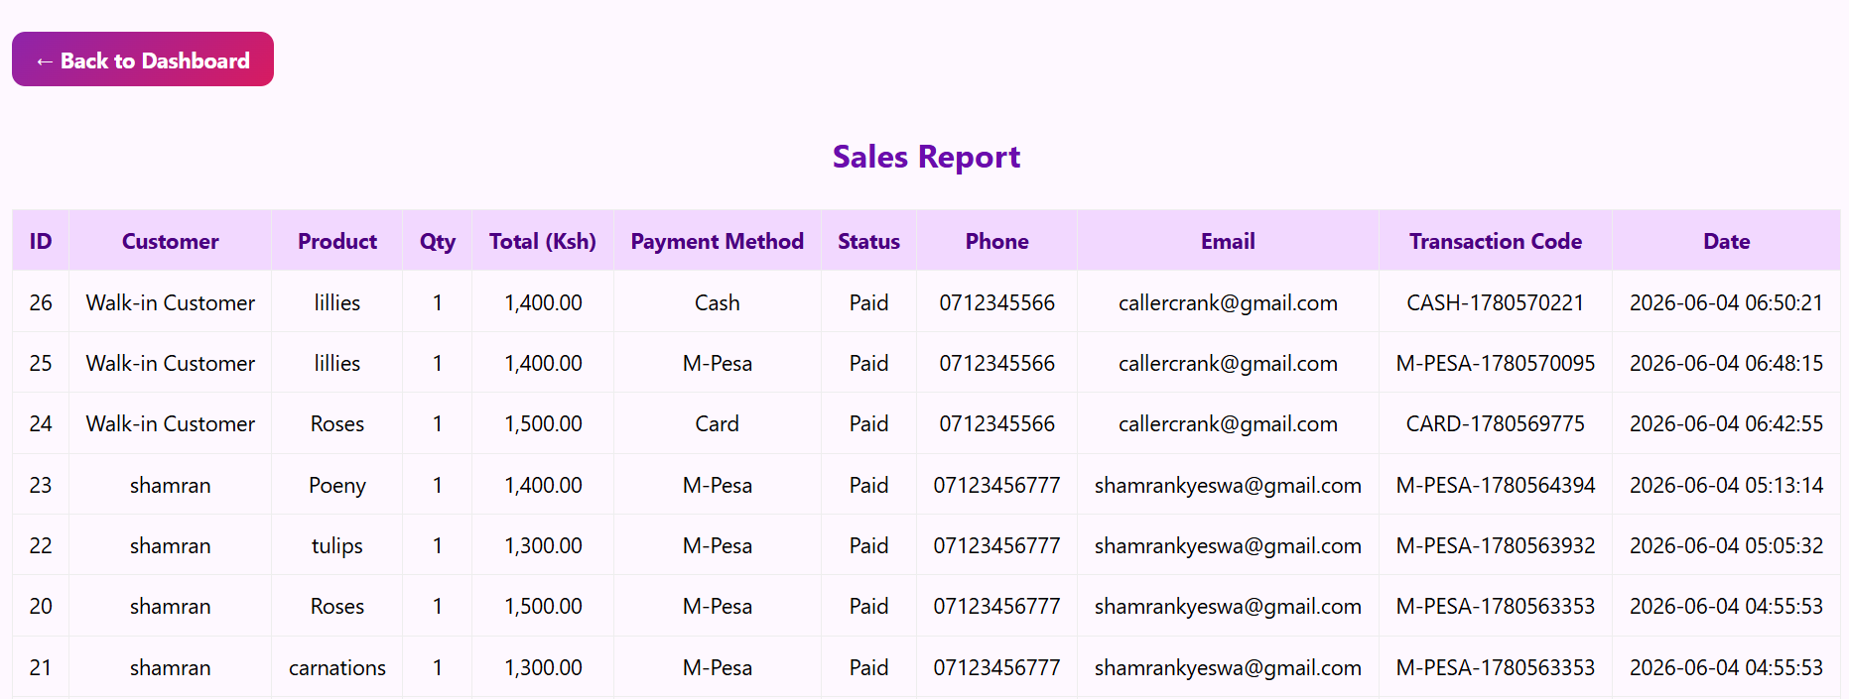

CHAPTER SEVEN: TESTING RESULTS AND CONCLUSION

7.1Testing Results
Module | Expected Result | Status
Login | Admin can access dashboard | Passed
Product Management | Products can be added | Passed
Customer Management | Customers can be registered | Passed
Supplier Management | Suppliers can be managed | Passed
POS | Products can be added to cart | Passed
Payment Module | Payment confirmation generated | Passed
Email Receipt | Receipt emailed to customer | Passed
Sales Report | Sales stored and displayed | Passed

7.2Conclusion
The Floral Culture Management System successfully achieved its objectives by providing a computerized platform for managing products, customers, suppliers, purchases, sales, shopping cart operations, payment processing, and receipt generation. The system improves efficiency, reduces manual record keeping, and enhances customer service.

7.3 Recommendations
Based on the development and testing of the Floral Culture Management System, the following recommendations are proposed for future improvements:
- Real Mobile Payment Integration
The current system uses a simulated payment process. Future versions should integrate real mobile payment services such as M-Pesa STK Push to enable customers to make payments directly from their mobile phones.
- SMS Notification Services
The system can be enhanced by incorporating SMS notifications to inform customers about successful orders, payments, and delivery updates.
- Mobile Application Development
A mobile version of the Floral Culture Management System can be developed to allow customers and staff to access the system using smartphones and tablets.
- Multi-Branch Support
Future versions should support multiple flower shop branches, allowing centralized management of inventory, sales, and customer records across different locations.
- Online Ordering Platform
An e-commerce module can be added to enable customers to browse flowers, place orders, and make payments online without visiting the physical store.
- Enhanced Security Features
Additional security measures such as two-factor authentication, password encryption, and role-based access control should be implemented to improve system security.
- Advanced Reporting and Analytics
Future improvements may include advanced reporting tools with graphical dashboards, sales forecasting, and customer purchasing trend analysis to assist management in decision-making.
- Inventory Prediction System
Artificial Intelligence and machine learning techniques can be incorporated to predict stock requirements based on historical sales data, helping reduce stock shortages and overstocking.
- Customer Loyalty Program
A customer loyalty module can be introduced to reward frequent customers through discounts, points, and promotional offers.
- Cloud-Based Deployment
The system can be deployed on cloud platforms to improve accessibility, scalability, and data backup capabilities while allowing remote access from different locations.

7.4 REFERENCE

W3Schools. (2025). PHP Tutorial. Retrieved from https://www.w3schools.com

Oracle. (2025). MySQL Documentation. Retrieved from https://dev.mysql.com/doc

Mozilla Developer Network. (2025). HTML and CSS Documentation. Retrieved from https://developer.mozilla.org

PHP Official Documentation. (2025). PHP Manual. Retrieved from https://www.php.net/docs.php

XAMPP Documentation. (2025). Apache Friends. Retrieved from https://www.apachefriends.org

W3Schools. (2025). PHP Tutorial. Retrieved from https://www.w3schools.com

Oracle. (2025). MySQL Documentation. Retrieved from https://dev.mysql.com/doc

Mozilla Developer Network. (2025). HTML and CSS Documentation. Retrieved from https://developer.mozilla.org

PHP Official Documentation. (2025). PHP Manual. Retrieved from https://www.php.net/docs.php

XAMPP Documentation. (2025). Apache Friends. Retrieved from https://www.apachefriends.org

7.5 APPENDICE

7.5.1APPENDIX A: SYSTEM FLOWCHART
This APPENDIX presents the system flowchart used in the Floral Culture Management System. The flowchart illustrates the sequence of activities performed by users from login to sales processing and report generation.
Objectives of the Flowchart
• Illustrate system workflow.
• Show decision-making processes.
• Demonstrate interactions between modules.
Description
The process begins when the administrator logs into the system. After successful authentication, the user accesses the dashboard and can manage products, customers, suppliers, sales, and reports. The user can process customer purchases through the POS module, complete payment, generate receipts, and update inventory records automatically

7.5.2 APPENDIX B: ENTITY RELATIONSHIP DIAGRAM (ERD)
The ERD provides a graphical representation of entities and their relationships within the Floral Culture database.
Purpose of the ERD
• Identify database entities.
• Define relationships among entities.
• Support database implementation.

Entity Descriptions
Products
Stores information about flowers available for sale.
Customers
Stores customer registration details.
Sales
Stores completed sales transactions.
Suppliers
Stores supplier information.
Purchases
Stores inventory restocking records.
Categories
Stores flower classification information.
Relationship Analysis
A customer can make multiple purchases. A product can appear in multiple sales transactions. Suppliers provide products that are recorded through purchase transactions.

7.5.3 APPENDIX C: DATABASE RELATIONSHIP DIAGRAM
The database relationship diagram shows the logical structure of the database and illustrates how tables are linked using primary and foreign keys.

Key Relationships
• Customers → Sales
• Products → Sales
• Suppliers → Purchases
• Categories → Products
Database Integrity
The use of primary and foreign keys ensures consistency and prevents duplication of records.

7.5.4 APPENDIX D: SAMPLE SOURCE CODE
Database Connection Code

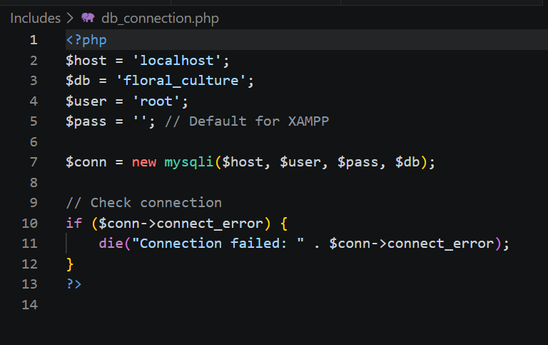
Product Management Code
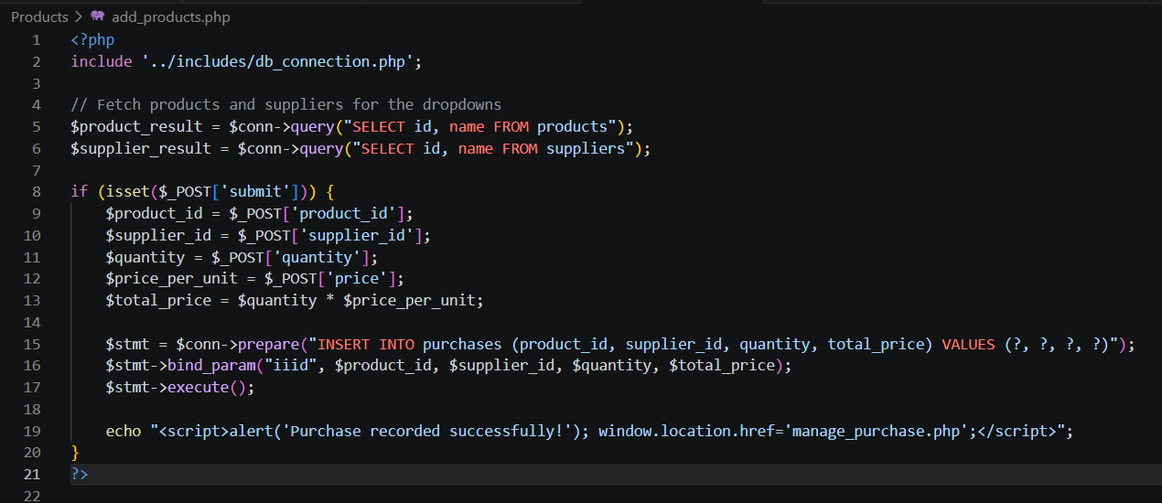

Sales Processing Code
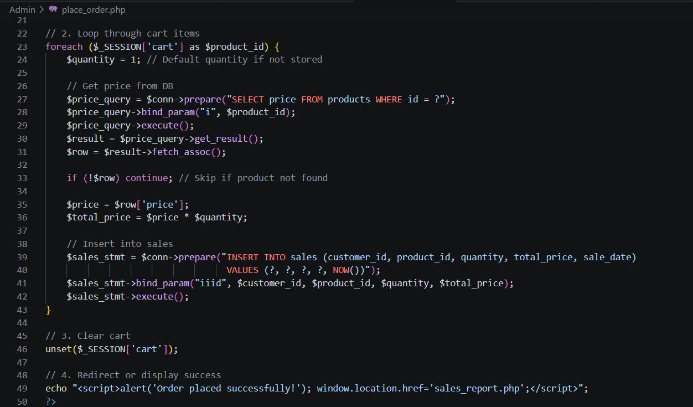

Receipt Generation Code
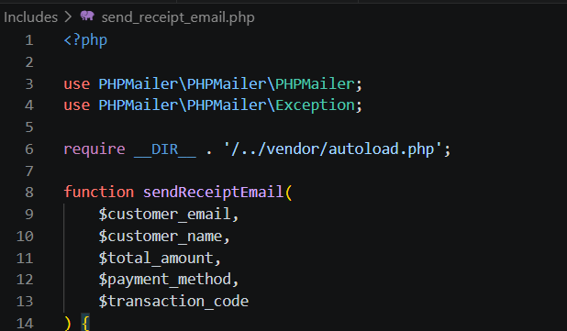
Code Explanation
The code demonstrates the implementation of core system functionality including database connectivity, product management, sales processing, and receipt generation.

7.5APPENDIX E: USER MANUAL
System Login
Step 1: Open the Floral Culture System.
Step 2: Enter username and password.
Step 3: Click Login.
Managing Products
Step 1: Navigate to Products.
Step 2: Click Add Product.
Step 3: Enter product details.
Step 4: Upload product image.
Step 5: Save product.
Managing Customers
Step 1: Open Customer Management.
Step 2: Click Add Customer.
Step 3: Enter customer details.
Step 4: Save information.
Processing Sales
Step 1: Open POS.
Step 2: Select products.
Step 3: Add items to cart.
Step 4: Enter customer details.
Step 5: Select payment method.
Step 6: Confirm payment.
Step 7: Generate receipt.
Generating Reports
Step 1: Open Reports.
Step 2: Select report type.
Step 3: View or print report.

7.6 APPENDIX F: ADDITIONAL SYSTEM SCREENSHOTS
Figure F.1 Login Page

Figure F.2 Dashboard


Figure F.3 Product Management


Figure F.4 Customer Management


Figure F.5 Supplier Management


Figure F.6 POS Page


Figure F.7 Shopping Cart


Figure F.8 Payment Confirmation


Figure F.9 Sales Report


Figure F.10 Receipt Generation


Screenshot Analysis
The screenshots provide evidence of successful implementation and demonstrate the functionality of the Floral Culture Management System.

