CAFE MANAGEMENT SYSTEM
PROJECT FOR INFORMATICS PRACTICES

SUBMITTED BY:

EMAN FAIZAL, CLASS XII B

SUBMITTED TO:

Mrs. SHABANA ANVAR (TEACHER, INFORMATICS PRACTICES)

SUBMITTED AS A PARTIAL FULFILLMENT OF THE SUBJECT INFORMATICS

PRACTICES AS REQUIRED FOR ALL INDIA SENIOR SECONDARY CERTIFICATE

EXAMINATION (AISSCE)

MARCH 2027



BHAVAN’S PUBLIC SCHOOL, DOHA, QATAR

CERTIFICATE

Certified to be a bonafide record of project work titled…….….......………………………………in ……………..…….....………………..…., done by Master/Ms.……………………………………….of class XII ……..in Bhavan’s Public School, Doha, Qatar, during the Academic Year 2026-’27.

Register Number………………………….

Principal: ………………… Teacher In Charge: ………………

Date: ……………...

Submitted for All India Senior Secondary School Practical Examination in Informatics Practices, held at Bhavan’s Public School, Doha, Qatar, in 2026-‘27.

Internal Examiner External Examiner

Name: …………………. Name: ………………….

Signature:…………………………. Signature:………………………….

ACKNOWLEDGEMENT

I would like to extend my deepest appreciation to all those who provided me the possibility to complete this project. First and foremost, I am grateful to the Almighty for his abundant blessings!
With an immense sense of gratitude, I wish to acknowledge and thank our dear Principal,
Mrs. Shanthi CV for her incessant encouragement, constant support and invaluable guidance and the ample facilities rendered to me in completing this project.

My profound thanks are due to my mentor and guide Mrs..………………...………………… for endowing this opportunity and whose contribution in stimulating suggestions and encouragement helped me to coordinate my project. This research project wouldn’t have been possible without the timely assistance of my teachers, parents and peers. My sincere gratitude to each and every one of them.

CONTENT

1. INTRODUCTION
2. SYNOPSIS
3. TABLES
4. SOURCE CODE
5. SAMPLE OUTPUT
6. BIBLIOGRAPHY

INTRODUCTION TO PYTHON

Python is a widely used general-purpose, high level programming language. It was created by Guido van Rossum in 1991 and further developed by the Python Software Foundation. It was designed with an emphasis on code readability, and its syntax allows programmers to express their concepts in fewer lines of code.It can run on various operating systems such as Mac, Windows, Linux, Unix etc. This makes it a cross platform and portable language. Python is a open source programming language.
Python comes with a large standard library that has some handy codes and functions which we can use while writing code in Python.Python supports exception handling which means we can write less error prone code and can test various scenarios that can cause an exception later on.Supports generators and list comprehensions. Python supports automatic memory management which means the memory is cleared and freed automatically.



INTRODUCTION TO CSV

A CSV is a comma-separated values file, which allows data to be saved in a tabular format. It is a delimited text file that uses a comma to separate values. Each line of the file is a data record. Each record consists of one or more fields, separated by commas. The use of the comma as a field separator is the source of the name for this file format. A CSV file typically stores tabular data (numbers and text) in plain text, in which case each line will have the same number of fields.

The CSV file format is not fully standardized. Separating fields with commas is the foundation, but commas in the data or embedded line breaks have to be handled specially. Some implementations disallow such content while others surround the field with quotation marks, which yet again creates the need for escaping if quotation marks are present in the data.

The term "CSV" also denotes several closely-related delimiter-separated formats that use other field delimiters such as semicolons. These include tab-separated values and space-separated values. A delimiter guaranteed not to be part of the data greatly simplifies parsing.



SYNOPSIS

Cafe Management System is a menu-driven application built using Python. It is designed for both admin and employee users to manage day-to-day cafe operations easily. The front-end of the project is Python, which handles all the menus, inputs, and outputs. The back end is made up of CSV files that act as a simple database to store all the data. The admin can manage menu items, manage user accounts, and view all orders, while employees can log customer orders and generate receipts - all from a simple numbered menu without any complicated interface.
Features
- Menu Management - add, edit, delete, and view cafe menu items with categories and prices
- User Management - add, remove, and change roles of admin and employee accounts
- Order Management - log customer orders, generate receipts, and view all orders with total revenue
- Authentication - secure login for admin and employee users
- Graphs - bar chart of top-selling items by quantity and line chart of revenue over time
Uses
- Saves time - no need to maintain paper registers
- Easy to add, edit, or remove menu items at any point
- Receipts give a clear summary of each order instantly
- All data is stored safely in CSV files and updated automatically after every change
- Useful for any small cafe that wants a simple digital record system
This project demonstrates how Python and the Pandas library can build a real-life management system. It supports both admin and employee roles and is menu-driven, making it very easy to operate. Using CSV files as the backend keeps the project simple and lightweight. The project applies key Informatics Practices concepts, such as DataFrames and file handling, in practice. Overall, this project is a clean and functional solution for managing a cafe efficiently.

TABLES

menu.csv

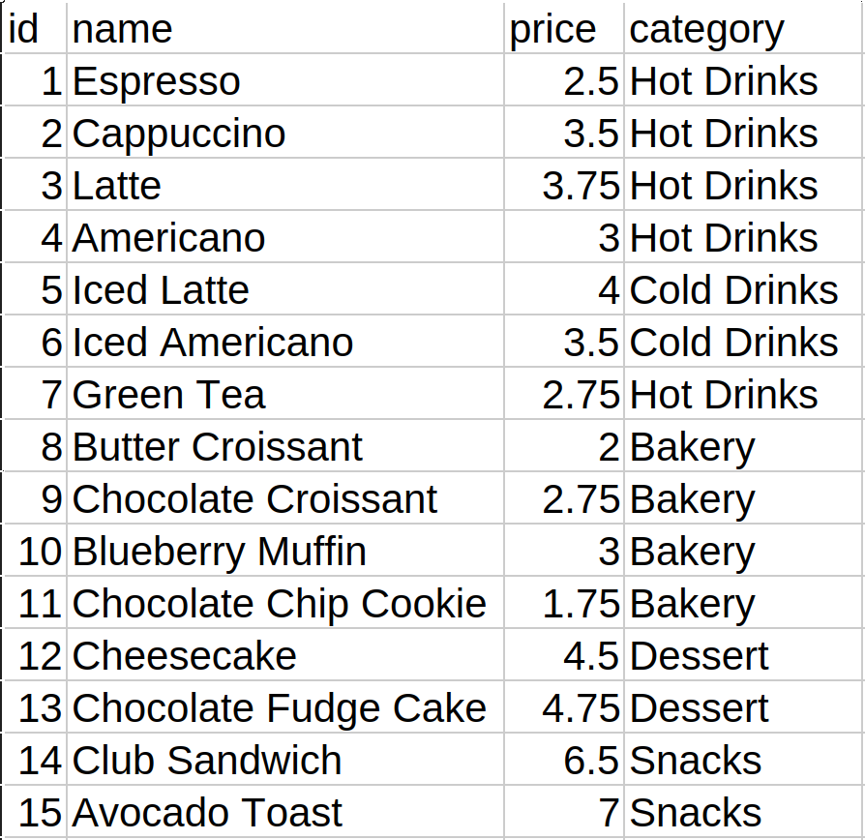
users.csv

orders.csv

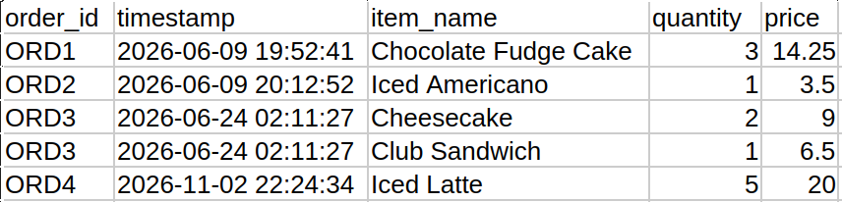

SOURCE CODE
import pandas as pd
import os
import datetime

# --- FILE PATH CONFIGURE ---
BASE_DIR = os.path.dirname(os.path.abspath(__file__))
MENU_FILE = os.path.join(BASE_DIR, "menu.csv")
USERS_FILE = os.path.join(BASE_DIR, "users.csv")
ORDERS_FILE = os.path.join(BASE_DIR, "orders.csv")

# --- DATABASE OPERATIONS USING PANDAS ---

def save_order(order_id, order_cart, menu_df):
"""Logs each item in the cart as a separate row in orders.csv using pandas .loc."""
timestamp = datetime.datetime.now().strftime("%Y-%m-%d %H:%M:%S")

if os.path.exists(ORDERS_FILE):
orders_df = pd.read_csv(ORDERS_FILE)
else:
orders_df = pd.DataFrame(columns=['order_id', 'timestamp', 'item_name', 'quantity', 'price'])

for item_id, qty in order_cart.items():
item_row = menu_df[menu_df['id'] == item_id].iloc[0]
item_price = float(item_row['price']) * qty
orders_df.loc[len(orders_df)] = [order_id, timestamp, item_row['name'], qty, round(item_price, 2)]

orders_df.to_csv(ORDERS_FILE, index=False)

def get_next_order_id():
"""Calculates the next order number based on unique order IDs."""
if not os.path.exists(ORDERS_FILE):
return "ORD1"

try:
orders_df = pd.read_csv(ORDERS_FILE)
if orders_df.empty:
return "ORD1"
unique_order_count = orders_df['order_id'].nunique()
return f"ORD{unique_order_count + 1}"
except Exception:
return "ORD1"

# --- TERMINAL UI FUNCTIONS ---

def clear_screen():
"""Clears the terminal screen."""
os.system('cls' if os.name == 'nt' else 'clear')

def draw_header(title):
"""Draws a frame for section titles."""
border = "=" * 50
print(border)
print(f" {title.upper().center(48)} ")
print(border)

def display_menu_public():
"""Displays the menu in a table using Pandas grouping."""
if not os.path.exists(MENU_FILE):
print("\n[!] The cafe menu is currently empty.")
return

menu_df = pd.read_csv(MENU_FILE)
if menu_df.empty:
print("\n[!] The cafe menu is currently empty.")
return

print("\n" + "-" * 50)
print(f"{'ID':<4} | {'Name':<25} | {'Price':<10}")
print("-" * 50)

categories = menu_df['category'].unique()

for category in categories:
print(f"\n--- {str(category).upper()} ---")
category_rows = menu_df[menu_df['category'] == category]

for _, item in category_rows.iterrows():
print(f"[{int(item['id']):<2}] | {item['name']:<25} | ${float(item['price']):>6.2f}")

print("-" * 50 + "\n")

# --- AUTHENTICATION ---

def login_screen():
"""Asks for credentials, checking users.csv for match"""
draw_header("Account Login")
username = input("Username: ").strip()
password = input("Password: ").strip()

if not os.path.exists(USERS_FILE):
print("\n[!] Database file not found.")
input()
return None

users_df = pd.read_csv(USERS_FILE)

users_list = users_df.to_dict('records')

for user in users_list:
if user['username'] == username and user['password'] == password:
return user

print("\n[!] Invalid username or password. Press Enter to try again.")
input()
return None

# --- EMPLOYEE DASHBOARD & ORDER LOGGING ---

def log_customer_order(employee_user):
"""To select items, calculate sub-total and total, write receipt, and log to file."""
if not os.path.exists(MENU_FILE):
print("\n[!] Cafe menu database not found.")
input("\nPress Enter to return.")
return

menu_df = pd.read_csv(MENU_FILE)
if menu_df.empty:
print("\n[!] Cannot place order. The cafe menu is empty.")
input("\nPress Enter to return.")
return

order_cart = {}

while True:
clear_screen()
draw_header("Create Customer Order")
display_menu_public()

if order_cart:
print("--- CURRENT CART ---")
temp_total = 0.0
for item_id, qty in order_cart.items():
match = menu_df[menu_df['id'] == item_id]
if not match.empty:
item_row = match.iloc[0]
subtotal = float(item_row['price']) * qty
temp_total += subtotal
print(f" * {item_row['name']} x{qty} = ${subtotal:.2f}")
print(f"Current Total: ${temp_total:.2f}")
print("-" * 50)

print("\nCommands: Enter 'done' to complete order, or 'cancel' to exit.")
choice = input("Enter Item ID to add: ").strip().lower()

if choice == 'cancel':
print("\n[-] Order discarded.")
input("Press Enter to return.")
return

if choice == 'done':
if not order_cart:
print("\n[!] Cart is empty. Cannot complete order.")
input("Press Enter to continue.")
continue
break

try:
item_id = int(choice)
except ValueError:
print("\n[!] Please enter a valid numerical ID, 'done', or 'cancel'.")
input("Press Enter to try again.")
continue

match = menu_df[menu_df['id'] == item_id]
if match.empty:
print("\n[!] Item ID not found in menu.")
input("Press Enter to try again.")
continue

selected_item = match.iloc[0]

qty_input = input(f"Enter quantity for {selected_item['name']}: ").strip()
try:
qty = int(qty_input)
if qty <= 0:
print("\n[!] Quantity must be greater than zero.")
input("Press Enter to try again.")
continue
except ValueError:
print("\n[!] Quantity must be a valid number.")
input("Press Enter to try again.")
continue

order_cart[item_id] = order_cart.get(item_id, 0) + qty
print(f"\n[+] Added {qty}x {selected_item['name']} to cart.")

order_id = get_next_order_id()
total_price = 0.0

clear_screen()
draw_header("Order Receipt")
print(f"Order ID: {order_id}")
print(f"Server: {employee_user['name']}")
print(f"Date/Time: {datetime.datetime.now().strftime('%Y-%m-%d %H:%M:%S')}")
print("-" * 50)
print(f"{'Item Name':<25} | {'Qty':<5} | {'Price':<8} | {'Total':<8}")
print("-" * 50)

for item_id, qty in order_cart.items():
item_row = menu_df[menu_df['id'] == item_id].iloc[0]
price = float(item_row['price'])
subtotal = price * qty
total_price += subtotal
print(f"{item_row['name']:<25} | {qty:<5} | ${price:>6.2f} | ${subtotal:>6.2f}")

print("-" * 50)
print(f"{'GRAND TOTAL:':<40} ${total_price:>7.2f}")
print("-" * 50)

save_order(order_id, order_cart, menu_df)

print("\n[+] Order successfully logged and saved to database.")
input("\nPress Enter to return to Employee Menu.")

def employee_dashboard(employee_user):
"""Menu displayed only to authenticated Employee users."""
while True:
clear_screen()
draw_header(f"Employee Dashboard: {employee_user['name']}")
print("1. Log New Customer Order")
print("2. Logout")
print("-" * 50)

choice = input("Select an option (1-2): ").strip()

if choice == "1":
log_customer_order(employee_user)
elif choice == "2":
print("\nLogging out...")
break
else:
print("\n[!] Invalid input. Press Enter to retry.")
input()

# --- ADMIN DASHBOARD & MANAGEMENT ---

def _read_menu():
if not os.path.exists(MENU_FILE):
return pd.DataFrame(columns=['id', 'name', 'price', 'category'])
try:
return pd.read_csv(MENU_FILE)
except Exception:
return pd.DataFrame(columns=['id', 'name', 'price', 'category'])

def _save_menu(menu_df):
menu_df.to_csv(MENU_FILE, index=False)

def _read_users():
if not os.path.exists(USERS_FILE):
return pd.DataFrame(columns=['username', 'password', 'role', 'name', 'hourly_wage', 'contact_number'])
try:
return pd.read_csv(USERS_FILE)
except Exception:
return pd.DataFrame(columns=['username', 'password', 'role', 'name', 'hourly_wage', 'contact_number'])

def _save_users(users_df):
users_df.to_csv(USERS_FILE, index=False)

def add_menu_item():
clear_screen()
draw_header("Add Menu Item")
name = input("Item name: ").strip()
if not name:
print("\n[!] Name cannot be empty.")
input("Press Enter to return.")
return
price_input = input("Price: ").strip()
try:
price = float(price_input)
if price <= 0:
raise ValueError
except ValueError:
print("\n[!] Price must be a positive number.")
input("Press Enter to return.")
return
category = input("Category: ").strip()
if not category:
print("\n[!] Category cannot be empty.")
input("Press Enter to return.")
return

menu_df = _read_menu()
if menu_df.empty:
new_id = 1
else:
new_id = int(menu_df['id'].max()) + 1

new_row = pd.DataFrame([[new_id, name, round(price, 2), category]],
columns=['id', 'name', 'price', 'category'])
menu_df = pd.concat([menu_df, new_row], ignore_index=True)
_save_menu(menu_df)
print(f"\n[+] Added item '{name}' with ID {new_id}.")
input("Press Enter to return.")

def edit_menu_item():
clear_screen()
draw_header("Edit Menu Item")
menu_df = _read_menu()
if menu_df.empty:
print("\n[!] Menu is empty.")
input("Press Enter to return.")
return
display_menu_public()
id_input = input("Enter Item ID to edit: ").strip()
try:
item_id = int(id_input)
except ValueError:
print("\n[!] Invalid ID.")
input("Press Enter to return.")
return
mask = menu_df['id'] == item_id
if not mask.any():
print("\n[!] Item ID not found.")
input("Press Enter to return.")
return

idx = menu_df[mask].index[0]
current = menu_df.loc[idx]
print(f"\nCurrent: {current['name']} | ${float(current['price']):.2f} | {current['category']}")
print("Leave a field blank to keep its current value.")

new_name = input(f"New name [{current['name']}]: ").strip()
new_price_input = input(f"New price [{float(current['price']):.2f}]: ").strip()
new_category = input(f"New category [{current['category']}]: ").strip()

if new_name:
menu_df.at[idx, 'name'] = new_name
if new_price_input:
try:
new_price = float(new_price_input)
if new_price <= 0:
raise ValueError
menu_df.at[idx, 'price'] = round(new_price, 2)
except ValueError:
print("\n[!] Invalid price. Edit cancelled.")
input("Press Enter to return.")
return
if new_category:
menu_df.at[idx, 'category'] = new_category

_save_menu(menu_df)
print("\n[+] Item updated.")
input("Press Enter to return.")

def delete_menu_item():
clear_screen()
draw_header("Delete Menu Item")
menu_df = _read_menu()
if menu_df.empty:
print("\n[!] Menu is empty.")
input("Press Enter to return.")
return
display_menu_public()
id_input = input("Enter Item ID to delete: ").strip()
try:
item_id = int(id_input)
except ValueError:
print("\n[!] Invalid ID.")
input("Press Enter to return.")
return
mask = menu_df['id'] == item_id
if not mask.any():
print("\n[!] Item ID not found.")
input("Press Enter to return.")
return

item_name = menu_df.loc[mask, 'name'].iloc[0]
confirm = input(f"Delete '{item_name}'? (y/n): ").strip().lower()
if confirm != 'y':
print("\n[-] Cancelled.")
input("Press Enter to return.")
return

menu_df = menu_df[~mask].reset_index(drop=True)
_save_menu(menu_df)
print("\n[+] Item deleted.")
input("Press Enter to return.")

def add_user():
clear_screen()
draw_header("Add User")
users_df = _read_users()
username = input("Username: ").strip()
if not username:
print("\n[!] Username cannot be empty.")
input("Press Enter to return.")
return
if (not users_df.empty) and (username in users_df['username'].astype(str).values):
print("\n[!] Username already exists.")
input("Press Enter to return.")
return
password = input("Password: ").strip()
if not password:
print("\n[!] Password cannot be empty.")
input("Press Enter to return.")
return
name = input("Name: ").strip()
if not name:
print("\n[!] Name cannot be empty.")
input("Press Enter to return.")
return
print("Role: 1. Admin 2. Employee")
role_choice = input("Select role (1-2): ").strip()
if role_choice == "1":
role = "admin"
elif role_choice == "2":
role = "employee"
else:
print("\n[!] Invalid role.")
input("Press Enter to return.")
return

new_row = pd.DataFrame([[username, password, role, name, 0.0, "N/A"]],
columns=['username', 'password', 'role', 'name', 'hourly_wage', 'contact_number'])
users_df = pd.concat([users_df, new_row], ignore_index=True)
_save_users(users_df)
print(f"\n[+] User '{username}' added as {role}.")
input("Press Enter to return.")

def view_users():
clear_screen()
draw_header("All Users")
users_df = _read_users()
if users_df.empty:
print("\n[!] No users found.")
input("Press Enter to return.")
return
print(f"{'Username':<15} | {'Name':<20} | {'Role':<10}")
print("-" * 50)
for _, u in users_df.iterrows():
print(f"{str(u['username']):<15} | {str(u['name']):<20} | {str(u['role']):<10}")
print("-" * 50)
input("Press Enter to return.")

def remove_user():
clear_screen()
draw_header("Remove User")
users_df = _read_users()
if users_df.empty:
print("\n[!] No users found.")
input("Press Enter to return.")
return
view_users_inline(users_df)
username = input("Enter username to remove: ").strip()
if (users_df.empty) or (username not in users_df['username'].astype(str).values):
print("\n[!] User not found.")
input("Press Enter to return.")
return
confirm = input(f"Remove user '{username}'? (y/n): ").strip().lower()
if confirm != 'y':
print("\n[-] Cancelled.")
input("Press Enter to return.")
return
users_df = users_df[users_df['username'].astype(str) != username].reset_index(drop=True)
_save_users(users_df)
print("\n[+] User removed.")
input("Press Enter to return.")

def view_users_inline(users_df):
print(f"{'Username':<15} | {'Name':<20} | {'Role':<10}")
print("-" * 50)
for _, u in users_df.iterrows():
print(f"{str(u['username']):<15} | {str(u['name']):<20} | {str(u['role']):<10}")
print("-" * 50)

def change_user_role():
clear_screen()
draw_header("Change User Role")
users_df = _read_users()
if users_df.empty:
print("\n[!] No users found.")
input("Press Enter to return.")
return
view_users_inline(users_df)
username = input("Enter username: ").strip()
if username not in users_df['username'].astype(str).values:
print("\n[!] User not found.")
input("Press Enter to return.")
return
print("New role: 1. Admin 2. Employee")
role_choice = input("Select role (1-2): ").strip()
if role_choice == "1":
new_role = "admin"
elif role_choice == "2":
new_role = "employee"
else:
print("\n[!] Invalid role.")
input("Press Enter to return.")
return
idx = users_df[users_df['username'].astype(str) == username].index[0]
users_df.at[idx, 'role'] = new_role
_save_users(users_df)
print(f"\n[+] Role updated to {new_role}.")
input("Press Enter to return.")

def view_all_orders():
clear_screen()
draw_header("All Orders")
if not os.path.exists(ORDERS_FILE):
print("\n[!] No orders found.")
input("Press Enter to return.")
return
try:
orders_df = pd.read_csv(ORDERS_FILE)
except Exception:
print("\n[!] Could not read orders file.")
input("Press Enter to return.")
return
if orders_df.empty:
print("\n[!] No orders found.")
input("Press Enter to return.")
return
print(orders_df.to_string(index=False))
print("-" * 50)
try:
total = orders_df['price'].astype(float).sum()
print(f"Total revenue (sum of line prices): ${total:.2f}")
except Exception:
pass
input("\nPress Enter to return.")

def view_sales_charts():
clear_screen()
draw_header("Sales Charts")
if not os.path.exists(ORDERS_FILE):
print("\n[!] No orders found.")
input("Press Enter to return.")
return
try:
orders_df = pd.read_csv(ORDERS_FILE)
except Exception:
print("\n[!] Could not read orders file.")
input("Press Enter to return.")
return
if orders_df.empty:
print("\n[!] No orders found.")
input("Press Enter to return.")
return

try:
import matplotlib.pyplot as plt
except Exception as e:
print(f"\n[!] matplotlib not available: {e}")
input("Press Enter to return.")
return

# Top-selling items by quantity
item_qty = orders_df.groupby('item_name')['quantity'].sum().sort_values(ascending=True)
# Revenue over time by day
orders_df['timestamp'] = pd.to_datetime(orders_df['timestamp'], errors='coerce')
revenue_by_day = orders_df.dropna(subset=['timestamp']).groupby(orders_df['timestamp'].dt.date)['price'].sum()

fig, axes = plt.subplots(1, 2, figsize=(12, 5))

# Bar chart: top-selling items
axes[0].barh(item_qty.index, item_qty.values, color='steelblue')
axes[0].set_title('Top-Selling Items (by quantity)')
axes[0].set_xlabel('Quantity sold')
axes[0].set_ylabel('Item')

# Line chart: revenue over time
if not revenue_by_day.empty:
axes[1].plot(list(revenue_by_day.index), list(revenue_by_day.values), marker='o', color='darkorange')
axes[1].set_title('Revenue Over Time')
axes[1].set_xlabel('Date')
axes[1].set_ylabel('Revenue ($)')
axes[1].tick_params(axis='x', rotation=45)
else:
axes[1].text(0.5, 0.5, 'No dated orders', ha='center', va='center')
axes[1].set_title('Revenue Over Time')

fig.tight_layout()
chart_path = os.path.join(BASE_DIR, "sales_charts.png")
fig.savefig(chart_path, dpi=100)
plt.close(fig)
print(f"\n[+] Chart saved to {chart_path}")
try:
import sys
import subprocess
if sys.platform.startswith("win"):
os.startfile(chart_path)
elif sys.platform == "darwin":
subprocess.Popen(["open", chart_path])
else:
subprocess.Popen(["xdg-open", chart_path])
print("[+] Opening chart in your image viewer...")
except Exception as e:
print(f"[!] Could not open viewer: {e}")
input("Press Enter to return.")

def admin_dashboard(admin_user):
"""Menu displayed only to authenticated Admin users."""
while True:
clear_screen()
draw_header(f"Admin Dashboard: {admin_user['name']}")
print("1. Add Menu Item")
print("2. Edit Menu Item")
print("3. Delete Menu Item")
print("4. View Full Menu")
print("5. Add User")
print("6. View All Users")
print("7. Remove User")
print("8. Change User Role")
print("9. View All Orders")
print("10. View Sales Charts")
print("11. Logout")
print("-" * 50)

choice = input("Select an option (1-11): ").strip()

if choice == "1":
add_menu_item()
elif choice == "2":
edit_menu_item()
elif choice == "3":
delete_menu_item()
elif choice == "4":
clear_screen()
draw_header("Cafe Menu Items")
display_menu_public()
input("Press Enter to return.")
elif choice == "5":
add_user()
elif choice == "6":
view_users()
elif choice == "7":
remove_user()
elif choice == "8":
change_user_role()
elif choice == "9":
view_all_orders()
elif choice == "10":
view_sales_charts()
elif choice == "11":
print("\nLogging out...")
break
else:
print("\n[!] Invalid input. Press Enter to retry.")
input()

# --- MAIN ENTRY POINT ---

def main():
"""Main loop for the Cafe Management System."""
while True:
clear_screen()
draw_header("Welcome to the Cafe Management System")
print("1. View Current Menu")
print("2. User Login (Employee / Admin)")
print("3. Exit System")
print("-" * 50)

choice = input("Select an option (1-3): ").strip()

if choice == "1":
clear_screen()
draw_header("Cafe Menu Items")
display_menu_public()
input("Press Enter to return to main menu.")

elif choice == "2":
clear_screen()
user_session = login_screen()
if user_session:
if user_session['role'] == 'admin':
admin_dashboard(user_session)
elif user_session['role'] == 'employee':
employee_dashboard(user_session)

elif choice == "3":
clear_screen()
print("\nShutting down system. Have a great day!\n")
break
else:
print("\n[!] Invalid option. Press Enter to try again.")
input()

if __name__ == "__main__":
main()

SAMPLE OUTPUT
1. View Current Menu

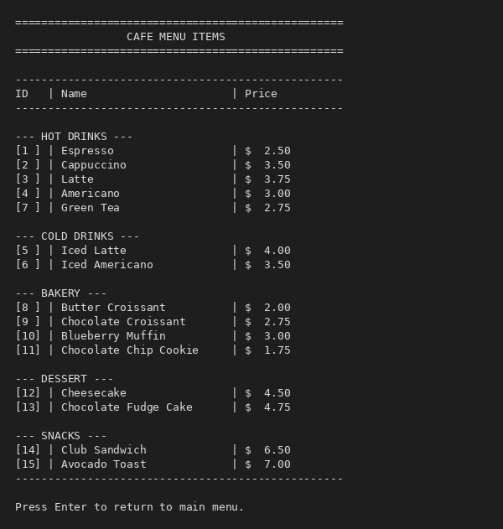

2. User Login

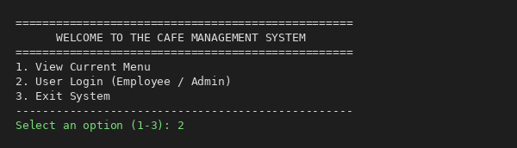

3. Log New Customer Order

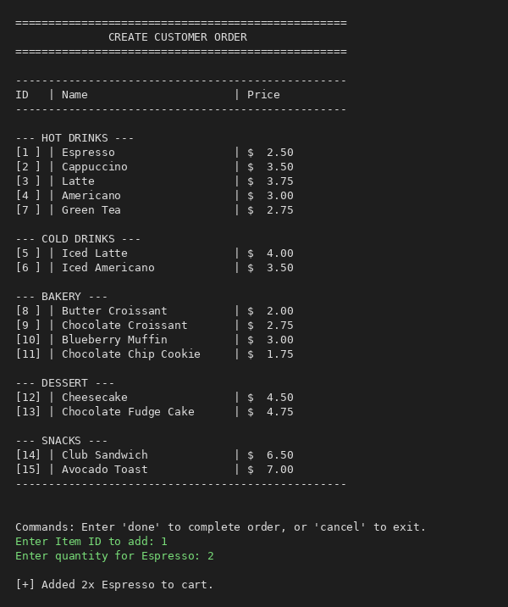

4. Order Receipt

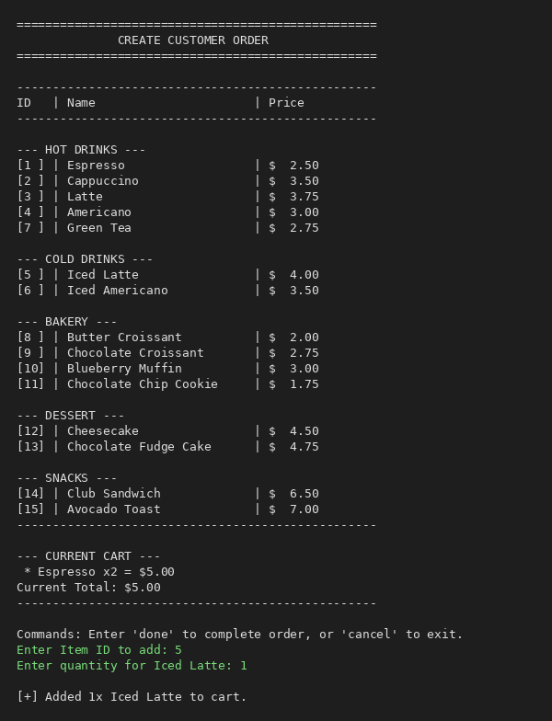

5. Admin Dashboard

6. Add Menu Item

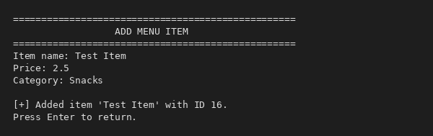

7. Edit Menu Item

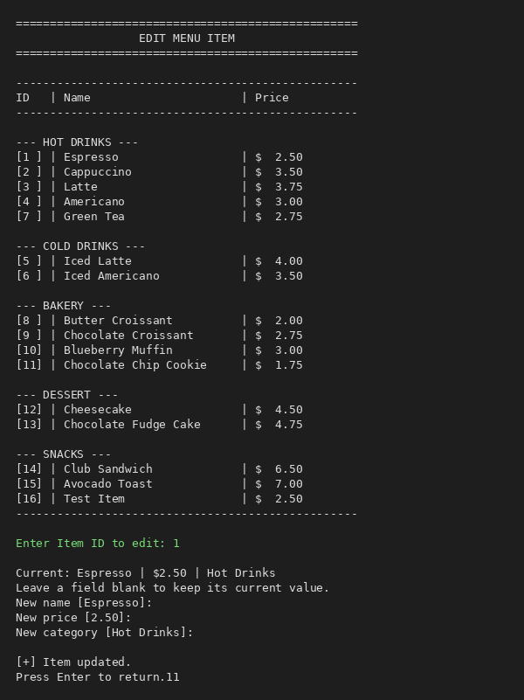

8. Delete Menu Item

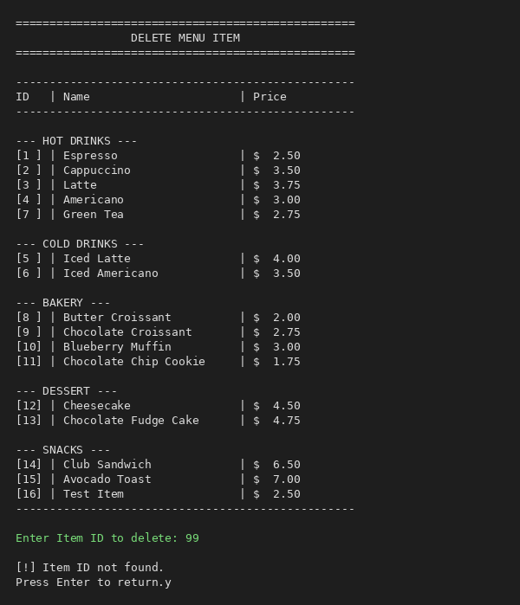

9. View Full Menu

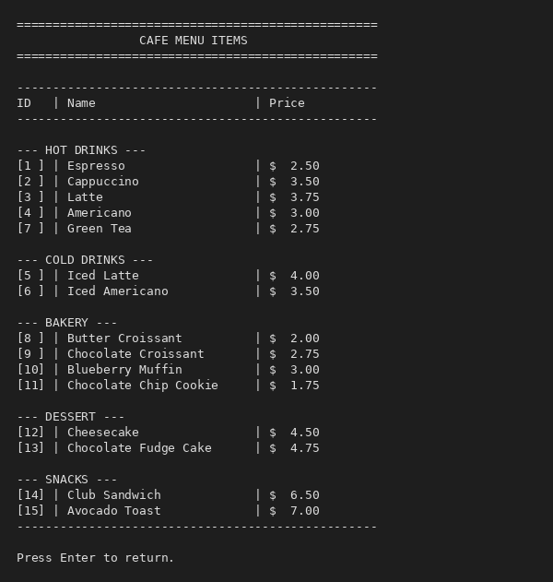

10. Add User

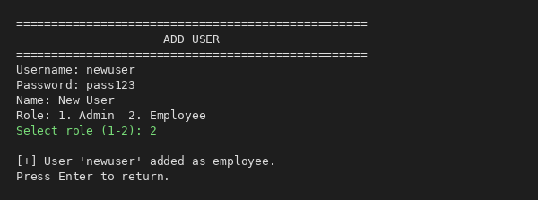

11. View All Users

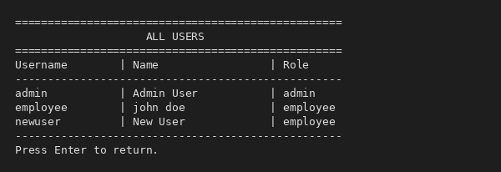

12. Remove User

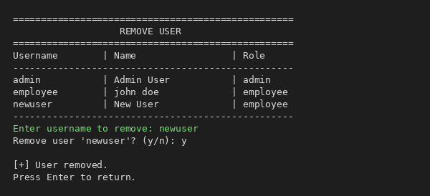

13. Change User Role

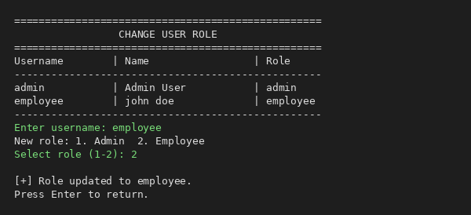

14. View All Orders

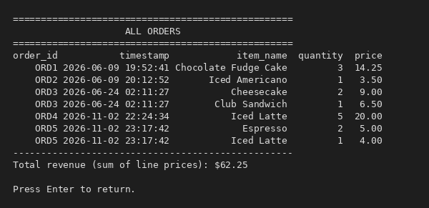

15. View Sales Charts

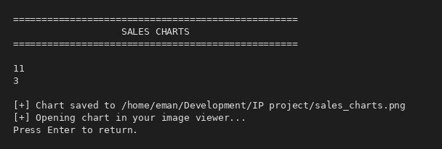

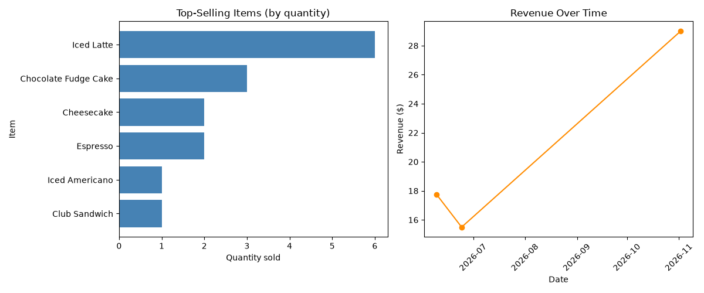

16. Exit

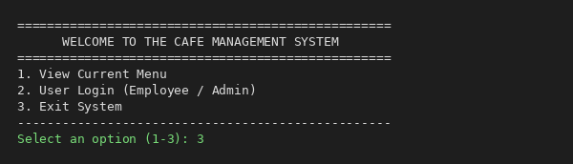

17. Entering An Invalid Option

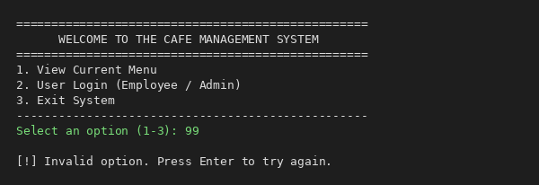

BIBLIOGRAPHY

Preeti Arora, Informatics Practices with Python – Class XII

NCERT, Informatics Practices – Class XII

Claude – https://claude.ai – used to understand the code, debug errors, and improve input validation.

