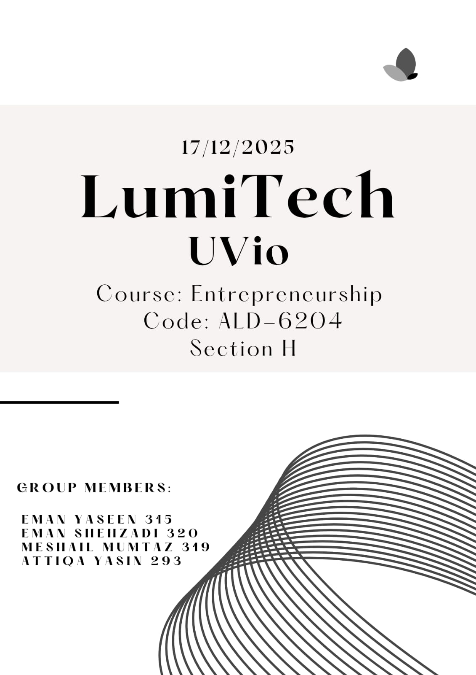

Executive Summary:
The COVID-19 pandemic significantly changed global attitudes toward hygiene and cleanliness. Even after the pandemic, awareness about germs, viruses, and personal safety remains high. However, traditional hygiene solutions such as sanitizer bottles, wipes, and sprays are often inconvenient to carry, wasteful, harmful to electronic devices, and frequently forgotten when people are on the move. This problem is especially visible in developing countries like Pakistan, where public hygiene awareness is growing but access to smart, affordable hygiene tools remain limited.
UVio is an innovative portable hygiene keychain developed by LumiTech to address this issue. It is a compact 3-in-1 device that combines a UV-C sterilizer, a mini sanitizer spray, and an LED flashlight. The product allows users to instantly disinfect small everyday items such as mobile phones, keys, earphones, masks, and currency notes anytime and anywhere.
The primary target customers include students, office workers, travelers, and health-conscious individuals who require quick, reliable, and portable hygiene solutions. UVio stands out due to its affordability, eco-friendly reusable design, compact size, and multi-functionality. By offering a locally made hygiene innovation, UVio aims to redefine everyday cleanliness and make modern hygiene technology accessible to everyone.
Problem Identification
- Identified Problem:
After COVID-19, hygiene has become a daily necessity rather than a luxury. Despite increased awareness, people still struggle to maintain cleanliness in public and shared spaces. Traditional sanitizing methods such as liquid sanitizers, wipes, and sprays are not always practical or sustainable.
- Who Experiences This Problem:
- Students using shared desks, books, and transport.
- Office workers touching shared equipment and surfaces.
- Travelers and commuters using public transport.
- Individuals handling cash and mobile phones frequently.
- Why This Issue Is Important:
- Germs on frequently touched items can cause illness.
- Excessive use of alcohol-based sanitizers leads to dry skin.
- Single-use wipes contribute to environmental pollution.
- Electronic devices can be damaged by liquid sanitizers.

- Supporting Observations:
Informal surveys and observations revealed that many people sanitize their hands but ignore personal items like phones and keys. Public transport users rarely have access to quick disinfection options, increasing the risk of germ transmission.
Idea Generation and Selection
- Initial Business Ideas:
- Smart sanitizer vending machines
- Disposable antibacterial wipes brand
- UV-based phone sterilization box
- Portable UV hygiene keychain (UVio)
- Selection Criteria:
  - Affordability
  - Portability
  - Environmental sustainability
  - Ease of daily use
  - Market demand
- Final Selected Idea:
UVio was selected because it combines multiple hygiene functions into one compact, reusable, and affordable device. Unlike bulky UV boxes or disposable products, UVio fits modern lifestyles.
- Innovation Aspect:
- 3-in-1 multifunction device
- Chemical-free UV-C disinfection
- Rechargeable and eco-friendly design
- Keychain-sized portability
Customer & Market Analysis
- Target Customer Profile:
- Age: 16–45 years
- Gender: Male & Female
- Location: Urban & semi-urban areas
- Income level: Middle-income groups
- Needs: Convenience, hygiene, portability, affordability

- Competitor Analysis:
- PhoneSoap – Expensive, bulky UV sterilizer
- Xiaomi UV Sterilizer – Imported, limited availability
- Sanitizer Brands – Single-use, chemical-based
- Market Gap:
- Lack of locally made, affordable UV hygiene gadgets.
- No compact multi-purpose hygiene solution.
- KYC Insights:
Customers want fast, safe, and reusable hygiene tools that do not damage electronics and are easy to carry.
- Website Benchmarking:
Competitor websites focus on premium pricing and limited features, while UVio emphasizes affordability, simplicity, and local relevance.
Marketing Strategy – The 7 Ps
- Product:
- 3-in-1 portable hygiene device.
- UV-C sterilizer for chemical-free disinfection.
- Mini sanitizer spray for quick use.
- LED flashlight for added utility.
- Rechargeable, eco-friendly battery.
- Compact keychain design.
- Price:
- Affordable mid-range pricing strategy.
- Lower cost than imported UV devices.
- Value-for-money for students and professionals.
- Competitive pricing with quality assurance.
- Place:
- Company website and online stores.
- E-commerce platforms (e.g., Daraz).
- Retail electronics and gadget shops.
- University campuses and office stalls.
- Promotion:
- Social media marketing (Instagram, Facebook, TikTok).
- Influencer collaborations and product reviews.
- Hygiene awareness campaigns.
- Product demonstration videos.
- People:
- Trained customer support staff.
- Sales representatives for retail and bulk orders.
- Technical support for after-sales service.
- Friendly, customer-focused team
- Process:
- Customer places order online or in store.
- Secure and simple payment process.
- Product quality check and packaging.
- Fast delivery and customer confirmation.
- Warranty and after-sales support.
- Physical Evidence:
- Professionally branded packaging.
- Informative and user-friendly website.
- Printed user manual and safety guide.
- Product design reflecting quality and trust
Branding Elements
- Mission Statement:
“Our mission is to deliver innovative hygiene solutions that blend modern UV technology, eco-friendly design, and everyday usability — ensuring that cleanliness is always within reach.”
- Vision Statement:
“To redefine everyday hygiene through smart, sustainable, and affordable technology — empowering people to live cleaner, healthier lives.”
- Logo:


- Slogan:
"Clean Anywhere, Anytime"
- Tagline:
"Your Pocket Hygiene Partner"
Business Plan
- Business Overview:
- UVio is a consumer electronics hygiene product developed by LumiTech.
- It operates at the intersection of the personal care and tech accessories industries.
- The business focuses on providing portable, affordable, and modern hygiene solutions.
- UVio addresses the growing demand for on-the-go cleanliness in post-COVID lifestyles.
- The brand aims to become a trusted local hygiene technology provider in Pakistan and South Asia.
- Product / Service Details:
- Uses UV-C LED sterilization to eliminate germs without chemicals.
- Features a compact keychain-sized design for portability and daily use.
- Includes auto shut-off safety technology to prevent accidental UV exposure.
- Combines multiple functions into one device for added convenience.
- Designed to be durable, reusable, and eco-friendly.
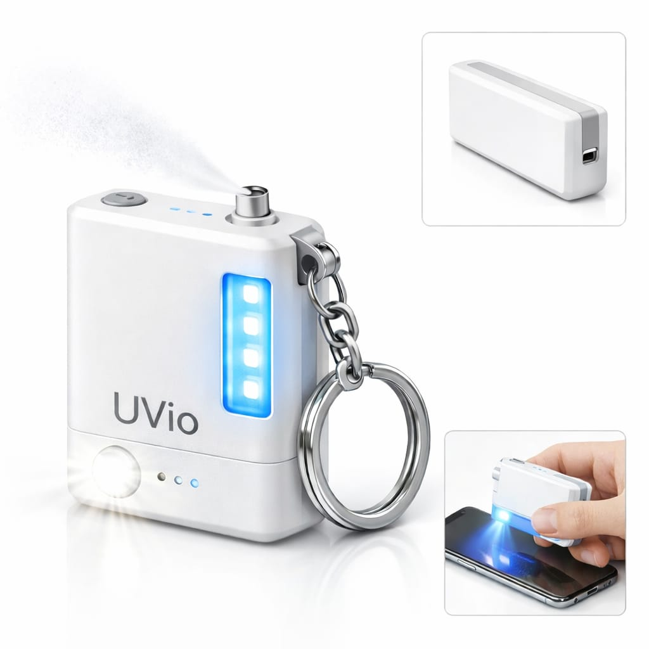
Design and Prototype Sketch:

Unique Selling Product ( USP ):
- 3-in-1 portable hygiene device
- Chemical-free UV-C sterilization
- Compact keychain design
- Affordable and eco-friendly
- Safe auto shut-off feature
- Operations Plan:
- Sourcing of high-quality electronic components and UV-C LEDs.
- Assembly of device parts at a local manufacturing or assembly unit.
- Regular quality testing for safety, performance, and durability.
- Final packaging and labeling following brand and safety standards.
- Inventory management and coordination with logistics partners.
- Marketing & Sales Plan:
- Direct-to-consumer online sales through website and e-commerce platforms.
- Retail distribution via electronics and gadget stores.
- Institutional partnerships with schools, offices, and health organizations.
- Promotional campaigns to drive customer acquisition and brand awareness.
- Use of discounts and bundles to encourage repeat purchases.

- Revenue Model:
Pricing:
- Selling price per UVio device: PKR 2,000
- Cost per unit (approx.): PKR 1,200

Monthly Income Streams:
- Device sales (800 units × 2,000): PKR 1,600,000
- Sanitizer refills & accessories: PKR 200,000
- Bulk/corporate orders: PKR 300,000
- Total Monthly Revenue: PKR 2,100,000

Business Financial Plan
- Startup Costs:
- Product design & prototyping: 150,000
- Tooling, molds & initial setup: 250,000
- Initial raw materials & components (1,000 units): 400,000
- Branding, packaging & logo design: 100,000
- Website & online store setup: 100,000
- 👉 Total Startup Cost: PKR 1,000,000
- Monthly Operating Expenses:
- Manufacturing & assembly: 300,000
- Marketing & promotions: 150,000
- Salaries & operations: 200,000
- Distribution & logistics: 100,000
- Utilities & miscellaneous costs: 50,000
- 👉 Total Monthly Expenses: PKR 800,000
- Pricing Strategy:
- Cost per unit (production & assembly): PKR 1,200
- Selling price per unit: PKR 2,000
- Pricing approach: Cost-plus pricing with competitive margins
- Strategy ensures affordability for students while maintaining profitability
- Discounts offered for bulk and institutional orders
- Sales Forecast:
- Expected device sales: 800 units/month
- Revenue from device sales: 800 × 2,000 = PKR 1,600,000
- Additional income (refills & accessories): PKR 200,000
- Bulk/corporate orders: PKR 300,000
- 👉 Total Monthly Revenue: PKR 2,100,000
- Break-Even Overview:
- Initial investment: PKR 1,000,000
- Estimated monthly profit:
Revenue (2,100,000) – Expenses (800,000) = PKR 1,300,000
- Break-even point expected within 8–10 months
- Achievable through stable sales growth and controlled costs
Risk Analysis
- Market Risks:
- Low awareness about UV-C hygiene technology among general consumers
- Customers preferring traditional sanitizers due to habit or price sensitivity
- Changing hygiene trends after the pandemic
Risk Management Strategies:
- Conduct hygiene awareness campaigns and product demonstrations
- Use social media and influencers to educate customers
- Offer affordable pricing and free demos to encourage trials
- Financial Risks:
- High initial investment costs
- Cash flow issues during early months
- Lower-than-expected sales volume
Risk Management Strategies:
- Start with small-scale production
- Maintain strict cost control
- Secure advance payments for bulk and institutional orders
- Operational Risks:
- Delay in sourcing components or raw materials
- Manufacturing or quality control issues
- Logistics and delivery delays
Risk Management Strategies:
- Maintain multiple suppliers for key components
- Implement quality checks at every production stage
- Partner with reliable logistics companies
- Competitor-Related Risks:
- Entry of international brands with strong marketing power
- Price competition from cheaper alternatives
- Product imitation by local competitors
Risk Management Strategies:
- Build strong branding and customer trust
- Focus on innovation, safety, and quality
- Offer after-sales service and warranty support
Conclusion:
UVio is a practical, innovative, and feasible business idea that addresses a real and growing need for convenient personal hygiene solutions. The increasing awareness of cleanliness, combined with the lack of affordable and portable hygiene devices in the local market, creates a strong opportunity for success.
The business is expected to generate steady revenue through device sales, refills, and institutional partnerships. With proper marketing, quality control, and customer education, UVio can establish itself as a trusted local brand.
In the future, the business has strong growth potential through product upgrades, new hygiene-related gadgets, and expansion into regional and international markets. UVio represents a sustainable and impactful solution for modern hygiene challenges.
References:
- World Health Organization (WHO) – Hygiene and sanitation guidelines
- Government of Pakistan – Public health awareness resources
- Market research articles on UV-C sterilization technology
- Online product reviews of UV sterilizers and sanitizer devices
- E-commerce platforms (Daraz, Amazon) for competitor analysis

