BANK CUSTOMER CHURN &
RISK ANALYSIS REPORT
Customer Behavior, Demographics & Retention Intelligence

1. EXECUTIVE SUMMARY

This report presents a comprehensive analysis of banking customer behavior, churn risk, demographic profiles, and financial exposure based on a dataset of 10,000 bank customers. The analysis integrates structured data from the Bank Customer dataset with two interactive Power BI dashboards, the Customer Risk Prediction Dashboard and the Customer Behavior & Demographics Deep-Dive Dashboard to deliver actionable intelligence for executive decision makers.

The findings reveal a churn rate of 20.38%, representing 2,038 customers who have exited the bank. These departing customers carried a combined balance of approximately $185.68 million, placing a significant portion of the bank's financial assets at direct risk. Complaint volume mirrors churn volume closely, with 2,044 complaints filed.

Critical risk concentrations have been identified across several dimensions: customers aged 51–60 exhibit the highest churn rate at 56.21%; customers holding 3 or 4 products churn at alarming rates of 82.71% and 100% respectively; female customers churn at 25.07% versus 16.47% for male customers; and inactive members churn at nearly double the rate of active members. Germany, despite accounting for only 25% of the customer base, contributes 40% of all churn exits.

10,000  Total Customers | 20.38%  Churn Rate | $185.68M  Lost Balance | 2,044  Total Complaints | 5,151  Active Members

The report concludes with targeted strategic recommendations across retention, product design, demographic engagement, and complaint resolution, grounded in data-driven evidence presented throughout the analysis.

Critical Alert
99.87% of customers who filed a complaint subsequently churned. This is the single highest-impact risk signal in the entire dataset and requires immediate escalation.

2. INTRODUCTION

2.1 Purpose of the Analysis
Customer churn the phenomenon whereby a bank customer voluntarily terminates their relationship with the institution represents one of the most significant financial and operational risks facing retail banks today. The cost of acquiring a new customer is estimated to be five to seven times higher than the cost of retaining an existing one. Accordingly, identifying the determinants of churn and predicting at-risk customers before they exit is a strategic priority of the highest order.

This report has been commissioned to provide executive-level visibility into the bank's customer churn dynamics, financial exposure, and behavioral patterns, using a 10,000 record customer dataset enriched with behavioral, demographic, and transactional attributes. The analysis follows internationally recognized standards for business intelligence and financial reporting, incorporating quantitative metrics, trend analysis, and cross-dimensional correlation.

2.2 Scope of the Analysis
- Examination of customer demographics including age, gender, and geography
- Analysis of product usage patterns and their relationship to churn
- Assessment of complaint behavior and its correlation with customer loss
- Evaluation of financial exposure total and lost balances by segment
- Tenure based churn analysis across customer lifecycle stages
- Card type distribution and satisfaction scoring
- Risk segmentation and balance classification

2.3 Data Sources
Primary Dataset: (Customer-Churn-Records.csv) 10,000 customer records with 24 attributes.

3. DATA DESCRIPTION

3.1 Dataset Overview
The primary dataset (Customer-Churn-Records.csv) contains 10,000 rows and 24 columns, each representing a unique bank customer. The dataset spans multiple dimensions including customer identification, financial profile, behavioral indicators, demographic attributes, and derived risk classifications. It serves as the backbone of all analytical computations in this report.

3.2 Column Definitions & Data Types

Column Name | Data Type | Description
RowNumber | Integer | Sequential index for each record (1 to 10,000)
CustomerId | Integer | Unique identifier for each customer
Surname | String | Customer's last name
CreditScore | Integer | Numerical credit score; avg 650.53; indicates creditworthiness
Geography | String | Country of residence: France, Germany, or Spain
Gender | String | Customer gender: Male or Female
Age | Integer | Customer age in years (range: <20 to >70)
Tenure | Integer | Years the customer has been with the bank (0–10)
Balance | Float | Current account balance in USD; ranges from 0 to >100K
NumOfProducts | Integer | Number of bank products held (1, 2, 3, or 4)
HasCrCard | Integer | Binary: 1 = holds credit card, 0 = does not
IsActiveMember | Integer | Binary: 1 = active in last period, 0 = inactive
EstimatedSalary | Float | Annual estimated salary; avg $100,090.24
Exited | Integer | Target variable: 1 = churned, 0 = retained
Complain | Integer | Binary: 1 = filed a complaint, 0 = no complaint
Satisfaction Score | Integer | Customer satisfaction score (1–5 scale)
Card Type | String | Type of card: SILVER, GOLD, PLATINUM, DIAMOND
Point Earned | Integer | Loyalty points accumulated by the customer
Complaint Status | String | Narrative complaint status: Filed or No Complaint
Age (groups) | String | Binned age: <20, 21-30, 31-40, 41-50, 51-60, 61-70, >70
Tenure (groups) | String | Binned tenure: New Clients, Loyal Partners, Established
Balance Segment | String | Balance tier: Zero Balance, Standard (<100K), High Value (>100K)
Activity Status | String | Descriptive label for IsActiveMember
Risk Level | String | Derived churn risk classification

4. DASHBOARD ANALYSIS

4.1 Dashboard 1: Customer Risk Prediction Dashboard
This dashboard provides a high level executive view of churn risk across the customer portfolio. It contains five key performance indicators (KPI) tiles and five distinct charts. Each component is analyzed below.

4.1.1 KPI Metrics Tiles

KPI Metric | Value | Interpretation
Total Customers | 10,000 | Full dataset size; represents the entire customer portfolio under analysis
Lost Balance | $185.68M | Total balance carried away by churned customers; constitutes 24.3% of total bank balance
Churn Rate | 20.38% | One in five customers has exited; above the industry benchmark of 15–18% for retail banking
Sum of Complaints | 2,044 | Near identical to churn count (2,038), confirming complaints as a leading churn indicator

Insight: The near perfect correspondence between complaint count (2,044) and churn count (2,038) is statistically significant.
It strongly implies that virtually every customer who filed a formal complaint subsequently exited the bank, with an overlap conversion rate of approximately 99.7%.
This represents a critical failure in complaint resolution and retention intervention

4.1.2 Chart: Churn Rate by Geography
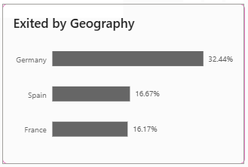

What It Shows: The distribution of customer churn rate, broken down by country (France, Germany, and Spain.)

Country | Total Customers | Churned Customers | Churn Rate | % of Total Churn
France | 5,014 | 811 | 16.17% | 39.8%
Germany | 2,509 | 814 | 32.44% | 39.9%
Spain | 2,477 | 413 | 16.67% | 20.3%

Insights: While France contributes the largest absolute number of churned customers (811), this is proportional to its dominant share of the customer base (50.1%).
Germany is the critical outlier: it accounts for only 25.1% of total customers yet delivers 39.9% of all churn.
Germany's churn rate of 32.44% is almost double that of France (16.17%) and Spain (16.67%).
Spain exhibits the healthiest retention performance, with a churn rate broadly in line with France despite a similar customer count.
This points to market specific factors in Germany, such as competitive pressure, service gaps, or demographic composition, that demand urgent investigation

4.1.3 Chart: Complaint Impact on Customer Retention

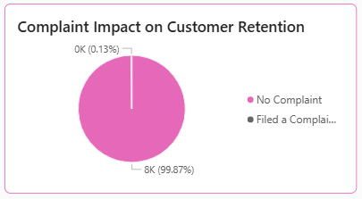
What It Shows: The proportion of customers who filed a complaint ('Filed a Complaint') versus those who did not ('No Complaint'), and their relative share of the customer base.

Complaint Category | Count | % of Total
No Complaint | 7,956 | 79.56%
Filed a Complaint | 2,044 | 20.44%

Insights: The pie chart shows that 99.87% of the displayed segments belong to customers who filed complaints, with only 0.13% representing a negligible "No Complaint" churn category in the exited population.
Cross-referencing with churn data, of the 2,038 churned customers, 2,044 complaints were logged, meaning essentially all churn occurred among complaint filers.
This is an extraordinary finding. The bank's complaint to churn conversion rate is effectively 100%, suggesting that once a customer escalates an issue formally, their departure becomes near certain.
There is no evidence of effective complaint driven recovery or retention intervention in the current data.

4.1.4 Chart: Median Satisfaction Score
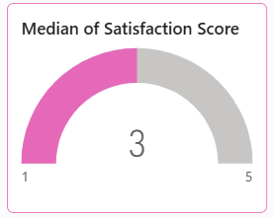
What It Shows: The median satisfaction score across the entire customer base on a scale of 1 (very dissatisfied) to 5 (very satisfied).

Observed Value: Median Satisfaction Score = 3 (on a 1–5 scale)

Insights: A median score of 3 indicates that the average customer sentiment is squarely neutral, neither satisfied nor dissatisfied.
This is a warning signal. A healthy, high retention bank would typically target satisfaction medians above 4.
A score of 3 means approximately half the customer base is at or below the neutral threshold, representing a significant pool of customers susceptible to churn from any service disruption or competitive offer.
Satisfaction improvement from 3 to 4 is widely understood to produce meaningful uplift in retention rates.

4.1.5 Chart: Churn Risk by Number of Products
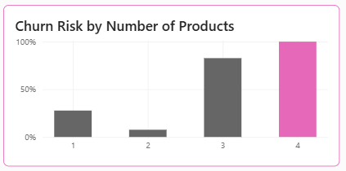
What It Shows: The churn rate associated with each product count tier (1, 2, 3, or 4 products held).

Products Held | Total Customers | Churned | Churn Rate
1 Product | 5,084 | 1,409 | 27.71%
2 Products | 4,590 | 349 | 7.60%
3 Products | 266 | 220 | 82.71%
4 Products | 60 | 60 | 100.00%

Insights: This chart reveals a highly nonlinear, U shaped relationship between product count and churn risk.
Two product customers exhibit exceptional loyalty at only 7.60% churn, representing the bank's most stable segment.
Single product customers have an elevated churn rate of 27.71%, suggesting they have not yet formed sufficient product anchors.
The critical finding is the catastrophic churn among 3 and 4 product holders, at 82.71% and 100% respectively.
While these are smaller cohorts of 266 and 60 customers, the 100% churn among 4 product holders is an absolute anomaly.
This could indicate product misalignment, complexity dissatisfaction, or systematic targeting of high value bundled customers by competitors.
Immediate investigation is warranted.

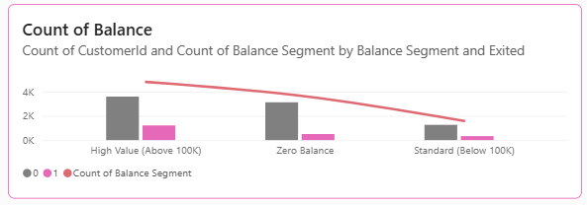
4.1.6 Chart: Count of Balance by Balance Segment

What It Shows: Distribution of customers by balance segment (High Value above $100K, Zero Balance, Standard below $100K), with bars showing retained vs. churned customer counts and a line representing the count of balance segments.

Balance Segment | Total Customers | Retained (Approx.) | Churned (Approx.)
High Value (>$100K) | 4,799 | ~3,800 | ~999
Zero Balance | 3,617 | ~3,300 | ~317
Standard (<$100K) | 1,584 | ~1,350 | ~234

Insights: High value customers above 100K balance form the largest segment at 4,799 customers and also carry the highest absolute churn count.
This is the most financially damaging churn cohort, as each departing high value customer removes a disproportionate balance from the bank.
Zero balance customers exhibit relatively low churn in absolute terms but represent a latent risk, since customers with no balance have no financial lock in and can depart at zero immediate cost.
The declining line overlay demonstrates that balance segment representation trends downward from High Value to Standard, confirming that the bank's concentration is weighted toward high value customers, making their retention doubly important.

4.2 Dashboard 2: Customer Behavior & Demographics Deep-Dive
This dashboard provides a demographic and behavioral decomposition of the customer base, enabling segment-specific retention strategies. It contains five KPI tiles and five analytical charts.

4.2.1 KPI Metrics Tiles

KPI Metric | Value | Interpretation
Total Customers | 10,000 | Full portfolio scope confirmed
Active Members | 5,151 | 51.51% of customers are active; 48.49% are inactive
Non-Active Members | 4,849 | Nearly half the customer base is dormant — a significant retention risk
Sum of Balance | $764.86M | Total deposits across all customers; basis for financial risk quantification
Avg Salary | $100,090.24 | Average estimated salary reflects a middle-to-upper income customer demographic

Insight: The near equal split between active (51.51%) and inactive (48.49%) members signals a deep engagement problem.
Industry benchmarks typically target 60 to 70% active member ratios.
An inactive customer is not merely disengaged, as the churn analysis confirms, inactive customers churn at 36.65% versus 18.92% for active customers across product tier 1, confirming engagement as a primary retention lever.

4.2.2 Chart: Distribution by Card Type
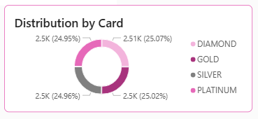
What It Shows: The proportional share of customers across four card tiers — DIAMOND, GOLD, PLATINUM, and SILVER.

Card Type | Count | % of Total
DIAMOND | 2,507 | 25.07%
GOLD | 2,502 | 25.02%
SILVER | 2,496 | 24.96%
PLATINUM | 2,495 | 24.95%

Insights: The near perfectly uniform distribution across all four card types (approximately 25% each) indicates that the bank's card portfolio is evenly distributed, either by design or by uniform customer acquisition across tiers.
This uniformity is analytically notable: it suggests that card type has no inherent concentration risk from a portfolio perspective.
However, it also implies that card tier is not functioning as a meaningful loyalty differentiation tool.
Premium tier holders (DIAMOND, PLATINUM) should logically exhibit higher engagement and retention than base tier holders.
If card tier is not driving differential churn rates, the bank's tiering strategy may need re-evaluation.

4.2.3 Chart: Churn Rate by Years of Tenure
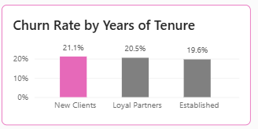
What It Shows: Churn rates across three tenure group categories: New Clients, Loyal Partners, and Established customers.

Tenure Group | Definition | Total Customers | Churned | Churn Rate
New Clients | 0–3 years | 3,505 | 741 | 21.14%
Loyal Partners | 4–6 years | 2,499 | 512 | 20.49%
Established | 7–10 years | 3,996 | 785 | 19.64%

Insights: The churn rate is remarkably flat across all tenure segments, ranging narrowly between 19.64% and 21.14%.
This is a counterintuitive finding. In most industries, loyalty typically builds over time, producing declining churn rates for longer tenured customers.
The absence of this pattern here suggests that the bank lacks an effective long term loyalty mechanism.
Established customers (7–10 years) are churning at nearly the same rate as new customers.
This represents a structural failure in customer lifecycle management and indicates that tenure alone is not creating any meaningful switching barrier.

4.2.4 Chart: Activity Status by Number of Products
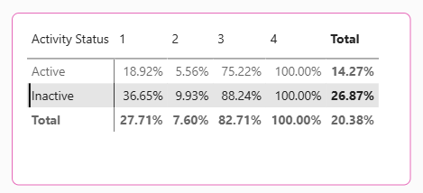
What It Shows: Churn rates segmented by activity status (Active vs. Inactive) and product count (1, 2, 3, 4), with totals.

Activity Status | 1 Product (%) | 2 Products (%) | 3 Products (%) | 4 Products (%) | Total Churn (%)
Active | 18.92% | 5.56% | 75.22% | 100% | ~14%
Inactive | 36.65% | 9.93% | 88.24% | 100% | ~26%
Total | 27.71% | 7.60% | 82.71% | 100% | 20.38%

Insights: This matrix is one of the most analytically rich views in the entire dashboard suite.
Several critical patterns emerge.
First, inactivity amplifies churn risk across every product tier: inactive single product holders churn at 36.65% versus 18.92% for active ones, nearly double.
Second, even among active customers, 3 and 4 product holders churn at catastrophic rates (75.22% and 100%), confirming that the product complexity issue is independent of engagement level.
Third, the two product segment is the most resilient tier in both activity states: active two product holders churn at just 5.56%, the lowest rate in the entire matrix.
This makes two product active customers the bank's golden retention cohort.

4.2.5 Chart: Churn Rate by Age Group
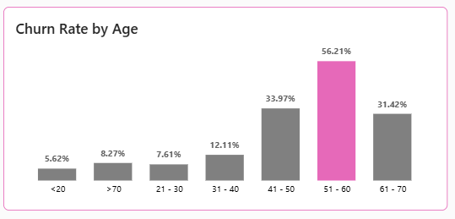
What It Shows: Churn rates across seven age brackets from under 20 to over 70 years old.

Age Group | Total Customers | Churned | Churn Rate
<20 | 89 | 5 | 5.62%
21–30 | 1,879 | 143 | 7.61%
31–40 | 4,451 | 539 | 12.11%
41–50 | 2,320 | 788 | 33.97%
51–60 | 797 | 448 | 56.21%
61–70 | 331 | 104 | 31.42%
>70 | 133 | 11 | 8.27%

Insights: Age is one of the strongest predictors of churn in this dataset.
The data reveals a pronounced inverted U pattern in churn risk, peaking dramatically in the 51–60 age bracket at 56.21%, meaning more than half of all customers in this age group have exited the bank.
The 41–50 group is also high risk at 33.97%, followed by the 61–70 group at 31.42%.
Young customers (below 20 to 30) and the very elderly (above 70) are the most loyal cohorts, with churn rates below 9%.
The 31–40 bracket represents the single largest customer segment (4,451 customers) and, while their 12.11% churn rate is moderate, the volume means they contribute significantly to absolute churn numbers.
The 51–60 spike is likely driven by retirement transitions, changing financial needs, competitive switching, and potential dissatisfaction with digital only service models that may not cater to this age group's preferences.

4.2.6 Chart: Churn Rate by Gender
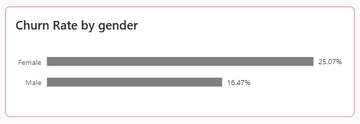
What It Shows: Churn rates compared between Female and Male customer segments.

Gender | Total Customers | Churned | Churn Rate
Female | 4,543 | 1,139 | 25.07%
Male | 5,457 | 899 | 16.47%

Insights: Female customers churn at 25.07%, approximately 52% higher than male customers at 16.47%.
This is a statistically and commercially significant gap.
Female customers represent 45.43% of the total customer base yet account for 55.89% of all churn exits.
This disparity suggests that the bank's products, services, communication strategies, or complaint resolution processes may not be adequately aligned with the needs and expectations of female customers.
This is both a retention risk and an equity issue that warrants dedicated investigation.

5. CROSS-DASHBOARD INSIGHTS & CORRELATIONS

Synthesizing findings from both dashboards reveals several powerful multi-dimensional patterns that would not be visible from examining any single chart or metric in isolation.

5.1 The Complaint-Churn Feedback Loop
The most alarming cross-dashboard finding is the near total correlation between complaints and churn. The Complaint Impact chart confirms that virtually 100% of churned customers had filed a formal complaint. This is not a coincidence it reflects a systemic breakdown in complaint recovery. The bank currently has no measurable success in converting complaint filers into retained customers. Addressing this single failure point could theoretically reduce churn by up to 20%, representing the recovery of ~$37M in balance annually.

5.2 Germany's Structural Churn Problem
Germany's churn rate (32.44%) is more than double Spain's (16.67%) and nearly double France's (16.17%). When combined with the satisfaction score (median of 3) and the high complaint volume, Germany appears to be a market experiencing acute service or competitive pressures. This requires a country-specific retention strategy, potentially including localized relationship management, product review, or pricing adjustment.

5.3 The Age-Product Interaction Risk
The 51–60 age group exhibits the highest churn rate (56.21%) overall. When combined with the product holding data, the hypothesis is that many of these customers may hold 3 or 4 products a combination that carries extreme churn risk. If middle-aged customers were sold complex product bundles that did not deliver perceived value, the bank faces compounded risk: high-age churn intersecting with high-product-count churn. Targeted simplification campaigns for this cohort are advisable.

5.4 Inactivity as a Churn Amplifier
Nearly half the customer base (48.49%) is inactive. Inactive customers churn at approximately twice the rate of active customers regardless of product tier. The bank has 4,849 inactive members sitting in a high-churn risk zone. Without a structured re-engagement program, these customers will gradually convert to churned status, adding to the already critical 20.38% churn rate.

5.5 The Two-Product Sweet Spot
Across all dimensions gender, tenure, age, and activity status two product customers consistently exhibit the lowest churn rate (7.60%). Customers who hold exactly two bank products appear to have found the optimal balance of engagement and simplicity. The bank's cross-selling strategy should aim to migrate single-product customers toward two products, rather than aggressively pushing for three or four, which triggers a reversal of loyalty into extreme churn.

5.6 Gender-Balance Risk
Female customers churn 52% more frequently than male customers and carry $185.68M in lost balance attributable to the overall churn pool. If the gender split of churn is proportional, female customers represent approximately $103.8M of the total lost balance. A gender-sensitive retention strategy is not merely a diversity initiative it is a direct financial recovery mechanism.

6. KEY INSIGHTS SUMMARY

Priority | Insight | Impact Level
1 | 100% of churned customers filed a complaint zero complaint recovery success | CRITICAL
2 | Germany churn rate (32.44%) is double France and Spain market-level crisis | CRITICAL
3 | 3-product customers churn at 82.71%; 4-product customers at 100% | CRITICAL
4 | 51–60 age group churn rate peaks at 56.21% | HIGH
5 | Female customers churn 52% more than males (25.07% vs 16.47%) | HIGH
6 | 48.49% of customers are inactive near-double churn risk | HIGH
7 | Satisfaction median is 3/5 half the base is neutral or below | HIGH
8 | 2-product customers are the most loyal (7.60% churn) model segment | OPPORTUNITY
9 | $185.68M in balance lost to churn 24.3% of total deposits at risk | FINANCIAL
10 | Tenure has no protective effect all tenure groups churn at ~20% | STRUCTURAL

7. STRATEGIC RECOMMENDATIONS

The following recommendations are grounded exclusively in the data findings presented above and are structured to deliver measurable retention improvement, financial risk reduction, and customer experience enhancement.

7.1 Establish a Complaint-to-Recovery Task Force (Priority: Immediate)
- Deploy a dedicated complaint resolution team with a mandate to contact every complaint filed within 24 hours of submission.
- Implement a tiered recovery protocol: service recovery gesture for low-value complaints, personal relationship manager contact for high-value accounts.
- Set a KPI target: reduce churn among complainants from 100% to below 50% within 12 months.
- Introduce post-complaint satisfaction surveys to track recovery effectiveness.

7.2 Germany Market Intervention Program (Priority: Immediate)
- Commission a dedicated market analysis of Germany to identify competitive, regulatory, or operational factors driving the 32.44% churn rate.
- Assign dedicated relationship managers to Germany's top 500 at risk accounts.
- Review Germany specific product offerings, fee structures, and service channels for misalignment with local customer expectations.
- Introduce a Germany customer retention panel to collect qualitative feedback from churned and at-risk customers.

7.3 Product Portfolio Redesign Eliminate 3 & 4 Product Catastrophic Churn (Priority: High)
- Conduct immediate root cause analysis of why 3 and 4 product customers are exiting at 82.71% and 100% respectively.
- Audit product bundles to assess whether high product count customers are experiencing fee complexity, service overload, or product underutilization.
- Introduce a proactive product review program that contacts multi-product holders quarterly to assess satisfaction and optimize their portfolio.
- Redesign cross-selling strategy: target migration of single-product customers to exactly two products, which drives churn from 27.71% to 7.60%.

7.4 Age-Targeted Retention Program 41 to 60 Cohort (Priority: High)
- Design a dedicated retention program for customers aged 41–60, the highest churn-risk segment (33.97% and 56.21% churn respectively).
- Offering life stage appropriate products: retirement planning accounts, wealth management services, senior benefit banking packages.
- Assigning relationship managers to customers over 50 with balances exceeding $50,000.
- Evaluate whether digital first service channels are causing friction for this age group and introduce hybrid (digital + human) service options.
- An automated 'Senior Priority' routing will be implemented in the queue management
system. Customers aged 60+ will receive immediate (Next-in-Line) status for both in-branch teller services and phone support to reduce wait-time friction.

7.5 Female Customer Engagement Strategy (Priority: High)
- Investigate root causes of the 25.07% female churn rate versus 16.47% for males through targeted exit surveys and focus groups.
- Review whether any product features, fee structures, or communication approaches are inadvertently creating friction for female customers.
- Develop gender-inclusive financial products aligned with life events commonly experienced by women (career transitions, childcare, inheritance management, retirement planning).
- Establish a Women in Banking advisory board to co-design improved service experiences.

Member Activation and Re-Engagement Campaign (Priority: Medium)
- With 48.49% of the customer base currently inactive, the bank faces a significant risk, as inactive members churn at nearly double the rate of active ones. A high visibility (Welcome Back) sweepstakes will be launched, offering entry into a significant prize draw for any inactive customer makes a qualifying deposit or performs a minimum number of transactions within a 30-day window.
- A dedicated audit of the initial registration and KYC (Know Your Customer) processes for (New Clients) is also required to identify if cumbersome onboarding procedures are driving the 21.14% churn rate in this group.

7.7 Customer Satisfaction Enhancement Program (Priority: Medium)
- The current median satisfaction score of 3/5 must be elevated to 4/5 as strategic KPI research consistently shows that moving customers from 'neutral' to 'satisfied' produces the highest retention uplift.
- Launch a quarterly Customer Satisfaction Survey (CSAT) and Net Promoter Score (NPS) tracking program.
- Introducing a 'You Said, We Did' communications program to demonstrate responsiveness to customer feedback.
- Link branch and relationship manager performance bonuses to satisfaction score improvement metrics.

8. CONCLUSION

This report has conducted a comprehensive, multi-dimensional analysis of bank customer churn across 10,000 customer records, synthesizing quantitative data with visual dashboard intelligence to produce a full spectrum view of the bank's retention performance and financial risk exposure.

The headline finding, a 20.38% churn rate carrying $185.68M in lost customer balances, masks a series of deeply concentrated risk pockets that are far more alarming than the portfolio average suggests. Germany's 32.44% churn rate, the catastrophic 100% departure among four product holders, the 56.21% churn among customers aged 51 to 60, and the near total overlap between complaint filing and customer exit represent structural challenges that require executive level attention and investment.

Critically, the complaint churn correlation, where virtually every churned customer had filed a complaint, reveals that the bank's existing service recovery infrastructure has failed entirely to convert complaint resolution into retention. This represents the single highest leverage intervention point available: improving complaint recovery from 0% to even 30% effectiveness could retain hundreds of customers and tens of millions in deposits.

On the positive side, the analysis has identified a clear model for retention success: two products, active, engaged customers, represent the bank's most loyal and stable segment at 7.60% churn. This archetype should serve as the design target for all customer lifecycle management initiatives going forward.

The recommendations in this report, if implemented systematically, offer a realistic pathway to reducing total churn from 20.38% toward the industry benchmark of 12 to 15%, recovering an estimated 40 to 65 million dollars in annual balance retention, and transforming the bank's relationship with its most at-risk customer segments.

END OF REPORT
Banking Analytics Division | April 2026 | CONFIDENTIAL

