Design:

- There is error message
http://fivevidya.in/Travellinmind/test/thank-you/
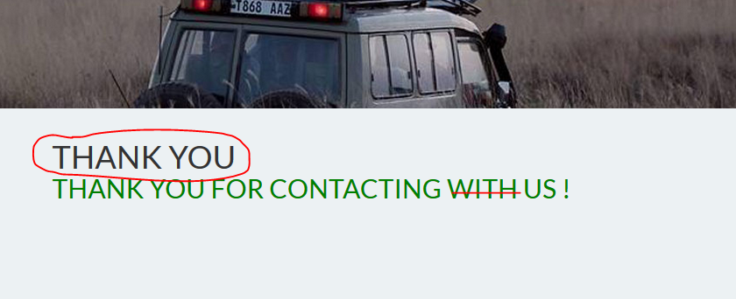
- There is design issue
Click directly on submit and check.
http://fivevidya.in/Travellinmind/test/package/pilgrimage-package-1/

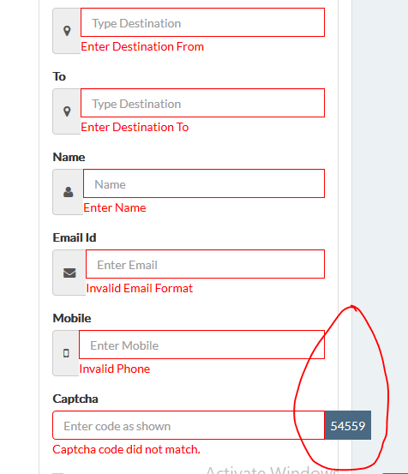
- There is more space beside the captcha. By default "terms and condition" is selected.
> this form should have "book now" as highlighten
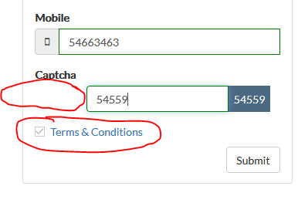
http://fivevidya.in/Travellinmind/test/package/pilgrimage-package-1/

- When clicked on "add testimonial" – its going to error page.

- Error in displaying
With respect to space and manadtory field. With error field.
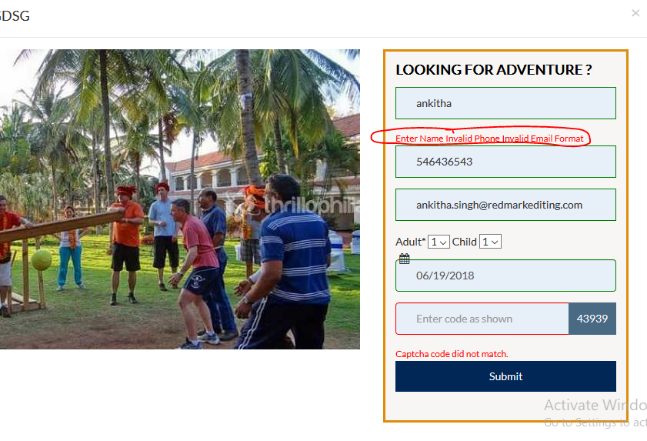
- There is no icons
meta title – Travellinmind spelling mistake
http://fivevidya.in/Travellinmind/test/trekkings/
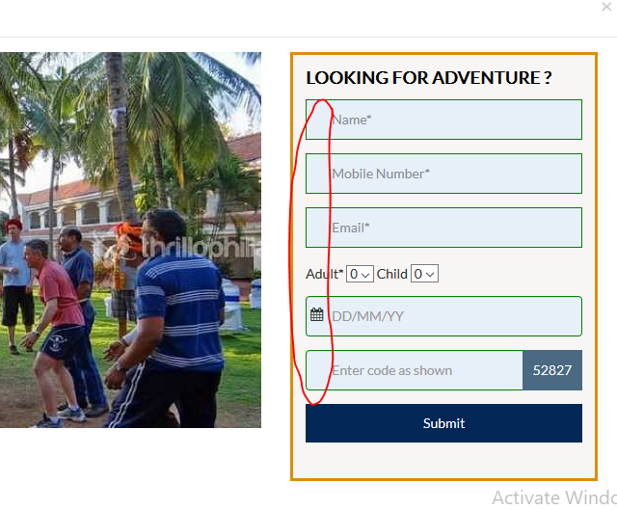

- there is no Icons for form – Sign up
Alignment should be proper
http://fivevidya.in/Travellinmind/test/contact-us/ - contact us

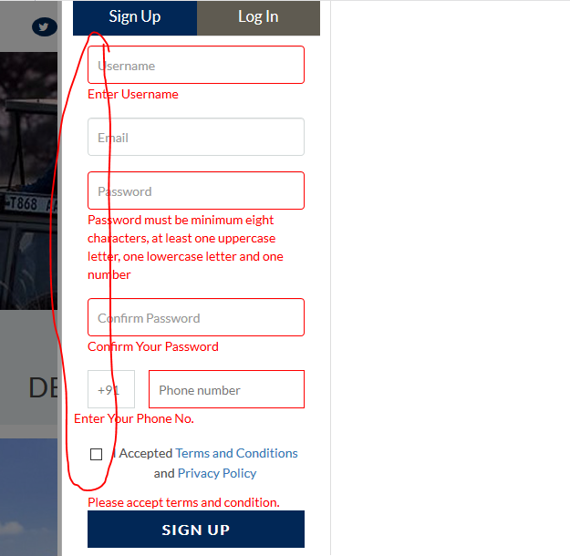
- http://fivevidya.in/Travellinmind/test/events/ - remove infant option and no error message displayed
9) http://fivevidya.in/Travellinmind/test/trekkings/ - no error message displayed
10 ) Under "add testimonial", when clicked on send now. No error message.
http://fivevidya.in/Travellinmind/test/
11) There is no error message when clicked on "explore" on the banner.

