 | MEMORANDUM  No  MALE-M-2310004 | Iss./Ed. A  Date/Fecha  10/03/2023 | Page/ Pág.  1 of 9 | REFERENCE /  REFERENCIA  N/A
SUBJECT / ASUNTO  Input file generator for Secciones. User manual |  | From / De Marina Cantador Tamurejo  Dpt ./ Dpto. TEPAA-TL8  Approved / Aprobado Mercedes Marzal Pitarch
ATTACHMENTS / DOCUMENTOS ADJUNTOS  N/A |  | TO / A N/A  Dpt. / Depto. N/A  Response Required / NO  Requiere Respuesta  Dateline / Fecha Tope N/A  Conforme/Approval Xxxxxxxxxxxxxxxxx
DISTRIBUTION / DISTRIBUCION Airbus Amber
TEPAA – TL8

Issue / Edic. | Change reason / Motivo de Modificación |  |  | App. / Aprobado
Date / Fecha | Chapters and/or sheets affected /  Capítulos y/o hojas afectadas |  |  | Signed / Firmado
A | Initial Release
10/03/2023 | All pages
TEXT/TEXTO
The current memorandum explains by an easy and clear way how to use TCL tool which generates input file for SECCIONES software and the main guidelines to make a correct use of this tool.
TABLE OF CONTENTS

1 INTRODUCTION 2
1.1 SCOPE 2
1.2 ABBREVIATIONS AND SYMBOLS 2
1.3 REFERENCES 2
2 SOFTWARE PRESENTATION AND MOTIVATION 2
3 PREVIOUS STEPS 2
4 RUN THE SOFTWARE 3
5 EXPLANATION OF EACH STEP OF THE SOFTWARE 4
6 CONSIDERATIONS 9

INTRODUCTION

SCOPE
The current memorandum explains by an easy and clear way how to use TCL tool which generates input file for SECCIONES software and the main guidelines to make a correct use of this tool. The testing of the tool has been done using Hypermesh 2021.2, but other previous versions could be used.

ABBREVIATIONS AND SYMBOLS
Symbol Units Definition
A/C - Aircraft
ID - Identification
TCL - Tool command language

REFERENCES
Document Reference Issue Title
- NT-T-ADP-01011 A ‘Programas varios de postprocesado NASTRAN’

SOFTWARE PRESENTATION AND MOTIVATION
The current memorandum explains by an easy and clear way how to use TCL tool which generates input file for SECCIONES software and the main guidelines to make a correct use of this tool.
SECCIONES software is part of Airbus DS tools and its inputs consist of four files: XXXX.f06 and header.dat which contain the results of a GFEM model, XXXX.dat and XXXX.res which are the definition of the section with nodes and the results of the SECCIONES calculation, respectively (for a detailed description of SECCIONES software, see Ref. 1). The TCL tool allows to generate the XXXX.dat file by selecting the nodes which define the section in Hypermesh environment graphically, instead of writing the nodes ID’s in the file manually. In the following explanation the nomenclature used is the same mentioned in this section.

PREVIOUS STEPS
In Hypermesh environment the TCL script must be active. It is done in the following menu.
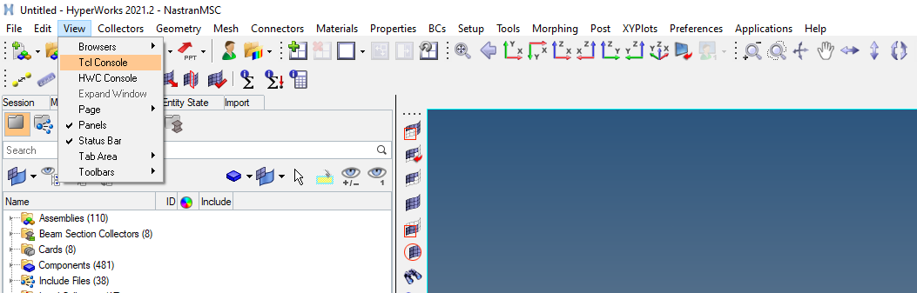
- Tcl screen activation
And the Hypermesh environment must look like:
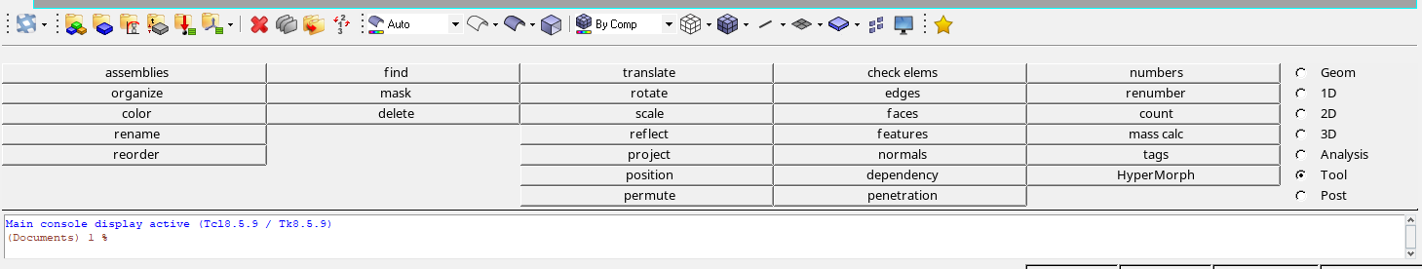
- Appearance of Tcl console

RUN THE SOFTWARE
The software runs by right-clicking the Main Console and select the option ‘File load file’:
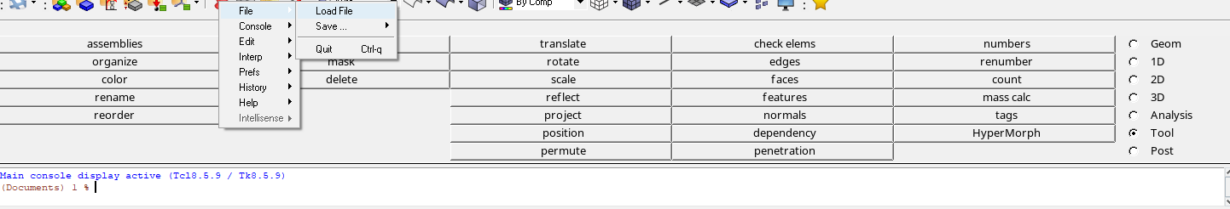
- Load a file in Tcl console
Search the Tcl tool in the folder where it is located, and select it in the pop-up window:
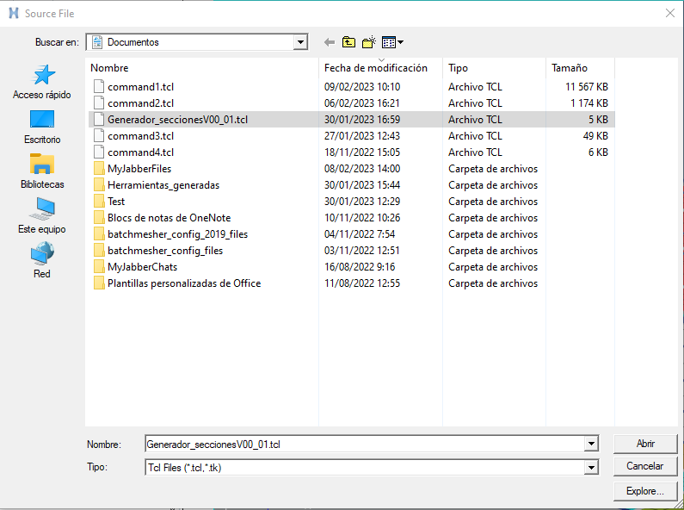
- Select the tool

EXPLANATION OF EACH STEP OF THE SOFTWARE
For a better comprehension of the tool way of function, an example is used for all this section. The objective is to analyse three sections which are comprised of a stringer and half of the panel on each side of the stringer. Each section is defined by nodes in a GFEM model. It is analysed the forces which come from the forward part of the section (see Figure 5).
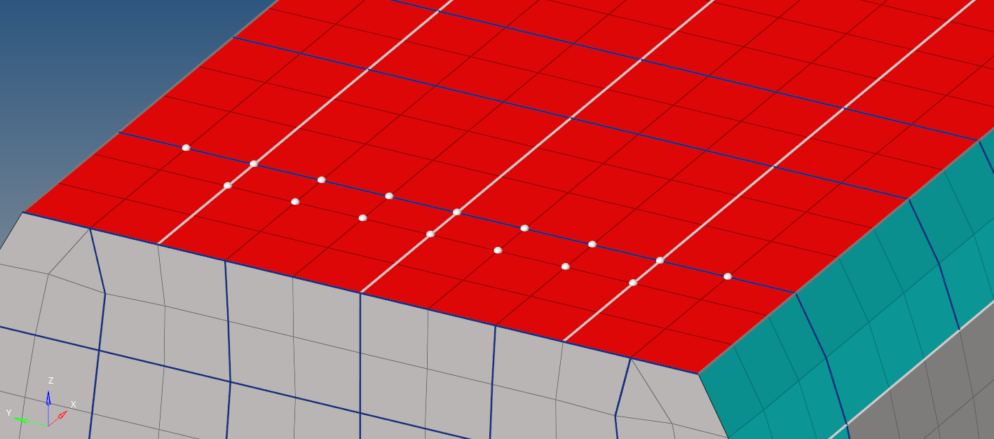
Section 1
Section 2
Section 3
- Sections selected for the example
Once the code is run as described in the previous section, the file generation process begins
- First, generate the XXXX.dat file where all the information will be written. If a file previously created is selected, all the information in it is deleted and replaced with the new one. Click ‘Save’ when the name is written.
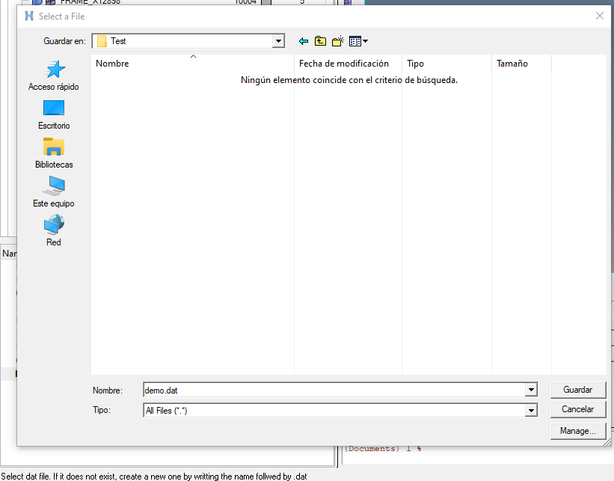
- Creation of XXXX.dat file

- Next, select only the node which define the centre point of the section, and when it is ready click ‘proceed’. If a mistake is made-more nodes selected, a wrong node is selected, the selection can be cleared by clicking on 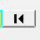:

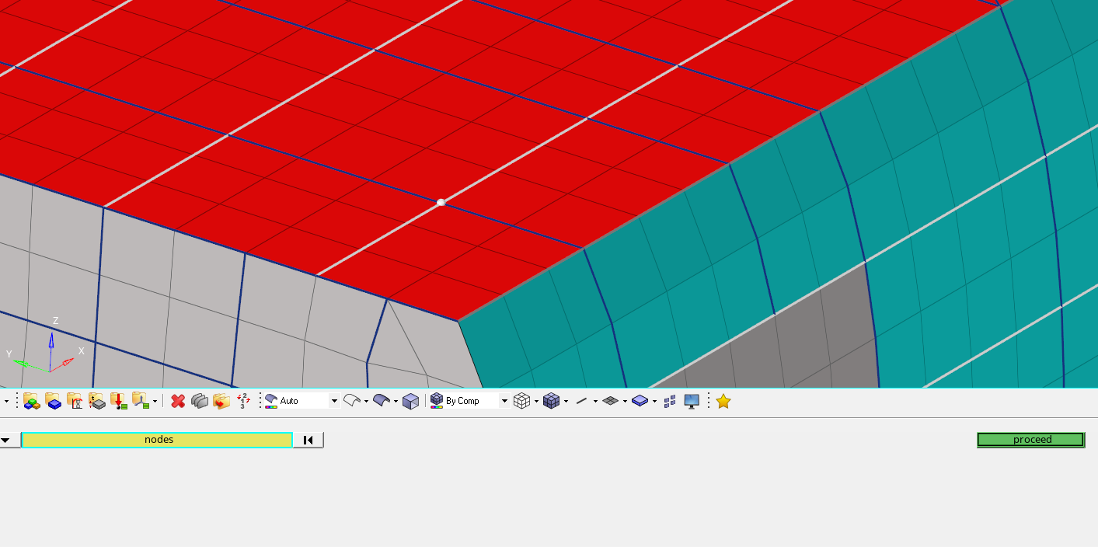
- Node selection. First screen

- In the following step, select the nodes on one of the sides of the centre of the section. Again, click ‘proceed’ when it is ready or  if the selection want to be redone.
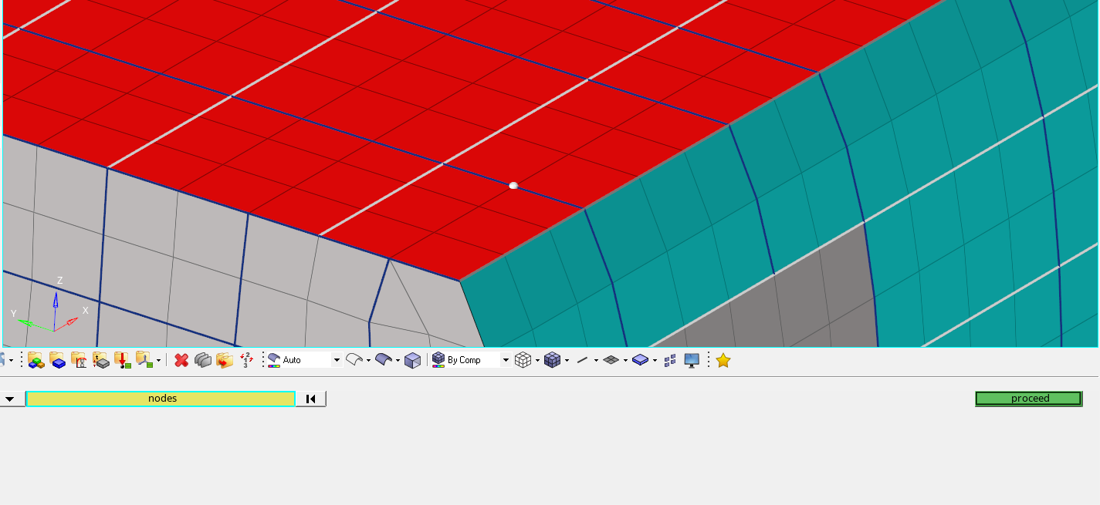
- Node selection. Second screen

- Repeat the previous step but select the nodes in the other side.
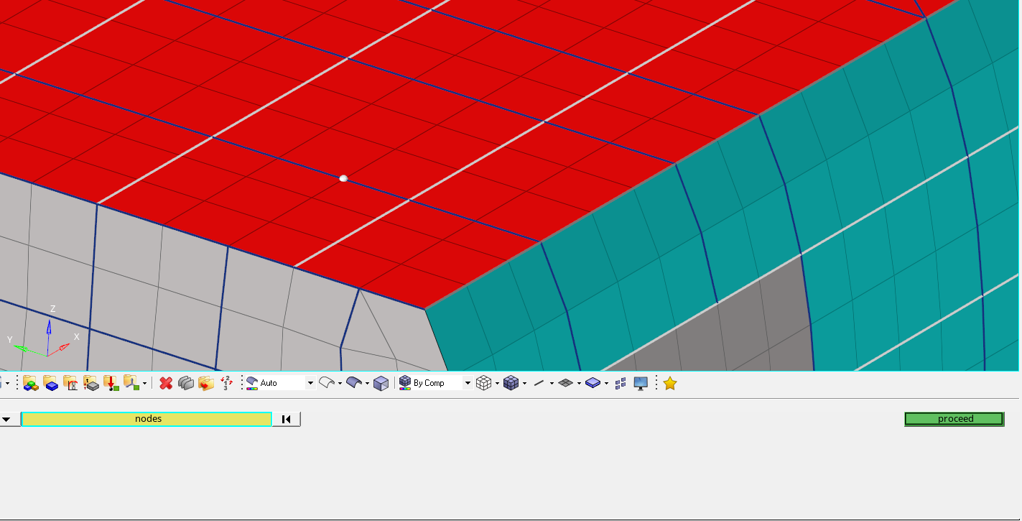
- Node selection. Third screen
Because the analysis is the load introduced by the forward area of the fuselage, the following nodes selected are from this part of the fuselage, using the same structure described in the previous steps.
- Select only the node which define the X direction, orientated to the forward direction.
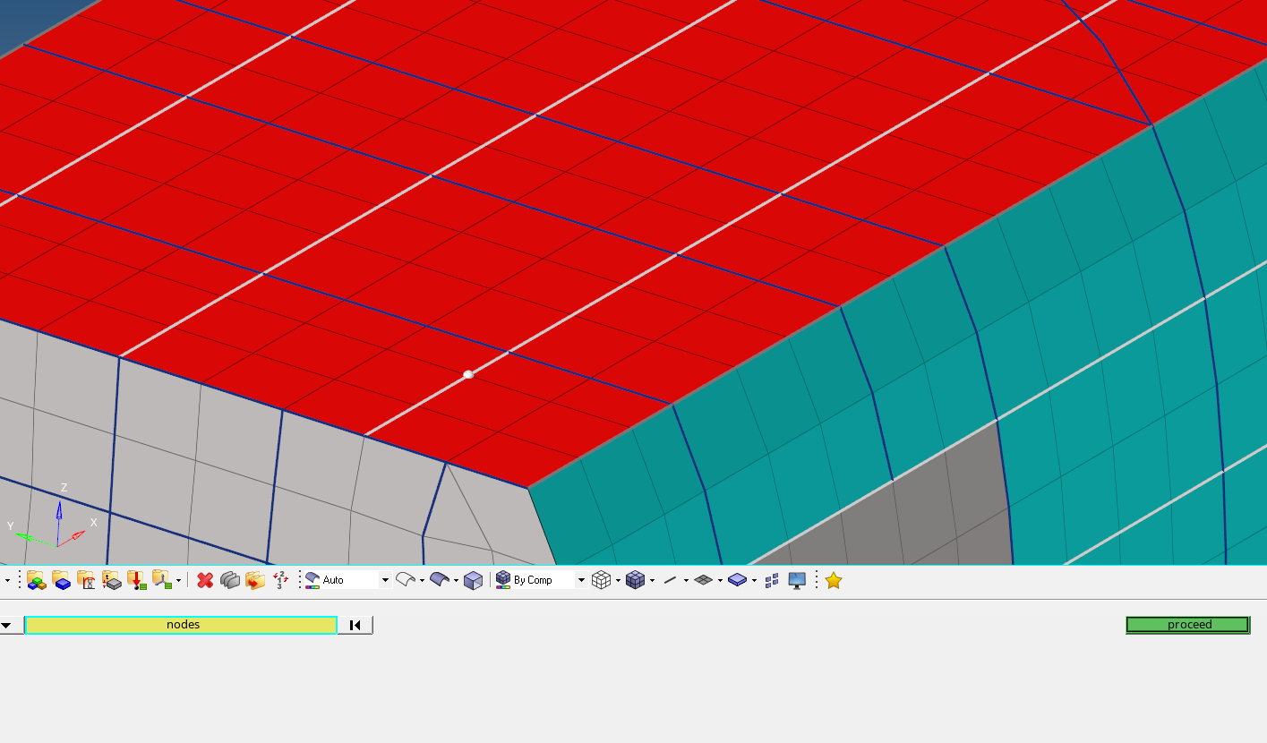
- Node selection. Fourth screen

- Select the nodes in one of the side of the previous node. For the example, there are not any nodes in this field, so keep it blank and press ‘proceed’ button. Every field could be left blank if needed.
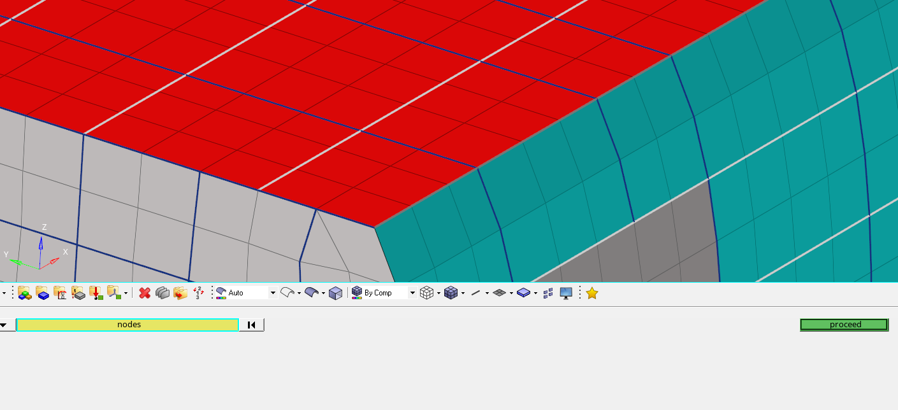
- Node selection. Fifth screen
- Select the nodes in the other side and click the ‘proceed’ button.
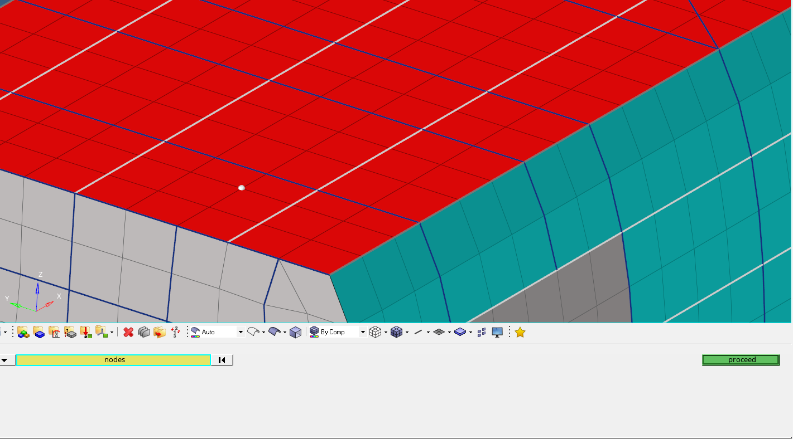
- Node selection. Sixth screen

- Next, select the node which defines the Y direction. For the example, it is a node in the floor.
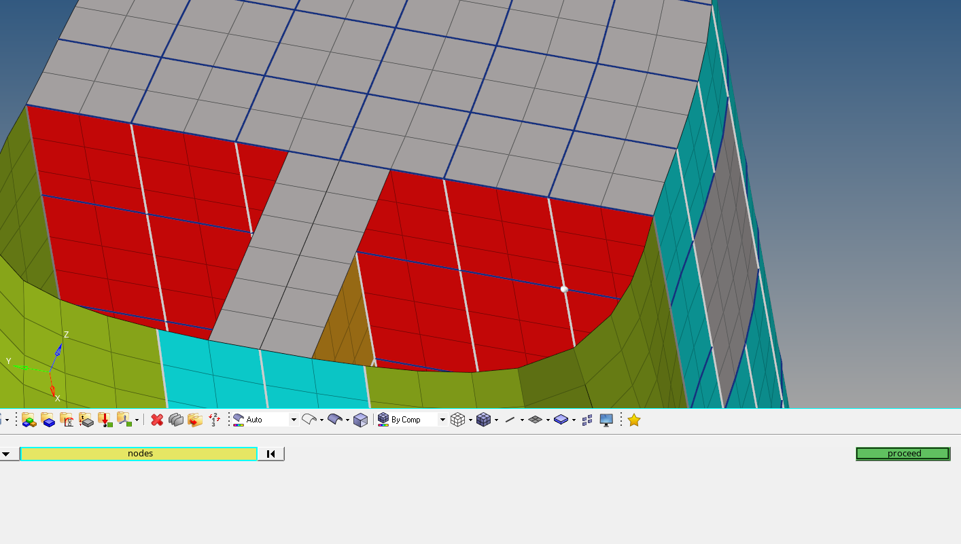
- Node selection. Seventh screen
- The last step is to indicate if there is other section or not. In this example there are three sections, so the field must be blank for this first iteration.
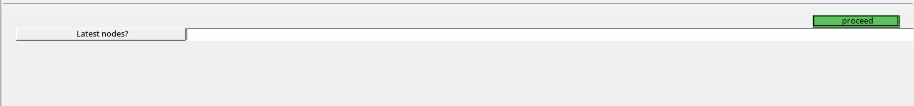
- Select if it is the last section defined
In order to make the example file with the three sections, the steps must be repeated selecting the nodes which define the sections indicated in Figure 5, and in the last section the step 9 must be filled with ‘yes’.

The output file has the following appearance:
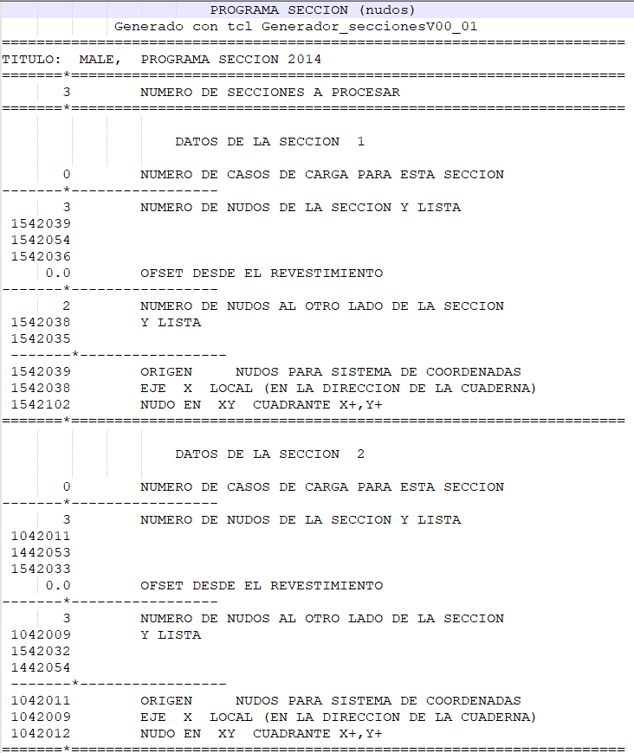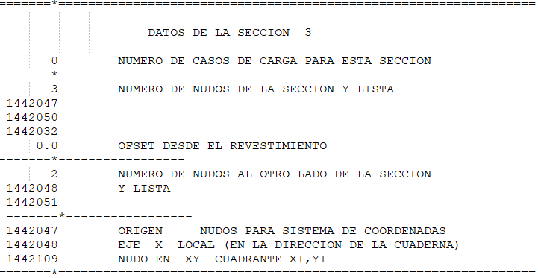
- Output file

CONSIDERATIONS
- Every field can be left blank if needed.
- The data for each section is written when the ‘proceed’ button in step 9 is pressed so before this step, the information of the corresponding section is temporal and it is not written in the file.

