 | NOTA TECNICA  TECHNICAL REPORT |  |  |  | Núm. No. | ME-T-NT-100006
 | Departamento Department |  | Methods |  | Avión Aircraft |  | Technologies
Título/Title
Program EH User’s Manual
Version 3
Palabras clave/Key words |  |  |  |  |  |  |  | Clasificación acceso Access class
MANUALS / EH / COMPUTER PROGRAMS |  |  |  |  |  |  |  | P1
Registro de Revisiones
Revision Record
 |  |  |  |  |  |  |  | Pag. 2
Resumen/Summary
The purpose of this Technical Report is to define the way to use the EH program.
The EH program calculates the stress and strain distribution around a circular hole in an infinite orthotropic plate.

This new version of the program includes a graphical windows user interface based in Visual Basic language.
WARNING

Applicability: holes in homogeneous orthotropic flat plates subject to any combination of in-plane loads (NOT valid for non symmetric laminates)

Method: ESDU85001

Note to be included in future revisions of user’s manual (G.B.L. 16/9/2015)
PROPIEDAD DE EADS CASA, Sociedad Unipersonal. Este documento no puede ser utilizado ni reproducido total o parcialmente sin la previa autorización escrita de la Dirección de Ingeniería y Tecnología de EADS-CASA.
EADS CASA, Sociedad Unipersonal PROPERTY. This document shall neither be used nor completely or partially reproduced without previous written authorization by EADS-CASA Engineering and Technology Directorate.
Distribución/Distribution |  | Realización/Execution |  |  |  |  | Fecha 1ª edición  1st issue Date
 |  |  |  |  |  |  | July- 1993
Archivo de Cálculo |  | Realizado  Prepared |  |  |  |  | Firma  Signature
Jefe de la Subd. de Cálculo (*) |  | Álvaro García Herrero
Jefes de Depto. de Calculo (*)
Jefes de Sección de Cálculo
 |  | Comprobado  Checked |  | Álvaro García Herrero
(*) Cover sheet only |  | Aprobado  Approved |  | Darío Fernández Villalba

REGISTRO DE REVISIONES/REVISIONS RECORD

Revisión | Motivo de Modificación/Change reason | Realiz./Prep. | Compr./Check. | Aprobado/App.
Fecha/Date | Capítulos,Secciones,Hojas afectadas/Chapters,Sections,Sheets affected | Firma/Sign | Firma/Sign | Firma/Sign
A | Primera edición / First issue | Álvaro García | Álvaro García | Darío Fernandez
Oct. 2010

INDEX
1 Technical sheet of the program 5
2 Introduction 6
3 Execution of the program 7
4 Input data file 8
5 Output results 11
5.1 Output file 11
5.2 Error messages 12
6 Windows application 14
7 Example 16
7.1 Formulation of the sample problem 16
7.2 Example 17

List of figures
Figure 1: Notation and sign criteria 8
Figure 2: Input data form. 14
Figure 3: Results form: Graph. 15
Figure 4: Results form: Results. 15
Figure 5: Ejemplo 1 Results graph: Cartesian Global Axis 22
Figure 6: Ejemplo 1 Results graph: Polar Global Axis 22

Technical sheet of the program
Technical Note ME-T-NT-100006
PROGRAM REFERENCE DATE
EH 2010
OBJECTIVE
This program performs the calculation of the stress and strain distribution around a circular hole in an infinite orthotropic plate.
LANGUAGE COMPUTER
Fortran 77 Sun Solaris
Visual .NET v.9.0 Windows PC’s
NUMBER OF LINES (APROX.) EXECUTION MODE
4000 Interactive
AUTHOR VERSION
Álvaro García Herrero 3.0
ADDITIONAL DOCUMENTS
Technical Report: NT–00–ECE–059 A. Theoretical Manual of the EH Program. V1.1.
Technical Report: ME-T-NT-100007 Programa EH. Manual del Programador.

Introduction
This report makes up the User’s Manual for the EH Program, which has been developed by EADS CASA from 1993 to date.
This program performs the calculation of the stress and strain distribution around a circular hole in an infinite orthotropic plate, with the following particularities:
- Allows the user to create a laminate plate, using up to 100 different materials and 500 layers.
- The program calculates the stresses and strains for up to 1000 load cases.
- Moreover, EH program calculates the laminate stiffness matrix and the reserve factors for each load case and ply.
- The results around the hole are given in intervals of 5 degrees.
- EH program, in its windows version, allows the user to plot the results and export them into an image file.

Differences between versions:
Version 1.1:
Initial version developed in Fortran 77.
Version 2.2:
The program is adapted to the new Sun Solaris computer.
Version 3.0:
Now, the user can choose the language for screen dialogs and for output files, between Spanish and English.
The format of the general input data file has some little differences from previous version. Now the data are grouped in the same way as for other applications.
The format of the results is practically the same, with exception of the language.
The program source is restructured to allow the creation of a Dynamic Link Library DLL for Windows operating system.
In parallel with this, a Windows application has been developed as Graphic User Interface GUI for the program EH, adapted to the new platform Microsoft .NET Framework. This application uses the same input files and provides the same output results. The analysis is performed by calling to the DLL (eh.dll), compiled from the same source as the official FORTRAN version.
FORTRAN source code is redistributed in different files without additional changes in the code.

Execution of the program
Prior to the program execution, it is necessary to create the input data file, as described in section 4. The program can be then executed by typing its full path name.
If the software symbol table has been previously assigned (consult with the System Manager in order to know how to assign this symbol table), it can be executed by typing the command:
$eh
The program asks for the language to use and the name of the input file, as shown in the following example:

Idioma / Language:
==================
_
1 ... ESPANOL

2 ... ENGLISH

Idioma / Language: 2

Name of the input file: Example.dat

The CPU time for calculation depends on the laminate and the number load cases to be considered, being a few seconds as much.
It is possible to execute the program with a single command, including the input filename, the output results filename and the language as parameters. The above example can be executed as follows:
$eh Example.dat Results.txt 2

Input data file
In this chapter, it is described the structure of the input file, which is required for the correct execution of the EH program.
This file contains all the necessary data that defines the problem. It basically contains four data groups, all them are necessary. They will be numbered from 1 to 4 and can appear in any order.
All the numerical data contained in this file will be read in a free format. The variables will be separated by one or more blank spaces. The numbering of each group will be included in the first column.
Figure 1 below shows the notation and sign criteria defined in the EH program.
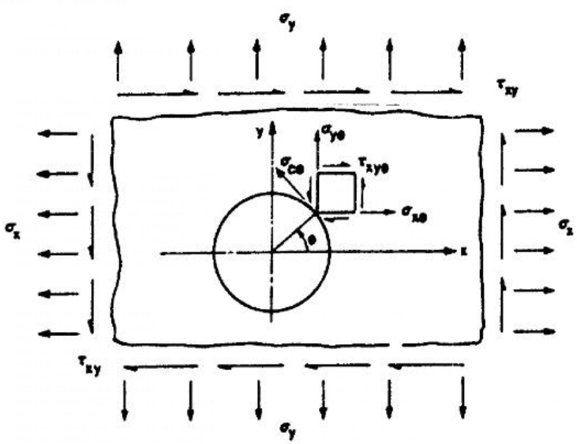
- Notation and sign criteria

Listed below are the contents of each data group:

- GROUP 1: Title of the problem.
Four lines, containing the title of the problem to be solved, which will appear at the header of the output file:
Line 1 -------> 1 First line of the title
Line 2 -------> Second line of the title
Line 3 -------> Third line of the title
Line 4 -------> Fourth line of the title
- GROUP 2: Material data.
Line 1--> 2 MATERIAL DATA
Three different ways of material data introduction can be used:

- Ply properties: In this case, the structure of this group is the following one:
Line 1--> 1 Ply properties
[Nm lines] Nm Mat(1) Ex(1) Ey(1) Gxy(1) µxy(1) h(1) Ө(1) et(1) ec(1)
Mat(2) Ex(2) Ey(2) Gxy(2) µxy(2) h(2) Ө(2) et(2) ec(2)
… … … … …
… … … … …
Mat(Nm) Ex(Nm) Ey(Nm) Gxy(Nm) μxy(Nm) h(NMm) Ө(Nm) et(Nm) ec(Nm)
Where: Nm Number of different materials
Mat(i) Number of material
Ex(i) Elastic Modulus of material i in x-direction
Ey(i) Elastic Modulus of material i in y-direction
Gxy(i) Elastic Shear Modulus of material i in xy-direction
μxy(i) Poisson coefficient of material i in xy-direction
h(i) Thickness of material ply i
Ө(i) Orientation angle of the ply i
et(i) Allowable tension strain of material i
ec(i) Allowable compression strain of material i
- Stiffness matrix: In this case, the structure of this group is the following:
Line 1--> 2 Stiffness matrix
A11 A12 A22 A33 H
Where: A11 Stiffness matrix element: row 1, column 1
A12 Stiffness matrix element: row 1, column 2
A22 Stiffness matrix element: row 2, column 2
A33 Stiffness matrix element: row 3, column 3
H Thickness of the plate
- Mean plate properties: In this case, the structure of this group is the following:
Line 1--> 3 Mean plate properties
Exx Eyy Gxy υxy
Where: Exx Elastic Modulus of the plate in x-direction
Eyy Elastic Modulus of the plate in y-direction
Gxy Elastic Shear Modulus of the plate in xy-direction
υxy Poisson coefficient of the plate in xy-direction
- GROUP 3: Lay-Out.
This group will be required only when the Material data have been introduced using option number 1 (Ply properties). The structure of this group is the following one:
Line 1--> 3 LAY-OUT
NPly Ply(1) Ply(2) Ply(3) Ply(4) … … … Ply(i-1)
Ply(i) Ply(i+1) … … … Ply(NPly-1) Ply(NPly)
Where: NPly Number of plies
Ply(i) Material number of ply i

- GROUP 4: Loads.
This group will contain the applied loads, and the structure of this group is the following one:
Line 1--> 4 LOADS
NLoads Fx(1) Fy(1) Fxy(1)
Fx(1) Fy(1) Fxy(1)
… … …
Fx(NLoads) Fy(NLoads) Fxy(NLoads)
Where: NLoads Number of load cases
Fx(i) Applied stress in x-direction for load case i
Fy(i) Applied stress in y-direction for load case i
Fxy(i) Applied shear stress in xy-direction for load case i

Output results

Output file
The EH program creates one printable file with all the results of the analysis carried out.
This file includes the following information:
- Stiffness matrix:
If the material input data is given as option 1, the results file contains the calculated stiffness matrix.
- Plate mean properties:
The results file also contains the resultant mechanical mean properties of the plate.
- Strain/Stress distribution and Reserve Factors:
For each load case, the file contains the calculated stresses and strains, showing the values in 5 degrees interval around the hole. Printed values are:
THT Angle from the x-axis (counter clockwise)
Sigma Stress in the direction of THT angle
XStress Stress in x-axis direction
YStress Stress in y-axis direction
XYStress Stress in xy-plane direction
XStrain Strain in x-axis direction
YStrain Strain in y-axis direction
XYStrain Strain in xy-plane direction
ECircum Strain in circumferential direction
ERad Strain in radial direction
ERTheta Strain in circumferential-radial plane direction
Examples of the output file are provided in chapter 7.

Error messages
When the program detects an error in the input data, it writes the corresponding message in the console and stops the execution. The error messages that might appear are listed below:
Error messages. English output:
ERROR: The input file cannot be opened'
ERROR: Bad input data in input file'
ERROR: Group 1 missing in input file (Title)'
ERROR: End of file while reading group 1 in input file (Title)'
ERROR: Group 2 missing in input file (Material data)'
ERROR: End of file while reading group 2 in input file (Material data)'
ERROR: Group 2 is defined badly (Entry type of material data)'
ERROR: Too many material types, exceeding the program capability'
ERROR: Group 3 missing in input file (Lay-Out)'
ERROR: End of file while reading group 3 in input file (Lay-Out)'
ERROR: Group 3 is defined badly (Lay-Out)'
ERROR: Too many plies in the lay-out, exceeding the program capability'
ERROR: Group 4 missing in input file (Loads)'
ERROR: End of file while reading group 4 in input file (Loads)'
ERROR: Group 4 is defined badly (Loads)'
ERROR: Too many load cases, exceeding the program capability'
ERROR: Division by zero in matrix QQ (Ex-Ey*Vxy^2)'
ERROR: Null value of A11'
ERROR: Null value of A22'
ERROR: Null value of H'
ERROR: Null value of EX'
ERROR: Null value of EY'
ERROR: Null value of GXY'
ERROR: Output file cannot be opened'
Error messages. Spanish output:
ERROR: No se puede abrir el fichero de entrada'
ERROR: Datos erróneos en el fichero de entrada'
ERROR: Grupo 1 ausente en el fichero de entrada (Título)'
ERROR: Fin de fichero mientras se leía el grupo 1 en el fichero de entrada (Título)'
ERROR: Grupo 2 ausente en el fichero de entrada (Datos de materiales)'
ERROR: Fin de fichero mientras se leía el grupo 2 en el fichero de entrada (Datos de materiales)'
ERROR: Grupo 2 mal definido (Tipos de entrada de datos de materiales)'
ERROR: Demasiados tipos de materiales, excediendo la capacidad del programa'
ERROR: Grupo 3 ausente en el fichero de entrada (Apilado)'
ERROR: Fin de fichero mientras se leía el grupo 3 en el fichero de entrada (Apilado)'
ERROR: Grupo 3 mal definido (Apilado)'
ERROR: Demasiadas capas en el apilado, excediendo la capacidad del programa'
ERROR: Grupo 4 ausente en el fichero de entrada (Cargas)'
ERROR: Fin de fichero mientras se leía el grupo 4 en el fichero de entrada (Cargas)'
ERROR: Grupo 4 mal definido (Cargas)'
ERROR: Demasiados casos de carga, excediendo la capacidad del programa'
ERROR: División por cero en matriz QQ (Ex-Ey*Vxy^2)'
ERROR: Valor nulo de A11'
ERROR: Valor nulo de A22'
ERROR: Valor nulo de H'
ERROR: Valor nulo de EX'
ERROR: Valor nulo de EY'
ERROR: Valor nulo de GXY'
ERROR: No se puede abrir el fichero de salida'

Windows application
An application has been developed in Visual Basic .NET for Windows environment. The original routines of the program for calculation and output results have been included in a Dynamic Link Library, which is used by this application. Therefore the same results will be obtained, with only differences due to rounding.
Since this is a Windows application, it must be installed in the user’s PC before it can be executed. For installation, please contact with the system manager.
The application can be executed by “double click” in the file Eh.exe, located in the PC’s server, or by means a link in the “desktop” or in the “start menu”.
The input data must be typed in the application form or retrieved from an input file. The form, after loading the data corresponding to the example 1 (see section 7), has the following appearance:
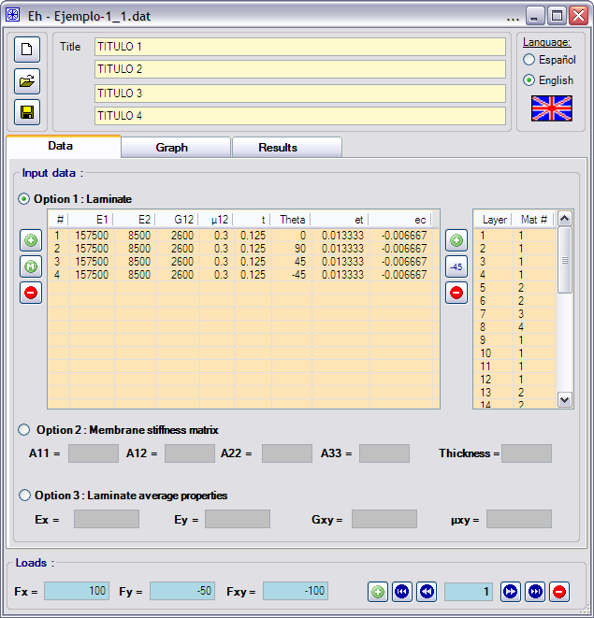
- Input data form.
The analysis will be performed using option 1 for input data, that is, defining a laminated of 32 plies, using four different materials.
The program calculates the results for all the included load cases at the moment it has all the required data. In example 1, there are four load cases and the user can access to the results by clicking on the taps “Graph” and “Results” (See Figures 2 and 3 below).
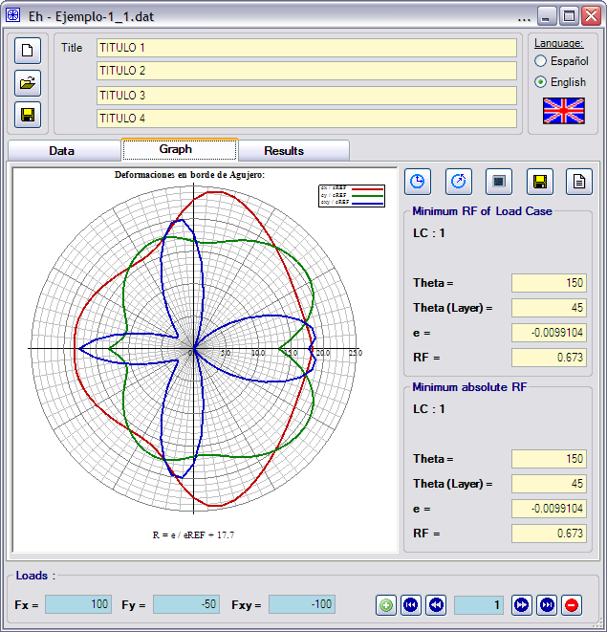
WARNING

eRef is an “arbitrary” value for plotting purposes. Use graph just for a qualitative understanding of the stress distribution.

Note to be included in future revisions of user’s manual (G.B.L. 18/2/2016)
- Results form: Graph.
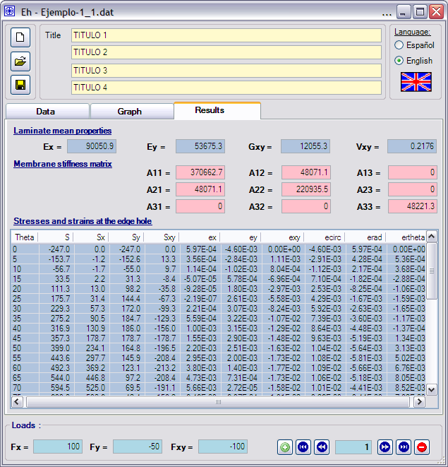
- Results form: Results.

Example
Three examples of how to use the program are given below. All them correspond to the same situation, but solved in three different ways.

Formulation of the sample problem
The problem consists of a drilled hole in a plate of composite material. The material of the layers has the following properties:
Ex 175500 MPa
Ey 8500 MPa
Gxy 2600 MPa
υxy 0.30
t 0.125 mm
et 0.013333 με
ec -0.006667 με

The laminate plate is composed of 32 plies distributed in a symmetric lay-out:
(0/0/0/0/90/90/45/-45/0/0/0/0/90/90/45/-45)_{S}
Four load cases will be applied over the plate (unit are MPa):
Load Case Fx Fy Fz
======== ======= ======= =======
1 100 -50 -100
2 100 0 0
3 0 -50 0
4 0 0 -100

Example

The example shows how to solve the problem using the options input data.

General input data file: Option 1
1 Example 1: Program EH
Stresses/Strains Around a Hole in an infinite orthotropic plate
Input 1: 4 Materials, 32 Layers
4 Load Cases
2 MATERIAL DATA
1 Ply Properties
4 1. 157500.0 8500.0 2600.0 0.300 0.125 0.0 0.013333 -0.006667
2. 157500.0 8500.0 2600.0 0.300 0.125 90.0 0.013333 -0.006667
3. 157500.0 8500.0 2600.0 0.300 0.125 45.0 0.013333 -0.006667
4. 157500.0 8500.0 2600.0 0.300 0.125 -45.0 0.013333 -0.006667

3 LAMINATE
32 1. 1. 1. 1. 2. 2. 3. 4. 1. 1. 1. 1. 2. 2. 3. 4.
4. 3. 2. 2. 1. 1. 1. 1. 4. 3. 2. 2. 1. 1. 1. 1.
4 LOADS
4 100.0 -50.0 -100.0
100.0 0.0 0.0
0.0 -50.0 0.0
0.0 0.0 -100.0

General input data file: Option 2
1 Example 2: Program EH
Stresses/Strains Around a Hole in an infinite orthotropic plate
Input 2: Stiffnes matrix
4 Load Cases
2 MATERIAL DATA
2 Stiffness Matrix
370662.7 48071.1 220935.5 48221.3 4.000
4 LOADS
4 100.0 -50.0 -100.0
100.0 0.0 0.0
0.0 -50.0 0.0
0.0 0.0 -100.0

General input data file: Option 3

1 Example 3: Program EH
Stresses/Strains Around a Hole in an infinite orthotropic plate
Input 3: Mean properties of the plate
4 Load Cases
2 MATERIAL DATA
3 Laminate Mean Properties
90050.90 53675.30 12055.30 0.22
4 LOADS
4 100.0 -50.0 -100.0
100.0 0.0 0.0
0.0 -50.0 0.0
0.0 0.0 -100.0

Output results file:

PROGRAM EH, VERSION 3.0
========================

Example 1: Program EH
Stresses/Strains Around a Hole in an infinite orthotropic plate
Input 1: 4 Materials, 32 Layers
4 Load Cases

PLATE CONSTRUCTION

LAY LAYER DIST. FROM E11 E22 G12 µ12 LAYER ANGLE ALLOWABLE ALLOWABLE
NUM THICKNESS NEUTRAL PLN DEGREES TENSION COMPRESSION
=== =========== =========== =========== =========== =========== =========== =========== =========== ===========
1 1.2500E-01 1.9375E+00 1.5750E+05 8.5000E+03 2.6000E+03 3.0000E-01 0.0000E+00 1.3333E-02 -6.6670E-03
2 1.2500E-01 1.8125E+00 1.5750E+05 8.5000E+03 2.6000E+03 3.0000E-01 0.0000E+00 1.3333E-02 -6.6670E-03
3 1.2500E-01 1.6875E+00 1.5750E+05 8.5000E+03 2.6000E+03 3.0000E-01 0.0000E+00 1.3333E-02 -6.6670E-03
4 1.2500E-01 1.5625E+00 1.5750E+05 8.5000E+03 2.6000E+03 3.0000E-01 0.0000E+00 1.3333E-02 -6.6670E-03
5 1.2500E-01 1.4375E+00 1.5750E+05 8.5000E+03 2.6000E+03 3.0000E-01 9.0000E+01 1.3333E-02 -6.6670E-03
6 1.2500E-01 1.3125E+00 1.5750E+05 8.5000E+03 2.6000E+03 3.0000E-01 9.0000E+01 1.3333E-02 -6.6670E-03
7 1.2500E-01 1.1875E+00 1.5750E+05 8.5000E+03 2.6000E+03 3.0000E-01 4.5000E+01 1.3333E-02 -6.6670E-03
8 1.2500E-01 1.0625E+00 1.5750E+05 8.5000E+03 2.6000E+03 3.0000E-01 -4.5000E+01 1.3333E-02 -6.6670E-03
9 1.2500E-01 9.3750E-01 1.5750E+05 8.5000E+03 2.6000E+03 3.0000E-01 0.0000E+00 1.3333E-02 -6.6670E-03
10 1.2500E-01 8.1250E-01 1.5750E+05 8.5000E+03 2.6000E+03 3.0000E-01 0.0000E+00 1.3333E-02 -6.6670E-03
11 1.2500E-01 6.8750E-01 1.5750E+05 8.5000E+03 2.6000E+03 3.0000E-01 0.0000E+00 1.3333E-02 -6.6670E-03
12 1.2500E-01 5.6250E-01 1.5750E+05 8.5000E+03 2.6000E+03 3.0000E-01 0.0000E+00 1.3333E-02 -6.6670E-03
13 1.2500E-01 4.3750E-01 1.5750E+05 8.5000E+03 2.6000E+03 3.0000E-01 9.0000E+01 1.3333E-02 -6.6670E-03
14 1.2500E-01 3.1250E-01 1.5750E+05 8.5000E+03 2.6000E+03 3.0000E-01 9.0000E+01 1.3333E-02 -6.6670E-03
15 1.2500E-01 1.8750E-01 1.5750E+05 8.5000E+03 2.6000E+03 3.0000E-01 4.5000E+01 1.3333E-02 -6.6670E-03
16 1.2500E-01 6.2500E-02 1.5750E+05 8.5000E+03 2.6000E+03 3.0000E-01 -4.5000E+01 1.3333E-02 -6.6670E-03
17 1.2500E-01 -6.2500E-02 1.5750E+05 8.5000E+03 2.6000E+03 3.0000E-01 -4.5000E+01 1.3333E-02 -6.6670E-03
18 1.2500E-01 -1.8750E-01 1.5750E+05 8.5000E+03 2.6000E+03 3.0000E-01 4.5000E+01 1.3333E-02 -6.6670E-03
19 1.2500E-01 -3.1250E-01 1.5750E+05 8.5000E+03 2.6000E+03 3.0000E-01 9.0000E+01 1.3333E-02 -6.6670E-03
20 1.2500E-01 -4.3750E-01 1.5750E+05 8.5000E+03 2.6000E+03 3.0000E-01 9.0000E+01 1.3333E-02 -6.6670E-03
21 1.2500E-01 -5.6250E-01 1.5750E+05 8.5000E+03 2.6000E+03 3.0000E-01 0.0000E+00 1.3333E-02 -6.6670E-03
22 1.2500E-01 -6.8750E-01 1.5750E+05 8.5000E+03 2.6000E+03 3.0000E-01 0.0000E+00 1.3333E-02 -6.6670E-03
23 1.2500E-01 -8.1250E-01 1.5750E+05 8.5000E+03 2.6000E+03 3.0000E-01 0.0000E+00 1.3333E-02 -6.6670E-03
24 1.2500E-01 -9.3750E-01 1.5750E+05 8.5000E+03 2.6000E+03 3.0000E-01 0.0000E+00 1.3333E-02 -6.6670E-03
25 1.2500E-01 -1.0625E+00 1.5750E+05 8.5000E+03 2.6000E+03 3.0000E-01 -4.5000E+01 1.3333E-02 -6.6670E-03
26 1.2500E-01 -1.1875E+00 1.5750E+05 8.5000E+03 2.6000E+03 3.0000E-01 4.5000E+01 1.3333E-02 -6.6670E-03
27 1.2500E-01 -1.3125E+00 1.5750E+05 8.5000E+03 2.6000E+03 3.0000E-01 9.0000E+01 1.3333E-02 -6.6670E-03
28 1.2500E-01 -1.4375E+00 1.5750E+05 8.5000E+03 2.6000E+03 3.0000E-01 9.0000E+01 1.3333E-02 -6.6670E-03
29 1.2500E-01 -1.5625E+00 1.5750E+05 8.5000E+03 2.6000E+03 3.0000E-01 0.0000E+00 1.3333E-02 -6.6670E-03
30 1.2500E-01 -1.6875E+00 1.5750E+05 8.5000E+03 2.6000E+03 3.0000E-01 0.0000E+00 1.3333E-02 -6.6670E-03
31 1.2500E-01 -1.8125E+00 1.5750E+05 8.5000E+03 2.6000E+03 3.0000E-01 0.0000E+00 1.3333E-02 -6.6670E-03
32 1.2500E-01 -1.9375E+00 1.5750E+05 8.5000E+03 2.6000E+03 3.0000E-01 0.0000E+00 1.3333E-02 -6.6670E-03

A IN PLANE STIFFNESS
=======================================
3.7066E+05 4.8071E+04 0.0000E+00
4.8071E+04 2.2094E+05 0.0000E+00
0.0000E+00 0.0000E+00 4.8221E+04

ESPESOR TOTAL DEL LAMINADO = 4.0000

PROPIEDADES MEDIAS DE LAMINADO
=====================================================
EX EY EXY VXY
=========== =========== =========== ===========
9.0051E+04 5.3675E+04 1.2055E+04 2.1758E-01

LOAD CASE : 1 X-STRESS Y-STRESS XY-STRESS
=========== =========== ===========
1.0000E+02 -5.0000E+01 -1.0000E+02

THT SIGMA XSTRESS YSTRESS XYSTRESS XSTRAIN YSTRAIN XYSTRAIN ECIRCUM ERAD ERTHETA
=== =========== =========== =========== =========== =========== =========== =========== =========== =========== ===========
0 -2.4697E+02 0.0000E+00 -2.4697E+02 0.0000E+00 5.9672E-04 -4.6011E-03 0.0000E+00 -4.6011E-03 5.9672E-04 0.0000E+00
5 -1.5374E+02 -1.1678E+00 -1.5257E+02 1.3348E+01 3.5567E-04 -2.8396E-03 1.1072E-03 -2.9115E-03 4.2753E-04 5.3556E-04
10 -5.6673E+01 -1.7089E+00 -5.4964E+01 9.6916E+00 1.1383E-04 -1.0199E-03 8.0393E-04 -1.1232E-03 2.1712E-04 3.6770E-04
15 3.3546E+01 2.2472E+00 3.1299E+01 -8.3865E+00 -5.0670E-05 5.7769E-04 -6.9567E-04 7.0951E-04 -1.8249E-04 -2.8829E-04
20 1.1126E+02 1.3015E+01 9.8243E+01 -3.5757E+01 -9.2848E-05 1.7989E-03 -2.9661E-03 2.5309E-03 -8.2485E-04 -1.0562E-03
25 1.7575E+02 3.1390E+01 1.4436E+02 -6.7316E+01 -2.1945E-07 2.6137E-03 -5.5839E-03 4.2856E-03 -1.6721E-03 -1.5869E-03
30 2.2928E+02 5.7321E+01 1.7196E+02 -9.9282E+01 2.2104E-04 3.0652E-03 -8.2355E-03 5.9203E-03 -2.6340E-03 -1.6546E-03
35 2.7521E+02 9.0541E+01 1.8467E+02 -1.2931E+02 5.5925E-04 3.2217E-03 -1.0726E-02 7.3854E-03 -3.6044E-03 -1.1666E-03
40 3.1690E+02 1.3094E+02 1.8597E+02 -1.5604E+02 1.0047E-03 3.1483E-03 -1.2944E-02 8.6363E-03 -4.4833E-03 -1.3668E-04
45 3.5734E+02 1.7867E+02 1.7867E+02 -1.7867E+02 1.5524E-03 2.8970E-03 -1.4821E-02 9.6350E-03 -5.1856E-03 1.3446E-03
50 3.9896E+02 2.3412E+02 1.6484E+02 -1.9645E+02 2.2016E-03 2.5054E-03 -1.6296E-02 1.0351E-02 -5.6442E-03 3.1289E-03
55 4.4363E+02 2.9768E+02 1.4595E+02 -2.0844E+02 2.9530E-03 1.9999E-03 -1.7290E-02 1.0763E-02 -5.8102E-03 5.0179E-03
60 4.9226E+02 3.6919E+02 1.2306E+02 -2.1315E+02 3.8025E-03 1.4007E-03 -1.7681E-02 1.0858E-02 -5.6551E-03 6.7607E-03
65 5.4401E+02 4.4684E+02 9.7163E+01 -2.0837E+02 4.7274E-03 7.3054E-04 -1.7284E-02 1.0634E-02 -5.1758E-03 8.0483E-03
70 5.9450E+02 5.2496E+02 6.9543E+01 -1.9107E+02 5.6615E-03 2.7234E-05 -1.5849E-02 1.0096E-02 -4.4075E-03 8.5196E-03
75 6.3298E+02 5.9058E+02 4.2402E+01 -1.5825E+02 6.4558E-03 -6.3699E-04 -1.3127E-02 9.2624E-03 -3.4435E-03 7.8216E-03
80 6.3995E+02 6.2065E+02 1.9297E+01 -1.0944E+02 6.8456E-03 -1.1401E-03 -9.0779E-03 8.1572E-03 -2.4517E-03 5.7992E-03
85 5.9119E+02 5.8670E+02 4.4907E+00 -5.1329E+01 6.5043E-03 -1.3339E-03 -4.2578E-03 6.8145E-03 -1.6440E-03 2.8320E-03
90 4.7501E+02 4.7501E+02 1.2608E-11 7.7388E-05 5.2749E-03 -1.1477E-03 6.4194E-09 5.2749E-03 -1.1477E-03 -4.3267E-09
95 3.1104E+02 3.0868E+02 2.3627E+00 2.7006E+01 3.4221E-03 -7.0180E-04 2.2401E-03 3.5853E-03 -8.6497E-04 -1.4900E-03
100 1.4097E+02 1.3672E+02 4.2508E+00 2.4108E+01 1.5080E-03 -2.5115E-04 1.9998E-03 1.7969E-03 -5.4008E-04 -1.2775E-03
105 -2.4430E+00 -2.2794E+00 -1.6365E-01 -6.1076E-01 -2.4917E-05 2.4585E-06 -5.0663E-05 -3.5749E-05 1.3290E-05 3.0188E-05
110 -1.0935E+02 -9.6560E+01 -1.2792E+01 -3.5145E+01 -1.0414E-03 -5.0099E-06 -2.9153E-03 -1.8571E-03 8.1072E-04 1.5671E-03
115 -1.8477E+02 -1.5177E+02 -3.3002E+01 -7.0773E+01 -1.6057E-03 -2.4813E-04 -5.8707E-03 -3.6118E-03 1.7580E-03 2.7337E-03
120 -2.3785E+02 -1.7839E+02 -5.9463E+01 -1.0299E+02 -1.8373E-03 -6.7680E-04 -8.5433E-03 -5.2465E-03 2.7324E-03 3.2666E-03
125 -2.7664E+02 -1.8562E+02 -9.1010E+01 -1.2998E+02 -1.8414E-03 -1.2471E-03 -1.0782E-02 -6.7116E-03 3.6231E-03 3.1290E-03
130 -3.0690E+02 -1.8009E+02 -1.2680E+02 -1.5112E+02 -1.6935E-03 -1.9272E-03 -1.2535E-02 -7.9625E-03 4.3417E-03 2.4069E-03
135 -3.3235E+02 -1.6617E+02 -1.6617E+02 -1.6617E+02 -1.4438E-03 -2.6944E-03 -1.3784E-02 -8.9612E-03 4.8230E-03 1.2506E-03
140 -3.5511E+02 -1.4672E+02 -2.0839E+02 -1.7486E+02 -1.1258E-03 -3.5278E-03 -1.4504E-02 -9.6774E-03 5.0238E-03 -1.5317E-04
145 -3.7597E+02 -1.2369E+02 -2.5228E+02 -1.7665E+02 -7.6401E-04 -4.4013E-03 -1.4653E-02 -1.0089E-02 4.9241E-03 -1.5938E-03
150 -3.9443E+02 -9.8607E+01 -2.9582E+02 -1.7079E+02 -3.8025E-04 -5.2731E-03 -1.4167E-02 -1.0185E-02 4.5312E-03 -2.8464E-03
155 -4.0846E+02 -7.2953E+01 -3.3550E+02 -1.5645E+02 5.1143E-07 -6.0743E-03 -1.2977E-02 -9.9600E-03 3.8862E-03 -3.6881E-03
160 -4.1422E+02 -4.8454E+01 -3.6576E+02 -1.3313E+02 3.4568E-04 -6.6973E-03 -1.1043E-02 -9.4226E-03 3.0709E-03 -3.9323E-03
165 -4.0607E+02 -2.7202E+01 -3.7887E+02 -1.0152E+02 6.1336E-04 -6.9929E-03 -8.4210E-03 -8.5886E-03 2.2091E-03 -3.4897E-03
170 -3.7760E+02 -1.1386E+01 -3.6621E+02 -6.4573E+01 7.5840E-04 -6.7952E-03 -5.3564E-03 -7.4835E-03 1.4466E-03 -2.4499E-03
175 -3.2425E+02 -2.4630E+00 -3.2179E+02 -2.8153E+01 7.5015E-04 -5.9891E-03 -2.3353E-03 -6.1407E-03 9.0171E-04 -1.1295E-03
180 -2.4697E+02 -2.6221E-11 -2.4697E+02 8.0472E-05 5.9672E-04 -4.6011E-03 6.6752E-09 -4.6011E-03 5.9672E-04 3.2879E-09

STRAINS IN PLIES
==================

THT ANGULO CAPA ANGULO CAPA ANGULO CAPA ANGULO CAPA RF 1 RF 2 RF 3 RF 4 MIN RF
0. 90. 45. -45.
=== =========== =========== =========== =========== ======== ======== ======== ======== ========
0 5.9672E-04 -4.6011E-03 -2.0022E-03 -2.0022E-03 22.34 1.45 3.33 3.33 1.45
5 3.5567E-04 -2.8396E-03 -6.8836E-04 -1.7956E-03 37.49 2.35 9.69 3.71 2.35
10 1.1383E-04 -1.0199E-03 -5.1062E-05 -8.5499E-04 117.13 6.54 130.57 7.80 6.54
15 -5.0670E-05 5.7769E-04 -8.4326E-05 6.1134E-04 131.58 23.08 79.06 21.81 21.81
20 -9.2848E-05 1.7989E-03 -6.3004E-04 2.3361E-03 71.81 7.41 10.58 5.71 5.71
25 -2.1945E-07 2.6137E-03 -1.4852E-03 4.0987E-03 1000.00 5.10 4.49 3.25 3.25
30 2.2104E-04 3.0652E-03 -2.4746E-03 5.7609E-03 60.32 4.35 2.69 2.31 2.31
35 5.5925E-04 3.2217E-03 -3.4725E-03 7.2535E-03 23.84 4.14 1.92 1.84 1.84
40 1.0047E-03 3.1483E-03 -4.3955E-03 8.5485E-03 13.27 4.24 1.52 1.56 1.52
45 1.5524E-03 2.8970E-03 -5.1856E-03 9.6350E-03 8.59 4.60 1.29 1.38 1.29
50 2.2016E-03 2.5054E-03 -5.7944E-03 1.0501E-02 6.06 5.32 1.15 1.27 1.15
55 2.9530E-03 1.9999E-03 -6.1686E-03 1.1122E-02 4.51 6.67 1.08 1.20 1.08
60 3.8025E-03 1.4007E-03 -6.2391E-03 1.1442E-02 3.51 9.52 1.07 1.17 1.07
65 4.7274E-03 7.3054E-04 -5.9131E-03 1.1371E-02 2.82 18.25 1.13 1.17 1.13
70 5.6615E-03 2.7234E-05 -5.0803E-03 1.0769E-02 2.36 489.57 1.31 1.24 1.24
75 6.4558E-03 -6.3699E-04 -3.6539E-03 9.4727E-03 2.07 10.47 1.82 1.41 1.41
80 6.8456E-03 -1.1401E-03 -1.6862E-03 7.3917E-03 1.95 5.85 3.95 1.80 1.80
85 6.5043E-03 -1.3339E-03 4.5631E-04 4.7141E-03 2.05 5.00 29.22 2.83 2.05
90 5.2749E-03 -1.1477E-03 2.0636E-03 2.0636E-03 2.53 5.81 6.46 6.46 2.53
95 3.4221E-03 -7.0180E-04 2.4802E-03 2.4007E-04 3.90 9.50 5.38 55.54 3.90
100 1.5080E-03 -2.5115E-04 1.6283E-03 -3.7145E-04 8.84 26.55 8.19 17.95 8.19
105 -2.4917E-05 2.4585E-06 -3.6561E-05 1.4102E-05 267.57 1000.00 182.35 945.44 182.35
110 -1.0414E-03 -5.0099E-06 -1.9809E-03 9.3446E-04 6.40 1000.00 3.37 14.27 3.37
115 -1.6057E-03 -2.4813E-04 -3.8622E-03 2.0084E-03 4.15 26.87 1.73 6.64 1.73
120 -1.8373E-03 -6.7680E-04 -5.5287E-03 3.0146E-03 3.63 9.85 1.21 4.42 1.21
125 -1.8414E-03 -1.2471E-03 -6.9351E-03 3.8466E-03 3.62 5.35 0.96 3.47 0.96
130 -1.6935E-03 -1.9272E-03 -8.0780E-03 4.4572E-03 3.94 3.46 0.83 2.99 0.83
135 -1.4438E-03 -2.6944E-03 -8.9612E-03 4.8230E-03 4.62 2.47 0.74 2.76 0.74
140 -1.1258E-03 -3.5278E-03 -9.5791E-03 4.9254E-03 5.92 1.89 0.70 2.71 0.70
145 -7.6401E-04 -4.4013E-03 -9.9092E-03 4.7439E-03 8.73 1.51 0.67 2.81 0.67
150 -3.8025E-04 -5.2731E-03 -9.9104E-03 4.2570E-03 17.53 1.26 0.67 3.13 0.67
155 5.1143E-07 -6.0743E-03 -9.5256E-03 3.4518E-03 1000.00 1.10 0.70 3.86 0.70
160 3.4568E-04 -6.6973E-03 -8.6973E-03 2.3457E-03 38.57 1.00 0.77 5.68 0.77
165 6.1336E-04 -6.9929E-03 -7.4003E-03 1.0208E-03 21.74 0.95 0.90 13.06 0.90
170 7.5840E-04 -6.7952E-03 -5.6966E-03 -3.4022E-04 17.58 0.98 1.17 19.60 0.98
175 7.5015E-04 -5.9891E-03 -3.7871E-03 -1.4518E-03 17.77 1.11 1.76 4.59 1.11
180 5.9672E-04 -4.6011E-03 -2.0022E-03 -2.0022E-03 22.34 1.45 3.33 3.33 1.45

MINIMUM RESERVE FACTOR = 0.67 THETA = 45.

LOAD CASE : 2 X-STRESS Y-STRESS XY-STRESS
=========== =========== ===========
1.0000E+02 0.0000E+00 0.0000E+00

THT SIGMA XSTRESS YSTRESS XYSTRESS XSTRAIN YSTRAIN XYSTRAIN ECIRCUM ERAD ERTHETA
=== =========== =========== =========== =========== =========== =========== =========== =========== =========== ===========
0 -7.7205E+01 0.0000E+00 -7.7205E+01 0.0000E+00 1.8654E-04 -1.4384E-03 0.0000E+00 -1.4384E-03 1.8654E-04 0.0000E+00
5 -7.3547E+01 -5.5867E-01 -7.2988E+01 6.3856E+00 1.7015E-04 -1.3585E-03 5.2969E-04 -1.3928E-03 2.0453E-04 2.5621E-04
10 -6.3457E+01 -1.9135E+00 -6.1543E+01 1.0852E+01 1.2745E-04 -1.1420E-03 9.0016E-04 -1.2576E-03 2.4311E-04 4.1171E-04
15 -4.9022E+01 -3.2839E+00 -4.5738E+01 1.2256E+01 7.4046E-05 -8.4420E-04 1.0166E-03 -1.0368E-03 2.6669E-04 4.2129E-04
20 -3.2407E+01 -3.7909E+00 -2.8616E+01 1.0415E+01 2.7045E-05 -5.2398E-04 8.6397E-04 -7.3719E-04 2.4026E-04 3.0765E-04
25 -1.5083E+01 -2.6939E+00 -1.2389E+01 5.7771E+00 1.8833E-08 -2.2430E-04 4.7921E-04 -3.6779E-04 1.4350E-04 1.3619E-04
30 2.3295E+00 5.8239E-01 1.7472E+00 -1.0087E+00 2.2458E-06 3.1143E-05 -8.3674E-05 6.0151E-05 -2.6762E-05 -1.6811E-05
35 1.9885E+01 6.5419E+00 1.3343E+01 -9.3429E+00 4.0408E-05 2.3278E-04 -7.7500E-04 5.3362E-04 -2.6043E-04 -8.4294E-05
40 3.8097E+01 1.5741E+01 2.2357E+01 -1.8759E+01 1.2078E-04 3.7848E-04 -1.5561E-03 1.0382E-03 -5.3897E-04 -1.6432E-05
45 5.7807E+01 2.8903E+01 2.8903E+01 -2.8903E+01 2.5113E-04 4.6865E-04 -2.3976E-03 1.5587E-03 -8.3889E-04 2.1752E-04
50 8.0134E+01 4.7024E+01 3.3109E+01 -3.9458E+01 4.4220E-04 5.0322E-04 -3.2731E-03 2.0791E-03 -1.1337E-03 6.2846E-04
55 1.0649E+02 7.1459E+01 3.5035E+01 -5.0036E+01 7.0888E-04 4.8007E-04 -4.1505E-03 2.5837E-03 -1.3948E-03 1.2045E-03
60 1.3860E+02 1.0395E+02 3.4649E+01 -6.0014E+01 1.0706E-03 3.9438E-04 -4.9782E-03 3.0572E-03 -1.5922E-03 1.9035E-03
65 1.7829E+02 1.4645E+02 3.1844E+01 -6.8290E+01 1.5494E-03 2.3943E-04 -5.6648E-03 3.4851E-03 -1.6963E-03 2.6378E-03
70 2.2697E+02 2.0042E+02 2.6550E+01 -7.2945E+01 2.1614E-03 1.0397E-05 -6.0509E-03 3.8545E-03 -1.6827E-03 3.2526E-03
75 2.8389E+02 2.6488E+02 1.9017E+01 -7.0973E+01 2.8954E-03 -2.8569E-04 -5.8873E-03 4.1542E-03 -1.5444E-03 3.5080E-03
80 3.4322E+02 3.3287E+02 1.0349E+01 -5.8694E+01 3.6715E-03 -6.1147E-04 -4.8688E-03 4.3750E-03 -1.3149E-03 3.1103E-03
85 3.9128E+02 3.8831E+02 2.9722E+00 -3.3972E+01 4.3049E-03 -8.8285E-04 -2.8180E-03 4.5102E-03 -1.0881E-03 1.8744E-03
90 4.1024E+02 4.1024E+02 1.0889E-11 6.6837E-05 4.5557E-03 -9.9123E-04 5.5442E-09 4.5557E-03 -9.9123E-04 -3.7368E-09
95 3.9128E+02 3.8831E+02 2.9722E+00 3.3972E+01 4.3049E-03 -8.8285E-04 2.8180E-03 4.5102E-03 -1.0881E-03 -1.8744E-03
100 3.4322E+02 3.3287E+02 1.0349E+01 5.8695E+01 3.6715E-03 -6.1147E-04 4.8688E-03 4.3750E-03 -1.3149E-03 -3.1103E-03
105 2.8389E+02 2.6488E+02 1.9017E+01 7.0973E+01 2.8954E-03 -2.8569E-04 5.8873E-03 4.1542E-03 -1.5444E-03 -3.5080E-03
110 2.2697E+02 2.0042E+02 2.6550E+01 7.2945E+01 2.1614E-03 1.0398E-05 6.0509E-03 3.8545E-03 -1.6827E-03 -3.2526E-03
115 1.7829E+02 1.4645E+02 3.1844E+01 6.8290E+01 1.5494E-03 2.3943E-04 5.6648E-03 3.4851E-03 -1.6963E-03 -2.6378E-03
120 1.3860E+02 1.0395E+02 3.4649E+01 6.0014E+01 1.0706E-03 3.9438E-04 4.9782E-03 3.0572E-03 -1.5922E-03 -1.9035E-03
125 1.0649E+02 7.1458E+01 3.5035E+01 5.0036E+01 7.0888E-04 4.8007E-04 4.1505E-03 2.5837E-03 -1.3948E-03 -1.2045E-03
130 8.0134E+01 4.7024E+01 3.3109E+01 3.9458E+01 4.4220E-04 5.0322E-04 3.2731E-03 2.0791E-03 -1.1337E-03 -6.2846E-04
135 5.7807E+01 2.8903E+01 2.8903E+01 2.8903E+01 2.5113E-04 4.6865E-04 2.3976E-03 1.5587E-03 -8.3889E-04 -2.1752E-04
140 3.8097E+01 1.5741E+01 2.2356E+01 1.8759E+01 1.2078E-04 3.7848E-04 1.5561E-03 1.0382E-03 -5.3897E-04 1.6432E-05
145 1.9885E+01 6.5419E+00 1.3343E+01 9.3428E+00 4.0408E-05 2.3278E-04 7.7499E-04 5.3362E-04 -2.6043E-04 8.4294E-05
150 2.3295E+00 5.8237E-01 1.7471E+00 1.0087E+00 2.2458E-06 3.1143E-05 8.3672E-05 6.0149E-05 -2.6761E-05 1.6811E-05
155 -1.5083E+01 -2.6939E+00 -1.2389E+01 -5.7771E+00 1.8886E-08 -2.2431E-04 -4.7921E-04 -3.6779E-04 1.4350E-04 -1.3619E-04
160 -3.2407E+01 -3.7909E+00 -2.8616E+01 -1.0415E+01 2.7045E-05 -5.2398E-04 -8.6397E-04 -7.3719E-04 2.4026E-04 -3.0765E-04
165 -4.9022E+01 -3.2839E+00 -4.5738E+01 -1.2256E+01 7.4046E-05 -8.4420E-04 -1.0166E-03 -1.0368E-03 2.6669E-04 -4.2129E-04
170 -6.3457E+01 -1.9135E+00 -6.1543E+01 -1.0852E+01 1.2745E-04 -1.1420E-03 -9.0016E-04 -1.2576E-03 2.4311E-04 -4.1171E-04
175 -7.3547E+01 -5.5866E-01 -7.2988E+01 -6.3856E+00 1.7015E-04 -1.3585E-03 -5.2969E-04 -1.3928E-03 2.0453E-04 -2.5620E-04
180 -7.7205E+01 -8.1970E-12 -7.7205E+01 2.5156E-05 1.8654E-04 -1.4384E-03 2.0867E-09 -1.4384E-03 1.8654E-04 1.0278E-09

STRAINS IN PLIES
==================

THT ANGULO CAPA ANGULO CAPA ANGULO CAPA ANGULO CAPA RF 1 RF 2 RF 3 RF 4 MIN RF
0. 90. 45. -45.
=== =========== =========== =========== =========== ======== ======== ======== ======== ========
0 1.8654E-04 -1.4384E-03 -6.2591E-04 -6.2591E-04 71.47 4.64 10.65 10.65 4.64
5 1.7015E-04 -1.3585E-03 -3.2931E-04 -8.5900E-04 78.36 4.91 20.25 7.76 4.91
10 1.2745E-04 -1.1420E-03 -5.7174E-05 -9.5734E-04 104.61 5.84 116.61 6.96 5.84
15 7.4046E-05 -8.4420E-04 1.2323E-04 -8.9338E-04 180.06 7.90 108.20 7.46 7.46
20 2.7045E-05 -5.2398E-04 1.8352E-04 -6.8045E-04 493.00 12.72 72.65 9.80 9.80
25 1.8833E-08 -2.2430E-04 1.2746E-04 -3.5175E-04 1000.00 29.72 104.60 18.95 18.95
30 2.2458E-06 3.1143E-05 -2.5143E-05 5.8532E-05 1000.00 428.12 265.17 227.79 227.79
35 4.0408E-05 2.3278E-04 -2.5090E-04 5.2409E-04 329.96 57.28 26.57 25.44 25.44
40 1.2078E-04 3.7848E-04 -5.2842E-04 1.0277E-03 110.39 35.23 12.62 12.97 12.62
45 2.5113E-04 4.6865E-04 -8.3889E-04 1.5587E-03 53.09 28.45 7.95 8.55 7.95
50 4.4220E-04 5.0322E-04 -1.1638E-03 2.1093E-03 30.15 26.50 5.73 6.32 5.73
55 7.0888E-04 4.8007E-04 -1.4808E-03 2.6697E-03 18.81 27.77 4.50 4.99 4.50
60 1.0706E-03 3.9438E-04 -1.7566E-03 3.2216E-03 12.45 33.81 3.80 4.14 3.80
65 1.5494E-03 2.3943E-04 -1.9380E-03 3.7268E-03 8.61 55.69 3.44 3.58 3.44
70 2.1614E-03 1.0397E-05 -1.9395E-03 4.1114E-03 6.17 1000.00 3.44 3.24 3.24
75 2.8954E-03 -2.8569E-04 -1.6388E-03 4.2485E-03 4.60 23.34 4.07 3.14 3.14
80 3.6715E-03 -6.1147E-04 -9.0436E-04 3.9644E-03 3.63 10.90 7.37 3.36 3.36
85 4.3049E-03 -8.8285E-04 3.0201E-04 3.1200E-03 3.10 7.55 44.15 4.27 3.10
90 4.5557E-03 -9.9123E-04 1.7822E-03 1.7822E-03 2.93 6.73 7.48 7.48 2.93
95 4.3049E-03 -8.8285E-04 3.1200E-03 3.0200E-04 3.10 7.55 4.27 44.15 3.10
100 3.6715E-03 -6.1147E-04 3.9644E-03 -9.0437E-04 3.63 10.90 3.36 7.37 3.36
105 2.8954E-03 -2.8569E-04 4.2485E-03 -1.6388E-03 4.60 23.34 3.14 4.07 3.14
110 2.1614E-03 1.0398E-05 4.1114E-03 -1.9395E-03 6.17 1000.00 3.24 3.44 3.24
115 1.5494E-03 2.3943E-04 3.7268E-03 -1.9380E-03 8.61 55.69 3.58 3.44 3.44
120 1.0706E-03 3.9438E-04 3.2216E-03 -1.7566E-03 12.45 33.81 4.14 3.80 3.80
125 7.0888E-04 4.8007E-04 2.6697E-03 -1.4808E-03 18.81 27.77 4.99 4.50 4.50
130 4.4220E-04 5.0322E-04 2.1093E-03 -1.1638E-03 30.15 26.50 6.32 5.73 5.73
135 2.5113E-04 4.6865E-04 1.5587E-03 -8.3889E-04 53.09 28.45 8.55 7.95 7.95
140 1.2078E-04 3.7848E-04 1.0277E-03 -5.2842E-04 110.39 35.23 12.97 12.62 12.62
145 4.0408E-05 2.3278E-04 5.2409E-04 -2.5090E-04 329.96 57.28 25.44 26.57 25.44
150 2.2458E-06 3.1143E-05 5.8530E-05 -2.5142E-05 1000.00 428.13 227.80 265.17 227.80
155 1.8886E-08 -2.2431E-04 -3.5175E-04 1.2746E-04 1000.00 29.72 18.95 104.60 18.95
160 2.7045E-05 -5.2398E-04 -6.8045E-04 1.8352E-04 493.00 12.72 9.80 72.65 9.80
165 7.4046E-05 -8.4420E-04 -8.9338E-04 1.2323E-04 180.06 7.90 7.46 108.20 7.46
170 1.2745E-04 -1.1420E-03 -9.5734E-04 -5.7175E-05 104.61 5.84 6.96 116.61 5.84
175 1.7015E-04 -1.3585E-03 -8.5900E-04 -3.2931E-04 78.36 4.91 7.76 20.25 4.91
180 1.8654E-04 -1.4384E-03 -6.2591E-04 -6.2591E-04 71.47 4.64 10.65 10.65 4.64

MINIMUM RESERVE FACTOR = 2.93 THETA = 0.

LOAD CASE : 3 X-STRESS Y-STRESS XY-STRESS
=========== =========== ===========
0.0000E+00 -5.0000E+01 0.0000E+00

THT SIGMA XSTRESS YSTRESS XYSTRESS XSTRAIN YSTRAIN XYSTRAIN ECIRCUM ERAD ERTHETA
=== =========== =========== =========== =========== =========== =========== =========== =========== =========== ===========
0 -1.6976E+02 0.0000E+00 -1.6976E+02 0.0000E+00 4.1018E-04 -3.1627E-03 0.0000E+00 -3.1627E-03 4.1018E-04 0.0000E+00
5 -1.6545E+02 -1.2568E+00 -1.6419E+02 1.4365E+01 3.8276E-04 -3.0559E-03 1.1916E-03 -3.1333E-03 4.6010E-04 5.7635E-04
10 -1.5368E+02 -4.6340E+00 -1.4904E+02 2.6281E+01 3.0866E-04 -2.7656E-03 2.1800E-03 -3.0457E-03 5.8876E-04 9.9707E-04
15 -1.3724E+02 -9.1934E+00 -1.2805E+02 3.4310E+01 2.0730E-04 -2.3634E-03 2.8461E-03 -2.9027E-03 7.4661E-04 1.1794E-03
20 -1.1907E+02 -1.3929E+01 -1.0514E+02 3.8269E+01 9.9369E-05 -1.9252E-03 3.1745E-03 -2.7086E-03 8.8279E-04 1.1304E-03
25 -1.0127E+02 -1.8087E+01 -8.3182E+01 3.8789E+01 1.2644E-07 -1.5060E-03 3.2175E-03 -2.4694E-03 9.6351E-04 9.1441E-04
30 -8.4903E+01 -2.1226E+01 -6.3677E+01 3.6764E+01 -8.1852E-05 -1.1351E-03 3.0496E-03 -2.1923E-03 9.7536E-04 6.1270E-04
35 -7.0266E+01 -2.3117E+01 -4.7149E+01 3.3014E+01 -1.4279E-04 -8.2256E-04 2.7386E-03 -1.8856E-03 9.2028E-04 2.9786E-04
40 -5.7200E+01 -2.3634E+01 -3.3566E+01 2.8166E+01 -1.8135E-04 -5.6826E-04 2.3364E-03 -1.5588E-03 8.0922E-04 2.4671E-05
45 -4.5313E+01 -2.2656E+01 -2.2656E+01 2.2656E+01 -1.9685E-04 -3.6736E-04 1.8794E-03 -1.2218E-03 6.5757E-04 -1.7050E-04
50 -3.4100E+01 -2.0011E+01 -1.4089E+01 1.6791E+01 -1.8817E-04 -2.1414E-04 1.3928E-03 -8.8474E-04 4.8242E-04 -2.6744E-04
55 -2.2997E+01 -1.5431E+01 -7.5657E+00 1.0805E+01 -1.5308E-04 -1.0367E-04 8.9627E-04 -5.5793E-04 3.0119E-04 -2.6011E-04
60 -1.1393E+01 -8.5445E+00 -2.8482E+00 4.9332E+00 -8.8004E-05 -3.2418E-05 4.0921E-04 -2.5130E-04 1.3088E-04 -1.5647E-04
65 1.3222E+00 1.0861E+00 2.3616E-01 -5.0644E-01 1.1490E-05 1.7756E-06 -4.2010E-05 2.5846E-05 -1.2580E-05 1.9562E-05
70 1.5609E+01 1.3783E+01 1.8259E+00 -5.0166E+00 1.4865E-04 7.1504E-07 -4.1613E-04 2.6508E-04 -1.1572E-04 2.2369E-04
75 3.1377E+01 2.9275E+01 2.1019E+00 -7.8443E+00 3.2002E-04 -3.1576E-05 -6.5069E-04 4.5914E-04 -1.7070E-04 3.8772E-04
80 4.7238E+01 4.5814E+01 1.4244E+00 -8.0782E+00 5.0531E-04 -8.4157E-05 -6.7009E-04 6.0213E-04 -1.8097E-04 4.2807E-04
85 5.9834E+01 5.9380E+01 4.5451E-01 -5.1951E+00 6.5831E-04 -1.3501E-04 -4.3093E-04 6.8969E-04 -1.6639E-04 2.8663E-04
90 6.4763E+01 6.4763E+01 1.7190E-12 1.0551E-05 7.1918E-04 -1.5648E-04 8.7523E-10 7.1918E-04 -1.5648E-04 -5.8991E-10
95 5.9834E+01 5.9380E+01 4.5451E-01 5.1951E+00 6.5830E-04 -1.3500E-04 4.3094E-04 6.8969E-04 -1.6639E-04 -2.8663E-04
100 4.7238E+01 4.5813E+01 1.4244E+00 8.0782E+00 5.0531E-04 -8.4157E-05 6.7009E-04 6.0213E-04 -1.8097E-04 -4.2807E-04
105 3.1377E+01 2.9275E+01 2.1019E+00 7.8443E+00 3.2002E-04 -3.1576E-05 6.5069E-04 4.5914E-04 -1.7070E-04 -3.8772E-04
110 1.5609E+01 1.3783E+01 1.8259E+00 5.0166E+00 1.4865E-04 7.1511E-07 4.1613E-04 2.6508E-04 -1.1572E-04 -2.2369E-04
115 1.3222E+00 1.0860E+00 2.3615E-01 5.0642E-01 1.1490E-05 1.7755E-06 4.2008E-05 2.5845E-05 -1.2580E-05 -1.9561E-05
120 -1.1393E+01 -8.5445E+00 -2.8482E+00 -4.9332E+00 -8.8004E-05 -3.2418E-05 -4.0921E-04 -2.5130E-04 1.3088E-04 1.5647E-04
125 -2.2997E+01 -1.5431E+01 -7.5657E+00 -1.0805E+01 -1.5308E-04 -1.0367E-04 -8.9628E-04 -5.5793E-04 3.0119E-04 2.6011E-04
130 -3.4100E+01 -2.0011E+01 -1.4089E+01 -1.6791E+01 -1.8817E-04 -2.1414E-04 -1.3928E-03 -8.8474E-04 4.8242E-04 2.6744E-04
135 -4.5313E+01 -2.2656E+01 -2.2656E+01 -2.2656E+01 -1.9685E-04 -3.6736E-04 -1.8794E-03 -1.2218E-03 6.5757E-04 1.7050E-04
140 -5.7200E+01 -2.3634E+01 -3.3566E+01 -2.8166E+01 -1.8135E-04 -5.6826E-04 -2.3364E-03 -1.5588E-03 8.0922E-04 -2.4672E-05
145 -7.0266E+01 -2.3117E+01 -4.7149E+01 -3.3014E+01 -1.4279E-04 -8.2257E-04 -2.7386E-03 -1.8856E-03 9.2028E-04 -2.9787E-04
150 -8.4903E+01 -2.1226E+01 -6.3677E+01 -3.6764E+01 -8.1852E-05 -1.1351E-03 -3.0496E-03 -2.1923E-03 9.7536E-04 -6.1270E-04
155 -1.0127E+02 -1.8087E+01 -8.3182E+01 -3.8789E+01 1.2680E-07 -1.5060E-03 -3.2175E-03 -2.4694E-03 9.6351E-04 -9.1442E-04
160 -1.1907E+02 -1.3929E+01 -1.0514E+02 -3.8269E+01 9.9370E-05 -1.9252E-03 -3.1745E-03 -2.7086E-03 8.8279E-04 -1.1304E-03
165 -1.3724E+02 -9.1934E+00 -1.2805E+02 -3.4310E+01 2.0730E-04 -2.3634E-03 -2.8461E-03 -2.9027E-03 7.4661E-04 -1.1794E-03
170 -1.5368E+02 -4.6340E+00 -1.4905E+02 -2.6281E+01 3.0866E-04 -2.7656E-03 -2.1800E-03 -3.0457E-03 5.8876E-04 -9.9707E-04
175 -1.6545E+02 -1.2567E+00 -1.6419E+02 -1.4365E+01 3.8276E-04 -3.0559E-03 -1.1916E-03 -3.1333E-03 4.6010E-04 -5.7635E-04
180 -1.6976E+02 -1.8024E-11 -1.6976E+02 5.5315E-05 4.1018E-04 -3.1627E-03 4.5885E-09 -3.1627E-03 4.1018E-04 2.2600E-09

STRAINS IN PLIES
==================

THT ANGULO CAPA ANGULO CAPA ANGULO CAPA ANGULO CAPA RF 1 RF 2 RF 3 RF 4 MIN RF
0. 90. 45. -45.
=== =========== =========== =========== =========== ======== ======== ======== ======== ========
0 4.1018E-04 -3.1627E-03 -1.3763E-03 -1.3763E-03 32.51 2.11 4.84 4.84 2.11
5 3.8276E-04 -3.0559E-03 -7.4080E-04 -1.9324E-03 34.83 2.18 9.00 3.45 2.18
10 3.0866E-04 -2.7656E-03 -1.3846E-04 -2.3185E-03 43.20 2.41 48.15 2.88 2.41
15 2.0730E-04 -2.3634E-03 3.4499E-04 -2.5011E-03 64.32 2.82 38.65 2.67 2.67
20 9.9369E-05 -1.9252E-03 6.7430E-04 -2.5002E-03 134.18 3.46 19.77 2.67 2.67
25 1.2644E-07 -1.5060E-03 8.5582E-04 -2.3617E-03 1000.00 4.43 15.58 2.82 2.82
30 -8.1852E-05 -1.1351E-03 9.1635E-04 -2.1333E-03 81.45 5.87 14.55 3.13 3.13
35 -1.4279E-04 -8.2256E-04 8.8661E-04 -1.8520E-03 46.69 8.11 15.04 3.60 3.60
40 -1.8135E-04 -5.6826E-04 7.9338E-04 -1.5430E-03 36.76 11.73 16.81 4.32 4.32
45 -1.9685E-04 -3.6736E-04 6.5757E-04 -1.2218E-03 33.87 18.15 20.28 5.46 5.46
50 -1.8817E-04 -2.1414E-04 4.9526E-04 -8.9757E-04 35.43 31.13 26.92 7.43 7.43
55 -1.5308E-04 -1.0367E-04 3.1976E-04 -5.7651E-04 43.55 64.31 41.70 11.56 11.56
60 -8.8004E-05 -3.2418E-05 1.4439E-04 -2.6482E-04 75.76 205.66 92.34 25.18 25.18
65 1.1490E-05 1.7756E-06 -1.4372E-05 2.7638E-05 1000.00 1000.00 463.88 482.42 463.88
70 1.4865E-04 7.1504E-07 -1.3338E-04 2.8275E-04 89.70 1000.00 49.98 47.16 47.16
75 3.2002E-04 -3.1576E-05 -1.8112E-04 4.6957E-04 41.66 211.14 36.81 28.39 28.39
80 5.0531E-04 -8.4157E-05 -1.2447E-04 5.4562E-04 26.39 79.22 53.56 24.44 24.44
85 6.5831E-04 -1.3501E-04 4.6183E-05 4.7712E-04 20.25 49.38 288.70 27.94 20.25
90 7.1918E-04 -1.5648E-04 2.8135E-04 2.8135E-04 18.54 42.61 47.39 47.39 18.54
95 6.5830E-04 -1.3500E-04 4.7712E-04 4.6182E-05 20.25 49.38 27.94 288.70 20.25
100 5.0531E-04 -8.4157E-05 5.4562E-04 -1.2447E-04 26.39 79.22 24.44 53.56 24.44
105 3.2002E-04 -3.1576E-05 4.6957E-04 -1.8112E-04 41.66 211.14 28.39 36.81 28.39
110 1.4865E-04 7.1511E-07 2.8274E-04 -1.3338E-04 89.70 1000.00 47.16 49.98 47.16
115 1.1490E-05 1.7755E-06 2.7637E-05 -1.4372E-05 1000.00 1000.00 482.44 463.90 463.90
120 -8.8004E-05 -3.2418E-05 -2.6482E-04 1.4440E-04 75.76 205.66 25.18 92.34 25.18
125 -1.5308E-04 -1.0367E-04 -5.7651E-04 3.1976E-04 43.55 64.31 11.56 41.70 11.56
130 -1.8817E-04 -2.1414E-04 -8.9757E-04 4.9526E-04 35.43 31.13 7.43 26.92 7.43
135 -1.9685E-04 -3.6736E-04 -1.2218E-03 6.5757E-04 33.87 18.15 5.46 20.28 5.46
140 -1.8135E-04 -5.6826E-04 -1.5430E-03 7.9338E-04 36.76 11.73 4.32 16.81 4.32
145 -1.4279E-04 -8.2257E-04 -1.8520E-03 8.8661E-04 46.69 8.11 3.60 15.04 3.60
150 -8.1852E-05 -1.1351E-03 -2.1333E-03 9.1635E-04 81.45 5.87 3.13 14.55 3.13
155 1.2680E-07 -1.5060E-03 -2.3617E-03 8.5582E-04 1000.00 4.43 2.82 15.58 2.82
160 9.9370E-05 -1.9252E-03 -2.5002E-03 6.7430E-04 134.18 3.46 2.67 19.77 2.67
165 2.0730E-04 -2.3634E-03 -2.5011E-03 3.4499E-04 64.32 2.82 2.67 38.65 2.67
170 3.0866E-04 -2.7656E-03 -2.3185E-03 -1.3847E-04 43.20 2.41 2.88 48.15 2.41
175 3.8276E-04 -3.0559E-03 -1.9324E-03 -7.4080E-04 34.83 2.18 3.45 9.00 2.18
180 4.1018E-04 -3.1627E-03 -1.3763E-03 -1.3763E-03 32.51 2.11 4.84 4.84 2.11

MINIMUM RESERVE FACTOR = 2.11 THETA = 90.

LOAD CASE : 4 X-STRESS Y-STRESS XY-STRESS
=========== =========== ===========
0.0000E+00 0.0000E+00 -1.0000E+02

THT SIGMA XSTRESS YSTRESS XYSTRESS XSTRAIN YSTRAIN XYSTRAIN ECIRCUM ERAD ERTHETA
=== =========== =========== =========== =========== =========== =========== =========== =========== =========== ===========
0 0.0000E+00 0.0000E+00 0.0000E+00 0.0000E+00 0.0000E+00 0.0000E+00 0.0000E+00 0.0000E+00 0.0000E+00 0.0000E+00
5 8.5257E+01 6.4762E-01 8.4609E+01 -7.4023E+00 -1.9724E-04 1.5747E-03 -6.1403E-04 1.6146E-03 -2.3709E-04 -2.9700E-04
10 1.6046E+02 4.8386E+00 1.5562E+02 -2.7441E+01 -3.2229E-04 2.8877E-03 -2.2762E-03 3.1801E-03 -6.1475E-04 -1.0411E-03
15 2.1981E+02 1.4724E+01 2.0509E+02 -5.4952E+01 -3.3201E-04 3.7853E-03 -4.5584E-03 4.6491E-03 -1.1958E-03 -1.8890E-03
20 2.6274E+02 3.0734E+01 2.3200E+02 -8.4442E+01 -2.1926E-04 4.2481E-03 -7.0045E-03 5.9767E-03 -1.9479E-03 -2.4942E-03
25 2.9210E+02 5.2171E+01 2.3993E+02 -1.1188E+02 -3.6473E-07 4.3440E-03 -9.2807E-03 7.1228E-03 -2.7791E-03 -2.6375E-03
30 3.1186E+02 7.7964E+01 2.3389E+02 -1.3504E+02 3.0065E-04 4.1692E-03 -1.1201E-02 8.0524E-03 -3.5826E-03 -2.2505E-03
35 3.2559E+02 1.0712E+02 2.1847E+02 -1.5298E+02 6.6163E-04 3.8115E-03 -1.2690E-02 8.7374E-03 -4.2643E-03 -1.3802E-03
40 3.3601E+02 1.3883E+02 1.9718E+02 -1.6545E+02 1.0653E-03 3.3381E-03 -1.3724E-02 9.1569E-03 -4.7535E-03 -1.4492E-04
45 3.4484E+02 1.7242E+02 1.7242E+02 -1.7242E+02 1.4981E-03 2.7957E-03 -1.4302E-02 9.2981E-03 -5.0043E-03 1.2976E-03
50 3.5293E+02 2.0711E+02 1.4582E+02 -1.7378E+02 1.9476E-03 2.2163E-03 -1.4415E-02 9.1569E-03 -4.9930E-03 2.7679E-03
55 3.6013E+02 2.4165E+02 1.1848E+02 -1.6921E+02 2.3972E-03 1.6235E-03 -1.4036E-02 8.7374E-03 -4.7167E-03 4.0734E-03
60 3.6505E+02 2.7379E+02 9.1264E+01 -1.5807E+02 2.8199E-03 1.0388E-03 -1.3112E-02 8.0524E-03 -4.1937E-03 5.0136E-03
65 3.6439E+02 2.9931E+02 6.5082E+01 -1.3957E+02 3.1665E-03 4.8934E-04 -1.1577E-02 7.1228E-03 -3.4669E-03 5.3910E-03
70 3.5193E+02 3.1076E+02 4.1168E+01 -1.1311E+02 3.3515E-03 1.6122E-05 -9.3823E-03 5.9767E-03 -2.6091E-03 5.0434E-03
75 3.1771E+02 2.9643E+02 2.1283E+01 -7.9428E+01 3.2404E-03 -3.1972E-04 -6.5886E-03 4.6491E-03 -1.7284E-03 3.9259E-03
80 2.4949E+02 2.4196E+02 7.5230E+00 -4.2665E+01 2.6688E-03 -4.4447E-04 -3.5391E-03 3.1801E-03 -9.5582E-04 2.2608E-03
85 1.4007E+02 1.3901E+02 1.0640E+00 -1.2162E+01 1.5411E-03 -3.1605E-04 -1.0088E-03 1.6146E-03 -3.8953E-04 6.7101E-04
90 -2.7283E-04 -2.7283E-04 -7.2417E-18 -4.4449E-11 -3.0297E-09 6.5920E-10 -3.6871E-15 -3.0297E-09 6.5920E-10 2.4851E-15
95 -1.4007E+02 -1.3901E+02 -1.0640E+00 -1.2162E+01 -1.5411E-03 3.1605E-04 -1.0088E-03 -1.6146E-03 3.8954E-04 6.7102E-04
100 -2.4949E+02 -2.4196E+02 -7.5230E+00 -4.2665E+01 -2.6688E-03 4.4447E-04 -3.5391E-03 -3.1801E-03 9.5582E-04 2.2609E-03
105 -3.1771E+02 -2.9643E+02 -2.1283E+01 -7.9428E+01 -3.2404E-03 3.1972E-04 -6.5886E-03 -4.6491E-03 1.7284E-03 3.9259E-03
110 -3.5193E+02 -3.1076E+02 -4.1168E+01 -1.1311E+02 -3.3515E-03 -1.6123E-05 -9.3823E-03 -5.9767E-03 2.6091E-03 5.0434E-03
115 -3.6439E+02 -2.9931E+02 -6.5082E+01 -1.3957E+02 -3.1665E-03 -4.8934E-04 -1.1577E-02 -7.1228E-03 3.4669E-03 5.3910E-03
120 -3.6505E+02 -2.7379E+02 -9.1264E+01 -1.5807E+02 -2.8199E-03 -1.0388E-03 -1.3112E-02 -8.0524E-03 4.1938E-03 5.0136E-03
125 -3.6013E+02 -2.4165E+02 -1.1848E+02 -1.6921E+02 -2.3972E-03 -1.6235E-03 -1.4036E-02 -8.7374E-03 4.7167E-03 4.0734E-03
130 -3.5293E+02 -2.0711E+02 -1.4582E+02 -1.7378E+02 -1.9476E-03 -2.2163E-03 -1.4415E-02 -9.1569E-03 4.9930E-03 2.7679E-03
135 -3.4484E+02 -1.7242E+02 -1.7242E+02 -1.7242E+02 -1.4981E-03 -2.7957E-03 -1.4302E-02 -9.2981E-03 5.0043E-03 1.2976E-03
140 -3.3600E+02 -1.3883E+02 -1.9718E+02 -1.6545E+02 -1.0653E-03 -3.3381E-03 -1.3724E-02 -9.1569E-03 4.7535E-03 -1.4493E-04
145 -3.2559E+02 -1.0712E+02 -2.1847E+02 -1.5298E+02 -6.6163E-04 -3.8115E-03 -1.2690E-02 -8.7374E-03 4.2643E-03 -1.3802E-03
150 -3.1186E+02 -7.7964E+01 -2.3389E+02 -1.3504E+02 -3.0065E-04 -4.1692E-03 -1.1201E-02 -8.0524E-03 3.5826E-03 -2.2505E-03
155 -2.9210E+02 -5.2171E+01 -2.3993E+02 -1.1188E+02 3.6575E-07 -4.3440E-03 -9.2807E-03 -7.1228E-03 2.7791E-03 -2.6375E-03
160 -2.6274E+02 -3.0734E+01 -2.3200E+02 -8.4442E+01 2.1926E-04 -4.2481E-03 -7.0045E-03 -5.9767E-03 1.9479E-03 -2.4942E-03
165 -2.1981E+02 -1.4724E+01 -2.0509E+02 -5.4952E+01 3.3201E-04 -3.7853E-03 -4.5583E-03 -4.6491E-03 1.1958E-03 -1.8890E-03
170 -1.6046E+02 -4.8385E+00 -1.5562E+02 -2.7441E+01 3.2229E-04 -2.8877E-03 -2.2762E-03 -3.1801E-03 6.1475E-04 -1.0411E-03
175 -8.5256E+01 -6.4761E-01 -8.4609E+01 -7.4023E+00 1.9724E-04 -1.5747E-03 -6.1403E-04 -1.6146E-03 2.3709E-04 -2.9700E-04
180 3.2524E-04 3.4532E-17 3.2524E-04 -1.0598E-10 -7.8584E-10 6.0594E-09 -8.7909E-15 6.0594E-09 -7.8584E-10 -4.3299E-15

STRAINS IN PLIES
==================

THT ANGULO CAPA ANGULO CAPA ANGULO CAPA ANGULO CAPA RF 1 RF 2 RF 3 RF 4 MIN RF
0. 90. 45. -45.
=== =========== =========== =========== =========== ======== ======== ======== ======== ========
0 0.0000E+00 0.0000E+00 0.0000E+00 0.0000E+00 1000.00 1000.00 1000.00 1000.00 1000.00
5 -1.9724E-04 1.5747E-03 3.8174E-04 9.9577E-04 33.80 8.47 34.93 13.39 8.47
10 -3.2229E-04 2.8877E-03 1.4458E-04 2.4208E-03 20.69 4.62 92.22 5.51 4.62
15 -3.3201E-04 3.7853E-03 -5.5255E-04 4.0058E-03 20.08 3.52 12.07 3.33 3.33
20 -2.1926E-04 4.2481E-03 -1.4879E-03 5.5167E-03 30.41 3.14 4.48 2.42 2.42
25 -3.6473E-07 4.3440E-03 -2.4685E-03 6.8122E-03 1000.00 3.07 2.70 1.96 1.96
30 3.0065E-04 4.1692E-03 -3.3658E-03 7.8356E-03 44.35 3.20 1.98 1.70 1.70
35 6.6163E-04 3.8115E-03 -4.1082E-03 8.5814E-03 20.15 3.50 1.62 1.55 1.55
40 1.0653E-03 3.3381E-03 -4.6605E-03 9.0638E-03 12.52 3.99 1.43 1.47 1.43
45 1.4981E-03 2.7957E-03 -5.0043E-03 9.2981E-03 8.90 4.77 1.33 1.43 1.33
50 1.9476E-03 2.2163E-03 -5.1258E-03 9.2897E-03 6.85 6.02 1.30 1.44 1.30
55 2.3972E-03 1.6235E-03 -5.0076E-03 9.0283E-03 5.56 8.21 1.33 1.48 1.33
60 2.8199E-03 1.0388E-03 -4.6268E-03 8.4855E-03 4.73 12.84 1.44 1.57 1.44
65 3.1665E-03 4.8934E-04 -3.9608E-03 7.6166E-03 4.21 27.25 1.68 1.75 1.68
70 3.3515E-03 1.6122E-05 -3.0074E-03 6.3749E-03 3.98 827.02 2.22 2.09 2.09
75 3.2404E-03 -3.1972E-04 -1.8340E-03 4.7546E-03 4.11 20.85 3.64 2.80 2.80
80 2.6688E-03 -4.4447E-04 -6.5738E-04 2.8817E-03 5.00 15.00 10.14 4.63 4.63
85 1.5411E-03 -3.1605E-04 1.0812E-04 1.1169E-03 8.65 21.09 123.32 11.94 8.65
90 -3.0297E-09 6.5920E-10 -1.1853E-09 -1.1853E-09 1000.00 1000.00 1000.00 1000.00 1000.00
95 -1.5411E-03 3.1605E-04 -1.1170E-03 -1.0811E-04 4.33 42.19 5.97 61.67 4.33
100 -2.6688E-03 4.4447E-04 -2.8817E-03 6.5738E-04 2.50 30.00 2.31 20.28 2.31
105 -3.2404E-03 3.1972E-04 -4.7546E-03 1.8340E-03 2.06 41.70 1.40 7.27 1.40
110 -3.3515E-03 -1.6123E-05 -6.3749E-03 3.0074E-03 1.99 413.50 1.05 4.43 1.05
115 -3.1665E-03 -4.8934E-04 -7.6166E-03 3.9608E-03 2.11 13.62 0.88 3.37 0.88
120 -2.8199E-03 -1.0388E-03 -8.4855E-03 4.6268E-03 2.36 6.42 0.79 2.88 0.79
125 -2.3972E-03 -1.6235E-03 -9.0283E-03 5.0076E-03 2.78 4.11 0.74 2.66 0.74
130 -1.9476E-03 -2.2163E-03 -9.2897E-03 5.1258E-03 3.42 3.01 0.72 2.60 0.72
135 -1.4981E-03 -2.7957E-03 -9.2981E-03 5.0043E-03 4.45 2.38 0.72 2.66 0.72
140 -1.0653E-03 -3.3381E-03 -9.0638E-03 4.6605E-03 6.26 2.00 0.74 2.86 0.74
145 -6.6163E-04 -3.8115E-03 -8.5814E-03 4.1082E-03 10.08 1.75 0.78 3.25 0.78
150 -3.0065E-04 -4.1692E-03 -7.8356E-03 3.3658E-03 22.18 1.60 0.85 3.96 0.85
155 3.6575E-07 -4.3440E-03 -6.8121E-03 2.4685E-03 1000.00 1.53 0.98 5.40 0.98
160 2.1926E-04 -4.2481E-03 -5.5167E-03 1.4879E-03 60.81 1.57 1.21 8.96 1.21
165 3.3201E-04 -3.7853E-03 -4.0058E-03 5.5254E-04 40.16 1.76 1.66 24.13 1.66
170 3.2229E-04 -2.8877E-03 -2.4208E-03 -1.4458E-04 41.37 2.31 2.75 46.11 2.31
175 1.9724E-04 -1.5747E-03 -9.9576E-04 -3.8174E-04 67.60 4.23 6.70 17.46 4.23
180 -7.8584E-10 6.0594E-09 2.6368E-09 2.6368E-09 1000.00 1000.00 1000.00 1000.00 1000.00

MINIMUM RESERVE FACTOR = 0.72 THETA = 45.

Output results graph:
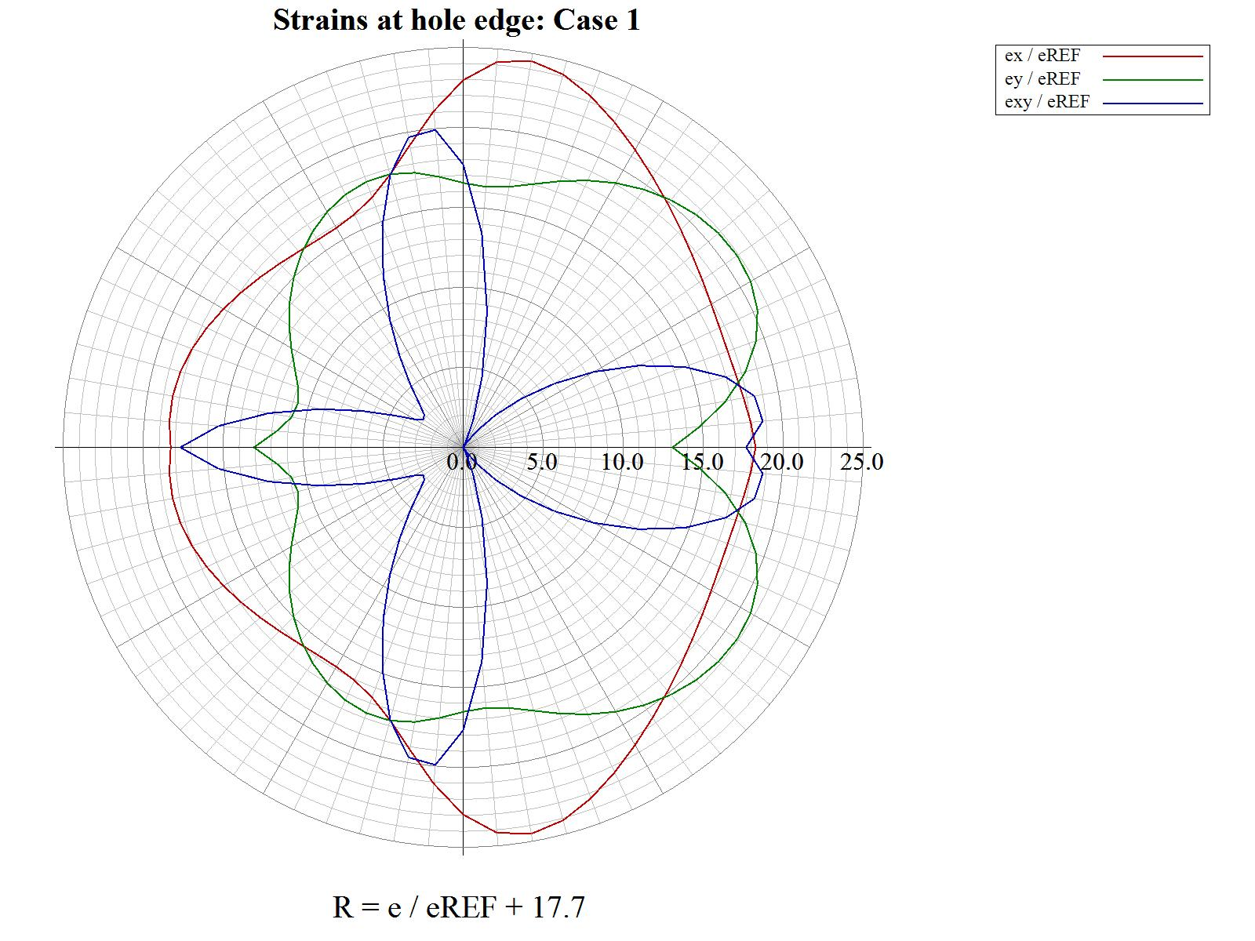
- Ejemplo 1 Results graph: Cartesian Global Axis

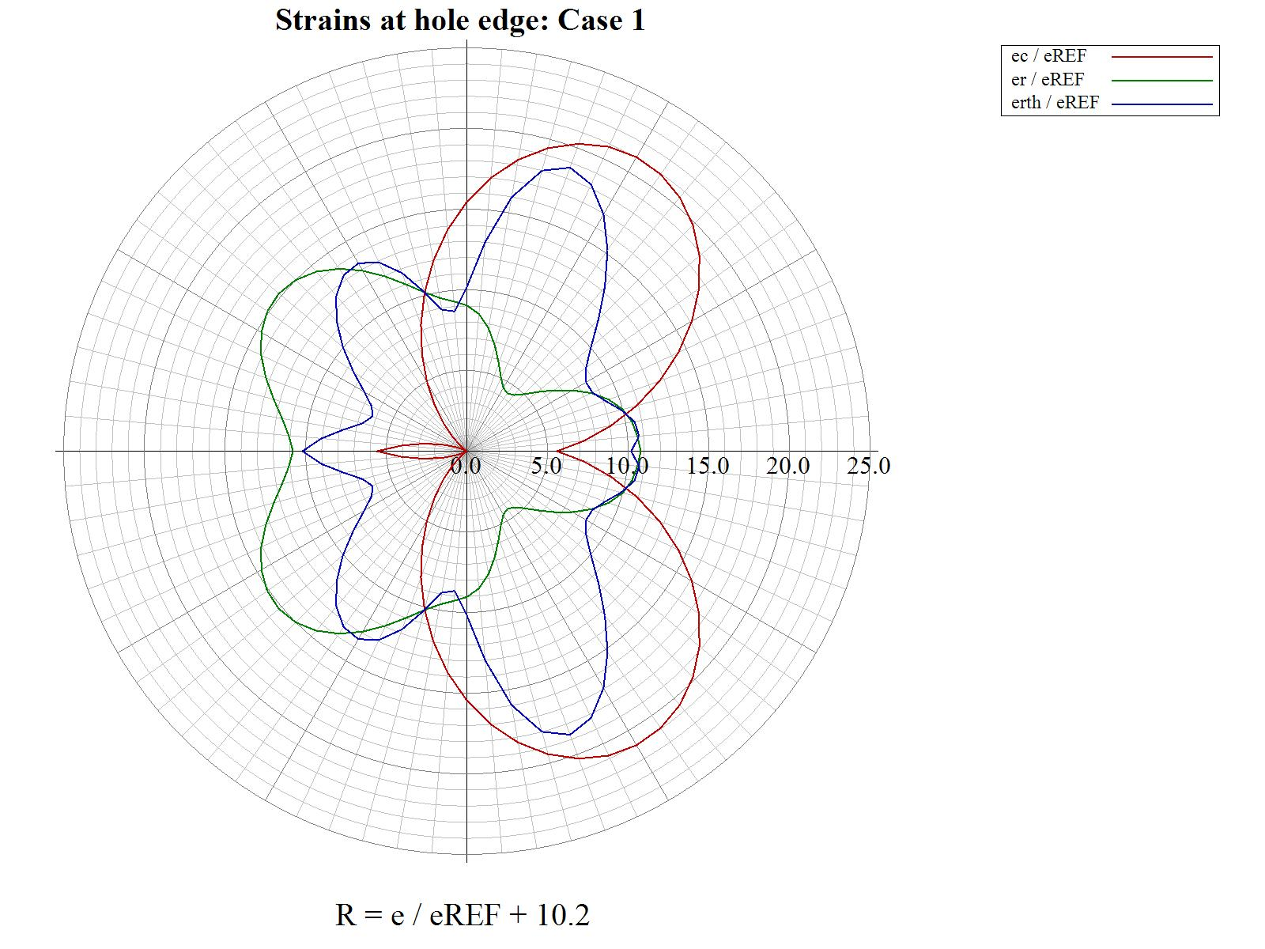
- Ejemplo 1 Results graph: Polar Global Axis

