 | NOTA TECNICA  TECHNICAL REPORT |  |  |  | Núm.  No. | ME-T-NT-100050
 | Departamento Department |  | Methods |  | Avión  Aircraft | Technologies
Título/Title
Program CRIPPLING User’s Manual
Version 5
Palabras clave/Key words |  |  |  |  |  |  |  | Clasificación acceso  Access class
SOFTWARE, BUCKLING,CRIPPLING, ALLOWABLES |  |  |  |  |  |  |  | P1
Registro de Revisiones
Revision Record
 |  |  |  |  |  |  |  | Pag. 2
Resumen/Summary
The purpose of this technical report is to define the way to use the CRIPPLING program, version 5.
This program calculates the crippling allowable stress for metallic stiffeners.
Input data and output results are given by means of files.
PROPIEDAD DE EADS CASA, Sociedad Unipersonal. Este documento no puede ser utilizado ni reproducido total o parcialmente sin la previa autorización escrita de la Dirección de Ingeniería y Tecnología de EADS-CASA.
EADS CASA, Sociedad Unipersonal PROPERTY. This document shall neither be used nor completely or partially reproduced without previous written authorization by EADS-CASA Engineering and Technology Directorate.
Distribución/Distribution |  | Realización/Execution |  |  |  |  | Fecha 1ª edición  2nd issue Date
 |  |  |  |  |  |  | December - 2016
Archivo de Cálculo |  | Realizado  Prepared |  |  |  |  | Firma  Signature
Jefe de la Subd. de Cálculo (*) |  | Guillermo Moreda Gonzalez
Jefes de Depto. de Cálculo (*)
Jefes de Sección de Cálculo
 |  | Comprobado  Checked |  | Gustavo Baños Lapuente
(*) – Cover sheet only |  | Aprobado  Approved |  | Darío Fernández Villalba

REGISTRO DE REVISIONES/REVISIONS RECORD

Revisión | Motivo de Modificación / Change reason | Realiz./Prep. | Compr./Check. | Aprobado/App.
Fecha/Date | Capítulos, Secciones, Hojas afectadas / Chapters, Sections, Sheets affected | Firma/Sign. | Firma/Sign. | Firma/Sign.
A | Primera edición / First issue | Darío Fernández | Álvaro García | Darío Fernández
December 2010
B | Bulbs input data description  improved at pages 9 and 11 | Guillermo  Moreda | Gustavo  Baños | Darío Fernández
December 2016

Table of contents
1.- Technical sheet of the program 4
2.- Introduction 5
3.- Execution of the program 7
4.- Input data file 8
5.- Output results 12
5.1 Output result file 12
5.2 Errors: 13
6.- Windows application 15
7.- Examples 17
7.1 Example 1 17
7.2 Example 2 21
7.3 Example 3 25
7.4 Example 4 29

List of figures
Figure 1: External length. Measurement criteria. 10
Figure 2: Circular bulb. 11
Figure 3: Input data form. 15
Figure 4: Output results form. 16
Figure 5: Example 1 geometry. 17
Figure 6: Example 2 geometry. 21
Figure 7: Example 2 geometry. 25
Figure 8: Example 2 geometry. 29

Technical sheet of the program
Technical Note ME-T-NT-100050
PROGRAM REFERENCE DATE
CRIPPLING 2010
OBJECTIVE
This program calculates the crippling allowable stress for metallic stiffeners.
LANGUAGE COMPUTER
Fortran 77 Sun Solaris
NUMBER OF LINES (APROX.) EXECUTION MODE
2510 Interactive
AUTHOR VERSION
Darío Fernández Villalba 5.0
ADDITIONAL DOCUMENTS
Technical Note: NT–T–ADS–94025.
CRIPPLING Program, v. 3.0, Theoretical Manual

Introduction
This technical report describes the usage procedure for version 5 of CRIPPLING program. Four examples are included.
Once the geometry and material data are introduced, the program calculates the local buckling stress and the crippling stress of each segment of the stiffener. This crippling stress is limited by the ultimate tensile stress of the material.
Only two possible boundary conditions are considered for each segment: free-supported or supported-supported. Other conditions, taking into account the stiffness supplied by the corners of the section to each segment, are not considered. The local buckling stress for each segment includes the reduction due to plasticity and a simplified reduction due to cladding, which is enough for the purpose of the program.
The output results for this program are the local crippling stress, or buckling stress if higher, for each segment of the stiffener, as well as the global allowable crippling stress for the stiffener.
Differences between versions:
- Version 1.0:
Initial version developed in Fortran 77 for Digital VAX computer.
Input data are given interactively and the results are shown on the screen as well as in an output file.
- Version 2.0:
The program is adapted to the new Sun Solaris computer.
- Version 3.0:
This version of the program includes an additional improvement that consists on the simultaneous calculation of the local buckling in compression for each segment, and the comparison with the previously calculated crippling stress, so that if local buckling is higher, it is taken as the crippling stress for that segment.
The local buckling is calculated taking into account two possible support conditions and it includes the reduction due to plasticity and a simplified reduction due to cladding, as explained above.
- Version 4.0:
The program source is restructured to allow the creation of a Dynamic Link Library DLL for Windows operating system.
In parallel with this, a Windows application has been developed as Graphic User Interface GUI for the program CRIPPLING. This application uses the same input file and provides the same output results. The analysis is performed by calling to the DLL, compiled from the same source as the official Fortran version.
- Version 4.1:
The protection to prevent unauthorized execution is updated. The rest of the program remains unchanged.
- Version 4.2:
The heather shown by the program when it starts is removed.
- Version 4.3:
The functionality of the program is improved. The changes are no significant and they do not affect to the results.
- Version 4.4:
The functionality of the program is improved. The changes are no significant and they do not affect to the results.
- Version 5.0:
Now, the user can choose the language for screen dialogs and for the output file, between Spanish and English.
The data flow of the program is modified. Now, the input data as well as the output results are provided by means of files:
- Input file: With the input data grouped in the same way as for other applications.
- Output file: With all the input data and output results in printable form.
Since the format and arrangement of the input file is completely different from previous version, input files are not compatible between versions.
- Version 5.4:

Execution of the program
Prior to the program execution, it is necessary to create the input data file, as described in section 4. The program can be then executed by typing its full path name.
It the software symbol table has been previously assigned (consult with the System Manager in order to know how to assign this symbol table), it can be executed by typing the command:
$crippling
The program asks for the language to use, the name of the input file and the name of the two output files.

Idioma / Language:
==================
_
1 ... ESPANOL

2 ... ENGLISH

Idioma / Language: 2

Name of the input file: Example.dat

Name of the output file: Example.txt

Details of the input and output files are provided in next sections. The CPU time for calculation is negligible.
It is possible to execute the program with a single command, including the input and output filenames and the language as parameters. The above example can be executed as follows:
$crippling Example.dat Example.txt 2
If the third parameter (language) is omitted, the Spanish language will be taken by the program.

Input data file
This file contains all the necessary data that define the problem, as well as the different options required for solving it.
Basically, it contains four data groups, all of them are necessary. They will be numbered from 1 to 4 and must be in order.
All the numerical data contained in this file will be read in a free format. The variables will be separated by one or more blank spaces. The numbering of each group will be included in the first column. Listed below are the contents of each data group:
GROUP 1: Title of the problem:
Four lines containing the title of the problem to be solved.
Line 1 -------> 1 First line of the title
Line 2 -------> Second line of the title
Line 3 -------> Third line of the title
Line 4 -------> Fourth line of the title
GROUP 2: Length of the stiffener:
This group has three lines with the following information
Line 1 -------> 2 “Optional commentary”
Line 2 -------> [Force]
Line 3 -------> [Length]
Where [Force] = This parameter contains a string to define the units for forces. It must be one of the following:
N = Newtons
kg = Kilograms force
lb = Pounds force
klb = Kilopounds force
[Length] = It is another string to define the units for lengths. It must be one of the following:
mm = Millimetres
cm = Centimetres
in = Inches
GROUP 3: Material data:
The structure of this group is the following:
Line 1 -------> 3 “Optional commentary”
Line 2 -------> Mat
Line 2 -------> Et Fty Ftu Mu Ec Fcy ε%
Where Mat = Material denomination. The American denomination must be used. The program evaluates if the “Mat” parameter contains 2024 or 7075.
Et = Tensile Young modulus yield.
Fty = Tensile yield stress.
Ftu = Ultimate tensile stress.
Mu = Poisson´s ratio.
Ec = Compression Young modulus.
Fcy = Compression yield stress.
ε% = Maximum elongation, expressed in %.
GROUP 4: Segment data
This group has N+1 lines with the following content:
Line 1 -------> 4 “Optional commentary”
Line 2 -------> N W(1) t(1) Sup₁(1) Prop₁(1) Sup₂(1) Prop₂(1) [Bulbs]
Line 3 -------> W(2) t(2) Sup₁(1) Prop₁(2) Sup₂(2) Prop₂(2) [Bulbs]
········ ······ ············ ············· ············ ············· ············
········ ······ ············ ············· ············ ············· ············
Line N+1 ---> W(N) t(N) Sup₁(N) Prop₁(N) Sup₂(N) Prop₂(N) [Bulbs]
Where: N = Number of segments defining the cross section of the stiffener.
W(i) = Is the external length of the segment. The Figure 1 defines the way to measure this length for all the possible types of segments to be considered. Notice that in case of a bulb, the length of the adjacent segment must include the bulb’s length/diameter itself (See Example 4 in section 7.4).
t(i) = Is the thickness of the segment.
Sup_{x}(i) = Is the type of support condition for segment “i” at end “x” (1 or 2). It is a couple of characters and its meaning will be explained later.
Prop_{x}(i) = Is the main property that defines the support condition for segment “i” at end “x” (1 or 2). Its meaning will be explained later.
[Bulbs] = They are none, two or four parameters at the end of each line, defining additional properties for bulbs, if any in the segment.
The way to define the external length of each one of the segments of the cross section of the stiffener is defined in the following sketches:
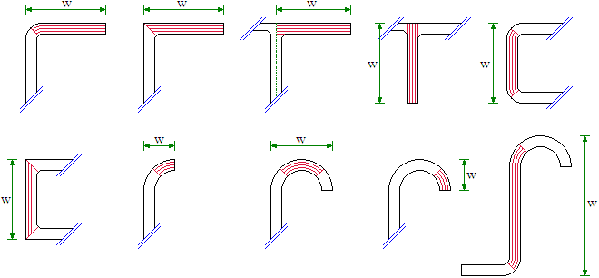
- External length. Measurement criteria.
The support condition key as well as the main property defining the support is provided in the following table:

Key |  | Type of support | Main property
FR | LI | Free edge | Number of the segment that is supporting by its other end.  Prop = 0:  - If this segment is considered as a lip or effective support. The effectiveness analysis will not be done.  - If the segment under consideration is the external part of a 180º circular section of the profile.
BU |  | Bulb | Diameter or typical length of the bulb. The length is used in the case of non-circular bulbs.
FA | DA | Folded angle | Internal folding radius.
FN | DN | Folded no angle (*) | Internal folding radius.
EA |  | Extruded angle | Internal fillet radius.
EN |  | Extruded no angle (*) | Internal fillet radius.
(*) ‘no angle’ means that adjacent segment is also connected to a third one (= not free).
In some cases, two different keys can be specified, to be representative of the support condition in Spanish and in English.
In case of bulbs, two additional properties per bulb must be provided at the end of the line of data for the considered segment:
- Area of the bulb.
- Moment of inertia of the bulb, respect of the mean line of the adjacent segment (see Figure 2:).
In case of circular bulbs, the above properties can be set to zero. In that case, the program will automatically calculate the area and the moment of inertia for a circle.

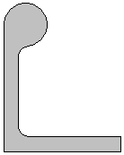

- Circular bulb.

Output results
This section includes the description of the output result file as well as the possible error messages.

Output result file
This file provides the following information:
- Summary of the input data:
- Title.
- Material data.
- Stiffener geometry.
- Crippling stress for each segment:
- Allowable Crippling load of the segment.
- Indication if the allowable load is due to crippling or local buckling.
- Allowable stress for the stiffener:
- Allowable Crippling stress for the stiffener.
- Notes and remarks:
- Keys for support at the ends and allowable load for segments.
- Effectiveness of segments with free edge.
- Effectiveness and properties of bulbs.
- Warnings about the coherence of the input data and geometry.

Errors:
When the program detects an error in the input data or writing the results, it writes the corresponding message in the console and aborts the execution of the program.
The error messages that might appear in the console are listed below:

Error messages. English output:
ERROR: The input file cannot be opened
ERROR: Erroneous group number in the input file
ERROR: Group 1 missing in input file (Title)
ERROR: End of file while reading group 1 in input file (Title)
ERROR: Group 2 missing in input file (Units)
ERROR: End of File or error while reading group 2 in input file (Units)
ERROR: Units no supported by the program
ERROR: Group 3 missing in input file (Material)
ERROR: End of file or error while reading group 3 in input file (Material)
ERROR: The group 3 contains erroneous data (Material)
ERROR: Group 4 missing in input file (Segments)
ERROR: End of file or error reading group 4 (Segments)
ERROR: The number of segments exceeds the maximum of the program
ERROR: The group 4 contains erroneous data (Segments)
ERROR: The output file cannot be opened
ERROR: Writing error in the output file

Error messages. Spanish output:
ERROR: No se puede abrir el fichero de entrada
ERROR: Número de grupo erróneo en el fichero de entrada
ERROR: Grupo 1 ausente en el fichero de entrada (Título)
ERROR: Fin de fichero mientras se leía el grupo 1 en el fichero de entrada (Título)
ERROR: Grupo 2 ausente en el fichero de entrada (Unidades)
ERROR: Fin de fichero o error mientras se leía el grupo 2 (Unidades)
ERROR: Unidades no soportadas por el programa
ERROR: Grupo 3 ausente en el fichero de entrada (Material)
ERROR: Fin de fichero o error mientras se leía el grupo 3 (Material)
ERROR: El grupo 3 contiene datos erróneos (Material)
ERROR: Grupo 4 ausente en el fichero de entrada (Tramos)
ERROR: Fin de fichero o error mientras se leía el grupo 4 (Tramos)
ERROR: El número de tramos excede el máximo del programa
ERROR: El grupo 4 contiene datos erróneos (Tramos)
ERROR: No se puede abrir el fichero de salida
ERROR: Error de escritura en el fichero de salida

Windows application
An application has been developed in Visual Basic for Windows environment. The original routines of the program for input data, calculation and output results have been included in a Dynamic Link Library, which is used by this application. Therefore the same results will be obtained, with only differences due to rounding.
Since this is a Windows application, it must be installed in the user’s PC before it can be executed. For installation, please consult with the system manager,
The application can be executed by “double click” in the file Crippling.exe, located in the PC’s server, or by means of a link in the “Desktop” or in the “Start Menu”.
The input data can be retrieved from an input data file or directly typed in the application form. The form has the following appearance:
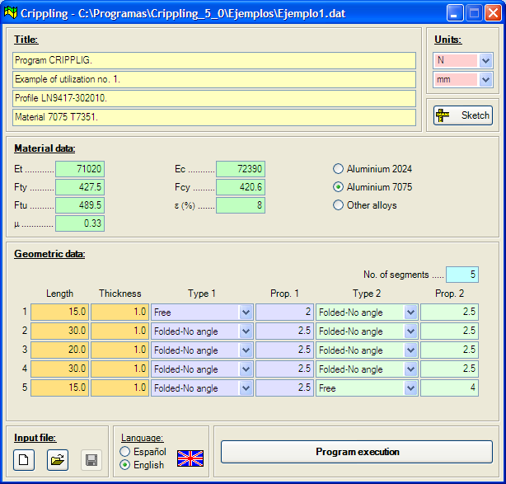
- Input data form.
The program can be executed clicking the button “Program execution”. Then the application solves the problem and shows the results in the following form:
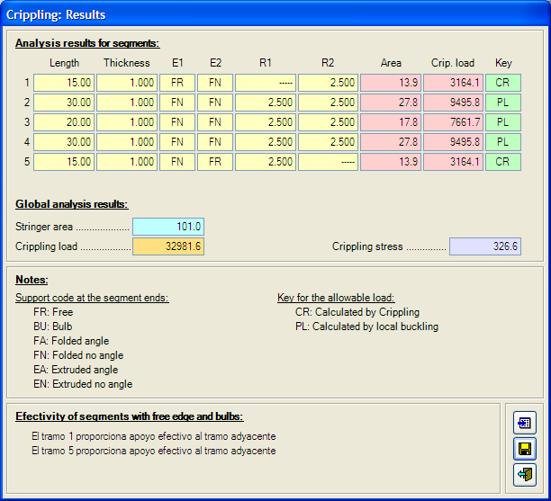
- Output results form.
It is now possible to write the output results in a file, by clicking on the corresponding button (the mid one of the three buttons located at the bottom right corner of the form).

Examples
Input data and obtained results are presented for the four following examples.

Example 1
The case to solve is a Ω-shape stringer, specification LN9417-302010 (CAN 35023). The geometry is as shown on next figure:
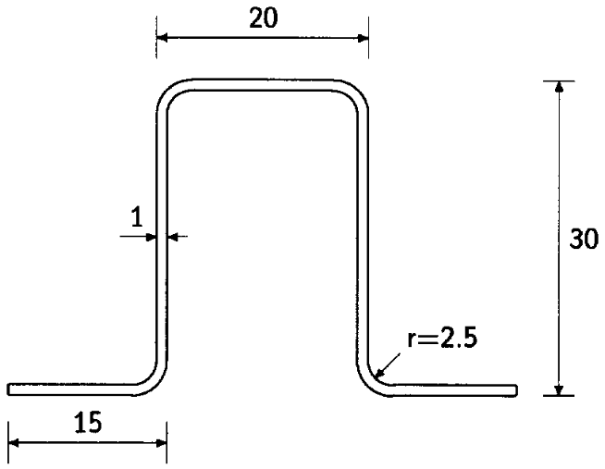
- Example 1 geometry.
The stringer material is 7075 T6 Clad sheet. The properties for this material and thickness are the following:
- Et = 71020.0 N/mm²
- Fty = 427.5 N/mm2
- Ftu = 489.5 N/mm²
- μ = 0.33
- Ec = 72390.0 N/mm2
- Fcy = 420.6 N/mm2
- ε = 8.0 %
The profile can be split in five segments and its corresponding input data and output results files are shown on next pages:

Input file:
1 Program CRIPPLIG.
Example of utilization no. 1.
Profile LN9417-302010.
Material 7075 T7351.
2 Units [Force] / [Length]
N
mm
3 Material: Denom / Et Fty Ftu Mu Ec Fcy Delta%
7075 T6 Clad
71020.0 427.5 489.5 0.33 72390.0 420.6 8.0
4 Segments: No. W t Sup1 Prop1 Sup2 Prop2
5 15.0 1.0 FR 2 FN 2.5
30.0 1.0 FN 2.5 FN 2.5
20.0 1.0 FN 2.5 FN 2.5
30.0 1.0 FN 2.5 FN 2.5
15.0 1.0 FN 2.5 FR 4

Output file:
**************************************
* *
* <<< CRIPPLING >>> *
* *
**************************************
* Calculation of crippling allowable *
* stress for metallic stringers *
**************************************

Title:
======

Program CRIPPLIG.
Example of utilization no. 1.
Profile LN9417-302010.
Material 7075 T7351.

Material data:
==============

Material: 7075 T6 Clad

Tensile Young modulus ..........: Et = 71020.0 N/mm²
Tensile yield stress ...........: Fty = 427.5 N/mm²
Tensile ultimate stress ........: Ftu = 489.5 N/mm²
Poisson's ratio ................: Mu = 0.330
Compression Young modulus ......: Ec = 72390.0 N/mm²
Compression yield stress .......: Fcy = 420.6 N/mm²
Maximum elongation .............: El = 8.00 %

Stringer geometry and Crippling load:
=====================================

Supp Radius
------ --------------
Seg Length Thickn. E1 E2 E1 E2 Area Crip. load Key
----- -------- ------- -- -- ------ ------ -------- ---------- -----
1 15.00 1.000 FR FN -- 2.500 13.88 3164.1 CR
2 30.00 1.000 FN FN 2.500 2.500 27.75 9495.8 PL
3 20.00 1.000 FN FN 2.500 2.500 17.75 7661.7 PL
4 30.00 1.000 FN FN 2.500 2.500 27.75 9495.8 PL
5 15.00 1.000 FN FR 2.500 -- 13.88 3164.1 CR
-------- ----------
101.00 32981.6

Notes:
======

Support code at the segment ends: Key for the allowable load:
--------------------------------- ---------------------------
FR: Free CR: Calculated by Crippling
BU: Bulb PL: Calculated by local buckling
FA: Folded angle
FN: Folded no angle
EA: Corner angle
EN: Corner no angle

Output file: (cont.)
Effectiveness of segments with free edge:
-----------------------------------------
- The segment 1 provides effective support to the adjacent segment
- The segment 5 provides effective support to the adjacent segment

Allowable Crippling stress:
===========================

Allowable stress = 326.6 N/mm²

Example 2
The case to solve is a CAN35024 profile 30×22×1.6. The shape of this profile is shown on next figure:
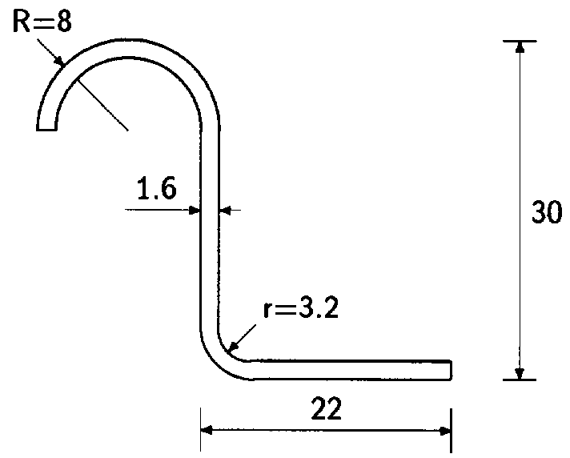
- Example 2 geometry.
The stringer material is 2024 T3 sheet. The properties for this material and thickness are the following:
- Et = 72390.0 N/mm²
- Fty = 324.1 N/mm2
- Ftu = 441.3 N/mm²
- μ = 0.33
- Ec = 72770.0 N/mm2
- Fcy = 268.9 N/mm2
- ε = 15.0 %
The profile can be split in four segments and its corresponding input data and output results files are shown on next pages:

Input file:
1 Program CRIPPLIG.
Example of utilization no. 2.
Profile CAN35024.
Material 2024 T3.
2 Units [Force] / [Length]
N
mm
3 Material: Denom / Et Fty Ftu Mu Ec Fcy Delta%
2024 T3
72390.0 324.1 441.3 0.33 72770.0 268.9 15.0
4 Segments: No. W t Sup1 Prop1 Sup2 Prop2
4 8.0 1.6 FR 2 FN 6.4
16.0 1.6 FN 6.4 FN 6.4
30.0 1.6 FN 6.4 FN 3.2
22.0 1.6 FN 3.2 FR 3

Output file:
**************************************
* *
* <<< CRIPPLING >>> *
* *
**************************************
* Calculation of crippling allowable *
* stress for metallic stringers *
**************************************

Title:
======

Program CRIPPLIG.
Example of utilization no. 2.
Profile CAN35024.
Material 2024 T3.

Material data:
==============

Material: 2024 T3

Tensile Young modulus ..........: Et = 72390.0 N/mm²
Tensile yield stress ...........: Fty = 324.1 N/mm²
Tensile ultimate stress ........: Ftu = 441.3 N/mm²
Poisson's ratio ................: Mu = 0.330
Compression Young modulus ......: Ec = 72770.0 N/mm²
Compression yield stress .......: Fcy = 268.9 N/mm²
Maximum elongation .............: El = 15.00 %

Stringer geometry and Crippling load:
=====================================

Supp Radius
------ --------------
Seg Length Thickn. E1 E2 E1 E2 Area Crip. load Key
----- -------- ------- -- -- ------ ------ -------- ---------- -----
1 8.00 1.600 FR FN -- 6.400 8.96 3484.3 CR
2 16.00 1.600 FN FN 6.400 6.400 17.92 7230.6 CR
3 30.00 1.600 FN FN 6.400 3.200 41.60 14023.4 CR
4 22.00 1.600 FN FR 3.200 -- 32.64 7107.4 CR
-------- ----------
101.12 31845.8

Notes:
======

Support code at the segment ends: Key for the allowable load:
--------------------------------- ---------------------------
FR: Free CR: Calculated by Crippling
BU: Bulb PL: Calculated by local buckling
FA: Folded angle
FN: Folded no angle
EA: Corner angle
EN: Corner no angle

Output file: (cont.)
Effectiveness of segments with free edge:
-----------------------------------------
- The segment 1 provides effective support to the adjacent segment
- The segment 4 provides effective support to the adjacent segment

Allowable Crippling stress:
===========================

Allowable stress = 314.9 N/mm²

Example 3
The case to solve is a C-shape stringer, specification LN9498-070 (CAN35106). The geometry is as shown on next figure:
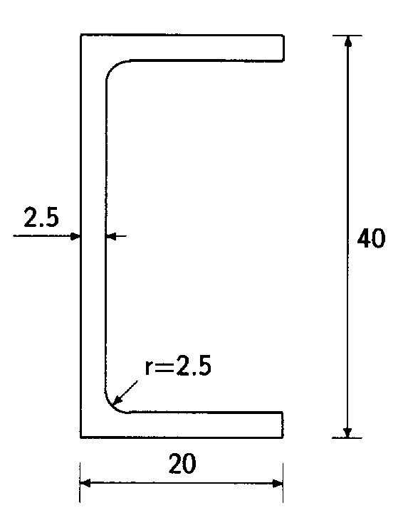
- Example 2 geometry.
The stringer material is 7075 T76511 extrusion. The properties for this material and thickness are the following:
- Et = 71710.0 N/mm²
- Fty = 482.6 N/mm2
- Ftu = 537.8 N/mm²
- μ = 0.33
- Ec = 73770.0 N/mm2
- Fcy = 482.6 N/mm2
- ε = 7.0 %
The profile can be split in three segments and its corresponding input data and output results files are shown on next pages:

Input file:
1 Program CRIPPLIG.
Example of utilization no. 3.
Profile LN9498-070.
Material 7075 T76511.
2 Units [Force] / [Length]
N
mm
3 Material: Denom / Et Fty Ftu Mu Ec Fcy Delta%
7075 T76511
71710.0 482.6 537.8 0.33 73770.0 482.6 7.0
4 Segments: No. W t Sup1 Prop1 Sup2 Prop2
3 20.0 2.5 FR 2 EN 2.5
40.0 2.5 EN 2.5 EN 2.5
20.0 2.5 EN 2.5 FR 2

Output file:
**************************************
* *
* <<< CRIPPLING >>> *
* *
**************************************
* Calculation of crippling allowable *
* stress for metallic stringers *
**************************************

Title:
======

Program CRIPPLIG.
Example of utilization no. 3.
Profile LN9498-070.
Material 7075 T76511.

Material data:
==============

Material: 7075 T76511

Tensile Young modulus ..........: Et = 71710.0 N/mm²
Tensile yield stress ...........: Fty = 482.6 N/mm²
Tensile ultimate stress ........: Ftu = 537.8 N/mm²
Poisson's ratio ................: Mu = 0.330
Compression Young modulus ......: Ec = 73770.0 N/mm²
Compression yield stress .......: Fcy = 482.6 N/mm²
Maximum elongation .............: El = 7.00 %

Stringer geometry and Crippling load:
=====================================

Supp Radius
------ --------------
Seg Length Thickn. E1 E2 E1 E2 Area Crip. load Key
----- -------- ------- -- -- ------ ------ -------- ---------- -----
1 20.00 2.500 FR EN -- 2.500 47.50 21738.6 PL
2 40.00 2.500 EN EN 2.500 2.500 95.00 47515.9 PL
3 20.00 2.500 EN FR 2.500 -- 47.50 21738.6 PL
-------- ----------
190.00 90993.1

Notes:
======

Support code at the segment ends: Key for the allowable load:
--------------------------------- ---------------------------
FR: Free CR: Calculated by Crippling
BU: Bulb PL: Calculated by local buckling
FA: Folded angle
FN: Folded no angle
EA: Corner angle
EN: Corner no angle

Output file: (cont.)
Effectiveness of segments with free edge:
-----------------------------------------
- The segment 1 provides effective support to the adjacent segment
- The segment 3 provides effective support to the adjacent segment

Allowable Crippling stress:
===========================

Allowable stress = 478.9 N/mm²

Example 4
The case to solve is a LN9087-060 (CAN35107) profile. The shape of this profile is shown on next figure.
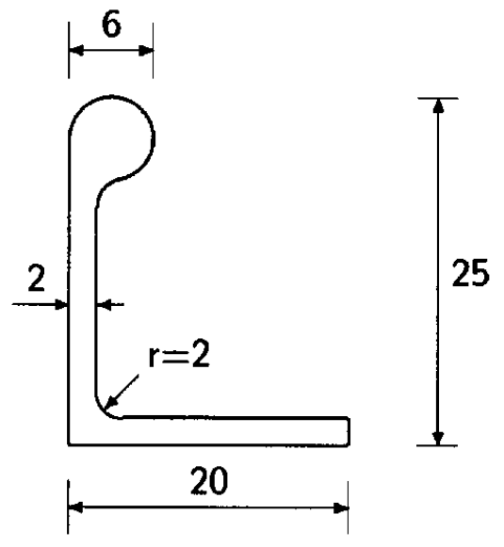
- Example 2 geometry.
The stringer material is 2024 T3511 extrusion. The properties for this material and thickness are the following:
- Et = 74460.0 N/mm²
- Fty = 289.6 N/mm2
- Ftu = 393.0 N/mm²
- μ = 0.33
- Ec = 75840.0 N/mm2
- Fcy = 234.4 N/mm2
- ε = 12.0 %
The profile can be split in two segments and its corresponding input data and output results files are shown on next pages:

Input file:
1 Program CRIPPLIG.
Example of utilization no. 4.
Profile LN9087.
Material 2024 T3511.
2 Units [Force] / [Length]
N
mm
3 Material: Denom / Et Fty Ftu Mu Ec Fcy Delta%
2024 T3511
74460.0 289.6 393.0 0.33 75840.0 234.4 12.0
4 Segments: No. W t Sup1 Prop1 Sup2 Prop2
2 25.0 2.0 BU 6.0 EA 2.0 0.0 0.0
20.0 2.0 EA 2.0 LI 1

Output file:
**************************************
* *
* <<< CRIPPLING >>> *
* *
**************************************
* Calculation of crippling allowable *
* stress for metallic stringers *
**************************************

Title:
======

Program CRIPPLIG.
Example of utilization no. 4.
Profile LN9087.
Material 2024 T3511.

Material data:
==============

Material: 2024 T3511

Tensile Young modulus ..........: Et = 74460.0 N/mm²
Tensile yield stress ...........: Fty = 289.6 N/mm²
Tensile ultimate stress ........: Ftu = 393.0 N/mm²
Poisson's ratio ................: Mu = 0.330
Compression Young modulus ......: Ec = 75840.0 N/mm²
Compression yield stress .......: Fcy = 234.4 N/mm²
Maximum elongation .............: El = 12.00 %

Stringer geometry and Crippling load:
=====================================

Supp Radius
------ --------------
Seg Length Thickn. E1 E2 E1 E2 Area Crip. load Key
----- -------- ------- -- -- ------ ------ -------- ---------- -----
1 25.00 2.000 BU EA -- 2.000 64.67 12396.4 CR
2 20.00 2.000 EA FR 2.000 -- 38.40 9039.0 CR
-------- ----------
103.07 21435.3

Notes:
======

Support code at the segment ends: Key for the allowable load:
--------------------------------- ---------------------------
FR: Free CR: Calculated by Crippling
BU: Bulb PL: Calculated by local buckling
FA: Folded angle
FN: Folded no angle
EA: Corner angle
EN: Corner no angle

Output file: (cont.)
Effectiveness of segments with free edge:
-----------------------------------------
- The segment 2 provides effective support to the adjacent segment

Effectiveness and properties for bulbs:
---------------------------------------
- The bulb of segment 1 end 1 does not provide effective support
Its properties are:
= Length ...............: 6.00 mm
= Area .................: 28.27 mm²
= Moment of inertia ....: 176.7 mm4

Allowable Crippling stress:
===========================

Allowable stress = 208.0 N/mm²

WARNING: Due to the lack of effectiveness of some element, the results could
be not valid.

It is recommended to check the consistence of the input data.
NOTE: In this case, since the second segment (the horizontal one) provides effective support to the first segment (the vertical one, having a bulb in its upper end), the definition and consistence of the input data can be considered as correct.

