 | NOTA TECNICA  TECHNICAL REPORT |  |  |  | Núm.  No. | ME-T-NT-130109
 | Departamento Department |  | Stress Methods and Optimisation (TEASP-TL3) |  | Avión  Aircraft | Tecnologies
Título/Title
Program ALLOWEE, version 4
User's manual
Palabras clave/Key words |  |  |  |  |  |  |  | Clasificación acceso  Access class
A |  |  |  |  |  |  |  | A
Registro de Revisiones
Revision Record
 |  |  |  |  |  |  |  | Pag. 2
Resumen/Summary
This technical report describes how to use the ALLOWEE Computer Program, Version 4, and it includes examples to further clarify its use.
The ALLOWEE Program calculates the allowable values (A Basis value and B Basis value) of composite material properties as it is shown in the MIL-HDBK-17-1D procedure.
This program is part of section XVIII (Computer Programs and Procedures) of Volume 8 (Stress Analysis) of C.A.S.A.'s Design Manual.
PROPIEDAD DE EADS CASA, Sociedad Unipersonal. Este documento no puede ser utilizado ni reproducido total o parcialmente sin la previa autorización escrita de la Dirección de Ingeniería y Tecnología de EADS CASA.
EADS CASA, Sociedad Unipersonal PROPERTY. This document shall neither be used nor completely or partially reproduced without previous written authorization by EADS CASA Engineering and Technology Directorate.
Distribución/Distribution |  | Realización/Execution |  |  |  |  | Edición/Issue  Fecha edición/Issue date
B
December 2017
Stress Methods and Optimisation (TEASP-TL3) |  | Realizado  Prepared |  |  |  |  | Firma  Signature
 |  |  |  | G. Moreda González (TEASP-TL3)
 |  | Comprobado  Checked |  | G. Baños Lapuente (TEASP-TL3)
 |  | Aprobado  Approved |  | D. Fernández Villalba (TEASP-TL3)

REGISTRO DE REVISIONES/REVISIONS RECORD

Revisión | Motivo de Modificación / Change reason | Realiz./Prep. | Compr./Check. | Aprobado/App.
Fecha/Date | Capítulos, Secciones, Hojas afectadas / Chapters, Sections, Sheets affected | --- | --- | ---
A | Primera edición / First issue | José Ángel Velasco | Gustavo  Baños | Darío  Fernández
Jun 2013 | Todas las páginas / All pages | --- | --- | ---
B | Adapt manual to software version 4.3. Software execution by a unique command. | Guillermo  Moreda | Gustavo  Baños | Darío  Fernández
Dec 2017 | Sub-chapter 3.2 | --- | --- | ---

INDICE
1 Technical sheet of the Program 4
2 Introduction 5
2.1 Object 5
2.2 References 5
2.3 Differences among versions 5
3 Program Execution 6
3.1 PC Server Version 6
3.2 Multivac Computer Version 8
4 Input data file 9
5 Output results file 11
6 Limitations of the program 13
7 Examples 14

Technical sheet of the Program
Nota Técnica ME-T-NT-130109
PROGRAM REFERENCE DATE
ALLOWEE December 2017
OBJECTIVE
The ALLOWEE program calculates the allowable values (A Basis value and B Basis value) of composite material properties as it is shown in the MIL-HDBK-17-1D procedure.
LANGUAGE COMPUTER
Fortran 77 Sun/PC
Visual Basic .NET PC
NUMBER OF LINES (APROX.) EXECUTION MODE
3900 (Fortran, analysis core) Interactive
+3000 (Visual Basic .Net) Interactive GUI
Total 6900
Notes:
- Blank lines and commented lines excluded
- Count for Visual Basic code excludes lines created by Visual Studio in designer.vb files

AUTHOR VERSION
S. Cervigón 1.0
J.C. Gómez
S. Cervigón 2.0
L. Claramonte 2.1
A. Matesanz 3.0
J.A.Velasco 4.0
G. Moreda 4.3

ADDITIONAL DOCUMENTS
Nota Técnica NT-T-ADP-08003:
Manual Teórico del Programa ALLOWEE, versión 3.

Nota Técnica NT-T-ADP-03005:
Manual del Programador del Programa ALLOWEE.

Introduction

Object
This technical report describes how to use the ALLOWEE Computer Program, version 4, and it includes examples to further clarify its use.
The ALLOWEE Program calculates the allowable values (A Basis value and B Basis value) of composite material properties following the method explained in Ref. 1. Moreover, the program does the following calculations:
  - For more than one batch:
- It determines if the data are from the same population (k-sample Anderson-Darling test).
- It determines if the different batches have similar variances (Levene test).
  - It determines if the data fit in any of these distributions: Weibull, normal or lognormal.
  - It calculates the parameters and A and B basis value of the distributions Weibull, normal and lognormal, and of the methods ANOVA and non parametric.
  - It finds ‘outliers’ in the different batches and, if the values are poolable, in the whole population. But all the calculations are done using all the data.
  - If the data are from different environmental conditions, the program determines if it is possible to pool the data and, in that case, it calculates the allowable values for each environmental condition.

References
- NT-T-ADP-08003 Ed. A “Manual Teórico del Programa ALLOWEE, versión 3”
- NT-T-ADP-03005 Ed. A “Manual del Programador del Programa ALLOWEE”
- PP0300181 Is. 2 “Composite statistical methods to determine B-bases value from small data sets”.

Differences among versions
Version 4.0
The user can introduce the Coefficient of Variation of the samples population, which will be set by the program as a lower bound of the CV value to be used in the Small Samples Formula (ignored in the rest of the statistical methods).
TBC

Program Execution

PC Server Version
An application has been developed in Visual Basic for Windows environment. The original routines of the program for calculation and output results have been included in a Dynamic Link Library, which is used by this application. Therefore, the same results will be obtained with only differences due to rounding.
Since this is a Windows application, it must be installed in the user’s PC before it can be executed, for installation, please contact with the system manager.
The application can be executed by “double click” in the Allowee.exe, located in the PC’s server, or by means a link in the “desktop” or in the “start menu”
\\Cae\InfoCalculo\Soft\Allowee\
In the folder \\Cae\InfoCalculo\Soft\Allowee\Consola , there is another executable program, which is the Fortran program in console mode.
In the PC version, when the program starts, the following information window is displayed:


Figure 3.1. Program start

The input data must be typed in the application form or retrieved from an input file. The Form, after loading the data corresponding to the example 1 (see section §7), has the following appearance:
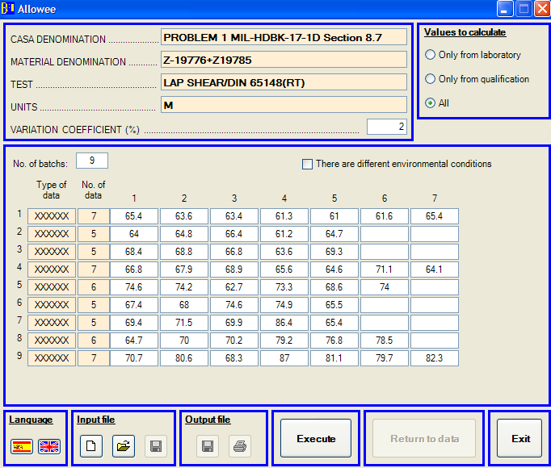

Figure 3.2. Input data form
The program can be executed clicking the button “Program execution”. Then the application solves the problems showing the following form:
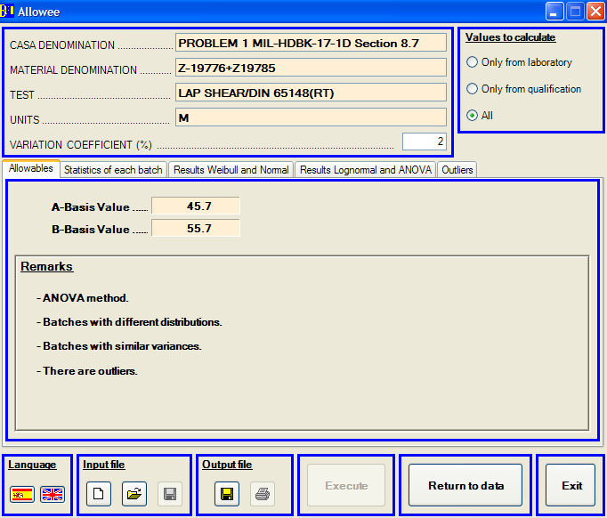

Figure 3.3. Output results form
The output results shown in this form can also be written in the output file (details in section §5).

Multivac Computer Version
To execute the ALLOWEE program in the MULTIVAC computer, its full path name has to be typed unless the software symbol table has been previously assigned (consult with the System Manager in order to know how to assign this symbol table), it can be executed by typing the command:
$allowee

Data input is performed by means of a data file. The dialog with the program is the following:

Program ALLOWEE

This program calculates the allowable values (A and B)
of the mechanical properties of composites
materials using the procedure of MIL-HDBK-17-1D.

 | Version 4.0 | June 2013

To continue, press <RETURN>
Notes
- This software and the data that are produced by it are EADS-CASA
property.
The total or partial reproduction of this software is forbidden,
as well as its use out of the EADS-CASA environment.

To continue, press <RETURN>

The input data file must be introduced interactively via the keyboard:

Name of the input data file

The full name of the file containing the output data must be given.

Name of the output file without extension [ALLOWEE]

Alternatively, it is possible to execute the program with a single command, including the input and output filenames and the language as parameters. An example can be executed as follows:

$allowee Example.dat Example 2

Notice above that output file name must be written without extension. English language can be selected by number 2 and Spanish language by number 1.

Input data file
The composition of the input data file is the following:

The symbols used are:
DEN CASA: CASA_den
DEN MAT.: Mat_den
TEST: Test_den
UNITS: Unit
LOTS: N_b
CV(%): CVP
'Data_type’(1), N_d(1), Data₁(1), Data₂(1), Data₃(1), ..., Data_{N_d(1)}(1)
------------- ------- -------- --------- --------- --- ---------
'Data_type'(i), N_d(i), Data₁(i), Data₂(i), Data₃(i), ..., Data_{N_d(i)}(i)
------------- ------- -------- --------- --------- --- ---------
------------- ------- -------- --------- --------- --- ---------
'Data_type'(N_b), N_d(N_b), Data₁(N_b), Data₂(N_b), Data₃(N_b), ..., Data_{N_d(N_b)}(N_b)
Calculation data type
Environmental conditions
CASA_den
Denomination CASA of the material used.
Mat_den
Denomination of the material used.
Test_den
Denomination of the type and conditions of the test done.
Unit
Units in which the data are given.
N_b
Number of batches whose data will be given next. It must be an integer.
CVP
Coefficient of Variation of the samples population, in %. This magnitude is used only in the Small Samples Formula: the calculation of the B-value is done with the maximum between this figure (CVP) and the CV calculated for the sample data. The recommended values of CVP for Fibre Reinforced Polymer materials are (see Ref. 3):
- Young Modulus 4.7 %
- Fiber strength (in-plane tension) 5.8 %
- Resin strength (compression, shear, CAI,...) 9.0 %
The reading of the previous data is done from the first character different from a blank after the ‘:’. They must be given in one line and they must have a maximum of 255 characters.
Next, the values of the data obtained of each of the N_b batches are given. One line per batch is written with the following values:
'Data_type'(i)
It identifies the data type of the batch i. If the batch is from the laboratory reception then a letter ‘L’ must be written inside the character ‘Data_type’, any position is possible. If the batch is from qualification then a letter ‘C’ must be written inside the character ‘Data_type’, any position is possible. If it doesn’t matter where the values are from because all the data will be used in the calculations, it is not necessary to write anything here.
N_d(i)
Number of data of the batch i.
Data₁(i), Data₂(i), ..., Data_{N_d(i)}(i)
Values obtained for the batch i.
Calculation data type
It is an integer that identifies the data used in the calculation. If a number ’1’ is written here only the batches from laboratory reception must be used in the calculations. If a number ‘2’ is written here only the batches from qualification must be used in the calculations. If a number ‘3’ or anything except ‘1’ or ‘2’ is written here all values are used in the calculations.
Environmental conditions
It identifies if data are from different environmental conditions or not. If ‘Y’ or ‘y’ (yes) is written here, the program will consider that each batch is from different environmental condition. If ‘N’ or ‘n’ (no) or anything except ‘Y’ or ‘y’ is written here different environmental conditions are not consider.

If all the values are going to be used in calculations and there aren’t different environmental conditions, it is not necessary to write anything after the data of the batches. But if the user wants to consider only some values or there are data from different environmental conditions, both lines must be written.

Output results file
The output ‘.RES’ file is structured in several groups:
1. Analysis identification
- CASA denomination
- Material denomination
- Test name and conditions
- Units
- Total number of data values
- Batches number
- Coefficient of Variation of the samples population
2. Allowable values and remarks
- A and B allowable values; if the data are from different environmental conditions and they can be poolable, here the A and B basis value for each environmental condition is given.
- Remarks
- If there are batches from different environmental conditions, it is said if these data are poolable or not.
- Distribution assumed for the data or method used.
- If the data are from the same population or not.
- If the batches have similar variances or not.
- If outliers exist.
3. Input data
- Batch number
- Number of values of each batch
- Individual values of each batch
4. Statistics of each batch
- Mean values of each batch
- Standard deviation of each batch
- Mean of the whole sample
- Standard deviation of the whole sample
4. Batch to batch variability (only if the batch number is bigger than one)
- Results of the k-simple Anderson-Darling test
- Results of the equality of variances test
5. Summary of allowables (only in big samples)
- Two parameters Weibull method: parameters, tolerance limit factors, observance level and A and B values if the population is considered to fit a Weibull distribution.
- Normal method: parameters, tolerance limit factors, observance level and A and B values if the population is considered to fit a Normal distribution.
- Lognormal method: parameters, tolerance limit factors, observance level and A and B values if the population is considered to fit a Lognormal distribution.
- Non parametrical method: A and B values if the non parametrical method is used.
- ANOVA method: parameters, tolerance limit factors, observance level and A and B values if ANOVA method is used.
6. Small sample additional data (only in small samples)
- Kb of the normalized data: calculated using the normalized data and assuming normal distribution.
- Coefficient of variation used: it only appears when the small sample formula is used and, in that case, it is the maximum value between the coefficient of variation calculated for the sample data, and the coefficient of variation of the samples population (defined in the input file).
- Kb obtained from the small sample formula: it only appears when the small sample formula is used and it is calculated as it was shown in the theoretical manual.

Limitations of the program
There are some intrinsic limitations in the calculation method used in this program. Those limitations are notified if they occur by warnings on the screen or in the output file. They are the following:
- The non-parametrical method can be only used if there isn’t an important variation between batches.
- The ANOVA method cannot be applied if there are less than 3 batches.
- Allowable values cannot be calculated by the two parameters Weibull method when there are less than 10 values in the sample.
- Allowables cannot be calculated for less than 4 values.
- The Levene test of equality of variances cannot be applied if the variance of any of the samples is null.
Moreover those limitations in the calculation methods, there are some more requirements in the Military Handbook MIL-HDBK-17-1D about the sample size in order that the allowables values may be published like B-basis values.
- The sample size necessary to publish the calculated allowables values as B-basis values depends on the material condition and its specification in the process. If there isn’t a normalized specification of the production process, it is necessary a minimum of 5 batches with 6 specimens each from each manufacturer that wants to publish a B-basis value. If there is a normalized specification of the production process, it is possible to pool the data from each manufacturer that wants to publish a B-basis value. In that case, it is required a minimum of 3 manufacturers with 3 batches each manufacturer and with 6 specimens each batch.
- The specimens of the samples must be obtained from random selected panel areas. These panels must be manufactured as it is said in the material specification. The specimen number of each batch must be as uniform as it will be possible, and the size of the biggest batch must not be more than one and a half times bigger than the size of the smallest batch.
If the previous requirements are not fulfilled, the B-basis value can be calculated but the results cannot be published.

Examples
Below are 11 examples of the use of this program. The examples one to seven are from the Military Handbook MIL-HDBK-17-1D. It is hoped that these examples will clarify the information given in this manual.

EXAMPLE 1:

The input data file (ej_allowee_1.dat) is the following:

DEN CASA: PROBLEM 1 MIL-HDBK-17-1D Section 8.7
DEN MAT.: Z-19776+Z19785
TEST: LAP SHEAR/DIN 65148(RT)
UNITS: MPA
LOTS: 9
CV (%): 2
'XXXXXX',7,65.4,63.6,63.4,61.3,61.0,61.6,65.4
'XXXXXX',5,64.0,64.8,66.4,61.2,64.7
'XXXXXX',5,68.4,68.8,66.8,63.6,69.3
'XXXXXX',7,66.8,67.9,68.9,65.6,64.6,71.1,64.1
'XXXXXX',6,74.6,74.2,62.7,73.3,68.6,74.0
'XXXXXX',5,67.4,68.0,74.6,74.9,65.5
'XXXXXX',5,69.4,71.5,69.9,86.4,65.4
'XXXXXX',6,64.7,70.0,70.2,79.2,76.8,78.5
'XXXXXX',7,70.7,80.6,68.3,87.0,81.1,79.7,82.3

The ouput file is:

ej_allowee_1.RES

18-06-2013, Allowee 4.0

CASA DENOMINATION : PROBLEM 1 MIL-HDBK-17-1D Section 8.7
MATERIAL DENOMINATION : Z-19776+Z19785
TEST : LAP SHEAR/DIN 65148(RT)
UNITS : MPA
TOTAL NUMBER OF VALUES : 53
NUMBER OF BATCHES : 9

ALLOWABLE VALUES
--------- ------

A-BASIS VALUE = 45.74
B-BASIS VALUE = 55.67

=========================================================================

REMARKS:

ANOVA method.
Batches with different distributions. The data should not be pooled.
Batches with similar variances.
There are outliers. Outliers are included in all calculations.

=========================================================================

INPUT DATA
----------

BATCH N SPECIMEN DATA
---------------------------------------------------------------------------

1 7 61.0 61.3 61.6 63.4 63.6 65.4
65.4
2 5 61.2 64.0 64.7 64.8 66.4
3 5 63.6 66.8 68.4 68.8 69.3
4 7 64.1 64.6 65.6 66.8 67.9 68.9
71.1
5 6 62.7 68.6 73.3 74.0 74.2 74.6
6 5 65.5 67.4 68.0 74.6 74.9
7 5 65.4 69.4 69.9 71.5 86.4 *
8 6 64.7 70.0 70.2 76.8 78.5 79.2
9 7 68.3 70.7 79.7 80.6 81.1 82.3
87.0

-------------------------------------------------------------------------------
TOTAL OF 9 BATCHES, 53 SPECIMEN(S).

* = Outlier at the 0.05 level.

===============================================================================
PRELIMINARY DESCRIPTIVE STATISTICS
----------------------------------

NUMBER SAMPLE STANDARD
OF BATCH SIZE AVERAGE DEVIATION
------------------------------------------------------------------------
1 7 63.10 1.86
2 5 64.22 1.90
3 5 67.38 2.31
4 7 67.00 2.50
5 6 71.23 4.73
6 5 70.08 4.36
7 5 72.52 8.08
8 6 73.23 5.81
9 7 78.53 6.64

------------------------------------------------------------------------
POOLED SAMPLE 53 69.78 6.48

=========================================================================

INVESTIGATION OF BATCH-TO-BATCH VARIABILITY
------------- -- --------------------------

THE K-SAMPLE ANDERSON-DARLING TEST STATISTIC = 2.67
THE CRITICAL VALUE = 1.44
SIGNIFICANT LEVEL = 0.05
DIFFERENT POPULATION

THE TEST STATISTIC FOR EQUALITY OF VARIANCE = 1.05
THE CRITICAL VALUE WITH 9-1 DEGREES OF FREEDOM = 2.16
SIGNIFICANT LEVEL = 0.05
VARIANCES ARE NOT SIGNIFICANTLY DIFFERENT

============================================================================

COMPUTATION ALLOWABLE VALUES
----------------------------

THE TWO-PARAMETER WEIBULL METHOD
--- --- --------- ------- ------
SHAPE PARAMETER = 10.21
SCALE PARAMETER = 72.86
TOLERANCE LIMIT FACTOR (A Basis) = 8.38
TOLERANCE LIMIT FACTOR (B Basis) = 4.65
A-D STATISTIC = 2.31
OBSERVANCE LEVEL = 0.00

THE A VALUE = 52.22
THE B VALUE = 54.91

THE NORMAL METHOD
--- ------ ------
MEAN = 69.78
STANDARD DEVIATION = 6.48
TOLERANCE LIMIT FACTOR (A Basis) = 2.84
TOLERANCE LIMIT FACTOR (B Basis) = 1.63
A-D STATISTIC = 1.37
OBSERVANCE LEVEL = 0.00

THE A VALUE = 51.35
THE B VALUE = 59.19

THE LOGNORMAL METHOD
--- --------- ------
AVERAGE OF LOG DATA = 4.24
STD. DEV. OF LOG DATA = 0.09
TOLERANCE LIMIT FACTOR (A Basis) = 2.84
TOLERANCE LIMIT FACTOR (B Basis) = 1.63
A-D STATISTIC = 1.03
OBSERVANCE LEVEL = 0.01

THE A VALUE = 53.83
THE B VALUE = 60.01

THE NONPARAMETRIC METHOD
--- ------------- ------
THE A VALUE = 49.63 (Hanson-Koopmans value)
THE B VALUE = 61.20

NORMAL ANALYSIS IN THE PRESENCE OF BATCH-TO-BATCH VARIATION (ANOVA)
------ -------- -- --- -------- -- ----- -- ----- --------- -------
THE ASSUMPTIONS ARE:
1) THE DATA FROM EACH BATCH ARE NORMALLY DISTRIBUTED,
2) THE BATCH MEANS ARE NORMALLY DISTRIBUTED, AND
3) THE VARIANCES WITHIN EACH BATCH ARE THE SAME.

BETWEEN BATCH MEAN SQUARE = 150.97
WITHIN BATCH VARIANCE = 22.18
POPULATION STANDARD DEVIATION = 6.64
TOLERANCE LIMIT FACTOR (A Basis) = 3.62
TOLERANCE LIMIT FACTOR (B Basis) = 2.12

THE A VALUE = 45.74
THE B VALUE = 55.67

If the PC version is used and the input file shown before is open, the program shows the following on the screen:

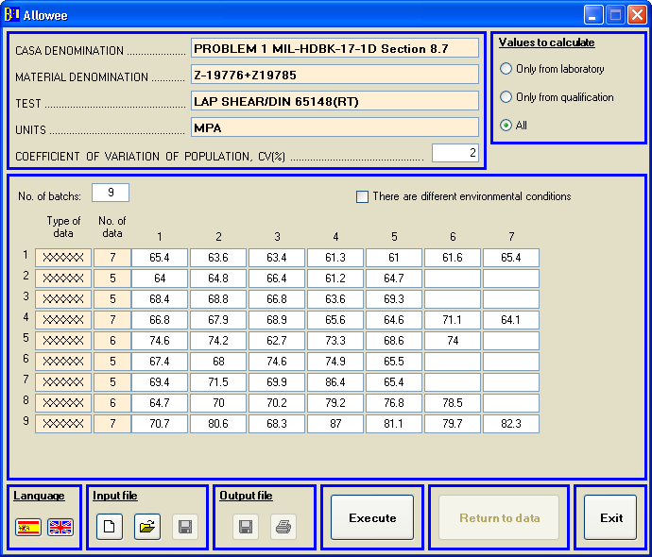

Figure 7.1. Example 1 input data
If the ‘Calculate’ button is pressed the results are shown:

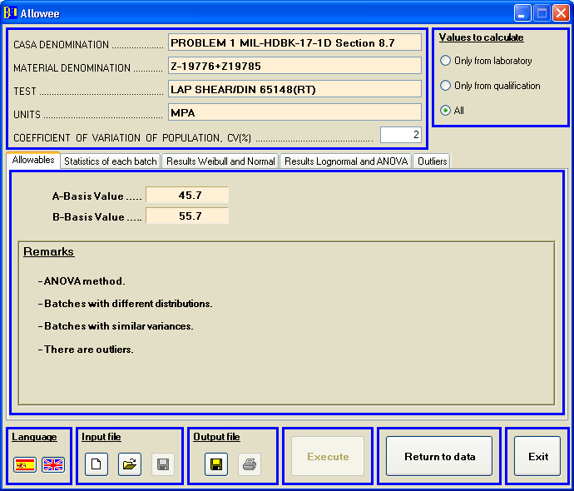

Figure 7.2. Example 1 output results
EXAMPLE 2:

The input data file (ej_allowee_2.dat) is the following:

DEN CASA: PROBLEM 2 MIL-HDBK-17-1D Section 8.7
DEN MAT.: Z-19776+Z19785
TEST: LAP SHEAR/DIN 65148(RT)
UNITS: MPA
LOTS: 9
CV. (%): 2
'XXXXXX',7,61.3,68.5,62.5,66.0,66.6,64.8,69.5
'XXXXXX',5,66.5,64.7,64.9,65.2,70.3
'XXXXXX',5,66.0,72.7,67.1,67.7,65.7
'XXXXXX',7,61.9,68.0,63.3,74.6,66.2,68.2,69.1
'XXXXXX',6,68.9,65.0,70.9,65.4,66.5,64.9
'XXXXXX',5,75.8,75.2,71.5,69.6,66.1
'XXXXXX',5,72.8,75.0,66.3,69.5,71.9
'XXXXXX',6,71.9,71.0,69.5,69.5,72.6,74.6
'XXXXXX',7,68.7,76.3,76.6,69.6,66.2,72.4,72.8

The ouput file is:

ej_allowee_2.RES

.
18-06-2013, Allowee 4.0

CASA DENOMINATION : PROBLEM 2 MIL-HDBK-17-1D Section 8.7
MATERIAL DENOMINATION : Z-19776+Z19785
TEST : LAP SHEAR/DIN 65148(RT)
UNITS : MPA
TOTAL NUMBER OF VALUES : 53
NUMBER OF BATCHES : 9

ALLOWABLE VALUES
--------- ------

A-BASIS VALUE = 55.50
B-BASIS VALUE = 61.05

=========================================================================

REMARKS:

ANOVA method.
Batches with different distributions. The data should not be pooled.
Batches with similar variances.
There are not outliers.

=========================================================================

INPUT DATA
----------

BATCH N SPECIMEN DATA
---------------------------------------------------------------------------

1 7 61.3 62.5 64.8 66.0 66.6 68.5
69.5
2 5 64.7 64.9 65.2 66.5 70.3
3 5 65.7 66.0 67.1 67.7 72.7
4 7 61.9 63.3 66.2 68.0 68.2 69.1
74.6
5 6 64.9 65.0 65.4 66.5 68.9 70.9

6 5 66.1 69.6 71.5 75.2 75.8
7 5 66.3 69.5 71.9 72.8 75.0
8 6 69.5 69.5 71.0 71.9 72.6 74.6

9 7 66.2 68.7 69.6 72.4 72.8 76.3
76.6

-------------------------------------------------------------------------------
TOTAL OF 9 BATCHES, 53 SPECIMEN(S).
PRELIMINARY DESCRIPTIVE STATISTICS
----------------------------------

NUMBER SAMPLE STANDARD
OF BATCH SIZE AVERAGE DEVIATION
------------------------------------------------------------------------
1 7 65.60 2.99
2 5 66.32 2.33
3 5 67.84 2.84
4 7 67.33 4.17
5 6 66.93 2.45
6 5 71.64 4.03
7 5 71.10 3.33
8 6 71.52 1.96
9 7 71.80 3.88

------------------------------------------------------------------------
POOLED SAMPLE 53 68.84 3.87

=========================================================================

INVESTIGATION OF BATCH-TO-BATCH VARIABILITY
------------- -- --------------------------

THE K-SAMPLE ANDERSON-DARLING TEST STATISTIC = 1.81
THE CRITICAL VALUE = 1.44
SIGNIFICANT LEVEL = 0.05
DIFFERENT POPULATION

THE TEST STATISTIC FOR EQUALITY OF VARIANCE = 0.57
THE CRITICAL VALUE WITH 9-1 DEGREES OF FREEDOM = 2.16
SIGNIFICANT LEVEL = 0.05
VARIANCES ARE NOT SIGNIFICANTLY DIFFERENT

============================================================================

COMPUTATION ALLOWABLE VALUES
----------------------------

THE TWO-PARAMETER WEIBULL METHOD
--- --- --------- ------- ------
SHAPE PARAMETER = 18.75
SCALE PARAMETER = 70.68
TOLERANCE LIMIT FACTOR (A Basis) = 8.38
TOLERANCE LIMIT FACTOR (B Basis) = 4.65
A-D STATISTIC = 1.06
OBSERVANCE LEVEL = 0.01

THE A VALUE = 58.96
THE B VALUE = 60.59

THE NORMAL METHOD
--- ------ ------
MEAN = 68.84
STANDARD DEVIATION = 3.87
TOLERANCE LIMIT FACTOR (A Basis) = 2.84
TOLERANCE LIMIT FACTOR (B Basis) = 1.63
A-D STATISTIC = 0.51
OBSERVANCE LEVEL = 0.18

THE A VALUE = 57.84
THE B VALUE = 62.52

THE LOGNORMAL METHOD
--- --------- ------
AVERAGE OF LOG DATA = 4.23
STD. DEV. OF LOG DATA = 0.06
TOLERANCE LIMIT FACTOR (A Basis) = 2.84
TOLERANCE LIMIT FACTOR (B Basis) = 1.63
A-D STATISTIC = 0.43
OBSERVANCE LEVEL = 0.26

THE A VALUE = 58.62
THE B VALUE = 62.73

THE NONPARAMETRIC METHOD
--- ------------- ------
THE A VALUE = 53.86 (Hanson-Koopmans value)
THE B VALUE = 61.90

NORMAL ANALYSIS IN THE PRESENCE OF BATCH-TO-BATCH VARIATION (ANOVA)
------ -------- -- --- -------- -- ----- -- ----- --------- -------
THE ASSUMPTIONS ARE:
1) THE DATA FROM EACH BATCH ARE NORMALLY DISTRIBUTED,
2) THE BATCH MEANS ARE NORMALLY DISTRIBUTED, AND
3) THE VARIANCES WITHIN EACH BATCH ARE THE SAME.

BETWEEN BATCH MEAN SQUARE = 39.64
WITHIN BATCH VARIANCE = 10.47
POPULATION STANDARD DEVIATION = 3.93
TOLERANCE LIMIT FACTOR (A Basis) = 3.39
TOLERANCE LIMIT FACTOR (B Basis) = 1.98

THE A VALUE = 55.50
THE B VALUE = 61.05

If the PC version is used and the input file shown before is open, the program shows the following on the screen:

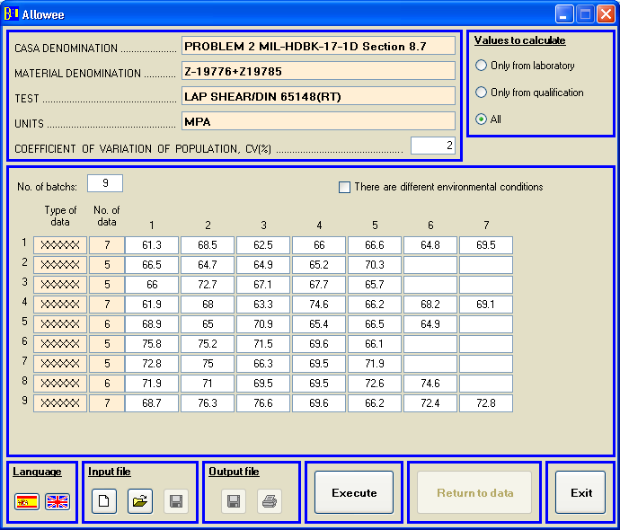

Figure 7.3. Example 2 input data
If the ‘Calculate’ button is pressed the results are shown:
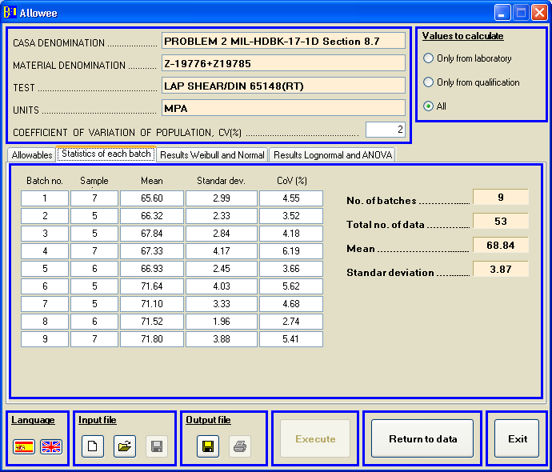

Figure 7.4. Example 2 output results
EXAMPLE 3:

The input data file (ej_allowee_3.dat) is the following:

DEN CASA: PROBLEM 3 MIL-HDBK-17-1D Section 8.7
DEN MAT.: Z-19776+Z19785
TEST: LAP SHEAR/DIN 65148(RT)
UNITS: MPA
LOTS: 9
CV (%): 2
'XXXXXX',7,67.4,61.8,72.6,56.0,69.0,75.0,65.4
'XXXXXX',5,59.4,66.2,74.8,75.7,63.9
'XXXXXX',5,70.5,61.7,66.6,66.1,72.7
'XXXXXX',7,65.5,61.7,60.6,75.0,64.4,75.3,71.7
'XXXXXX',6,51.6,64.3,74.2,75.4,60.5,47.1
'XXXXXX',5,73.5,77.0,66.7,66.4,65.0
'XXXXXX',5,64.0,66.2,64.3,60.4,72.4
'XXXXXX',6,71.0,66.9,76.8,64.4,70.0,72.1
'XXXXXX',7,73.9,78.5,68.0,75.0,79.5,60.6,71.4

The ouput file is:

ej_allowee_3.RES

.
18-06-2013, Allowee 4.0

CASA DENOMINATION : PROBLEM 3 MIL-HDBK-17-1D Section 8.7
MATERIAL DENOMINATION : Z-19776+Z19785
TEST : LAP SHEAR/DIN 65148(RT)
UNITS : MPA
TOTAL NUMBER OF VALUES : 53
NUMBER OF BATCHES : 9

ALLOWABLE VALUES
--------- ------

A-BASIS VALUE = 53.63
B-BASIS VALUE = 55.92

=========================================================================

REMARKS:

Data fit in a Weibull distribution.
Batches are from the same population. The data may be pooled.
Batches with similar variances.
There are not outliers.

=========================================================================

INPUT DATA
----------

BATCH N SPECIMEN DATA
---------------------------------------------------------------------------

1 7 56.0 61.8 65.4 67.4 69.0 72.6
75.0
2 5 59.4 63.9 66.2 74.8 75.7
3 5 61.7 66.1 66.6 70.5 72.7
4 7 60.6 61.7 64.4 65.5 71.7 75.0
75.3
5 6 47.1 51.6 60.5 64.3 74.2 75.4

6 5 65.0 66.4 66.7 73.5 77.0
7 5 60.4 64.0 64.3 66.2 72.4
8 6 64.4 66.9 70.0 71.0 72.1 76.8

9 7 60.6 68.0 71.4 73.9 75.0 78.5
79.5

-------------------------------------------------------------------------------
TOTAL OF 9 BATCHES, 53 SPECIMEN(S).

PRELIMINARY DESCRIPTIVE STATISTICS
----------------------------------

NUMBER SAMPLE STANDARD
OF BATCH SIZE AVERAGE DEVIATION
------------------------------------------------------------------------
1 7 66.74 6.45
2 5 68.00 7.06
3 5 67.52 4.26
4 7 67.74 6.18
5 6 62.18 11.54
6 5 69.72 5.24
7 5 65.46 4.41
8 6 70.20 4.30
9 7 72.41 6.53

------------------------------------------------------------------------
POOLED SAMPLE 53 67.85 6.77

=========================================================================

INVESTIGATION OF BATCH-TO-BATCH VARIABILITY
------------- -- --------------------------

THE K-SAMPLE ANDERSON-DARLING TEST STATISTIC = 0.99
THE CRITICAL VALUE = 1.44
SIGNIFICANT LEVEL = 0.05
SAME POPULATION

THE TEST STATISTIC FOR EQUALITY OF VARIANCE = 1.30
THE CRITICAL VALUE WITH 9-1 DEGREES OF FREEDOM = 2.16
SIGNIFICANT LEVEL = 0.05
VARIANCES ARE NOT SIGNIFICANTLY DIFFERENT

============================================================================

COMPUTATION ALLOWABLE VALUES
----------------------------

THE TWO-PARAMETER WEIBULL METHOD
--- --- --------- ------- ------
SHAPE PARAMETER = 12.27
SCALE PARAMETER = 70.77
TOLERANCE LIMIT FACTOR (A Basis) = 8.38
TOLERANCE LIMIT FACTOR (B Basis) = 4.65
A-D STATISTIC = 0.54
OBSERVANCE LEVEL = 0.17

THE A VALUE = 53.63
THE B VALUE = 55.92

THE NORMAL METHOD
--- ------ ------
MEAN = 67.85
STANDARD DEVIATION = 6.77
TOLERANCE LIMIT FACTOR (A Basis) = 2.84
TOLERANCE LIMIT FACTOR (B Basis) = 1.63
A-D STATISTIC = 0.56
OBSERVANCE LEVEL = 0.13

THE A VALUE = 48.62
THE B VALUE = 56.80

THE LOGNORMAL METHOD
--- --------- ------
AVERAGE OF LOG DATA = 4.21
STD. DEV. OF LOG DATA = 0.10
TOLERANCE LIMIT FACTOR (A Basis) = 2.84
TOLERANCE LIMIT FACTOR (B Basis) = 1.63
A-D STATISTIC = 0.76
OBSERVANCE LEVEL = 0.04

THE A VALUE = 50.16
THE B VALUE = 56.92

THE NONPARAMETRIC METHOD
--- ------------- ------
THE A VALUE = 34.75 (Hanson-Koopmans value)
THE B VALUE = 51.60

NORMAL ANALYSIS IN THE PRESENCE OF BATCH-TO-BATCH VARIATION (ANOVA)
------ -------- -- --- -------- -- ----- -- ----- --------- -------
THE ASSUMPTIONS ARE:
1) THE DATA FROM EACH BATCH ARE NORMALLY DISTRIBUTED,
2) THE BATCH MEANS ARE NORMALLY DISTRIBUTED, AND
3) THE VARIANCES WITHIN EACH BATCH ARE THE SAME.

BETWEEN BATCH MEAN SQUARE = 53.37
WITHIN BATCH VARIANCE = 44.38
POPULATION STANDARD DEVIATION = 6.78
TOLERANCE LIMIT FACTOR (A Basis) = 2.91
TOLERANCE LIMIT FACTOR (B Basis) = 1.68

THE A VALUE = 48.10
THE B VALUE = 56.48

If the PC version is used and the input file shown before is open, the program shows the following on the screen:

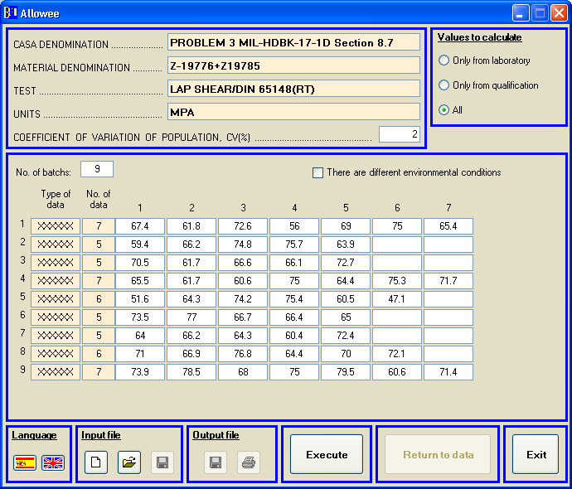

Figure 7.5. Example 3 input data
If the ‘Calculate’ button is pressed the results are shown:
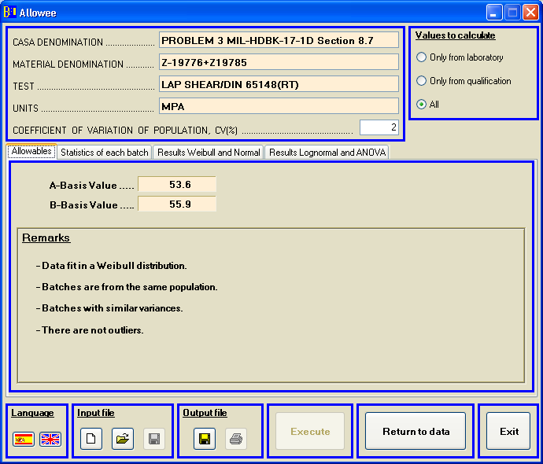

Figure 7.6. Example 3 output results
EXAMPLE 4:

The input data file (ej_allowee_4.dat) is the following:

DEN CASA: PROBLEM 4 MIL-HDBK-17-1D Section 8.7
DEN MAT.: Z-19776+Z19785
TEST: LAP SHEAR/DIN 65148(RT)
UNITS: MPA
LOTS: 9
CV (%): 2
'XXXXXX',7,30.4,29.6,29.3,27.9,29.8,30.5,29.4
'XXXXXX',5,31.5,31.1,27.9,34.5,29.5
'XXXXXX',5,29.6,29.8,29.1,30.0,30.4
'XXXXXX',7,32.1,29.7,26.9,30.0,31.4,28.3,31.9
'XXXXXX',6,30.0,31.5,32.0,30.2,30.6,31.1
'XXXXXX',5,29.6,29.3,30.4,32.1,32.8
'XXXXXX',5,29.9,30.9,32.1,31.4,32.0
'XXXXXX',6,29.2,31.0,31.8,30.3,28.2,28.0
'XXXXXX',7,30.1,29.2,27.7,28.0,31.4,29.6,32.3

The ouput file is:

ej_allowee_4.RES

18-06-2013, Allowee 4.0

CASA DENOMINATION : PROBLEM 4 MIL-HDBK-17-1D Section 8.7
MATERIAL DENOMINATION : Z-19776+Z19785
TEST : LAP SHEAR/DIN 65148(RT)
UNITS : MPA
TOTAL NUMBER OF VALUES : 53
NUMBER OF BATCHES : 9

ALLOWABLE VALUES
--------- ------

A-BASIS VALUE = 26.00
B-BASIS VALUE = 27.81

=========================================================================

REMARKS:

Data fit in a Normal distribution.
Batches are from the same population. The data may be pooled.
Batches with similar variances.
There are not outliers.

=========================================================================

INPUT DATA
----------

BATCH N SPECIMEN DATA
---------------------------------------------------------------------------

1 7 27.9 29.3 29.4 29.6 29.8 30.4
30.5
2 5 27.9 29.5 31.1 31.5 34.5
3 5 29.1 29.6 29.8 30.0 30.4
4 7 26.9 28.3 29.7 30.0 31.4 31.9
32.1
5 6 30.0 30.2 30.6 31.1 31.5 32.0

6 5 29.3 29.6 30.4 32.1 32.8
7 5 29.9 30.9 31.4 32.0 32.1
8 6 28.0 28.2 29.2 30.3 31.0 31.8

9 7 27.7 28.0 29.2 29.6 30.1 31.4
32.3

-------------------------------------------------------------------------------
TOTAL OF 9 BATCHES, 53 SPECIMEN(S).

PRELIMINARY DESCRIPTIVE STATISTICS
----------------------------------

NUMBER SAMPLE STANDARD
OF BATCH SIZE AVERAGE DEVIATION
------------------------------------------------------------------------
1 7 29.56 0.87
2 5 30.90 2.47
3 5 29.78 0.48
4 7 30.04 1.94
5 6 30.90 0.77
6 5 30.84 1.54
7 5 31.26 0.90
8 6 29.75 1.54
9 7 29.76 1.68

------------------------------------------------------------------------
POOLED SAMPLE 53 30.25 1.50

=========================================================================

INVESTIGATION OF BATCH-TO-BATCH VARIABILITY
------------- -- --------------------------

THE K-SAMPLE ANDERSON-DARLING TEST STATISTIC = 1.04
THE CRITICAL VALUE = 1.44
SIGNIFICANT LEVEL = 0.05
SAME POPULATION

THE TEST STATISTIC FOR EQUALITY OF VARIANCE = 1.77
THE CRITICAL VALUE WITH 9-1 DEGREES OF FREEDOM = 2.16
SIGNIFICANT LEVEL = 0.05
VARIANCES ARE NOT SIGNIFICANTLY DIFFERENT

============================================================================

COMPUTATION ALLOWABLE VALUES
----------------------------

THE TWO-PARAMETER WEIBULL METHOD
--- --- --------- ------- ------
SHAPE PARAMETER = 20.33
SCALE PARAMETER = 30.96
TOLERANCE LIMIT FACTOR (A Basis) = 8.38
TOLERANCE LIMIT FACTOR (B Basis) = 4.65
A-D STATISTIC = 0.86
OBSERVANCE LEVEL = 0.02

THE A VALUE = 26.19
THE B VALUE = 26.86

THE NORMAL METHOD
--- ------ ------
MEAN = 30.25
STANDARD DEVIATION = 1.50
TOLERANCE LIMIT FACTOR (A Basis) = 2.84
TOLERANCE LIMIT FACTOR (B Basis) = 1.63
A-D STATISTIC = 0.36
OBSERVANCE LEVEL = 0.36

THE A VALUE = 26.00
THE B VALUE = 27.81

THE LOGNORMAL METHOD
--- --------- ------
AVERAGE OF LOG DATA = 3.41
STD. DEV. OF LOG DATA = 0.05
TOLERANCE LIMIT FACTOR (A Basis) = 2.84
TOLERANCE LIMIT FACTOR (B Basis) = 1.63
A-D STATISTIC = 0.38
OBSERVANCE LEVEL = 0.34

THE A VALUE = 26.25
THE B VALUE = 27.87

THE NONPARAMETRIC METHOD
--- ------------- ------
THE A VALUE = 23.28 (Hanson-Koopmans value)
THE B VALUE = 27.70

NORMAL ANALYSIS IN THE PRESENCE OF BATCH-TO-BATCH VARIATION (ANOVA)
------ -------- -- --- -------- -- ----- -- ----- --------- -------
THE ASSUMPTIONS ARE:
1) THE DATA FROM EACH BATCH ARE NORMALLY DISTRIBUTED,
2) THE BATCH MEANS ARE NORMALLY DISTRIBUTED, AND
3) THE VARIANCES WITHIN EACH BATCH ARE THE SAME.

BETWEEN BATCH MEAN SQUARE = 2.43
WITHIN BATCH VARIANCE = 2.20
POPULATION STANDARD DEVIATION = 1.50
TOLERANCE LIMIT FACTOR (A Basis) = 2.88
TOLERANCE LIMIT FACTOR (B Basis) = 1.66

THE A VALUE = 25.94
THE B VALUE = 27.77

If the PC version is used and the input file shown before is open, the program shows the following on the screen:

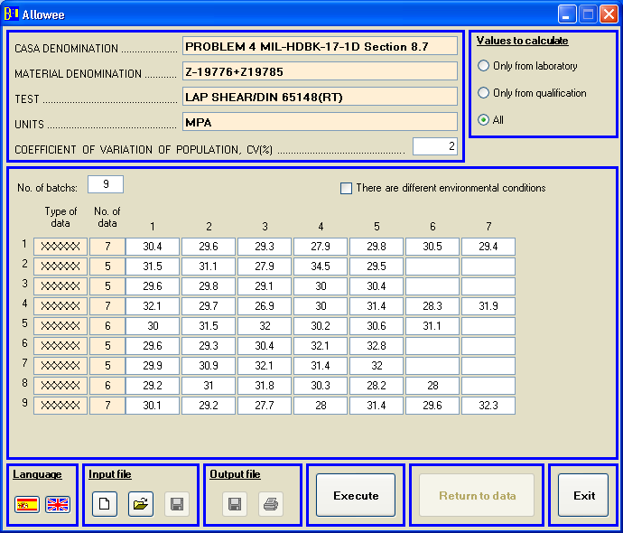

Figure 7.7. Example 4 input data
If the ‘Calculate’ button is pressed the results are shown:
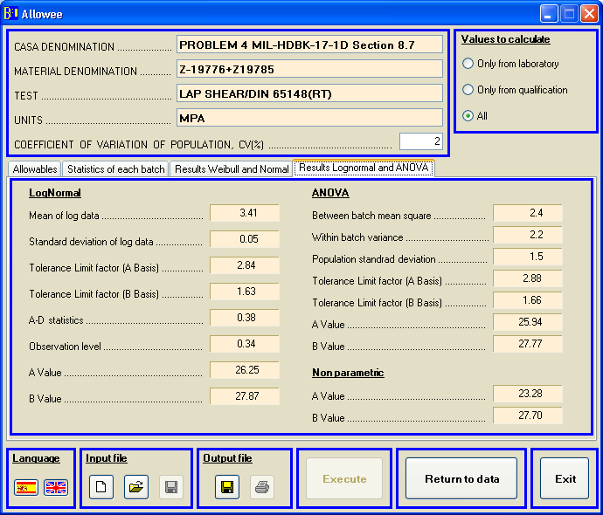

Figure 7.8. Example 4 output results
EXAMPLE 5:

The input data file (ej_allowee_5.dat) is the following:

DEN CASA: PROBLEM 5 MIL-HDBK-17-1D Section 8.7
DEN MAT.: Z-19776+Z19785
TEST: LAP SHEAR/DIN 65148(RT)
UNITS: MPA
LOTS: 9
CV (%): 2
'XXXXXX',7,30.4,29.0,34.8,30.5,27.3,27.9,29.4
'XXXXXX',5,29.8,32.4,33.2,29.9,30.5
'XXXXXX',5,31.1,32.0,31.0,29.3,29.9
'XXXXXX',7,32.2,29.9,29.1,29.9,32.7,31.6,31.6
'XXXXXX',6,27.5,29.3,29.1,29.5,28.7,29.5
'XXXXXX',5,29.9,28.9,29.2,29.1,31.1
'XXXXXX',5,31.1,30.4,33.4,30.0,27.3
'XXXXXX',6,31.3,30.2,30.2,29.1,33.0,34.4
'XXXXXX',7,28.4,30.1,30.5,29.4,28.7,32.3,29.6

The ouput file is:

ej_allowee_5.RES

.
18-06-2013, Allowee 4.0

CASA DENOMINATION : PROBLEM 5 MIL-HDBK-17-1D Section 8.7
MATERIAL DENOMINATION : Z-19776+Z19785
TEST : LAP SHEAR/DIN 65148(RT)
UNITS : MPA
TOTAL NUMBER OF VALUES : 53
NUMBER OF BATCHES : 9

ALLOWABLE VALUES
--------- ------

A-BASIS VALUE = 25.90
B-BASIS VALUE = 27.68

=========================================================================

REMARKS:

Data fit in a Lognormal distribution.
Batches are from the same population. The data may be pooled.
Batches with similar variances.
There are not outliers.

=========================================================================

INPUT DATA
----------

BATCH N SPECIMEN DATA
---------------------------------------------------------------------------

1 7 27.3 27.9 29.0 29.4 30.4 30.5
34.8
2 5 29.8 29.9 30.5 32.4 33.2
3 5 29.3 29.9 31.0 31.1 32.0
4 7 29.1 29.9 29.9 31.6 31.6 32.2
32.7
5 6 27.5 28.7 29.1 29.3 29.5 29.5

6 5 28.9 29.1 29.2 29.9 31.1
7 5 27.3 30.0 30.4 31.1 33.4
8 6 29.1 30.2 30.2 31.3 33.0 34.4

9 7 28.4 28.7 29.4 29.6 30.1 30.5
32.3

-------------------------------------------------------------------------------
TOTAL OF 9 BATCHES, 53 SPECIMEN(S).

PRELIMINARY DESCRIPTIVE STATISTICS
----------------------------------

NUMBER SAMPLE STANDARD
OF BATCH SIZE AVERAGE DEVIATION
------------------------------------------------------------------------
1 7 29.90 2.46
2 5 31.16 1.55
3 5 30.66 1.06
4 7 31.00 1.36
5 6 28.93 0.76
6 5 29.64 0.90
7 5 30.44 2.19
8 6 31.37 1.99
9 7 29.86 1.30

------------------------------------------------------------------------
POOLED SAMPLE 53 30.31 1.68

=========================================================================

INVESTIGATION OF BATCH-TO-BATCH VARIABILITY
------------- -- --------------------------

THE K-SAMPLE ANDERSON-DARLING TEST STATISTIC = 1.24
THE CRITICAL VALUE = 1.44
SIGNIFICANT LEVEL = 0.05
SAME POPULATION

THE TEST STATISTIC FOR EQUALITY OF VARIANCE = 0.76
THE CRITICAL VALUE WITH 9-1 DEGREES OF FREEDOM = 2.16
SIGNIFICANT LEVEL = 0.05
VARIANCES ARE NOT SIGNIFICANTLY DIFFERENT

============================================================================

COMPUTATION ALLOWABLE VALUES
----------------------------

THE TWO-PARAMETER WEIBULL METHOD
--- --- --------- ------- ------
SHAPE PARAMETER = 17.14
SCALE PARAMETER = 31.14
TOLERANCE LIMIT FACTOR (A Basis) = 8.38
TOLERANCE LIMIT FACTOR (B Basis) = 4.65
A-D STATISTIC = 1.91
OBSERVANCE LEVEL = 0.00

THE A VALUE = 25.53
THE B VALUE = 26.31

THE NORMAL METHOD
--- ------ ------
MEAN = 30.31
STANDARD DEVIATION = 1.68
TOLERANCE LIMIT FACTOR (A Basis) = 2.84
TOLERANCE LIMIT FACTOR (B Basis) = 1.63
A-D STATISTIC = 0.81
OBSERVANCE LEVEL = 0.03

THE A VALUE = 25.52
THE B VALUE = 27.56

THE LOGNORMAL METHOD
--- --------- ------
AVERAGE OF LOG DATA = 3.41
STD. DEV. OF LOG DATA = 0.05
TOLERANCE LIMIT FACTOR (A Basis) = 2.84
TOLERANCE LIMIT FACTOR (B Basis) = 1.63
A-D STATISTIC = 0.65
OBSERVANCE LEVEL = 0.08

THE A VALUE = 25.90
THE B VALUE = 27.68

THE NONPARAMETRIC METHOD
--- ------------- ------
THE A VALUE = 23.71 (Hanson-Koopmans value)
THE B VALUE = 27.30

NORMAL ANALYSIS IN THE PRESENCE OF BATCH-TO-BATCH VARIATION (ANOVA)
------ -------- -- --- -------- -- ----- -- ----- --------- -------
THE ASSUMPTIONS ARE:
1) THE DATA FROM EACH BATCH ARE NORMALLY DISTRIBUTED,
2) THE BATCH MEANS ARE NORMALLY DISTRIBUTED, AND
3) THE VARIANCES WITHIN EACH BATCH ARE THE SAME.

BETWEEN BATCH MEAN SQUARE = 3.82
WITHIN BATCH VARIANCE = 2.66
POPULATION STANDARD DEVIATION = 1.69
TOLERANCE LIMIT FACTOR (A Basis) = 2.99
TOLERANCE LIMIT FACTOR (B Basis) = 1.72

THE A VALUE = 25.27
THE B VALUE = 27.40
If the PC version is used and the input file shown before is open, the program shows the following on the screen:

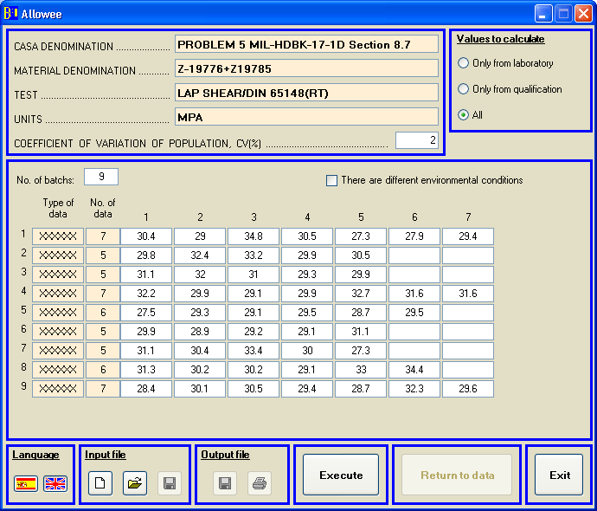

Figure 7.9. Example 5 input data
If the ‘Calculate’ button is pressed the results are shown:
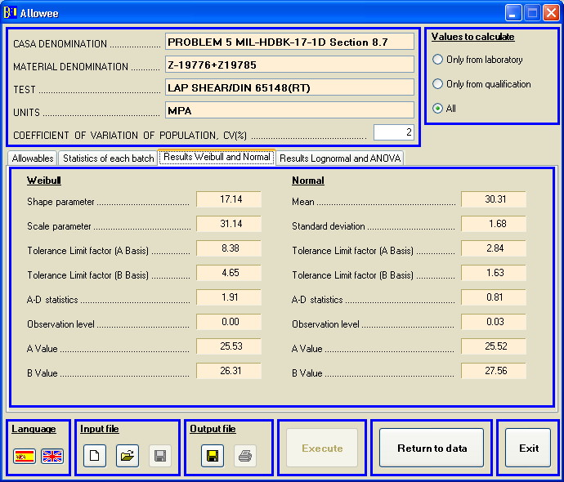

Figure 7.10. Example 5 output results
EXAMPLE 6:

The input data file (ej_allowee_6.dat) is the following:

DEN CASA: PROBLEM 6 MIL-HDBK-17-1D Section 8.7
DEN MAT.: Z-19776+Z19785
TEST: LAP SHEAR/DIN 65148(RT)
UNITS: MPA
LOTS: 9
CV (%): 2
'XXXXXX',7,72.3,65.3,74.3,68.5,65.7,64.3,72.8
'XXXXXX',5,74.5,66.3,74.3,69.3,64.9
'XXXXXX',5,75.3,68.5,75.2,74.5,69.6
'XXXXXX',7,65.6,74.6,76.5,72.0,69.2,74.3,78.7
'XXXXXX',6,68.1,72.1,66.6,75.0,67.2,73.4
'XXXXXX',5,66.4,72.6,67.5,76.3,65.1
'XXXXXX',5,73.3,72.6,67.8,69.4,67.3
'XXXXXX',6,75.2,72.8,67.8,76.2,72.8,68.7
'XXXXXX',7,72.3,76.0,65.8,69.9,67.8,74.6,71.3

The ouput file is:

ej_allowee_6.RES

18-06-2013, Allowee 4.0

CASA DENOMINATION : PROBLEM 6 MIL-HDBK-17-1D Section 8.7
MATERIAL DENOMINATION : Z-19776+Z19785
TEST : LAP SHEAR/DIN 65148(RT)
UNITS : MPA
TOTAL NUMBER OF VALUES : 53
NUMBER OF BATCHES : 9

ALLOWABLE VALUES
--------- ------

A-BASIS VALUE = 57.18
B-BASIS VALUE = 64.90

=========================================================================

REMARKS:

Non parametric method.
Batches are from the same population. The data may be pooled.
Batches with similar variances.
There are not outliers.

=========================================================================

INPUT DATA
----------

BATCH N SPECIMEN DATA
---------------------------------------------------------------------------

1 7 64.3 65.3 65.7 68.5 72.3 72.8
74.3
2 5 64.9 66.3 69.3 74.3 74.5
3 5 68.5 69.6 74.5 75.2 75.3
4 7 65.6 69.2 72.0 74.3 74.6 76.5
78.7
5 6 66.6 67.2 68.1 72.1 73.4 75.0

6 5 65.1 66.4 67.5 72.6 76.3
7 5 67.3 67.8 69.4 72.6 73.3
8 6 67.8 68.7 72.8 72.8 75.2 76.2

9 7 65.8 67.8 69.9 71.3 72.3 74.6
76.0

-------------------------------------------------------------------------------
TOTAL OF 9 BATCHES, 53 SPECIMEN(S).

PRELIMINARY DESCRIPTIVE STATISTICS
----------------------------------

NUMBER SAMPLE STANDARD
OF BATCH SIZE AVERAGE DEVIATION
------------------------------------------------------------------------
1 7 69.03 4.09
2 5 69.86 4.44
3 5 72.62 3.30
4 7 72.99 4.46
5 6 70.40 3.55
6 5 69.58 4.71
7 5 70.08 2.74
8 6 72.25 3.39
9 7 71.10 3.61

------------------------------------------------------------------------
POOLED SAMPLE 53 70.91 3.82

=========================================================================

INVESTIGATION OF BATCH-TO-BATCH VARIABILITY
------------- -- --------------------------

THE K-SAMPLE ANDERSON-DARLING TEST STATISTIC = 0.89
THE CRITICAL VALUE = 1.44
SIGNIFICANT LEVEL = 0.05
SAME POPULATION

THE TEST STATISTIC FOR EQUALITY OF VARIANCE = 0.26
THE CRITICAL VALUE WITH 9-1 DEGREES OF FREEDOM = 2.16
SIGNIFICANT LEVEL = 0.05
VARIANCES ARE NOT SIGNIFICANTLY DIFFERENT

============================================================================

COMPUTATION ALLOWABLE VALUES
----------------------------

THE TWO-PARAMETER WEIBULL METHOD
--- --- --------- ------- ------
SHAPE PARAMETER = 21.12
SCALE PARAMETER = 72.70
TOLERANCE LIMIT FACTOR (A Basis) = 8.38
TOLERANCE LIMIT FACTOR (B Basis) = 4.65
A-D STATISTIC = 0.97
OBSERVANCE LEVEL = 0.01

THE A VALUE = 61.89
THE B VALUE = 63.41

THE NORMAL METHOD
--- ------ ------
MEAN = 70.91
STANDARD DEVIATION = 3.82
TOLERANCE LIMIT FACTOR (A Basis) = 2.84
TOLERANCE LIMIT FACTOR (B Basis) = 1.63
A-D STATISTIC = 1.08
OBSERVANCE LEVEL = 0.01

THE A VALUE = 60.05
THE B VALUE = 64.67

THE LOGNORMAL METHOD
--- --------- ------
AVERAGE OF LOG DATA = 4.26
STD. DEV. OF LOG DATA = 0.05
TOLERANCE LIMIT FACTOR (A Basis) = 2.84
TOLERANCE LIMIT FACTOR (B Basis) = 1.63
A-D STATISTIC = 1.11
OBSERVANCE LEVEL = 0.01

THE A VALUE = 60.73
THE B VALUE = 64.83

THE NONPARAMETRIC METHOD
--- ------------- ------
THE A VALUE = 57.18 (Hanson-Koopmans value)
THE B VALUE = 64.90

NORMAL ANALYSIS IN THE PRESENCE OF BATCH-TO-BATCH VARIATION (ANOVA)
------ -------- -- --- -------- -- ----- -- ----- --------- -------
THE ASSUMPTIONS ARE:
1) THE DATA FROM EACH BATCH ARE NORMALLY DISTRIBUTED,
2) THE BATCH MEANS ARE NORMALLY DISTRIBUTED, AND
3) THE VARIANCES WITHIN EACH BATCH ARE THE SAME.

BETWEEN BATCH MEAN SQUARE = 12.49
WITHIN BATCH VARIANCE = 14.98
POPULATION STANDARD DEVIATION = 3.82
TOLERANCE LIMIT FACTOR (A Basis) = 2.84
TOLERANCE LIMIT FACTOR (B Basis) = 1.63

THE A VALUE = 60.07
THE B VALUE = 64.68
If the PC version is used and the input file shown before is open, the program shows the following on the screen:

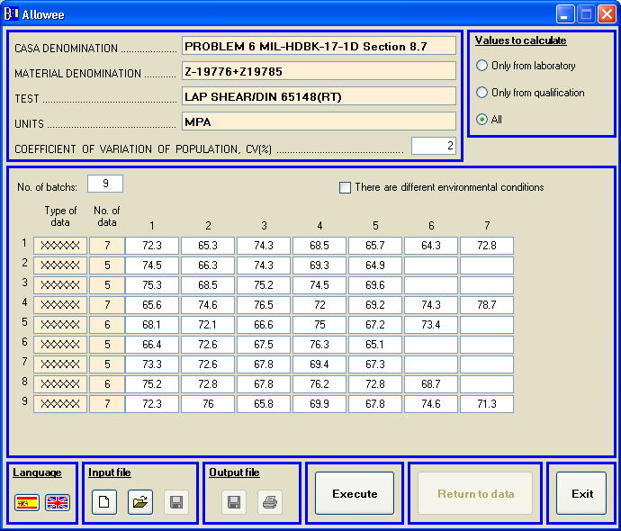

Figure 7.11. Example 6 input data

If the ‘Calculate’ button is pressed the results are shown:

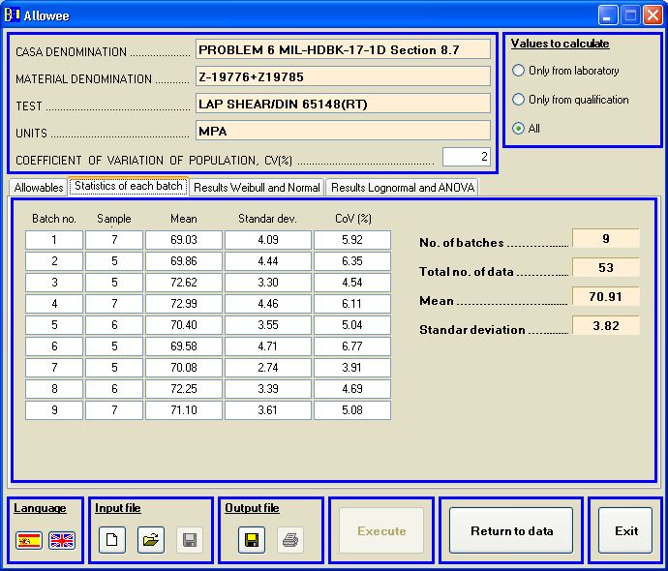

Figure 7.12. Example 6 output results

EXAMPLE 7:

The input data file (ej_allowee_7.dat) is the following:

DEN CASA: PROBLEM 7 MIL-HDBK-17-1D Section 8.7
DEN MAT.: Z-19776+Z19785
TEST: LAP SHEAR/DIN 65148(RT)
UNITS: MPA
LOTS: 5
CV (%): 2
'XXXXXX',5,63.9,76.2,76.9,67.9,80.4
'XXXXXX',5,62.2,79.8,62.4,76.6,80.5
'XXXXXX',5,72.2,61.3,74.8,81.6,55.9
'XXXXXX',5,58.2,77.0,87.5,63.0,77.4
'XXXXXX',5,66.2,75.8,62.6,78.0,78.4

The ouput file is:

ej_allowee_7.RES

18-06-2013, Allowee 4.0

CASA DENOMINATION : PROBLEM 7 MIL-HDBK-17-1D Section 8.7
MATERIAL DENOMINATION : Z-19776+Z19785
TEST : LAP SHEAR/DIN 65148(RT)
UNITS : MPA
TOTAL NUMBER OF VALUES : 25
NUMBER OF BATCHES : 5

ALLOWABLE VALUES
--------- ------

A-BASIS VALUE = 33.68
B-BASIS VALUE = 54.67

=========================================================================

REMARKS:

Hanson-Koopmans method. The Non parametric method cannot be used, N < 29.
Batches are from the same population. The data may be pooled.
Batches with similar variances.
There are not outliers.

=========================================================================

INPUT DATA
----------

BATCH N SPECIMEN DATA
---------------------------------------------------------------------------

1 5 63.9 67.9 76.2 76.9 80.4
2 5 62.2 62.4 76.6 79.8 80.5
3 5 55.9 61.3 72.2 74.8 81.6
4 5 58.2 63.0 77.0 77.4 87.5
5 5 62.6 66.2 75.8 78.0 78.4

-------------------------------------------------------------------------------
TOTAL OF 5 BATCHES, 25 SPECIMEN(S).

PRELIMINARY DESCRIPTIVE STATISTICS
----------------------------------

NUMBER SAMPLE STANDARD
OF BATCH SIZE AVERAGE DEVIATION
------------------------------------------------------------------------
1 5 73.06 6.87
2 5 72.30 9.25
3 5 69.16 10.41
4 5 72.62 11.87
5 5 72.20 7.30

------------------------------------------------------------------------
POOLED SAMPLE 25 71.87 8.64

=========================================================================

INVESTIGATION OF BATCH-TO-BATCH VARIABILITY
------------- -- --------------------------

THE K-SAMPLE ANDERSON-DARLING TEST STATISTIC = 0.59
THE CRITICAL VALUE = 1.63
SIGNIFICANT LEVEL = 0.05
SAME POPULATION

THE TEST STATISTIC FOR EQUALITY OF VARIANCE = 0.27
THE CRITICAL VALUE WITH 5-1 DEGREES OF FREEDOM = 2.92
SIGNIFICANT LEVEL = 0.05
VARIANCES ARE NOT SIGNIFICANTLY DIFFERENT

============================================================================

COMPUTATION ALLOWABLE VALUES
----------------------------

THE TWO-PARAMETER WEIBULL METHOD
--- --- --------- ------- ------
SHAPE PARAMETER = 10.13
SCALE PARAMETER = 75.57
TOLERANCE LIMIT FACTOR (A Basis) = 9.50
TOLERANCE LIMIT FACTOR (B Basis) = 5.20
A-D STATISTIC = 0.80
OBSERVANCE LEVEL = 0.03

THE A VALUE = 50.16
THE B VALUE = 54.61

THE NORMAL METHOD
--- ------ ------
MEAN = 71.87
STANDARD DEVIATION = 8.64
TOLERANCE LIMIT FACTOR (A Basis) = 3.16
TOLERANCE LIMIT FACTOR (B Basis) = 1.84
A-D STATISTIC = 0.95
OBSERVANCE LEVEL = 0.01

THE A VALUE = 44.61
THE B VALUE = 56.00

THE LOGNORMAL METHOD
--- --------- ------
AVERAGE OF LOG DATA = 4.27
STD. DEV. OF LOG DATA = 0.12
TOLERANCE LIMIT FACTOR (A Basis) = 3.16
TOLERANCE LIMIT FACTOR (B Basis) = 1.84
A-D STATISTIC = 1.05
OBSERVANCE LEVEL = 0.01

THE A VALUE = 48.35
THE B VALUE = 56.89

THE NONPARAMETRIC METHOD
--- ------------- ------
THE A VALUE = 33.68 (Hanson-Koopmans value)
THE B VALUE = 54.67 (Hanson-Koopmans value)

NORMAL ANALYSIS IN THE PRESENCE OF BATCH-TO-BATCH VARIATION (ANOVA)
------ -------- -- --- -------- -- ----- -- ----- --------- -------
THE ASSUMPTIONS ARE:
1) THE DATA FROM EACH BATCH ARE NORMALLY DISTRIBUTED,
2) THE BATCH MEANS ARE NORMALLY DISTRIBUTED, AND
3) THE VARIANCES WITHIN EACH BATCH ARE THE SAME.

BETWEEN BATCH MEAN SQUARE = 12.02
WITHIN BATCH VARIANCE = 87.08
POPULATION STANDARD DEVIATION = 8.49
TOLERANCE LIMIT FACTOR (A Basis) = 3.16
TOLERANCE LIMIT FACTOR (B Basis) = 1.84

THE A VALUE = 45.07
THE B VALUE = 56.27
If the PC version is used and the input file shown before is open, the program shows the following on the screen:

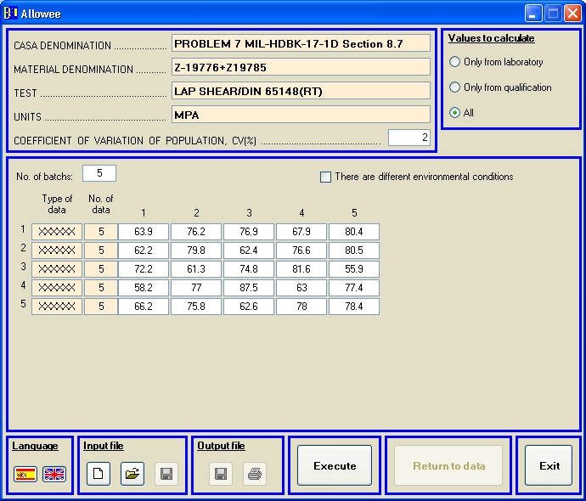

Figure 7.13. Example 7 input data
If the ‘Calculate’ button is pressed the results are shown:

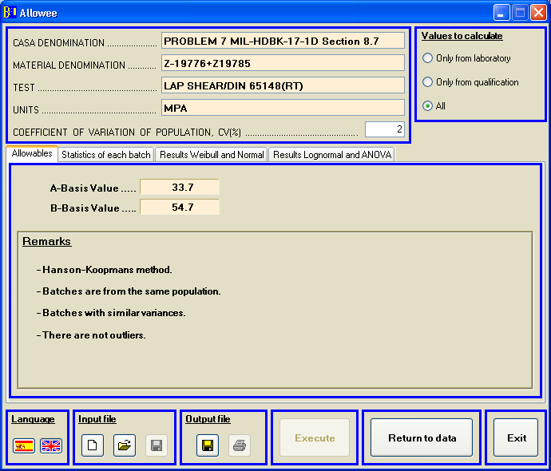

Figure 7.14. Example 7 output results
EXAMPLE 8:

The input data file (ej_allowee_8.dat) is the following:

CASA DENOMINATION : EXAMPLE 8
MATERIAL DENOMINATION : Z-19781
TEST : TEST
UNITS : MPA
LOTS: 3
CV (%): 2
'XXXXXX',5,118.58,121.77,137.54,140.39,134.03
'XXXXXX',5,133.44,114.56,123.28,130.33,138
'XXXXXX',5,122.69,137.1,137.49,122.87,135.82

The ouput file is:

ej_allowee_8.RES

18-06-2013, Allowee 4.0

CASA DENOMINATION : EXAMPLE 8
MATERIAL DENOMINATION : Z-19781
TEST : TEST
UNITS : MPA
TOTAL NUMBER OF VALUES : 15
NUMBER OF BATCHES : 3

ALLOWABLE VALUES
--------- ------

B-BASIS VALUE = 112.77

=========================================================================

REMARKS:

AGATE method has been used.
Data fit in a Normal distribution.
Batches with similar variances.
There are not outliers.

=========================================================================

INPUT DATA
----------

BATCH N SPECIMEN DATA
---------------------------------------------------------------------------

1 5 118.6 121.8 134.0 137.5 140.4
2 5 114.6 123.3 130.3 133.4 138.0
3 5 122.7 122.9 135.8 137.1 137.5

-------------------------------------------------------------------------------
TOTAL OF 3 BATCHES, 15 SPECIMEN(S).

PRELIMINARY DESCRIPTIVE STATISTICS
----------------------------------

NUMBER SAMPLE STANDARD
OF BATCH SIZE AVERAGE DEVIATION
------------------------------------------------------------------------
1 5 130.46 9.72
2 5 127.92 9.19
3 5 131.19 7.71

------------------------------------------------------------------------
POOLED SAMPLE 15 129.86 8.38

=========================================================================

INVESTIGATION OF BATCH-TO-BATCH VARIABILITY
------------- -- --------------------------

THE K-SAMPLE ANDERSON-DARLING TEST STATISTIC = 0.60
THE CRITICAL VALUE = 1.89
SIGNIFICANT LEVEL = 0.05
SAME POPULATION

THE TEST STATISTIC FOR EQUALITY OF VARIANCE = 0.09
THE CRITICAL VALUE WITH 3-1 DEGREES OF FREEDOM = 5.12
SIGNIFICANT LEVEL = 0.05
VARIANCES ARE NOT SIGNIFICANTLY DIFFERENT

============================================================================

SMALL SAMPLE ADDITIONAL DATA
----------------------------

Kb (normalized data) = 0.868

============================================================================

If the PC version is used and the input file shown before is open, the program shows the following on the screen:

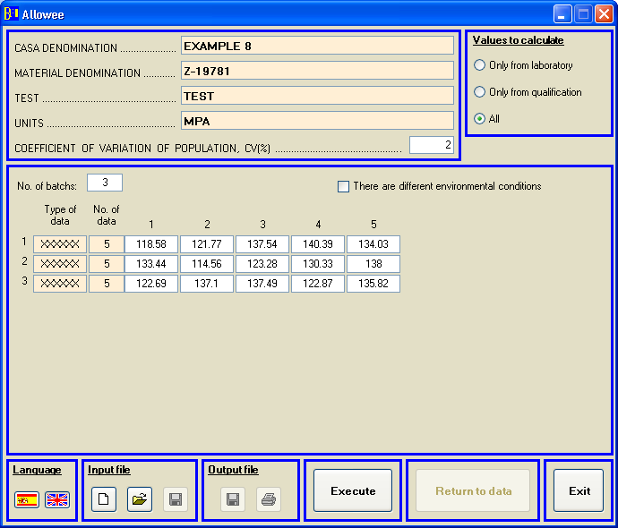

Figure 7.15. Example 8 input data

If the ‘Calculate’ button is pressed the results are shown:

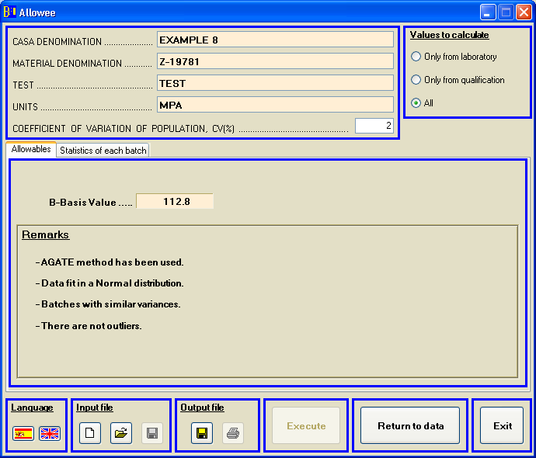

Figure 7.16. Example 8 output results
EXAMPLE 9:

The input data file (ej_allowee_9.dat) is the following:

DEN CASA: EXAMPLE 9
DEN MAT.: Z-19776
TEST: TEST
UNITS: MPA
LOTS: 2
CV (%): 5.8
'XXXXXX',2,237,234.7
'XXXXXX',3,244.4,242.1,245.2
3
Y

The ouput file is:

ej_allowee_9.RES

21-06-2013, Allowee 4.0

CASA DENOMINATION : EXAMPLE 9
MATERIAL DENOMINATION : Z-19776
TEST : TEST
UNITS : MPA
TOTAL NUMBER OF VALUES : 5
NUMBER OF BATCHES : 2
CV(%) OF POPULATION* : 5.8

(*) Coefficient of Variation of population only for small samples formula
Find recommended values for several data types in user's manual

ALLOWABLE VALUES
--------- ------

ENVIRONMENTAL CONDITION 1

B-BASIS VALUE = 209.38

ENVIRONMENTAL CONDITION 2

B-BASIS VALUE = 216.53

=========================================================================

REMARKS:

The data from different environmental conditions are poolable.
Small samples method has been used.
Environmental conditions with similar variances.
The pooled data are assumed to fit in a normal distribution.
There are not outliers.

=========================================================================

INPUT DATA
----------

BATCH N SPECIMEN DATA
---------------------------------------------------------------------------

1 2 234.7 237.0
2 3 242.1 244.4 245.2

-------------------------------------------------------------------------------
TOTAL OF 2 BATCHES, 5 SPECIMEN(S).

PRELIMINARY DESCRIPTIVE STATISTICS
----------------------------------

NUMBER SAMPLE STANDARD
OF BATCH SIZE AVERAGE DEVIATION
------------------------------------------------------------------------
1 2 235.85 1.63
2 3 243.90 1.61

------------------------------------------------------------------------
POOLED SAMPLE 5 240.68 4.63

=========================================================================

INVESTIGATION OF BATCH-TO-BATCH VARIABILITY
------------- -- --------------------------

THE K-SAMPLE ANDERSON-DARLING TEST STATISTIC = 0.00
THE CRITICAL VALUE = 2.03
SIGNIFICANT LEVEL = 0.05
SAME POPULATION

THE TEST STATISTIC FOR EQUALITY OF VARIANCE = 0.02
THE CRITICAL VALUE WITH 2-1 DEGREES OF FREEDOM = 758.77
SIGNIFICANT LEVEL = 0.05
VARIANCES ARE NOT SIGNIFICANTLY DIFFERENT

============================================================================

SMALL SAMPLE ADDITIONAL DATA
----------------------------

Kb (normalized data) = 0.980
Coefficient of variation used (%) = 5.8
Kb (small sample formula) = 0.888

============================================================================

If the PC version is used and the input file shown before is open, the program shows the following on the screen:

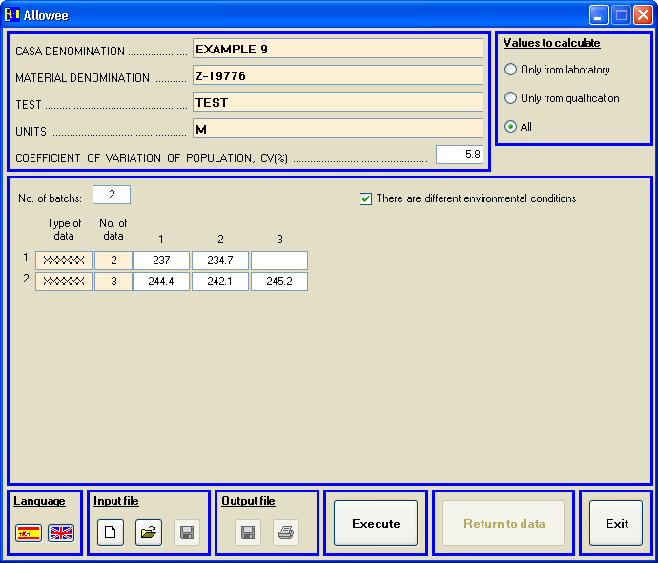

Figure 7.17. Example 9 input data
If the ‘Calculate’ button is pressed the results are shown:
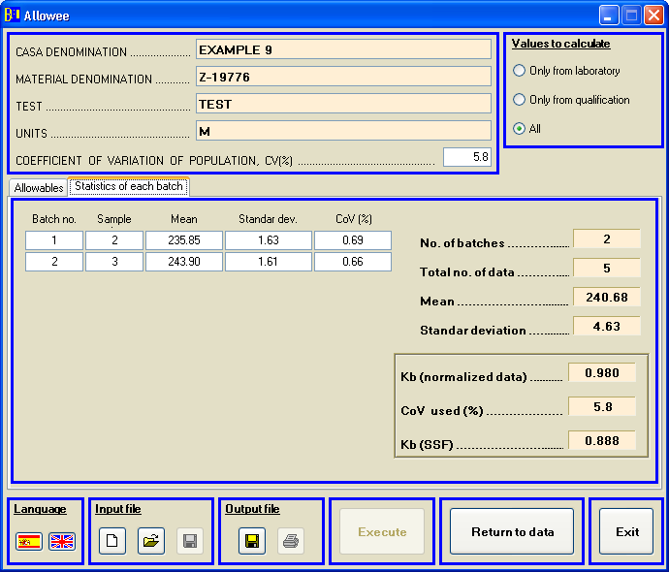

Figure 7.18. Example 9 output results

EXAMPLE 10:

The input data file (ej_allowee_10.dat) is the following:

DEN CASA: EXAMPLE 10
DEN MAT.: Z-19776
TEST: TEST
UNITS: MPA
BATCHES: 2
CV(%): 9.0
'XXXXXX',2,237,234.7
'XXXXXX',3,244.4,242.1,245.2
3
Y
The ouput file is:

ej_allowee_10.RES

21-06-2013, Allowee 4.0

DENOMINACIÓN CASA : EXAMPLE 10
DENOMINACIÓN DEL MATERIAL : Z-19776
ENSAYO : TEST
UNIDADES : MPA
NÚMERO TOTAL DE VALORES : 5
NÚMERO DE BATCHES : 2
CV(%) DE LA POBLACION* : 9.0

(*) Coeficiente de Variacion de población sólo para fórmula de pequeñas muestras
Valores recomendados para varios tipos de datos en manual de usuario

ADMISIBLES
----------

CONDICIÓN AMBIENTAL 1

VALOR B = 195.69

CONDICIÓN AMBIENTAL 2

VALOR B = 202.37

=========================================================================

CONSIDERACIONES:

Los datos de distintas condiciones ambientales se pueden agrupar.
Utilización de fórmula para pequeñas muestras.
Igualdad de varianzas entre condiciones ambientales.
Se asume población normal en los datos agrupados.
No existen outliers.

=========================================================================

DATOS DE ENTRADA
----------------

BATCH N DATOS DE ESPECÍMENES
---------------------------------------------------------------------------

1 2 234.7 237.0
2 3 242.1 244.4 245.2

-------------------------------------------------------------------------------
TOTAL DE 2 BATCHES, 5 ESPECIMEN(ES).

DATOS ESTADÍSTICOS PRELIMINARES
-------------------------------

NÚMERO TAMAÑO DESVIACIÓN
DE BATCH DE MUESTRA MEDIA ESTÁNDAR
------------------------------------------------------------------------
1 2 235.85 1.63
2 3 243.90 1.61

------------------------------------------------------------------------
POOLED SAMPLE 5 240.68 4.63

=========================================================================

INVESTIGACION DE LA VARIABILIDAD BATCH-TO-BATCH
-----------------------------------------------

VALOR ESTADÍSTICO DEL TEST DE K-SAMPLE ANDERSON-DARLING = 0.00
VALOR CRÍTICO = 2.03
NIVEL SIGNIFICATIVO = 0.05
MISMA POBLACIÓN

VALOR ESTADÍSTICO PARA IGUALDAD DE VARIANZAS = 0.02
VALOR CRÍTICO CON 2-1 GRADOS DE LIBERTAD = 758.77
NIVEL SIGNIFICATIVO = 0.05
VARIANZAS NO SIGNIFICATIVAMENTE DIFERENTES

============================================================================

DATOS ADICIONALES DE PEQUEÑAS MUESTRAS
--------------------------------------

Kb (datos normalizados) = 0.980
Coeficiente de variación utilizado (%) = 9.0
Kb (fórmula pequeñas muestras) = 0.830

============================================================================
If the PC version is used and the input file shown before is open, the program shows the following on the screen:

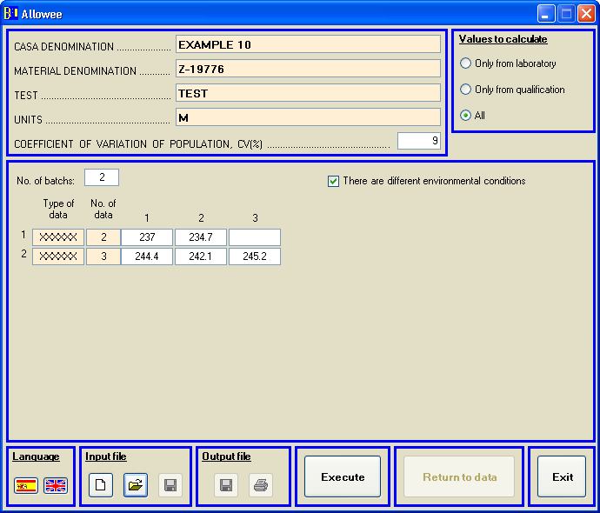

Figure 7.19. Example 10 input data
If the ‘Calculate’ button is pressed the results are shown:
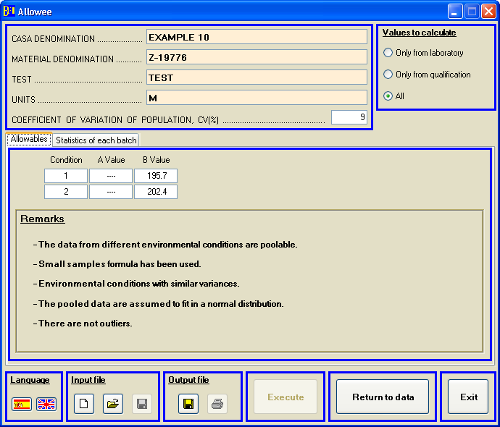

Figure 7.20. Example 10 output results

EXAMPLE 11:

The input data file (ej_allowee_11.dat) is the following:

DEN CASA: EXAMPLE 11
DEN MAT.: Z-19776
TEST: TEST
UNITS: MPA
BATCHES: 2
CV(%): 0.1
'XXXXXX',2,237,234.7
'XXXXXX',3,244.4,242.1,245.2
3
Y

The ouput file is:

ej_allowee_11.RES

21-06-2013, Allowee 4.0

DENOMINACIÓN CASA : EXAMPLE 11
DENOMINACIÓN DEL MATERIAL : Z-19776
ENSAYO : TEST
UNIDADES : MPA
NÚMERO TOTAL DE VALORES : 5
NÚMERO DE BATCHES : 2
CV(%) DE LA POBLACION* : 0.1

(*) Coeficiente de Variacion de población sólo para fórmula de pequeñas muestras
Valores recomendados para varios tipos de datos en manual de usuario

ADMISIBLES
----------

CONDICIÓN AMBIENTAL 1

VALOR B = 233.10

CONDICIÓN AMBIENTAL 2

VALOR B = 241.06

=========================================================================

CONSIDERACIONES:

Los datos de distintas condiciones ambientales se pueden agrupar.
Utilización de fórmula para pequeñas muestras.
Igualdad de varianzas entre condiciones ambientales.
Se asume población normal en los datos agrupados.
No existen outliers.

=========================================================================

DATOS DE ENTRADA
----------------

BATCH N DATOS DE ESPECÍMENES
---------------------------------------------------------------------------

1 2 234.7 237.0
2 3 242.1 244.4 245.2

-------------------------------------------------------------------------------
TOTAL DE 2 BATCHES, 5 ESPECIMEN(ES).

DATOS ESTADÍSTICOS PRELIMINARES
-------------------------------

NÚMERO TAMAÑO DESVIACIÓN
DE BATCH DE MUESTRA MEDIA ESTÁNDAR
------------------------------------------------------------------------
1 2 235.85 1.63
2 3 243.90 1.61

------------------------------------------------------------------------
POOLED SAMPLE 5 240.68 4.63

=========================================================================

INVESTIGACION DE LA VARIABILIDAD BATCH-TO-BATCH
-----------------------------------------------

VALOR ESTADÍSTICO DEL TEST DE K-SAMPLE ANDERSON-DARLING = 0.00
VALOR CRÍTICO = 2.03
NIVEL SIGNIFICATIVO = 0.05
MISMA POBLACIÓN

VALOR ESTADÍSTICO PARA IGUALDAD DE VARIANZAS = 0.02
VALOR CRÍTICO CON 2-1 GRADOS DE LIBERTAD = 758.77
NIVEL SIGNIFICATIVO = 0.05
VARIANZAS NO SIGNIFICATIVAMENTE DIFERENTES

============================================================================

DATOS ADICIONALES DE PEQUEÑAS MUESTRAS
--------------------------------------

Kb (datos normalizados) = 0.980
Coeficiente de variación utilizado (%) = 0.6
Kb (fórmula pequeñas muestras) = 0.988

============================================================================
If the PC version is used and the input file shown before is open, the program shows the following on the screen:

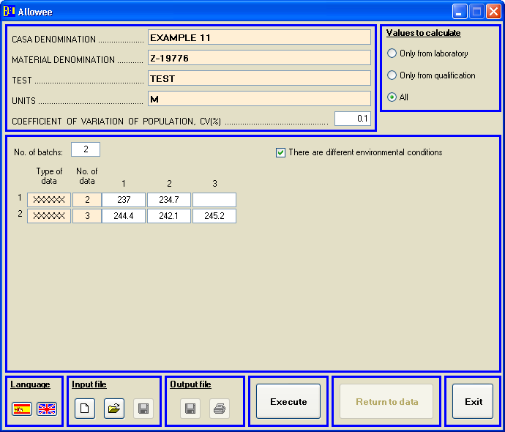

Figure 7.21. Example 11 input data
If the ‘Calculate’ button is pressed the results are shown:
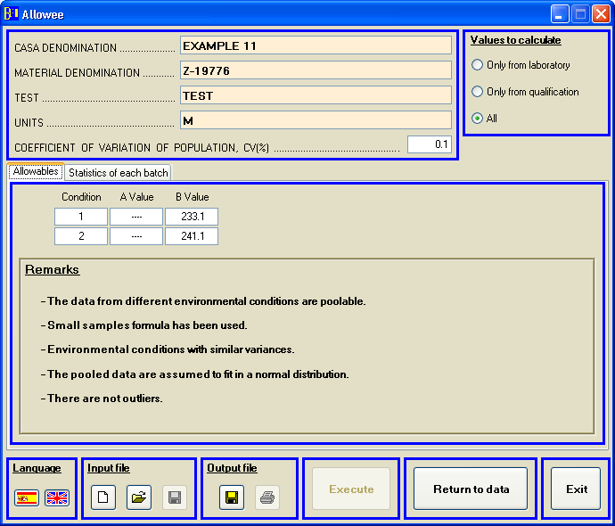

Figure 7.22. Example 11 output results

