GNSS-IR Reference Station
Quick Setup Guide
Install • Verify • Process & Plot
No prior experience with GNSS-IR, Linux, or this project required.

What This Guide Covers
This is a short, practical walkthrough for getting a GNSS-IR reference station up and running: downloading the code, connecting your receiver, installing the software, confirming everything works, and generating your first real plot. It assumes you have never touched this project before and don't need to understand GNSS-IR (GNSS Interferometric Reflectometry) in detail to follow along — each step explains exactly what to type and what to expect.
GNSS-IR uses the same signals an ordinary GPS receiver already picks up, but analyzes how they reflect off a nearby surface — water, soil, or snow — to work out how far below the antenna that surface sits, and how that distance changes over time.
TIP: For the complete, in-depth version of this guide — including every configuration option and detailed troubleshooting — see QUICKSTART.md and STATION_JSON_REFERENCE.md included with this project.

Before You Begin
You'll need:
- A computer running Ubuntu (or a similar Linux distribution)
- A supported GNSS receiver, connected via USB
- A GNSS antenna, mounted with a reasonably clear view of the sky
- Your antenna's approximate location (latitude, longitude, height) — even a rough consumer GPS reading is enough to start
- An internet connection
STEP 1

Download the Project Code
All of this project's code lives in a single git repository. If you've never used git before: it's just a tool for downloading (and later updating) a whole folder of code with one command.
Open a terminal and run git clone to download the project. This example downloads it to ~/GNSS/v4.1, matching every other command in this guide — if you use a different folder, adjust accordingly.
● ● ● Terminal — git clone
$ git clone -b master-scripts \
https://github.com/emarsjanik/GPS_code.git \
~/GNSS/v4.1

Cloning into '/home/user/GNSS/v4.1'...
remote: Enumerating objects: 40, done.
remote: Counting objects: 100% (40/40), done.
Receiving objects: 100% (40/40), done.
$ cd ~/GNSS/v4.1

TIP: The -b master-scripts part matters: it selects the clean, focused branch meant for getting a new station running, rather than a branch full of one project's own internal development history.
TIP: If this repository is private, you'll need to be given access by its owner first, and may be prompted to sign in (or provide a personal access token) when you run this command.

STEP 2

Identify Your Receiver's Port
Before installing anything, plug in your GNSS receiver via USB and find out what your computer is calling it. Linux gives every serial device a name like /dev/ttyUSB0 — you'll need this exact name shortly.
Plug in the receiver, then run dmesg | tail -20 and look for a new device near the bottom of the output.
● ● ● Terminal — dmesg
$ dmesg | tail -20

[ 1234.567890] usb 1-1: new full-speed USB device
[ 1234.612345] usb 1-1: Product: USB Serial
[ 1234.654321] ch341-uart converter now attached to ttyUSB0

$ ls -la /dev/ttyUSB*
crw-rw---- 1 root dialout 188, 0 Aug 21 09:00 /dev/ttyUSB0

TIP: In this example, the receiver is at /dev/ttyUSB0 — yours may show a different number, or end in ttyACM0 instead. Write down whichever name you actually see; the rest of this guide will refer to it as your "receiver port."

STEP 3

Make the Port Name Permanent
The device name from Step 2 isn't guaranteed to stay the same — it can change after a reboot, or if you plug in a second USB-serial device. Creating a udev rule gives your receiver a fixed, permanent name (this guide uses /dev/USB_GPS) that never changes, no matter what else is plugged in.

Find your receiver's vendor and product ID
Using the port name from Step 2, run:
● ● ● Terminal — udevadm info
$ udevadm info -a -n /dev/ttyUSB0 | grep -m1 -E "idVendor|idProduct"

ATTRS{idVendor}=="1a86"
ATTRS{idProduct}=="7523"

Write down both values — you'll see your own receiver's real numbers here, which will likely be different from this example.

Create the rule
Create a new rule file:
● ● ● Terminal — create the rule
$ sudo nano /etc/udev/rules.d/99-usb-gps.rules

Type this one line into the file, replacing the two ID values with your own from above, then save and exit:
● ● ● 99-usb-gps.rules
SUBSYSTEM=="tty", ATTRS{idVendor}=="1a86", ATTRS{idProduct}=="7523", SYMLINK+="USB_GPS"

Apply it
● ● ● Terminal — apply the rule
$ sudo udevadm control --reload-rules
$ sudo udevadm trigger
$ ls -la /dev/USB_GPS

lrwxrwxrwx 1 root root 7 Aug 21 09:05 /dev/USB_GPS -> ttyUSB0

TIP: That final ls confirms it worked: /dev/USB_GPS now always points to your receiver, however its underlying ttyUSB number changes. When Step 4's setup wizard asks for your receiver's port, use /dev/USB_GPS — not /dev/ttyUSB0 directly.

STEP 4

Install the Software
Open a terminal in the project folder and run ./install.sh. This checks for (and installs, if missing) every piece of software this project needs — Python, the GNSS-IR analysis engine, and the tool that converts your receiver's raw data into a standard format.
● ● ● Terminal — install.sh
$ ./install.sh

================================================================
GNSS-IR Reference Station -- Installer
================================================================

================================================================
Step 1: System packages
================================================================
[OK] python3 already installed
[OK] git already installed
[OK] build-essential already installed

================================================================
Step 2: RTKLIB (convbin)
================================================================
[OK] convbin already on PATH

================================================================
Step 3: Python environment and gnssrefl
================================================================
[OK] Virtual environment created
[OK] gnssrefl installed

================================================================
Step 5: Station configuration
================================================================
No station.json found yet -- starting the setup wizard...

Once installed, the setup wizard starts automatically and asks a short series of questions — your station's name, your receiver's connection details, and (most importantly) its location. Every question is explained as you go, so just answer honestly and move on.
TIP: Getting the location fields right matters more than anything else in this whole setup — an error here won't cause a crash, it will just quietly produce results that don't mean anything. Double-check them before moving on.
STEP 5

Verify Everything Works
Before doing anything else, run ./test_installation.sh. It checks your whole setup — the software environment, your configuration, and (if a receiver is plugged in) that it can actually talk to it — and gives you a clear pass or fail for each one.
● ● ● Terminal — test_installation.sh
$ ./test_installation.sh

================================================================
GNSS-IR Reference Station -- Installation Verification
================================================================

================================================================
1. Python environment
================================================================
[PASS] Virtual environment found and activated

================================================================
2. Required tools and packages
================================================================
[PASS] convbin found
[PASS] gnssrefl importable (version 4.1.5)

================================================================
3. Station configuration
================================================================
[PASS] station.json exists and is valid JSON
[PASS] latitude: 41.89
[PASS] longitude: -69.96

================================================================
5. Unit test suite
================================================================
[PASS] Ran 222 tests -- all passed

================================================================
Summary
================================================================
Passed: 16 Warnings: 0 Failed: 0

Next step: ./process_and_plot.sh

If you see any [FAIL] lines, don't worry — each one comes with a short, specific explanation of exactly what to do about it right below it. Fix those first, then run this script again before moving on to Step 6.
STEP 6

Process Your Data and Plot It
Once you have some recorded data (even a few hours is enough for a first test), run ./process_and_plot.sh. This one command converts it, runs the actual GNSS-IR analysis, and produces a plot — all in a single step.
● ● ● Terminal — process_and_plot.sh
$ ./process_and_plot.sh

================================================================
Step 2: Processing new data
================================================================
Found 3 new raw file(s) to process.

[OK] Running pipeline (3/3 files)

================================================================
Step 4: Generating plot (days 190-193)
================================================================
[OK] Generating plots

Plots saved to:
products/refl_code/Files/usgs

The main result is usually the file ending in _last.png
in that directory.

That's it — open the _last.png file it points you to, and you'll see something like this:

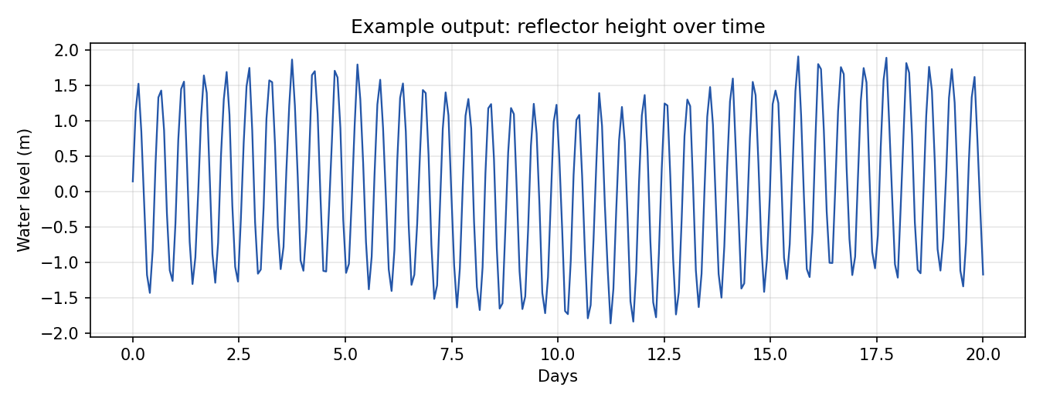
Example output — your own plot will use your real, recorded data.
TIP: It's normal for the very first run to show a short, choppy-looking record — real, clear patterns usually take many hours to days of data to emerge. Run this same command again any time you have new data; it automatically picks up only what's new.

If Something Doesn't Look Right
A few common situations, and what they usually mean:

"No results found," but no errors either
Most likely, that particular day simply didn't have enough usable satellite passes — a normal outcome for some sites and configurations, not necessarily a problem. This is expected to happen occasionally, not on every day.

Results look confident but seem physically wrong
Double-check the latitude, longitude, and height fields in your configuration first. An error here is the single most common cause of a result that looks fine on the surface but doesn't actually mean anything.

A [FAIL] you're not sure how to fix
Re-run ./test_installation.sh — it's always safe to run again, and the fix suggestion under each failure is usually all you need.

Where to Learn More
This guide covers the everyday path — install, verify, process. For everything else (advanced configuration, running continuously and unattended, checking whether a result is scientifically meaningful, and more), see:
- QUICKSTART.md — the complete, start-to-finish walkthrough
- STATION_JSON_REFERENCE.md — every configuration option explained

