Design Specifications

Conflict Notification Tool

13-Nov-2017

Document Version 1.0

Document No: N/A



Author(s): Ed Martini

This document and any attachments, supplements, or references contains Bracket information that is privileged, confidential or otherwise exempt from disclosure under applicable law and is intended solely for the use of the individual(s) to whom it was intended to be addressed. If you are in possession of this document by mistake, or you are not the intended reader, any disclosure, dissemination, distribution, copying or other use or retention of this document or its substance is prohibited. If you have received this document in error, please immediately notify Bracket in writing that you received this document by mistake and also permanently delete the original and all electronic or physical copies of this document and any attachments and supplements.

Document Details

**PRODUCT NAME:** Conflict Notification Tool

**DOCUMENT TYPE:** Design Specifications Document

**DOCUMENT ISSUE DATE:** 13-Nov-2017 (v.1.0)

**DOCUMENT NO.:** N/A

Authorized Document Approvals

| Name and Title/Organization | Signature | Date |
| --- | --- | --- |
| Paul Mavely  **Product Analyst, Product Analysis, Product Innovation** | As author, my electronic signature on this document indicates that I acknowledge that this document is accurate, complete and contains the necessary degree of detail to accomplish the intended purpose. | See e-signature |
| Stan Chow  **Manager, Product Analysis, Product Innovation** | My electronic signature on this document indicates that I have inspected the content and format of this document and have found no errors or omissions that are substantive enough to prohibit its use. | See e-signature |
| Steven Battisti  **Senior Product Manager, Product Management, Product Innovation** | My electronic signature on this document indicates that I have inspected the content and format of this document and have found no errors or omissions that are substantive enough to prohibit its use. | See e-signature |
| Thomas Schmidt  **Project Manager, Product Development, Product Innovation** | My electronic signature on this document indicates that I have inspected the content and format of this document and have found no errors or omissions that are substantive enough to prohibit its use. | See e-signature |
| Dorean Downing  **Regional Associate Director, Product Development, Product Innovation** | My electronic signature on this document indicates that I have inspected the content and format of this document and have found no errors or omissions that are substantive enough to prohibit its use. | See e-signature |
| Andrea DiRico  Team Lead, Product Testing, Product Innovation | My electronic signature on this document indicates that I have inspected the content and format of this document and have found no errors or omissions that are substantive enough to prohibit its use. | See e-signature |
| Sam Whitaker  CTO, Product Innovation | My electronic signature on this document indicates that I have inspected the content and format of this document and have found no errors or omissions that are substantive enough to prohibit its use. | See e-signature |
| Thomas Barlow  **Associate Vice President, Total Quality Management** | My electronic signature on this document indicates that I have inspected the content and format of this document and have found no errors or omissions that are substantive enough to prohibit its use. | See e-signature |

# Revision History

| Version | Date | Author | Reason for Changes |
| --- | --- | --- | --- |
| 0.1 | 13-Nov-2017 | Ed Martini | Initial draft document created |
| 1.0 |  |  | Document Approval |

Table of Contents

1. Introduction 5

1.1 Document Purpose 5

1.2 Audience 5

1.3 Document Conventions 5

1.4 Document Scope 5

1.5 References 5

1.6 Glossary and Acronyms 6

2. Executive Summary 7

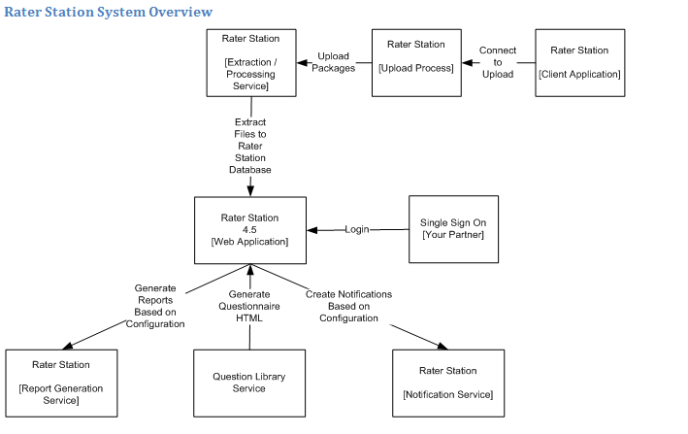82.1SYSTEM ARCHITECTURE SOLUTION 7

3. Application Framework 9

3.1 9

3.2 Data Access -ADO.NET Framework 9

4. Web Components 10

4.1 Security 10

4.2 Application Composition 11

4.3 Resource Localization 19

4.4 UI Components 19

4.5 Session Handling 22

5. Unit Testing 23

5.1 MS Unit Testing Framework 23

6. Program API 24

• List of Application Framework Components 25

7. Rater Station Conflict Notification Tool Reprocess Packages Changes ...…………………… 26

8. Operational Impact…………………………………………………………………………………………...28

9. Deployment……………………………………………………………………………………………………..29

Appendix A Application Framework Common Components 30

A1 Rater Station Conflict Notification Tool Common Components 30

Appendix B Supported Browsers 31

# Introduction

The Rater Station Conflict Notification Tool Application can host one or more studies that consist of a series of interview items. The interview items used in a study is based on configuration and can include informative text, educational data, and scales.  The application is designed to capture information about a subject.

## Document Purpose

This Design Specifications Document (DSD) contains design specifications for the Rater Station Conflict Notification Tool. Detailed functional requirements and specifications are covered comprehensively in the Rater Station Conflict Notification Tool Requirements Documents (PRDs).

## Audience

This document is intended for Project Managers, Product Test Engineers, and Product Developers. Each team member or role uses the information in the following way:

| Project Team Member/Role | Use |
| --- | --- |
| Project Managers | Determine requirement needs to manage the project. |
| Product Test Engineers | Develop test plans and test cases. |
| Product Developers | Implement the design specifications to create the product. |

## Document Conventions

The following conventions are contained in this section: document standards.

### Document Standards

The following typographical standards are used in this document:

| Font Convention | Type of Information |
| --- | --- |
| **Bold** type | Important terms and literals |
| Italic type | Variables and document names |
| Courier type | Commands that are typed and samples |

## Document Scope

The DSD defines how the design solution and functional requirements that are in the Rater Station Conflict Notification Tool Requirements Documents (PRDs) will be met.

The scope of this document is limited to the Rater Station Conflict Notification Tool’s design specifications. Whenever necessary, this document refers to other design specifications that cover already-existing or standard functionality.

## References

The following is a list of references that apply to this project. All documents in this list reside on the document management system (SOPs, STDs, etc.) or in the designated development collaboration environment (SDKs, other PRDs, etc.).

* *PRD500—Rater Station Conflict Notification Tool Requirements Documents*
* *STD-RD-001—Software Development Standards*

## Glossary and Acronyms

The following is a list of common terminology and acronyms used throughout this document.

| Term | Definition |
| --- | --- |
| CNT | Conflict Notification Tool |
| Ng | Angular |
| EF | Entity Framework |
| Framework | Foundation |
| ADO.NET | Framework |
| SOA | Service-Oriented Architecture |
| UDF | User-Defined Functions (typically name/value pair) |
| UI | User Interface |

# Executive Summary

The contents of this section fulfill the following requirements:

| Requirements Document | Requirement(s) |
| --- | --- |
| *PRD500— Rater Station Conflict Notification Tool Requirements Documents* | PRD500 |

## System Architecture Solution



The following diagram provides a high-level Overview of the Rater Station Conflict Notification Tool.

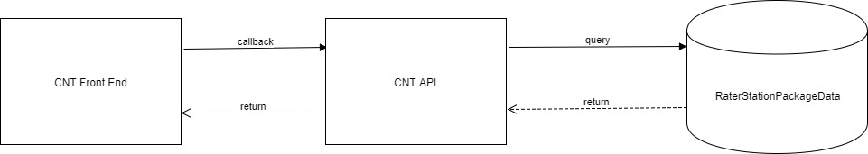

The following figure gives an overview of the *Rater Station Conflict Notification Tool* technology stack.

***Technology stack***

1. Angular 1.5
2. TypeScript 6.5.5
3. Bootstrap 3.0.0
4. jQuery 1.10.2
5. EF 6.1.3
6. .NET 4.5.2
7. ASP.NET MVC 5.2.3
8. Newtonsoft.Json 2.6.2
9. Owin 1.0
10. SQL Server 2008
11. C#

## System Functionality Architecture

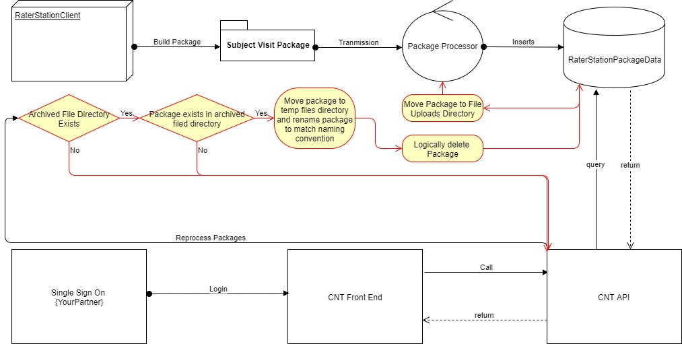

# Application Framework

This section contains various aspects and components of the Application Framework.

## 3.1 Model-Driven Design (MDA)

### Entities

Entities are key objects of the domain model, critical to the modeling process. C# objects in the domain are analogous to tables in the database. The Root entity or Aggregate Root is the primary object that is responsible for performing read and write operations from the database (repository) as an atomic action.

* Entities hold all the of domain logic and expose meaningful methods to change the state of the entity in a consistent manner.
* Entities ideally have read-only properties and use Collection<T>s to handle the child objects.
* Domain entities are persistence ignorant.

### Repositories

Repositories are responsible for handling the entities persistence.

* All of the read and write operations are handled through EF.

## EF

DCTDataAccess Class Library uses **EF** data access technology from the [Microsoft](https://en.wikipedia.org/wiki/Microsoft)[.NET Framework](https://en.wikipedia.org/wiki/.NET_Framework) that provides communication between relational systems through a common set of components

# Web Components

The following are the details of various web components.

## Security

The contents of this section fulfill the following requirements:

| Requirements Document | Requirements |
| --- | --- |
| *PRD500— Rater Station Conflict Notification Tool Requirements Documents* | N/A |

### Authentication

The contents of this section fulfill the following requirements:

| Requirements Document | Requirements |
| --- | --- |
| *PRD500— Rater Station Conflict Notification Tool Requirements Documents* | N/A |

This application interfaces with Your Partner Single-Sign-On.

privatestringGetUsernameFromYourPartner()

{

stringreturnValue = "";

booluseMockSetting;

Boolean.TryParse(WebConfigurationManager.AppSettings[Constant.UseMockSecurity], outuseMockSetting);

if (useMockSetting)

{

returnValue = WebConfigurationManager.AppSettings[Constant.MockUsername];

}

else

{

HttpCookierequestCookie = HttpContext.Current.Request.Cookies.Get("UserName") ?? HttpContext.Current.Request.Cookies["UserName"] ?? Request.Cookies["UserName"];

if (requestCookie != null)

{

returnValue = requestCookie.Value;

}

}

ReturnToYourPartnerPageIfTheReturnValueEmpty(returnValue);

returnreturnValue;

}

privatevoidReturnToYourPartnerPageIfTheReturnValueEmpty(stringreturnValue)

{

if (string.IsNullOrEmpty(returnValue))

{

stringyourPartnerUrl = WebConfigurationManager.AppSettings[Constant.RedirectToHomePage];

HttpContext.Current.Response.Redirect(yourPartnerUrl);

}

*Bracket Common Authentication System Design Specifications Document* for SSO design specifications.

### Authorization

The contents of this section fulfill the following requirements:

| Requirements Document | Requirements |
| --- | --- |
| *PRD500— Rater Station Conflict Notification Tool Requirements Documents* | PR3 |

Authorization includes primarily two processes:

* Permitting only certain users to access, process, or alter data
* Applying varying limitations on user access or actions. The limitations placed on (or removed from) users can apply to objects, such as schemas, tables, or rows; or to resources, such as time (CPU, connect, or idle times).

Conflict Notification Tool User Authorization is done against RaterStationPackageData User Roles and Permissions Database Tables.

## Application Composition

### Application Architecture

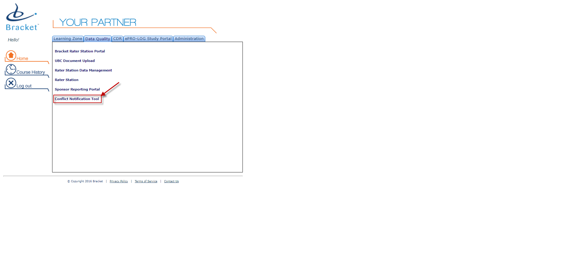**SinlgeSignOn [YourPartner]:**

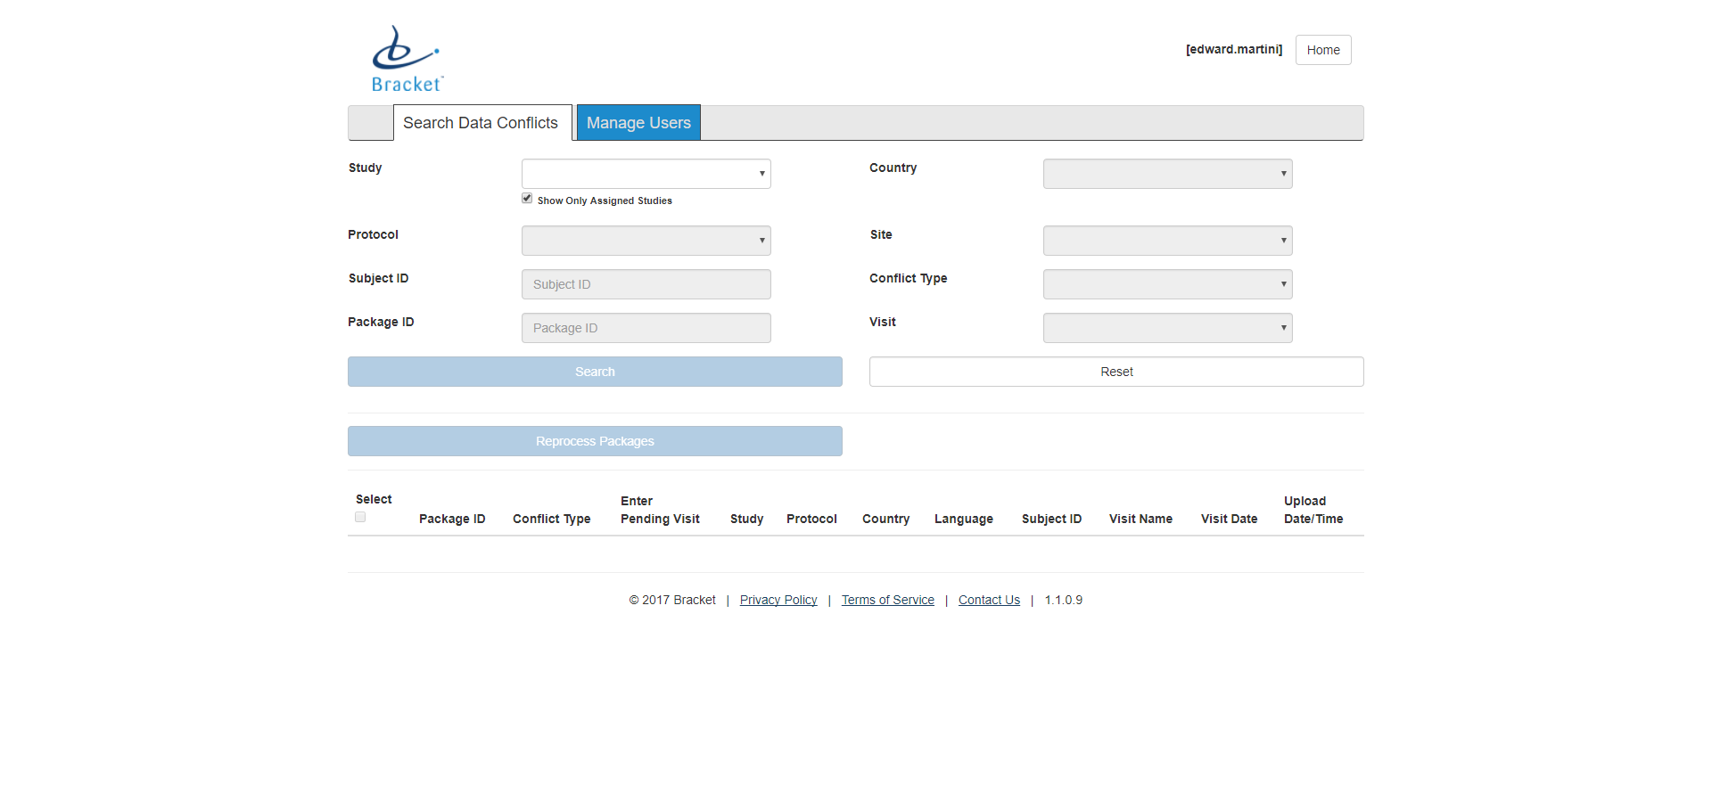**subjectVisit.html:**

**compare.html:**

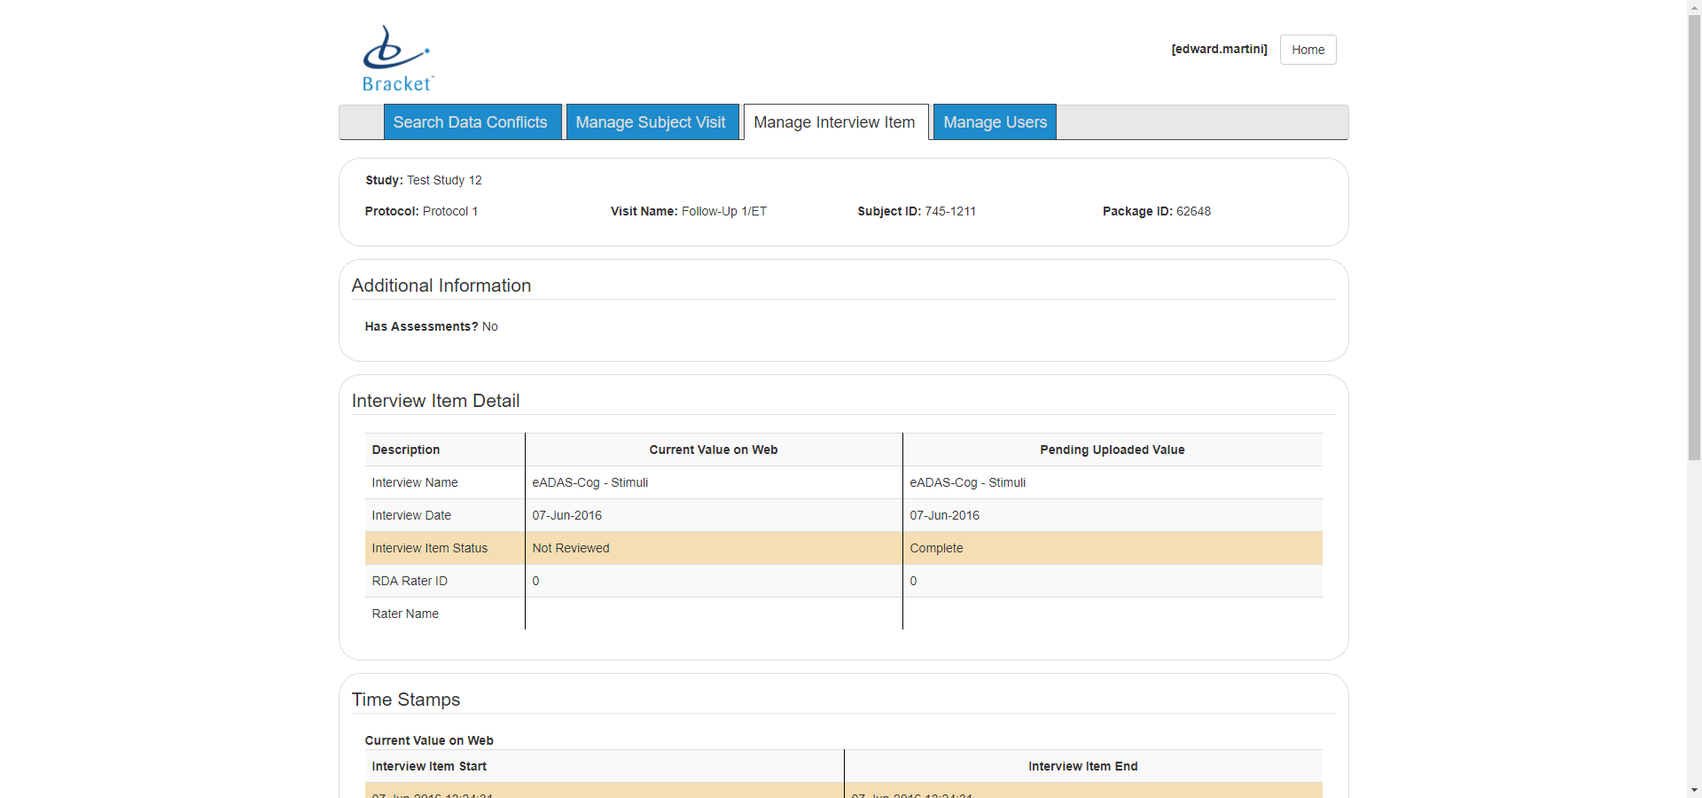

**interviewItem.html:**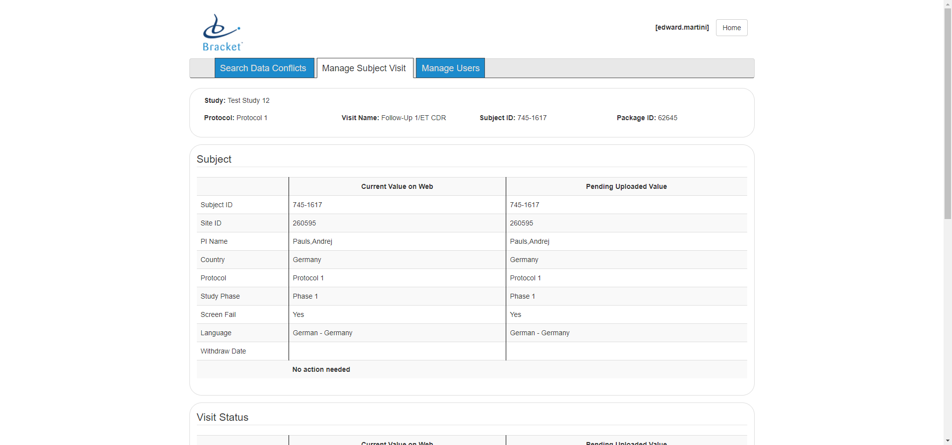

**manageUsers.html**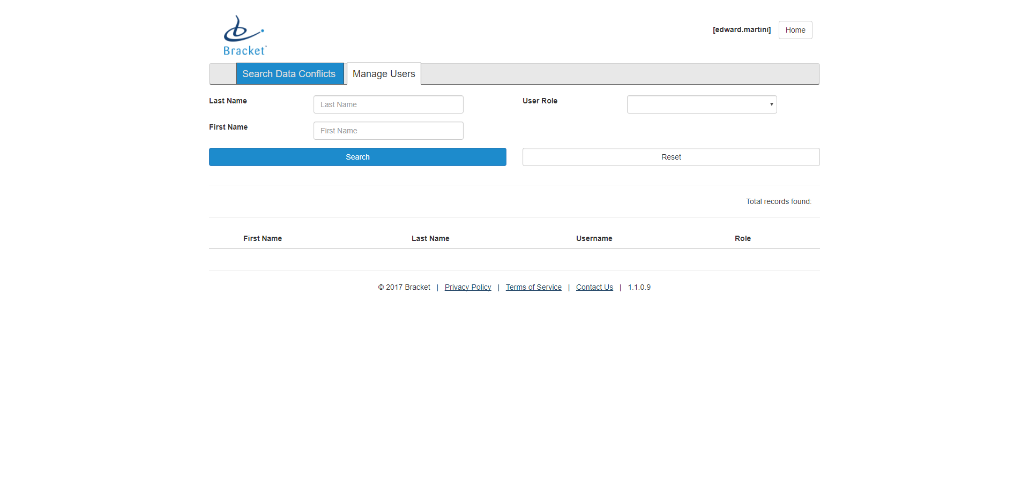

## Resource Localization

The contents of this section fulfill the following requirements:

| Requirements Document | Requirements |
| --- | --- |
| *PRD500— Rater Station Conflict Notification Tool Requirements Documents* | N/A |

The product supports resource (strings, web content, etc.) localization.

All application string resources (labels, messages, prompts, and web content) are stored in the database, retrieved in the application on demand, and get cached for future use.

* Database queries can include the resource table to get the right resource (given culture) for various non-web scenarios, including reports and notifications.

## UI Components

The contents of this section fulfill the following requirements:

* authentication.html
* compare.html
* header.html
* interviewItem.html
* editUser.html
* manageUsers.html
* reprocessPackages.html
* SpecsRunner.html
* reprocessedPackages.html
* subjectVisit.html
* breadcrumb.html

| Requirements Document | Requirements |
| --- | --- |
| *PRD500— Rater Station Conflict Notification Tool Requirements Documents* | PR4  PR5  PR6  PR7  PR8 |

Bootstrap cascade styling sheets are designed to take standard HTML elements and style them to match the web’s current standards.

* Common web project includes various sharable UI components for handling the display and edit of views.
* User Controls
* Bootstrap Web Components

## Users and Roles

| Requirements Document | Requirement(s) |
| --- | --- |
| *PRD500— Rater Station Conflict Notification Tool Requirements Documents* | 4.1 |

The following user roles are available in CNT:

|  |  |
| --- | --- |
| **Role** | **Tier** |
| Standard User | 1 |

## Session Handling

The contents of this section fulfill the following requirements:

| Requirements Document | Requirement(s) |
| --- | --- |
| *PRD500— Rater Station Conflict Notification Tool Requirements Documents* | N/A |

The applications connection to the server is terminated leaving the user no other option but to log out in order to continue use.

# Unit Testing

This section contains the unit test strategy for the product.

## MS Unit Testing Framework

# CNT API

The contents of this section fulfill the following requirements:

| Requirements Document | Requirement(s) |
| --- | --- |
| *PRD500— Rater Station Conflict Notification Tool Requirements Documents* | NA |

This section contains the Program API strategy for the product. CNT’s API contains 5 different controllers that are utilized in order for the front end to communicate with the back end.

|  |  |
| --- | --- |
| **Controller** | **Purpose** |
| HomeController | To initiate communication from the front end to the back end. |
| AuthenticationController | To open communication from the authentication service to the back end. |
| ConflictPackageController | To open communication from the data access service to the back end for all calls coming from the compare component. |
| ManageUsersController | To open communication from the data access service to the back end for all calls coming from the manage users component. |
| SubjectVisitSearchController | To open communication from the data access service to the back end for all calls coming from the subject visit component. |

* List of Rater Station Conflict Notification Tool Framework Components

| Module/Category  Component | Type | Application Impact | Testing Strategy |
| --- | --- | --- | --- |
| Application Domain Entities, Services, Repositories | Library | No | Unit Testing |
| DataAccess Framework | Library | No | Unit Testing  Test Harness |
| Security/Web  Authentication, Authorization | Application | Yes | Unit Testing  QA |
| Web  Shared UI Components | Web Library  Bootstrap | Yes | Unit Testing  QA |
| Customizations | Library | Yes | Automation  QA |
| Utilities  Logging | Library | No | Unit Testing  QA |

| Requirements Document | Requirements |
| --- | --- |
| *PRD500— Rater Station Conflict Notification Tool Requirements Documents* |  |

# Operations Impact

NA

# Deployment

* Changing Web.config file settings that must be different in the destination environment, such as settings for debugging, or database connection strings.
* Propagating data or data structures in databases that are used by the Web application.
* Configuring IIS settings on the destination computer, such as the application pool, the authentication method, whether directory browsing is allowed, and error handling.
* Installing security certificates.
* Setting values in the registry of the destination computer.
* Installing application assemblies in the global assembly cache (GAC) on the destination computer.
* Copy Application Solution Files to Webserver Virtual Folder

1. Application Framework Common Components

This section details the technical requirements for Bracket common components, including third party components. These are Dynamic Link Libraries (DLLs) and internal implementation tools that are shared among more than one Bracket application.

* 1. CNT Common Components

| Component Name | Technical Specification (Requirement) | Fulfills Requirement(s) |
| --- | --- | --- |
| DCTCommon | A Core DLL for generically shared modules | N/A |
| DCTDataAccess | A Core DLL for accessing the data store. | N/A |
| DCTWeb | MVC Ng application | N/A |

1. Supported Browsers

The contents of this appendix fulfill the following requirements:

| Requirements Document | Requirements |
| --- | --- |
| *PRD500— Rater Station Conflict Notification Tool Requirements Documents* | PRD502 |

|  |  |
| --- | --- |
| **Supported Browsers** | **Version** |
| Internet Explorer on Windows | * 9.0+ |
| Chrome | * 47+ |

END OF DOCUMENT