**frmBase.cs:**

The Bracket Support Application consists of one form which is used as a bootstrapper to three different applications. This form is also utilized to manage the user that is currently utilizing the application and handle access permissions.

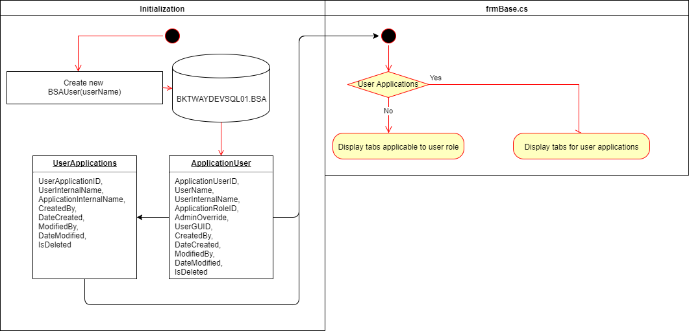

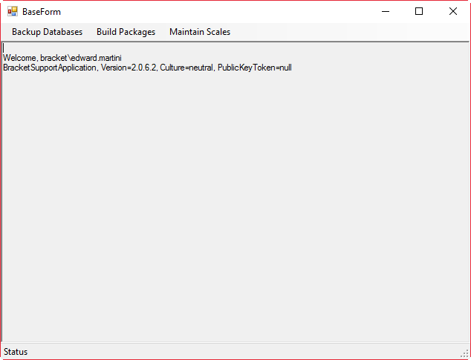

**frmDatabaseBackup.cs:**

The purpose of this form is to collect the desired actions from the user that they would like to execute on the specific SQL environment in which they choose.

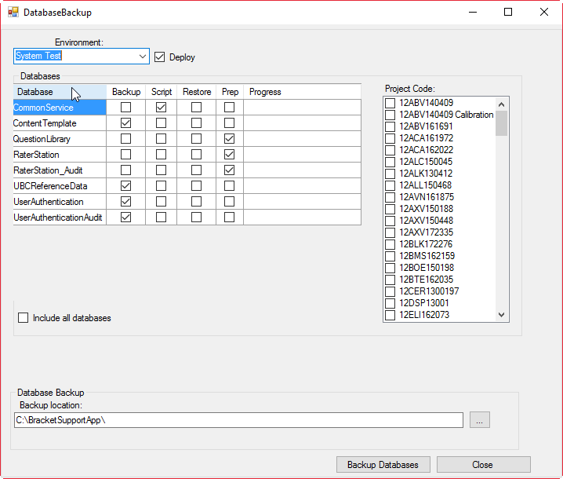

**Environment:** The usersdesiredSQL environment in which they would like the actions to be executed.

**Deploy:** Whether or not the user would like to deploy the end result of the actions chosen to a study package.

**Databases:** The databases in which the user would like to perform actions on and what actions they would like executed.

**Project Code:** The project(s) the user would like the database “Prep”ed for and/or the end result of the actions deployed to.

**Include all databases:** Whether or not the user would like to display all databases on the server or just the databases specific to a study package.

**Backup location:** The location in which the user would like the databases copied to.

**Backup Databases:** Prompts the user with the actions chosen and requests a response for whether or not they would like to move forward with performing the actions listed.

**Cancel:** Closes down the form.

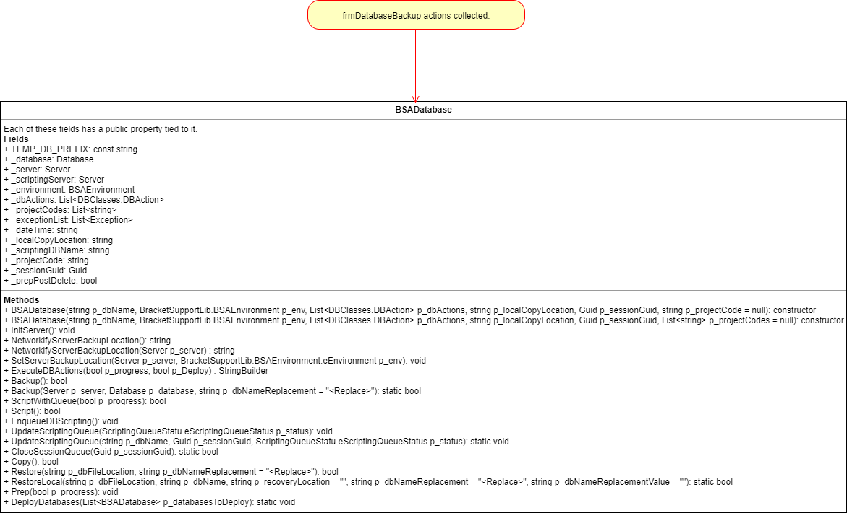

**BSA Database Action Process**

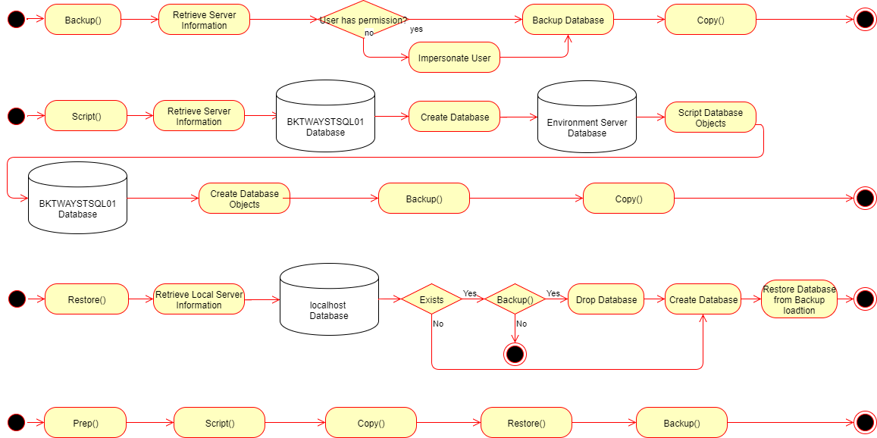

**frmScaleGenerator.cs:**

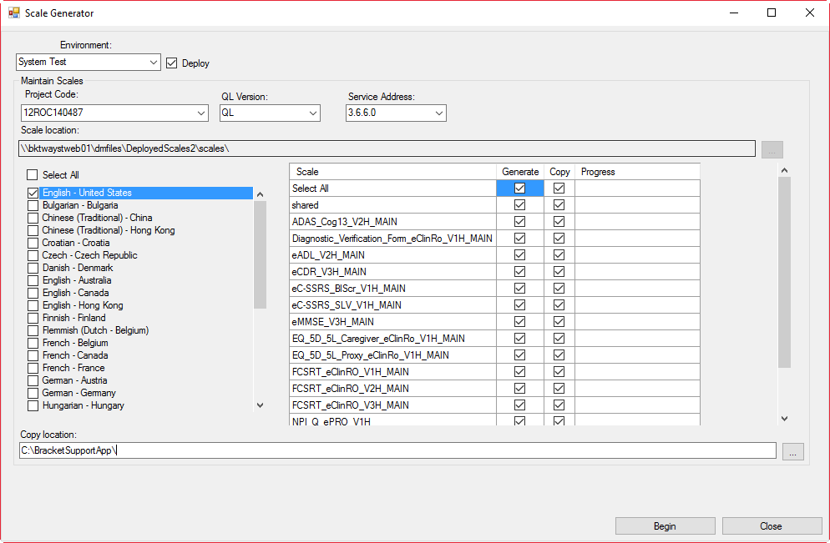

**Environment:** The usersdesiredQL environment in which they would like the actions to be executed.

**Deploy:** Whether or not the user would like to deploy the end result of the actions chosen to a study package.

**Project Code:** The project(s) the user would like the scales copied or generated for and/or the end result of the actions deployed to.

**QL Version:** The version of the QL service the user would like to utilize in order to generate scales. Also, to alter the location in which the scales are located.

**Service Address:** The service address of the QL service the user would like to utilize in order to generate scales. Also, to alter the location in which the scales are located.

**Scale location:** Disabled text box to provide the scale location to the user.

**Language Overflow:** List of study site languages tied to the study sites that belong to the chosen project code.

**Scale:** Name of the questions group(s) tied to the chosen project code.

**Copy location:** The location in which the user would like the scales copied to.

**Scale Action Process**

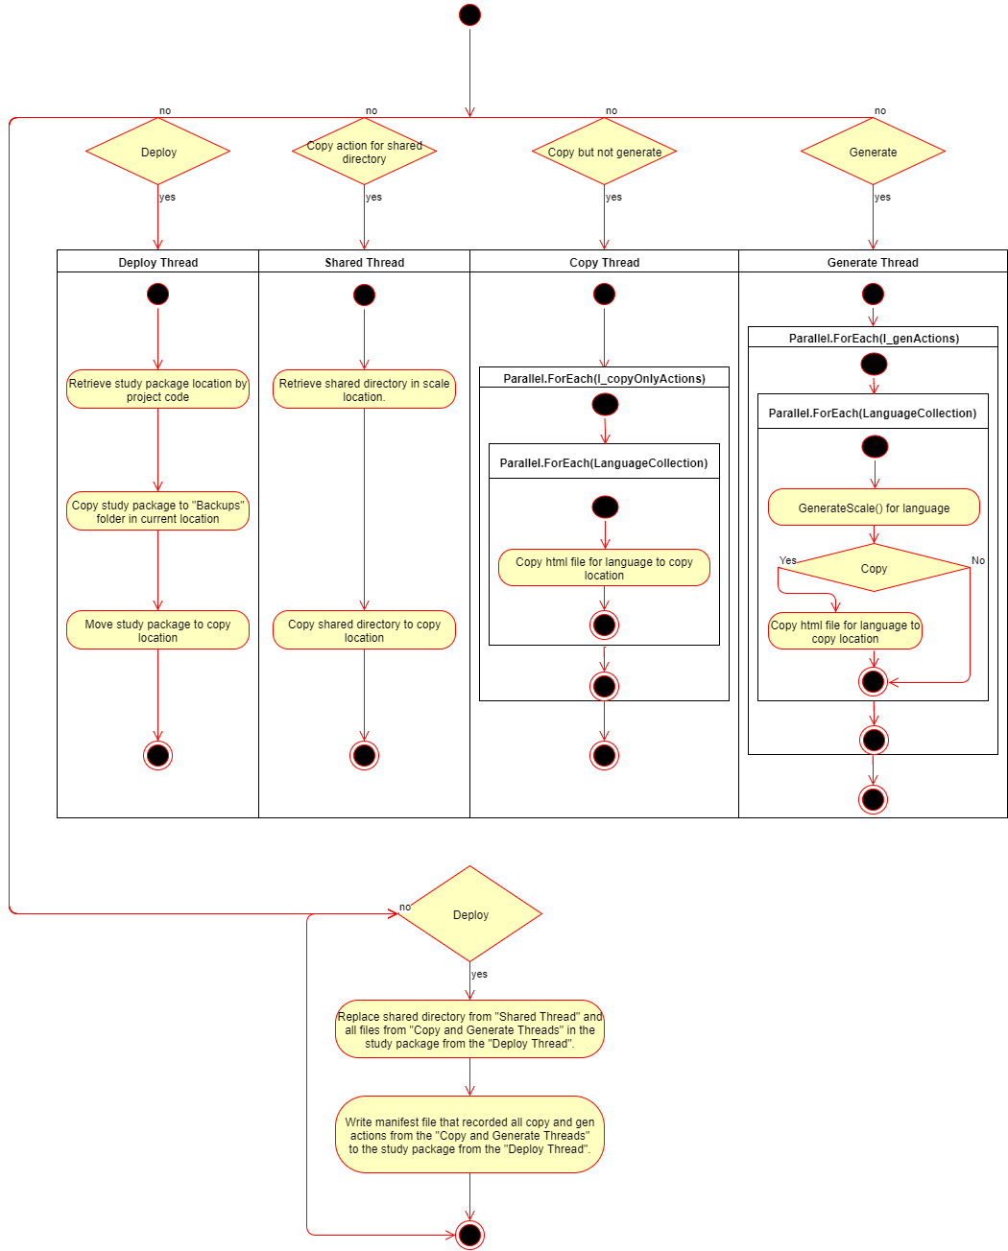

**frmPackageBuilder.cs:**

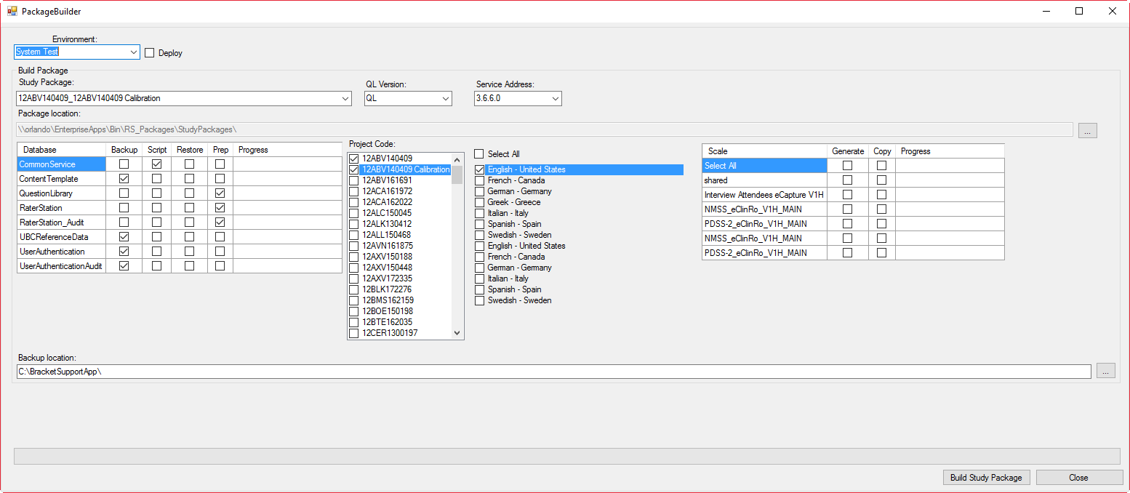

**Environment:** The usersdesiredSQL environment and QL environment in which they would like the actions to be executed.

**Deploy:** Whether or not the user would like to deploy the end result of the actions chosen to a study package.

**Study Package**: The study package located in the study package repo that the user would like to use as a template.

**Study Package Repo**:\\orlando\EnterpriseApps\Bin\RS_Packages\StudyPackages

**QL Version:** The version of the QL service the user would like to utilize in order to generate scales. Also, to alter the location in which the scales are located.

**Service Address:** The service address of the QL service the user would like to utilize in order to generate scales. Also, to alter the location in which the scales are located.

**Package location:** Disabled text box to provide the study package repo to the user. Can be altered by clicking the button to the right of the control.

**Project Code:** The project(s) the user would like the database “Prep”ed for, the scales copied or generated for, and/or the end result of the actions deployed to.

**Databases:** The databases in which the user would like to perform actions on and what actions they would like executed.

**Language Overflow:** List of study site languages tied to the study sites that belong to the chosen project code.

**Scale:** Name of the questions group(s) tied to the chosen project code.

**Backup location:** The location in which the user would like the scales copied to.

**Package Builder Process**

