Solution Design Document — Smart Assets Lifecycle Tracker
1.Document Control
Item | Details
Document Name | Solution Design Document — Smart Assets Lifecycle Tracker
Version | 1.0
Status | Draft
Author | Sep Collaborative group 2
Architecture Owner | Team
Business Owner | Kent
Date | 13-SEP-2026
Reviewers
2. Revision History
Version | Date | Author | Change
0.1 | 13-Sep-2026 | Architect | Initial draft
3. Executive Summary
- Objectives:
Develop application will help an organization track it’s assets such as car model details, car model prices car parts, car parts prices. The system must record each cars location, purchase date, purchase value, current depreciated value, condition, maintenance history, and expected replacement date. The application will also use artificial intelligence to:
- Analyze an uploaded photograph of an asset.
- Suggest an asset category and description.
- Recommend cleaning, inspection, maintenance, or replacement intervals.
- Explain why a particular maintenance action is recommended.
- Proposed solution:
- A website/mobile apps to provide a secured platform for the user to share his/her asset (car) details (purchase, maintenance, travels records etc.) to track or archive the assets(car) history through cloud storage.
- Evaluate the assets(cars) life cycles through cloud (AWS) process services.
- Generate the best recommendation on the future cleaning, maintenance, or upgradation through cloud (AWS) AI models.
- Benefit to use AWS platform:
- Scaling, cost and available AI models
- Major risks/constraints:
- User access management
- Data Security
- AI result biased
4. Business Requirements
An user(he/she/organization) tracks its assets(cars) information history through smart assets lifecycle tracker (this website/mobile app) , and provision the assets(cars) lifecycles with recommendation for the future maintenance and upgradations.
- What assets(cars) the user owns.
- Where each asset(cars) is located.
- Who is responsible for an asset.
- How much the assets(cars) is currently worth.
- When assets(cars) was last serviced.
- When an asset(cars) should be cleaned, repaired, or upgraded.
4.1 Business Objectives
- Maintain the lifecycle of an assets(cars)
- Evaluate the assets current worth and future maintenance requirement.
- Effective communication to the asset’s owner on their asset’s life cycles details

4.2 Functional Requirements
ID | Requirement | Details
FR-01 | Users must access application through HTTPS with a cognito login page | - Provide options for login and for a new user(Normal/admin) setup.  - User need to provide the mail id and password for setup and login  - An access level role would be added in platform for the user according to the data access.  - Normal user gets read access on stores assets details where admin level user get access to manipulate the assets details( data addition).
FR-02 | Input Data validations | 3 options would be available  - Input form for a single asset’s details  - Input template (as an excel) for multiple assets inputs  - Image uploads about the assets
FR-03 | Assets details records/stores | Input assets details would store in database or relevant storage
FR-04 | Evaluation for current and Depreciation Value of assets. | Current and depreciated value of the assets evaluate through configured calculations or formulas
FR-05 | AI-Assisted Maintenance Recommendations | Input assets details would pass to AI model to generate the recommendation details.
FR-06 | Collaborate the FR-04/FR-05 details and push to output  Notification setup | - Current and depreciated value details with AI generated recommendation details , push to output.  - Notification setup

4.3 Non-Functional Requirements
Category | Requirement
Availability | 99.95%
RTO | 1 hour
RPO | 15 minutes
Performance | API response < 500 ms
Scalability | Auto scaling required
Security | Encryption at rest and in transit
Compliance | Enterprise security standards

5. High-Level Solution Design Diagram
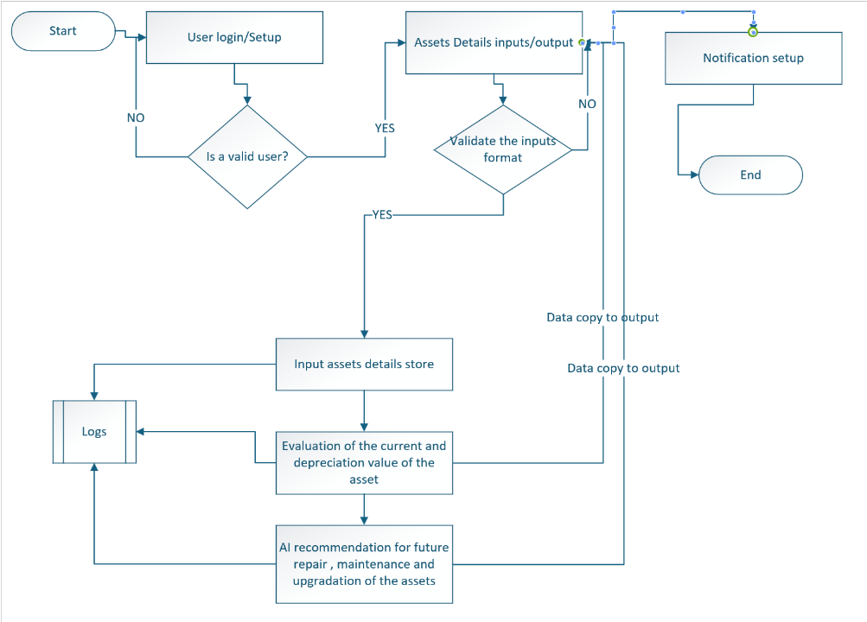

6. Proposed Solution Design with AWS Architecture
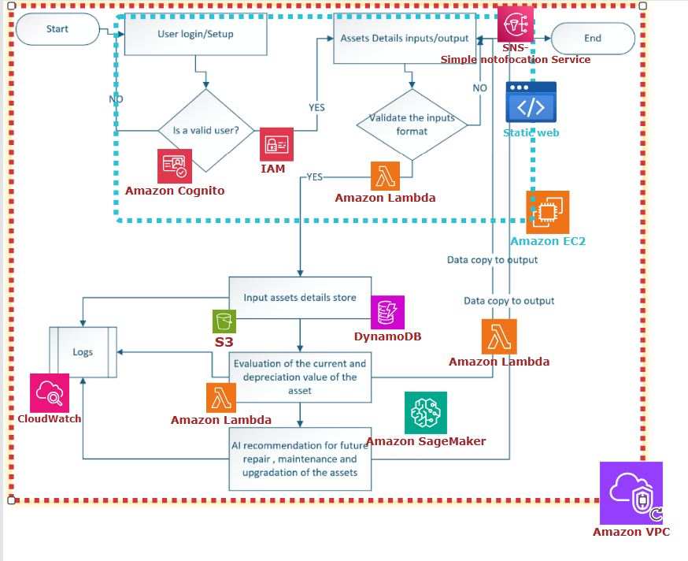

7. AWS Services
Create a service mapping.
Requirement | AWS Service | Purpose
DNS | Route 53 | Domain resolution
CDN | CloudFront | Content delivery
Security | AWS WAF | Web protection
Load balancing | ALB | Traffic distribution
Compute | EC2 | Application hosting
Scaling | Auto Scaling | Horizontal scaling
Database | RDS/Aurora | Relational database
Object storage | S3 | Files/objects
Secrets | Secrets Manager | Credential management
Monitoring | CloudWatch | Metrics/logs
Audit | CloudTrail | API auditing
IAM | IAM | Access control
Encryption | KMS | Key management

8. Network Architecture
9. Security Architecture
10. Data Architecture
11. Application Architecture
12. Integration Architecture
13. High Availability & Resilience
14. Disaster Recovery
15. Performance & Scalability
16. Monitoring & Operations
Logs
17. Backup & Restore
18. DevOps / CI-CD Architecture
19. Infrastructure as Code
20. Cost Estimate
21. AWS Well-Architected Review
Map the design against the six pillars:
- Operational Excellence
- Security
- Reliability
- Performance Efficiency
- Cost Optimization
- Sustainability
22. Risks, Assumptions & Dependencies
23. Implementation Plan
25. Testing Strategy
26. Operational Runbook
27. Appendices

