movePlayer – function

pseudocode:

swich direction

case w or up

if playery> 0, playery—

break

case s or down

if playery <worldheight-1, playery++

break

case a or left

if playerx> 0, playerx—

break

case d or right

if playerx <worldwidth-1, playerx++

break

default

break

flowchart:

Swich

(Direction)

false

true

break

if playery<worldheight-1, playery++

break

if playery> 0, playery—

Case w or up

Case s or down

break

if playerx> 0, playerx—

false

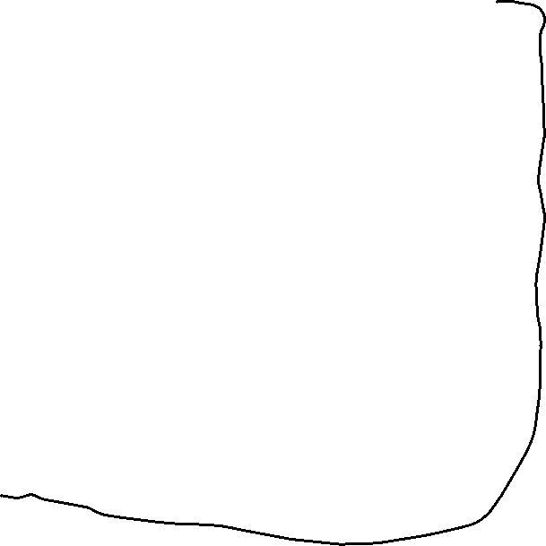

true

true

true

false

false

break

if playerx<worldwidth-1, playerx++

Case d or right

Case a or left