JavaCraft

Provisional Report: Group 43

Saturday, October 7, 2023

**Table of contents**

1 Introduction 1

2 JavaCraft’s Workflow 2

3 Functionality Exploration 4

4 Finite State Automata (FSA) Design 6

5 Git Collaboration & Version Control 8

6 Appendix 9

|  |  |  |  |  |
| --- | --- | --- | --- | --- |
| Attribute | | Details | | |
| Group Name | | Syntax Error | | |
| Group Number | | 43 | | |
| TA | | José Manuel Ros | | |
|  | Student Name | | Student ID |  |
|  | Botond Moksony | | [I6365627] |  |
|  | Vicente Muñoz | | [I6346464] |  |
|  | Zhili Yang Wu | | [I6362675] |  |
|  | Malo Coquin | | [I6302990] |  |

# Introduction

|  |  |
| --- | --- |
| Name | Tasks |
| Vicente Muñoz | * Function definitions (25%) * Flowcharts (20%) * Pseudocodes (20%) * Game flowchart (100%) * FSA illustration & design (33%) * Git student (40%) * Git trouble summary (100%) |
| Botond Moksony | * Function definitions (25%) * Flowcharts (30%) * Pseudocode (30%) * Appendix (100%) * FSA illustration & design (33%) * Git teacher (100%) * Report final revision (100%) |
| Zhili Yang Wu | * Function definitions (25%) * Flowcharts (40%) (Did startGame flowchart) * Pseudocodes (50%) * Game pseudocode (30%) * FSA description (100%) * FSA illustration & design (13%) * Git student (40%) |
| Malo Coquin | * Function definitions (25%) * Flowcharts (10%) * Game pseudocode (70%) * FSA illustration & design (20%) * SourceTree student (20%) |

# JavaCraft’s Workflow

* Flowchart For Game (also included in the appendix in higher resolution):A diagram of a flowchart

  Description automatically generatedPseudocode For Game:

create JavaCraft class

create  main function

call initGame function

call generateWorld function

print the instructions of the game with the commands

ask to the player if he want to start the game

if yes

call startgame function

else

print: game not started. Goodbye!

create initGame function

set the world size

set the initial player’s position

create inventory

create generateWorld function

create a random world

create displayWorld function

print the world map

create getBlockSymbol function

return the color of the block and call getBlockChar for the same block

create getBlockChar function

return the symbol of the block

create startGame function

call clearScreen function

call displayLegend function

call displayWorld function

call displayInventory function

print the instructions

do what the player’s action

if the player move

call movePlayer function

else if the player mine

call mineBlock function

else if the player place a block

ask witch block he want to place

call placeBlock function

else if the player craft

ask witch item he want to craft

call craftItem function

else if the player interact with the world

call interactWithWorld function

else if the player save

ask for the file name to save the game

call saveGame function

else if the player load

ask witch load he want to load

call loadGame function

else if the player exit

print: Exiting the game. Goodbye!

stop the game

else if the player look

call lookAround function

else if the player unlock

set unlockMode to true

else if the player ask getflag

call getCountryAndQuoteFromServer function

call waitForEnter function

else if the player open

if all the conditions are true

call resetWorld function

print: Secret door unlocked!

call waitForEnter function

else

print: Invalid passkey, Try again!

call waitForEnter function

set all the conditions to false

else

print: Invalid input, Please try again.

if the first condition is true

check if the others conditions are true too

if secretDoorUnlocked is true

call clearScreen function

print the context

set inSecretArea to true

call resetWorld function

set secretDoorUnlocked to false

call fillInventory function

call waitForEnter function

create fillInventory function

clear the inventory

add blockType in the inventory

create resetWorld function

call generateEmptyWorld function

set the player’s initial position

create generateEmptyWorld function

create a new world

divide in tree strip the world from the top to the bot

fill each strip with a different color, to make the dutch flag

create clearScreen function

clear the screen’

create lookAround function

print the context

print the blocks next to the player

call waitForEnter function

create movePlayer function

move the player the way he ask

create mineBlock function

if the block on the player’s location is a air block

print: No block to mine here.

if not

add the block to his inventory

replace the original block by an air block

print: “Mined ” and call getBlockName function with the blockType in parameter

call waitForEnter function

create placeBlock function

check if the inventory contain the block asked

if yes

remove the block from the inventory

place the block

print: “Placed “ and call getBlockName function and print: “ at your position.”

else

print that the player don’t have the block by using getBlockName function

if the block that the player want to place doesn’t exist

print: Invalid block number. Please enter a valid block number.

print the block’s numbers infos

call waitForEnter function

create getBlockTypeFromCraftedItem function

return the number of the block asked

create getCraftedItemFromBlockType function

return the name of the item ask

create displayCraftingRecipes function

print the crafting recipes

create craftItem function

if the player choose recipes 1

call craftWoodenPlanks function

if the player choose recipes 2

call craftStick function

if the player choose recipes 3

call craftIronIngot function

else

print: Invalid recipes number.

call waitForEnter function

create craftWoodenPlanks function

call inventoryContains function with for parameters the recipes of the item

if the inventoryContain function return true

call removeItemsFromInventory function with the recipes of the item

call addCraftedItem function with for parameter the item just crafted

print: Crafted Wooden Planks.

else

print insufficient resources to craft wooden Planks.

create craftStick function

call inventoryContains function with for parameters the recipes of the item

if the inventoryContain function return true

call removeItemsFromInventory function with the recipes of the item

call addCraftedItem function with for parameter the item just crafted

print: Crafted Stick.

else

print insufficient resources to craft Stick.

create craftIronIngot function

call inventoryContains function with for parameters the recipes of the item

if the inventoryContain function return true

call removeItemsFromInventory function with the recipes of the item

call addCraftedItem function with for parameter the item just crafted

print: Crafted Iron Ingot.

else

print insufficient resources to craft Iron Ingot.

create inventoryContains function

return

true if inventory contains items

false if inventory does not contain items

create inventoryContains function for adding count in inventory

itemCount is equal to 0

for all i within inventory

if i is equal to item

increment itemCount

if itemCount is equal to count

inventoryContains is true

create removeItemsFromInventory function

removedCount is equal to 0

iterator is equal to inventory with the iteration function called into it

while iterator has a token

i is equal to iterator with next method called into it

if i is equal to item

remove item from inventory by iterator

increments for removedCount

if removedCount is equal to count

break loop

create addCraftedItem function

if craftedItems is empty

create an array list for craftedItems

add craftedItem to craftedItem

create interactWithWorld function

switch for blockType

case wood

print where you obtained the wood

add wood block to inventory

case leaves

print where you obtained the leaves

add leaves block to inventory

case stone

print where you obtained the stone

add stone block to inventory

case iron ore

print where you obtained the iron ore

add iron ore to inventory

case air

print “Nothing to interact with here”

default

print “Unrecognized block. Cannot interact here”

call waitForEnter function to wait for user confirmation

create saveGame function

takes a string of the name of a file as a parameter from which to save the game

serializes the game state data for saving

prints where the game state was saved into

prints whether if there is an error while saving the game

calls waitForEnter function to ask for user confirmation

create loadGame function

takes a string of the name of a file as a parameter to load the game from a file

obtains the game state data from the file and loads the game

prints the origin of the file from which the game was loaded from

prints whether if there is an error when loading the game

calls waitForEnter function to ask for user confirmation

create getBlockName function

assigns to which type of block does a block belong to

prints the name for the block

create displayLegend function

prints out the legend for all the symbols that appear in the game

create displayInventory function

informs the user about the contents of the inventory

informs the user about the items that have been crafted by the user

create getBlockColor function

assigns a color for each type of block that exists in the game

create waitForEnter function

prints in the terminal “Press enter to continue..”

scan the enter input of user

create getCraftedItemName function

prints the name of the items that can be crafted into the terminal

create getCraftedItemColor function

get the color for the items that can be crafted

create getCountryAndQuoteFromServer function

try the following for errors

create a variable that is an URL: “<https://flag.ashish.nl/get_flag>

create conn variable responsible for opening the connection to URL

set the request method “POST”

set request property with key: “Content-Type”, value: “application/json

set do output to post requests

string payload

call new outputStreamWriter on conn to convert string streams to byte streams

write payload into the stream

flush payload into the output stream

close stream

create variable reader that reads text for the connection conn to URL

create a modifiable string called sb

create a string called line

while line is equal to line of text from console and it is not empty

append sb to line

string json is set equal to sb converted to String

countryStart is equal to the first occurrence of “ ” in json plus 11

countryEnd is equal to the first occurrence of “ ” starting from countryStart

country is equal to the substring of json from position countryStart to countryEnd

quoteStart is equal to the first occurrence of “ ” in json plus 9

quoteEnd is equal to the first occurrence of “ ” in json starting from quoteStart

quote is equal to the substring of json from quoteStart to quoteEnd

replace “ ” in quote with “ ”

print “ ” and country

print “ ” and quote

if there is an error

print where in the code the error occurred

Print “Error connecting to the server”

# Functionality Exploration

List of key functionalities explored:

|  |  |  |
| --- | --- | --- |
| No. | Function Name | Description |
| 1 | main | Print out the game’s description and initiate the game after user confirmation |
| 2 | initGame | create the world width, set the initial position of the player & create the inventory |
| 3 | generateWorld | generate blocks for all the coordinates on the map based on random values |
| 4 | displayWorld | display map on terminal |
| 5 | getBlockSymbol | function for getting block colors and symbols (some blocks are represented by symbols, e.g.: $) |
| 6 | getBlockChar | function for getting the characters for the blocks |
| 7 | startGame | ask for the action, & call a function for the specific action we choose. It also can open the secret door but only with some conditions. |
| 8 | fillInventory | fills up the inventory with all the existing blocktypes |
|  | resetWorld | calls for the dutch flag function (generateEmptyWord) and moves the player to the middle of the screen |
| 9 | generateEmptyWorld | Generates the Dutch flag |
| 10 | clearScreen | clear the screen according to the os type |
| 11 | lookAround | prints out the blocks around the player |
| 12 | movePlayer | Changes player coordinates according to the input |
| 13 | mineBlock | It allows the player to mine the blocks to get materials if the specified coordinate is not air |
| 14 | placeBlock | It allows the player to put a material in a specific coordinate |
| 15 | getBlockTypeFromCraftedItem | Return the blockType from the itemID |
| 16 | getCraftedItemFromBlockType | Return the itemID from the blockType |
| 17 | displayCraftingRecipes | Prints out the crafting recipes. |
| 18 | craftItem | It allows the player to use their materials to create an item. |
| 19 | craftWoodenPlanks | It allows the player to use the wood they collected in the game and turn it into wooden planks |
| 20 | craftStick | It allows the player to use the wood they collected in the game and turn it into a stick |
| 21 | craftIronIngot | It allows the player to use the iron ore they collected in the game and turn it into iron ingots |
| 22 | inventoryContains | Checks whether the inventory contains a specific item. |
| 23 | inventoryContains | Checks whether the inventory contains a certain amount of items |
| 24 | removeItemsFromInventory | Remove a specified number of items from the inventory |
| 25 | addCraftedItem | Add itemID to the craftedItems list |
| 26 | interactWithWorld | Add block to inventory according to the place where the player stands |
| 27 | saveGame | Save the game variables, objects to an external file |
| 28 | loadGame | Load variables and objects from a previously saved game file |
| 29 | getBlockName | Returns the name of the block from blockType |
| 30 | displayLegend | print the legend with the symbols and names of the blocks |
| 31 | displayInventory | print the player’s inventory with the number of blocks that the player has |
| 32 | getBlockColor | return the color of each block |
| 33 | waitForEnter | It tells the player to “press enter to continue” whenever they need to, and waits for input. |
| 34 | getCraftedItemName | return the name of the item from craftedItem |
| 35 | getCraftedItemColor | return the color off block, but only for the iron ingot (brown). |
| 36 | getCountryAndQuoteFromServer | Communicates with an external server in order to get a flag of a country and a quote besides it. |

# Finite State Automata (FSA) Design

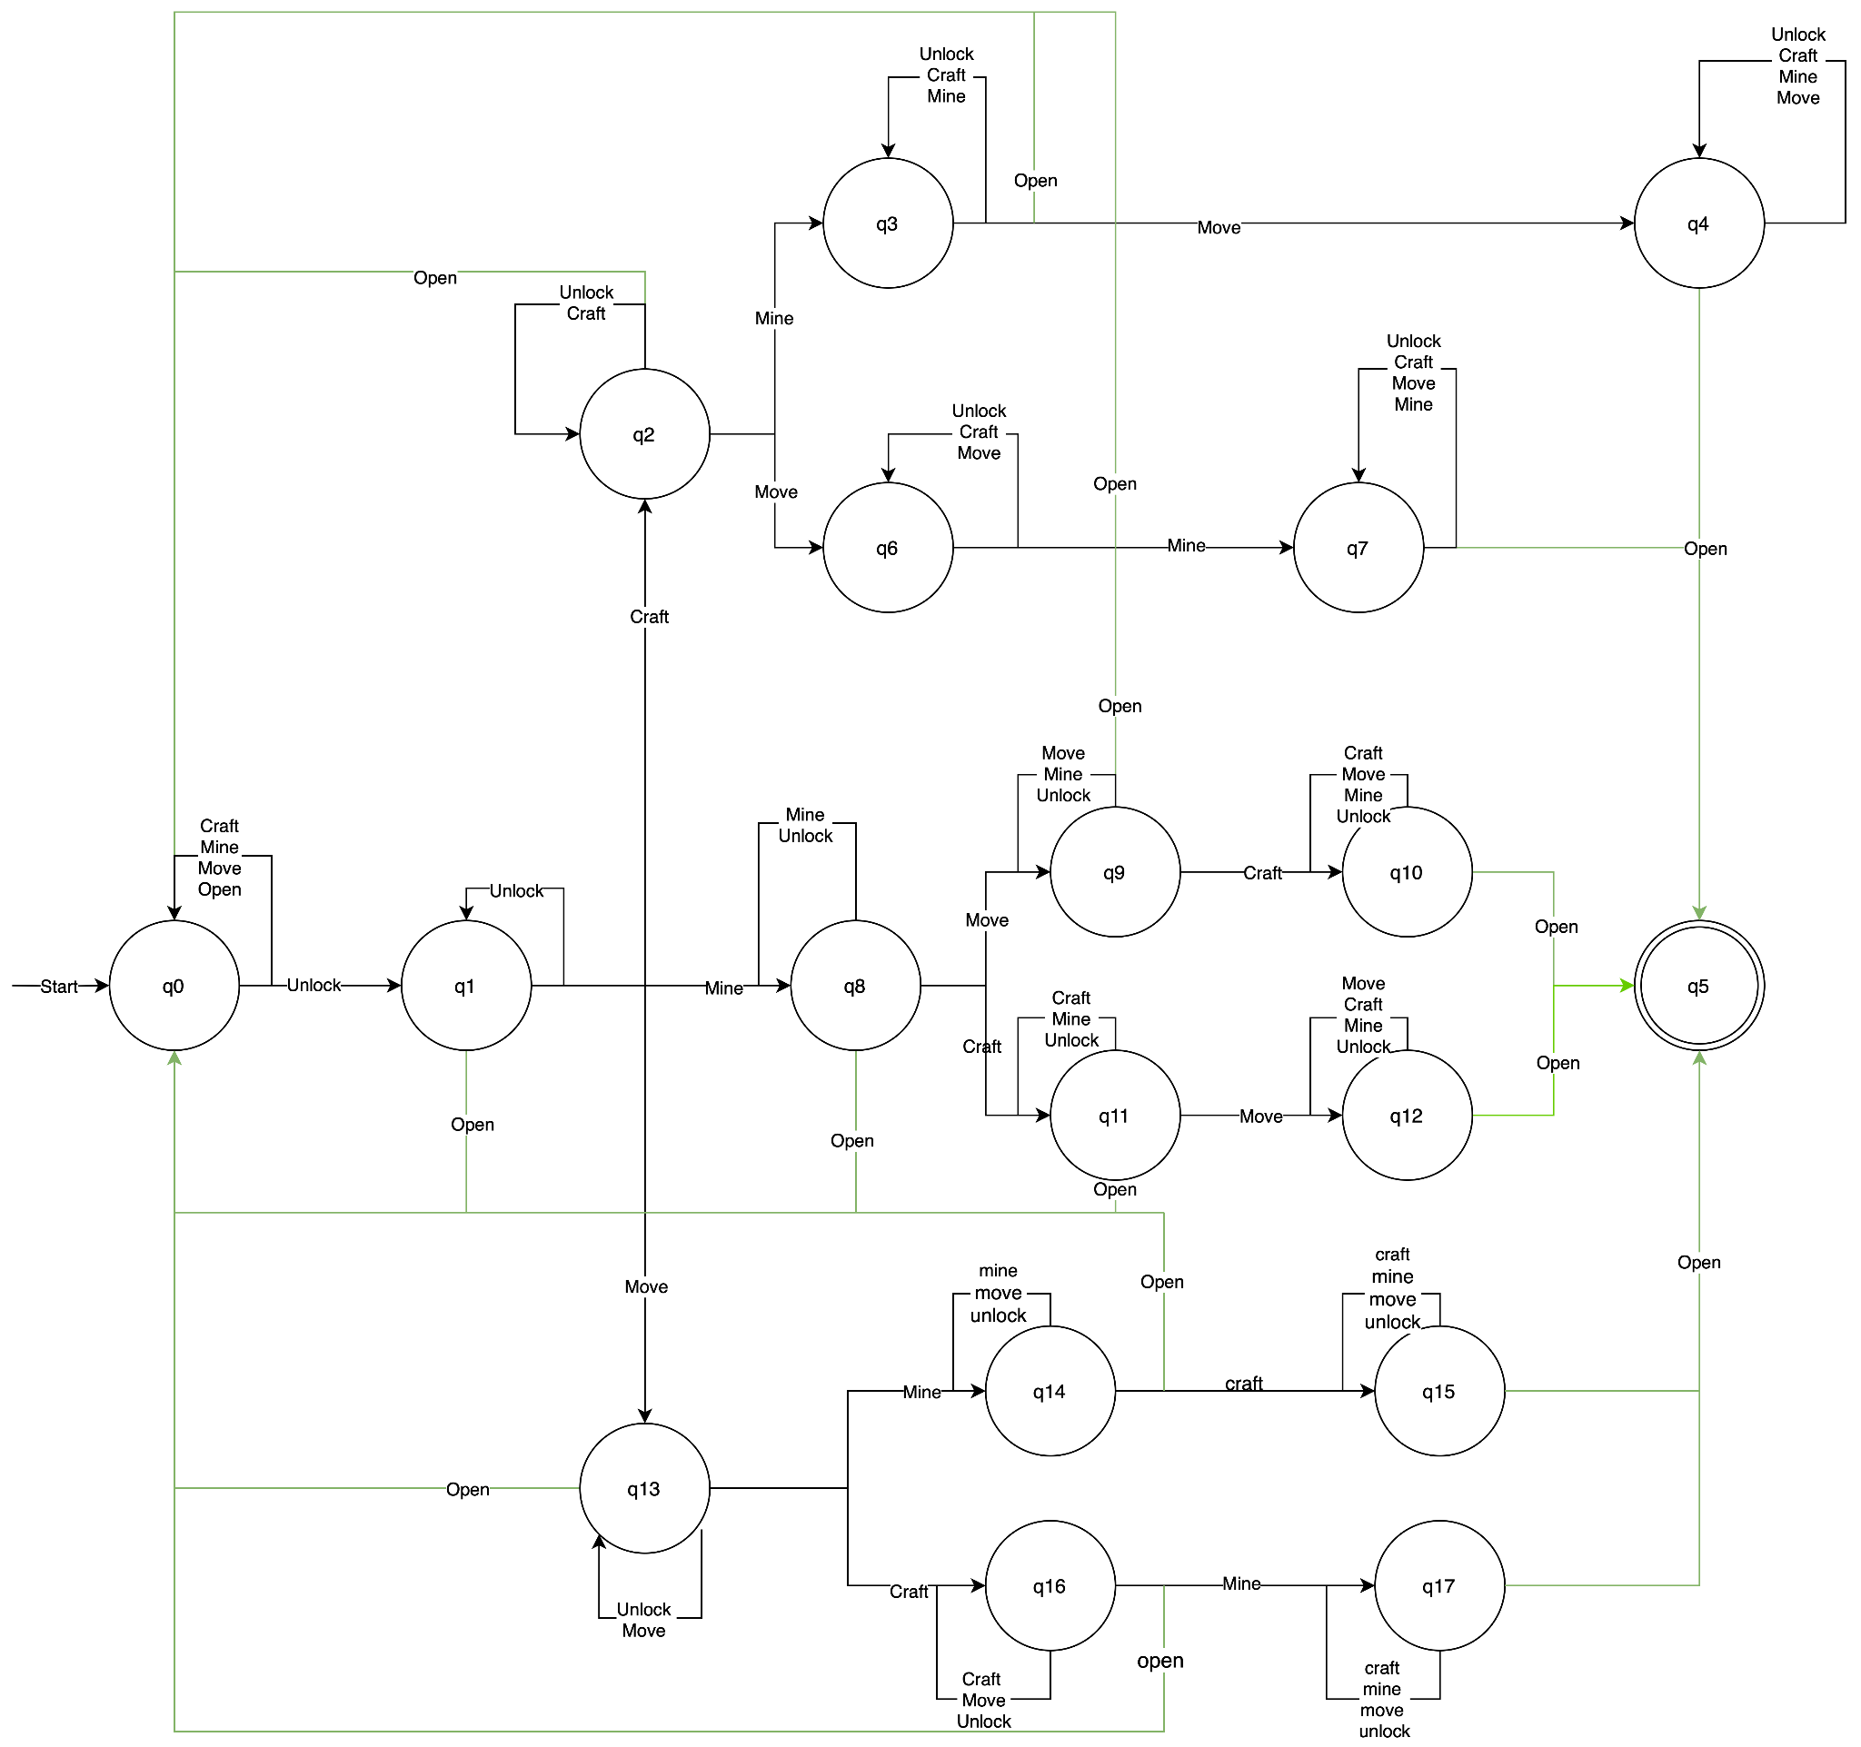

The secret door is a hidden option within the game that is activated when entering the following commands into the terminal:

* Unlock
* Mine (user has to input “m” in either upper or lower case in order to mine)
* Move (user has to either character from WASD in upper or lower case for moving)
* Craft (user has to select any crafting option in this command)
* Open

For opening the secret door function, the user needs to input these commands in specific orders, where each command is entered one and without any repetition in the following inputs. The main conditions needed to enter the sequence are the following:

* The Unlock command always needs to be the first command to be inputted (although you can input this command in intermediate steps as we will mention later).
* Open command has to be strictly the last command to be inputted.
* In between the first input (unlock) and the last output (open), the remaining commands and/or unlock are to be inputted in any order.

With the input of these commands, we can describe the sequencing of the input of these commands as a change of states within the game, where we can identify an initial state and a final/accepting state and determine a finite state automaton (FSA). Here, the FSA's alphabet is the set of all the commands accepted by the game as valid inputs (as described in the outputs of the game) and the language accepted by this is the set of commands mentioned earlier. By applying the conditions for the sequence of inputs for unlocking the door, we can get the following representation of the language:

𝚺 = { L $∈$ {valid inputs within the game}* | L contains ‘unlock’ as first string, has the following commands {‘unlock’, ‘mine’, ‘move’, ‘craft’} in any order and has ‘open’ as last string}

With this language, we will proceed to describe the steps required for reaching the secret door. First step, when the game locates us into the game right after entering the correct inputs for starting the game, we begin at the initial state q0, from which we move to q1 after entering the ‘unlock’ command. If we enter ‘unlock’ for a second time right after entering it from q0, we will not move from q1 as no new changes or alterations to the game are noticed, meaning we have a loop for ‘unlock’ in this state. From q1 and onwards, we will have loops in the states for all repeating commands that we input, meaning that we can only advance in the FSA by inputting the commands exactly once, as long as the condition that ‘unlock’ is the first command entered and ‘open’ is the last entered. For all cases, if the input ‘open’ is entered in intermediate states, the FSA returns the user to q0 losing all progress (as represented with the green line in the FSA diagram).

Upon opening the secret door the game plots a Dutch flag into the terminal and the player’s inventory gets filled up with all of the block types.

# Git Collaboration & Version Control

* Repository Link: [**https://gitlab.maastrichtuniversity.nl/bcs1110/javacraft/-/tree/group_43**](https://gitlab.maastrichtuniversity.nl/bcs1110/javacraft/-/tree/group_43)
* Branch Details: **group_43**

Changes & Conflicts & Problems:

* We had problems at the start understanding how to use git and how to commit/push/pull, but thankfully we had Botond there to help us understand all of this.
* We also had problems at one point when trying to push and pull, in which error messages kept appearing. We solved this by merging the previous branches, then pulling, and finally pushing.
* We had problems when setting up SourceTree, where we needed to create an access token and ssh keys in gitlab. We had many errors so we had to do the process all over again carefully and we made it work.
* Some conflicting branches were very problematic, so we had to copy paste parts of one to the other before effectively pushing them.

# Appendix