Emanuele Costantino

ASEN 5519 Algorithmic Motion Planning

September 9, 2021

Homework 2 Solutions

Exercise 1

Handwritten and attached below.

Exercise 2

1. Plot the paths generated by Bug 1 and Bug 2 algorithm.

Below in Figure 1 and Figure 2, the red circle is the start, and the green is the goal. I used blue circles to indicate points on the path. The turquoise rectangles represent the obstacles.

**Figure 1:**  Left turning Bug 1 and Bug 2 algorithms in Workspace 1

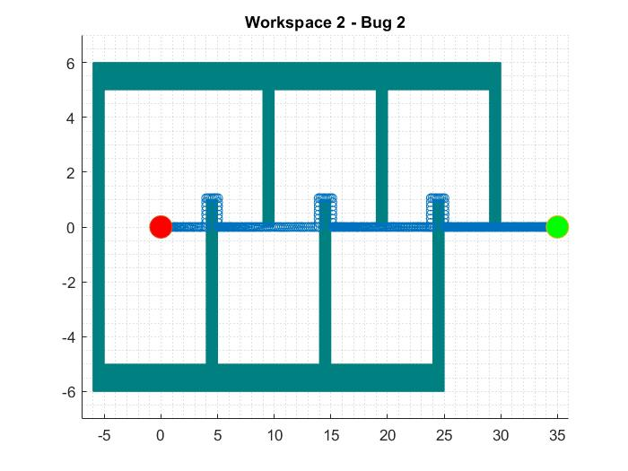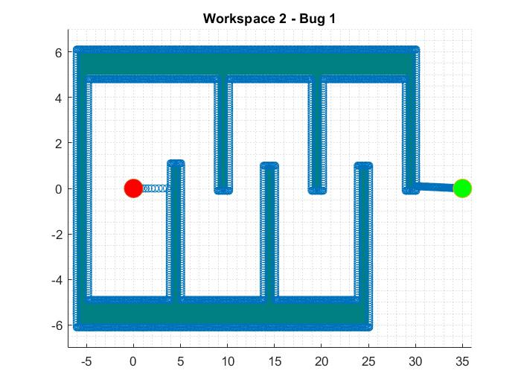

**Figure 2:**  Left turning Bug 1 and Bug 2 algorithms in Workspace 2

1. What are the lengths of the paths generated by Bug 1 and Bug 2 algorithms?

|  |  |  |
| --- | --- | --- |
| Workspace | Bug | Travel Distance |
| 1 | 1 | 133.168 |
| 1 | 2 | 52.805 |
| 2 | 1 | 368.633 |
| 2 | 2 | 41.624 |

1. Would you expect the same path lengths if the robot were right turning?

Sometime this may be the case for a given workspace but not always. Consider the case below in Figure 3. Using Bug 2 we see that the right turning robot (in red) takes a much shorter path than the left turning robot (in yellow).

m-line

**Figure 3**: Left vs Right turning Bug 2 algorithm