Emanuele Costantino

Homework #8

10/21/2021

**Exercise 1**

1. C-space of Centralized RRT
2. The C-space of an individual disk robot is $R^{2}$

ii. The C-space of the meta-agent is $R^{2}$ $×$ $R^{2}$ $×$ $R^{2}$ $×$ $R^{2}$ $×$ $R^{2}$ $×$ $R^{2}$ for 6 robots, which in reduced form is just $R^{12}$.

iii. The dimension of the C-space increases linearly for every new robot added

1. Chart, scatter chart

   Description automatically generated

1. 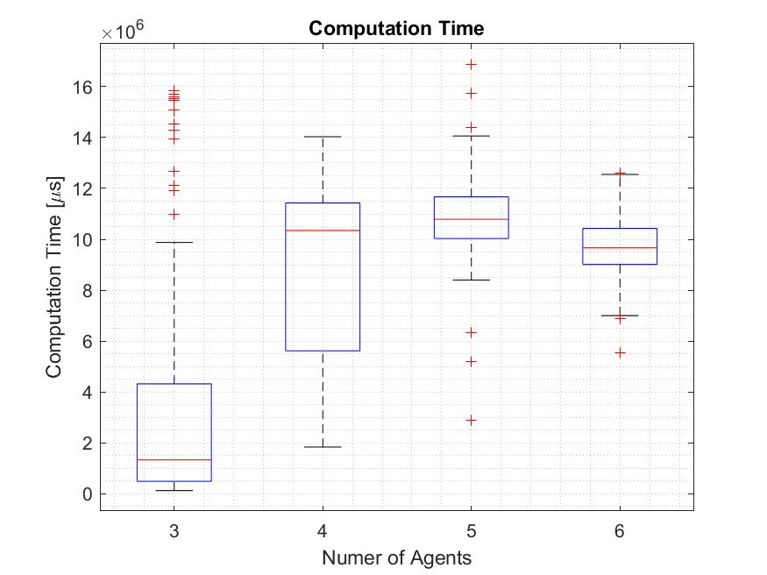

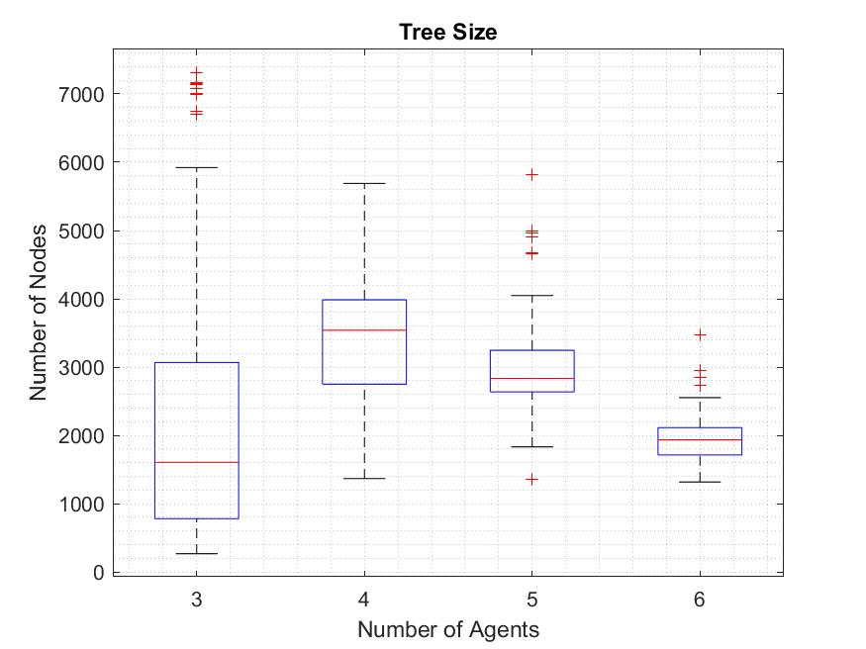

1. Chart, scatter chart

   Description automatically generated

I found that the computation time and size of the meta-agent increase as the number of robots increases but past m = 4, this behavior does not hold. This is because as the number of agents increases, there is “less space” for the robots to move which results in the sampling method to fail more often. I found that after m =4, the algorithm fails to find solutions more than 10% of the time. In addition, because there are less nodes in the trees formed with m>4 configurations, the algorithm can quickly search the tree to find the nearest node. For this reason, we see a decrease in computation time and tree size as the number of agents increases.

**Exercise 2**

1. The C-space in the decentralized planner is $R^{2}$
2. The dimension of the C-space is constant
3. This is different than the centralized planner because the C-space does not grow when we add robots. The C-space obstacles are temporal in the decentralized case where the trace of the previously planned robots in a given time step act as obstacles to the current robot being planned for.

I associated discrete time to every node in the path for the robot equal to the time of the nodes parent plus one. To ensure that collisions do not occur at or between time steps n and n+1, when a random node is generated, I check to see if there are collisions between the current time step to the new time step for the current robot and all previous computed robot paths in discrete locations j between nodes. Illustration below:

t = n +1

j+3

j+2

j+1

j

j

j+1

j+2

j+3

t = n

t = n +1

t = n

As the number of agents increases we see an increase in computation time. This is because we must grow 6 individual trees in an environment with small temporal obstacles. This allows the planner to successfully add nodes to each tree and find paths for each robot. The trade of is that as more robots are added it takes longer to find a path to goal for subsequent robots as the temporal obstacles increases and take up more space at a given time step.