Here are some nice formulas for– there are lots more:

Ifthen

Ifthen

Ifthen

Example 1
and compound interest
I investfor one year. How much is my investment worth if ...
a) the interest rate is 100% per year
answer
b) the interest rate is 50% peryear
answer
c) the interest rate is 10% peryear
answer
d) the interest rate is 5% peryear
answer
e) the interest rate isperyear
answer
Note:
asso

Example 2
and arranging ornaments
I have 3 ornaments. In how many ways can I arrange some (or none) ornaments in a line on my mantelpiece? see chapter: Arrangements and Selections
There arearrangements with no ornaments.
There arearrangements with one ornament.
There are arrangements with two ornaments.
There arearrangements with three ornaments.
The total number of arrangements is:

In general:
If I haveornaments then the number of arrangements is:

Ifis large then the number of arrangements is about

Example 3
Theorem

Proof:

Example 4
Theorem
is irrational
Note:

So:

Proof (by contradiction)
Assumeis rational, say
Now:

So:

So:

The LHS is an integer and the first bracket on the RHS is an integer but the second bracket isn’t – see above.
Contradiction.
If we assume:
whereandare any positive integers, then we can repeat the above argument and again get a contradiction. Somust be irrational.

It has been proved thatandare irrational
We do not know about

Example 5 if you know about differentiation ...
Investigation
Can you think of another pair of positive integers with this property?
Hint:
If:

show that:

so:

Here is the graph:

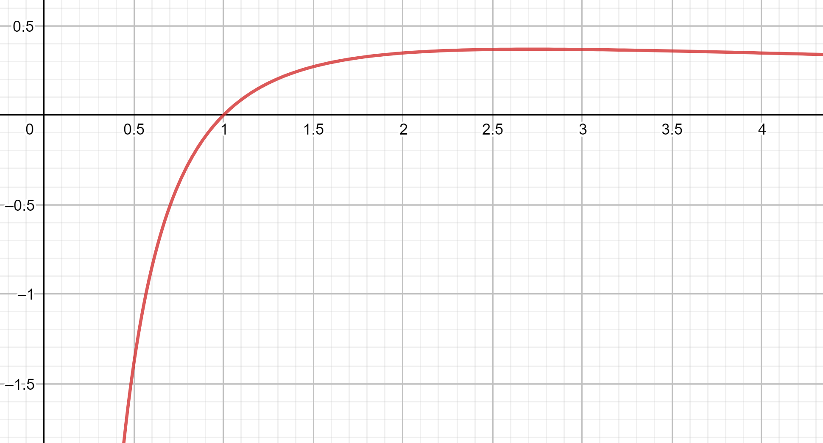

We want two differentvalues, call themandwith the samevalue.
So we want to be able to draw a horizontal line that cuts the graph twice.
Use differentiation to show that the maximum point on the graph occurs at
Hence show thatis the only solution ofifandare positive integers.
Also
The maximum on the graph occurs at
So:
for anyvalue, in particular
Show:

Show:

