Pi
Here are some nice formulas for– there are lots more.

where the numerators are the primes (not including2) and each denominator is the multiple of 4 nearest to the corresponding numerator.

whereis preceded by asign if and only ifhas an odd number of prime factors of the form

We can estimateusing random numbers

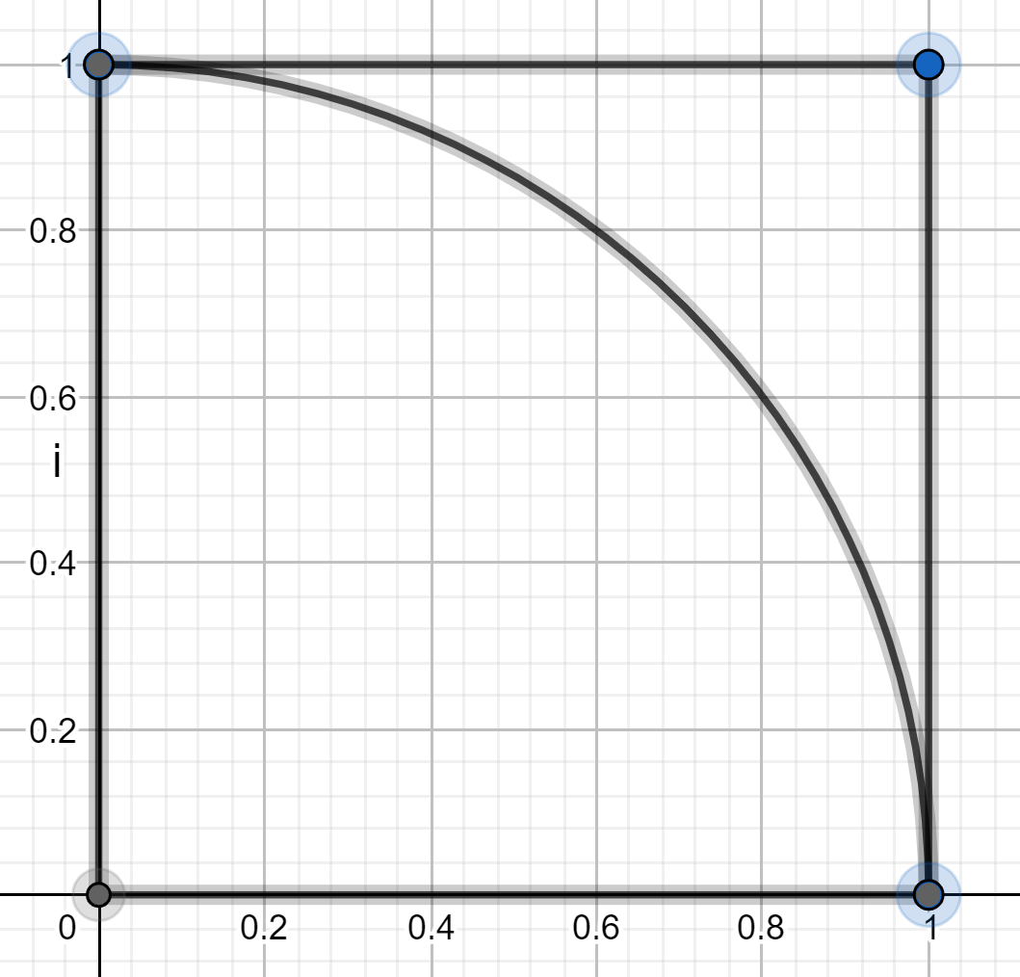

Get two random numbersandwhereand
We can think ofas the co-ordinates of a point inside the unit square. This point will be inside the quarter circle ifNow get lots of points.
The number of points inside the quarter circle divided by the total number of points will be approximately equal to the area of the quarter circle divided by the area of the unit square.
Show that this is
So if we pick 1000 points and 763 of these points are inside the quarter circle then:
giving
To get a better approximation we need to take more points. See Appendix 1 for a computer program to estimate

Viete’s formula for if you know about trigonometry … (all angles in radians)
a) We know:
the double angle formula
Show that:
the half angle formula
We know:

Use the half angle formula to show that:

Use the half angle formula to show that:

etc
b) We know:
the double angle formula
If we repeatedly use the double angle formula we get:
etc
So:

So:

So:

We know:
ifthen
So:
ifthen
So:

Put:

and show that:

c) Use part (a) and part (b) to obtain Viete’s formula:

