/projects/project-name/tools—compilers, linkers, assemblers used by this
project. All tools will be checked into the VCS (version control system) so in 5 to 10
years, when a change is required, the (now obsolete and unobtainable) tools will still be
around. It ’ s impossible to recompile and retest the project code every time a new version

of the compiler or assembler comes out; the only alternative is to preserve old versions,
forever, in the VCS.

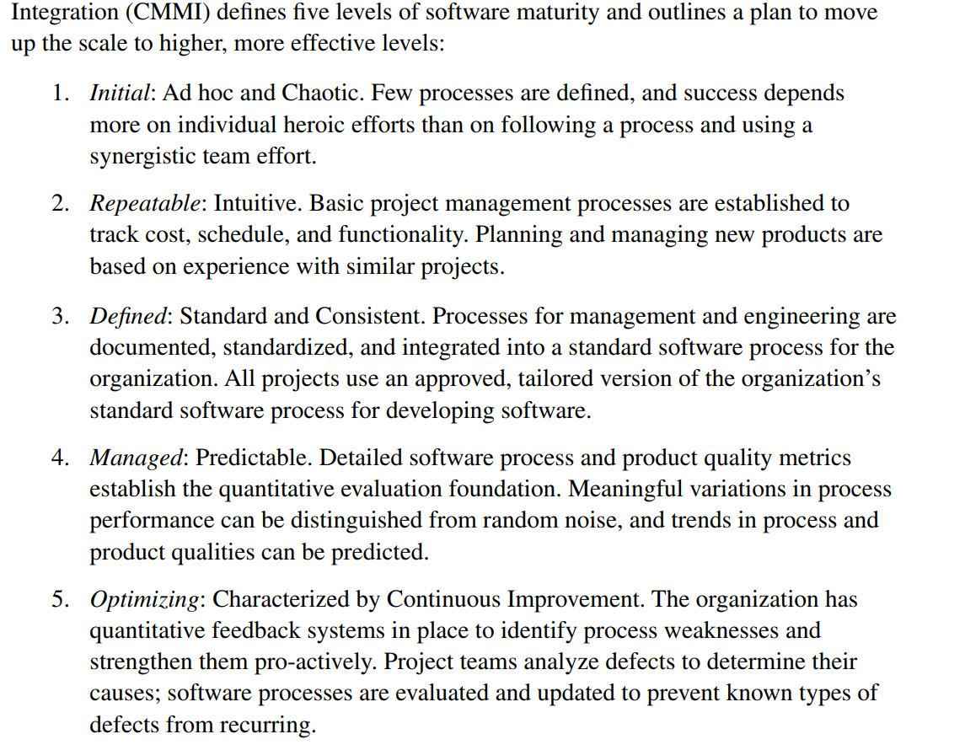

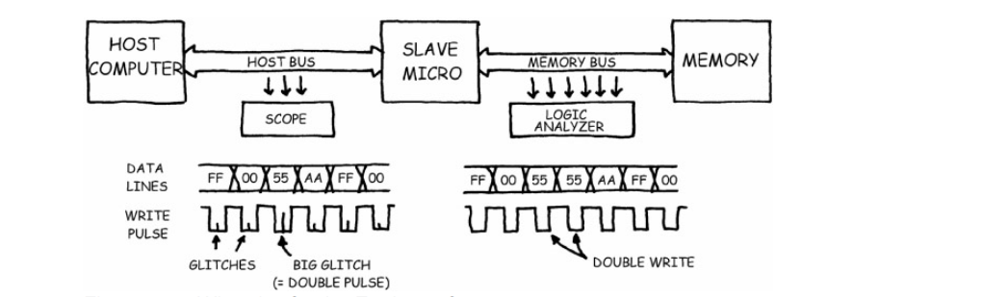
Bom