**CONCEPTION ET PROGRAMMATION DE SITES WEB**

**TP 2 : Architecture MVC**

**e2395411 | Erika Ampudia-Vales**

Mon projet est une plateforme ou les membres peuvent échanger des plans avec d’autres membres. Pour le faire plus simple, ma structure pour cette phase ci est plutôt similaire à un échange transactionnel.

Voici l’EERD :

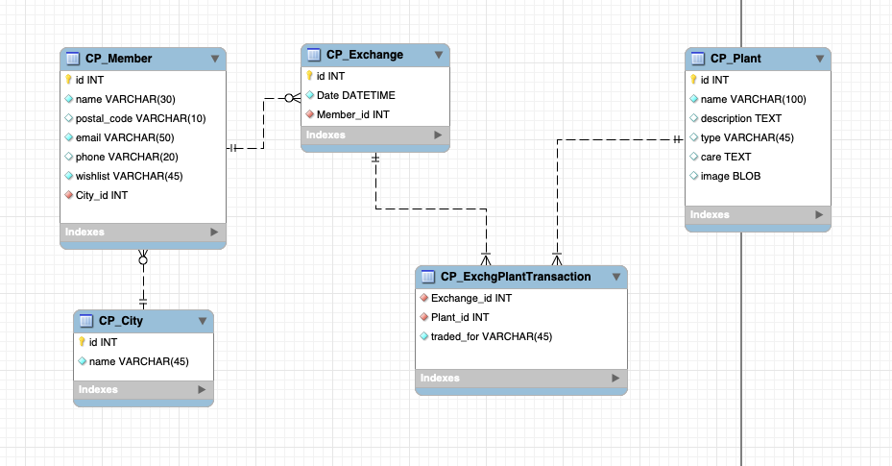

Les commandes SQL pour créer la db sont dans un fichier workbench dans ce dossier. Je les ai modifié aussi au moment de les exécuter sur WebDev car le nom de la DB a du changer.

Les données pour créer des membres :

Name : Maria Denis

City : Montréal

Postal Code : H1YH1Y

Email: mariadb@gmail.com

Phone : 514 555 6677

Wishlist : Monstera thai constellation, ficus lyrate

Name : Carlos Jones

City : Québec

Postal Code : H3PH3P

Email: carjo27@gmail.com

Phone : 789 777 8899

Wishlist : Pilea, snake plant

Name : Karine Gagnon

City : Sherbrooke

Postal Code : T6JT6J

Email: kGagnon@gmail.com

Phone : 438 666 7788

Wishlist : Strelizia, lemon tree

Name : Jerôme Lemaistre

City : Gaspé

Postal Code : K9LK9L

Email: jerrypants@gmail.com

Phone : 544 888 9900

Wishlist: Christmas cactus, jade plant

Les données pour créer des fiches-plante :

Name : Fiddle-leaf fig (ficus lyrata)

Type : fig family Moraceae

Description : Ficus lyrata, commonly known as the fiddle-leaf fig, is a species of flowering plant in the mulberry and fig family Moraceae. It is native to western Africa, from Cameroon west to Sierra Leone, where it grows in lowland tropical rainforest. It can grow up to 12–15 m (39–49 ft) tall.

Care : Light - Needs Bright, Filtered Light. Will rapidly deteriorate in dim lighting.

Watering - Keep soil evenly moist at all times. (about 2-3x per week) Do not overwater or leave plant sitting in water.

Fertilizer - Feed bi-weekly with a weak green plant liquid solution during the growing season

Repotting -Change dirt and transplant to a a larger pot annually. This plant naturally wants to become large, and therefore needs both spacial height and room for roots to extend.

Name : Common wood sorrel (oxalis acetosella)

Type : Family Oxalidaceae

Description : Oxalis acetosella, the wood sorrel or common wood sorrel, is a rhizomatous flowering plant in the family Oxalidaceae, common in most of Europe and parts of Asia. The specific epithet acetosella refers to its sour taste. The common name wood sorrel is often used for other plants in the genus Oxalis. In much of its range it is the only member of its genus and hence simply known as "the" wood sorrel.

Care : Sunlight

Thrives in bright indirect to bright direct light. Not suited for low light conditions.

Water

Water every 1-2 weeks, allowing soil to dry out halfway down between waterings. Expect to water more often in brighter light and less often in lower light.

Humidity

Any humidity level will do. Normal room humidity is fine.

Temperature

65°F-85°F (18°C-30°C). It’s best not to let it go below 60°F (15°C).

Name : Cosmos (Cosmos bipinnatus)

Type : Family Asteraceae

Description : Cosmos are annual flowers with colorful, daisy-like flowers that sit atop long, slender stems. Blooming from the summer through fall, they attract birds, bees, and butterflies to your garden. They’re grown easily from seeds and will even survive in poor soil conditions! Here’s how to grow cosmos.

Care : Water regularly until plants are established or if it is unusually dry. Make sure you don’t over-water cosmos; over-watering and over-fertilization can lead to plants with fewer flowers. Cosmos can tolerate dry soil, even in a hot, arid, sunbaked spot.

Cosmos beds may become weedy due to the fact that they self-seed, so remember to remove flowers before they go to seed or to thin seedlings in the spring.