

Technical Documentation

**Document ID : 5455**

**5451**

**Document Version : 1.0**

**Author : Parthasarathy H M**

**Naveen**

**Task1:**

**Creating Module :**

In this project we have created a module named “Newmodule” with a “Custform” namespace.

The path of the Module is:

**app/code/** Custform **/** Newmodule

**Steps followed while creating Module:**

* Created registration.php for registering the module.

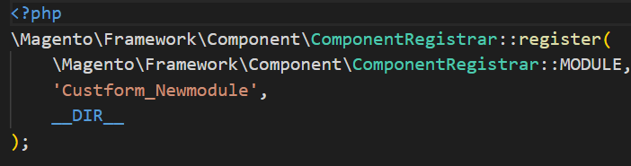

* Created module.xml inside etc folder.

**etc/module.xml**

Then created routes.xml to create the route in the module.

**app/code/Custform/Newmodule/etc/adminhtml/routes.xml.**

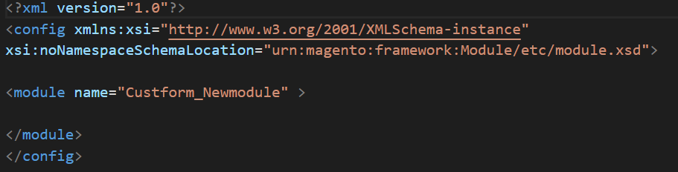

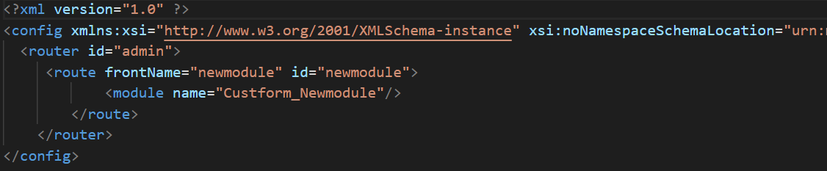

**UI Component :**

In this project we a created a UI component

Steps for creating UI component grid:

➢ First we created registration.php, composer.json and etc/module.xml for creating module UiComponent.

➢Then created Embitel/UiComponent/etc/acl.xml and Custform/Newmodule/etc/adminhtml/menu.xml for displaying menu in the admin panel.

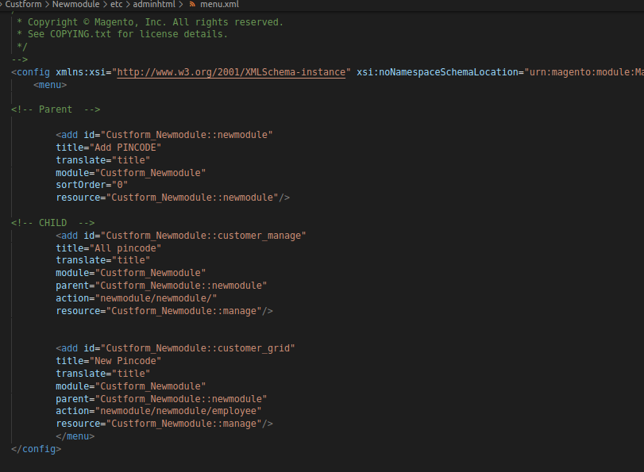

➢ Then created employee table in Custform/Newmodule/etc/db_schema.xml

➢ After that created Model, ResourceModel and Collection for the database connectivity.

➢ Later we created routes and controller in Custform/Newmodule/etc/adminhtml/routes.xml and Custform/Newmodule/Controller/Adminhtml/Newmodule/Index.php

➢ Then we created a layout xml file in Custform/Newmodule/view/adminhtml/layout/newmodule_newmodule_index.xml

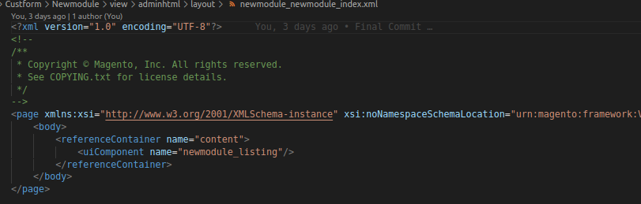

➢ Now we have to create a data source for fetching data from database and display in the front-end. For this we need to create a di.xml file in Custform/Newmodule/etc/di.xml.

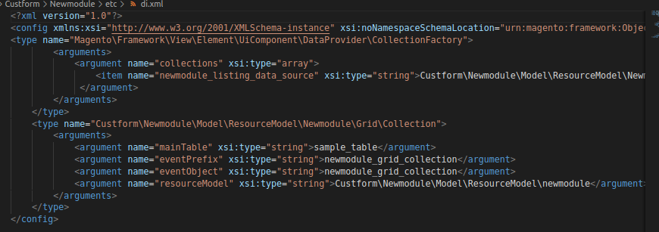

➢ The router and controller calls the UI component xml file in Custform/Newmodule/view/adminhtml/ui_component/newmodule_form.xml

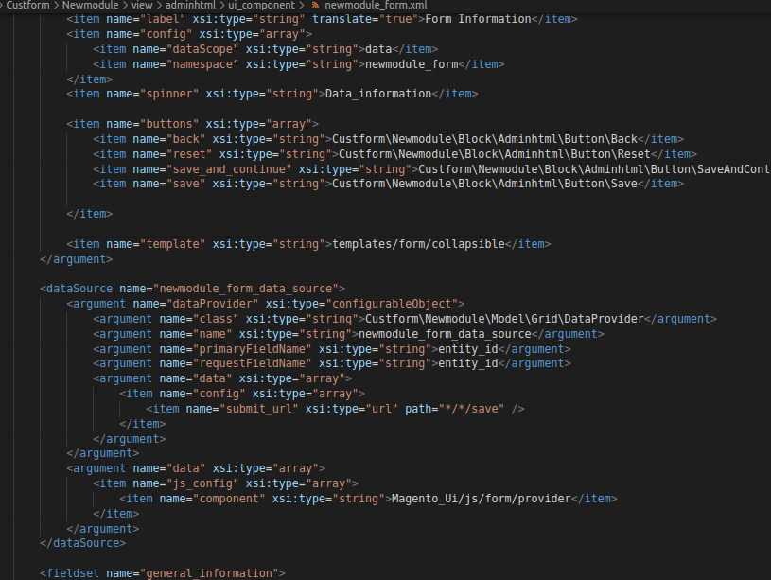

Custform/Newmodule/view/adminhtml/ui_component/newmodule_listing.xml

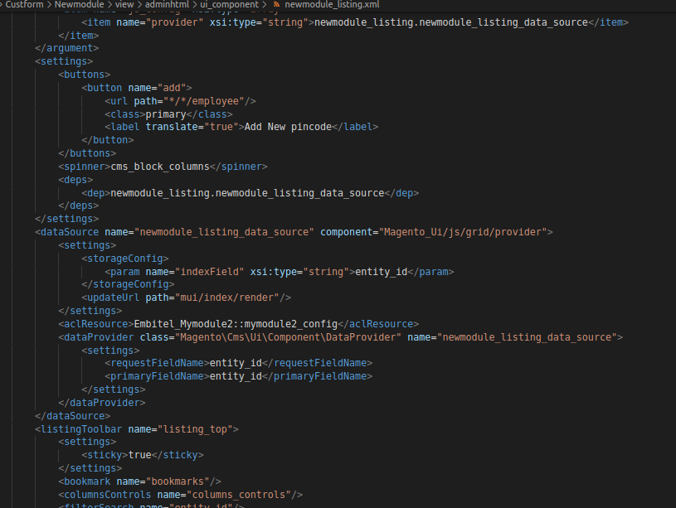

➢ And we provide some action buttons like back, reset and save in the Custform/Newmodule/Block/Adminhtml/Button/Generic.php Custform/Newmodule/Block/Adminhtml/Button/Back.php Custform/Newmodule/Block/Adminhtml/Button/Save.php Custform/Newmodule/Block/Adminhtml/Button/Reset.php

Custform/Newmodule/Block/Adminhtml/Button/SaveAndContinueButton.php

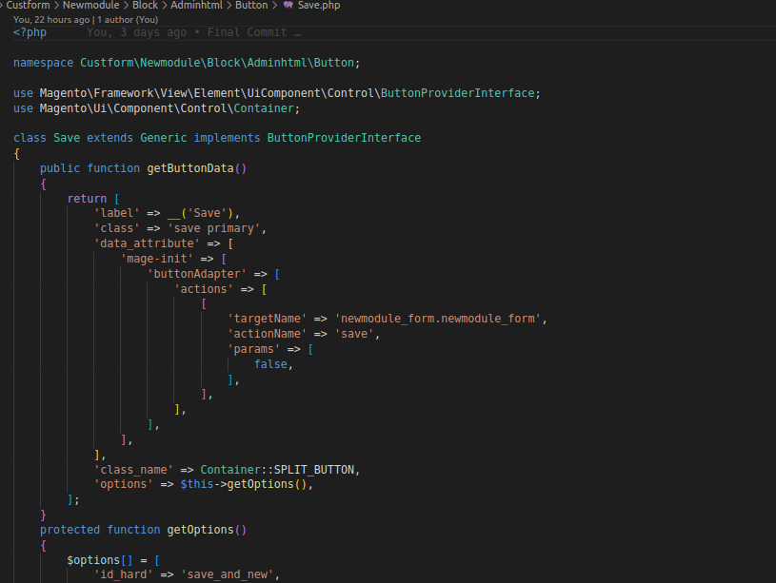

**Creating Admintheme:**

* Create Theme Directory

In the app/design/adminhtml directory, added the new directory: **Embitel/Admintheme**

* Create theme.xml file

The path is-

**app/design/adminhtml /Embitel/Admintheme/theme.xml**

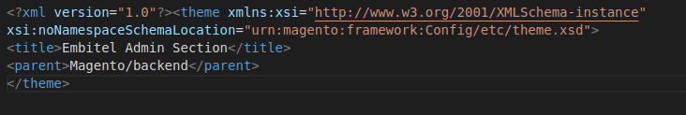

* Then created the registration.php file

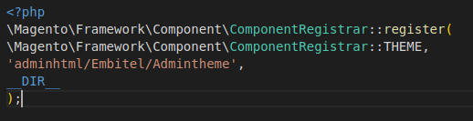

### Create web folder to save media file

**app/design/adminhtml/Embitel/Admintheme/web/Images/logo.png**



* Create Module to Declare Theme
* Then, added the folder “etc/” and created module.xml file and di.xml file.

The path is-

**app/code/Embitel/Admintheme/etc/module.xml**

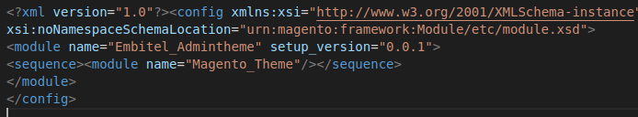

**app/code/Embitel/Admintheme/etc/di.xml**

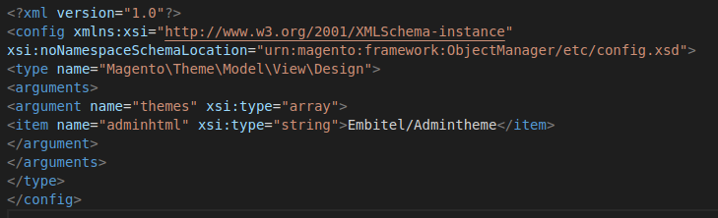

* Then created “view/” folder to push all media files and layout

The path is-

**app/code/Embitel/Admintheme/view/adminhtml/layout/admin_login.xml**

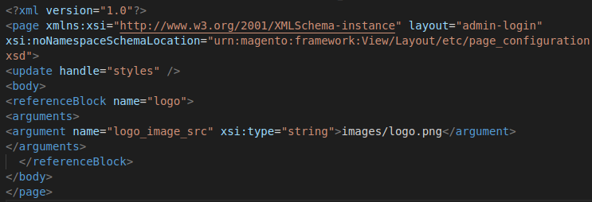

* Then we created default.xml file.
* The path is-

**app/code/Embitel/Admintheme/view/adminhtml/layout/default.xml**

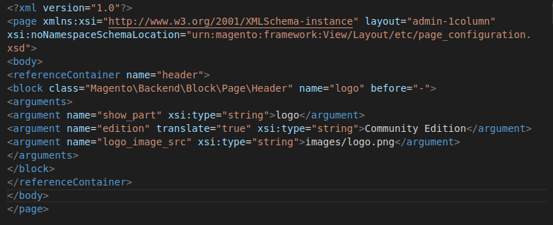

* **pin code verifcation for estimated delivry date in PDP**

overriding the form.phtml in theme.

Path:- design\frontend\Embitel\theme\Magento_catalog\template\product\view\

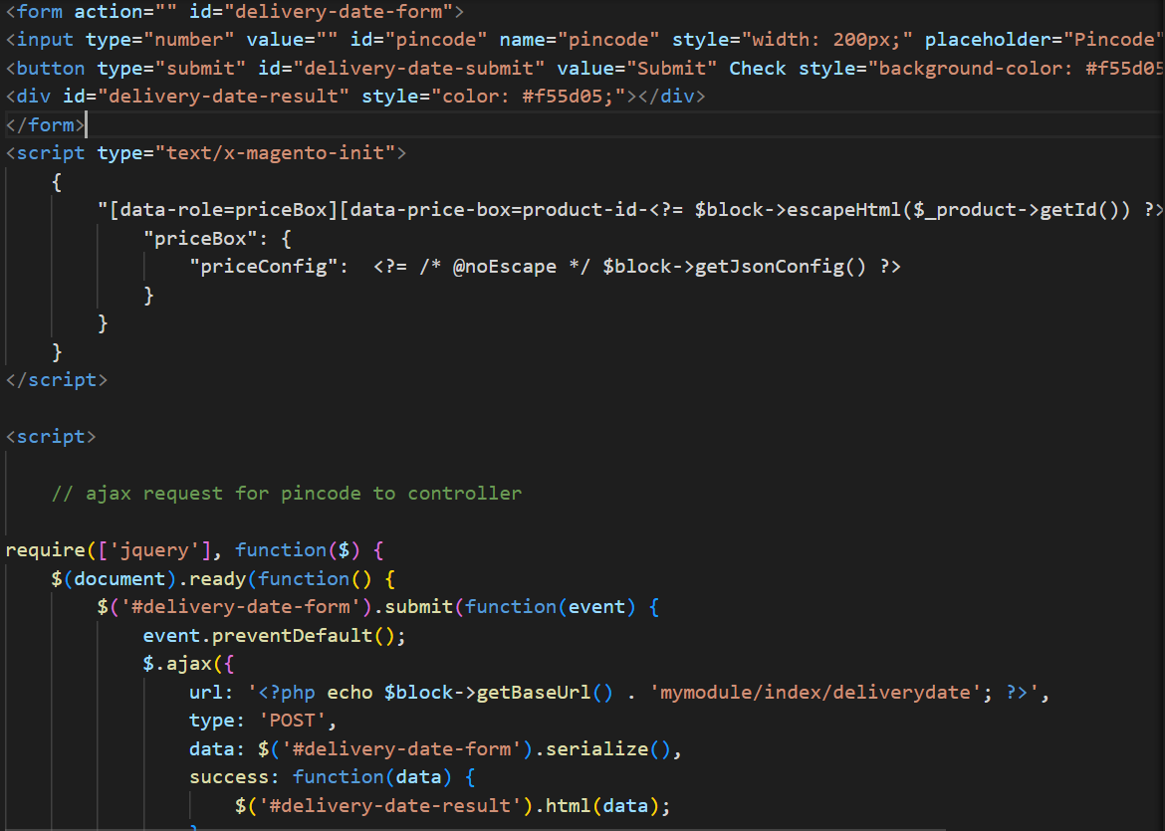

**Creation of controller:**

Path:- app\Custom\Mymodule\Controller\Index\DeliveryDate.php

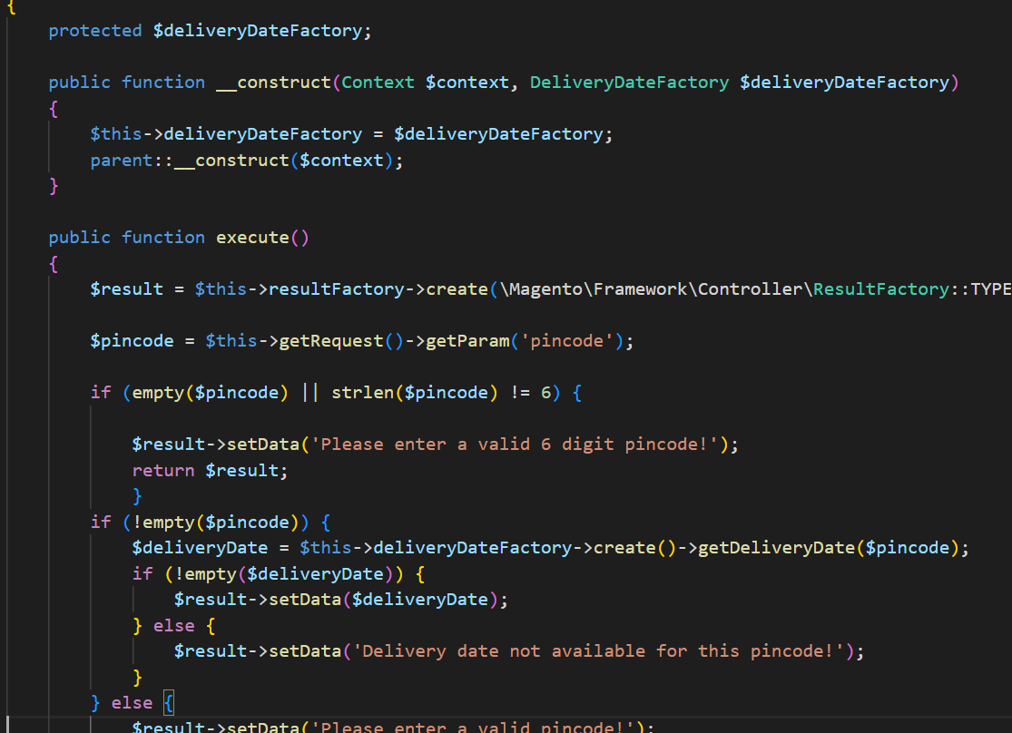

**Creation of Model and ResourceModel**

Creation of Deliverydate.php inside Model and ResourceModel

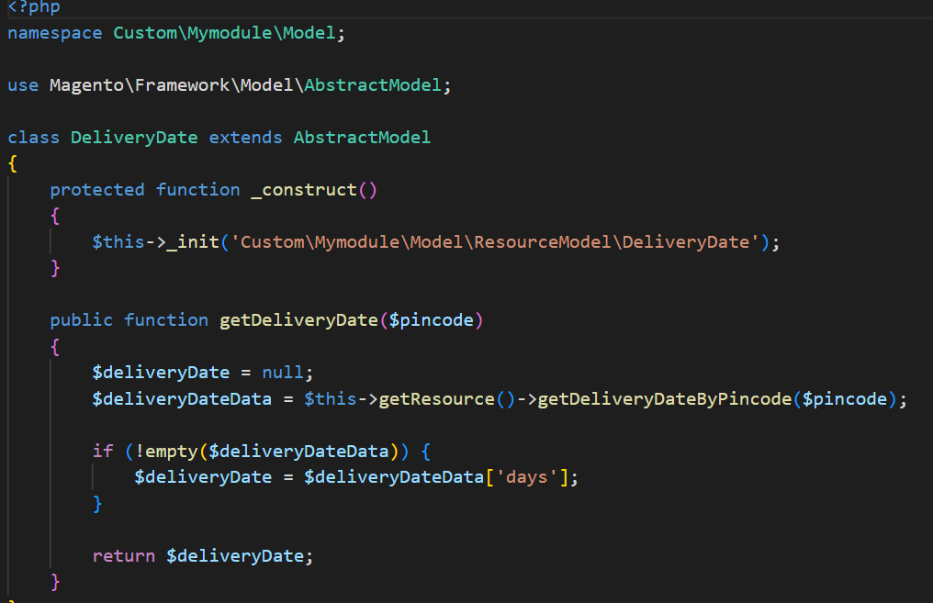

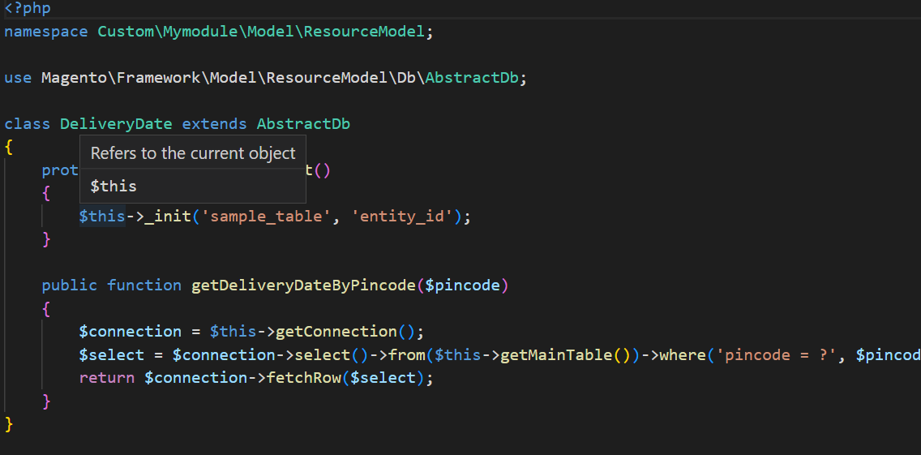

**Task 2:**

**Auto filling state and country based on entering pincode (checkout,myaccount)**

Overriding the checkout_index_index.xml file in theme.

Path:- design\frontend\Embitel\theme\Magento_Checkout\layout\

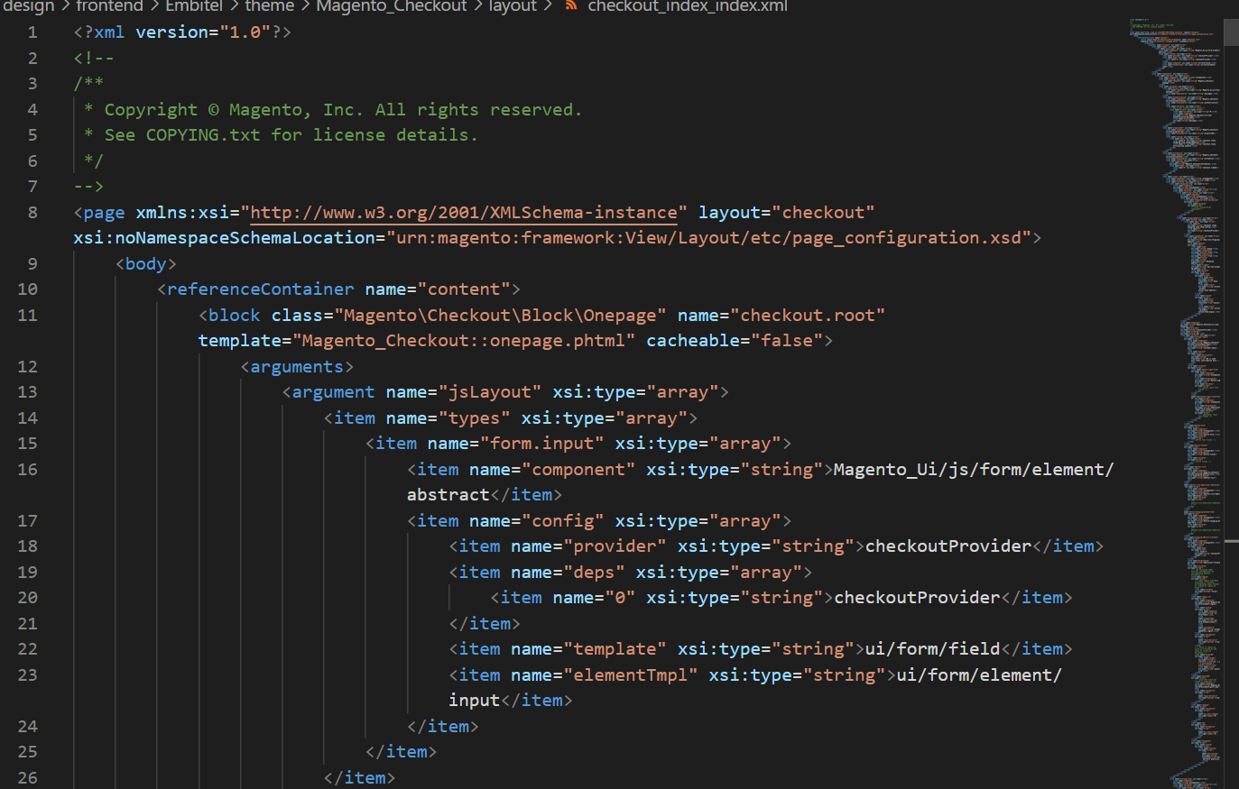

Overriding the address.js

Path:- design\frontend\Magento_Customer\web\js\model\customer\

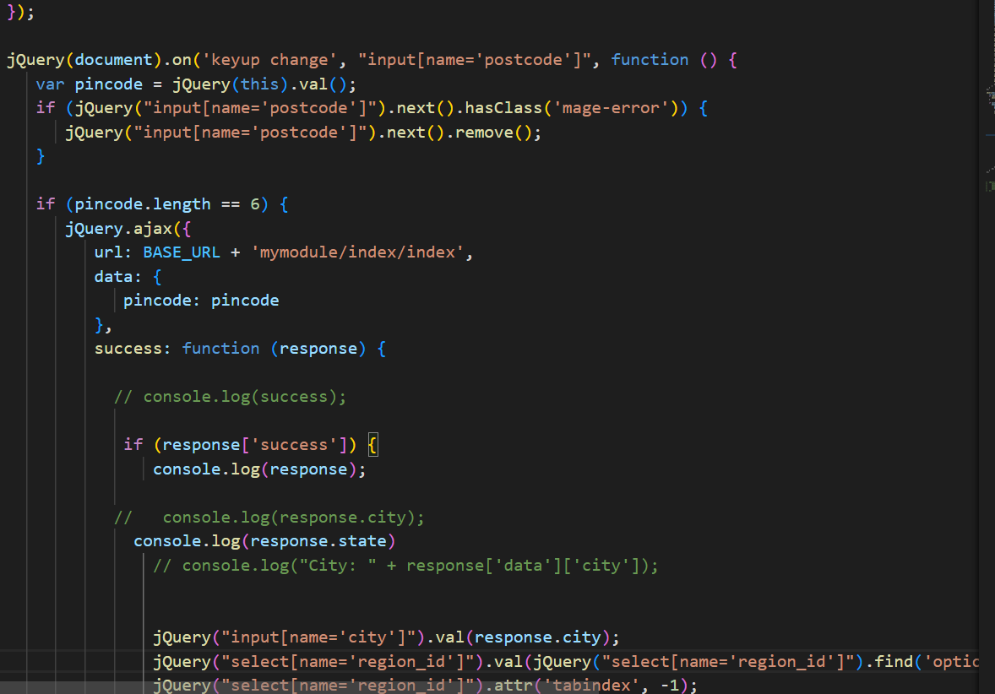

Creating Controller:

Path:-app\code\Custom\Mymodule\Controller\Index\

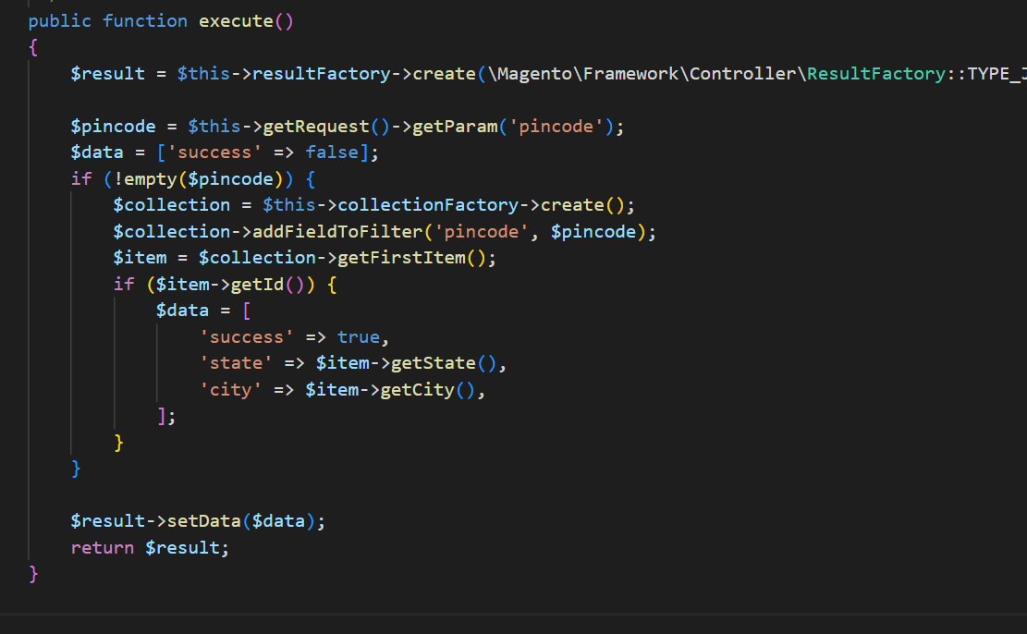

Creation of Model, ResourceModel, Collection

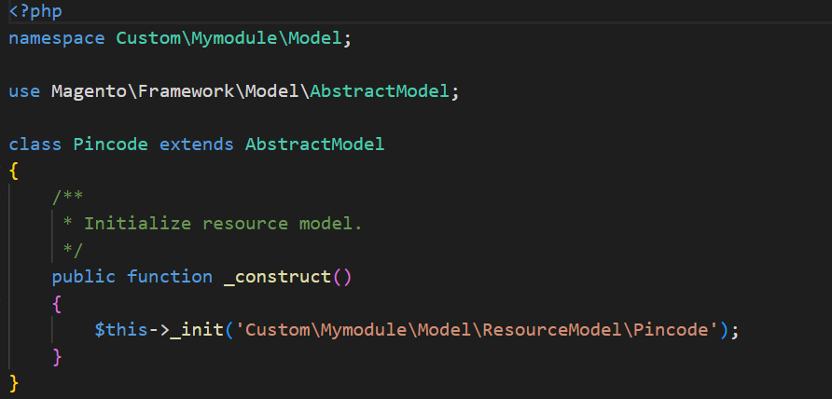

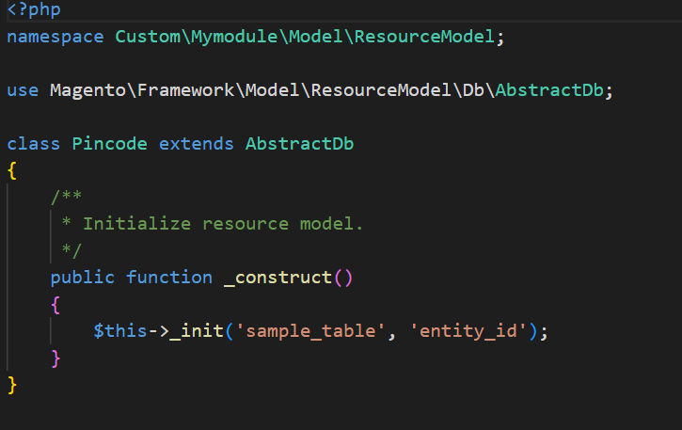

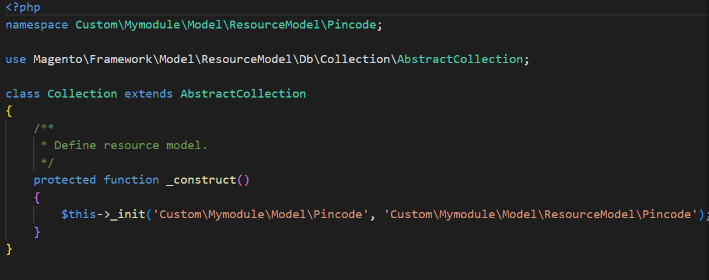

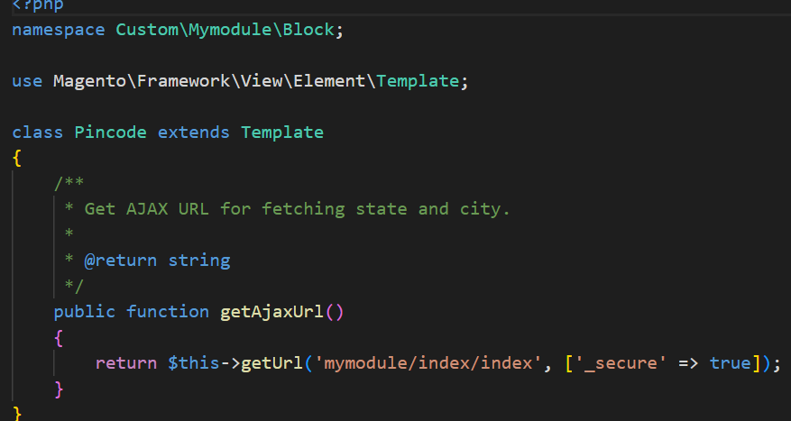

# To Auto filling state and country based on entering pincode (checkout,myaccount)

Overriding the edit.phtml and addressValidation.js

path:-design\frontend\Embitel\theme\Magento_Customer\templates\address\

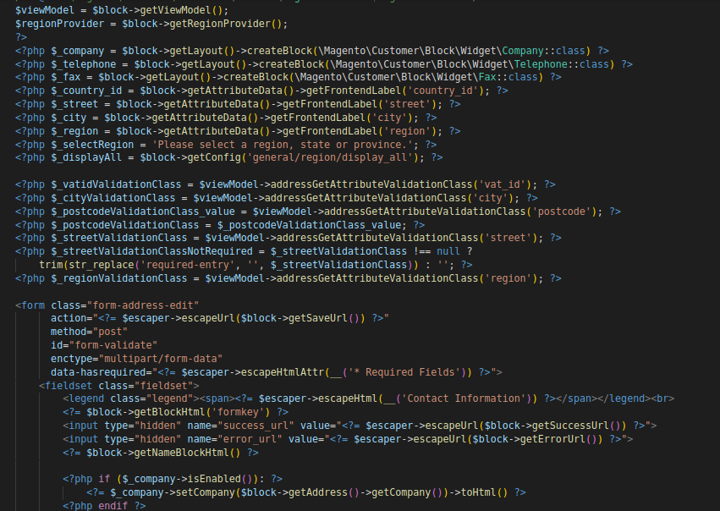

path:-design\frontend\Embitel\theme\Magento_Customer\web

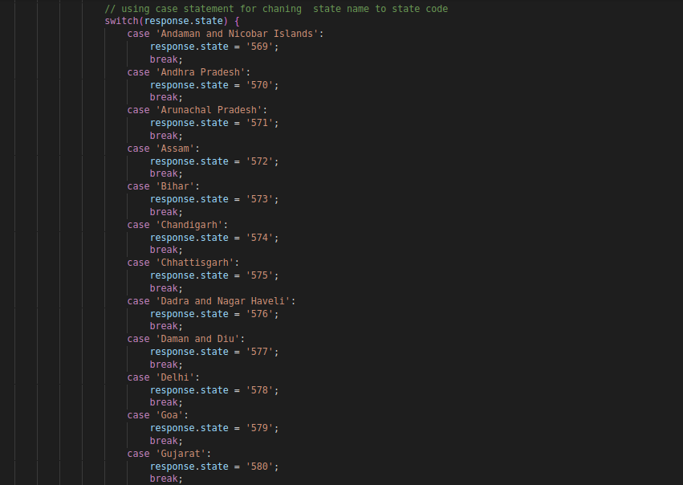

**Creation of Controller:**

**path:-** code\Custom\Mymodule\Index\

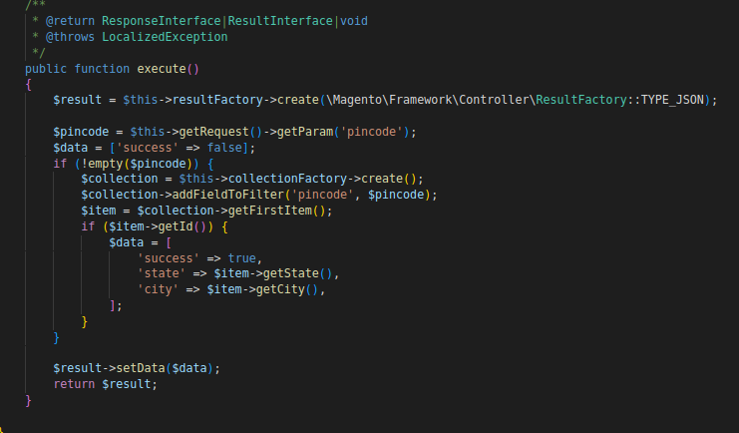

Use of same Model, ResourceModel and Collection that has use in checkout page.

**3. Display the delivery date in order view frontend and backend**

Override the info.phtml

Path:- design\frontend\Magento_Sales\templates\order\

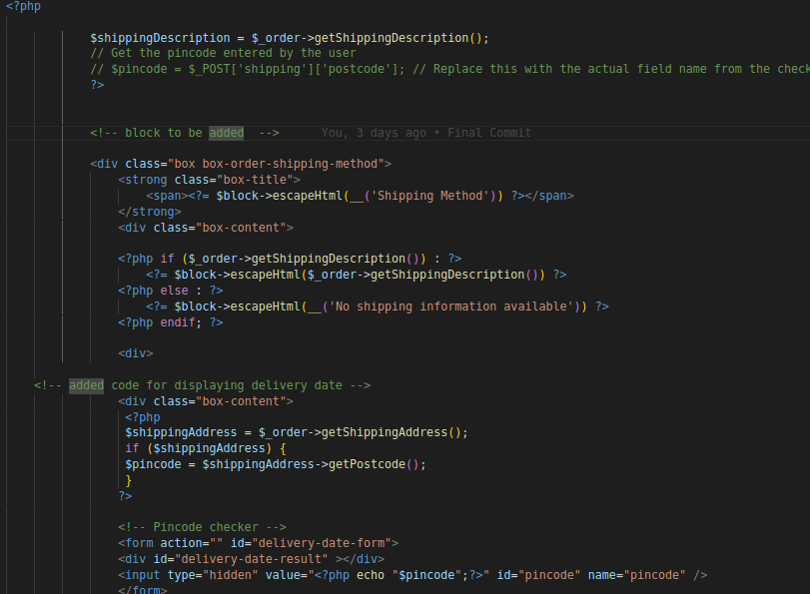

Using the same controller used in Pdp task.

**For backend:**

Path:-design\adminhtml\Embitel\Admintheme\Magento_Sales\templates\

