
Ritminukas

This is computerized system with graphical user interface (GUI) for personalization of the heart rate (HR) regulation model parameters associated with respiratory arrhythmia and baroreflex, and subsequential capturing of the remaining heart beat-to-beat variations – EKG R peak displacements that are expected not to be attributable to respiratory arrhythmia and cardiac baroreflex – from individual empirical human psychophysiological recordings. The system also includes automatic psychophysiological signals processing, EKG R peak detection algorithms, GUI for R peak revision and correction, the HR regulation model.
The system implemented during project No. 09.3.3-LMT-K-712-19-0228 “Computerized system for personalized heart rate regulation modelling and research”. This project was funded by the European Social Fund under the No 09.3.3-LMT-K-712 “Development of Competences of Scientists, other Researchers and Students through Practical Research Activities” measure.


© 2020-2023 Mindaugas Baranauskas
© 2020-2023 Kauno technologijos universitetas

License
This program is free software; you can redistribute it and/or modify it under the terms of the GNU General Public License as published by the Free Software Foundation; either version 3 of the License, or (at your option) any later version.
This program is distributed in the hope that it will be useful, but WITHOUT ANY WARRANTY; without even the implied warranty of MERCHANTABILITY or FITNESS FOR A PARTICULAR PURPOSE. See the GNU General Public License for more details.
You should have received a copy of the GNU General Public License along with this program. If not, see <http://www.gnu.org/licenses/>.

Some additional functions packaged in “external” directory may have other compatible license.

Requirements
MATLAB R2020b or higher version with
- Simulink
- Signal Processing Toolbox
- Statistics and Machine Learning Toolbox
- Curve Fitting Toolbox
- Global Optimization Toolbox
- Parallel Computing Toolbox (optional, but strongly recommended)

Supported psychophysiological datasets
“Ritminukas” supports these formats of psychophysiological recordings:
- European Data Format (EDF) or EDF+ via MATLAB edfinfo and edfread functions (these exist in “Signal Processing Toolbox” only in R2020b and newer versions);
- BIOPAC files exported to MATLAB MAT files (natively);
- BIOPAC ACQ via external load_acq function (however, compressed data not supported);
- EEGLAB SET and other files (only if EEGLAB installed in system – it is not included in “Ritminukas”) – other supported formats depends on installed EEGLAB plugins, e.g. BIOSIG, FILEIO.

Heart rate regulation model
The system with GUI could see and use any HR regulation models or their versions with word “ritminukas” at its beginning. Consult accompanied TXT files or see tooltips by hovering “Model parameters” button in “Ritminukas” main window for parameters of particular model.
By default, the inputs for the HR model are
- time instances of the real R peaks of EKG (‘Rt’);
- the respiration signal (‘kvepavimas’);
- arterial blood pressure signal (‘abp’);
  - besides, option to pass only systolic ‘SBP_real’ and diastolic ‘DBP_real’ instead is also available just for controlling of arterial pressure and error score calculation if the selected HR model version supports arterial pressure generation internally and outputs ‘BP_model’.
HR model outputs:
- time instances of the modeled R peaks (‘Rtm’) and
- sympathetic nerve activity (‘SNA’ or ‘MSNA’ timeseries type variables).
The default HR model itself implements the alignment of the real and modeled R peaks needed for the later extraction of the residual HR variations – the displacements of the modeled R peaks relative to real R peaks – outside the model.
Thus researchers can implement a new or modify the existing HR model and use the same “Ritminukas” GUI for HR model personalization.

Usage
Execute RITMINUKAS_GUI in MATLAB to launch “Ritminukas” GUI were you can choose psychophysiological datasets, HR model, configure workflow parameters (see Figure 1) and HR model parameters (see Figure 2), choose outputs and their place (output directory). Most options are self-explanatory.
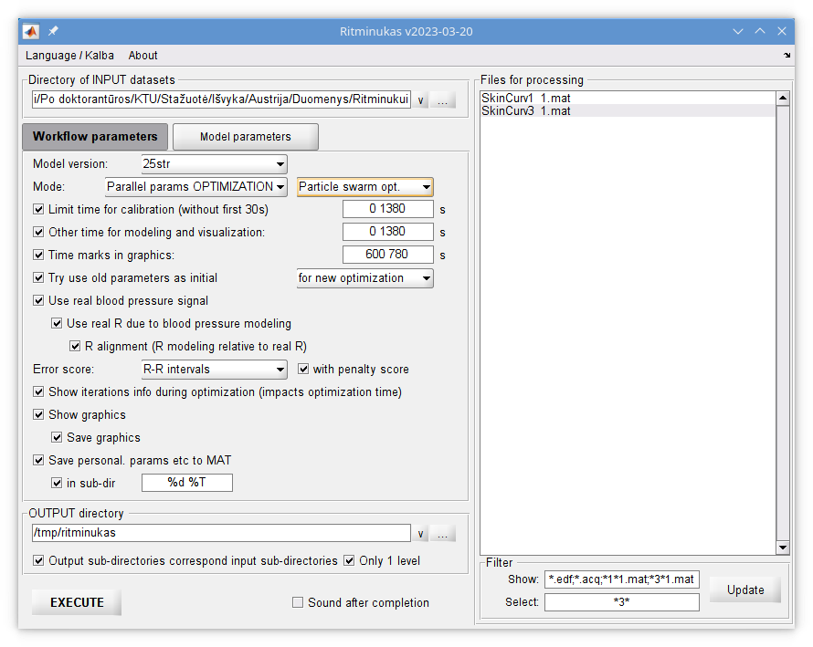Figure 1. Main window of “Ritminukas” with panel for configuration of workflow parameters.
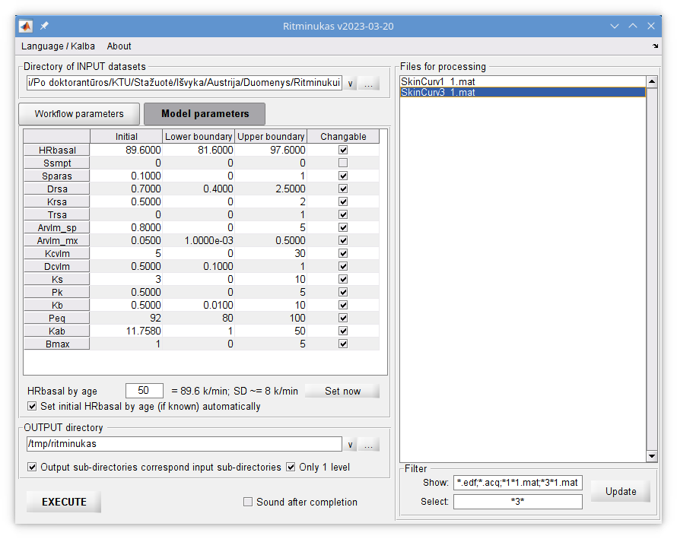Figure 2. Window of “Ritminukas” with panel for configuration of heart rate model parameters.

“Ritminukas“ has several workflow modes:
- “Single run with exact params” is for recommended for running HR regulation model only once with parameters entered as “Initial” (see Figure 2).
- “Parallel params OPTIMIZATION” is the recommended for automatized HR regulation model personalization within defined parameters’ lower and upper boundaries (see Figure 2); this mode can evaluate thousands of parameter sets by running HR model correspondingly. If possible, the optimization takes place in parallel processes - this significantly reduces the duration of calculations. You can choose one of these MATLAB optimization algorithms: Pattern search, Surrogate optimization, Particle swarm optimization, Genetic algorithm, Nonlinear programming, MultiStart and GlobalSearch.
- “Parameters OPTIMIZATION” is almost the same as above described “Parallel params OPTIMIZATION”, however optimization will be done as single sequential process (no parallel processes) and will take more time to get the same results. It can be useful to see live results of each evaluation.
- “Manual (load data only)” – will preload parameters entered as “Initial” (see Figure 2) and psychophysiological data into MATLAB workspace as “SimIn” object, but HR model will not be run.
- “Simulation only” – will load parameters and data (as “Manual (load data only)”, open Simulink model, run it, save “SimOut” object into MATLAB workspace. However it will not produce any jobs outside the model, e.g.: neither error score evaluation, neither correction of R peaks alignment, neither graphics will be saved.
- “Read old results only” – re-read previously generated solutions; HR model will not be run.
Press “Execute” to run you configured job.
If your selected psychophysiological dataset has not been yet used, a dialog will popup for time instances of R peaks (“R times”) revision and correction (see Figure 3). If after saving you realized that you did mistake or if you want correct these “R times” in future, open pop_RRI_perziura, import RRT file, correct data and overwrite RRT file by exporting the updated data.
At the end you will find TXT file with results and optionally graphics in output directory; also, optionally (according to configuration) optimized/personalized HR model parameters can be written as MAT files in input directory for later re-usage as input.

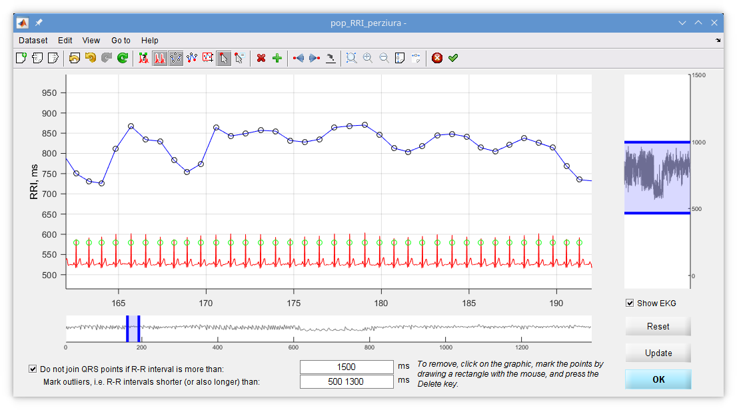
Figure 3. Interactive “pop_RRI_perziura” dialog for time instances of R peak revision and correction.

See https://sccn.ucsd.edu/eeglab/plugin_uploader/plugin_list_all.php
See also http://biosig.sourceforge.net/
See also https://www.fieldtriptoolbox.org/development/module/fileio/

