EEGLAB plugin Darbeliai

© 2015, M. Baranauskas <mindaugas.baranauskas@gf.vu.lt>
Permission is granted to copy, distribute and/or modify this document under the terms of the GNU Free Documentation License, Version 1.2 or any later version published by the Free Software Foundation; with no Invariant Sections, no Front-Cover Texts, and no Back-Cover Texts. A copy of the license is included in the section entitled “GNU Free Documentation License”.

Content
1 Purpose and features 2
2 Requirements 3
3 Installation 3
3.1 From EEGLAB v13 menu 3
3.2 Installation script 3
3.3 Manually 3
4 Usage 4
4.1 Common behaviour 4
4.2 Renaming datasets and/or updating datased information 6
4.3 Serial processing 7
4.4 Complex epoching 8
4.5 ERP properties and export 9
4.6 Spectral power 11
4.7 Custom command execution 12
5 Settings 13
GNU Free Documentation License 14

Purpose and features

EEGLAB plugin Darbeliai was created with intention to facilitate batch processing of selected EEG data files in graphical user interface (GUI). Darbeliai uses EEG data files in various formats (*.set, *.edf, *.cnt and others) as input directly, and outputs processed data directly to files in EEGLAB data format (*.set), so this in contrast to EEGLAB itseft where user must work with EEG datasets. So (in most cases) you no longer need to care about EEG data importing from raw EEG files into EEGLAB dataset and writing processed data back to file.
In Lithuanian – the most archaic live Indoeuropean language – darbeliai means the little works.
As of Darbeliai 2015.04.15 version, this EEGLAB plugin allows you to acomplish these jobs:
- rename EEG data files according dataset atributes (like subject, group, experiment condition or session), also extract these atributes from filenames and edit them manually (only EEGLAB *.set files supported);
- execute sequence of selected EEG processing tasks; results of each separate task can be saved with different filename suffix and/or into different subfolder.
- simple and conditional epoching (e.g. by particular stimulus if particular response exist);
- ERP visualization and feature extraction, exporting not only file-by-file, but also averages for subjects, groups, sessions, conditions separately, filtered by event type, channels and for custom time window;
- EEG spectrum visualization and spectral power analysis for both absolute and relative power in separate customisable power bands, though delta, theta, alpha, beta are predefined;
- custom command execution for list of data files.
Other features:
- filename filtering separately for listing available files and for selecting them;
- ability to work with multiple subdirectories;
- Loading files into EEGLAB as datasets after completing job;
- RAGU integration in menu, ERP data exporting for RAGU;
- two languages supported (Lithuanian and English) and it would be easy to add more;
- multiplatform: tested in Windows and Linux, with systems of different encodings.

Requirements

Before using Darbeliai, you must install:
- MATLAB
- EEGLAB 12 or newer is recommended

Installation

You can install Darbeliai plugin for EEGLAB by one of three ways. Note: Last two methods will (or will not) install a bit different version compared to installation via EEGLAB plugins' menu.

From EEGLAB v13 menu

Users of EEGLAB v13 (or newer version) can install plugin by these steps:
- In MATLAB start EEGLAB.
- EEGLAB menu File → Manage EEGLAB extensions →Data processing extensions.
- Navigate dialogs by 'Prev. Page' and 'Next page' buttons to find plugin Darbeliai.
- mark it for installation and press 'OK'.

Installation script

You can run MATLAB script, that automatically download plugin and extract it into EEGLAB plugins directory: https://github.com/embar-/eeglab_darbeliai/raw/stable/UTF-8/atnaujinimas.m

Manually

You can download https://github.com/embar-/eeglab_darbeliai/archive/stable.zip achive manually and extract it into EEGLAB installation subdirectory named 'plugins'. This method must work for all users of any supported EEGLAB version.

Usage

Common behaviour

Then EEGLAB is started, you can see meniu Darbeliai (Fig 1).
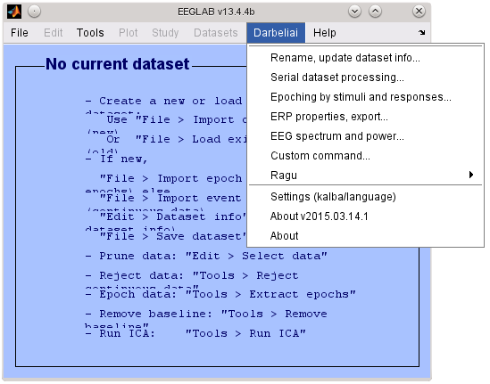Fig 1: Darbeliai in EEGLAB
Common elements in dialogs (see 2 Fig.):
- File loading options allows to select main directory for input files, and (sometimes) file loading order between functions.
- Selection of files for processing.
- Options of tasks.
Dialog-specific part.
- File saving options. Allow change output directory (and some parameters).
- Behaviour at termination of tasks.
- Button for execution of functions.

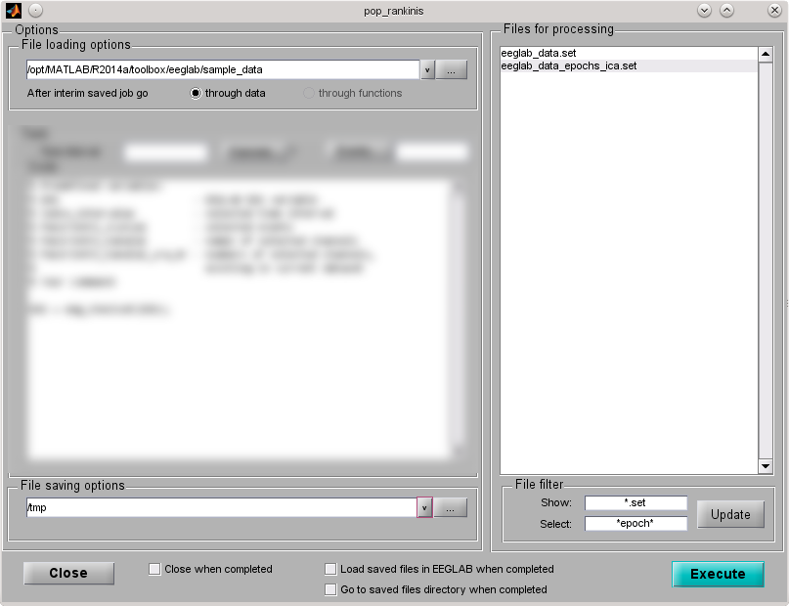Fig 2: Typical dialog
5.
6.
2.
1.
4.
3.
1.
- Ways to select directory for input or output (1 and 4 in Fig 2):
  - Enter path manually. If directory does not exist, program will ask about creation of it.
  - Press […] to navigate for existing directories.
  - Or press [v] to choose one from list: any level parent directory, one level subdirectory, directory of EEGLAB sample files (for input), temporary directory (for output) or some folder from history.
- Tips for selection of files (2 in Fig 2).
  - Files (to be displayed for selection) can be determined by entering filter string at 'Show';
    - '*' means all files;
    - 'x*' means all files, begining with x;
    - '*.set' means all files ending with '.set';
    - multiple rules can be separated by semicolon (;), e.g. '*.set;*.edf;*.cnt';
    - you can search for files in subdirectories:
      - './*/*.set' – search *.set format files in one level subdirectories in Linux/MAC;
      - './*/*/*.set' – search *.set format files in two level subdirectories in Linux/MAC;
      - '.\*\*.set' – search *.set format files in one level subdirectories in MS Windows;
      - '.\*\*\*.set' – search *.set format files in two level subdirectories in Windows;
    - you can search for files in parent directories:
      - '../*.set' – search *.set format files in parent directory in Linux/MAC;
      - '../../*.set' – search *.set format files in two levels up directory in Linux/MAC;
      - '..\*.set' – search *.set format files in parent directory in MS Windows;
      - '..\..\*.set' – search *.set format files in two levels up directory in MS Windows;
    - Some more complex example for Linux/MAC (in Windows folders separated by '\'):
      - '../m*.set;v*.set;./*/t*.set;./u*.set' – search *.set files, but in main directory look for files begining with 'u', in parent – with 'm' or 'v', in subdirectories – with 't';
i.e. if directory is not specified in some part of filter, filter is apllyied for last directory; to search in main directory, you must begin part of filter with './' for Linux/MAC or with '.\' for Windows.
  - Files can be selected (marked) by entering filter strings at 'Select'. Rules same as above.
  - You can select multiple files by mouse (hold Ctrl), by keyboard (hold Ctrl or Shift, move with ↑ and ↓, select with space).
- Dialog-specific options for particular tasks.
  - Options can provide button to select EEG channels and/or events (that exist in selected EEG data files), but this feature will work only with EEGLAB *.set files.
- Button for execution activation (6 in Fig 2).
  - You must select some files and choose correct parameters of tasks/functions, otherwise you can not press this button. Problematic area usually will be marked by yellow color.
- Behaviour at termination of tasks.
  - 'Closing then completed' closes active dialog of 'Darbeliai' then all task in it are done; EEGLAB or MATLAB program will not be closed.
  - 'Go to saved files directory then completed' option will change main directory for opening of files by value of output directory.
  - 'Break work' checkbox will appear at execution. If checked, program will stop execution of job not immediately, but safely after completing tasks with current data file. This checkbox will be automatically checked, if you press [Close] button in dialog or if you try to close window itself; if you do so and if checkbox is already checked, program may ask you about terminating of jobs.

Renaming datasets and/or updating datased information

Go Darbeliai → Rename, update dataset info... Opened dialog (3 Fig.) is not typical in this plugin.
- Choose directory and select *.set files to be renamed, copied and/or updated.
- Choose output directory and see new names for apropriate original files.
- Program try automatically construct unique filenames by rules. At first it try split original filenames by guessing its schema (influenced by separators). Rules can be defined manually.
- Press 'File name parts' to see result of filename analysis (see table in 4 Fig.).
- Define new information by these parts (%N format) or manually, press [Copy] or [Rename].
1.
4.
5.
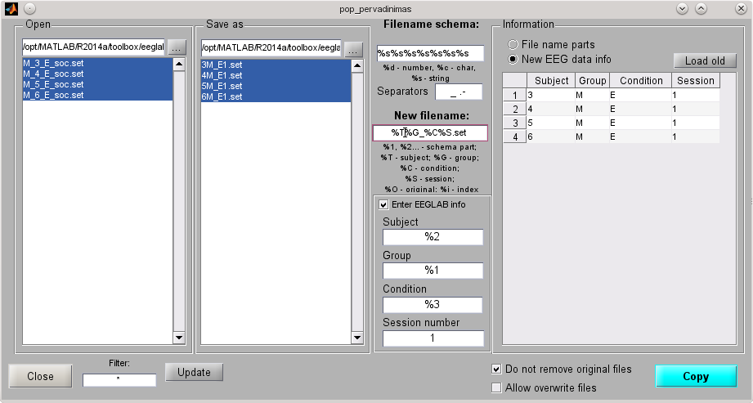Fig 3: Dialog for renaming and updating information in datasets
2.
3.
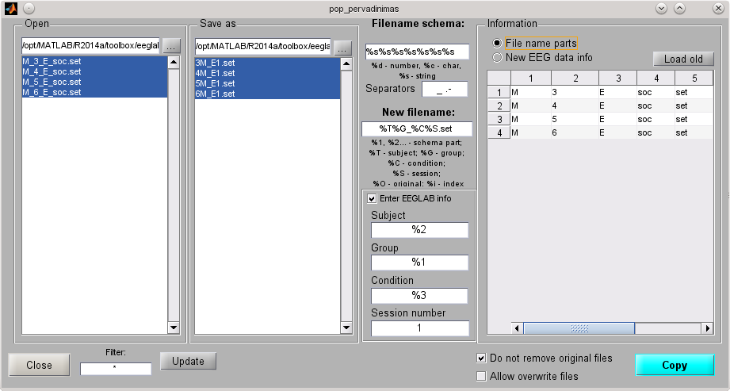Fig 4: Review analysed parts of original filenames

Serial processing

Go Darbeliai → Serial processing…
Features:
- Almost 20 selectable tasks can be done within this dialog.
  - Note: Some functions may be grayed, if recuired plugin was not found in EEGLAB.
  - Note: You can interpolate electrodes only according built-in 64 electrodes schema.
- Your can specify filename suffix then saving file after apropriate task.
- If you mark checkbox for subdirectory, result of particular task will go into it. If you don't mark these checkbox, result will not be written to disk, unless that task is the last one.
- Output subdirectories are always numbered. You can set value at '# of done jobs for subdir names' to change initial number in name of subdirectory (default 0, means that there is zero already numbered subdirectories, so numbering starts from 1)
- After saving interim result, you can
  - continue to do next tasks with just processed EEG data file, and switch to next original data file only after completing all selected tasks (option 'After interim saved job go through data');
  - or open next file(s) to do same task(s) until saving result to disk, and switch to next task(s) only after processing all original (or interim) EEG data files (option 'After interim saved job go through functions').

1.
2.
3.
4.
5.
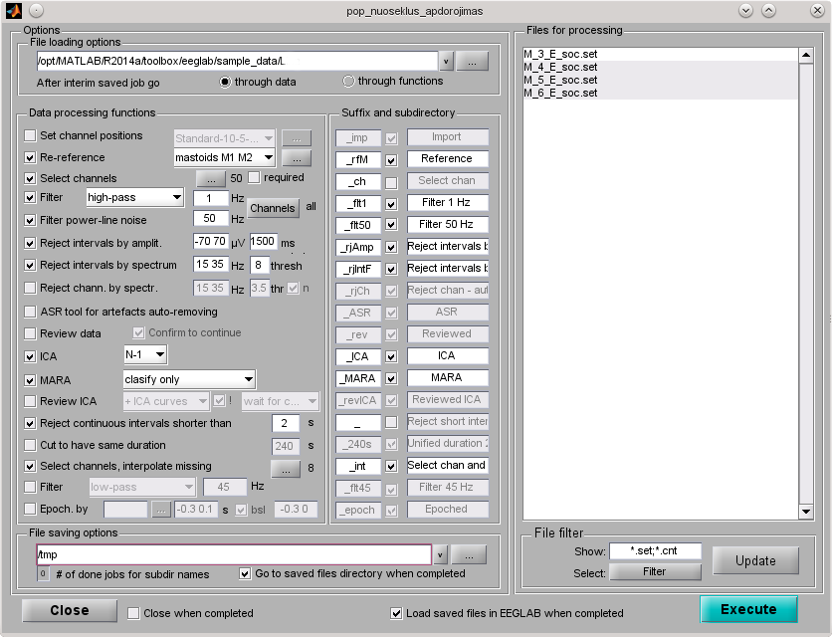Fig 5: Serial processing

Complex epoching

Go Darbeliai → Epoching by stimuli and responses...
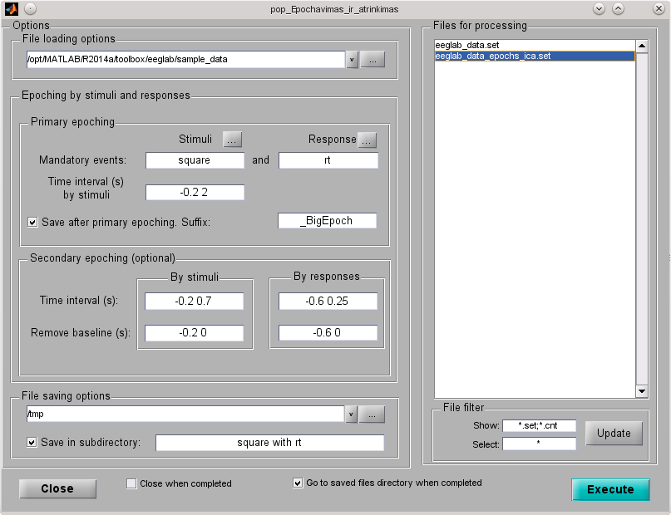Fig 6: Epoching by stimuli and responses
This dialog allows to create epochs by events (usually – by stimuli; by any event at 'Stimuli' in 'Primary epoching' section) and select only those epochs, that contains particular events (usually – responses; any event at 'Responses' in 'Primary epoching' section). Multiple stimuli and responses can be entered at once: numeric events can be entered manually, or by pressing […] button and selecting in pop-up dialog; string events can be selected only in pop-up dialog. If such big epochs are all what you need, then make sure to check 'Save after primary epoching' and clear parameters in 'Secondary epoching (optional)' section.

Optionally you can further split generated epochs to get files, containing one particular stimulus (but any response), one particular response (but any stimulus) or both (with one particular stimulus and one particular response). This is meaningful, if primary epoching was done with multiple stimuli and responses. To do so, enter time window values for stimulus and/or responses at 'Time interval (s)' in 'Secondary epoching (optional)' section. If values at 'Remove baseline (s)' are not empty, baseline remove will be removed.

Note: If option 'Save after primary epoching' is not checked and parameters in 'Secondary epoching (optional)' section are cleared, no output will be generated!

ERP properties and export

Go Darbeliai → ERP properties, export...

Features:
- ERP visualization with optional legend (check 'Preview')
  - for separate files or for averages of subjects, groups, conditions, sessions, custom filter;
  - for each selected channel or for mean of these channels;
  - for selected events (current version merges all events, don't display event separately);
  - click ERP image to open it in separate window.
- ERP properties calculation
  - in all or selected time interval,
  - mean, minimum and maximum amplitude, area; time and amplitude at half area.
- ERP properties export to text (TXT), Excel (XLS) or MATLAB (MAT) file.
- ERP export to text (TXT), RAGU or Excel (XLS) file.

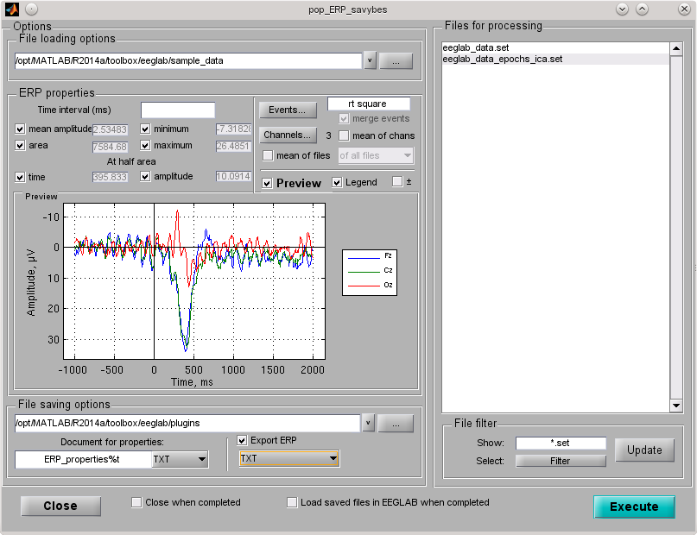Fig 7: Dialog for ERP and its properties visualization, exporting

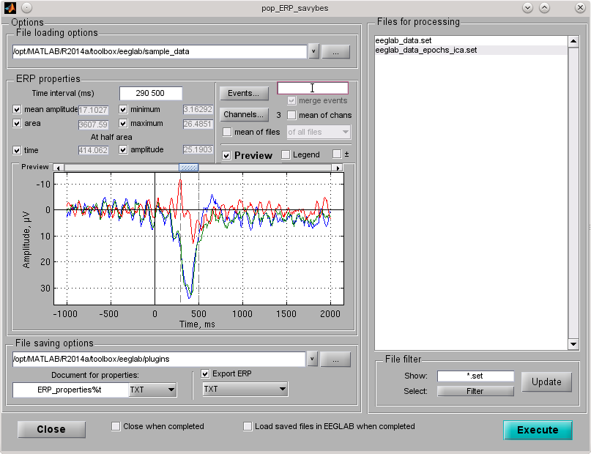Fig 8: Then time interval is specified, it can be moved by slider
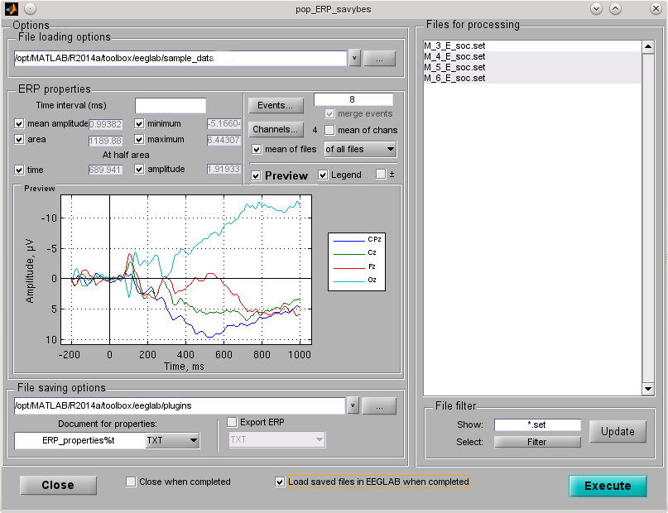Fig 9: ERP can be averaged for all files or by subject, groups, session, condition...

Spectral power
Go Darbeliai → EEG spectrum and power...

Features:
- absolute and relative spectral power calculation (Fast Fourier Transform (FFT) algorithm);
- spectrum, absolute and relative spectral power vizualization;
- customizable spectral bands: press [+] to add new band or [-] to remove last line;
- customizable frequency interval for all power (default auto – from minimum to maximum according specified spectral bands; most meaningfull in relative power calculation);
- customizable FFT window length (default 2 s);
- customizable spectral accuracy ('spectrum steps', default 10 points / 1 Hz);
- channel selection for analysis;
- missing channel interpolation using built-in 64 channels schema;
- export of results.

Fig 10: Dialog for spectral power visualization and exporting

Custom command execution

Go Darbeliai → Custom command...
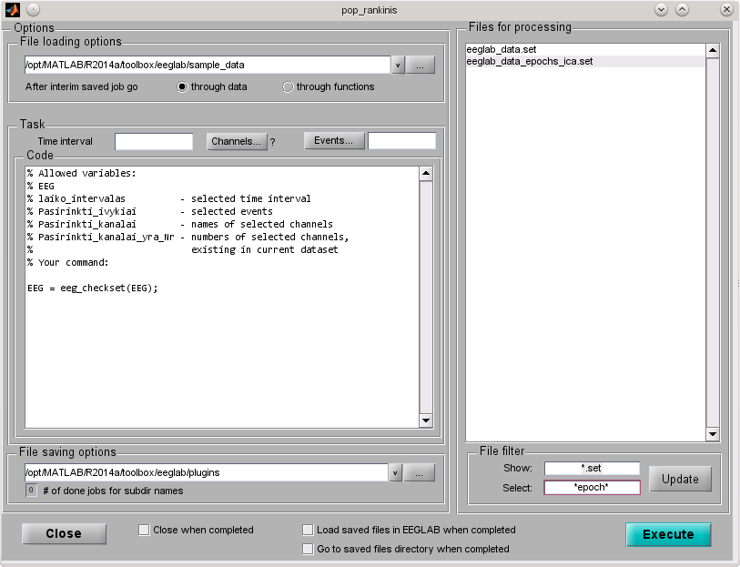Fig 11: Dialog for custom command
Each your selected file will be processed by your custom script and EEG variable will be saved with same filename as original file in EEGLAB data format (*.set), so if you don't want to overwrite existing file, make sure to set different output directory (at 'File saving options') than input (at 'File loading options').

Predefined variables:
EEG - main EEGLAB EEG data variable;
laiko_intervalas - selected time interval or any numeric entry;
Pasirinkti_ivykiai - selected events;
Pasirinkti_kanalai - names of selected channels;
Pasirinkti_kanalai_yra_Nr - indexes of selected channels, but only existing in current dataset.

Strings after '%' symbol are comments (valid only in particular line) – they will not be executed.

For example, to select EEG data only in particular time window (e. g. first 30 seconds) for each file, you can write start and end of this window (e. g. '0 30') at 'Time interval', and at 'Code' put:
EEG = pop_select( EEG,'time', laiko_intervalas );
or you can write directly:
EEG = pop_select( EEG,'time', [0 30] );

Settings

Go Darbeliai → Settings (kalba/language)

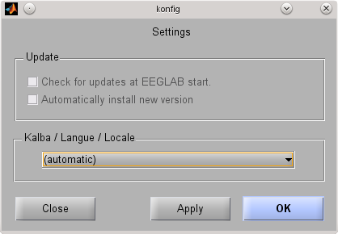Fig 12: Settings dialog
If you installed Darbeliai via EEGLAB 13 plugins menu, you will not be able change options in 'Update' section. Otherwise you can select to check for Darbeliai updates at each start of EEGLAB and then to update (or not) to new version of Darbeliai automatically.

You can change interface language. Currently only Lithuanian and English languages are supported. By default language is set to 'automatic', i.e. guessing acording your operating system or MATLAB environement, but with fallback to English in case of not existing translation of Darbeliai. Then program falbacks to English, it prints warning message with instructions how to add new language.

GNU Free Documentation License
Version 1.2, November 2002
Copyright (C) 2000,2001,2002 Free Software Foundation, Inc. 59 Temple Place, Suite 330, Boston, MA 02111-1307 USA
Everyone is permitted to copy and distribute verbatim copies of this license document, but changing it is not allowed.

1. PREAMBLE¶

The purpose of this License is to make a manual, textbook, or other functional and useful document “free” in the sense of freedom: to assure everyone the effective freedom to copy and redistribute it, with or without modifying it, either commercially or noncommercially. Secondarily, this License preserves for the author and publisher a way to get credit for their work, while not being considered responsible for modifications made by others.
This License is a kind of “copyleft”, which means that derivative works of the document must themselves be free in the same sense. It complements the GNU General Public License, which is a copyleft license designed for free software.
We have designed this License in order to use it for manuals for free software, because free software needs free documentation: a free program should come with manuals providing the same freedoms that the software does. But this License is not limited to software manuals; it can be used for any textual work, regardless of subject matter or whether it is published as a printed book. We recommend this License principally for works whose purpose is instruction or reference.

2. APPLICABILITY AND DEFINITIONS¶

This License applies to any manual or other work, in any medium, that contains a notice placed by the copyright holder saying it can be distributed under the terms of this License. Such a notice grants a world-wide, royalty-free license, unlimited in duration, to use that work under the conditions stated herein. The “Document”, below, refers to any such manual or work. Any member of the public is a licensee, and is addressed as “you”. You accept the license if you copy, modify or distribute the work in a way requiring permission under copyright law.
A “Modified Version” of the Document means any work containing the Document or a portion of it, either copied verbatim, or with modifications and/or translated into another language.
A “Secondary Section” is a named appendix or a front-matter section of the Document that deals exclusively with the relationship of the publishers or authors of the Document to the Document’s overall subject (or to related matters) and contains nothing that could fall directly within that overall subject. (Thus, if the Document is in part a textbook of mathematics, a Secondary Section may not explain any mathematics.) The relationship could be a matter of historical connection with the subject or with related matters, or of legal, commercial, philosophical, ethical or political position regarding them.
The “Invariant Sections” are certain Secondary Sections whose titles are designated, as being those of Invariant Sections, in the notice that says that the Document is released under this License. If a section does not fit the above definition of Secondary then it is not allowed to be designated as Invariant. The Document may contain zero Invariant Sections. If the Document does not identify any Invariant Sections then there are none.
The “Cover Texts” are certain short passages of text that are listed, as Front-Cover Texts or Back-Cover Texts, in the notice that says that the Document is released under this License. A Front-Cover Text may be at most 5 words, and a Back-Cover Text may be at most 25 words.
A “Transparent” copy of the Document means a machine-readable copy, represented in a format whose specification is available to the general public, that is suitable for revising the document straightforwardly with generic text editors or (for images composed of pixels) generic paint programs or (for drawings) some widely available drawing editor, and that is suitable for input to text formatters or for automatic translation to a variety of formats suitable for input to text formatters. A copy made in an otherwise Transparent file format whose markup, or absence of markup, has been arranged to thwart or discourage subsequent modification by readers is not Transparent. An image format is not Transparent if used for any substantial amount of text. A copy that is not “Transparent” is called “Opaque”.
Examples of suitable formats for Transparent copies include plain ASCII without markup, Texinfo input format, LaTeX input format, SGML or XML using a publicly available DTD, and standard-conforming simple HTML, PostScript or PDF designed for human modification. Examples of transparent image formats include PNG, XCF and JPG. Opaque formats include proprietary formats that can be read and edited only by proprietary word processors, SGML or XML for which the DTD and/or processing tools are not generally available, and the machine-generated HTML, PostScript or PDF produced by some word processors for output purposes only.
The “Title Page” means, for a printed book, the title page itself, plus such following pages as are needed to hold, legibly, the material this License requires to appear in the title page. For works in formats which do not have any title page as such, “Title Page” means the text near the most prominent appearance of the work’s title, preceding the beginning of the body of the text.
A section “Entitled XYZ” means a named subunit of the Document whose title either is precisely XYZ or contains XYZ in parentheses following text that translates XYZ in another language. (Here XYZ stands for a specific section name mentioned below, such as “Acknowledgements”, “Dedications”, “Endorsements”, or “History”.) To “Preserve the Title” of such a section when you modify the Document means that it remains a section “Entitled XYZ” according to this definition.
The Document may include Warranty Disclaimers next to the notice which states that this License applies to the Document. These Warranty Disclaimers are considered to be included by reference in this License, but only as regards disclaiming warranties: any other implication that these Warranty Disclaimers may have is void and has no effect on the meaning of this License.

3. VERBATIM COPYING¶

You may copy and distribute the Document in any medium, either commercially or noncommercially, provided that this License, the copyright notices, and the license notice saying this License applies to the Document are reproduced in all copies, and that you add no other conditions whatsoever to those of this License. You may not use technical measures to obstruct or control the reading or further copying of the copies you make or distribute. However, you may accept compensation in exchange for copies. If you distribute a large enough number of copies you must also follow the conditions in section 3.
You may also lend copies, under the same conditions stated above, and you may publicly display copies.

4. COPYING IN QUANTITY¶

If you publish printed copies (or copies in media that commonly have printed covers) of the Document, numbering more than 100, and the Document’s license notice requires Cover Texts, you must enclose the copies in covers that carry, clearly and legibly, all these Cover Texts: Front-Cover Texts on the front cover, and Back-Cover Texts on the back cover. Both covers must also clearly and legibly identify you as the publisher of these copies. The front cover must present the full title with all words of the title equally prominent and visible. You may add other material on the covers in addition. Copying with changes limited to the covers, as long as they preserve the title of the Document and satisfy these conditions, can be treated as verbatim copying in other respects.
If the required texts for either cover are too voluminous to fit legibly, you should put the first ones listed (as many as fit reasonably) on the actual cover, and continue the rest onto adjacent pages.
If you publish or distribute Opaque copies of the Document numbering more than 100, you must either include a machine-readable Transparent copy along with each Opaque copy, or state in or with each Opaque copy a computer-network location from which the general network-using public has access to download using public-standard network protocols a complete Transparent copy of the Document, free of added material. If you use the latter option, you must take reasonably prudent steps, when you begin distribution of Opaque copies in quantity, to ensure that this Transparent copy will remain thus accessible at the stated location until at least one year after the last time you distribute an Opaque copy (directly or through your agents or retailers) of that edition to the public.
It is requested, but not required, that you contact the authors of the Document well before redistributing any large number of copies, to give them a chance to provide you with an updated version of the Document.

5. MODIFICATIONS¶

You may copy and distribute a Modified Version of the Document under the conditions of sections 2 and 3 above, provided that you release the Modified Version under precisely this License, with the Modified Version filling the role of the Document, thus licensing distribution and modification of the Modified Version to whoever possesses a copy of it. In addition, you must do these things in the Modified Version:
A. Use in the Title Page (and on the covers, if any) a title distinct from that of the Document, and from those of previous versions (which should, if there were any, be listed in the History section of the Document). You may use the same title as a previous version if the original publisher of that version gives permission.
B. List on the Title Page, as authors, one or more persons or entities responsible for authorship of the modifications in the Modified Version, together with at least five of the principal authors of the Document (all of its principal authors, if it has fewer than five), unless they release you from this requirement.
C. State on the Title page the name of the publisher of the Modified Version, as the publisher.
D. Preserve all the copyright notices of the Document.
E. Add an appropriate copyright notice for your modifications adjacent to the other copyright notices.
F. Include, immediately after the copyright notices, a license notice giving the public permission to use the Modified Version under the terms of this License, in the form shown in the Addendum below.
G. Preserve in that license notice the full lists of Invariant Sections and required Cover Texts given in the Document’s license notice.
H. Include an unaltered copy of this License.
I. Preserve the section Entitled “History”, Preserve its Title, and add to it an item stating at least the title, year, new authors, and publisher of the Modified Version as given on the Title Page. If there is no section Entitled “History” in the Document, create one stating the title, year, authors, and publisher of the Document as given on its Title Page, then add an item describing the Modified Version as stated in the previous sentence.
J. Preserve the network location, if any, given in the Document for public access to a Transparent copy of the Document, and likewise the network locations given in the Document for previous versions it was based on. These may be placed in the “History” section. You may omit a network location for a work that was published at least four years before the Document itself, or if the original publisher of the version it refers to gives permission.
K. For any section Entitled “Acknowledgements” or “Dedications”, Preserve the Title of the section, and preserve in the section all the substance and tone of each of the contributor acknowledgements and/or dedications given therein.
L. Preserve all the Invariant Sections of the Document, unaltered in their text and in their titles. Section numbers or the equivalent are not considered part of the section titles.
M. Delete any section Entitled “Endorsements”. Such a section may not be included in the Modified Version.
N. Do not retitle any existing section to be Entitled “Endorsements” or to conflict in title with any Invariant Section.
O. Preserve any Warranty Disclaimers.
If the Modified Version includes new front-matter sections or appendices that qualify as Secondary Sections and contain no material copied from the Document, you may at your option designate some or all of these sections as invariant. To do this, add their titles to the list of Invariant Sections in the Modified Version’s license notice. These titles must be distinct from any other section titles.
You may add a section Entitled “Endorsements”, provided it contains nothing but endorsements of your Modified Version by various parties--for example, statements of peer review or that the text has been approved by an organization as the authoritative definition of a standard.
You may add a passage of up to five words as a Front-Cover Text, and a passage of up to 25 words as a Back-Cover Text, to the end of the list of Cover Texts in the Modified Version. Only one passage of Front-Cover Text and one of Back-Cover Text may be added by (or through arrangements made by) any one entity. If the Document already includes a cover text for the same cover, previously added by you or by arrangement made by the same entity you are acting on behalf of, you may not add another; but you may replace the old one, on explicit permission from the previous publisher that added the old one.
The author(s) and publisher(s) of the Document do not by this License give permission to use their names for publicity for or to assert or imply endorsement of any Modified Version.

6. COMBINING DOCUMENTS¶

You may combine the Document with other documents released under this License, under the terms defined in section 4 above for modified versions, provided that you include in the combination all of the Invariant Sections of all of the original documents, unmodified, and list them all as Invariant Sections of your combined work in its license notice, and that you preserve all their Warranty Disclaimers.
The combined work need only contain one copy of this License, and multiple identical Invariant Sections may be replaced with a single copy. If there are multiple Invariant Sections with the same name but different contents, make the title of each such section unique by adding at the end of it, in parentheses, the name of the original author or publisher of that section if known, or else a unique number. Make the same adjustment to the section titles in the list of Invariant Sections in the license notice of the combined work.
In the combination, you must combine any sections Entitled “History” in the various original documents, forming one section Entitled “History”; likewise combine any sections Entitled “Acknowledgements”, and any sections Entitled “Dedications”. You must delete all sections Entitled “Endorsements”.

7. COLLECTIONS OF DOCUMENTS¶

You may make a collection consisting of the Document and other documents released under this License, and replace the individual copies of this License in the various documents with a single copy that is included in the collection, provided that you follow the rules of this License for verbatim copying of each of the documents in all other respects.
You may extract a single document from such a collection, and distribute it individually under this License, provided you insert a copy of this License into the extracted document, and follow this License in all other respects regarding verbatim copying of that document.

8. AGGREGATION WITH INDEPENDENT WORKS¶

A compilation of the Document or its derivatives with other separate and independent documents or works, in or on a volume of a storage or distribution medium, is called an “aggregate” if the copyright resulting from the compilation is not used to limit the legal rights of the compilation’s users beyond what the individual works permit. When the Document is included in an aggregate, this License does not apply to the other works in the aggregate which are not themselves derivative works of the Document.
If the Cover Text requirement of section 3 is applicable to these copies of the Document, then if the Document is less than one half of the entire aggregate, the Document’s Cover Texts may be placed on covers that bracket the Document within the aggregate, or the electronic equivalent of covers if the Document is in electronic form. Otherwise they must appear on printed covers that bracket the whole aggregate.

9. TRANSLATION¶

Translation is considered a kind of modification, so you may distribute translations of the Document under the terms of section 4. Replacing Invariant Sections with translations requires special permission from their copyright holders, but you may include translations of some or all Invariant Sections in addition to the original versions of these Invariant Sections. You may include a translation of this License, and all the license notices in the Document, and any Warranty Disclaimers, provided that you also include the original English version of this License and the original versions of those notices and disclaimers. In case of a disagreement between the translation and the original version of this License or a notice or disclaimer, the original version will prevail.
If a section in the Document is Entitled “Acknowledgements”, “Dedications”, or “History”, the requirement (section 4) to Preserve its Title (section 1) will typically require changing the actual title.

10. TERMINATION¶

You may not copy, modify, sublicense, or distribute the Document except as expressly provided for under this License. Any other attempt to copy, modify, sublicense or distribute the Document is void, and will automatically terminate your rights under this License. However, parties who have received copies, or rights, from you under this License will not have their licenses terminated so long as such parties remain in full compliance.

11. FUTURE REVISIONS OF THIS LICENSE¶

The Free Software Foundation may publish new, revised versions of the GNU Free Documentation License from time to time. Such new versions will be similar in spirit to the present version, but may differ in detail to address new problems or concerns. See http://www.gnu.org/copyleft/.
Each version of the License is given a distinguishing version number. If the Document specifies that a particular numbered version of this License “or any later version” applies to it, you have the option of following the terms and conditions either of that specified version or of any later version that has been published (not as a draft) by the Free Software Foundation. If the Document does not specify a version number of this License, you may choose any version ever published (not as a draft) by the Free Software Foundation.

12. ADDENDUM: How to use this License for your documents¶

To use this License in a document you have written, include a copy of the License in the document and put the following copyright and license notices just after the title page:
Copyright (c) YEAR YOUR NAME.
Permission is granted to copy, distribute and/or modify this document
under the terms of the GNU Free Documentation License, Version 1.2
or any later version published by the Free Software Foundation;
with no Invariant Sections, no Front-Cover Texts, and no Back-Cover Texts.
A copy of the license is included in the section entitled “GNU
Free Documentation License”.

If you have Invariant Sections, Front-Cover Texts and Back-Cover Texts, replace the “with...Texts.” line with this:
with the Invariant Sections being LIST THEIR TITLES, with the
Front-Cover Texts being LIST, and with the Back-Cover Texts being LIST.

If you have Invariant Sections without Cover Texts, or some other combination of the three, merge those two alternatives to suit the situation.
If your document contains nontrivial examples of program code, we recommend releasing these examples in parallel under your choice of free software license, such as the GNU General Public License, to permit their use in free software.

