ALSPAC Longitudinal Driven Exercise Anlysis

Katherine Schaumberg

2022-06-30

# 1 Introduction

## 1.1 Driven Exercise in ALSPAC

Driven exercise is a common, debilitating symptom across eating disorders (ED). Up to 40% of individuals with bulimia nervosa and 80% of those with anorexia nervosa experience driven exercise. Driven exercise relates to high levels of ED symptoms and poor ED treatment outcomes, and has been purported to be an early ED symptom via retrospective reports. A previous study examined exercise for weight loss and driven exercise at age 14 in the ALSPAC cohort, identifying whether groups at age 14 were associated with ED behaviors at ages 14 and 16 (Schaumberg et al. 2022) Results found that both exercise for weight loss and driven exercise groups at age 14 were demonstrated higher levels of other ED behaviors (binge eating, fasting, purging) at age 16. In the current study, we extend a longitudinal investigation of exercise for weight loss and driven exercise as predictors of other ED behaviors across a larger developmental window (ages 14-24), and further clarify directionality of effects.

## 1.2 Current Study

The current study examines data from the ALSPAC Cohort at ages 14,16,18, and 24 years

**Aim 1:** To investigate rates of transition between ‘no exercise for weight loss’, ‘exercise for weight loss’, and ‘driven exercise’ groups between ages 14-24, and characterize initial predictors of transitions to driven exercise amongst boys and girls.

H1: Driven Exercise will be the most stable category, and transitions between the driven exercise and exercise for weight loss categories will be more common than transitions between the driven exercise and no exercise for weight loss category.

**Aim 2:** To examine overall changes in probability of driven exercise and exercise for weight loss from ages 14-24 and characterize initial predictors of changes in probability of driven exercise and exercise for weight loss over time

H2: ED cognitions at age 14 will predict driven exercise during ages 14-24

# 2 Method

## 2.1 Sample - The ALSPAC Cohort

The ALSPAC Cohort (Boyd et al. 2013; Fraser et al. 2013) was established to understand how genetic and environmental characteristics influence health and development in parents and children. Ethical approval for this study was granted by the ALSPAC Law and Ethics Committee and Local Ethics Committees. All pregnant women living in the geographical area of Avon, United Kingdom, who were expected to deliver between April 1, 1991 and December 31, 1992, were invited to participate in the study. Children from 14,541 pregnancies were enrolled; 13,988 children were alive at 1 year. An additional 913 children were enrolled during subsequent phases of enrollment, with a total sample size alive at 1 year of 14,901. All women gave informed and written consent. Among twin pairs, one twin per pair was randomly excluded from the current study.

A fully searchable ALSPAC data dictionary is available [here](http://www.bris.ac.uk/alspac/researchers/data-access/data-dictionary/).

The sample size is defined for the current study as the number of individuals of each gender reporting exercise for weight loss data from ages 14-24 years. Sample size ranged from 3229 (age 18) to 5950 (age 14), with slightly more female than male participants responding at all time points. Across all time points, 3319 Male, 4360 Female, and 9 participants not reporting gender completed at least one assessment of exercise for weight loss (**Total N = 7688**). Participants reporting exercise for weight loss data at one or more time points were included in analyses. A graph of sample size at each age is presented in Figure 2.1:

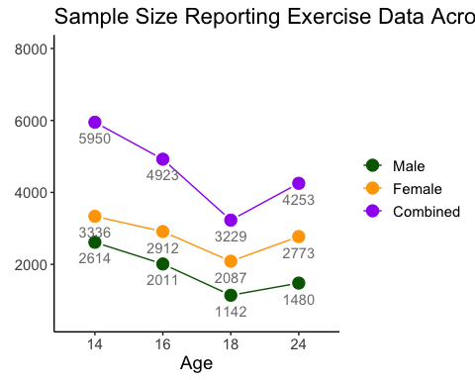

Figure 2.1: Sample Size Across Age

## 2.2 Measures

### 2.2.1 Socioeconomic Status (SES)

Measures of parent occupation were obtained for both mother and partner during child gestation. Parental occupations were then classified as unskilled(0), partly skilled (1), skilled manual (2), skilled non-manual (3), manegerial and technical (4), or professional (5). Of reported parent occupations, the highest reported occupation was used as a proxy for parent SES, to be treated as a continuous (0-5) covariate in analyses.

### 2.2.2 Eating Disorder Cognitions

Eating disorder cognitions were assessed when children were 14 years of age. Relevant variables for the current analyses included: body dissatisfaction, thin-ideal internalization, and fear of weight gain.

#### 2.2.2.1 Body Dissatisfaction

Body Dissatisfaction was assessed via an 11-item scale adapted from the satisfaction and dissatisfaction with body parts scale (Stice 2001), which has been used in several previous studies involving the ALSPAC Cohort (Bornioli et al. 2019, 2021; Schaumberg et al. 2019, 2021). Among the 11 items, one item differs between the sexes (satisfaction with ‘breasts’ is specified for girls and ‘build’ for boys). Two items address overall body satisfaction with weight and figure, and the remaining items evaluate satisfaction with specific body parts. Responses are graded on a 5 point likert scale from “Extremely Satisfied” (1) to “Extremely Dissatisfied” (5). Reliability was high in both girls (Cronbach’s $α$ = 0.909) and boys (Cronbach’s $α$ = 0.951) In the current study, body dissatisfaction was scored using the mean of all 11 items, with higher scores indicating greater body dissatisfaction, which was standardized within gender prior to analyses.

#### 2.2.2.2 Thin-ideal Internalization

Thin-ideal internalization was assessed using the Ideal-Body Stereotype Scale-Revised (IBSS-R) (Stice, Nemeroff, and Shaw 1996) Girls and boys were both asked six questions, three of which were the same and three of which were gender-specific, assessing the perceived attractiveness of same-sex individuals based on physical characteristics (e.g. being ‘lean’, ‘tall’, ‘petite’). Items are rated on a 5-point likert scale ranging from ‘Strongly Disagree’ to ‘Strongly Agree’. (Cronbach’s $α$ = 0.549 for girls; 0.714 for boys) (Calzo, Austin, and Micali 2018). As with body dissatisfaction, the mean of all items was calculated, which was then standardized within gender prior to analysis.

#### 2.2.2.3 Fear of Weight Gain

Fear of weight gain was assessed via a single item asking the degree to which participants have worried about gaining a little weight, using a likert response scale (0=not at all, 1=a little, 2=a lot, and 3=all the time).

### 2.2.3 Body Mass Index Z-score (BMI-Z) at Age 13

Child BMI-Z was assessed via two indices at age 13 years. First, objective height and weight were obtained for those who completed a clinic visit at age 13 (median age at clinic visit = 13.8 years). Second, parents reported child height and weight via questionnaire (median age = 13.1). An age and sex adjusted BMI-Z score was obtained from these self-report and clinic-recorded measurments. In order to maximize accuracy, when clinic-obtained measurements were obtained, this BMI-Z score was used (n = 5226; 67.98%). BMI-Z from parent report was used when clinic measurement was not available (n = 710; 9.24%). A portion of the sample had neither measurement available (n = 1752; 22.79%)

### 2.2.4 Exercise Measures

Questions related to driven exercise were self-reported at ages 14, 16, 18, and 24 years. Questions were adapted from the Youth Risk Behavior Survelliance System (Kann et al. 1995).

#### 2.2.4.1 Exercise for Weight Loss

At ages 14, 16, and 18 years, participants were asked if they exercised to lose weight or avoid gaining weight, with response options of: No(0), Yes-Sometimes(1), and Yes-Frequently(2).

At age 24, participants were asked the frequency with which they exercised to lose weight or avoid gaining weight, with response options of: Never, <1x/mo, 1-3x/mo, 1-4x/wk, and 5 or more times per week. For the purposes of analysis, responses at age 24 were harmonized with age 14, 16, and 18. Responses of Never were binned as “No” (0); 1x/mo - <1x/week were binned as ‘Yes - Sometimes’(1), and 1x/wk or more as ‘Yes - Frequently’(2). Once a week or more was chosen as the threshold for ‘frequent’ exercise for weight loss at age 24 to align with DSM-V diagnostic frequency thresholds for other eating disorder behaviors (i.e. binge eating, purging)(American Psychiatric Association 2013). The primary derived outcome variable of analysis for exericse for weight loss is an ordinal variable, defined as 0 = No, 1 = Sometimes, and 2 = Frequently.

#### 2.2.4.2 Driven Exercise

Issues that are associated with exercise were also reported at ages 14,16, 18, and 24 years. At all assessment points, participants reported whether exercise interferes with work/school (14,16,18), or their daily routine (24). At ages 14 and 24, participants also reported whether they exercised to lose weight even when sick or injured. At ages 16 and 18 years, participants reported whether they felt guilty about missing an exercise session – see Table 2.1 . Responses options for exercise issues were ‘No’, ‘yes - Sometimes’, or ‘Yes - Frequently’.

Table 2.1: Exercise Issues Assessed at Each Age

| age | Interferes | Sick_Injured | Guilt |
| --- | --- | --- | --- |
| 14 | x | x |  |
| 16 | x |  | x |
| 18 | x |  | x |
| 24 | x | x |  |

Exercise issues are deemmed to be ‘present’ at each time point if an individual endorses: (1) exercise interfering with work/school sometimes or more OR frequent guilt when missing an exercise session at ages 16 and 18 years and (2) exercise interfering with work/school/daily routine sometimes or more OR exercising even when sick/injured sometimes or more at ages 14 and 24 years.

The presence of driven exercise in this study was defined as exercising for weight loss **sometimes or frequently** and at least one **exercise issue** defined as present at each time point. Frequency of exercise for weight loss as sometimes or more was chosen for this definition as (1) existing literature suggests that frequency of exercise may be less important than cognitive features in defining exercise risk in the context of eating disorders (Adkins and Keel 2005; Mond et al. 2006) and (2) the nature of the epidemiological sample and the concomitant goals of this paper are such that we are interested in identifying early risk indicators, which may be best captured via a broad (vs. narrow) definition of driven exercise. The primary variable to define driven exercise was derived as described, resulting in a dichotomous outcome (0 = Absent, 1 = Present).

#### 2.2.4.3 Exercise Gropus

Exericse groups over time are defined for descriptive analyses and transition states, replicating groups defined in Schaumberg et al. (2022). Those who report no exericse for weight loss at each time point are placed in a ‘No Exercise for Weight Loss’ (No EWL) group, those who report exercise for weight loss at least sometimes, but do not meet criteria for driven exercise are placed in an ‘Exercise for Weight Loss’(EWL) group, and those meeting driven exercise criteria are placed in the ‘Driven Exercise’ (DEx) group.

# 3 Analytic Plan

Analyses will be gender stratified. The primary predictor variable of interest is time, with the purpose of investigating persistence and changes in exercise behavior over adolescent and young adult development. Secondary predictors include: BMI-Z score at age 13 and Eating Disorder Cognitions at Age 14. Parent SES will be entered as a covariate as it is possible, though not hypothesized, that exercise patterns may vary based on socioeconomic status.

## 3.1 Multi-State Transition Analyses

The first step in analyses will evaluate overall changes in the presence of exercise for weight loss and driven exercise over time in the sample. Visualization will be completed with transition plots (Cernat 2021) for those completing all four assessment points. For those completing at least two assessment points, transition analysis will include multi-state Markov models (Jackson 2021), which will describe how individuals move between the ‘No EWL’, ‘EWL’, and ‘DEx’ groups over time.

$$q_{rs}\left(t,z\left(t\right)\right)=\lim_{δt→0}P\left(S\left(t+δt\right)=s∣S\left(t\right)=r\right)/δt$$

. Exploratory analysis of transition states will examine whether baseline covariates (Parent SES, BMI-Z at age 13 years, eating disorder cognitions at age 14 years) predict transition amongst the three exercise states.

## 3.2 Missing Data

Prior to mixed-effects modeling, missing data will be imputed using the mice and miceadds packages (van Buuren and Groothuis-Oudshoorn 2021; Robitzsch, Grund, and Henke 2022). Data to be imputed is included in Supplemental Table ??. A mixed-model approach to imputation will be used. Time-invariant variables will be imputed at level-2 only using a Predictive Mean Matching (PMM) approach, and outcome variables will be imputed using 2-level approaches, which consider time (see Supplemental Table ??).

## 3.3 Mixed Effects Modeling

Mixed Effects Models will examine whether levels of exercise for weight loss (Oridnal; (Christensen 2015, 2019)) and driven exercise (Binary; (Landerman, Mustillo, and Land 2011)) change across age, using parameter pooling to combine models fit to the imputed datasets.

Nested models will be built will allow for a random intercept for each individual, then a fixed effect of Time (assessment point - with baseline set to 14 years), followed by fixed effects for all baseline predictors and covariates, and, finally, all Predictor x Time interactions. Models will be compared via the multivariate Wald test (using the D3 statistic, as recommended) (cite StefVanBuren). Parameters for each model are presented in [Supplement 1][Supplement 1]

# 4 Results

## 4.1 Descriptives

### 4.1.1 Covariates: SES, BMIZ at Age 13, ED Cognitions at age 14

Descriptives for continuous variables are provided in 4.1

Table 4.1: Continuous Variable Descriptives

| Variable | Mean | SD | Median | N | Missing N |
| --- | --- | --- | --- | --- | --- |
| BMI at Age 13 - Girls | 20.67 | 3.55 | 20 | 3199 | 1161 |
| BMI Z-score at age 13 - Girls | 0.26 | 1.08 | 0.23 | 3199 | 1161 |
| Thin-Ideal Internalization at age 14 - Girls | 2.02 | 0.5 | 2 | 3355 | 1005 |
| Body Dissatisfaction at age 14 - Girls | 2.77 | 0.97 | 2.64 | 3371 | 989 |
| BMI at Age 13 - Boys | 19.89 | 3.31 | 19.2 | 2730 | 589 |
| BMI Z-score at age 13 - Boys | 0.21 | 1.14 | 0.18 | 2730 | 589 |
| Thin-Ideal Internalization at age 14 - Boys | 2.08 | 0.57 | 2 | 2515 | 804 |
| Body Dissatisfaction at age 14 - Boys | 2.49 | 1.11 | 2.18 | 2647 | 672 |

Descriptives for ordinal variables (Parent SES and Fear of Weight Gain) are provided in Table 4.2 and Table 4.3

Table 4.2: Parent Highest Occupational Class - Responses Frequencies

|  | Response - Girls | N - Girls | Percent- Girls | N- Boys | Percent - Boys |
| --- | --- | --- | --- | --- | --- |
| Unskilled | 0 | 29 | 0.67 | 28 | 0.84 |
| Partially Skilled | 1 | 179 | 4.11 | 98 | 2.95 |
| Skilled Manual | 2 | 460 | 10.55 | 333 | 10.03 |
| Skilled Non-Manual | 3 | 1058 | 24.27 | 845 | 25.46 |
| Manegerial and Technical | 4 | 1483 | 34.01 | 1220 | 36.76 |
| Professional | 5 | 368 | 8.44 | 356 | 10.73 |
| Missing | NA | 783 | 17.96 | 439 | 13.23 |

Table 4.3: Fear of Weight Gain at Age 14 - Responses Frequencies

|  | Response - Girls | N - Girls | Percent - Girls | N- Boys | Percent - Boys |
| --- | --- | --- | --- | --- | --- |
| Not at All | 0 | 1797 | 41.22 | 2173 | 65.47 |
| A Little | 1 | 1148 | 26.33 | 371 | 11.18 |
| A Lot | 2 | 280 | 6.42 | 48 | 1.45 |
| All the Time | 3 | 118 | 2.71 | 19 | 0.57 |
| Missing | NA | 1017 | 23.33 | 708 | 21.33 |

### 4.1.2 Exercise for Weight Loss

Figure ?? shows exercise status at ages 14-24 years in girls and boys, as a percentage of the total number of boys and girls who reported exercise data at the timepoint.

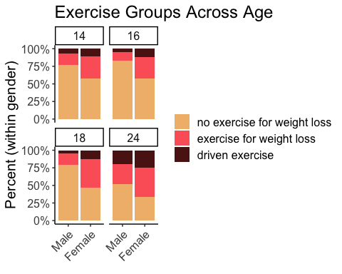

Overall, it appears that percentage of males and female in the three exercise groups is relatively stable from ages 14-18 years, with a possible increase in exercise for weight loss at age 18 among girls, and a more substantive increase in exercise for weight loss among men at age 24 along with an increase in driven exercise across gender at age 24.

## 4.2 Transitions in Exercise Groups Over Time

In the next two graphs, we examine transitions over time amongst the subset of girls (N = 1169) and boys (N = 568) who completed all assessments, ages 14-24. Transition plot code derived from Cernat (2021).

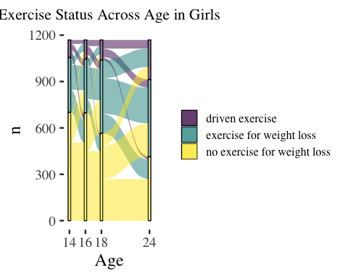

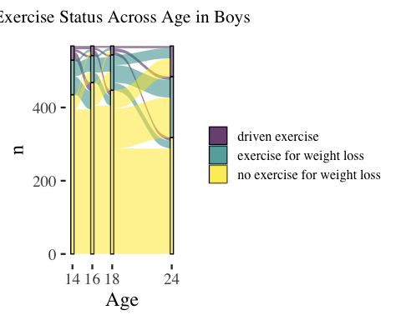

A multi-state model to panel data relies on a Markov assumption, that future evelolution only depends on the current state.

The likelihood for this basic model, used in msm, is calculated from the transition probability matrix $P\left(u;t+u\right)$. The $\left(r,s\right)$ entry of $P\left(u;t+u\right)$, $prs\left(u;t+u\right)$, is the probability of being in state s at a time t + u, given the state at time u is r.

Sampling times are ignorable if they are fixed in advance, or otherwise chosen independently of the outcome of the process

The subject id variable does not need to be numeric, but observations from the same subject must be adjacent in the dataset, and observations must be ordered by time within subjects

Below is the state table for exercise group, indicating transitions between each state. Transitions from ‘no exercise for weight loss’ to ‘driven exercise’ appear to be the least common of all transitions, wtih 164 instances of this transition.

### 4.2.1 Girls

## to  
## from 1 2 3  
## 1 2098 1003 323  
## 2 617 1025 395  
## 3 182 276 233

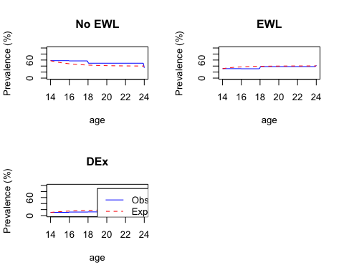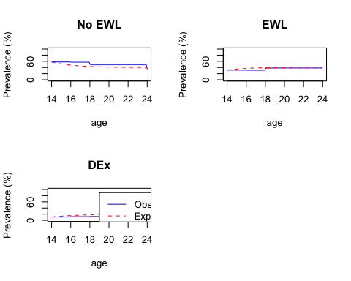

Table 4.4: Hazard Ratios for Transitions with Baseline Covariates - Girls

Covariate

No EWL to EWL

EWL to No EWL

EWL to DEx

DEx to EWL

Thin-Ideal Internalization [14]

1.052 ( 0.931, 1.188 )

0.963 ( 0.822, 1.127 )

0.972 ( 0.781, 1.210 )

0.947 ( 0.745, 1.203 )

Body Satisfaction [14]

1.198 ( 1.004, 1.429 )

1.326 ( 1.047, 1.680 )

1.075 ( 0.807, 1.431 )

1.102 ( 0.791, 1.536 )

Fear of Weight Gain [14]

1.485 ( 1.208, 1.824 )

1.244 ( 0.977, 1.584 )

1.278 ( 0.866, 1.887 )

1.076 ( 0.706, 1.641 )

BMI Z-score [13]

1.429 ( 1.279, 1.596 )

1.086 ( 0.934, 1.263 )

1.077 ( 0.826, 1.403 )

1.099 ( 0.811, 1.488 )

Parent Occupation

1.000 ( 0.899, 1.113 )

0.873 ( 0.764, 0.997 )

1.019 ( 0.823, 1.261 )

1.110 ( 0.874, 1.409 )

(#tab:unnamed-chunk-5)Hazard Ratios for Transitions with Baseline Covariates and Constrained Transitions - girls

Covariate

No EWL to EWL

No EWL to DEx

EWL to No EWL

EWL to DEx

DEx to No EWL

DEx to EWL

Fear of Weight Gain [14]

1.08 ( 0.97, 1.20 )

1.42 ( 1.20, 1.68 )

0.95 ( 0.84, 1.08 )

1.13 ( 0.97, 1.31 )

1.00 ( 0.81, 1.24 )

1.02 ( 0.86, 1.22 )

BMI Z-score [13]

1.23 ( 1.15, 1.31 )

1.29 ( 1.15, 1.46 )

0.88 ( 0.80, 0.98 )

1.02 ( 0.90, 1.16 )

0.99 ( 0.83, 1.18 )

1.01 ( 0.88, 1.17 )

Thin Ideal Internalization [14]

1.04 ( 0.97, 1.12 )

1.03 ( 0.91, 1.17 )

0.95 ( 0.86, 1.05 )

1.03 ( 0.93, 1.16 )

0.87 ( 0.73, 1.03 )

1.02 ( 0.91, 1.16 )

Body Satisfaction [14]

1.02 ( 0.95, 1.09 )

0.92 ( 0.80, 1.05 )

1.01 ( 0.90, 1.13 )

1.13 ( 0.98, 1.30 )

1.10 ( 0.91, 1.34 )

1.04 ( 0.88, 1.22 )

Parent Occupation

1.06 ( 0.99, 1.14 )

1.00 ( 0.89, 1.14 )

0.89 ( 0.81, 0.97 )

1.01 ( 0.90, 1.14 )

1.00 ( 0.84, 1.19 )

1.10 ( 0.95, 1.27 )

### 4.2.2 Boys

## to  
## from 1 2 3  
## 1 2444 454 199  
## 2 275 222 94  
## 3 114 44 50

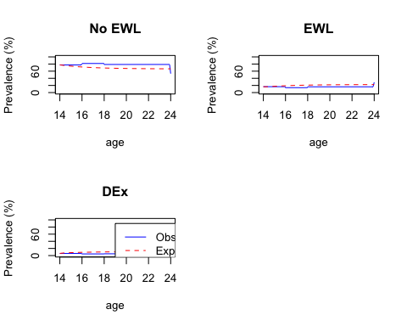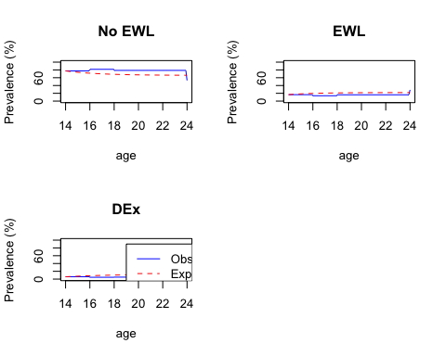

(#tab:Boys Hazard Ratios)Hazard Ratios for Transitions with Baseline Covariates - Boys

Covariate

No EWL to EWL

EWL to No EWL

EWL to DEx

DEx to EWL

Fear of Weight Gain [14]

1.97 ( 1.05, 3.70 )

2.07 ( 1.08, 3.96 )

0.09 ( 0.00, 162.53 )

0.07 ( 0.00, 140.63 )

BMI Z-score [13]

1.86 ( 1.60, 2.16 )

1.04 ( 0.86, 1.26 )

47.95 ( 0.01, 203082.35 )

45.84 ( 0.01, 182534.35 )

Thin Ideal Internalization [14]

1.15 ( 0.98, 1.35 )

1.11 ( 0.91, 1.36 )

10.17 ( 0.03, 3582.63 )

10.05 ( 0.03, 3476.67 )

column_spec(2, color = case_when(Girl_HRs$Covariate %in% c(‘Body Satisfaction [14]’, ‘Fear of Weight Gain [14]’, ‘BMI Z-score [13]’) ~ ‘blue’, TRUE ~‘black’)) %>%

(#tab:unnamed-chunk-7)Hazard Ratios for Transitions with Baseline Covariates and Constrained Transitions - Boys

Covariate

No EWL to EWL

No EWL to DEx

EWL to No EWL

EWL to DEx

DEx to No EWL

DEx to EWL

Fear of Weight Gain [14]

1.00 ( 0.79, 1.26 )

1.06 ( 0.76, 1.47 )

1.16 ( 0.92, 1.47 )

1.02 ( 0.67, 1.55 )

0.88 ( 0.64, 1.22 )

0.91 ( 0.55, 1.51 )

BMI Z-score [13]

1.59 ( 1.43, 1.77 )

1.94 ( 1.63, 2.30 )

0.79 ( 0.69, 0.92 )

1.37 ( 1.04, 1.80 )

0.80 ( 0.63, 1.02 )

1.79 ( 1.19, 2.71 )

Thin Ideal Internalization [14]

0.97 ( 0.86, 1.10 )

1.11 ( 0.94, 1.32 )

1.04 ( 0.90, 1.20 )

0.87 ( 0.65, 1.15 )

0.93 ( 0.76, 1.15 )

1.15 ( 0.83, 1.59 )

Body Satisfaction [14]

1.02 ( 0.92, 1.14 )

0.93 ( 0.78, 1.12 )

1.02 ( 0.86, 1.21 )

0.84 ( 0.61, 1.16 )

0.95 ( 0.68, 1.31 )

0.67 ( 0.36, 1.25 )

Parent Occupation

1.03 ( 0.92, 1.16 )

0.90 ( 0.77, 1.07 )

0.95 ( 0.81, 1.11 )

1.14 ( 0.87, 1.51 )

0.96 ( 0.76, 1.21 )

1.60 ( 1.04, 2.46 )

## 4.3 Mixed Effects Models - Driven Exercise over Time

### 4.3.1 Girls

(#tab:DEx Poled Coeffs Table - Girls)Table 1: Parameter Estimates for Models Predicting Driven Exercise in Girls

Model

term

estimate

std.error

0.25 %

99.75 %

Baseline Model

(Intercept)

0.132

0.045

0.007

0.258

Age Effect Model

(Intercept)

0.093

0.057

-0.066

0.253

Age Effect Model

Age

1.080

0.007

1.061

1.099

Step 1 Covariates

(Intercept)

0.079

0.124

-0.269

0.427

Step 1 Covariates

Age

1.080

0.007

1.062

1.099

Step 1 Covariates

Parent SES

1.023

0.034

0.927

1.118

Step 1 Covariates

BMI Z - Age 13

1.347

0.030

1.263

1.430

Step 2 Covariates

(Intercept)

0.061

0.125

-0.290

0.411

Step 2 Covariates

Age

1.081

0.007

1.062

1.100

Step 2 Covariates

Parent SES

1.024

0.034

0.930

1.118

Step 2 Covariates

BMI Z - Age 13

1.166

0.029

1.084

1.248

Step 2 Covariates

Fear of Wt Gain - Age 14

1.625

0.044

1.502

1.747

Step 2 Covariates

Body Satisifaction - Age 14

1.068

0.038

0.962

1.174

Step 2 Covariates

Thin-ideal Internalization - Age 14

1.138

0.034

1.041

1.235

Step 3 Age x Cov Interactions

(Intercept)

0.055

0.131

-0.314

0.424

Step 3 Age x Cov Interactions

Age

1.102

0.010

1.073

1.131

Step 3 Age x Cov Interactions

Parent SES

1.024

0.034

0.930

1.119

Step 3 Age x Cov Interactions

BMI Z - Age 13

1.151

0.043

1.030

1.271

Step 3 Age x Cov Interactions

Fear of Wt Gain - Age 14

1.784

0.057

1.623

1.945

Step 3 Age x Cov Interactions

Body Satisifaction - Age 14

1.135

0.059

0.969

1.301

Step 3 Age x Cov Interactions

Thin-ideal Internalization - Age 14

1.220

0.046

1.091

1.349

Step 3 Age x Cov Interactions

Age x BMI (13)

1.003

0.007

0.984

1.022

Step 3 Age x Cov Interactions

Age x Fear of Wt Gain (14)

0.979

0.009

0.954

1.005

Step 3 Age x Cov Interactions

Age x Body Satisfaction (14)

0.987

0.008

0.964

1.010

Step 3 Age x Cov Interactions

Age x Thin-Ideal Internalization (14)

0.985

0.007

0.965

1.004

Table 4.7: Table 2: Model Comparisons - Driven Exercise in Girls

statistic

df1

df2

p.value

riv

Baseline vs. Age Effects

134.731

1

235.974

0.000

0.302

Age vs. Step 1 Covariates

43.955

2

212.241

0.000

0.635

Step 1 vs. Step 2 Covariates

54.874

3

233.182

0.000

0.881

Step 2 vs. Age x Covariate Interactions

4.432

4

488.628

0.002

0.596

### 4.3.2 Boys

(#tab:DEx Poled Coeffs Table - Boys)Table 1: Parameter Estimates for Models Predicting Driven Exercise in Boys

Model

term

estimate

std.error

0.25 %

99.75 %

Baseline Model

(Intercept)

0.050

0.098

-0.224

0.324

Age Effect Model

(Intercept)

0.032

0.121

-0.309

0.372

Age Effect Model

Age

1.098

0.010

1.070

1.126

Step 1 Covariates

(Intercept)

0.032

0.229

-0.613

0.676

Step 1 Covariates

Age

1.099

0.010

1.071

1.127

Step 1 Covariates

Parent SES

0.963

0.050

0.821

1.105

Step 1 Covariates

BMI Z - Age 13

1.885

0.052

1.740

2.030

Step 2 Covariates

(Intercept)

0.028

0.228

-0.613

0.670

Step 2 Covariates

Age

1.100

0.010

1.071

1.128

Step 2 Covariates

Parent SES

0.979

0.049

0.841

1.117

Step 2 Covariates

BMI Z - Age 13

1.759

0.047

1.626

1.892

Step 2 Covariates

Fear of Wt Gain - Age 14

1.852

0.090

1.599

2.106

Step 2 Covariates

Body Satisifaction - Age 14

1.001

0.058

0.837

1.165

Step 2 Covariates

Thin-ideal Internalization - Age 14

1.168

0.067

0.980

1.355

Step 3 Age x Cov Interactions

(Intercept)

0.026

0.224

-0.604

0.656

Step 3 Age x Cov Interactions

Age

1.121

0.014

1.082

1.160

Step 3 Age x Cov Interactions

Parent SES

0.975

0.048

0.840

1.111

Step 3 Age x Cov Interactions

BMI Z - Age 13

1.789

0.066

1.604

1.974

Step 3 Age x Cov Interactions

Fear of Wt Gain - Age 14

2.261

0.107

1.961

2.560

Step 3 Age x Cov Interactions

Body Satisifaction - Age 14

1.000

0.075

0.790

1.209

Step 3 Age x Cov Interactions

Thin-ideal Internalization - Age 14

1.180

0.077

0.963

1.396

Step 3 Age x Cov Interactions

Age x BMI (13)

0.997

0.010

0.968

1.025

Step 3 Age x Cov Interactions

Age x Fear of Wt Gain (14)

0.956

0.017

0.907

1.005

Step 3 Age x Cov Interactions

Age x Body Satisfaction (14)

1.000

0.011

0.970

1.030

Step 3 Age x Cov Interactions

Age x Thin-Ideal Internalization (14)

0.997

0.010

0.970

1.025

Table 4.8: Table 2: Model Comparisons - Driven Exercise in boys

statistic

df1

df2

p.value

riv

Baseline vs. Age Effects

86.949

1

201.418

0.000

0.337

Age vs. Step 1 Covariates

80.459

2

153.396

0.000

0.853

Step 1 vs. Step 2 Covariates

17.101

3

142.191

0.000

1.543

Step 2 vs. Age x Covariate Interactions

2.077

4

555.176

0.082

0.532

## 4.4 Mixed-Effect Models - Exercise for Weight Loss

We are utilizing the same approach to examine endorsement of exercise for weight loss over time in the sample, but use an ordinal model (clmm)

### 4.4.1 Girls

(#tab:EWL Poled Coeffs Table - Girls)Table 1: Parameter Estimates for Models Predicting Driven Exercise in Girls

Model

term

OR

OR LCI

OR HCI

Age Effect Model

0|1

1.468

1.338

1.611

Age Effect Model

1|2

7.484

6.676

8.390

Age Effect Model

Age

1.113

1.097

1.130

Step 1 Covariates

0|1

2.137

1.674

2.729

Step 1 Covariates

1|2

10.888

8.423

14.074

Step 1 Covariates

Age

1.113

1.097

1.130

Step 1 Covariates

Parent SES

1.076

1.007

1.149

Step 1 Covariates

BMI Z - Age 13

1.564

1.468

1.665

Step 2 Covariates

0|1

2.772

2.186

3.514

Step 2 Covariates

1|2

14.140

10.962

18.240

Step 2 Covariates

Age

1.113

1.096

1.130

Step 2 Covariates

Parent SES

1.074

1.011

1.141

Step 2 Covariates

BMI Z - Age 13

1.366

1.279

1.459

Step 2 Covariates

Fear of Wt Gain - Age 14

1.634

1.478

1.805

Step 2 Covariates

Body Satisifaction - Age 14

1.074

0.992

1.162

Step 2 Covariates

Thin-ideal Internalization - Age 14

1.101

1.017

1.191

Step 3 Age x Cov Interactions

0|1

3.065

2.397

3.918

Step 3 Age x Cov Interactions

1|2

15.755

12.089

20.532

Step 3 Age x Cov Interactions

Age

1.138

1.116

1.160

Step 3 Age x Cov Interactions

Parent SES

1.075

1.012

1.143

Step 3 Age x Cov Interactions

BMI Z - Age 13

1.436

1.324

1.557

Step 3 Age x Cov Interactions

Fear of Wt Gain - Age 14

1.804

1.614

2.017

Step 3 Age x Cov Interactions

Body Satisifaction - Age 14

1.155

1.039

1.283

Step 3 Age x Cov Interactions

Thin-ideal Internalization - Age 14

1.130

1.030

1.241

Step 3 Age x Cov Interactions

Age x BMI (13)

0.989

0.975

1.003

Step 3 Age x Cov Interactions

Age x Fear of Wt Gain (14)

0.975

0.957

0.995

Step 3 Age x Cov Interactions

Age x Body Satisfaction (14)

0.983

0.967

0.999

Step 3 Age x Cov Interactions

Age x Thin-Ideal Internalization (14)

0.994

0.980

1.008

### 4.4.2 Boys

(#tab:EWL Poled Coeffs Table - boys)Table 1: Parameter Estimates for Models Predicting Driven Exercise in boys

Model

term

OR

OR LCI

OR HCI

Age Effect Model

0|1

5.677

4.887

6.596

Age Effect Model

1|2

20.072

16.263

24.773

Age Effect Model

Age

1.104

1.085

1.124

Step 1 Covariates

0|1

7.109

4.685

10.786

Step 1 Covariates

1|2

25.229

15.777

40.343

Step 1 Covariates

Age

1.105

1.085

1.125

Step 1 Covariates

Parent SES

1.020

0.919

1.131

Step 1 Covariates

BMI Z - Age 13

1.912

1.713

2.134

Step 2 Covariates

0|1

8.047

5.296

12.228

Step 2 Covariates

1|2

28.631

17.832

45.970

Step 2 Covariates

Age

1.105

1.085

1.125

Step 2 Covariates

Parent SES

1.030

0.930

1.141

Step 2 Covariates

BMI Z - Age 13

1.809

1.613

2.028

Step 2 Covariates

Fear of Wt Gain - Age 14

1.720

1.447

2.044

Step 2 Covariates

Body Satisifaction - Age 14

1.014

0.912

1.127

Step 2 Covariates

Thin-ideal Internalization - Age 14

1.081

0.973

1.203

Step 3 Age x Cov Interactions

0|1

8.826

5.801

13.429

Step 3 Age x Cov Interactions

1|2

31.496

19.623

50.554

Step 3 Age x Cov Interactions

Age

1.125

1.100

1.151

Step 3 Age x Cov Interactions

Parent SES

1.030

0.930

1.141

Step 3 Age x Cov Interactions

BMI Z - Age 13

1.890

1.657

2.155

Step 3 Age x Cov Interactions

Fear of Wt Gain - Age 14

2.071

1.667

2.574

Step 3 Age x Cov Interactions

Body Satisifaction - Age 14

1.067

0.933

1.219

Step 3 Age x Cov Interactions

Thin-ideal Internalization - Age 14

1.086

0.950

1.243

Step 3 Age x Cov Interactions

Age x BMI (13)

0.991

0.975

1.007

Step 3 Age x Cov Interactions

Age x Fear of Wt Gain (14)

0.956

0.923

0.990

Step 3 Age x Cov Interactions

Age x Body Satisfaction (14)

0.989

0.968

1.010

Step 3 Age x Cov Interactions

Age x Thin-Ideal Internalization (14)

0.999

0.981

1.017

# 5 Discussion

# References

# 6 Supplement 1 - Mixed Models

### 6.0.1 1. Baseline Model

$$Driven Exercise_{ij} = b_{0j} + e_{ij}\

b_{0j} = *{00} + u*{0j}$$

&

$$Exercise for Weight Loss_{ij} = b_{0j} + e_{ij}\

b_{0j} = *{00} + u*{0j}$$

### 6.0.2 2. Random Effect of Time

### 6.0.3 3. Main Effects of Predictors and Covariates

### 6.0.4 4. Time x Predictor Interactions

$$
Driven\ Exercise_{ij} = b_{0j} + b_1Age + e_{ij} \\
b_{0j} = \gamma_{00} + u_{0j}
$$

$$
Driven\ Exercise_{ij} = b_{0j} + b_1Age + b_2ParentSES + b_3BMI13 + b_4TI14 + b_5BodyDissat14 + b_6FearWt14 + e_{ij} \\
b_{0j} = \gamma_{00} + u_{0j}
$$

(#tab:imp_table1)Imputation Data

Variable

Data_Type

Method

Parent SES

Ordinal

PMM - Level 2

BMI Z-score (13)

Continuous

PMM - Level 2

Thin-ideal Internalization Z-score (14)

Continuous

PMM - Level 2

Body Dissatisfaction Z-score (14)

Continuous

PMM - Level 2

Fear of Weight Gain (14)

Ordinal

PMM - Level 2

Exercise for Weight Loss

Ordinal

2-level PMM

Driven Exercise

Binary

2-level Binary

Note. PMM = ‘Predictive Mean Matching’

Adkins, E. C., and P. K. Keel. 2005. “Does "Excessive" or "Compulsive" Best Describe Exercise as a Symptom of Bulimia Nervosa.” *Int J Eat Disord* 38 (July): 24–29. <https://doi.org/10.1002/eat.20140>.

American Psychiatric Association. 2013. *Diagnostic and Statistical Manual of Mental Disorders*. American Psychiatric Publishing.

Bornioli, A., Helena Lewis-Smith, Amy Slater, and Isabelle Bray. 2021. “Body Dissatisfaction Predicts the Onset of Depression Among Adolescent Females and Males: A Prospective Study.” *J Epidemiol Community Health* 75 (4): 343–48. <https://doi.org/10.1136/jech-2019-213033>.

Bornioli, A., Helena Lewis-Smith, Andrew Smith, Amy Slater, and Isabelle Bray. 2019. “Adolescent Body Dissatisfaction and Disordered Eating: Predictors of Later Risky Health Behaviours.” *Social Science & Medicine* 238 (October): 112458. <https://doi.org/10.1016/j.socscimed.2019.112458>.

Boyd, A., J. Golding, J. Macleod, D. A. Lawlor, A. Fraser, J. Henderson, L. Molloy, A. Ness, S. Ring, and G. Davey Smith. 2013. “Cohort Profile: The ’Children of the 90s’the Index Offspring of the Avon Longitudinal Study of Parents and Children.” *Int J Epidemiol* 42 (1): 111–27. <https://doi.org/10.1093/ije/dys064>.

Calzo, J. P., S. B. Austin, and N. Micali. 2018. “Sexual Orientation Disparities in Eating Disorder Symptoms Among Adolescent Boys and Girls in the UK.” *Eur Child Adolesc Psychiatry*, March. <https://doi.org/10.1007/s00787-018-1145-9>.

Cernat, Alexandru. 2021. “Visualizing Transitions in Time Using R.”

Christensen, Rune Haubo B. 2015. “Analysis of Ordinal Data with Cumulative Link Models Estimation with the R-package Ordinal.” *R-Package Version*, no. 28: 31.

———. 2019. “A Tutorial on Fitting Cumulative Link Mixed Models with Clmm2 from the Ordinal Package.” *Https://Cran. R-Project. Org/Web/Packages/Ordinal/Accessed*, 10.

Fraser, Abigail, Corrie Macdonald-Wallis, Kate Tilling, Andy Boyd, Jean Golding, George Davey Smith, John Henderson, et al. 2013. “Cohort Profile: The Avon Longitudinal Study of Parents and Children: ALSPAC Mothers Cohort.” *Int J Epidemiol* 42 (1): 97–110. <https://doi.org/10.1093/ije/dys066>.

Jackson, Christopher. 2021. “Multi-State Modelling with R: The Msm Package.”

Kann, L., C. W. Warren, W. A. Harris, J. L. Collins, K. A. Douglas, M. E. Collins, B. I. Williams, J. G. Ross, and L. J. Kolbe. 1995. “Youth Risk Behavior Surveillance, 1993.” *J Sch Health* 65 (5): 163–71.

Landerman, Lawrence R., Sarah A. Mustillo, and Kenneth C. Land. 2011. “Modeling Repeated Measures of Dichotomous Data.” *Soc Sci Res* 40 (5): 1456–64. <https://doi.org/10.1016/j.ssresearch.2011.05.006>.

Mond, J. M., P. J. Hay, B. Rodgers, and C. Owen. 2006. “An Update on the Definition of "Excessive Exercise" in Eating Disorders Research.” *Int J Eat Disord* 39 (March): 147–53. <https://doi.org/10.1002/eat.20214>.

Robitzsch, Alexander, Simon Grund, and Thorsten Henke. 2022. *Miceadds: Some Additional Multiple Imputation Functions, Especially for Mice*. <https://CRAN.R-project.org/package=miceadds>.

Schaumberg, K., Lauren Robinson, Ayelet Hochman, and Nadia Micali. 2022. “Prospective Associations Between Driven Exercise and Other Eating Disorder Behaviors in Adolescence: A Longitudinal Cohort Study.” *J Adolesc Health*, January, S1054-139X(21)00635-2. <https://doi.org/10.1016/j.jadohealth.2021.11.022>.

Schaumberg, K., Stephanie C. Zerwas, Cynthia M. Bulik, Chiara Fiorentini, and Nadia Micali. 2021. “Prospective Associations Between Childhood Social Communication Processes and Adolescent Eating Disorder Symptoms in an Epidemiological Sample.” *Eur Child Adolesc Psychiatry* 30 (12): 1929–38. <https://doi.org/10.1007/s00787-020-01655-9>.

Schaumberg, K., Stephanie Zerwas, Erica Goodman, Zeynep Yilmaz, Cynthia M. Bulik, and Nadia Micali. 2019. “Anxiety Disorder Symptoms at Age 10 Predict Eating Disorder Symptoms and Diagnoses in Adolescence.” *Journal of Child Psychology and Psychiatry* 60 (6): 686–96. <https://doi.org/10.1111/jcpp.12984>.

Stice, E. 2001. “A Prospective Test of the Dual-Pathway Model of Bulimic Pathology: Mediating Effects of Dieting and Negative Affect.” *Journal of Abnormal Psychology* 110 (1): 124. <https://doi.org/10.1037//0021-843X.110.1.124>.

Stice, E., C. Nemeroff, and H Shaw. 1996. “Test of the Dual Pathway Model of Bulimia Nervosa: Evidence for Dietary Restraint and Affect Regulation Mechanisms.” *Journal of Social & Clinical Psychology* 15 (3): 340–63.

van Buuren, Stef, and Karin Groothuis-Oudshoorn. 2021. *Mice: Multivariate Imputation by Chained Equations*. <https://CRAN.R-project.org/package=mice>.