Supplementary Figures
  - Exploring Deviations from Predicted BMI in ABCD Data
2026-10-09

Supplementary Figure S1
Weight-based accuracy metrics for forecast deviation classification.

Panel A: Full Classification Performance Heatmap
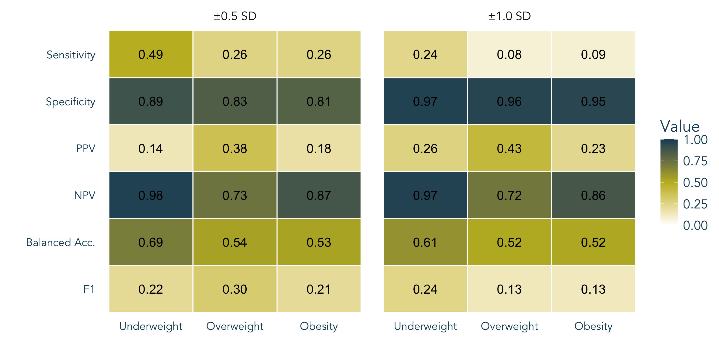
Supplementary Figure S1a. Full accuracy metrics (sensitivity, specificity, PPV, NPV, balanced accuracy, F1) for the mean + most recent forecast method at ±0.5 SD and ±1.0 SD thresholds, averaged across Years 2, 4, and 6.

Panel B: Overweight Concordance
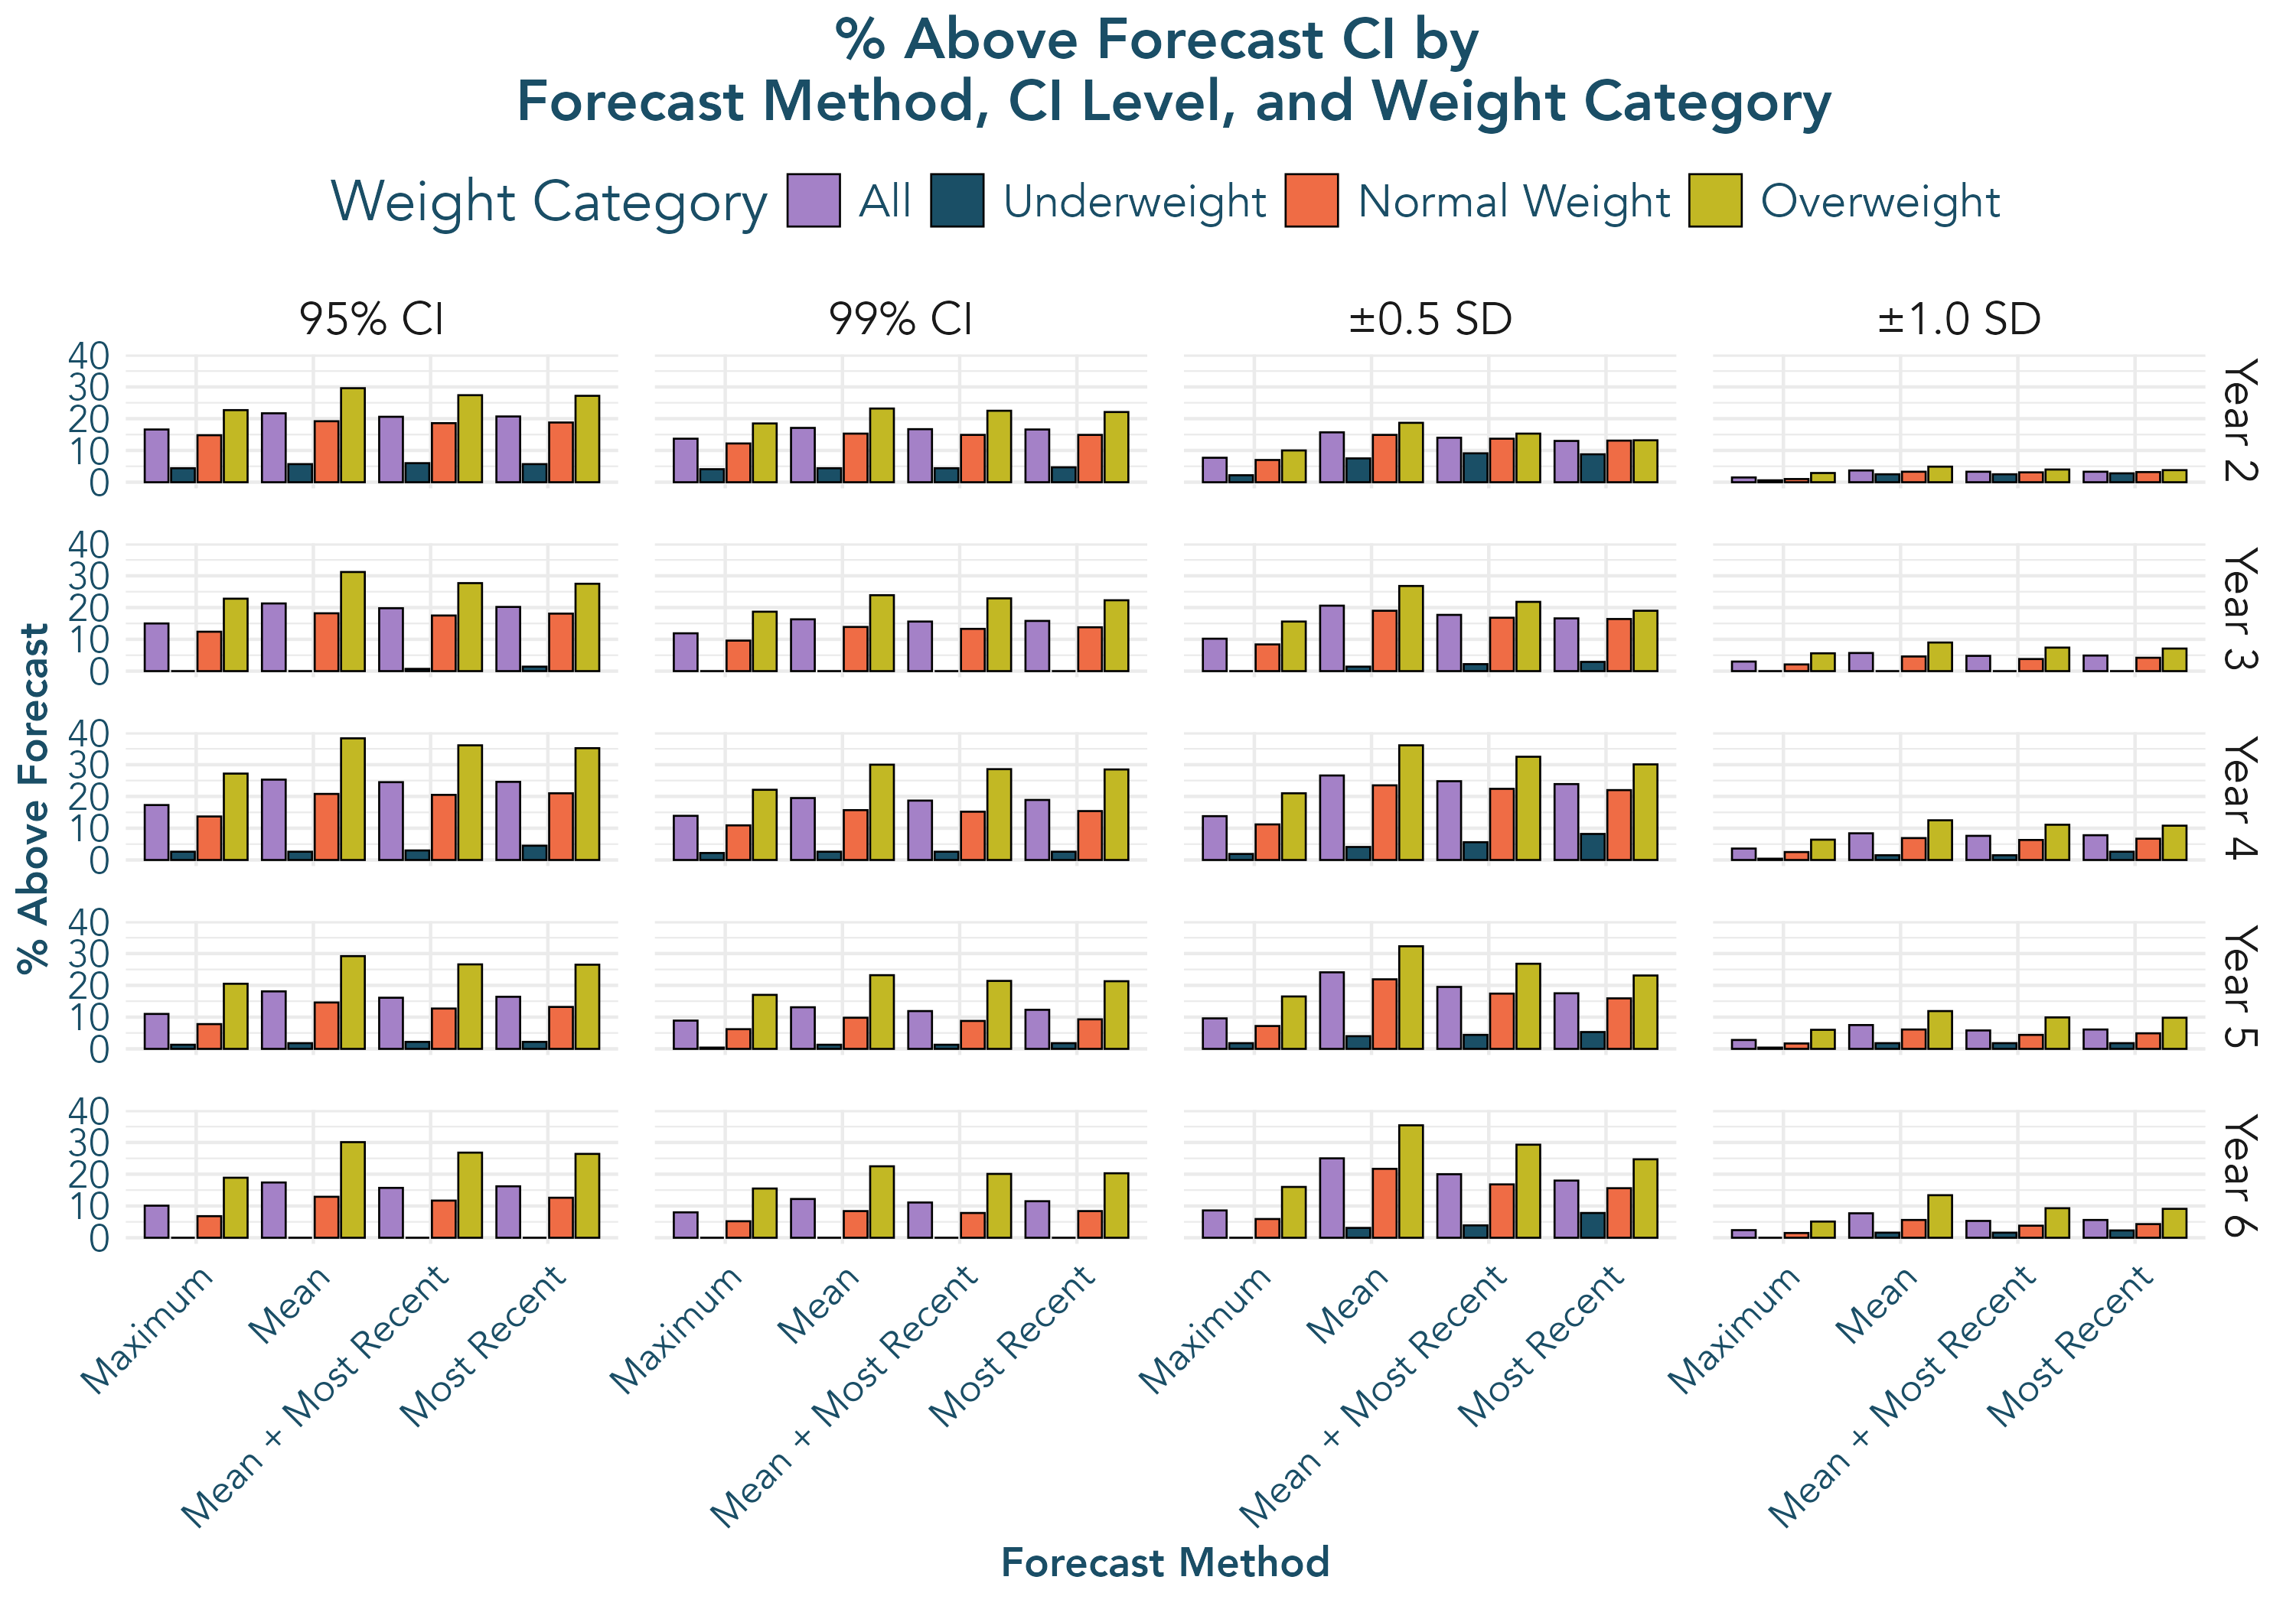
Supplementary Figure S1b. Concordance between population-based overweight classification and forecast-derived above-predicted status by forecast method, CI level, and timepoint.

Panel C: Underweight Concordance
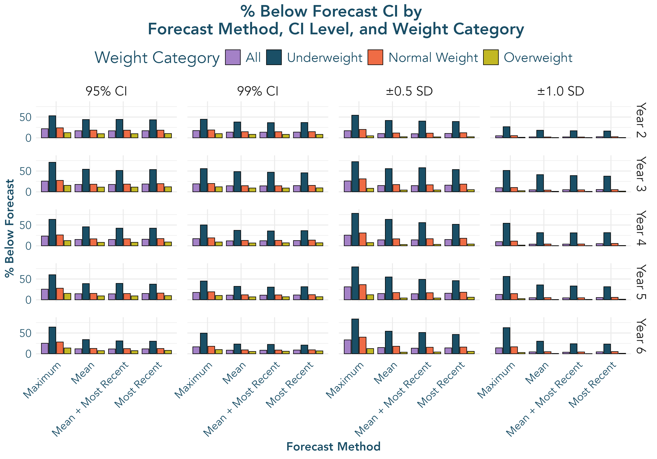
Supplementary Figure S1c. Concordance between population-based underweight classification and forecast-derived below-predicted status by forecast method, CI level, and timepoint.

Supplementary Figure S2
Continuous BMIz deviation predicting ED symptoms across all forecast methods.
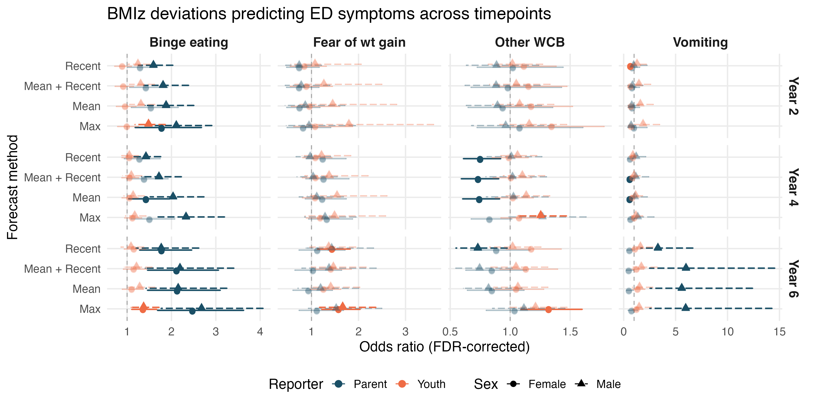
Supplementary Figure S2. Odds ratios from sex-stratified logistic regressions predicting ED symptoms from continuous BMIz deviation, shown for all four forecast methods (mean, most recent, maximum, mean + most recent). Opaque points are FDR-significant (p < .05), faded points are non-significant. Reporter distinguished by color; sex by line type/shape.

Supplementary Figure S3
Sex-stratified correlations among BMIz deviation, BMIz, pubertal development, and age.
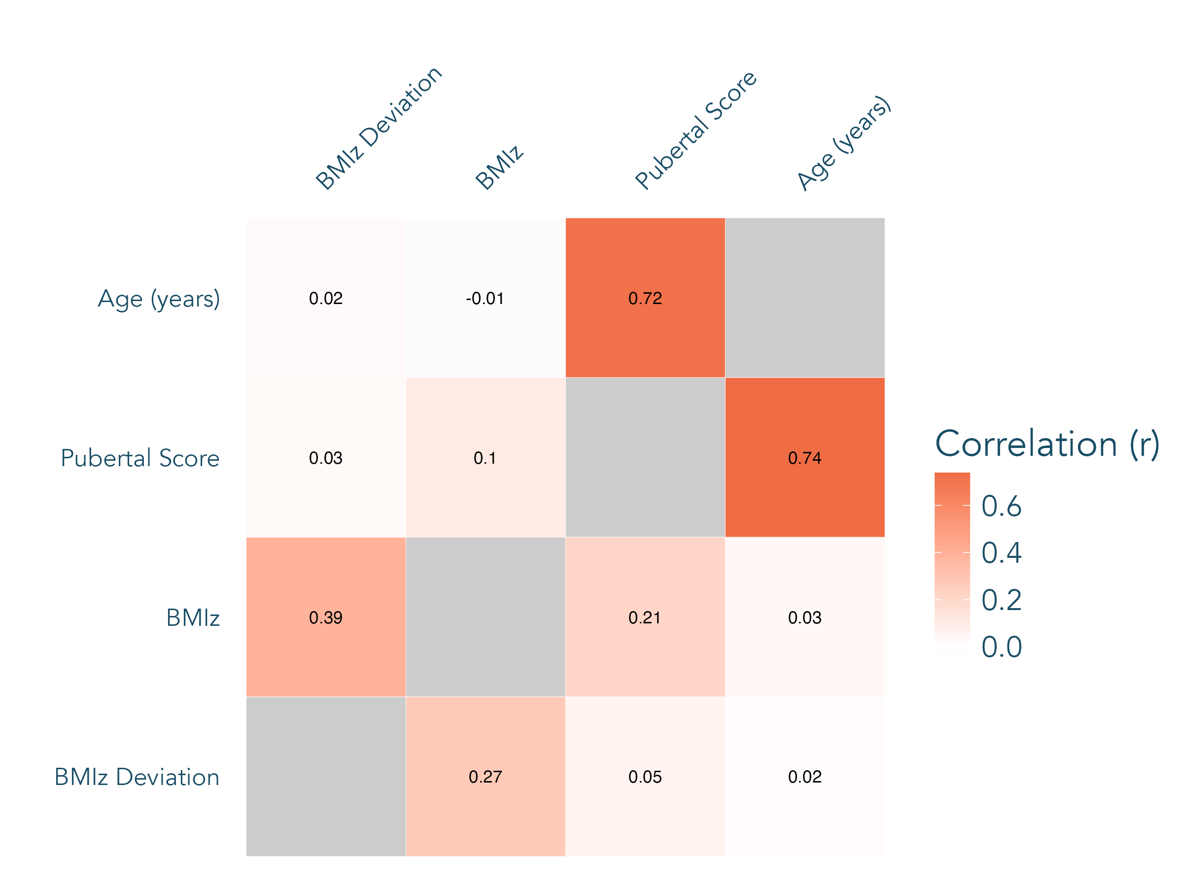
Supplementary Figure S3. Sex-stratified correlations among continuous BMIz deviation (observed minus forecasted BMIz; mean with most recent method, ±0.5 SD), BMIz, pubertal development score, and age, pooled across Years 2, 4, and 6. Boys are shown in the upper-left triangle and girls in the lower-right triangle; values are Pearson r. Pre-registered correlations with each ED symptom, by timepoint and reporter, are reported in Supplementary Table S9.

Supplementary Figure S4
Moderation of the growth deviation–ED association by BMIz level and pubertal stage.
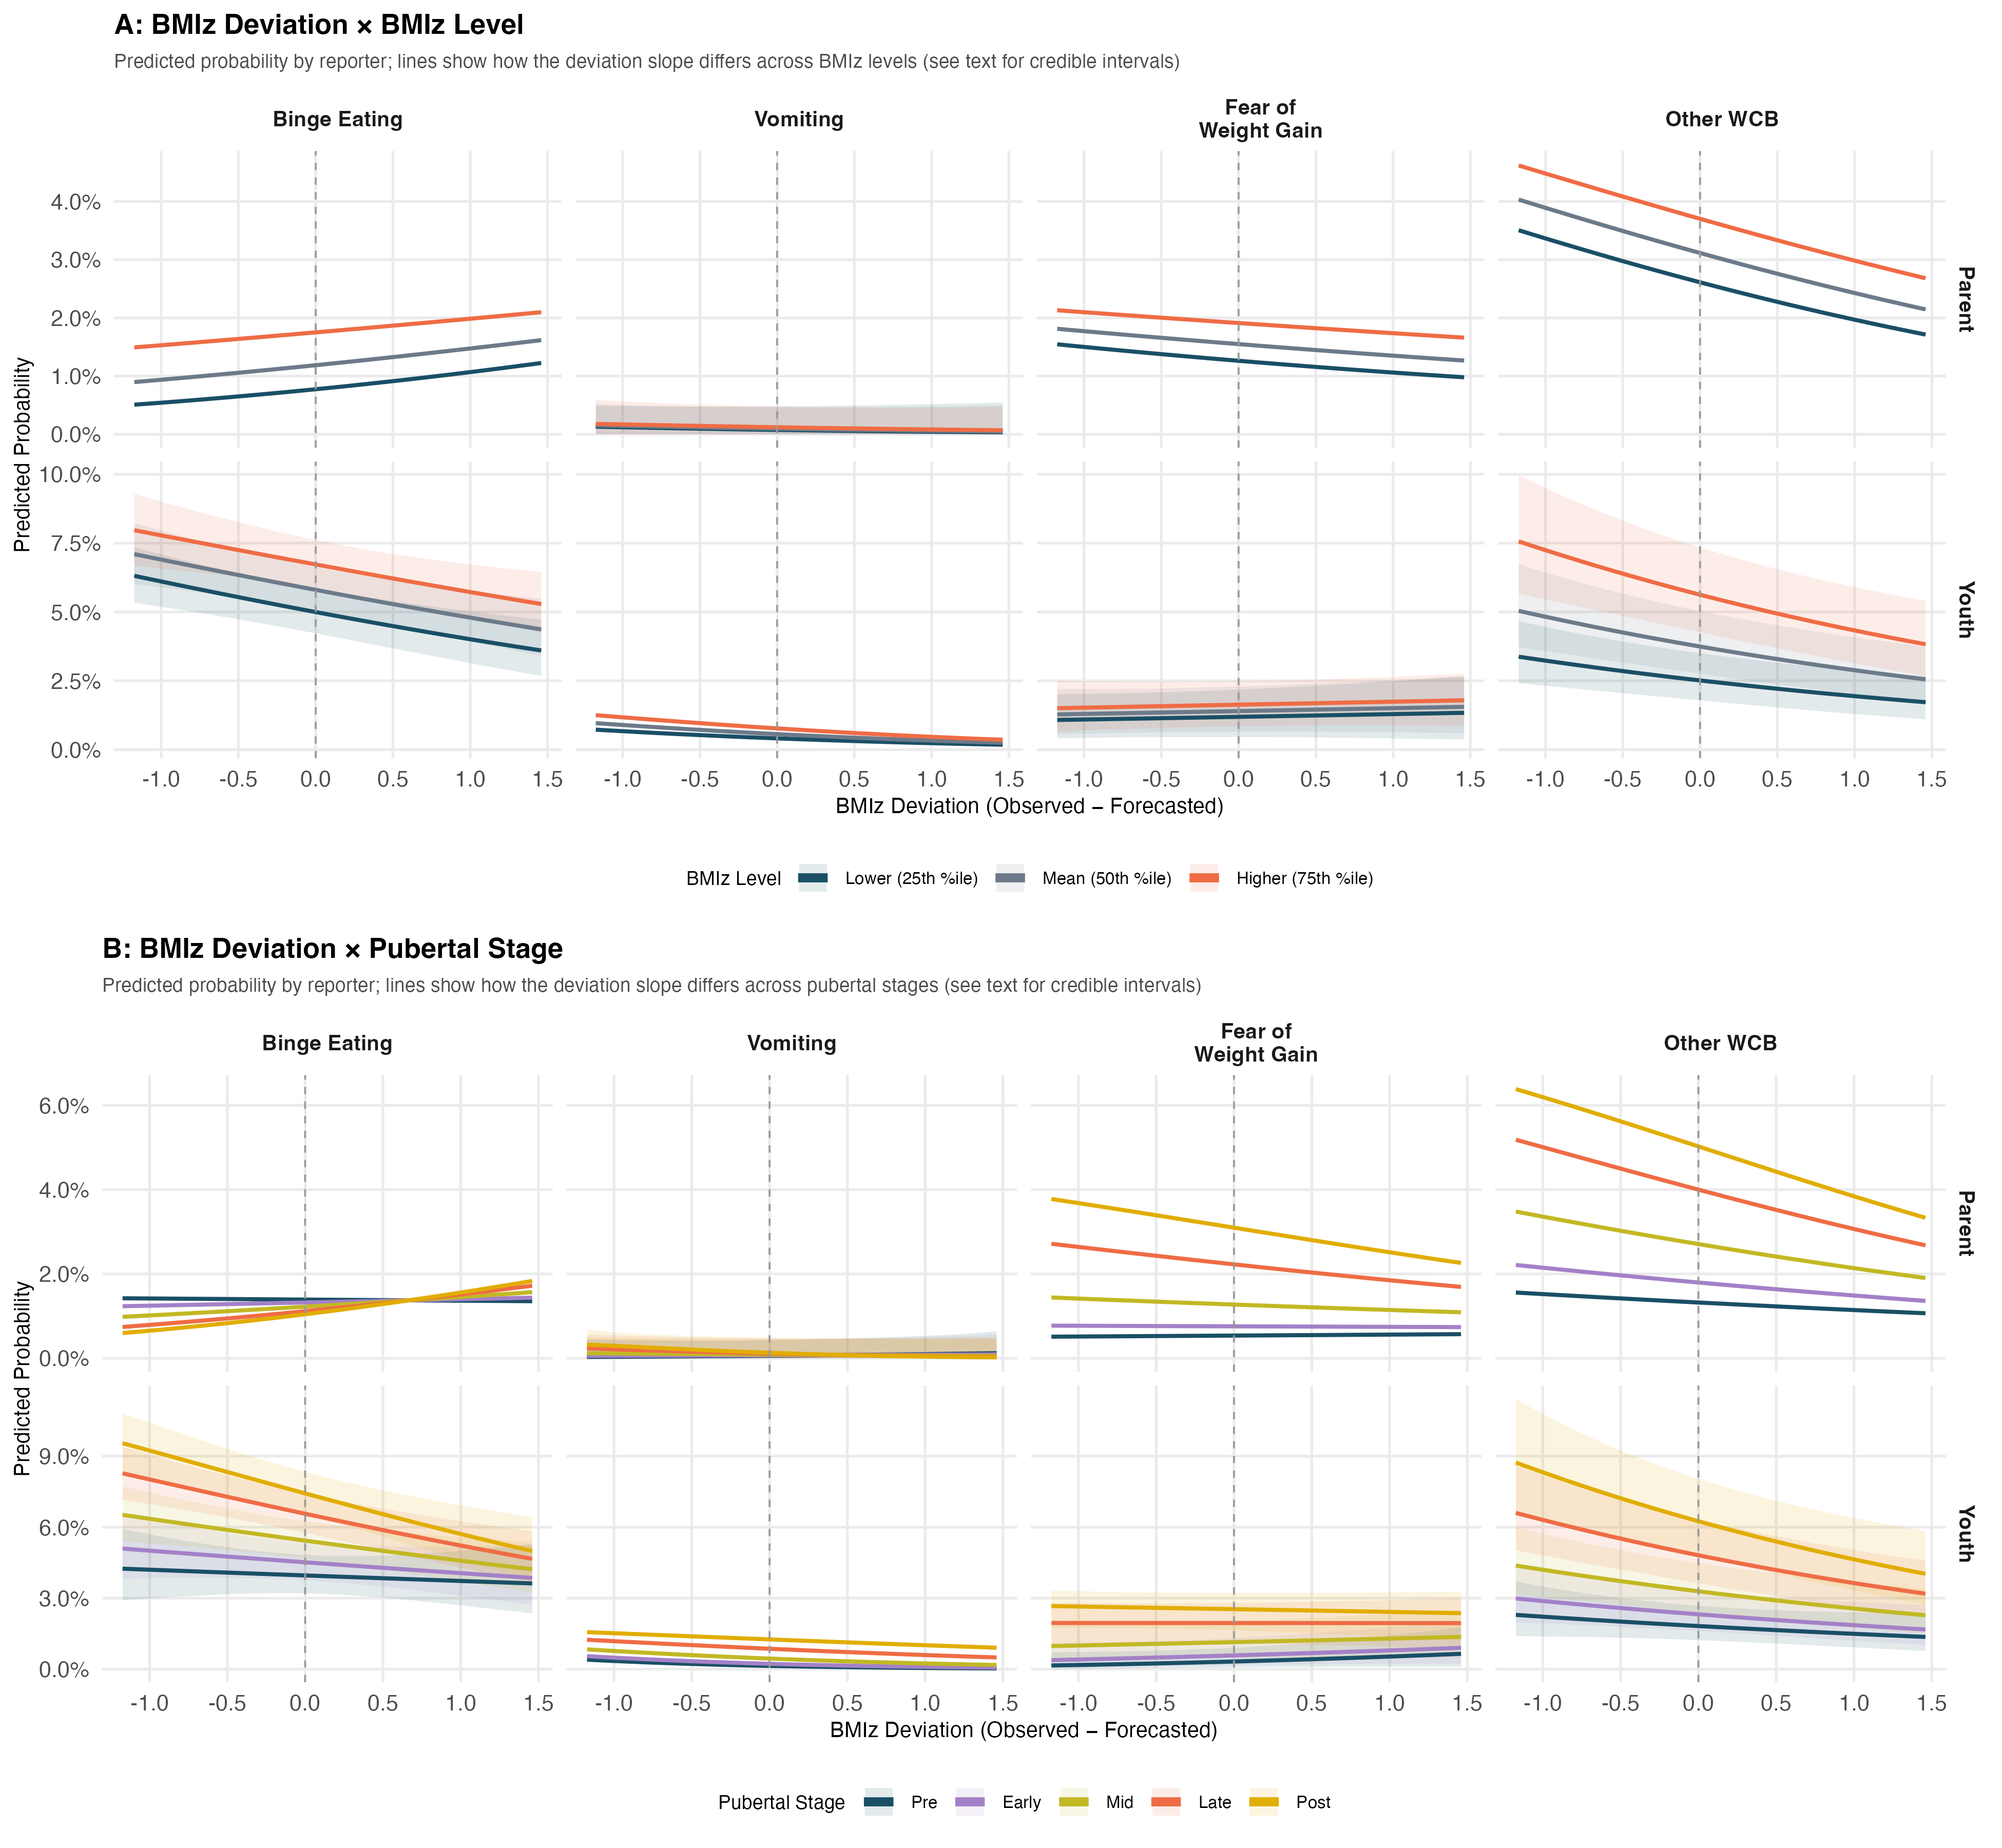
Supplementary Figure S4. Population-averaged predicted probabilities for the (A) BMIz × deviation interaction and (B) pubertal development × deviation interaction, faceted by ED outcome and reporter. Panel A shows that the deviation effect operates consistently across the weight spectrum for binge eating, vomiting, and other WCB (interaction 95% CrIs spanning 1.0), whereas for parent-reported fear of weight gain the below-forecast association attenuated at higher BMIz (BMIz × deviation OR = 1.08, 95% CrI: 1.01–1.15). In Panel B, no pubertal stage × deviation interaction met the 95% credible-interval threshold in Bayesian models (largest: parent-reported other WCB, OR = 0.81, 95% CrI: 0.65–1.02). Predictions in both panels are from frequentist GLMMs; confidence bands for several parent-reported models are implausibly narrow because of quasi-complete separation, so inference should rely on the Bayesian estimates in Supplementary Table S1.

Supplementary Figure S5
ED symptom endorsement rates in the Aims 2–3 analytic subsample.
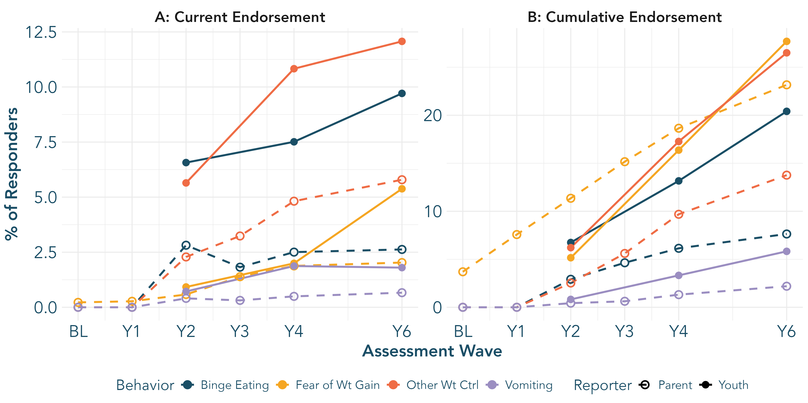
Supplementary Figure S5. ED symptom endorsement rates by assessment wave and reporter in the Aims 2–3 analytic subsample (N = 9,250), constructed as in Figure 1. (A) Current endorsement at each wave. (B) Cumulative (rolling) lifetime endorsement. Solid lines/filled markers = youth report; dashed lines/open markers = parent report. Because youth endorsing binge eating, vomiting, or other weight control behaviors at or before their second BMIz observation were excluded, endorsement of these behaviors is zero or near zero at baseline and Year 1 (the second BMIz observation is usually, but not always, Year 1); fear of weight gain was not an exclusion criterion and may be endorsed at any wave.

