CS 148: Database Design for the Web

Emily Bates

Assignment 10: Final Project

Bottoms Up

Version <1.0>

Table Of Contents

Time Log 3

Introduction 4

Purpose and Scope 4

Definitions, Acronyms, and Abbreviations 4

Overview 4

Overall Description 4

Data Dictionary 5

Entity Relationship Diagram 6

Schema 6

Story Board 6

Specific requirements 7

|  |  |  |  |
| --- | --- | --- | --- |
| Time Log | | | |
| Estimated time to complete assignment => | | | 50 Hours |
| Date | Time Spent  (in hours) | Description | Author |
| 11/22/14 | 1.0 | Planning assignment | Emily Bates |
| 11/24/14 | 2.0 | Writing project specs doc | Emily Bates |
|  |  |  |  |
|  |  |  |  |
|  |  |  |  |
|  |  |  |  |
|  |  |  |  |
|  |  |  |  |
|  |  |  |  |
|  |  |  |  |
|  |  |  |  |
|  |  |  |  |
|  |  |  |  |
|  |  |  |  |
|  |  |  |  |
|  |  |  |  |
|  |  |  |  |
|  |  |  |  |
|  |  |  |  |
|  |  |  |  |
|  |  |  |  |
|  | Mark me wrong if not updated | <=Total Time Spent |  |
|  |  |  |  |

# Introduction

### Purpose and Scope

The purpose of this document is to describe the requirement specification for the web site “Bottoms Up”. The intended audience for this document is the grader of this assignment and any users who wish to learn more information on the organization and development of the site.

This document will explain the layout of the website and backend of the database, along with any necessary additional information, such as term definitions and the database schema.

### Definitions, Acronyms, and Abbreviations

HTML – Hypertext markup language – used to define your content.

PHP – Personal Home Page – language that helps to customize html.

CSS – Cascading Style Sheets – used to define the look of a web site.

W3 Validation – refers to both Html and CSS validation tool provided by the W3c.org. the html validator is located at:

<http://validator.w3.org/>

with the CSS validator located at:

<http://jigsaw.w3.org/css-validator/>

# Overview

Bottoms Up is a website devoted to alcoholic beverage recipes. Users can select one alcoholic beverage and one non-alcoholic beverage, and they will be provided a list of possible beverages they can mix from those starting ingredients.

# Overall Description

The main page of the Bottoms Up website presents the user with two drop-down lists: alcoholic beverage and non-alcoholic beverage. The user can make their selection and then click the “Bottoms Up” button to be presented with a list of possible cocktails they can make from those two ingredients. The results table will show the user the ingredients in the cocktail, any special instructions, and the number of calories.

The Bottoms Up website also offers their users a newsletter service – visitors of the page can sign up to receive a weekly Drink Specials email with featured recipes, party-hosting tips, or drinking game ideas. A second page gives users a form to fill out their name, address, email, and phone number and select what they would like in their newsletter from a series of radio buttons. Users can also opt out of the newsletter if they are already receiving it. Additional pages on the website allow the user to learn about the site and give feedback.

# Data Dictionary

User first name

User last name

Email address

Address

Phone number

Newsletter preferences

Alcoholic beverage name

Alcoholic beverage ID

Non-alcoholic beverage name

Non-alcoholic beverage ID

Cocktail name

Cocktail ID

Cocktail recipe

Cocktail calories

Special instructions

Feedback ID

Feedback content

Feedback date

# Entity Relationship Diagram

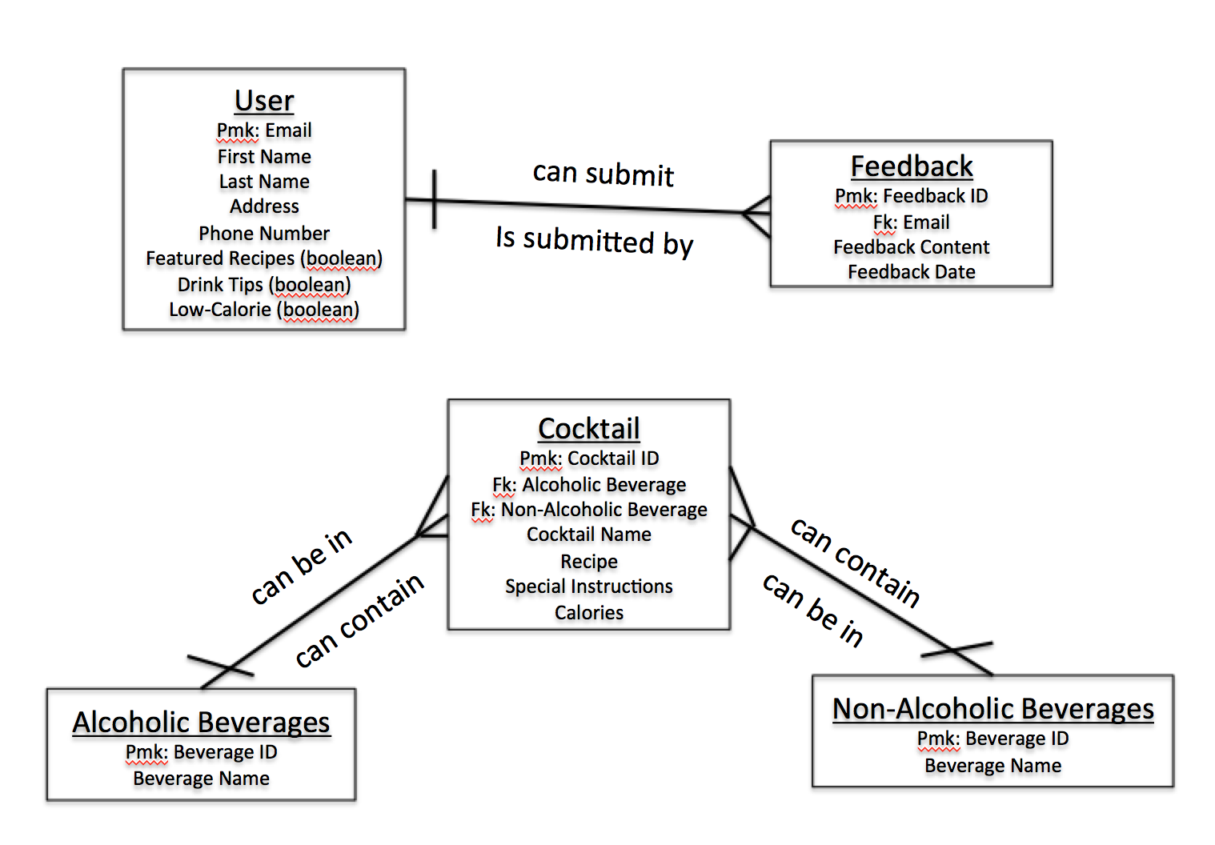

# Schema

Schema

# Story Board

Story board

# Specific requirements

1. *You fill out* – This is where you would put the exact detail of what you want for the project. For example:
2. *Title for main page*: *What is the title, shows up as a link in a search result.*
3. *Meta Description*: *what is the description for the above link.*
4. *Meta Character set*: UTF - 8
5. *Logo*: *pick a logo to be used on the site.*
6. *Main page photo*: *pick a photo of you.*
7. *Content can be found here*:
8. I hope you get the idea. The goal would be the developer would be able to make the entire site based on this document and the client would see you have included everything.