**Python In The Enterprise**

Portal for students using Python web framework Django.

**1.Create project.**

In appropriate folder simply type:

* django-admin startproject mysite

(mysite – project name)

C:\Users\Mateusz\Desktop\PiTe\mysite_images\1.PNG

… and now run server!

* python manage.py runserver

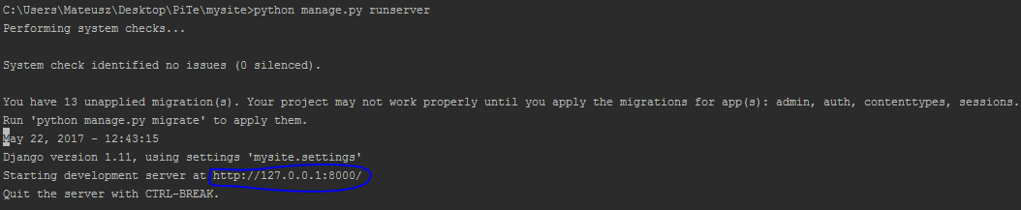

Python started development server for us. Copy this url to your browser and see result:

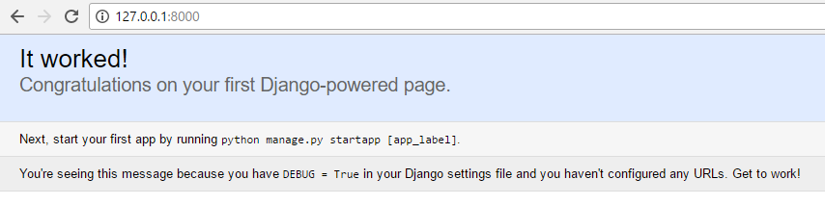

**2.Create first Django application.**

**Application** describes a Python package that provides some set of features. Applications may be reused in various projects.

* python manage.py startapp users

(users – app name)

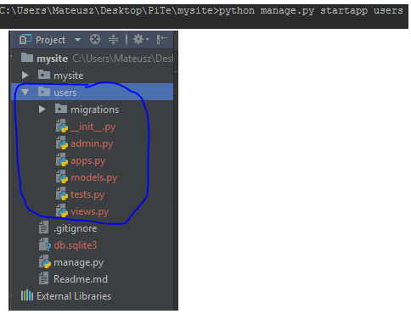

After that, we got blueprint for our application.

**3.Make migration**

Migrations are Django’s way of propagating changes you make to your models (adding a field, deleting a model, etc.) into your database schema.

When we have previous run server, Django told us that we have 13 unapplied migrations. Those are apps created by Django.

To make migration type:

* python manage.py migrate

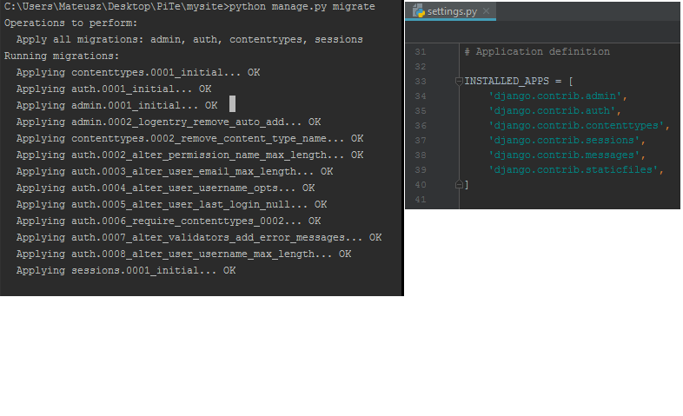

In settings.py we can see list of application created by Django. Remember that, when we create another app we need to include it here. Just like this:

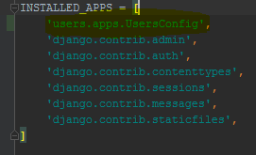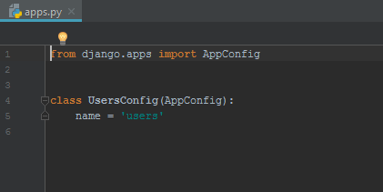

What **migrate** does: Django goes to mysite -> settings.py and it is looking for INSTALLED\_APPS. For each one it goes to each application directory and look for what tables are needed to work with this app. Each application has its own table that it requires.

**4.Create superuser**

To do that:

* python manage.py createsuperuser

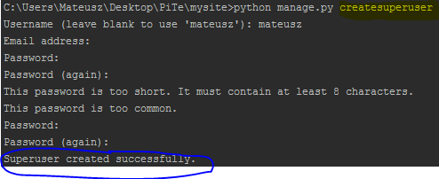

Now you can visit admin page(<http://127.0.0.1:8000/admin>).

It is created by Django and give you automatic admin interface.

