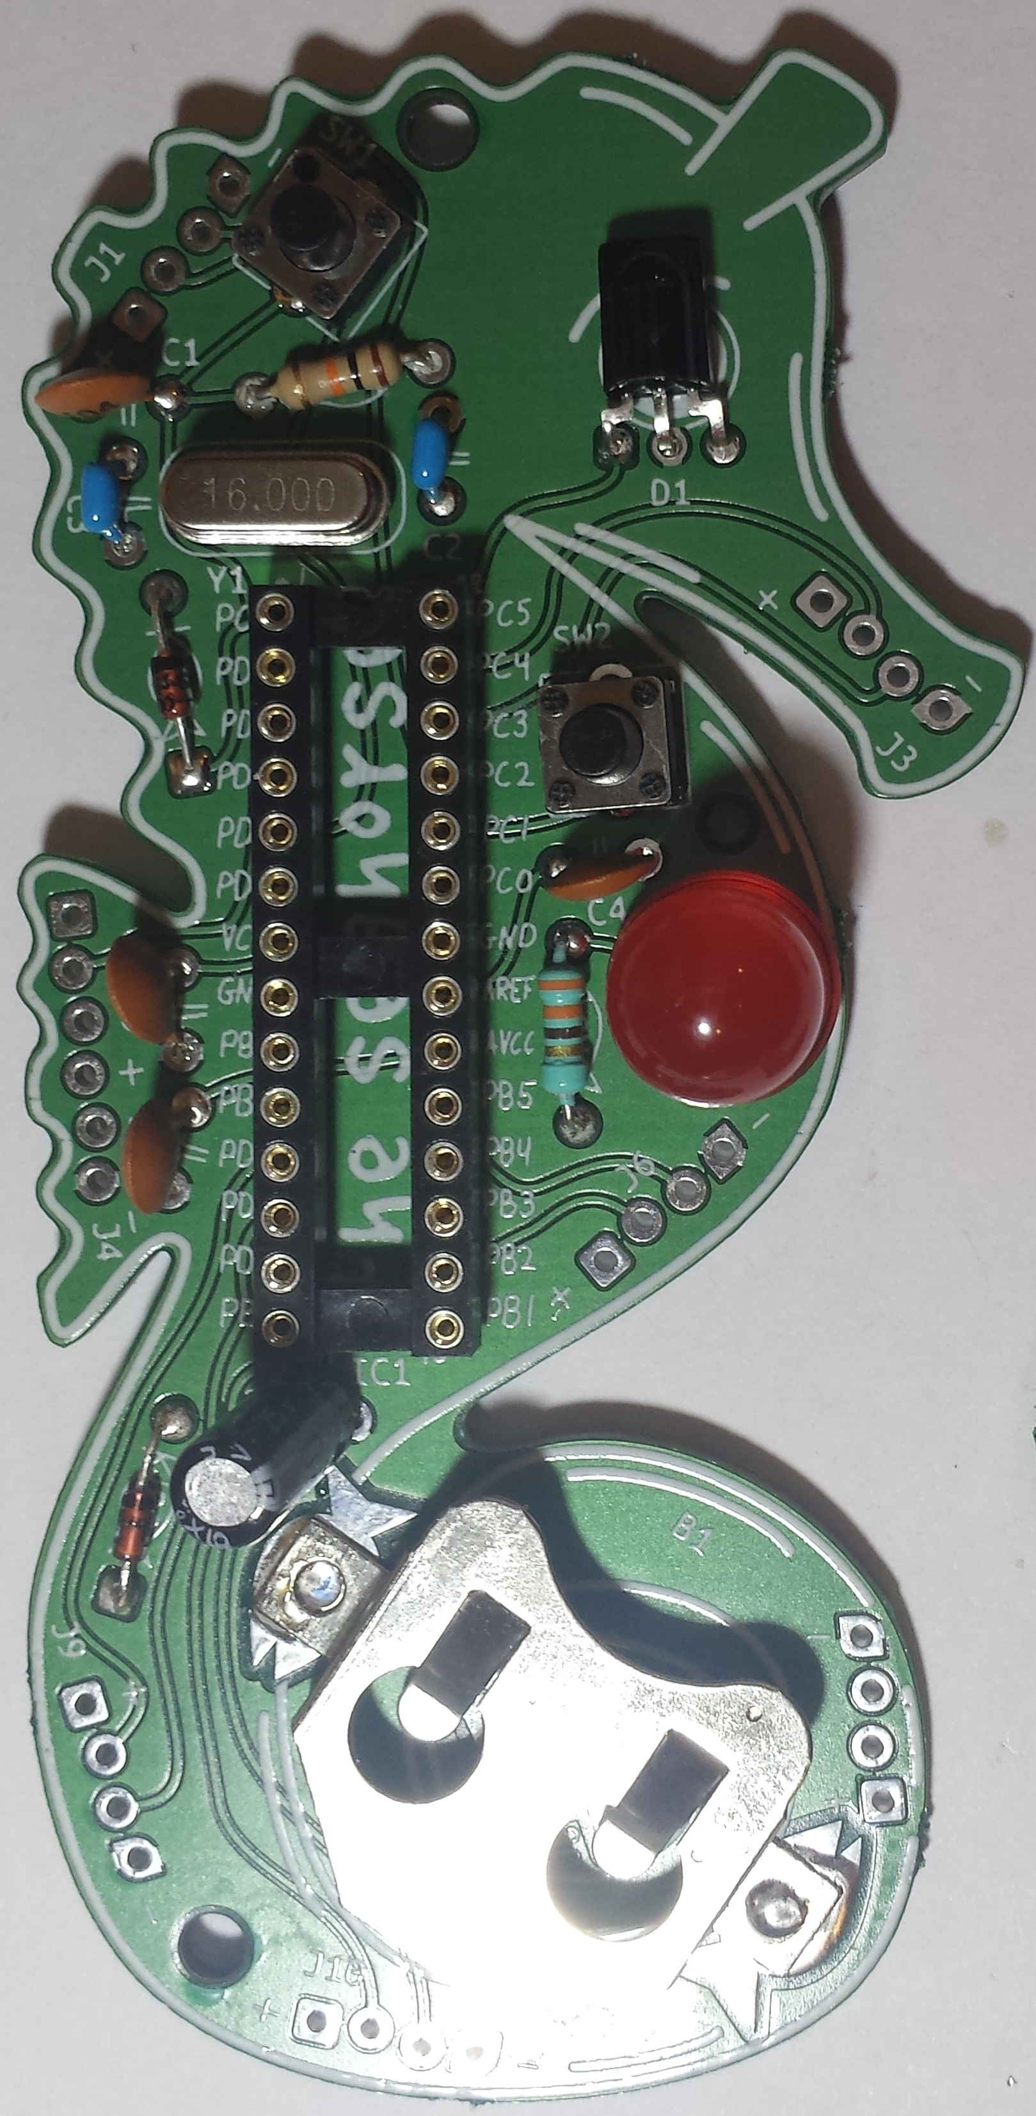
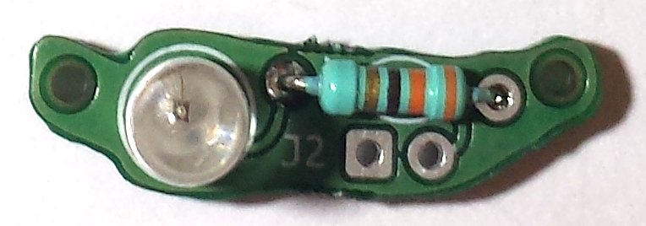
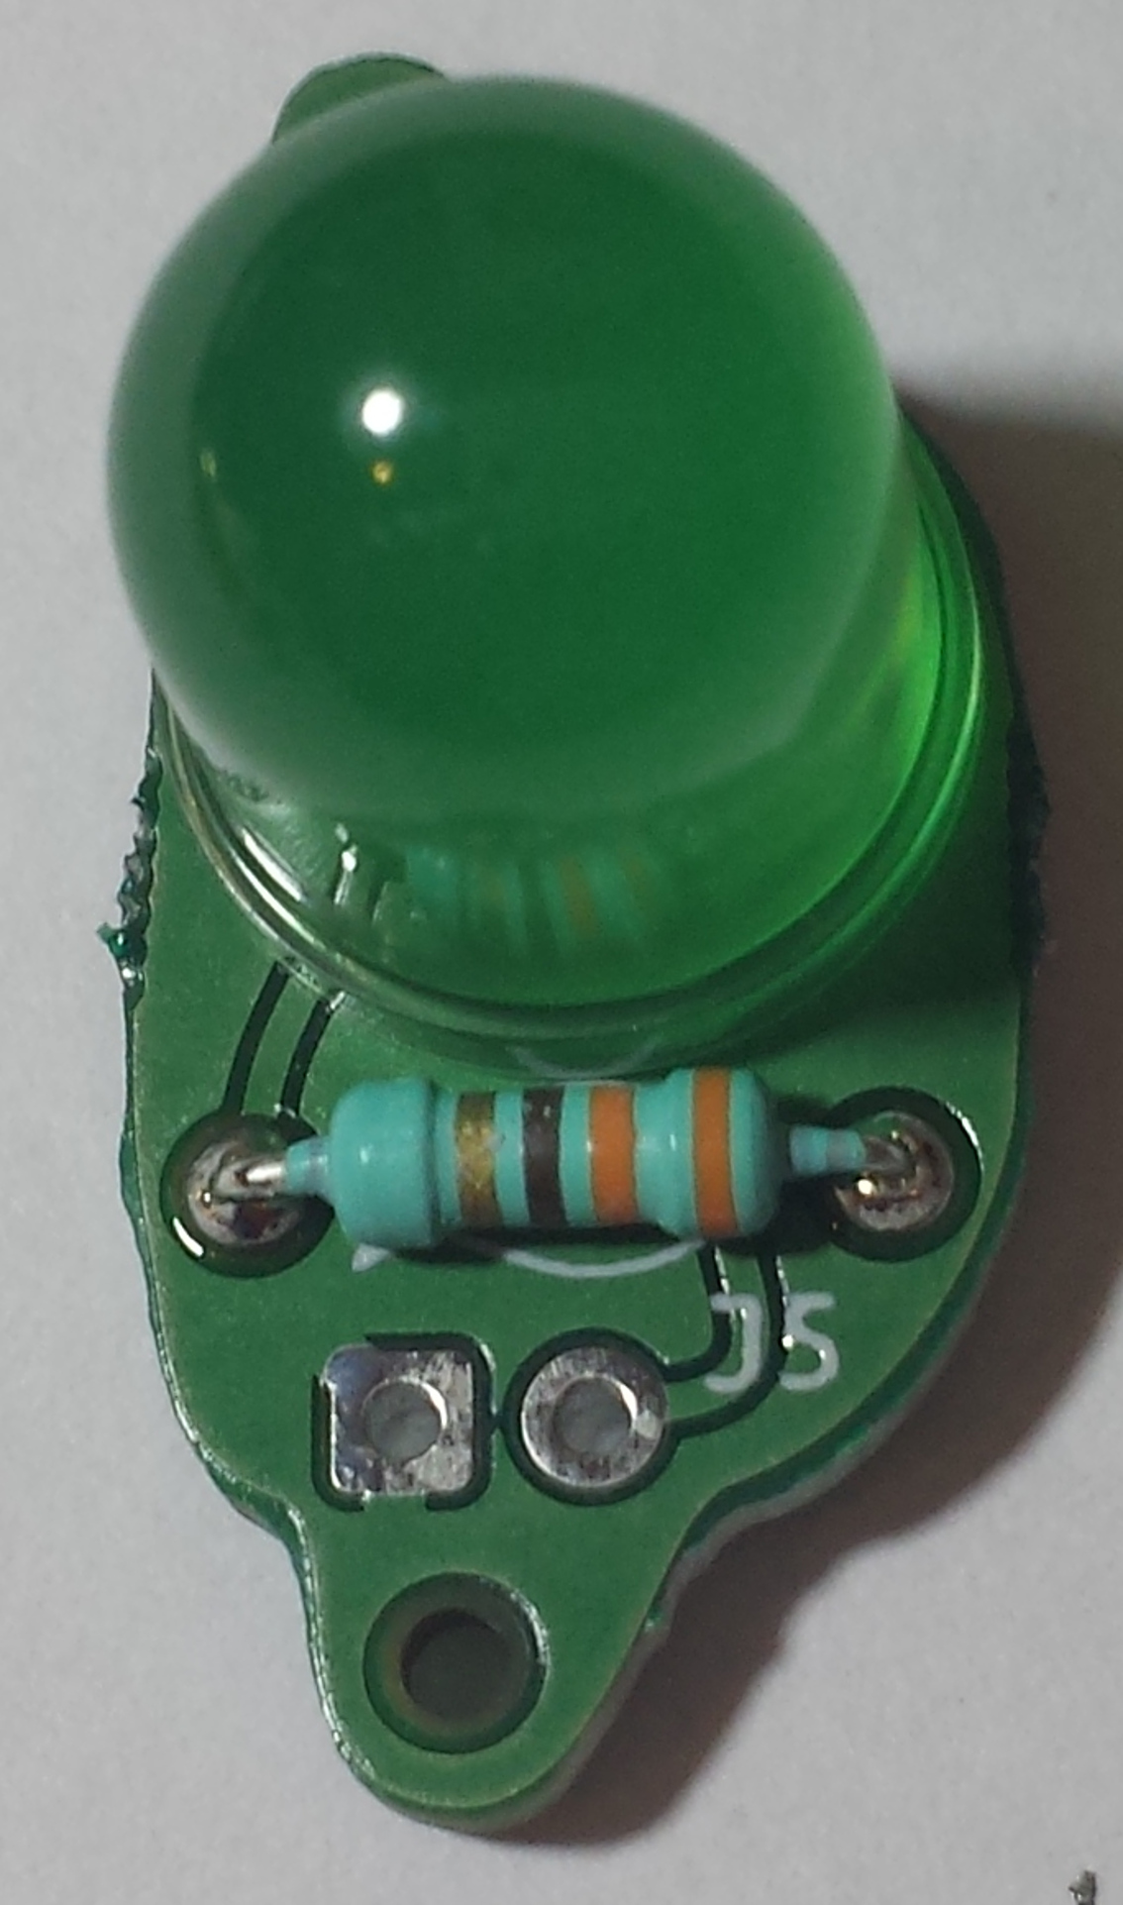
Notch in end
of the socket
www.embecosm.com
Freely available under a Creative Commons Attribution-ShareAlike license
Freely available under a Creative Commons Attribution-ShareAlike license
www.embecosm.com

EWH8: Seahorse Wearable Arduinio Kit
Notes for Users
About
The seahorse is a solderable Arduino UNO clone, intended for wearable electronics applications. It features large LEDs, an IR emitter and IR detector.
Tool set up
Install the Arduino IDE from arduino.cc/en/main/software.
When using the Arduino IDE, set up for Arduino Uno.
Circuit layout

IR emitter long leg in the square hole
LED long leg in
the square hole

LED long leg in
the square hole
UART press
connector

The programs
As a starter download the standard blink program, but change the LED pin number to 10 (default is 13, but the program may show ‘LED_BUILTIN’ instead).
Kit contents
The kit contains parts to build the persistence of vision circuit in both the minimal form shown here, and also the protected version.
1 x Seahorse PCB | 1 x 16MHz quartz crystal
1 x 6-pin header | 1 x 100Ω resistor
1 x 28 pin DIP socket | 1 x 10mm red LED
2 x 2-pin tactile switch | 1 x 10μF elecrolytic capacitor
1 x Atmel ATMega328-PU | 3 x 330Ω resistor
4 x 100nF capacitor | 1 x small signal diode
2 x 22pF capacitor | 1 x 10mm green LED
1 x 10kΩ resistor | 1 x T 1 ¾ 5mm IR emitter
1 x MINICAST AGC2 IR receiver | 1 x 20mm coin cell battery holder
2 x CR2016 coin cell
Note: Once completed please ask for conductive thread
More information
A detailed tutorial is in preparation. The draft of this, along with all design and tutorial material is on GitHub (github.com/embecosm/seahorse). It is all based on Cefn Hoile's original work at shrimping.it.
For more information about Embecosm, including careers in open source compiler development, please visit www.embecosm.com.

Notch in end
of the socket
www.embecosm.com
Freely available under a Creative Commons Attribution-ShareAlike license
www.embecosm.com
Freely available under a Creative Commons Attribution-ShareAlike license

EWH8: Seahorse Wearable Arduinio Kit
Notes for Users
About
The seahorse is a solderable Arduino UNO clone, intended for wearable electronics applications. It features large LEDs, an IR emitter and IR detector.
Tool set up
Install the Arduino IDE from arduino.cc/en/main/software.
When using the Arduino IDE, set up for Arduino Uno.
Circuit layout

IR emitter long leg in the square hole
LED long leg in
the square hole

LED long leg in
the square hole
UART press
connector

The programs
As a starter download the standard blink program, but change the LED pin number to 10 (default is 13, but the program may show ‘LED_BUILTIN’ instead).
Kit contents
The kit contains parts to build the persistence of vision circuit in both the minimal form shown here, and also the protected version.
1 x Seahorse PCB | 1 x 16MHz quartz crystal
1 x 6-pin header | 1 x 100Ω resistor
1 x 28 pin DIP socket | 1 x 10mm red LED
2 x 2-pin tactile switch | 1 x 10μF elecrolytic capacitor
1 x Atmel ATMega328-PU | 3 x 330Ω resistor
4 x 100nF capacitor | 1 x small signal diode
2 x 22pF capacitor | 1 x 10mm green LED
1 x 10kΩ resistor | 1 x T 1 ¾ 5mm IR emitter
1 x MINICAST AGC2 IR receiver | 1 x 20mm coin cell battery holder
2 x CR2016 coin cell
Note: Once completed please ask for conductive thread
More information
A detailed tutorial is in preparation. The draft of this, along with all design and tutorial material is on GitHub (github.com/embecosm/seahorse). It is all based on Cefn Hoile's original work at shrimping.it.
For more information about Embecosm, including careers in open source compiler development, please visit www.embecosm.com.

