
www.embecosm.com

EWH3: Shrimping Persistence of Vision Kit
Notes for #techmums
About
Persistence of vision is when a brief bright image (such as from an LED) stays fixed on your retina. By flashing a row of LEDs very fast and then waving them in front of someone's face, we can use this effect to spell out a message.
Tool set up
Install the Arduino IDE from arduino.cc/en/main/software. If needed, install the CP210x drivers from:
http://www.silabs.com/products/mcu/pages/usbtouartbridgevcpdrivers.aspx.
When using the Arduino IDE, set up for Arduino Uno.
Circuit layout
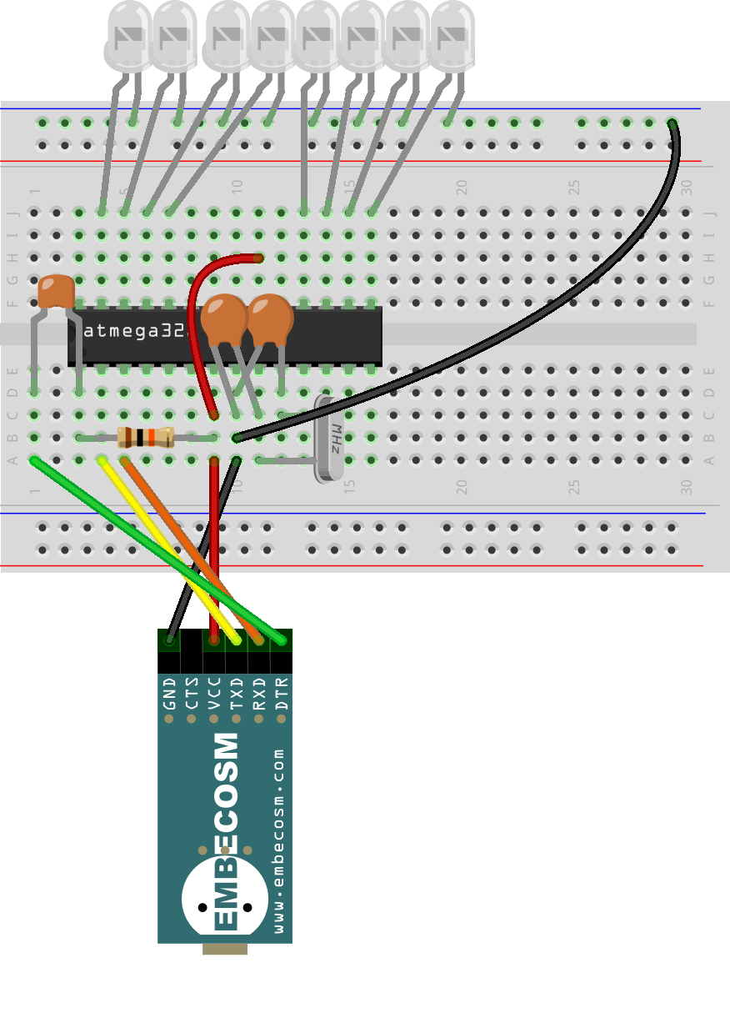

LED (shines red) long leg at the bottom
100nF capacitor labeled “104”
Dot by pin 1
22pF capacitors labeled “22J”
10kΩ resistor
brown-black-orange
gold on the end

Notch in end of the chip


Freely available under a Creative Commons Attribution-ShareAlike license
www.embecosm.com

The programs
Download the persistence of vision code from tinyurl.com/shrimpovcode. Unzip it and either open it from the Arduino IDE, or copy it to the IDE's sketchbook folder (find from the IDE preferences menu), so it appears in the list of example programs when you start up the IDE.
Kit contents
The kit contains parts to build the persistence of vision circuit in both the minimal form shown here, and also the protected version.
1 x battery box | 2 x 22pF capacitor
3 x AA battery | 1 x 10kΩ resistor: brown-black-orange
390 hole breadboard | 1 x 16MHz quartz crystal
10 x assorted wires | 1 x 75Ω resistor: violet-green-black
1 x Atmel ATMega328-PU | 8 x 100mCd red LED
1 x 100nF capacitor | 1 x rubber band
Embecosm EHW5 UART | This instruction leaflet
More information
A detailed tutorial is in preparation. The draft of this, along with all design and tutorial material is on GitHub (github.com/embecosm/shrimp-pov). It is all based on Cefn Hoile's original work at shrimping.it.
For more information about Embecosm, including careers in open source compiler development, please visit www.embecosm.com.

Freely available under a Creative Commons Attribution-ShareAlike license
www.embecosm.com

EWH3: Shrimping Persistence of Vision Kit
Notes for #techmums
About
Persistence of vision is when a brief bright image (such as from an LED) stays fixed on your retina. By flashing a row of LEDs very fast and then waving them in front of someone's face, we can use this effect to spell out a message.
Tool set up
Install the Arduino IDE from arduino.cc/en/main/software. If needed, install the CP210x drivers from:
http://www.silabs.com/products/mcu/pages/usbtouartbridgevcpdrivers.aspx.
When using the Arduino IDE, set up for Arduino Uno.
Circuit layout

LED (shines red) long leg at the bottom
100nF capacitor labeled “104”
Dot by pin 1
22pF capacitors labeled “22J”
10kΩ resistor
brown-black-orange
gold on the end

Notch in end of the chip

Freely available under a Creative Commons Attribution-ShareAlike license
www.embecosm.com

The programs
Download the persistence of vision code from tinyurl.com/shrimpovcode. Unzip it and either open it from the Arduino IDE, or copy it to the IDE's sketchbook folder (find from the IDE preferences menu), so it appears in the list of example programs when you start up the IDE.
Kit contents
The kit contains parts to build the persistence of vision circuit in both the minimal form shown here, and also the protected version.
1 x battery box | 2 x 22pF capacitor
3 x AA battery | 1 x 10kΩ resistor: brown-black-orange
390 hole breadboard | 1 x 16MHz quartz crystal
10 x assorted wires | 1 x 75Ω resistor: violet-green-black
1 x Atmel ATMega328-PU | 8 x 100mCd red LED
1 x 100nF capacitor | 1 x rubber band
Embecosm EHW5 UART | This instruction leaflet
More information
A detailed tutorial is in preparation. The draft of this, along with all design and tutorial material is on GitHub (github.com/embecosm/shrimp-pov). It is all based on Cefn Hoile's original work at shrimping.it.
For more information about Embecosm, including careers in open source compiler development, please visit www.embecosm.com.

Freely available under a Creative Commons Attribution-ShareAlike license
www.embecosm.com

EWH3: Shrimping Persistence of Vision Kit
Notes for #techmums
About
Persistence of vision is when a brief bright image (such as from an LED) stays fixed on your retina. By flashing a row of LEDs very fast and then waving them in front of someone's face, we can use this effect to spell out a message.
Tool set up
Install the Arduino IDE from arduino.cc/en/main/software. If needed, install the CP210x drivers from:
http://www.silabs.com/products/mcu/pages/usbtouartbridgevcpdrivers.aspx.
When using the Arduino IDE, set up for Arduino Uno.
Circuit layout

LED (shines red) long leg at the bottom
100nF capacitor labeled “104”
Dot by pin 1
22pF capacitors labeled “22J”
10kΩ resistor
brown-black-orange
gold on the end

Notch in end of the chip

Freely available under a Creative Commons Attribution-ShareAlike license
www.embecosm.com

The programs
Download the persistence of vision code from tinyurl.com/shrimpovcode. Unzip it and either open it from the Arduino IDE, or copy it to the IDE's sketchbook folder (find from the IDE preferences menu), so it appears in the list of example programs when you start up the IDE.
Kit contents
The kit contains parts to build the persistence of vision circuit in both the minimal form shown here, and also the protected version.
1 x battery box | 2 x 22pF capacitor
3 x AA battery | 1 x 10kΩ resistor: brown-black-orange
390 hole breadboard | 1 x 16MHz quartz crystal
10 x assorted wires | 1 x 75Ω resistor: violet-green-black
1 x Atmel ATMega328-PU | 8 x 100mCd red LED
1 x 100nF capacitor | 1 x rubber band
Embecosm EHW5 UART | This instruction leaflet
More information
A detailed tutorial is in preparation. The draft of this, along with all design and tutorial material is on GitHub (github.com/embecosm/shrimp-pov). It is all based on Cefn Hoile's original work at shrimping.it.
For more information about Embecosm, including careers in open source compiler development, please visit www.embecosm.com.

Freely available under a Creative Commons Attribution-ShareAlike license
www.embecosm.com

EWH3: Shrimping Persistence of Vision Kit
Notes for #techmums
About
Persistence of vision is when a brief bright image (such as from an LED) stays fixed on your retina. By flashing a row of LEDs very fast and then waving them in front of someone's face, we can use this effect to spell out a message.
Tool set up
Install the Arduino IDE from arduino.cc/en/main/software. If needed, install the CP210x drivers from:
http://www.silabs.com/products/mcu/pages/usbtouartbridgevcpdrivers.aspx.
When using the Arduino IDE, set up for Arduino Uno.
Circuit layout

LED (shines red) long leg at the bottom
100nF capacitor labeled “104”
Dot by pin 1
22pF capacitors labeled “22J”
10kΩ resistor
brown-black-orange
gold on the end

Notch in end of the chip

Freely available under a Creative Commons Attribution-ShareAlike license
www.embecosm.com

The programs
Download the persistence of vision code from tinyurl.com/shrimpovcode. Unzip it and either open it from the Arduino IDE, or copy it to the IDE's sketchbook folder (find from the IDE preferences menu), so it appears in the list of example programs when you start up the IDE.
Kit contents
The kit contains parts to build the persistence of vision circuit in both the minimal form shown here, and also the protected version.
1 x battery box | 2 x 22pF capacitor
3 x AA battery | 1 x 10kΩ resistor: brown-black-orange
390 hole breadboard | 1 x 16MHz quartz crystal
10 x assorted wires | 1 x 75Ω resistor: violet-green-black
1 x Atmel ATMega328-PU | 8 x 100mCd red LED
1 x 100nF capacitor | 1 x rubber band
Embecosm EHW5 UART | This instruction leaflet
More information
A detailed tutorial is in preparation. The draft of this, along with all design and tutorial material is on GitHub (github.com/embecosm/shrimp-pov). It is all based on Cefn Hoile's original work at shrimping.it.
For more information about Embecosm, including careers in open source compiler development, please visit www.embecosm.com.

Freely available under a Creative Commons Attribution-ShareAlike license

