
www.embecosm.com

EWH3: Shrimping Persistence of Vision Kit
Notes for Users
About
Persistence of vision is when a brief bright image (such as from an LED) stays fixed on your retina. By flashing a row of LEDs very fast and then waving them in front of someone's face, we can use this effect to spell out a message.
Tool set up
Install the Arduino IDE from arduino.cc/en/main/software. If running on Windows, install the FTDI drivers from www.ftdichip.com/FTDrivers.htm.
When using the Arduino IDE, set up for Arduino Uno.
Circuit layout
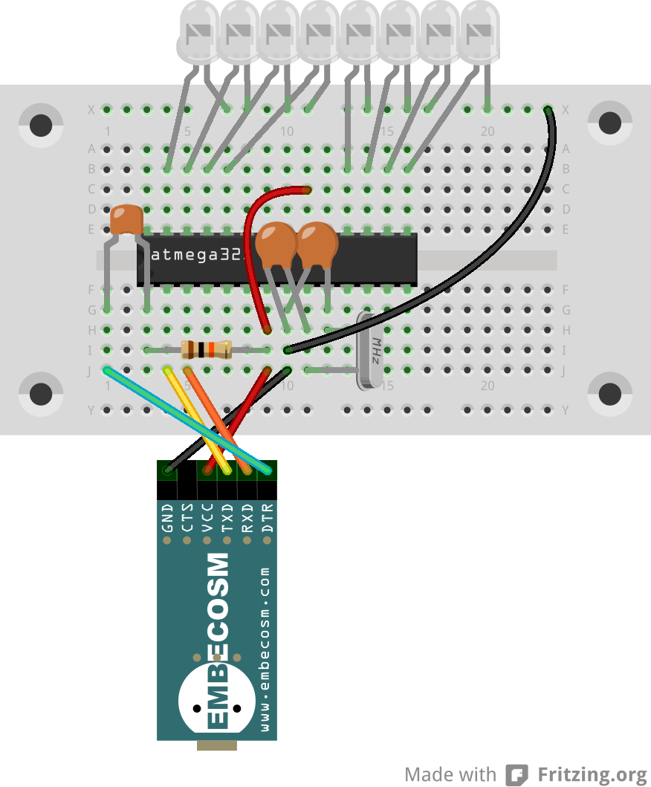
22pF capacitors labeled “22J”
LED (shines red) long leg at the bottom
100nF capacitors labeled “104”
Notch in the end of the chip
Dot by pin 1
22pF capacitors labeled “22J”
100kΩ resistor
brown-black-orange
gold on the end

Freely available under a Creative Commons Attribution-ShareAlike license
www.embecosm.com

The programs
Download the persistence of vision code from tinyurl.com/shrimpovcode. Unzip it and either open it from the Arduino IDE, or copy it to the IDE's sketchbook folder (find from the IDE preferences menu), so it appears in the list of example programs when you start up the IDE.
Kit contents
The kit contains parts to build the persistence of vision circuit in both the minimal form shown here, and also the protected version.
1 x battery box | 1 x 16MHz quartz crystal
3 x AAA battery | 1 x 100Ω resistor
270 hole breadboard (BB-301 type) | 8 x 100mCd red LED
10 x assorted wires | 1 x 10μF
1 x Atmel ATMega328-PU | 1 x 6mm tactile switch
4 x 100nF capacitor | 1 x small signal diode
2 x 22pF capacitor | 1 x rubber band
1 x 10kΩ resistor
More information
A detailed tutorial is in preparation. The draft of this, along with all design and tutorial material is on GitHub (github.com/embecosm/shrimp-pov). It is all based on Cefn Hoile's original work at shrimping.it.
For more information about Embecosm, including careers in open source compiler development, please visit www.embecosm.com.

Freely available under a Creative Commons Attribution-ShareAlike license
www.embecosm.com

EWH3: Shrimping Persistence of Vision Kit
Notes for Users
About
Persistence of vision is when a brief bright image (such as from an LED) stays fixed on your retina. By flashing a row of LEDs very fast and then waving them in front of someone's face, we can use this effect to spell out a message.
Tool set up
Install the Arduino IDE from arduino.cc/en/main/software. If running on Windows, install the FTDI drivers from www.ftdichip.com/FTDrivers.htm.
When using the Arduino IDE, set up for Arduino Uno.
Circuit layout
22pF capacitors labeled “22J”
LED (shines red) long leg at the bottom
100nF capacitors labeled “104”
Notch in the end of the chip
Dot by pin 1
22pF capacitors labeled “22J”
100kΩ resistor
brown-black-orange
gold on the end
Freely available under a Creative Commons Attribution-ShareAlike license
www.embecosm.com

The programs
Download the persistence of vision code from tinyurl.com/shrimpovcode. Unzip it and either open it from the Arduino IDE, or copy it to the IDE's sketchbook folder (find from the IDE preferences menu), so it appears in the list of example programs when you start up the IDE.
Kit contents
The kit contains parts to build the persistence of vision circuit in both the minimal form shown here, and also the protected version.
1 x battery box | 1 x 16MHz quartz crystal
3 x AAA battery | 1 x 100Ω resistor
270 hole breadboard (BB-301 type) | 8 x 100mCd red LED
10 x assorted wires | 1 x 10μF
1 x Atmel ATMega328-PU | 1 x 6mm tactile switch
4 x 100nF capacitor | 1 x small signal diode
2 x 22pF capacitor | 1 x rubber band
1 x 10kΩ resistor
More information
A detailed tutorial is in preparation. The draft of this, along with all design and tutorial material is on GitHub (github.com/embecosm/shrimp-pov). It is all based on Cefn Hoile's original work at shrimping.it.
For more information about Embecosm, including careers in open source compiler development, please visit www.embecosm.com.

Freely available under a Creative Commons Attribution-ShareAlike license

