Exercise 1: The Shrimp Blink System

This is the very simplest computer you can build. All it does is flash a light emitting diode (LED) on and off. You'll build the computer, then modify its program to change the speed of flashing.
Build the Circuit
Insert the components as shown on the following diagram. Note that it is important that components line up in the short columns exactly as shown.
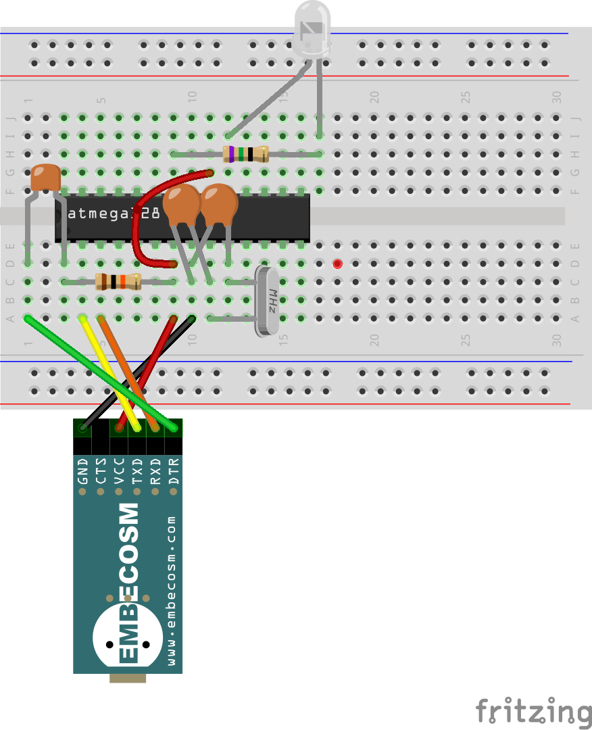
Programming the Circuit
LED (shines red) long leg on the left
22pF capacitors labeled “22J”
100nF capacitor labeled “104”
Notch in the end of the chip
Dot by pin 1
100kΩ resistor
brown-black-orange
gold on the end
75Ω resistor
violet-green-black
gold on the end
10kΩ resistor
brown-black-orange
gold on the end
When you connect using the USB cable, the light will start flashing once per second, because the chips is supplied with the program pre-loaded.
Start up the Arduino IDE on your laptop PC. Select Arduino Uno on the Tools>Board menu (this is the sort of chip you have). The load the “blink” program using the Files>Examples>01.Basics>Blink menu.
In the program change the lines saying delay (1000); (wait 1000 milliseconds) to delay (2000);. The compile the program (the tick symbol at the top) and load it into your computer (the right arrow at the top). You will see the light now flashes at half the speed. Experiment with changing the values to control your computer. What do you discover?

Exercise 2: Shrimp Persistence of Vision

This design uses eight LEDs and flashes them very fast in sequence. When you wave the LEDs in front of someone, the lights will paint a message in the air. Start by building the circuit as follows:
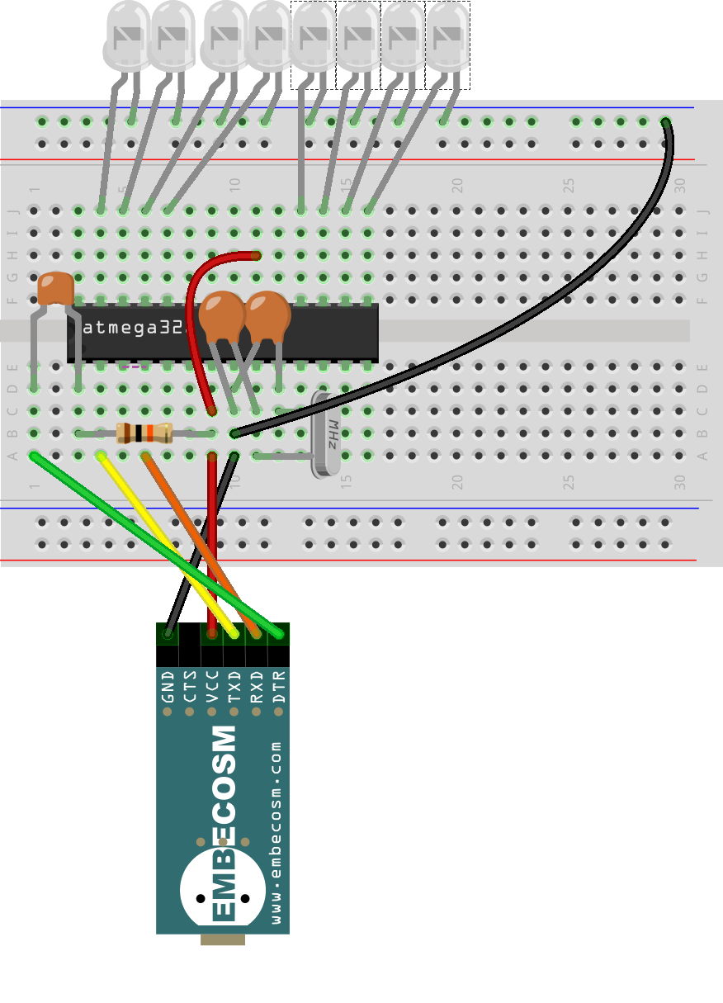
22pF capacitors labeled “22J”
100nF capacitor labeled “104”
Notch in the end of the chip
Dot by pin 1
LEDs (shine red) long leg at the bottom
10kΩ resistor
brown-black-orange
gold on the end
Programming the circuit
You will need to download the program if it is not already on your computer from tinyurl.com/shrimpovcode. Start up the Arduino IDE as before and load the program, using the File>Open... menu.
Compile and load the program using the tick and arrow buttons as before. The lights will start flashing, and if you wave your board it should spell out a message.
About half way down the program you can find the message:
String message = "MAD! $ ";
Change the message between the quote marks to something of your choice, recompile and reload.
Finally run your board direct from the battery pack. Remove the EMBECOSM UART and replace its red and black wires with the wires from the battery pack. Once the board is programmed you do not need the green, yellow and orange wires.

