关于sda ：sda1，sda2，sda3，sda4的讨论
命令：fdisk -l

WARNING: GPT (GUID Partition Table) detected on '/dev/sda'! The util fdisk doesn't support GPT. Use GNU Parted.

Disk /dev/sda: 500.1 GB, 500107862016 bytes
255 heads, 63 sectors/track, 60801 cylinders, total 976773168 sectors
Units = sectors of 1 * 512 = 512 bytes
Sector size (logical/physical): 512 bytes / 512 bytes
I/O size (minimum/optimal): 512 bytes / 512 bytes
Disk identifier: 0x00000000

Device Boot Start End Blocks Id System
/dev/sda1 1 976773167 488386583+ ee GPT

scc@ubuntu14:~$ df -lh
Filesystem Size Used Avail Use% Mounted on
/dev/sda4 454G 91G 341G 21% /
none 4.0K 0 4.0K 0% /sys/fs/cgroup
udev 1.9G 4.0K 1.9G 1% /dev
tmpfs 388M 1.2M 387M 1% /run
none 5.0M 0 5.0M 0% /run/lock
none 1.9G 110M 1.8G 6% /run/shm
none 100M 68K 100M 1% /run/user

scc@ubuntu14:~$ df -l
Filesystem 1K-blocks Used Available Use% Mounted on
/dev/sda4 476026936 94531384 357291728 21% /
none 4 0 4 0% /sys/fs/cgroup
udev 1971796 4 1971792 1% /dev
tmpfs 396500 1176 395324 1% /run
none 5120 0 5120 0% /run/lock
none 1982484 111964 1870520 6% /run/shm
none 102400 68 102332 1% /run/user

主引导记录(MBR)
主引导记录（Master Boot Record，缩写：MBR），又叫做主引导扇区，是计算机开机后访问硬盘时所必须要读取的首个扇区，它在硬盘上的三维地址为（柱面，磁头，扇区）＝（0，0，1）。在深入讨论主引导扇区内部结构的时候，有时也将其开头的446字节内容特指为“主引导记录”（MBR），其后是4个16字节的“磁盘分区表”（DPT），以及2字节的结束标志（55AA）。因此，在使用“主引导记录”（MBR）这个术语的时候，需要根据具体情况判断其到底是指整个主引导扇区，还是主引导扇区的前446字节。
主引导扇区记录着硬盘本身的相关信息以及硬盘各个分区的大小及位置信息，是数据信息的重要入口。如果它受到破坏，硬盘上的基本数据结构信息将会丢失，需要用繁琐的方式试探性的重建数据结构信息后才可能重新访问原先的数据。主引导扇区内的信息可以通过任何一种基于某种操作系统的分区工具软件写入，但和某种操作系统没有特定的关系，即只要建立了有效的主引导记录就可以引导任意一种操作系统（操作系统是建立在高级格式化的硬盘分区之上，是和一定的文件系统相联系的）。
对于硬盘而言，一个扇区可能的字节数为128×2^{n} (n=0,1,2,3)。大多情况下，取n=2，即一个扇区（sector）的大小为512字节。
标准 MBR 结构
位址 |  |  | 描述 |  | 长度  （位元組）
Hex | Oct | Dec |  |  | 长度  （位元組）
0000 | 0000 | 0 | 代码区 |  | 440  (最大 446)
01B8 | 0670 | 440 | 选用磁盘标志 |  | 4
01BC | 0674 | 444 | 一般为空值; 0x0000 |  | 2
01BE | 0676 | 446 | 标准 MBR 分区表规划  (四个16 byte的主分区表入口) |  | 64
01FE | 0776 | 510 | 55h | MBR 有效标志:  0x55AA | 2
01FF | 0777 | 511 | AAh | MBR 有效标志:  0x55AA | 2
MBR, 总大小: 446 + 64 + 2 = |  |  |  |  | 512

1主引导记录的组成
启动代码
主引导记录最开头是第一阶段引导代码。其中的硬盘引导程序的主要作用是检查分区表是否正确并且在系统硬件完成自检以后将控制权交给硬盘上的引导程序（如GNU GRUB）。 它不依赖任何操作系统，而且启动代码也是可以改变的，从而能够实现多系统引导。
硬盘分区表
硬盘分区表占据主引导扇区的64个字节(偏移01BEH--偏移01FDH)，可以对四个分区的信息进行描述，其中每个分区的信息占据16个字节。具体每个字节的定义可以参见硬盘分区结构信息。下面是一个例子：
如果某一分区在硬盘分区表的信息如下
80 01 01 00 0B FE BF FC 3F 00 00 00 7E 86 BB 00
则我们可以看到，最前面的"80"是一个分区的激活标志，表示系统可引导[1]；"01 01 00"表示分区开始的磁头号为1，开始的扇区号为1，开始的柱面号为0；"0B"表示分区的系统类型是FAT32，其他比较常用的有04（FAT16）、07（NTFS）；"FE BF FC"表示分区结束的磁头号为254，分区结束的扇区号为63、分区结束的柱面号为764；"3F 00 00 00"表示首扇区的相对扇区号为63；"7E 86 BB 00"表示总扇区数为12289662。
对于大于8.4G的现代硬盘，CHS已经无法表示, BIOS使用LBA模式，对于超出的部分，CHS值通常设为 0xFEFFFF, 并加以忽略，直接使用Offset 0x08-0x0c的4字节相对值，再进行内部转换.
结束标志字
结束标志字55，AA（偏移1FEH－偏移1FFH）最后两个字节，是检验主引导记录是否有效的标志。
硬盘分区结构信息
偏移 | 长度(字节) | 意义
00H | 1 | 分区状态：00-->非活动分区；80--> 活动分区；  其它数值没有意义
01H | 1 | 分区起始磁头号(HEAD)，用到全部8位
02H | 2 | 分区起始扇区号(SECTOR)，占据02H的位0－5；  该分区的起始磁柱号(CYLINDER)，占据  02H的位6－7和03H的全部8位
04H | 1 | 文件系统标志位
05H | 1 | 分区结束磁头号(HEAD)，用到全部8位
06H | 2 | 分区结束扇区号(SECTOR)，占据06H的位0－5；  该分区的结束磁柱号(CYLINDER)，占据  06H的位6－7和07H的全部8位
08H | 4 | 分区起始相对扇区号
0CH | 4 | 分区总的扇区数

主引导扇区的读取流程
- 系统开机或者重启。
- BIOS 加电(台灣用語：開機)自检 ( Power On Self Test -- POST )。BIOS执行内存地址为 FFFF:0000H 处的跳转指令，跳转到固化在ROM中的自检程序处，对系统硬件(包括内存)进行检查。
- 读取主引导记录(MBR)。当BIOS检查到硬件正常并与 CMOS 中的设置相符后，按照 CMOS 中对启动设备的设置顺序检测可用的启动设备。BIOS将相应启动设备的第一个扇区(也就是MBR扇区)读入内存地址为0000:7C00H 处。
- 检查0000:7CFEH-0000:7CFFH(MBR的结束标志位)是否等于55AAH，若不等于则转去尝试其他启动设备，如果没有启动设备满足要求则显示"NO ROM BASIC"然后死机。
- 当检测到有启动设备满足要求后，BIOS将控制权交给相应启动设备。启动设备的MBR将自己复制到0000:0600H处, 然后继续执行。
- 根据MBR中的引导代码启动引导程序。
- 事实上，BIOS不仅检查0000:7CFEH-0000:7CFFH(MBR的结束标志位)是否等于55AAH，往往还对磁盘是否有写保护、主引导扇区中是否存在活动分区等进行检查。如果发现磁盘有写保护，则显示磁盘写保护出错信息；如果发现磁盘中不存在活动分区，则显示类似如下的信息“Remove disk or other media Press any key to restart”。
主引导记录与硬盘分区
从主引导记录的结构可以知道，它仅仅包含一个64个字节的硬盘分区表。由于每个分区信息需要16个字节，所以对于采用MBR型分区结构的硬盘，最多只能识别4个主要分区（Primary partition）。所以对于一个采用此种分区结构的硬盘来说，想要得到4个以上的主要分区是不可能的。这里就需要引出扩展分区了。扩展分区也是主要分区的一种，但它与主分区的不同在于理论上可以划分为无数个逻辑分区。
扩展分区中逻辑驱动器的引导记录是链式的。每一个逻辑分区都有一个和MBR结构类似的扩展引导记录(EBR)，其分区表的第一项指向该逻辑分区本身的引导扇区，第二项指向下一个逻辑驱动器的EBR，分区表第三、第四项没有用到。
Windows系统默认情况下，一般都是只划分一个主分区给系统，剩余的部分全部划入扩展分区。这里有下面几点需要注意：
- 在MBR分区表中最多4个主分区或者3个主分区＋1个扩展分区，也就是说扩展分区只能有一个，然后可以再细分为多个逻辑分区。
- 在Linux系统中，硬盘分区命名为sda1－sda4或者hda1－hda4（其中a表示硬盘编号可能是a、b、c等等）。在MBR硬盘中，分区号1－4是主分区（或者扩展分区），逻辑分区号只能从5开始。
- 在MBR分区表中，一个分区最大的容量为2T，且每个分区的起始柱面必须在这个disk的前2T内。你有一个3T的硬盘，根据要求你至少要把它划分为2个分区，且最后一个分区的起始扇区要位于硬盘的前2T空间内。如果硬盘太大则必须改用GPT。

MBR分区表与GPT分区表的关系
与支持最大卷为2 TB（Terabytes）并且每个磁盘最多有4个主分区（或3个主分区，1个扩展分区和无限制的逻辑驱动器）的MBR磁盘分区的样式相比，GPT磁盘分区样式支持最大卷为128 EB（Exabytes）并且每磁盘的分区数没有上限，只受到操作系统限制（由于分区表本身需要占用一定空间，最初规划硬盘分区时，留给分区表的空间决定了最多可以有多少个分区，IA-64版Windows限制最多有128个分区，这也是EFI标准规定的分区表的最小尺寸）。与MBR分区的磁盘不同，至关重要的平台操作数据位于分区，而不是位于非分区或隐藏扇区。另外，GPT分区磁盘有备份分区表来提高分区数据结构的完整性。

Disk Geometry
The storage subsystem is one of the most critical elements on a Microsoft Exchange infra-structure, mainly because of the aggressive random I/O requirements of the Exchange Server 2003 database. The key to a healthy environment is proper configuration of the storage array, considering performance before capacity. One of the measures you can take is to realign the hard disk tracks with the Windows physical disk partitions, increasing performance up to 20 percent.

Introduction
If you’re planning an Exchange infra-structure or even if you have already implemented it, one of the must-reads is undoubtably Optimizing Storage for Exchange Server 2003. In this fine document you can read:
"Disk subsystem bottlenecks cause more performance problems than server-side CPU or RAM deficiencies, and a poorly designed disk subsystem can leave your organization vulnerable to hardware malfunctions."
This is so true! As memory chips become cheaper and consolidation dictates more users per server, the disk subsystem turns into the main cause of performance problems. The key to a system without problems is proper planning and design. Of course there’s always some tweaking you can do, preferably before going live with the system. Realigning the hard disk is one of these things, which can lead to a significant performance improvement.

Hard Disk Basics
Hard disks are organized as a concentric stack of platters. The data is stored on concentric circles on the surfaces known as tracks. Sections within each track are called sectors. A sector is the smallest physical storage unit on a disk and typically it will hold 512 bytes of data. The disk itself can't handle smaller amounts of data than one sector.
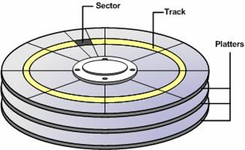
Figure 1: Hard disk schematic
Electromagnetic read/write heads are positioned above and below each platter. As the platters spin, the drive heads move in toward the center surface and out toward the edge. In this way, the drive heads can reach the entire surface of each platter. Reading from 2 tracks implies a realignment of the reading heads, thus it takes longer than reading a single track.
Simple, right? Well, it gets more complicated than this, but we’ll discuss that later.

The Theory
Microsoft provides a tool, DiskPar, which allows aligning the disk tracks with sector tracks. For partitions created by Windows 2000 and Windows Server 2003, the default starting sector for disks that have more than 63 sectors per track is the 64th sector. Because Windows will read blocks of 4 KB (8 sectors), one out of every eight blocks of data written to your disk will span two disk tracks (assuming 64 sectors per track). DiskPar can increase disk performance as much as 20 percent, but you should always consult your hardware vendor before using this tool (I’ll discuss why next). Some disk configurations will have no benefit from the tool.
There is also another tool that can perform the same job, DiskPart (notice the extra “t”), but you’ll have to install Windows 2003 Service Pack 1 in order to get this functionality.

The Real World
Now that you know what’s inside your hard disk and how the data is stored, it’s time to add some complexity.
If you imagine the surface of a disk platter, considering a constant number of sectors per track and knowing that track lengths increase the farther a track resides from the center of the disk (they are concentric circles), it’s not hard to conclude that the outer data sectors are longer than the inner data sectors.
This means that the outer tracks are greatly underutilized, because in theory they can hold many more sectors given the same linear bit density. In order to increase capacity and eliminate this wasted space, a technique called zone bit recording (ZBR) is employed on modern hard disks. With this technique, tracks are grouped into zones based on their distance from the center of the disk, and each zone is assigned a number of sectors per track. As you move from the innermost part of the disk to the outer edge, you move through different zones, each containing more sectors per track than the one before. This allows for more efficient use of the larger tracks on the outside of the disk.
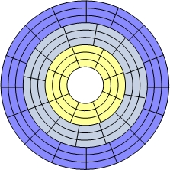
Figure 2: Zoned Bit Recording (ZBR)
Nowadays, disks use many complex internal structures, so there’s no simple way of knowing the real geometry of a disk. Indeed, the number of sectors per track is variable, because of zone bit recording, so there is no real number of sectors per track.
By now you may be confused, wondering if there’s a point in aligning disk tracks. I can assure you there is, but you should definitely consult your hardware vendor. He should provide you with pertinent information regarding the use of an alignment tool. One fine example of information provided by the storage vendor is HP. Just take a look at this document:HP StorageWorks Enterprise Virtual Array 5000 and Microsoft® Exchange Server 2003: storage performance and configuration — white paper.
And even if you can’t get the information from the vendor, you can make your own performance testing using a tool like JetStress and varying the starting disk offset with DiskPar or DiskPart. A good value to start is probably 64 sectors (or 32 KB).
There is also a KB article about how Windows handles the complex geometry of modern hard disks: Q161563: How Windows NT Handles Drive Translation.

Using DiskPar
The DiskPar utility is a command-line tool that finds and modifies the starting sector on a disk to improve performance and it can be found in the Windows 2000 Server Resource Kit. DiskPar only has 2 command line options, one for querying disk geometry and the other one for effectively changing that disk configuration. You can check the tool’s usage by executing DiskPar -?.
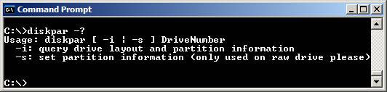
- Check disk information before using DiskPar.
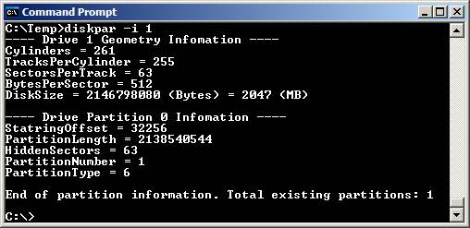
(Did you notice the spelling errors? Infomation and StatringOffset. Remember, this is a Resource Kit tool, so it’s not supposed to have the quality control that other Microsoft products have)
- Start Disk Management.
- Delete all partitions on the disk making it a raw drive. Backup any data you don't want to lose before removing partitions. Notice the number of the disk you want to change (we’ll use Disk 1).
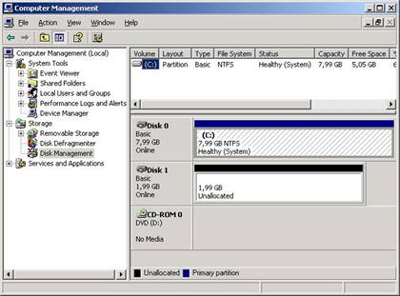
Figure 3: Disk Management snap-in
- Run DiskPar to set the starting offset and create the first partition on the disk you want to align: diskpar -s 1
- Enter the new starting offset (in sectors), and the partition length (in MB). This writes the new starting sector information to the Master Boot Record (MBR) for that disk, and creates the first partition.
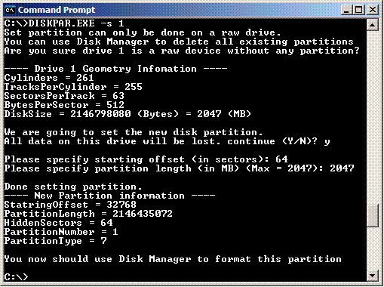
- Using Disk Manager, create and format all other desired partitions on that disk. When you format the hard disks remember not to use quick format. Configure the partition to use NTFS and to use an allocation unit size of 4096 (4 KB). By default Windows will use a 4KB allocation unit, even if you don’t explicitly specify it.
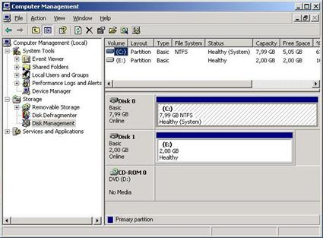
Figure 4: Creating the partition
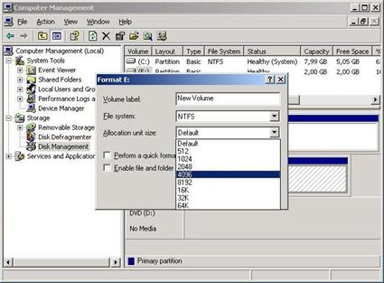
Figure 5: Formatting the partition
You should have present that the information reported by this tool isn’t always accurate, because the track information reported by disks doesn't always reflect reality (as we seen before) and most disks have different numbers of sectors on different tracks.

Using DiskPart
With the release of Service Pack 1 for Windows 2003, the ability to align disk tracks has been included in DiskPart. The original DiskPart that shipped with Windows Server 2003 has the version 5.2.3790, while the new one is 5.2.3790.1830.
The new syntax for creating partitions with DiskPart is:
create partition primary [size=N] [offset=N] [ID={Byte | GUID}] [align=N] [noerr]
For more information about DiskPart usage, read the command line reference.
The main difference between DiskPar and DiskPart is that in the latest you specify the offset in Kilobytes, not sectors.
- The first steps for using DiskPart are the same as the ones for DiskPar. Start Disk Management and delete all partitions on the disk making it a raw drive.
- Run DiskPart from a command prompt. From the DiskPart prompt, select the disk you want to align: select disk 1
- Issue the command to create the aligned partition: create partition primary align=32
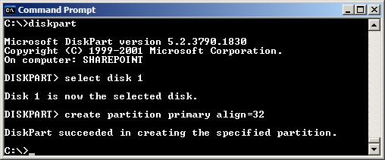
- You can then check disk information to confirm that the partition is in fact aligned.
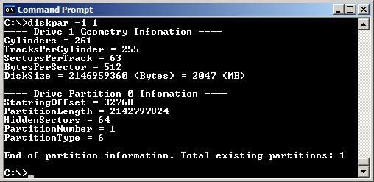

Conclusion
Because the disk subsystem is the main cause of performance bottlenecks on an Exchange infra-structure you should use all means to plan and design a proper solution. By using one of the available tools (DiskPar or DiskPart) to create aligned partitions (as compared with non-aligned partitions that are created by Windows), you can increase disk performance by 20 percent, but you should always check with your hardware vendor if it’s a recommended procedure.
After you finish aligning the disks, you can (and should) validate the potential performance improvement by running some performance tools, such as JetStress.

Primary, Extended and Logical Partitions
In order to use the space in a hard disk, it must be partitioned. Partitioning is the process of dividing the hard disk's space into chunks, so they can be prepared for use, or even dedicated to different uses. Even if the entire disk is intended to be left in one piece, it must be partitioned so that the operating system knows that it is intended to be left in one piece. There are many different considerations that go into deciding how to partition a hard disk.
The rules that determine how partitions are used were set down very early in the original design of the PC, and have remained virtually unchanged since that time. Recall that when the PC was first invented there was only (really) one type of file system. Still, it was envisioned that in the future, multiple operating systems and/or file systems might be wanted on a single machine. Therefore, provision was made in the partitioning scheme to allow for several different partitions. The rules that govern partition setup are as follows:
- A maximum of four partitions can be placed on any hard disk. These are sometimes called primary partitions. The limitation of four is one that is imposed on the system by the way that the master boot record is structured.
- Only one partition may be designated, at any given time, as active. That partition will be used for booting the system. See here for more on active partitions and switching active status between partitions.
- DOS (and the operating systems that depend on it for booting, which includes all consumer Windows operating systems) will only recognize the active primary partition. Any other primary partitions will be ignored.
- One of the four partitions may be designated as an extended DOS partition. This partition may then be subdivided into multiple logical partitions. This is the way that two or more logical DOS volumes can be placed on a single hard disk.
Alright, I realize that this is somewhat confusing, so let's take a look at some examples of systems, to show you how this scheme is used:
- Single Partition Windows PC: Many PCs have all of their disk space made into a single partition, and use one of the FAT file systems. Such a machine would have just a single FAT primary partition on it, and nothing else. The other three "slots" for partitions on the disk would be empty.
- Multiple Partition Windows PC: To use more than one partition at a time on a DOS/Windows system, two partitions are used. One is a regular DOS primary partition (which becomes the "C:" drive). The other is the extended DOS partition. Within the extended DOS partition, all the other logical drives are created. So a drive with four logical drive letters would have the first (C:) be the active primary partition, and the other three (D:, E: and F:) would be logicals within the extended DOS partition.
- Multiple Operating System PC: A system with multiple operating systems could use one primary partition for each of up to four different file systems.
If you want, you can also combine multiple partitions with multiple operating systems. For example, you could have a primary DOS partition, an extended DOS partition, and a Linux partition. Such setups are far less common than the simpler examples above.
The extended DOS partition causes most of the confusion on the part of those setting up new DOS/Windows PCs. It really functions as a "container" that holds all DOS partitions except for the first (primary) volume. The reason that this structure was used is that the original design, with its limit of four partitions, was too restrictive. The extended DOS partition system allows you to have up to 24 disk partitions in a single system, without violating compatibility with older hardware and software designed based on the original four-partition limit. Of course, nobody would use that many partitions on a system in most cases, because it would be a data organization nightmare! :^)
Within the extended DOS partition, the logical drives are stored in a linked structure. The extended partition's information is contained in the master partition table (since the extended partition is one of the four partitions stored in the master boot record). It contains a link to an extended partition table that describes the first logical partition for the disk. That table contains information about that first logical partition, and a link to the next extended partition table which describes the second logical partition on the disk, and so on. The extended partition tables are linked in a chain starting from the master partition table.
In terms of how the disk is used, there are only two main differences between a primary and a logical partition or volume. The first is that a primary partition can be set as bootable (active) while a logical cannot. The second is that DOS assigns drive letters (C:, D: etc.) differently to primary and logical volumes.
Here's an example to hopefully make all of this a bit more clear. Let's suppose you are setting up a new system and starting with an empty 60 GB hard disk. You could create a single 60 GB partition, which would be a primary DOS partition. However, in many cases dividing up such a large disk will make it easier to manage the space, will reduce lost disk space due to slack, and will reduce defragmentation time on partitions containing more actively-used data. (See here for much more on the issues involved in partitioning.) So instead, let's say you want to split up this drive as follows:
- One 8 GB primary partition for Windows and other operating system and program files.
- One 12 GB partition for data.
- One 16 GB partition for games.
- The rest of the disk in a 24 GB partition for large multimedia files, short-term backups and "future expansion".
I'm assuming no complicating factors here, just a simple example. To do this, you will first set up a primary DOS partition 8 GB in size. This is the first of your four partitions. You will then create an extended DOS partition that is 52 GB in size. This is the second partition on the hard disk. Within the extended DOS partition you will create three logical volumes: one 12 GB, one 16 GB and one 24 GB. These are your second, third and fourth volumes (logical partitions). The first partition will be your C: drive from which you boot the machine, and DOS will (normally) assign D:, E: and F: to the other three logical partitions. Your hard disk will have one primary DOS partition, and one extended DOS partition containing three logical DOS volumes.
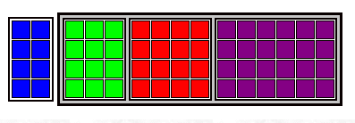
Graphical depiction of the partitioning of a 60 GB hard disk,
as described in the example above. Each square represents
1 GB of space on the hard disk. The blue squares are the 8 GB
primary partition; the green, red and purple squares are the
12 GB, 16 GB and 24 GB partitions respectively. The latter
three partitions are logical partitions contained within an extended
DOS partition, indicated by the larger, gray-shaded rectangle.
Once the system is set up, there is no functional difference between these partitions, other than the fact that C: is the only bootable one and is where all the DOS system files reside. Regular files can reside wherever you want them to.
Linux启动过程

概述
图 1 是我们在 20,000 英尺的高度看到的视图。

图 1. Linux 引导过程在 20,000 英尺处的视图
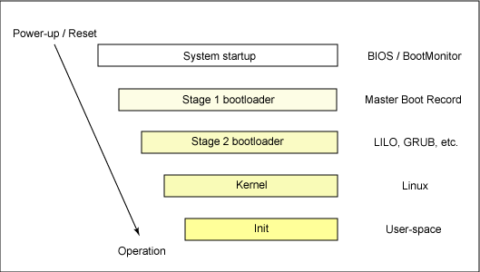
当系统首次引导时，或系统被重置时，处理器会执行一个位于已知位置处的代码。在个人计算机（PC）中，这个位置在基本输入/输出系统（BIOS）中，它保存在主板上的闪存中。嵌入式系统中的中央处理单元（CPU）会调用这个重置向量来启动一个位于闪存/ROM 中的已知地址处的程序。在这两种情况下，结果都是相同的。因为 PC 提供了很多灵活性，BIOS 必须确定要使用哪个设备来引导系统。稍后我们将详细介绍这个过程。
当找到一个引导设备之后，第一阶段的引导加载程序就被装入 RAM 并执行。这个引导加载程序在大小上小于 512 字节（一个扇区），其作用是加载第二阶段的引导加载程序。
当第二阶段的引导加载程序被装入 RAM 并执行时，通常会显示一个动画屏幕，并将 Linux 和一个可选的初始 RAM 磁盘（临时根文件系统）加载到内存中。在加载映像时，第二阶段的引导加载程序就会将控制权交给内核映像，然后内核就可以进行解压和初始化了。在这个阶段中，第二阶段的引导加载程序会检测系统硬件、枚举系统链接的硬件设备、挂载根设备，然后加载必要的内核模块。完成这些操作之后启动第一个用户空间程序（init），并执行高级系统初始化工作。
这就是 Linux 引导的整个过程。现在让我们深入挖掘一下这个过程，并深入研究一下 Linux 引导过程的一些详细信息。

系统启动
系统启动阶段依赖于引导 Linux 系统上的硬件。在嵌入式平台中，当系统加电或重置时，会使用一个启动环境。这方面的例子包括 U-Boot、RedBoot 和 Lucent 的 MicroMonitor。嵌入式平台通常都是与引导监视器搭配销售的。这些程序位于目标硬件上的闪存中的某一段特殊区域，它们提供了将 Linux 内核映像下载到闪存并继续执行的方法。除了可以存储并引导 Linux 映像之外，这些引导监视器还执行一定级别的系统测试和硬件初始化过程。在嵌入式平台中，这些引导监视器通常会涉及第一阶段和第二阶段的引导加载程序。

提取 MBR 的信息
要查看 MBR 的内容，请使用下面的命令：
# dd if=/dev/hda of=mbr.bin bs=512 count=1 # od -xa mbr.bin
这个 dd 命令需要以 root 用户的身份运行，它从 /dev/hda（第一个 IDE 盘） 上读取前 512 个字节的内容，并将其写入 mbr.bin 文件中。od 命令会以十六进制和 ASCII 码格式打印这个二进制文件的内容。

在 PC 中，引导 Linux 是从 BIOS 中的地址 0xFFFF0 处开始的。BIOS 的第一个步骤是加电自检（POST）。POST 的工作是对硬件进行检测。BIOS 的第二个步骤是进行本地设备的枚举和初始化。
给定 BIOS 功能的不同用法之后，BIOS 由两部分组成：POST 代码和运行时服务。当 POST 完成之后，它被从内存中清理了出来，但是 BIOS 运行时服务依然保留在内存中，目标操作系统可以使用这些服务。
要引导一个操作系统，BIOS 运行时会按照 CMOS 的设置定义的顺序来搜索处于活动状态并且可以引导的设备。引导设备可以是软盘、CD-ROM、硬盘上的某个分区、网络上的某个设备，甚至是 USB 闪存。
通常，Linux 都是从硬盘上引导的，其中主引导记录（MBR）中包含主引导加载程序。MBR 是一个 512 字节大小的扇区，位于磁盘上的第一个扇区中（0 道 0 柱面 1 扇区）。当 MBR 被加载到 RAM 中之后，BIOS 就会将控制权交给 MBR。

第一阶段引导加载程序
MBR 中的主引导加载程序是一个 512 字节大小的映像，其中包含程序代码和一个小分区表（参见图 2）。前 446 个字节是主引导加载程序，其中包含可执行代码和错误消息文本。接下来的 64 个字节是分区表，其中包含 4 个分区的记录（每个记录的大小是 16 个字节）。MBR 以两个特殊数字的字节（0xAA55）结束。这个数字会用来进行 MBR 的有效性检查。

图 2. MBR 剖析
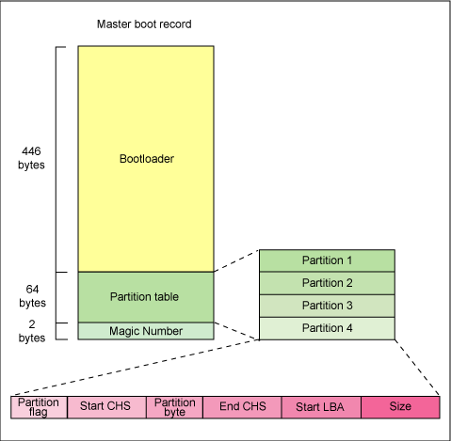
主引导加载程序的工作是查找并加载次引导加载程序（第二阶段）。它是通过在分区表中查找一个活动分区来实现这种功能的。当找到一个活动分区时，它会扫描分区表中的其他分区，以确保它们都不是活动的。当这个过程验证完成之后，就将活动分区的引导记录从这个设备中读入 RAM 中并执行它。

第二阶段引导加载程序
次引导加载程序（第二阶段引导加载程序）可以更形象地称为内核加载程序。这个阶段的任务是加载 Linux 内核和可选的初始 RAM 磁盘。

GRUB 阶段引导加载程序
/boot/grub 目录中包含了 stage1、stage1.5 和stage2 引导加载程序，以及很多其他加载程序（例如，CR-ROM 使用的是 iso9660_stage_1_5）。
在 x86 PC 环境中，第一阶段和第二阶段的引导加载程序一起称为 Linux Loader（LILO）或 GRand Unified Bootloader（GRUB）。由于 LILO 有一些缺点，而 GRUB 克服了这些缺点，因此下面让我们就来看一下 GRUB。
关于 GRUB，很好的一件事情是它包含了有关 Linux 文件系统的知识。GRUB 不像 LILO 一样使用裸扇区，而是可以从 ext2 或 ext3 文件系统中加载 Linux 内核。它是通过将两阶段的引导加载程序转换成三阶段的引导加载程序来实现这项功能的。阶段 1 （MBR）引导了一个阶段 1.5 的引导加载程序，它可以理解包含 Linux 内核映像的特殊文件系统。这方面的例子包括reiserfs_stage1_5（要从 Reiser 日志文件系统上进行加载）或 e2fs_stage1_5（要从 ext2 或 ext3 文件系统上进行加载）。当阶段 1.5 的引导加载程序被加载并运行时，阶段 2 的引导加载程序就可以进行加载了。
当阶段 2 加载之后，GRUB 就可以在请求时显示可用内核列表（在 /etc/grub.conf 中进行定义，同时还有几个软符号链接/etc/grub/menu.lst 和 /etc/grub.conf）。我们可以选择内核甚至修改附加内核参数。另外，我们也可以使用一个命令行的 shell 对引导过程进行高级手工控制。
将第二阶段的引导加载程序加载到内存中之后，就可以对文件系统进行查询了，并将默认的内核映像和 initrd 映像加载到内存中。当这些映像文件准备好之后，阶段 2 的引导加载程序就可以调用内核映像了。

内核
当内核映像被加载到内存中，并且阶段 2 的引导加载程序释放控制权之后，内核阶段就开始了。内核映像并不是一个可执行的内核，而是一个压缩过的内核映像。通常它是一个 zImage（压缩映像，小于 512KB）或一个 bzImage（较大的压缩映像，大于 512KB），它是提前使用 zlib 进行压缩过的。在这个内核映像前面是一个例程，它实现少量硬件设置，并对内核映像中包含的内核进行解压，然后将其放入高端内存中，如果有初始 RAM 磁盘映像，就会将它移动到内存中，并标明以后使用。然后该例程会调用内核，并开始启动内核引导的过程。
当 bzImage（用于 i386 映像）被调用时，我们从 ./arch/i386/boot/head.S 的 start 汇编例程开始执行（主要流程图请参看图 3）。这个例程会执行一些基本的硬件设置，并调用./arch/i386/boot/compressed/head.S 中的 startup_32 例程。此例程会设置一个基本的环境（堆栈等），并清除 Block Started by Symbol（BSS）。然后调用一个叫做decompress_kernel 的 C 函数（在 ./arch/i386/boot/compressed/misc.c 中）来解压内核。当内核被解压到内存中之后，就可以调用它了。这是另外一个 startup_32 函数，但是这个函数在 ./arch/i386/kernel/head.S中。
在这个新的 startup_32 函数（也称为清除程序或进程 0）中，会对页表进行初始化，并启用内存分页功能。然后会为任何可选的浮点单元（FPU）检测 CPU 的类型，并将其存储起来供以后使用。然后调用 start_kernel 函数（在 init/main.c 中），它会将您带入与体系结构无关的 Linux 内核部分。实际上，这就是 Linux 内核的 main 函数。

图 3. Linux 内核 i386 引导的主要函数流程
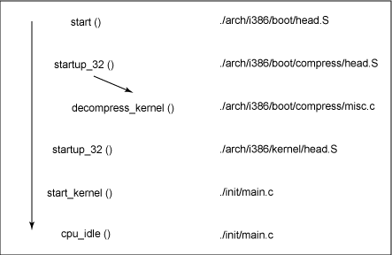
通过调用 start_kernel，会调用一系列初始化函数来设置中断，执行进一步的内存配置，并加载初始 RAM 磁盘。最后，要调用kernel_thread（在 arch/i386/kernel/process.c 中）来启动 init 函数，这是第一个用户空间进程（user-space process）。最后，启动空任务，现在调度器就可以接管控制权了（在调用 cpu_idle 之后）。通过启用中断，抢占式的调度器就可以周期性地接管控制权，从而提供多任务处理能力。
在内核引导过程中，初始 RAM 磁盘（initrd）是由阶段 2 引导加载程序加载到内存中的，它会被复制到 RAM 中并挂载到系统上。这个initrd 会作为 RAM 中的临时根文件系统使用，并允许内核在没有挂载任何物理磁盘的情况下完整地实现引导。由于与外围设备进行交互所需要的模块可能是 initrd 的一部分，因此内核可以非常小，但是仍然需要支持大量可能的硬件配置。在内核引导之后，就可以正式装备根文件系统了（通过 pivot_root）：此时会将 initrd 根文件系统卸载掉，并挂载真正的根文件系统。
initrd 函数让我们可以创建一个小型的 Linux 内核，其中包括作为可加载模块编译的驱动程序。这些可加载的模块为内核提供了访问磁盘和磁盘上的文件系统的方法，并为其他硬件提供了驱动程序。由于根文件系统是磁盘上的一个文件系统，因此 initrd 函数会提供一种启动方法来获得对磁盘的访问，并挂载真正的根文件系统。在一个没有硬盘的嵌入式环境中，initrd 可以是最终的根文件系统，或者也可以通过网络文件系统（NFS）来挂载最终的根文件系统。

decompress_kernel 输出
函数 decompress_kernel 就是显示我们通常看到的解压消息的地方：
Uncompressing Linux... Ok, booting the kernel.

GRUB 中的手工引导
在 GRUB 命令行中，我们可以使用 initrd 映像引导一个特定的内核，方法如下：
grub> kernel /bzImage-2.6.14.2
[Linux-bzImage, setup=0x1400, size=0x29672e]
grub> initrd /initrd-2.6.14.2.img
[Linux-initrd @ 0x5f13000, 0xcc199 bytes]
grub> boot
Uncompressing Linux... Ok, booting the kernel.
如果您不知道要引导的内核的名称，只需使用斜线（/）然后按下 Tab 键即可。GRUB 会显示内核和 initrd 映像列表。

Init
当内核被引导并进行初始化之后，内核就可以启动自己的第一个用户空间应用程序了。这是第一个调用的使用标准 C 库编译的程序。在此之前，还没有执行任何标准的 C 应用程序。
在桌面 Linux 系统上，第一个启动的程序通常是 /sbin/init。但是这不是一定的。很少有嵌入式系统会需要使用 init 所提供的丰富初始化功能（这是通过 /etc/inittab 进行配置的）。在很多情况下，我们可以调用一个简单的 shell 脚本来启动必需的嵌入式应用程序。

